

Plant Guide

# ventenata

*Ventenata dubia* (Leers) Coss*.*

Plant Symbol = VEDU

Contributed by: USDA NRCS Pullman Plant Materials Center

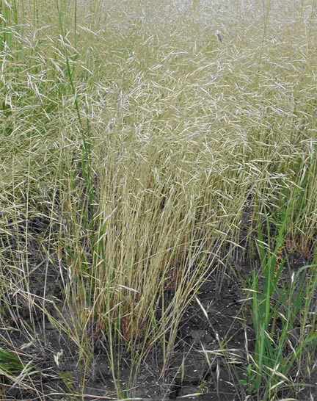 *Pamela Scheinost, USDA NRCS Pullman Plant Materials Center*

# Caution: This plant is weedy and can be invasive.

### Alternate Names

Wiregrass, North Africa grass, *Avena dubia* Leers, *Ventenata avenacea* Koel.

### Uses

Ventenata may be grazed in the early spring, however its forage value is minimal. Once the panicles begin to emerge, the stems harden and become unpalatable. There are no other known uses of this plant.

Consult the PLANTS Web site and your State Department of Natural Resources for this plant’s current status (e.g. state noxious status).

### Description

*General*: Grass Family (Poaceae). Ventenata is a winter annual that germinates in the fall when temperatures are moderate to high (18º - 28º C, or 64° - 82° F) (Northam & Callihan, 1986). Seed heads are produced May through June, about one month following annual *Bromus* species. The plant has slim, erect culms from 10 to 46 cm (4 to 18 in) tall with microscopic hairs that give the appearance of being smooth. Seedling leaves are in-rolled or lengthwise folded and appear very narrow. The inflorescence is an open panicle, appearing silvery green but rapidly maturing to a yellowish-tan color. At the end of each spreading to drooping rachilla are 1-5 spikelets. About 15 – 35 seeds are produced per plant (Lass & Prather, 2007). Ventenata was named after a professor of botany at Paris, Pierre Etienne Ventenat, 1757-1805 (Hitchcock & Cronquist, 1973).

Ventenata is beginning to replace perennial grasses and forbs along roadsides and in hay, pasture, range and CRP fields in the western U.S. In addition to having minimal forage value for livestock or wildlife, ventenata is also undesirable because its shallow root system may cause the soil to be more prone to erosion. Over time, decline of productivity and land value occurs.

*Key characteristics:* Ventenata can be easily identified in May – June based on its reddish-black nodes. Its unusually long ligule (1-8 mm) is another distinguishing characteristic. By late June - July the plant adopts a shiny appearance and an open panicle emerges. Once the plant senesces in July - August, the awns (1 – 2.5 mm in length) become twisted and bent, which is typical of members of the Aveneae tribe.

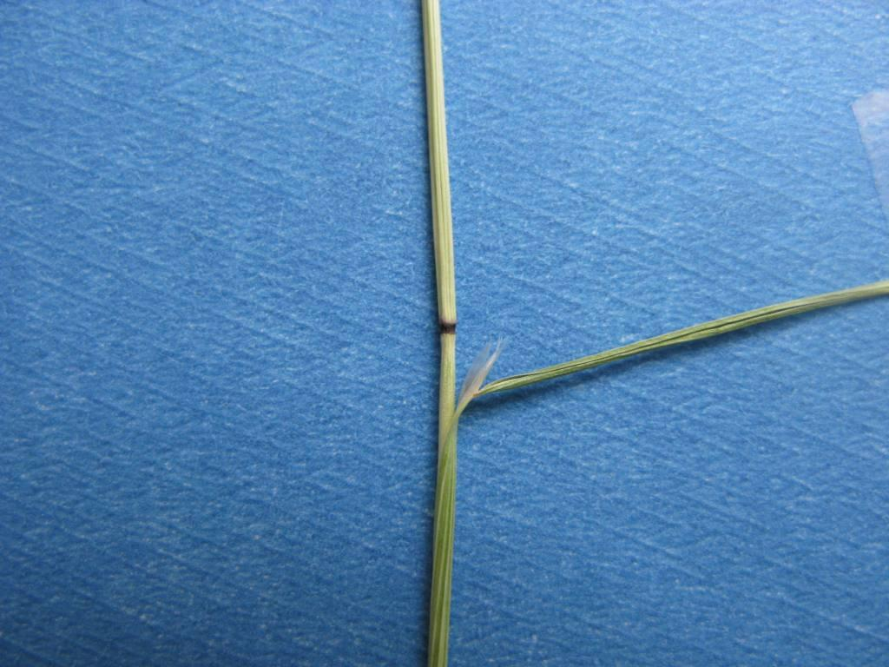

Pamela Scheinost, USDA NRCS Pullman Plant Materials Center

**Distribution**

Ventenata is native to southern Europe, western Asia and northern Africa. There are 5 known species of Ventenata, however only *V. dubia* has been documented on the North American continent.

Ventenata was first reported in the U.S. in Washington state in 1952 (Flora of North America Editorial Committee, 1993). Currently it is found throughout the northwestern and northeastern states of the U.S. (WA, OR, CA, ID, UT, MT, WY, WI, NY, ME) and the western and eastern provinces of Canada (BC, AB, ON, QC, NB). In the western U.S., ventenata is beginning to receive a great deal of attention due to its rate of spread and difficulty in control.

**Adaptation**

Ventenata is typically found from near-sea level to mid-range elevations (10 – 1800 m, or 35 – 6000 ft) and within moderate precipitation zones (35 – 112 cm/yr, or 14 – 44 in/yr). It is most commonly found on south-facing hillsides with shallow, rocky, clay or clay-loam soils. In addition, sites that are inundated in early spring but dry out by late spring tend to be preferred (Old, 2008).

**Vectors**

## Ventenata is spread primarily as a contaminant of Kentucky bluegrass, hay and annual crops. In addition, ventenata is found along roadsides and likely is moved along the transportation corridors where it has opportunities to move into surrounding areas. It can also be spread by humans and animals due to having long awns.

**Control**

Few control methods are known for ventenata, particularly in range and pasture settings. However, because the seed is thought to be viable for only two or three years, three to four years of aggressive management followed by vigilant monitoring may eliminate or severely reduce an infestation.

**Manual and Mechanical Control**

Ventenata cannot be mowed during heading; plants will only bend over or become tangled in the swather (hence the name wiregrass). If ventenata is mowed once prior to heading, plants may produce another flush of heads (Lass & Prather, 2007). Mowing ventenata multiple times throughout the growing season, however, has proven to be a successful method of control (Gribble, 2008). Plants kept at minimal height until soil moisture is unavailable may be prevented from producing seed.

Fire shows no promise as a control method. Where wildfires or prescribed fires burned in Oregon, ventenata populations have flourished (Brummer, 2008; Mafera, 2008). In Idaho, fire suppressed ventenata but tended to stimulate annual weedy bromes and left an opening for more ventenata the following year (Lass & Prather, 2007).

**Environmental/Cultural Control**

Maintaining a healthy stand of perennial vegetation may help to prevent ventenata invasion. A healthy stand can be created and maintained with appropriate selection of plant species, application of proper amount of nutrients, use of Integrated Pest Management (IPM) strategies such as spot spraying, following a suitable grazing plan, and good forage management.

**Chemical Control**

In cropland, several herbicides are available and known to be effective. In hay, pasture, range and CRP fields, selection of registered herbicides is limited. Ventenata has shown to be tolerant to glyphosate and sethoxydim when applied in the spring. Imazapic applied in the fall to semi-dormant perennial grass stands has been effective, particularly when ventenata comprises more than 25% of the vegetative ground cover. One technique that has shown promise is application of imazapic in the fall followed by applications of nitrogen fertilizer in the spring and fall of the next year. Fertilizer can help perennial grasses recover from herbicide damage and be more competitive.

Contact your local agricultural extension specialist or county weed specialist to learn what herbicides work best in your area and how to use them properly. Always read label and safety instructions for each control method. Trade names and control measures appear in this document only to provide specific information. USDA, NRCS does not guarantee or warranty the products and control methods named, and other products may be equally effective.

**Biological Control**

Biological control methods have not been considered.

**References**

Brummer, F., Oregon State University Extension. 2008. Personal communication.

**Burke Museum of Natural History and Culture. University of Washington. http://biology.burke.washington.edu/herbarium/imag ecollection.php?Genus=Ventenata&Species=dubia**

**(Accessed 5/27/2008).**

Flora of North America Editorial Committee. 1993. Flora of North America: North of Mexico. Vol. 24. Magnoliophyta. **Oxford University Press, New York. pp. 683-684.**

Gribble, R., NRCS, Grangeville, ID. 2008. Personal communication.

Hitchcock, C.L. and A. Cronquist. 1973. Flora of the Pacific Northwest. University of Washington Press, Seattle and London. p. 674.

Jaberg, J., Ochoco National Forest, Paulina Ranger District. 2008. Personal communication.

Johnson, C.G. and D.K. Swanson. 2005. Bluebunch Plant Communities of the Blue and Ochoco Mountains: A Guide for Managers. Gen. Tech. Rep. PNW-GTR-641. Porland, OR: USDA Forest Service, Pacific Northwest Research Station. 119 p.

Lass, L. and T. Prather. 2007. A scientific evaluation for noxious and invasive weeds of the highway 95 construction project between the Uniontown cutoff and Moscow. QuilaVision Inc., Missoula, MT. Online. Availble: http://northwestmedia.net/us95/pdf-final/Final-Weed- Report.pdf. (Accessed 5/27/2008).

Mafera D., Ochoco National Forest, Paulina Ranger District. 2008. Personal communication.

NatureServe. 2008. NatureServe Explorer: An online encyclopedia of life [web application]. Version 7.0. NatureServe, Arlington, Virginia. Available http://www.natureserve.org/explorer. (Accessed 6/25/2008).

Northam, F.E. and R.H. Callihan. 1986. Germination of four annual grass weeds at three temperatures. Proceedings of the Western Society of Weed Science. 39:173.

Old, R.R. and R.H. Callihan. 1987. *Ventenata dubia* in the Pacific Northwest. Proceedings of the Western Society of Weed Science. 40:130

Old, R.R. 2008. Personal communication.

**Whitson, T.D. 1996. Weeds of the West. 5th Edition. Western Weed Science Society. Pioneer of Jackson Hole, Jackson Hole, Wyoming. pp. 498-499.**

### Prepared By

## Pamela Scheinost, USDA NRCS Pullman Plant Materials Center, Pullman, WA

*Mark Stannard,* USDA NRCS Pullman Plant Materials Center, Pullman, WA

*Tim Prather,* University of Idaho, Moscow, ID

### Species Coordinator

## Pamela Scheinost, USDA NRCS Pullman Plant Materials Center, Pullman, WA

Published November, 2008

Edited: sept1008tp; sept1508ms; oct0708jsp; oct1508ps

For more information about this and other plants, please contact your local NRCS field office or Conservation District at <http://www.nrcs.usda.gov/> and visit the PLANTS Web site at <http://plants.usda.gov/> or the Plant Materials Program Web site <http://plant-materials.nrcs.usda.gov>.

PLANTS is not responsible for the content or availability of other Web sites.

**USDA IS AN EQUAL OPPORTUNITY PROVIDER AND EMPLOYER**