

Plant Guide

# hookedspur violet

## Viola adunca Sm.

Plant Symbol = VIAD

Contributed by: USDA NRCS Corvallis Plant Materials Center, Oregon

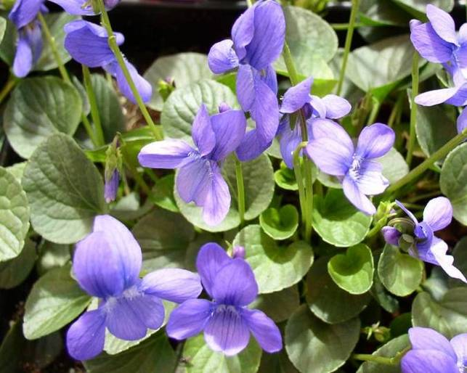

*Hookedspur violet, Photo by Amy Bartow, Corvallis Plant Materials Center, 2008*

**Alternate Names**

*Alternate Common Names:* early blue violet, western blue violet, western long-spurred violet, western dog violet, hooked violet, sand violet

### Warning: The rhizomes, fruit, and seeds are poisonous to humans, and can cause upset stomach, intestinal problems, respiratory and circulatory depression.

### Uses

*Wildlife:* The Mardon skipper butterfly (*Polites mardon*) uses the hookedspur violet as a spring-flowering nectar source, and is listed as a State of Washington Endangered Species and a Federal Candidate Species. Zerene fritillary butterflies (*Speyeria zerene*) use hookedspur violet as a larval host, and three subspecies of the Zerene fritillary are listed on the Federal Endangered Species List, including the Myrtle’s silverspot (ssp. *myrtleae*), the Behren’s silverspot (ssp. *behrensii*), and the Oregon silverspot (ssp. *hippolyta*). The Myrtle’s and Behren’s silverspot are also classified as endangered in California, and the Oregon silverspot is classified as threatened in California, Oregon, and Washington (Hayduck, 2012) Bees and other insects pollinate hookedspur violet, and are led to the flower’s nectaries by purple veins on the flower’s lower petals. In addition, birds and mice use the seeds of hookedspur violet as a food source.

*Habitat Restoration*: Hookedspur violet is used for coastal butterfly habitat restoration in the Pacific Northwest, and is established by either seed or as plugs.

### *Ornamental*: Hookedspur violet is a popular ornamental plant for wildflower and butterfly gardens in the Pacific Northwest.

### Status

*Viola adunca* is listed as endangered by the State of Massachusetts*.* Please consult the PLANTS Web site and your State Department of Natural Resources for this plant’s current status (e.g., threatened or endangered species, state noxious status, and wetland indicator values).

### Description

*General*: Hookedspur violet is a common, native, perennial forb of the violet family (Violaceae) with short to elongate slender rhizomes. Plants typically grow to approximately 4 inches in height. A branched stem from hairy rhizomes terminates in round to oval 2 inch leaves. Flowers are pale to deep violet with a white patch and purple veins at the base of the lower three petals, which act as nectar guides for bees. The two side petals have white beards at the base and hooked spurs at the tips (Clark and Trelawny, 1998). In this species, petaliferous flowers are produced in the spring while cleistogamous flowers are produced later in the season (Reznick and Voss, 2011). Seeds are borne in unique pods and are explosively thrown some distance when pods burst. Hookedspur violet blooms in midspring (Clark and Trelawny, 1998).

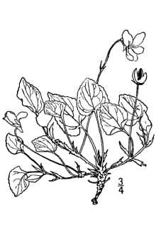

*Hookedspur violet, Image Courtesy of USDA PLANTS, 2012*

*Distribution*: Hookedspur violet is found extensively in the western half of the United States to New England and northward throughout Canada. For current distribution, please consult the Plant Profile page for this species on the PLANTS Web site.

*Habitat*: Hookedspur violet inhabits varied environments including dry to moist meadows, coastal areas, open woods, grasslands, and open, disturbed ground; from lowlands to near timberline.

**Ethnobotany**

Hookedspur violet was used in traditional medicine by the Blackfoot, Bella Coola and Tolowa tribes. Leaves and roots were used to treat stomach problems and asthma in children, and as a cataplasm to treat soreness and swelling. In addition, the Southern Carrier, and Klallam used the plant as an analgesic and gastrointestinal aid, and the Makah tribe used it as a gynecological aid (Appell, 2000).

The leaves and flowers of all violets are edible, and can be eaten in salads, used as potherbs, or brewed as tea. In addition, these plant parts are high in vitamins A and C, and can be used as garnishes, flavorings, colorings, and thickeners (Appell, 2000).

The Blackfoot Indians used a blue dye obtained from hookedspur violet to dye arrows (Appell, 2000).

**Adaptation**

Hookedspur violet is well adapted to frequent disturbance that controls taller, faster growing competitors. In addition, it is tolerant of salt spray when growing on the coast, and is adapted to seasonally saturated/droughty soils. It can grow in well-drained, sandy, loamy, or clayey soils with a neutral to slightly acidic pH.

### Establishment

Seeds can be sown on restoration sites in the fall at a rate of 1 pound per acre, or 50 seeds per square foot. Seeds should be sown less than 1/8 inch deep and covered lightly with soil or vermiculite. Seeds experience dormancy and need up to 120 days of wet, cool conditions (stratification) to trigger germination in the spring. Plants can also be established from plugs on restoration sites. Timing and spacing of plantings will depend on site conditions, and management objectives. Plugs can be sown in either the fall or spring, and can be spaced as closely as 6 inches.

### Management

Hookedspur violet prefers recently disturbed sites, and is easily outcompeted by taller or more vigorous plants. Management to control competition and prevent encroachment of trees may be necessary to ensure survival of this species on restoration sites. Mowing, or low to moderately intense burning in the fall may be a feasible means of controlling competition.

### Pests and Potential Problems

This species is covered with many types of insects, but no damage has been observed to established plants. Developing seed is highly predated by both birds and mice, and control measures are necessary to avoid loss of large amounts of seed in seed production fields. Slugs overwinter in violet crowns but typically do not cause enough damage to warrant control measures.

### Environmental Concerns

### Existing populations of hookedspur violet may face increased pressure due to habitat loss, and disruption of historic disturbance regimes.

### Seeds and Plant Production

### *Establishment:* Seeds experience dormancy and need up to 120 days of wet, cool conditions to trigger germination in the spring. For best establishment of seed production fields, stratify seeds in a cooler, sow into plugs in a greenhouse in late winter, and transplant out in spring. Transplanting into fields covered in weed fabric containing holes on a 1 foot by 1 foot spacing is most efficient for weed control and ease of seed harvest. Irrigation is not necessary, and weed control is primarily accomplished through the use of weed fabric on seed production fields. Hand weeding may be necessary where soil is exposed within the holes in the weed fabric, and field borders need to be kept clean using herbicides or tillage as weed fabric can easily catch undesired wind borne or ejected seeds from many feet away. Seeds ripen and are expelled onto weed fabric throughout the summer. Plants typically stop flowering in mid summer, yet still produce capsules filled with seed. The weed fabric collects all of the seed but also creates potential for predation by birds and mice that requires control measures such as traps and netting.

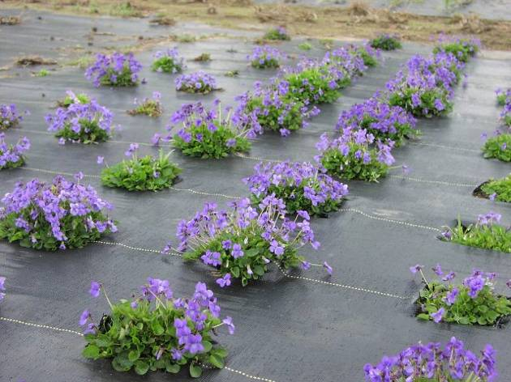

*Hookedspur violet seed production field; photo by Amy Bartow, Corvallis Plant Materials Center, 2011*

### *Harvest Method:* Production fields can be harvested by vacuuming shattered seed from the surface of weed fabric before fall rains begin. Fields are crawled and harvested using a shop vacuum powered by a generator. Care must be taken to vacuum seeds from under each plant, and from within the holes in the weed fabric. Plant material collected by the vacuum is placed in a tub to dry prior to cleaning.

*Seed Cleaning:* Following drying, an air screen machine can be used to separate seed from empty seed pods, chaff, and dirt. If necessary, a brush machine or thresher can be used to break up seed pods that have not fully opened.

*Yield & Longevity*: Hookedspur violet flowers and sets seed in the first year, if produced from plugs, yielding approximately 37 lb seed per acre the first year. Significantly higher seed yields of 180 lb per acre can be expected in the second and third years of production. Plants typically live upwards of five years and sustain high yields.

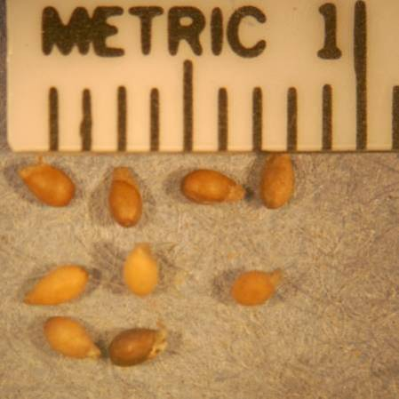

*Hookedspur violet seed; photo by Robert C. Hoffman, Corvallis Plant Materials Center, 2012*

### Cultivars, Improved, and Selected Materials (and area of origin)

### None, but containerized plants are sometimes available from commercial sources in the Pacific Northwest.

### References

Appell, S.D. 2000. The ethnobotanical uses of the genus *Viola* by Native Americans [Online]. Available at http://americanvioletsociety.org/Violets_In_America/ Ethnobotanical.htm (modified 2000; accessed 13 Mar 2012). American Violet Society.

Clark, L.J., and J. Trelawny. 1998. Wild Flowers of the Pacific Northwest. Harbor, Madeira Park.

Hayduck, E. 2012. SPP Plant Profile: Early-Blue Violet (*Viola adunca*). [Online]. Available at http://blogs.evergreen.edu/sustainableprisons/blog/20 12/01/12/spp-plant-profile-early-blue-violet-viola- adunca/ (modified 12 Jan 2012; accessed 13 Mar 2012). The Evergreen State College and Washington State Department of Corrections Sustainable Prisons Project, Olympia, WA.

Reznick, A.A, and E.G. Voss. 2011. MICHIGAN FLORA ONLINE: Viola. [Online]. Available at http://michiganflora.net/genus.aspx?id=viola (modified Feb. 2011; accessed 27 March 2012). University of Michigan, Ann Arbor, MI.

USDA, NRCS. 2012. The PLANTS Database. Available at http://plants.usda.gov (Accessed 15 Mar 2012). National Plant Data Team, Greensboro, NC.

**Prepared By**: Robert C. Hoffman, Corvallis Plant Materials Center, Oregon

### Citation

Hoffman, R. 2012. Plant guide for hookedspur violet (*Viola adunca)*. USDA-Natural Resources Conservation Service, Plant Materials Center, Corvallis, OR.

Published March, 2012

Edited: 21Mar2012 aym;15October2012jab

For more information about this and other plants, please contact your local NRCS field office or Conservation District at <http://www.nrcs.usda.gov/> and visit the PLANTS Web site at <http://plants.usda.gov/> or the Plant Materials Program Web site <http://plant-materials.nrcs.usda.gov>.

PLANTS is not responsible for the content or availability of other Web sites.

**USDA IS AN EQUAL OPPORTUNITY PROVIDER AND EMPLOYER**