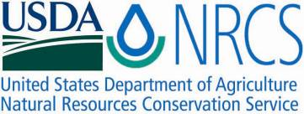

Plant Guide

# Deer pea vetch

## Vicia ludoviciana Nutt.

Plant Symbol = VILU

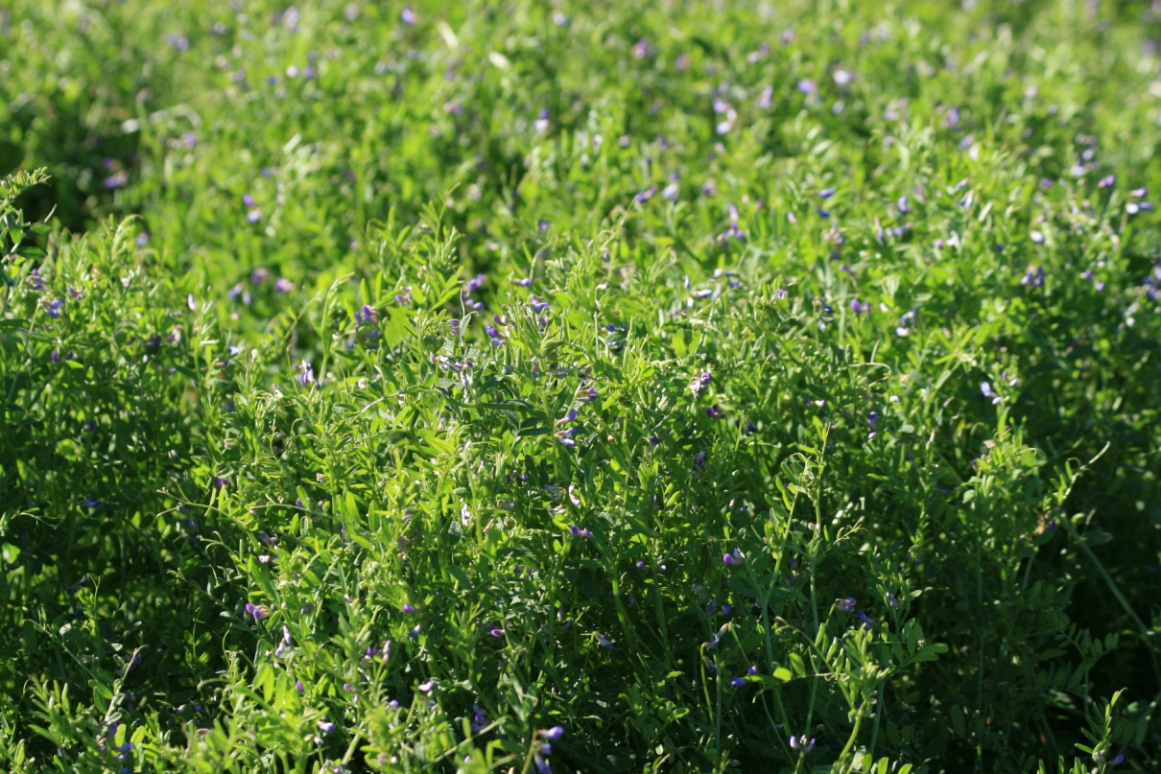

Deer pea vetch plant. Photo by Forrest Smith, South Texas Natives, Kingsville, TX.

*Contributed by: USDA NRCS E. “Kika” de la Garza Plant Materials Center and South Texas Natives*

### Uses

*Livestock:* Deer pea vetch (*Vicia ludoviciana* Nutt.) a cool season annual legume that is grazed by livestock.

*Wildlife*: Deer pea vetch provides leaf material for wildlife forage. It also produces seeds which are eaten by bobwhite quail and Rio Grande Turkeys.

### Status

Please consult the PLANTS Web site and your State Department of Natural Resources for this plant’s current status (e.g., threatened or endangered species, state noxious status, and wetland indicator values).

### Description

*General*: Deer pea vetch is a cool season, annual legume that has climbing stems. Leaves are 3-9 cm long with 6 to 12 leaflets rachis terminating in a usually forked tendril. Flowers are generally solitary, and are lavender-blue in color. Pods are 2-3 cm. long, with 4 to 8 seeds in each pod. Seed is spherical in shape very hard and light brown in color with dark brown markings (Correll and Johnston, 1970).

*Distribution*: The natural range of deer pea vetch is throughout the southern half of the United States. For current distribution, please consult the Plant Profile page for this species on the PLANTS Web site.

**Adaptation**

Deer pea vetch grows best on medium to heavy textured soils.

### Establishment

Seedbed preparation should begin well in advance of planting. Planting should be done in late fall to early winter in South Texas. Deer pea vetch can also be included in warm-season planting mixtures, but will not establish until the fall after planting. Establish a clean, weed-free seedbed by either tillage or herbicides. Prior to planting, the site should be firm and have accumulated soil moisture.

Deer pea vetch can be seeded using a drill or broadcaster. If broadcast seeded, some type of additional coverage such as culti-packing or light dragging is recommended to ensure good seed to soil contact.

Seed should be planted 1/8 to 1/4 inch deep. It is better to plant too shallow than too deep.

If one plant per square foot has become established in field plantings, then the seeding can be considered successful.

### Management

### Areas planted to Hoverson Germplasm should be deferred for 30 days to allow plants to become established. Established plants should be allowed to produce seed annually because in many areas with proper soil moisture deer pea vetch readily reseeds itself with minimal soil disturbance. As perennial cover increase on most sites deer pea vetch decreases without soil disturbance.

### Pests and Potential Problems

### No severe insect or disease problems have been observed in deer pea vetch once established.

### Environmental Concerns

### There are no known environmental concerns associated with deer pea vetch.

### Seeds and Plant Production

Seed increase plots have been managed by flat drill planting on 8” rows. It can also be grown from transplants planted in the late fall. Harvesting when 50% of the seed is ripe allows for some seed to shatter allowing stand to reseed itself for subsequent years of harvest.

Seed can be harvested using a combine with a grain header. This harvest method will result in both green and mature seed, as well as other high moisture material in the harvested product. Most of the green seed will mature, but care must be taken to insure adequate seed drying procedures are followed to prevent molding and heating of this mixture. Seed harvested with this method is best cleaned by hammer milling to release seed from un-opened pods, then screened using a Clipper seed cleaner.

### Cultivars, Improved, and Selected Materials (and area of origin)

Hoverson Germplasm deer pea vetch was released by *South Texas Natives,* the E. “Kika” de la Garza Plant Materials Center, and Texas AgriLife Research Beeville in 2012. It was selected for its seed production, plant vigor, forage production and its ability to be harvested. Hoverson Germplasm has also shown excellent performance when used as a component of range plantings. This germplasm is known to be adapted to the Rio Grande Plain, Gulf Coast Prairies and Marshes, and Coastal Sand Plains Ecoregions of South Texas.

For calibration purposes, Hoverson Germplasm contains approximately 66,000 seeds per bulk pound. A seeding rate of 5-10 pounds of pure live seed (PLS) per acre is recommended. In planting mixtures reduce the rate according to the percent of deer pea vetch desired on the planting site. Breeder seed is maintained by South Texas Natives.

Well managed seed fields of Hoverson Germplasm have produced 200 bulk pounds of clean seed per year. Purity of the seed is usually around 70% and germination rates average near 90%. Hoverson Germplasm typically has 50% dormant seed, however after scarafiction active germination is increased to 90%. It produces one seed crop per year when grown in south Texas.

### References

Correll, D. S., and M. C. Johnston. 1970. Manual of the vascular plants of Texas. Texas

Research Foundation, Renner, TX.

Everitt, H.J., D.L. Drawe, and R.L. Lonard. 1999. Field Guide to the Broad-Leaved Herbaceous Plants of South Texas. Texas Tech University Press, Pg. 145.

Smith, F.S., A.D. Falk, and W.R. Ocumpaugh. 2012. Notice of Release of Hoverson Germplasm deer pea vetch. Caesar Kleberg Wildlife Research Institute. Kingsville, TX.

**Prepared By**:

John Lloyd-Reilley, Manager

USDA-NRCS, E. “Kika” de la Garza Plant Materials Center, Kingsville, Texas

Forrest S. Smith, Director

South Texas Natives, Caesar Kleberg Wildlife Research Institute, Texas A&M University-Kingsville, Kingsville, Texas

### Citation

Lloyd-Reilley, J. and F. Smith. 2012. Hoverson Germplasm deer pea vetch. USDA-Natural Resources Conservation Service, E. “Kika” de la Garza Plant Materials Center and *South Texas Natives*, Caesar Kleberg Wildlife Research Institute, Texas A&M University-Kingsville, Kingsville, Texas 78363.

Published August 2012

For more information about this and other plants, please contact your local NRCS field office or Conservation District at <http://www.nrcs.usda.gov/> and visit the PLANTS Web site at <http://plants.usda.gov/> or the Plant Materials Program Web site <http://plant-materials.nrcs.usda.gov>.

PLANTS is not responsible for the content or availability of other Web sites.

**USDA IS AN EQUAL OPPORTUNITY PROVIDER AND EMPLOYER**