Palace On Wheels

We are Authorized Booking Agents (GSA) for Palace On Wheels Luxury Train

‘
Book With Confidence !

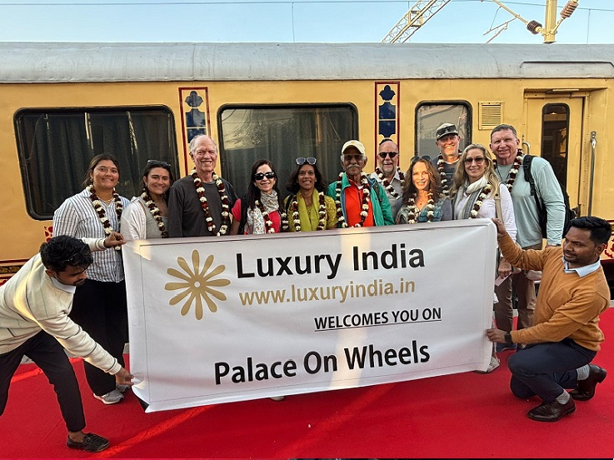

Palace On Wheels – A Week in Wonderland

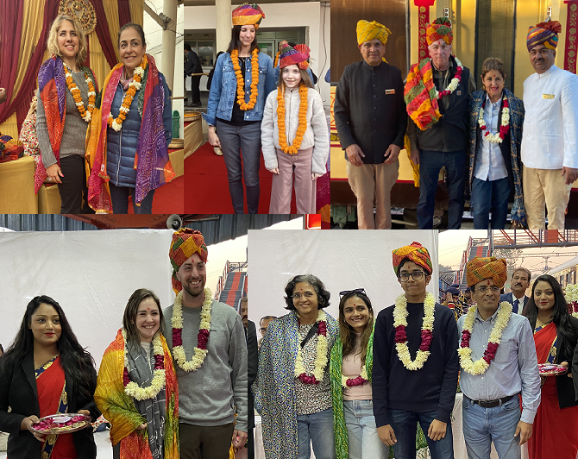

Visit us online : https://www.travelpalaceonwheels.com

(Luxury India is Authorized Booking Agent for Palace On Wheels)

PALACE ON WHEELS - 07NIGHTS & 08DAYS

(DELHI – JAIPUR – SAWAI MADHOPUR – CHITTORGARH – UDAIPUR – JAISALMER – JODHPUR – BHARATPUR – AGRA – DELHI)

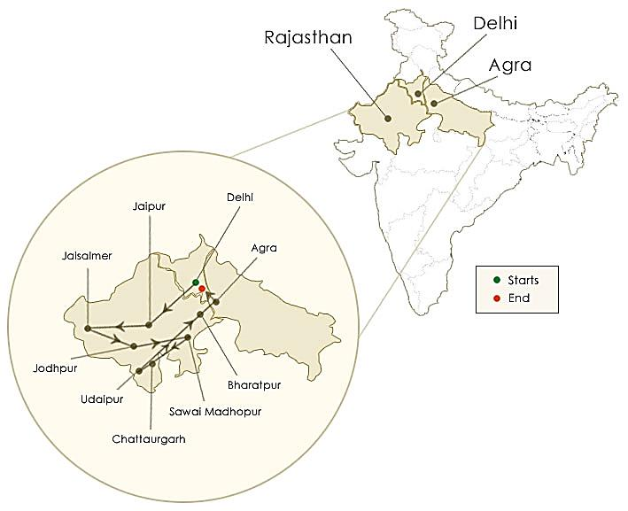
To discover the glorious history or the opulent lifestyle of Raja-Maharajas of the golden state of Rajasthan with one of the best luxurious train “Palace on Wheels” is really captivating.Originating and concluding in Delhi, this magical expedition will take you through the ideal gateway to royal Rajasthan, Jaipur, Venice of the East or Udaipur, the Blue City of Jodhpur, Golden City of Jaisalmer and Bharatpur are some of the cities that will be visited during this lavish tour of Rajasthan. Be its glorious golden past, royalty, history, spirituality, and wilderness everything about this tour will fondle your senses for sure!

So don’t seat back, come and explore Rajasthan with “Palace on Wheels”.

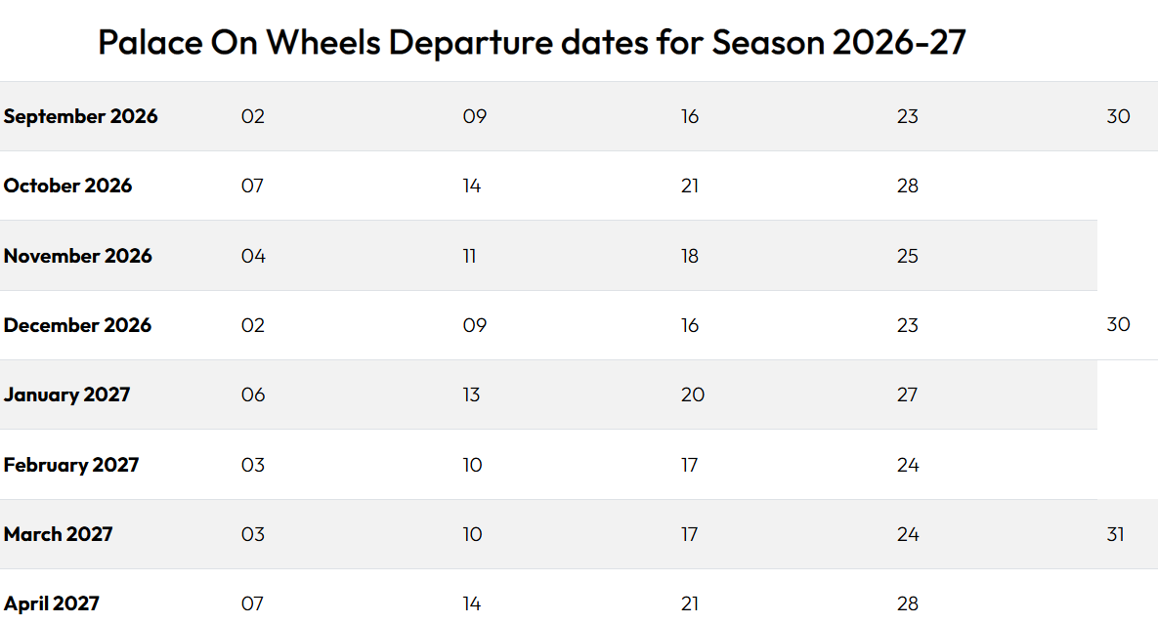

Cabin Category | Additional Facilities Offered as compared to Deluxe Cabin
Presidential Suite | • Luxury private car (Fortuner / similar) for excursions
Presidential Suite | • Dedicated private guide
Presidential Suite | • Indian & Foreign brands of Liquor & Beer Included (as per available Stock)
Presidential Suite | • 30-minute spa session for a couple (one time only)
Suite | • Private car (Innova / similar) for excursions
Suite | • Dedicated private guide
Suite | • Indian brands of Liquor & Beer Included (as per available Stock)
Super Deluxe Cabin | • Private car (Innova / similar) for excursions
Super Deluxe Cabin | • Dedicated private guide
Super Deluxe Cabin | • 30-minute spa session for a couple (one time only)

INCLUSIONS:

- PALACE ON WHEELS ACCOMODATION AS PER OCCUPANCY
- ALL MEALS ON TRAIN OR AS PER THE ITINERARY
- CITY SIGHTSEEING TOURS AS MENTIONED IN THE ITINERARY
- AC VEHICLE FOR ALL TRANSFERS
- GUIDES FOR ALL TOURS IN COACHES
- MONUMENT ENTRANCES
- PARKS AND PALACES ENTRANCE FEES
- CULTURAL PROGRAMS
- CAMEL RIDE AT JAISALMER
- BOATRIDE AT UDAIPUR
- RICKSHAW RIDE AT BHARATPUR
- ASSISTANCE FOR ALL STATIONS TRANSFERS
- ALL APPLICABLE TAXES AND SERVICE CHARGES

EXCLUSIONS:

ANY OPTIONAL TOURS AS MENTIONED IN THE ITINERARY, LIQUOR, SPA, INSURANCE, GRATUITIES, TELEPHONE CALLS, LAUNDRY, ALCOHOLIC BEVERAGES, VIDEO, FILM AND PROFESSIONAL STILL CAMERA FEES AND ARRIVAL AND DEPARTURE TRANSFERS.

INTERNATIONAL AND DOMESTIC AIR TICKETS, ANY TOUR EXTENSIONS ARE NOT INCLUDED UNLESS SPECIFICALLY MENTIONED AS PART OF THE JOURNEYS.

IMPORTANT NOTE:
✓If Due to Covid19 Travel Restrictions Or Low Occupancy Or Any other reason, the Scheduled Depart does not Operate or cancelled by the operator, You Will be Informed At least One Week Before Scheduled Depart, And Have option to adjust advance in Future Journey or a similar value credit note valid for 60 months, or request for a refund of the same.
Train Operators reserve the right to amend any tariff / fee / itinerary / cancellations/ refund rules or any rules etc., and any difference in tariff or additional charges is to be paid by the guest only as per the operators rules,
International / USD (United States Dollars) Refunds - all refund amounts would be calculated on the basis of actual INR (Indian Rupee) value received and any foreign exchange value difference is to be borne by you. LUXURY INDIA shall not be responsible for any such fluctuation in International currency and actual INR receipt shall be taken as base for all calculations. Luxury India reserves to deduct MINIMUM USD 235 per person towards Bank Charges / documentation charges in case of International refunds.

HOW TO CONFIRM THE TOUR OR CONFIRMATION PROCESS:

THE PROCESS OF TOUR CONFIRMATION & COMMUNICATION
Step 01:

-Selection & Finalization of the tour.
-Filling up booking form (which will be shared with you, along with cancellation & terms)
- Kindly share Passport copies, to refer the name/ nationality/ passport number

Step 02:

-Process the advance payment 40percent as per the invoice copy shared with you.
-If International flight ticket already arranged then share the details

Step 03:

After receiving the amount, you will receive the confirmation email & a letter from our end. Bifurcation of tour amount will also be shared (receiving and balance). Balance payment needs to be cleared atleast 95days prior to arrival.

Step 04:

If you still have any questions or would like to add anything, then kindly intimate us. We will check what are best possibility to bring the change (sometime thing will not fit in).

Step 05:

Clear balance payment 95days prior to arrival in India. After receiving balance payment, we will share the reciept email for the same.

Step 06:

On closer date or one week prior, we will share the arrival assistance details which say who will meet you at the airport & assigned guest relations manager.

CANCELLATION RULES - PALACE ON WHEELS :

- RTDC (Rajasthan Tourism Development Corporation, Government of Rajasthan) is Palace on Wheels Train Tour Operator & liability of Luxury Indiais limited to that of booking agent only.
- Cancellation requests must be made in writing & acknowledged by us.

Cancellation Charges :

- There will be MINIMUM levy of 15% cancellation fee on gross train ticket value -if informed more than 95 days before train tour depart.
- There will be MINIMUM levy of 30% cancellation fee on gross train ticket value -if informed between 65 days to 94 days prior to train tour depart.
- There will be MINIMUM levy of 55% cancellation fee on gross train ticket value -if informed between 35days to 64days prior to train tour depart.

- There will be Full 100% cancellation fee levied on gross train ticket value -if informed less than 34 days prior to train tour depart or No Show etc.,
No Shows/ En Route Termination:
-In case of No Show / Non-arrival of the guest, refund or adjustment for future travel will not be applicable. The whole amount shall be treated as forfeited.
-In case of En route termination of tour by the guest, for any reasons refund or adjustment will not be applicable. The amount for unused portion of the tour shall be treated as forfeited.
Tour Amendments :
-All Amendments are subject to Approvals by RTDC /Train Tour Operator
Amendments only possible under the circumstances like Natural Disaster / Natural Calamity or Serious Health Problem's (this needs to be supported by doctor's certificate) and is subject to Approval by RTDC.
No refunds are possible and every case will be decided on merits on a case to case basis. No amendment will be permissible in case of booking of groups or complete train.
Request for change in travel date & passenger names is governed by cancellation rules, subject to approval by RTDC Authorities

General Rules :
Cancellation rules to be applicable in case travel documents or pending payments not received as per booking terms & conditions.
In special case-where travel date of same passengers needs to be postponed to future specific dates, Minimum US$ 200 per person will be charged & subject to approval by RTDC Authorities
Request for refund of advance/full payment, due to death Or serious illness of passenger will be at sole discretion of RTDC Authorities.
In case of scheduled train tour depart is cancelled because of any reasons by Train tour operator (RTDC), Guest will be informed at least one week before train depart & in such cases - Full amount received will be refunded or adjusted against any further travel services, (without any cancelation fee) to the Guest .
Luxury India CANNOT BE held liable to compensate for any additional Financial Loss caused viz Fee towards Cancellation of Air Tickets, Hotel Booking etc or if any Mental Trauma caused.
All foreign passport holders require valid indian Visa before boarding flight to india.
Request for refund due to refusal of Indian Visa will not be entertain Or Overseas passenger landing in India without proper travel documents-will be governed by cancellation rules.
No refund will be made in case of no-show Or self-curtailment of journey
Un-willingness to follow train tour as per schedule, will be non-refundable
At times, due to local logistics/ conditions, if Train tour Manager is forced to cancel certain scheduled sightseeing tours Or activities, at short notice - No refund will be made to passenger to compensate for this.
Request for train tour cancellation due to increase of taxes/tariff by RTDC authorities will be governed by cancellation rules.
Where passenger makes request for refund due to self cancellation, it will be governed as per foreign exchange rules of RBI Bank and the process may take 5 to 8 weeks after documentention as per RBI guidlines is received.
Luxury India reserves the right to charge MINIMUM US$ 100 per person as service charge & refund will be made as per INR Rupees amount received.

