BUSINESS UNIT/ COMMUNITY | Dubai Mall |  | ☐ PR ☐ PO | ESTIMATED COST
DATE | 17th July 2026 | DEPARMENT | TDM-Operations | REFERENCE NO. | SFM-SOW-45
BUDGET | ☐ CAPEX ☐ OPEX |  |  | UNBUDGETED | ☐ I-Memo ☐ Others
SINGLE SOURCE | ☐ Y ☐ N
Justification:
PURCHASE REQUEST/PURCHASE ORDER FORM

TITLE | SOW-45-Reupholstery Of TDM Mall Furniture
 | SCOPE OF WORK/ DESCRIPTION | UNIT | QTY
1 | 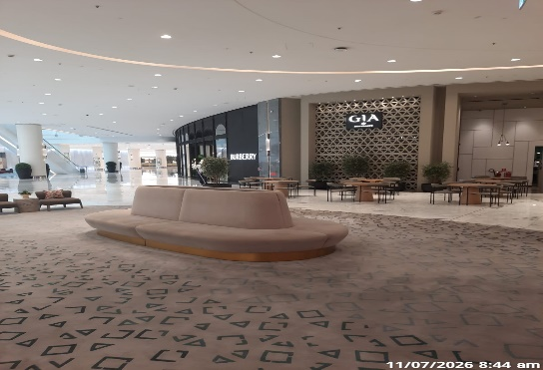  Single Sofa upholstery with Nano Fabric with new foam with Paint touch up if it is Required B08 Store | Each | 1
2 | 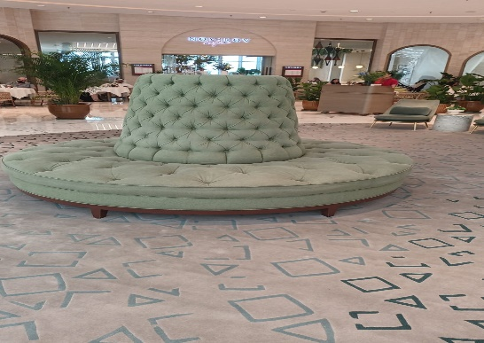  Single Sofa upholstery with Nano Fabric with new foam with Paint touch up if it is Required. B08 Store | Each | 1

SITE VISIT DATE & TIME |  | PROJECT DURATION
CONTACT PERSON /  E-MAIL |  | MOBILE NO.
COMPLIANCE  &  GENERAL REQUIREMENT | - All deliverables must match the technical specifications, materials, and methods outlined in the approved SOW without deviation.  - Any variations to the original scope must be formally requested, evaluated, and approved through a documented change order process before execution.  - All works or services must be inspected and verified by respective trade Manager/engineering team for alignment with contractual scope and quality standards.  - Substituting materials, brands, or methodologies not listed in the SOW is strictly prohibited unless written approval is obtained from authorized personnel.  - Works shall be subject to quality checks and performance testing to ensure compliance with the agreed specifications and performance standards.  - Ongoing tracking of project milestones and deliverables against the original scope to identify early signs of scope drift or non-compliance.  - Scope/PO/Contract must include penalty clauses or corrective actions in cases where the delivered scope does not meet agreed standards or timelines.  - Dilapidation reports is must from contractors before the work execution and to be verified after completion for accountability.  - 1000AED/Day- 100K projects  - 2000AED/Day -All project above 100K  - Over 1 million- TBA should be in % of invoice value  - Final acceptance of works or services must be supported by a detailed completion report, punch/Snag list closure, and sign-off by the respective trade Engineer/manager.  - All works must align with mall safety, security, aesthetic, and operational guidelines as part of the broader scope compliance.  - Warranty/Guarantee /DLP conditions must be clearly defined and should be under terms and condition  - All design and build project must have Professional indemnity insurance and rest of the project must have third party liability insurance, specially under Dubai mall name and not generic.  - Contractor shall verify the actual site condition prior to quoting.  - Obtain necessary General Work permit, Special Work Permit and Safety Induction as per Emaar procedure, policy and guidelines.  - Uniform must be worn while working inside the facility premises.  - All necessary site coordination, system verification, scope review, constraint identification is included in the Contractor’s scope and responsibility.
JUSTIFICATION
SUGGESTED VENDOR
ADDITIONAL DETAILS

PREPARED BY: | REVIEWED BY: | APPROVED BY:
Name: Winnie | Name: | Name:

