Specification bugg-ca-01-r1
Cable Assembly - Housing Bulkhead to Main Board
Bugg v3, Monad Gottfried Ltd.
Document revision r1

Summary
This cable passes power, audio and USB from the user connector on the outside of the plastic housing to the main PCB inside.
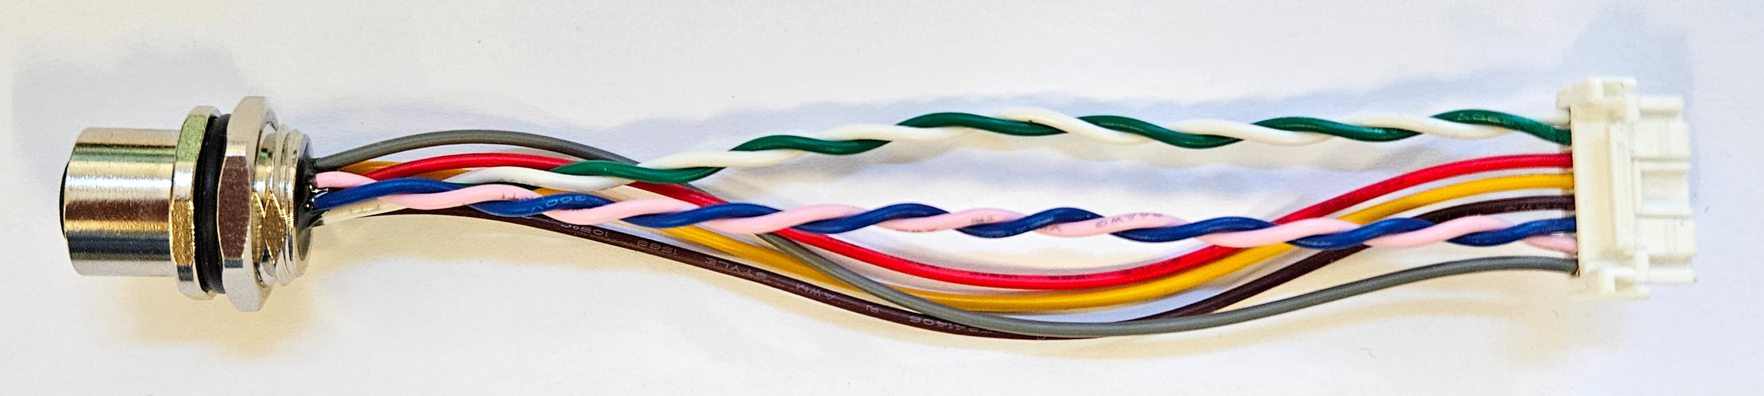

Parts
TE Connectivity  T4171320008-001  qty 1 | A 8-way panel-mount, IP-rated M12 connector.  It comes with 8 hermetically bonded flying wires 200mm long.  It seals to the outside of the housing with an O-ring.  To avoid losing the nut, keep it in place during the assembly process | 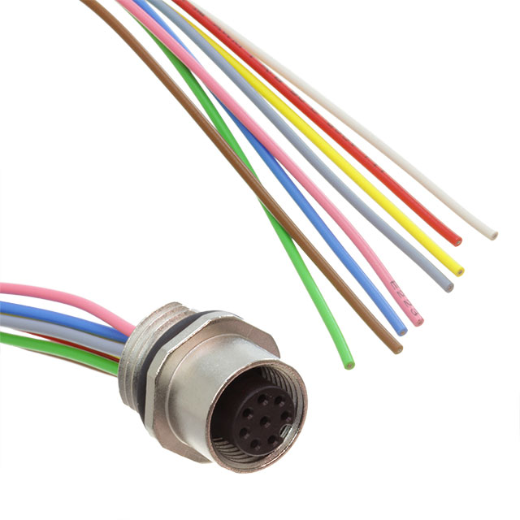
Molex  502439-0800  qty 1 | An 8-way, latching crimp housing wire-to-board connector. | 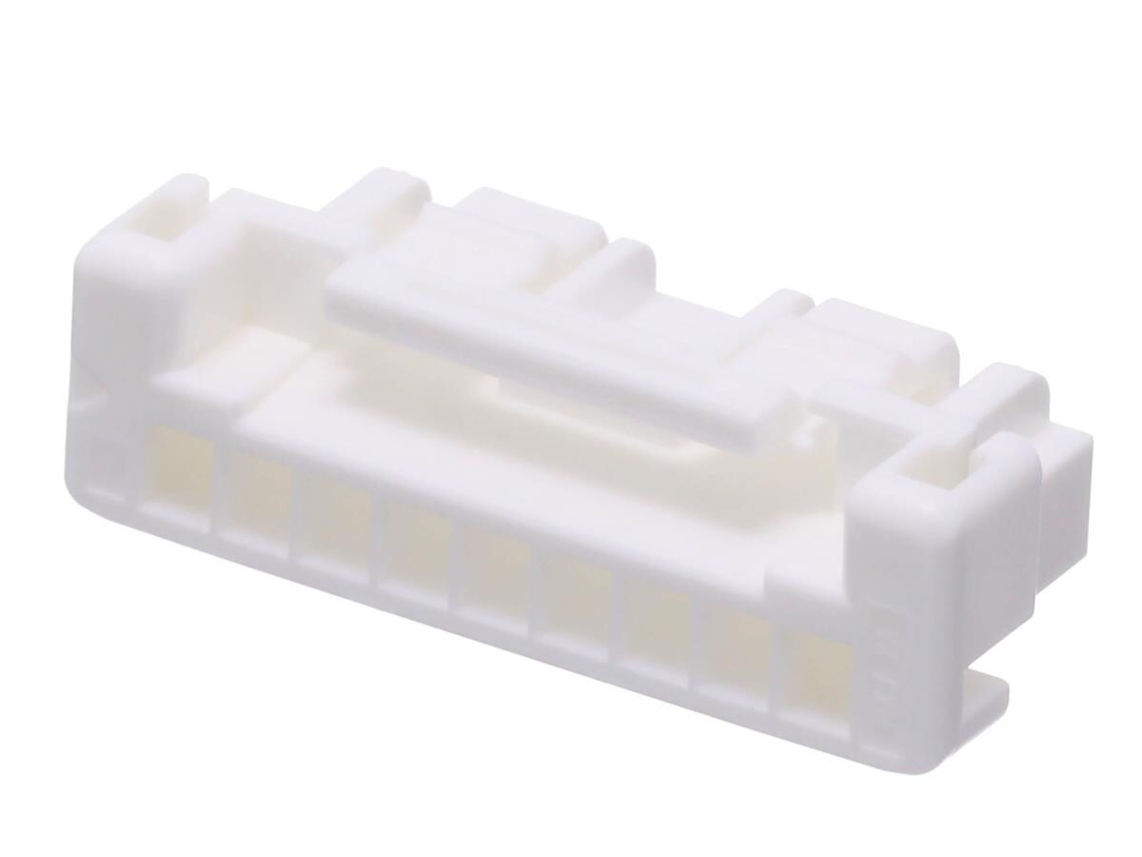
Molex  502438-0100  qty 8 | Crimp contacts that terminate the wires into the housing | 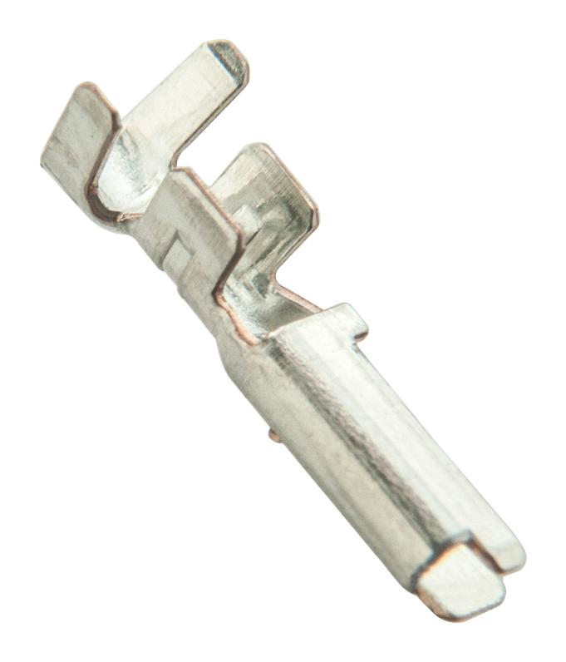

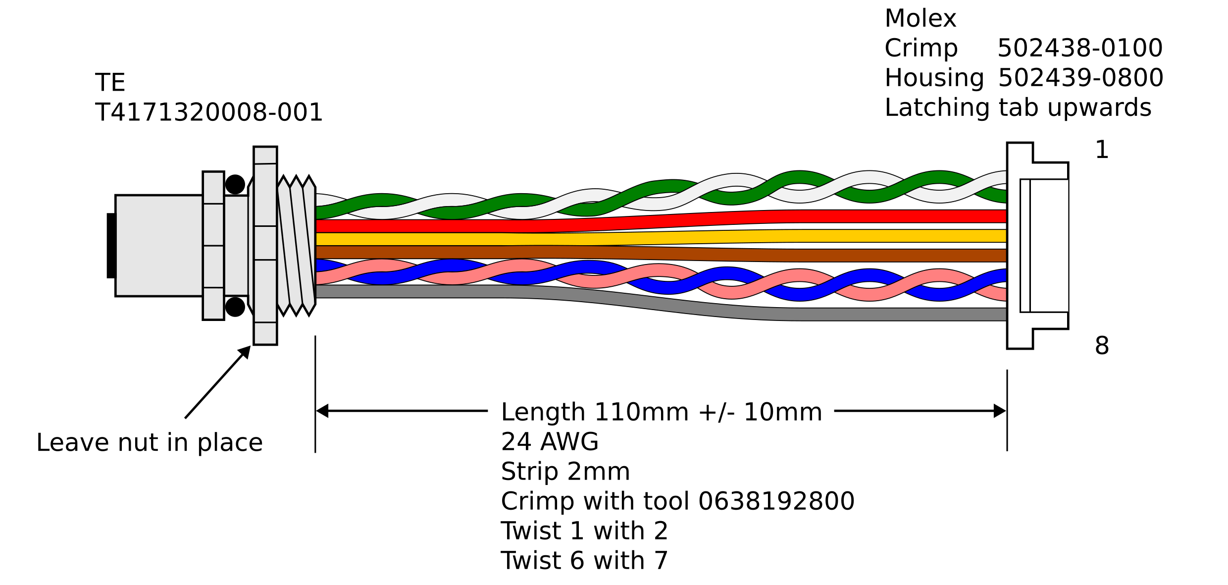
Connections
Molex Crimp Housing Pin | M12 Colour [pin] | Twist | Description | Signal Name
1 | White [1] | Pair A | USB diff pair D- | IN_USB_DN
2 | Green [3] | Pair A | USB diff pair D+ | IN_USB_DP
3 | Red [8] |  | Power in 7-36V | IN_VIN
4 | Yellow [4] |  | USB power in | IN_VUSB_5V
5 | Brown [2] |  | Ground | GND
6 | Blue [7] | Pair B | Audio diff pair - | MIC_IN_N
7 | Pink [6] | Pair B | Audio diff pair + | MIC_IN_P
8 | Grey [5] |  | Audio ground shield  (connects to GND at PCB connector) | GNDA

Tooling
Crimp with Molex 0638192800 tool only. The 24AWG position should be used. If necessary, the tool tension adjustment may need tuning to achieve full crimp strength, though this is unlikely if the tool is relatively new.

Testing
Destructive testing should be performed on some crimps until the operator is confident with the process. Pull the wire out from its crimp terminal (not the housing) with gradual axial loading. It should not fail before 30N is reached. See Molex document 5024431570, test 4-2-2.
After assembling all eight terminals into the housing, the operator should pull on each wire (approx 2-5 N) to verify that the terminal is properly latched in place. This is particularly important to perform on 100% of wires, because, in this connector series, the insertion force is quite high, the latching detent is not very positive, and it's quite easy to buckle the wire as it is pushed into place.

Inspection
100% of cables should be inspected to ensure that they have been assembled correctly; particularly that the order of wires is correct, as is the orientation of the latching tab, and the nut is in place.

