- Adventure Activities
- Top Rope Climbing, Abseiling and Zip-Line River Crossing
These adrenaline inducing exhilarating and achievement oriented adventure activities can be enjoyed in Likhubula and Muloza River Valleys in Mulanje. The sites are easily accessible and perfect a destination for group outings. These activities are spiced with an informative guided tour to the legendary Dziwe Lankhalamba falls and rock pools. Suitable for all ages above 10 and no previous experience is required
{PIC} {PIC}

- Water Sports Activities
Lake Malawi is the largest freshwater lake in Africa. Known for its open sand beaches, crystal clear waters and numerous colorful Mbuna fish species the destination offers a wide range of activities to choose from. Weather it is Diving, Snorkeling, Kayaking or simply to sail to the nearby Thumbi or Mumbo island is sure to that you are up to, your guide take you to
{PIC} {PIC} {PIC}

- Village visit

- Festivals
The best way to experience traditionally made crusines and mingle in with the locals is to attend any of the national festivals

- Sample Itineraries

3 Days 2 Nights Sunrise at Saptiwa (Grade 4)
A demanding but equally rewarding hike that culminates at the peak of Sapitwa which at 3002m above sea level is the highest point in central Africa from which views extend to as far as Milanje Mountain in Mozambique to the South East, Zomba Plateau & Lake Chirwa in the West.
Highlights: Sapitwa Peak, Dziwe Falls and Rock Pools and Elephant Head Sunset View Point

5 Days 4 Nights Grand Mulanje Traverse (Grade3)
This route takes you across the entire Massif allowing you to enjoy the diverse vegetation and landscapes offering picture perfect opportunities of the massifs panoramic landscape and a wide choice of optional peaks of varying difficulty above2500m to bag and numerous rock pools
Highlights: Sapitwa Peak, Dziwe Falls, Linje Pool and elephant head Sunset View Points & Rou Gorge

6 days 5 nights Southern Malawi Tour
A demanding but equally rewarding hike that culminates at the peak of Sapitwa which at 3002m above sea level is the highest point in central Africa from which views extend to as far as Milanje Mountain in the South East, Zomba Plateau and Lake Chirwa in the West.
Highlights: Sapitwa Peak, Dziwe Falls and Rock Pools and Elephant Head Sunset View Point

Day 1: Pick up at Airport/ Doogles Lodge in Blantyre and transfer directly to Mulanje. Check in at lodge Reception and tour overview briefing. Depending on your time of arrival we take warm up hike to nearby falls and rock pools returning to lodge a sun set. Detailed briefing of the entire tour before dinner. Drive Time: 3 Hrs.
Day 2: Starting very early we ascend Sapitwa peak which at 3002m above sea level is the highest peak in central Africa. On a clear day views stretch to as far as Zomba Plateau and Lake Chirwa to the North West and Milange Mountain in Mozambique. We return to Chisepho hut for brunch before proceeding across the undulating terrain to Thuchira hut passing through patches of mountain rain forest as we cross the numerous streams. Late afternoon we enjoy sunset at Elephant head view point. Overnight at Thuchira Forest hut: Hiking Time 8 Hrs.

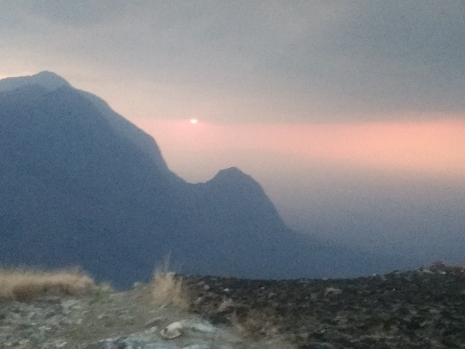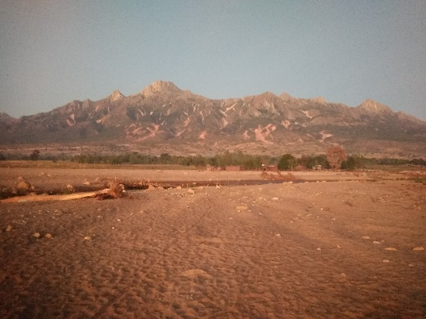

Day 4-Descend to pick up point at Tinyade Estate via the fairy shaded Namwali-Zaone trail that follows the Likulezi River to the bottom of the massif. Vehicle transfer back to Likhubula where we take a shower before Lunch and debrief. We part with our mountain guides and proceed drive to Zomba Plateau. Check in at Zomba Forest, Evening is spent at leisure however a drive to the nearby Queens sunset view point is recommended. Hiking Time: 4 Hrs. Drive Time: 4Hrs (BLD)
Day 5: Take a morning stroll to catch the sunrise at nearby Chigwe hole/ Fish farm to stretch out before breakfast. Check out of Lodge and transfer to Liwonde National Park arriving at Kuchire Lodge ideally located in the heart of the national Park on the bank of the mighty Shire River early afternoon. Enjoy an evening game drive on the well maintained trails that where crisscross the Park where you may chance to encounter the newly blossoming pride of cheaters amidst the abundant game and bird life returning to the lodge just after sunset. Overnight at Kuchuire Lodge, Diving time: 4 +2 Hrs.
Day 6: After breakfast we take a 2hr. boat ride up the Sire River to come up close and personal with crocks hippo as they wade in the murky waters and view the numerous birds and other land animals that come to take their ritual morning drink at her banks. After lunch we proceed to Cape Maclear in lake Malawi National Park stopping over at…….. For a taste of the local cuisine and …. we expect to be at the lake midafternoon Drive Time: 9 hrs.
Day 5 The day is spent at leisure where you can choose to roam the sandy beaches and take in the sun or participate in any the numerous watersport activities that are offered. In the late afternoon we take a sunset boat ride to West of Thumbi Island where you will enjoy fish eagle feeding returning just after sunset which will be the highlight of this part of the tour. Overnight at Thumbi Lodge. Drive Time: 0 hrs.
at the forest reserve barrier.
Day 8. This will largely depend upon which airport you intend to depart from and at what time your flight leaves. If we have enough time you may choose to visit a curios art shop tea estate for an informative guided field and factory tour

