1. Wrong Answer

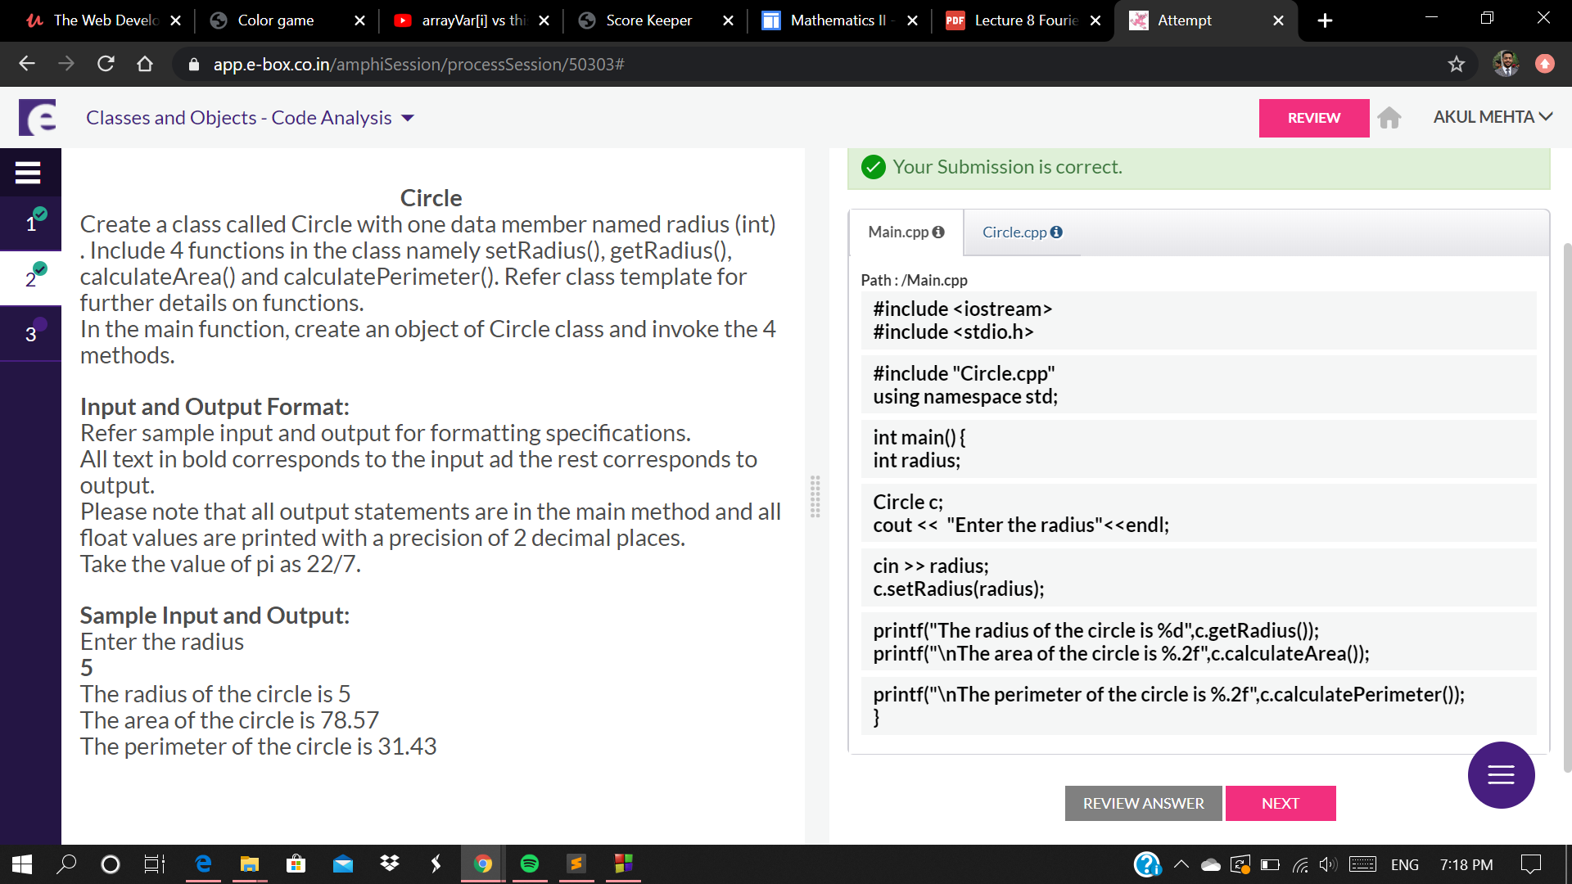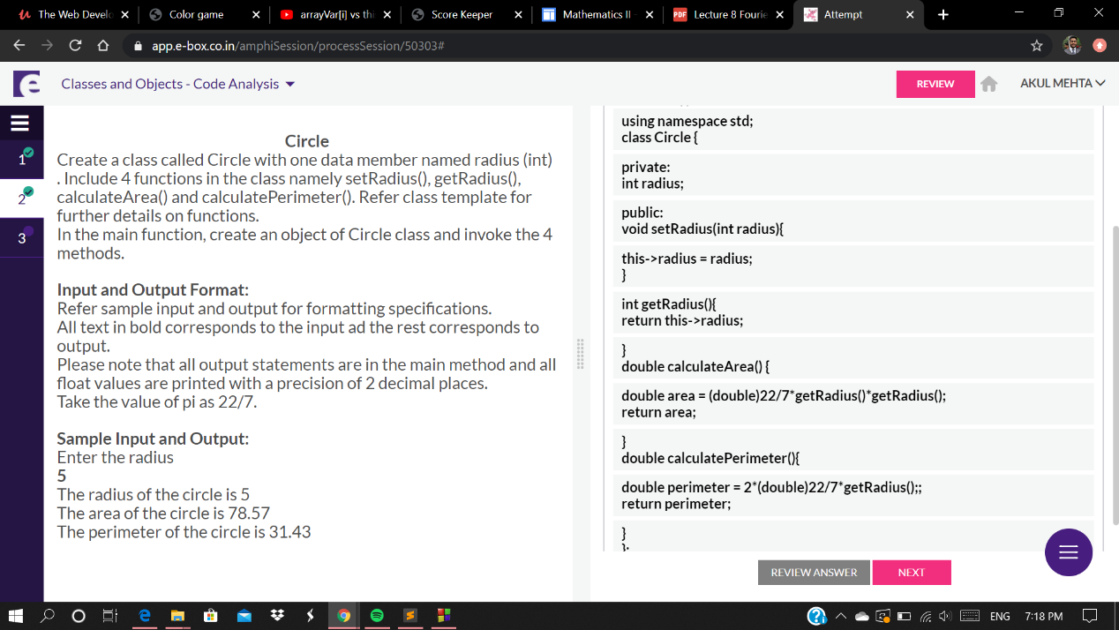

class Visitor{

private:

string name;

char gender;

int age;

public:

void initializeData(string name, char gender, int age){

this->name = name;

this->gender = gender;

this->age = age;

}

void displayData(){

if(this->gender=='m'|| this->gender=='M'){

if(this->age<10)

cout<<"Welcome "+this->name+"! Please wait for a minute!";

else

cout<<"Welcome Mr."+this->name+"! Please wait for a minute!";

}

else if(this->gender=='f'|| this->gender=='F'){

if(this->age<10)

cout<<"Welcome "+this->name+" ! Please wait for a minute!";

else

cout<<"Welcome Ms."+this->name+"! Please wait for a minute!";

}

}

};

#include <iostream>

using namespace std;

int main() {

string name;

char gender;

int age;

Visitor v;

cout<<"Enter your name\n";

cin>>name;

cout<<"Enter the gender M/m F/f\n";

cin>>gender;

cout<<"Enter your age\n";

cin>>age;

v.initializeData(name, gender, age);

v.displayData();

return 0;

}