**Goal:** Generate speaker embedding in unsupervised way (no speaker labels in training data)

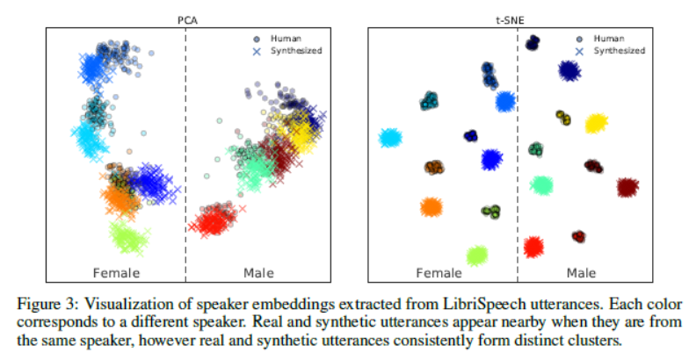

**<Speaker2Vec>**

**Autoencoder architecture**

Input -> K hidden layers -> Embedding layer -> K hidden layers -> Output

Basic: 4000 -> 2000 -> 40 -> 2000 -> 4000

Modified: 4000 -> 6000-> 2000 -> 256 -> 2000 -> 6000 -> 4000

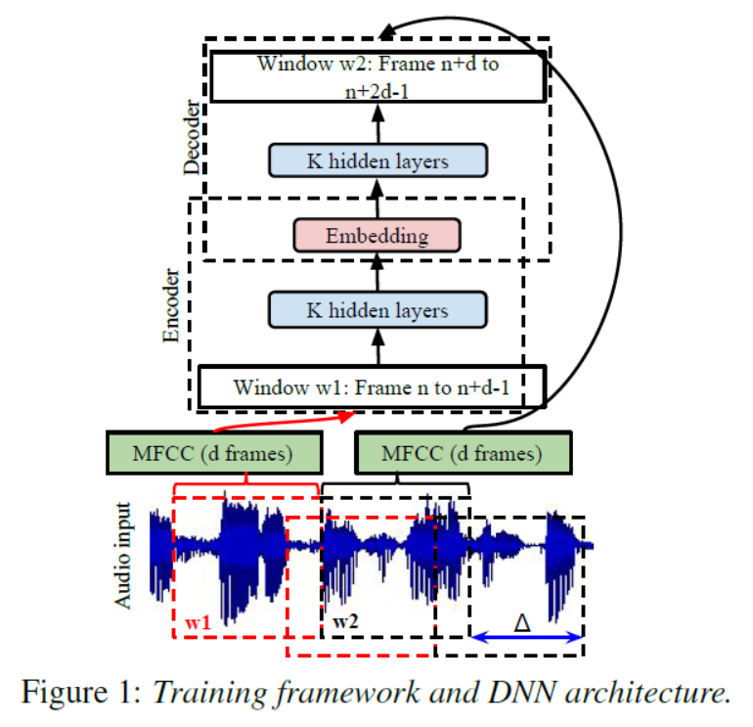

**Input:** A small window $w_{1}$ of speech (Fixed size, $d$ frames $=1.6s$, MFCC feature)

**Output:** Fixed size, $d$ frames $=1.6s$

**Training objective:** Given $w_{1}$, reconstruct a small window $w_{2}$ of speech from a temporally neighboring window (Fixed size, $d$ frames $=1.6s$, MFCC feature).

**Data: $\left(w_{1},w_{2}\right)→$**  a pair. Use all available pairs from an audio input, separated by $∆=10ms$