COMP4910 Senior Design Project 1, Fall 2026
Advisor: Dr. Arman Savran

Zindeo: A Calorie Tracking App with On-Device Food Recognition
Requirements Specifications Document
30.10.2026
Revision 1.0

By:
Taner Yıldırım, 22070001002
Yavuz Tuğcan, 22070001044
Ece Coşdur, 22070001050
Revision History
Revision | Date | Explanation
1.0 | 30.10.2026 | Initial requirements, textual form
Contents
1. Introduction 5
1.1. Purpose of This Document 5
1.2. Problem Statement 5
1.3. Project Goals 5
1.4. Scope and Project Outputs 6
1.5. Target Users 7
1.6. Approach: Two-Phase Recognition Strategy 7
2. Existing Systems 8
2.1. Commercial Applications 8
2.2. Academic Work and Datasets 9
2.3. Gap Analysis and Differentiation of Zindeo 9
3. Current Practice of Calorie Tracking 10
3.1. Setting a Goal 10
3.2. Logging a Meal Manually 10
3.3. Logging a Meal with a Photo in Existing Applications 10
3.4. Problems in the Current Practice 10
3.5. The Proposed Zindeo Workflow 11
4. Actors 13
5. Functional Requirements 14
5.1. User Account Management 14
5.2. Profile and Goal Setting 14
5.3. Food Catalogue and Search 15
5.4. Meal Logging 15
5.5. Image-Based Food Recognition 16
5.6. Portion Size Estimation 16
5.7. Barcode Scanning 18
5.8. Dashboard and Progress Tracking 18
5.9. Notifications 18
5.10. Subscription and Payment 18
5.11. Privacy, Consent and Data Management 19
5.12. Settings 19
5.13. Fridge Ingredient Detection and Recipe Suggestions 19
5.14. Healthy Restaurant Map 19
5.15. Food Catalogue Administration 20
5.16. Machine Learning Development 20
6. Data Requirements 22
7. Behavioral Requirements 24
7.1. Photo Recognition 24
7.2. Subscription 24
7.3. Meal Entry Synchronisation 24
7.4. Weight Goal 24
8. Non-Functional Requirements 25
8.1. Performance 25
8.2. Accuracy 25
8.3. Resource Usage on the Device 25
8.4. Usability and Accessibility 25
8.5. Reliability and Availability 26
8.6. Security 26
8.7. Privacy and Legal Compliance 26
8.8. Health, Safety and Ethics 26
8.9. Platform and Environment 27
8.10. Maintainability and Cost 27
9. Constraints and Assumptions 28
9.1. Constraints 28
9.2. Assumptions 28
10. Glossary 29
11. References 30

1. Introduction

1.1. Purpose of This Document
This Requirements Specifications Document (RSD) refines the problem definition given in the Project Assignment Form (PAF) of Zindeo. Revision 1.0 describes the requirements in textual form: the problem, the existing systems, the current practice of calorie tracking, the actors, and the functional, data, behavioral and non-functional requirements of the system. Revision 2.0 will model the same requirements in UML (use case, activity, class and state diagrams), following the object-oriented requirements modelling approach of [1] and the requirements engineering practices described in [2]. The requirement identifiers introduced in this document (e.g. FR-5.4, NFR-3) will be kept unchanged in later revisions so that every UML model element can be traced back to a requirement.

1.2. Problem Statement
Calorie and nutrition tracking is one of the most effective self-management tools for people who want to lose, gain or maintain weight, and for people who exercise. However, most people who start tracking stop within a few weeks. Our analysis of existing applications and of the literature points to four main reasons:
- Logging is slow and tedious. For every meal, the user has to search for the food, choose the right entry among many similar ones and guess the amount. Repeated three to five times a day, this effort makes users give up.
- Turkish cuisine is poorly represented. The food databases and AI models of global applications are built mainly around Western foods. Turkish home dishes such as karnıyarık, ezogelin soup or kuru fasulye are either missing or misrecognized. In our own test, a leading application recognized a photo of karnıyarık as “etli yufka”.
- Portion size is left to the user. Saying “one bowl” or “200 g” is a guess for most people, and portion error is the largest source of error in calorie tracking.
- Photo-based recognition in existing applications depends on the cloud. It does not work without an internet connection, the user's photo leaves the phone, and every recognition request has a server cost that is reflected to users as a high subscription price.

1.3. Project Goals
Zindeo is a mobile calorie and nutrition tracking application for iOS and Android, targeting the Turkish market first. The goals of the project are listed in Table 1.1, and Figure 1.1 gives an overview of the system and the external services it uses.
ID | Goal
G1 | Fast logging: a meal can be logged in less than 10 seconds, by taking a photo or by searching.
G2 | Accurate recognition of Turkish dishes: a food recognition model trained on a Turkish food dataset collected and labelled by the team, covering at least 100 dishes.
G3 | Automatic portion estimation: the weight of each food on a plate is estimated from a single photo, using the plate as a size reference, without a depth sensor or an extra reference object.
G4 | Personalised and safe goals: daily calorie and macronutrient targets calculated from the user's body data and goal, within medically reasonable safety limits.
G5 | On-device AI: the recognition models run on the phone, without an internet connection and without a per-request server cost.
G6 | A real product: the application is published on the App Store and Google Play with a sustainable freemium business model.
Table 1.1. Goals of the project
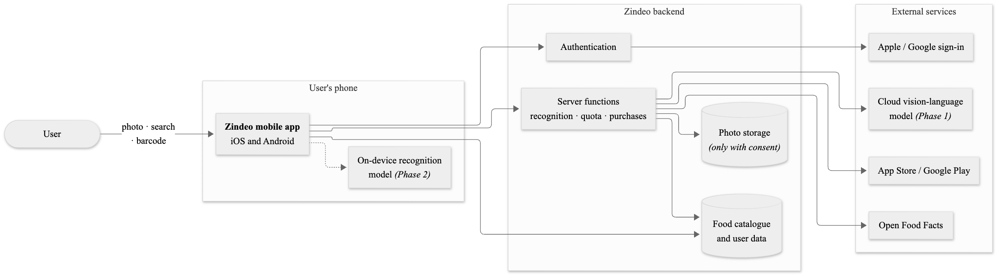
Figure 1.1. Overview of Zindeo and the external services it uses

1.4. Scope and Project Outputs
The project is carried out over two semesters (COMP 4910 and COMP 4920). The scope is divided into two phases:
- Phase 1 (first semester and early second semester): the complete tracking application (accounts, goal setting, food database and search, meal logging, dashboard, weight tracking, subscriptions, privacy) with photo-based recognition provided by a cloud vision-language model called through the Zindeo backend. In parallel, the team collects and labels the Turkish food dataset.
- Phase 2 (second semester): Zindeo's own food recognition and portion estimation models trained with PyTorch replace the cloud service and run on the device. The fridge ingredient detection with recipe suggestions and the healthy restaurant map are added. The own models are compared with the Phase 1 cloud service on the same test set.
The outputs (deliverables) of the project are:
- Zindeo mobile application for iOS and Android.
- Zindeo backend: database, authentication, file storage and server functions.
- Zindeo food catalogue: Turkish dishes, ingredients and packaged products with nutrition values and portion units.
- A labelled Turkish food image dataset, including a subset with weighed portions.
- Trained food recognition, portion estimation and ingredient detection models optimised for mobile devices, with an evaluation report.
- Project documentation: PAF, RSD, DSD, final reports, product manual.
Out of scope: a web application, a dietitian panel, social features (friends, feeds), smartwatch applications and medical nutrition plans (e.g. for diabetes or kidney disease).

1.5. Target Users
The primary users are smartphone users in Türkiye, aged 18–45, who track or want to track what they eat:
- Weight loss users who have a target weight and want to follow a daily calorie deficit.
- Sports and fitness users who follow protein and macronutrient targets for muscle gain or body recomposition.
- Health-conscious users who do not have a weight goal but want to see what they eat.

1.6. Approach: Two-Phase Recognition Strategy
Training an accurate recognition model requires a large labelled dataset, which takes time to collect. Instead of waiting for the model, Zindeo is developed so that the recognition engine can be replaced without changing the rest of the application:
- The application uses recognition through a single interface that receives a photo and returns, for each food on the plate, a list of candidate foods from the Zindeo catalogue with confidence scores and an estimated weight in grams.
- In Phase 1, a cloud vision-language model implements this interface through the Zindeo backend. In Phase 2, Zindeo's own on-device model implements it, and the cloud model may remain as a fallback when the on-device model is not confident.
- Calories and nutrients are never taken from the recognition engine. They are always calculated from the Zindeo food catalogue using the recognized food and its weight. This keeps photo, search and barcode logging consistent and prevents “invented” nutrition values.
- Every photo that the user confirms or corrects becomes a labelled training example, if the user has given explicit consent. Phase 1 therefore also serves as a data collection phase for Phase 2.
Figure 1.2 summarises this strategy: the recognition engine changes between the phases, while the confirmation step, the calorie calculation and the data collection loop stay the same.
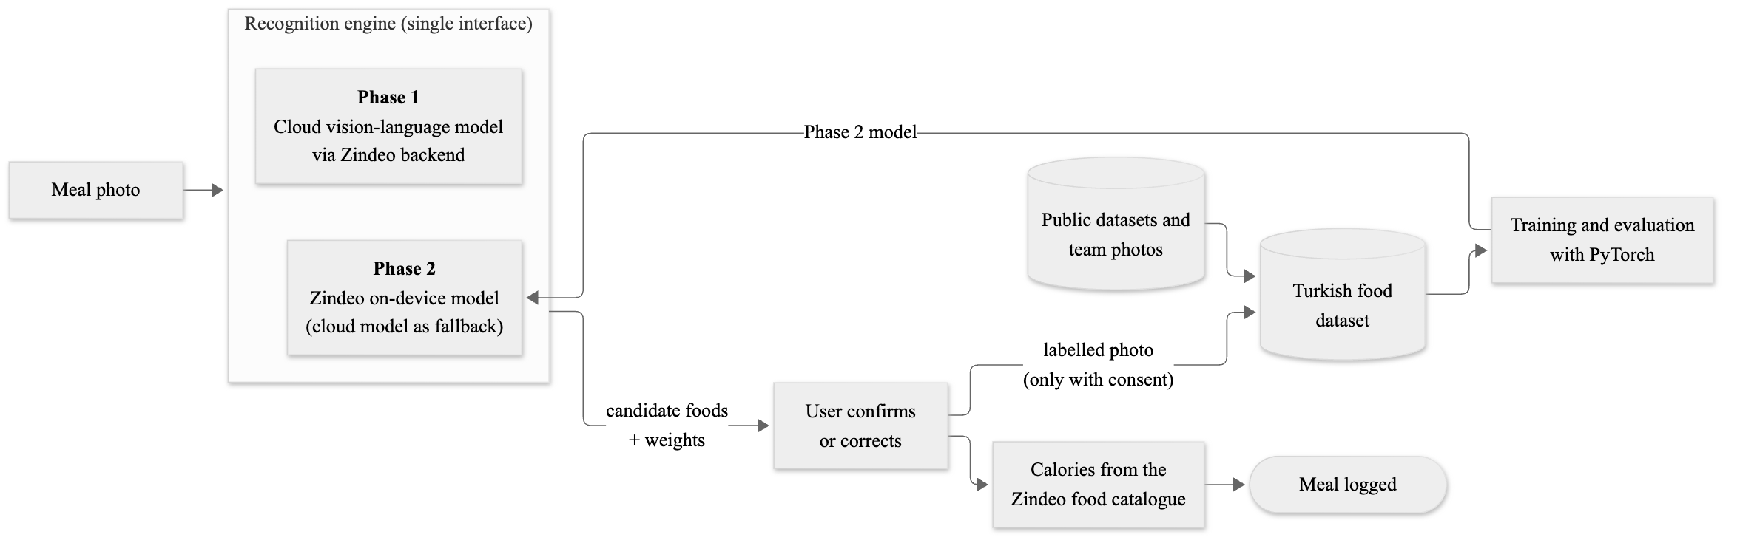
Figure 1.2. Two-phase recognition strategy and the data collection loop

2. Existing Systems
This section summarises the existing commercial applications and the academic work related to Zindeo. The full analysis, covering 10 applications and 32 papers, datasets and methods, is kept in the team's research spreadsheet [3]. Claims of companies (accuracy, number of downloads) are as published by the companies and have not been independently verified.

2.1. Commercial Applications
Table 2.1 summarises ten applications that offer photo-based food recognition: seven global applications and three applications from Türkiye.
Application | Market | Photo recognition and portion estimation | Limitation with respect to Zindeo
FatSecret | Global | Photo is sent to the company's cloud API; dishes and portions are matched with a large nutrition database. | Cloud only. In our test, karnıyarık was recognized as “etli yufka”.
MyFitnessPal (Meal Scan) | Global | Premium feature; recognizes multiple foods with the camera. Automatic weight estimation is reported as under development. | Paid feature; no specific work on Turkish dishes.
Cal AI | Global | Uses the phone's depth sensor for volume; claims about 90% accuracy on visible foods. | Requires a depth sensor for volume; model and data not disclosed.
SnapCalorie | Global | About 5,000 dishes photographed and weighed with a robotic setup; claims calorie error below 20%. | Not focused on Turkish cuisine; uses depth sensors where available.
Foodvisor | Global | Estimates distance from camera autofocus data, then area and volume per food type. | Not focused on Turkish cuisine.
Lose It! (Snap It) | Global | Estimates food and calories from a photo. | Reported difficulty with photos containing multiple foods.
YAZIO | Global | Photo-based estimation in the PRO subscription. | Database strong in European products; no Turkish dish focus.
Diyetkolik | Türkiye | Photo logging in beta; voice/text logging, barcode reader. | Accuracy on Turkish dishes not published.
Neyedim | Türkiye | Focused on Turkish cuisine; user corrects the amount in grams or ml. | iOS only; no automatic weight estimation method published; dataset and accuracy not published.
Kalorita | Türkiye | Trained with Turkish dishes; user places a finger next to the plate as a size reference. | iOS and Turkish only; requires an extra reference object; dataset and accuracy not published.
Table 2.1. Existing commercial applications with photo-based food recognition
Two observations are important for Zindeo. First, none of the examined applications states that its recognition model runs on the phone without an internet connection; in the known cases, the photo is sent to a server. Second, the applications focusing on Turkish food (Neyedim, Kalorita) are available only on iOS and do not publish their datasets or accuracy results.

2.2. Academic Work and Datasets
- Turkish food recognition. The first Turkish food benchmark, TurkishFoods-15, contains 15 dishes and 7,411 images [4]. TurkishFoods-25 extends it to 25 dishes and about 11,500 images and was used in a mobile classification application with 93% accuracy, without portion estimation [5]. The closest recent work recognizes 40 Turkish dishes with 93.5% accuracy using a large model (EfficientNetV2-L) and falls back to a cloud model (Gemini) when uncertain, reporting a mean absolute portion weight error of 18.4 g [6]. Large general-purpose vision-language models reach only about 77% weighted F1 on the 25 Turkish dishes without training and do not fit on a phone [7].
- General food datasets. Food-101 (101 dishes, 101,000 images) is the most widely used benchmark [8]. Larger datasets such as Food2K and FoodX-251 are useful for pre-training and fine-grained classification [3].
- Portion and calorie estimation. Nutrition5k provides about 5,000 real dishes with weighed components and calorie labels [9]. Im2Calories proposed a mobile food diary with on-phone classification and volume estimation [10]. ECUSTFD uses a reference object in every image for calibration [11]. FoodSeg103 provides pixel-level food segmentation masks [12].
- Application evaluation. A comparative study of 18 nutrition applications found that AI-enabled applications have large errors on mixed and non-Western dishes, for example overestimating the energy of pho by 49% [13]. Turkish cuisine consists largely of mixed dishes (stews, dolma, casseroles), which supports the motivation of this project.
- Mobile deployment. Mobile-friendly architectures (EfficientNet, MobileNetV3) [14], [15], confidence calibration with temperature scaling [16] and 8-bit quantization [17] are the main methods for an accurate, small and fast on-device model.

2.3. Gap Analysis and Differentiation of Zindeo
Table 2.2 matches each gap identified in the existing systems with the approach of Zindeo.
Gap in existing systems | Zindeo's approach
Recognition depends on the cloud | Own model runs on the device; works offline; no per-request cost; photo stays on the phone (Phase 2).
Turkish home dishes are poorly recognized | Turkish food dataset of at least 100 dishes, trained and evaluated specifically on Turkish cuisine.
Portion estimation requires a depth sensor or an extra reference object | The plate itself is used as the size reference; works on any phone.
Accuracy is claimed but not measured openly | Accuracy and calorie error are measured on a fixed test set and reported.
Turkish-focused applications are iOS only | iOS and Android from the first release.
The model is confidently wrong | Calibrated confidence; when uncertain, the user is offered 2–3 alternatives.
Table 2.2. Gaps in existing systems and how Zindeo addresses them

3. Current Practice of Calorie Tracking
This section describes how a typical user tracks calories today, without Zindeo, and where the process fails. It corresponds to the description of the current business activities in a classical RSD.

3.1. Setting a Goal
The user enters body data (sex, age, height, weight), an activity level and a goal into a calorie tracking application or an online calculator. The application calculates a daily calorie target, usually with a basal metabolic rate (BMR) equation multiplied by an activity factor. Many applications allow unrealistic targets, such as very low daily calories or very fast weight loss, without warning the user.

3.2. Logging a Meal Manually
- The user opens the application and selects the meal (breakfast, lunch, dinner or snack).
- The user types the name of the food. The search often returns many similar user-generated entries with different values, or no result for a Turkish dish; the user picks one or chooses a similar Western dish.
- The user estimates the amount. Units such as grams are hard to estimate; units such as “1 serving” are not defined clearly.
- The user repeats steps 2–3 for every item on the plate. A plate of rice, beans and cacık requires three separate searches.
- The application adds the calories and shows the remaining calories for the day.

3.3. Logging a Meal with a Photo in Existing Applications
In applications that support photo logging, the user takes a photo, which is uploaded to the company's server. The server returns the recognized foods and estimated amounts; the user corrects them and saves. This is faster than manual logging, but requires an internet connection, is often limited to paid subscriptions, and is weak on Turkish dishes and on mixed dishes.

3.4. Problems in the Current Practice
Table 3.1 lists the problems observed in the current practice. Each problem is referenced in the proposed workflow below.
ID | Problem
P1 | Manual logging takes too long; users stop tracking after a few weeks.
P2 | Turkish dishes are missing from databases or have inconsistent, user-generated values.
P3 | Portion sizes are guessed; this is the largest source of calorie error.
P4 | Photo recognition misidentifies Turkish and mixed dishes and does not show alternatives when it is uncertain.
P5 | Photo recognition needs an internet connection and sends personal photos to servers.
P6 | Unsafe goals (very low calorie targets, very fast weight loss) are possible.
P7 | Health data is processed without clear consent; users do not know how their photos are used.
Table 3.1. Problems in the current practice of calorie tracking

3.5. The Proposed Zindeo Workflow
- The user completes a short onboarding; Zindeo calculates safe daily calorie and macro targets (addresses P6).
- At a meal, the user takes one photo of the plate (addresses P1).
- Zindeo recognizes each dish on the plate and estimates the weight of each dish using the plate as a reference (addresses P3, P4).
- If Zindeo is not confident, it shows 2–3 likely alternatives instead of a single wrong answer (addresses P4).
- Calories and nutrients are calculated from Zindeo's curated catalogue of Turkish and other foods (addresses P2).
- The user confirms or corrects the result and saves it, usually in a few seconds. In Phase 2, all of this works on the phone, offline (addresses P5).
- The user decides explicitly whether the photo may be used to improve the model (addresses P7).
Figure 3.1 compares the manual logging workflow with the photo logging workflow of Zindeo.
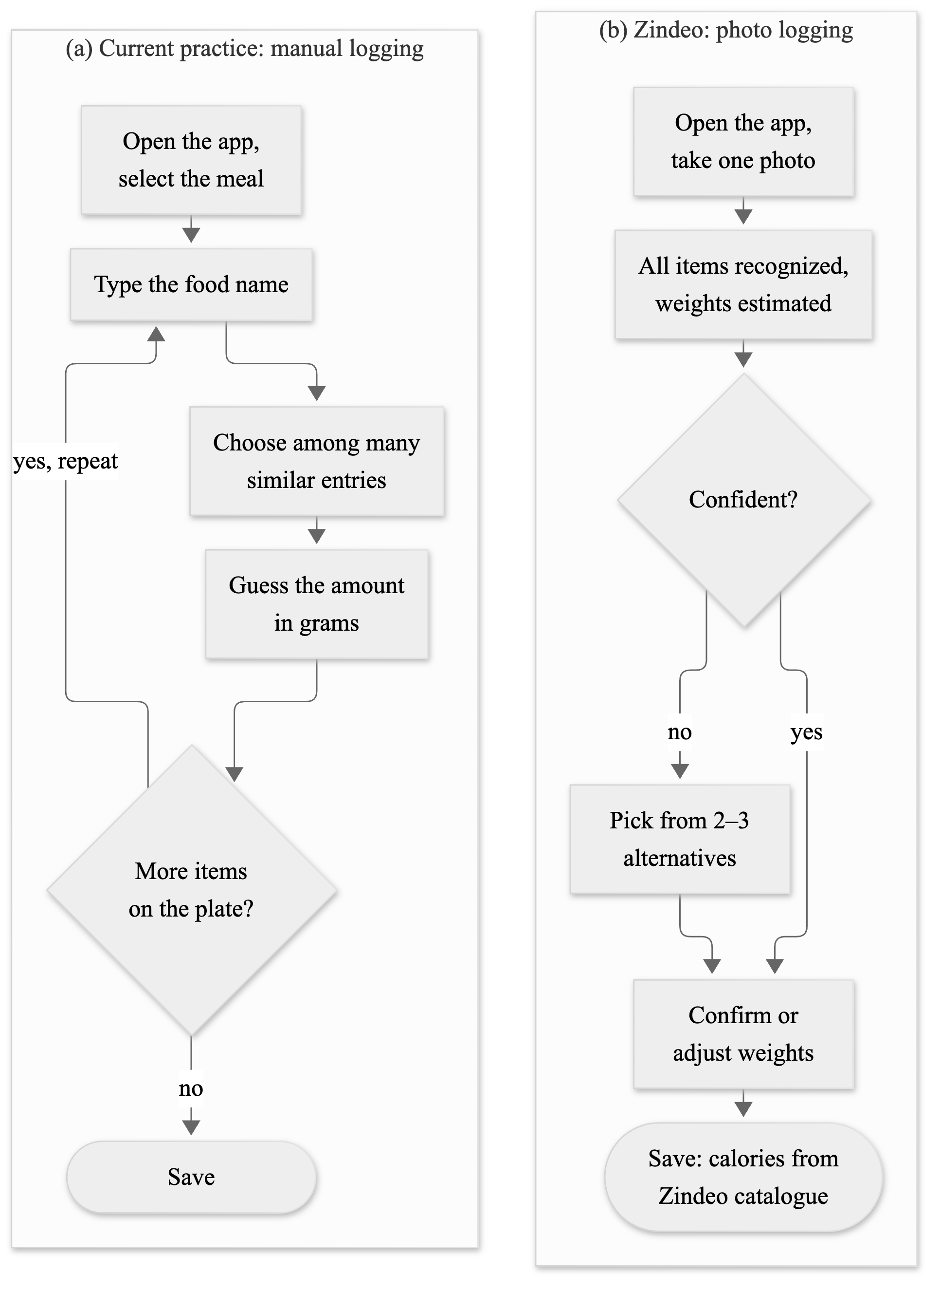
Figure 3.1. (a) Manual logging in the current practice and (b) photo logging in Zindeo

4. Actors
The actors that interact with Zindeo are listed in Table 4.1. The use cases of each actor will be modelled in RSD Revision 2.0.
Actor | Type | Description
Guest | Human | A person who has installed the application but has not registered. Can view the introduction screens and register or sign in.
User (Free User) | Human | A registered user. Sets goals, logs meals by search, photo and barcode, tracks weight and progress, manages privacy settings. Has a limited number of photo recognitions per day.
Premium User | Human | A user with an active subscription. Has unlimited photo recognition and access to premium features. Specialisation of User.
Content Administrator | Human | A member of the Zindeo team who maintains the food catalogue (foods, nutrition values, portions, standard recipes) and reviews new entries.
Food Recognition Service | System | Recognizes foods and estimates weights from a photo. In Phase 1, a cloud vision-language model; in Phase 2, Zindeo's on-device model.
Identity Provider | System | Apple and Google sign-in services.
App Store / Google Play | System | Sell subscriptions, verify purchases and notify renewals, cancellations and refunds.
Open Food Facts | System | Open database of packaged products, queried by barcode.
Notification Service | System | Delivers push notifications to the user's device.
Scheduler (Time) | System | Triggers time-based events: reminders, daily quota reset, target recalculation on birthdays.
Table 4.1. Actors of Zindeo

5. Functional Requirements
Functional requirements are grouped by subsystem. Each requirement has a unique identifier and a priority:
- Must: required for the first public release (end of Phase 1).
- Should: planned for the first release; may move to the next update if time does not allow.
- Could: desirable; planned after the first release.
- Phase 2: planned for the second semester.
In this document, “the system” refers to the Zindeo mobile application together with its backend. The requirements of each subsystem are listed in Tables 5.1–5.16.

5.1. User Account Management
ID | Requirement | Priority
FR-1.1 | The system shall allow a guest to register and sign in with an Apple ID (Sign in with Apple). | Must
FR-1.2 | The system shall allow a guest to register and sign in with a Google account. | Must
FR-1.3 | The system shall allow a guest to register with an e-mail address and password, including e-mail verification and password reset. | Must
FR-1.4 | The system shall keep the user signed in between sessions and allow the user to sign out. | Must
FR-1.5 | The system shall restore all of the user's data when the user signs in on a new device. | Must
FR-1.6 | The system shall allow the user to permanently delete the account and all associated data, including photos, from within the application. | Must
Table 5.1. User Account Management requirements

5.2. Profile and Goal Setting
ID | Requirement | Priority
FR-2.1 | The system shall collect the user's sex (male, female or prefer not to say), date of birth, height, current weight and activity level (sedentary, light, moderate, active, very active). | Must
FR-2.2 | The system shall allow the user to select a goal: lose weight, maintain weight or gain weight. | Must
FR-2.3 | The system shall allow the user to select a target weight and a weekly rate (0.25, 0.5, 0.75 or 1.0 kg/week for weight loss; 0.25 or 0.5 kg/week for weight gain). | Must
FR-2.4 | The system shall calculate the daily calorie target from the basal metabolic rate (Mifflin-St Jeor equation [18]), multiplied by the activity factor, minus (or plus) the daily energy difference required by the weekly rate (7,700 kcal per kg). | Must
FR-2.5 | The system shall calculate daily macronutrient targets: protein according to the goal and body weight, fat as 30% of energy, and carbohydrate as the remaining energy. | Must
FR-2.6 | The system shall show the estimated date on which the user will reach the target weight. | Must
FR-2.7 | The system shall enforce safety limits: (a) the weekly weight loss rate shall not exceed 1% of body weight; (b) the daily calorie target shall not be lower than 1,200 kcal (female or not specified) or 1,500 kcal (male); (c) the target weight shall not correspond to a body mass index below 18.5; (d) users under 18 shall not be able to select weight loss; (e) users who state that they are pregnant or breastfeeding shall be warned and shall not be offered weight loss. | Must
FR-2.8 | When a limit in FR-2.7 changes the calorie target, the system shall recalculate the effective weekly rate and the estimated date and inform the user. | Must
FR-2.9 | The system shall recalculate the targets when the user enters a new weight, changes profile data or goal, or has a birthday, and shall keep the history of targets so that past days are evaluated with the targets valid on those days. | Must
FR-2.10 | The system shall allow the user to override the calculated targets manually. | Should
FR-2.11 | The system shall suggest switching to “maintain weight” when the target weight is reached. | Should
Table 5.2. Profile and Goal Setting requirements

5.3. Food Catalogue and Search
ID | Requirement | Priority
FR-3.1 | The system shall provide a food catalogue containing Turkish home dishes, basic ingredients, world cuisine and packaged products, with energy, protein, carbohydrate and fat values per 100 g. | Must
FR-3.2 | The system shall allow the user to search foods by Turkish or English name and by alternative names (e.g. regional names), and shall return results regardless of Turkish characters (e.g. “ispanak” finds “ıspanak”) and minor spelling mistakes. | Must
FR-3.3 | The system shall rank the user's recently and frequently logged foods higher in search results. | Must
FR-3.4 | The system shall offer food-specific portion units (e.g. bowl, plate, slice, piece, tablespoon, glass) with their gram equivalents, in addition to grams. | Must
FR-3.5 | The system shall calculate the nutrition values of home dishes from standard recipes (ingredients, raw amounts and cooking yield). | Must
FR-3.6 | The system shall allow the user to create custom foods, visible only to that user. | Should
FR-3.7 | The system shall show additional nutrients (fibre, sugar, saturated fat, sodium) where available. | Should
FR-3.8 | The system shall allow the user to create recipes from ingredients and log them as portions. | Could
Table 5.3. Food Catalogue and Search requirements

5.4. Meal Logging
ID | Requirement | Priority
FR-4.1 | The system shall allow the user to add a food to a meal (breakfast, lunch, dinner or snack) of a given date with a quantity and unit, and shall calculate the weight in grams, the energy and the macronutrients of the entry. | Must
FR-4.2 | The system shall allow the user to edit or delete an entry and to move it to another meal. | Must
FR-4.3 | The system shall allow the user to log entries for past dates. | Must
FR-4.4 | The system shall preselect the meal according to the time of day. | Must
FR-4.5 | The system shall store the nutrition values of an entry at the time of logging, so that later corrections in the catalogue do not change the totals of past days. | Must
FR-4.6 | The system shall allow the user to copy a meal from a previous day to the current day. | Should
FR-4.7 | The system shall allow the user to log water intake. | Should
FR-4.8 | The system shall allow the user to log meals without an internet connection and shall synchronise the entries when the connection is restored, without creating duplicates. | Should
Table 5.4. Meal Logging requirements

5.5. Image-Based Food Recognition
ID | Requirement | Priority
FR-5.1 | The system shall allow the user to take a photo of a meal with the camera and submit it for recognition. | Must
FR-5.2 | The system shall identify each food item in the photo, including several items on the same plate (e.g. rice, beans and cacık), as separate items. | Must
FR-5.3 | The recognition shall return only foods that exist in the Zindeo catalogue, each with a confidence score and an estimated weight. Energy and nutrients shall be calculated from the catalogue, never taken directly from the recognition service. | Must
FR-5.4 | When the confidence is below a threshold, or when the recognized food belongs to a group of visually similar dishes (e.g. lentil soup and ezogelin soup), the system shall present 2–3 alternatives instead of a single answer. | Must
FR-5.5 | The system shall show a result screen listing the recognized items, their estimated weights and the total energy, and shall allow the user to confirm, replace an item, remove an item, add a missing item or adjust the weight before saving to a meal. | Must
FR-5.6 | The system shall store the user's final confirmation or correction together with the recognition result, as a quality measure and, with consent (FR-11.2), as a labelled training example. | Must
FR-5.7 | The system shall limit the number of photo recognitions per day for free users; the limit shall be enforced by the server. | Must
FR-5.8 | When the recognition service is not available, the system shall inform the user and offer logging by search. | Must
FR-5.9 | In Phase 1, recognition shall be performed by a cloud vision-language model called through the Zindeo backend. | Must
FR-5.10 | The system shall allow the user to select a photo from the gallery for recognition. | Should
FR-5.11 | In Phase 2, recognition shall be performed by Zindeo's own model on the device without an internet connection; when the on-device model is not confident and a connection is available, the system may use the cloud service as a fallback. | Phase 2
Table 5.5. Image-Based Food Recognition requirements

5.6. Portion Size Estimation
Figure 5.1 shows the portion estimation method planned for Phase 2, which uses the plate as the size reference. The corresponding requirements are FR-6.3 to FR-6.6.
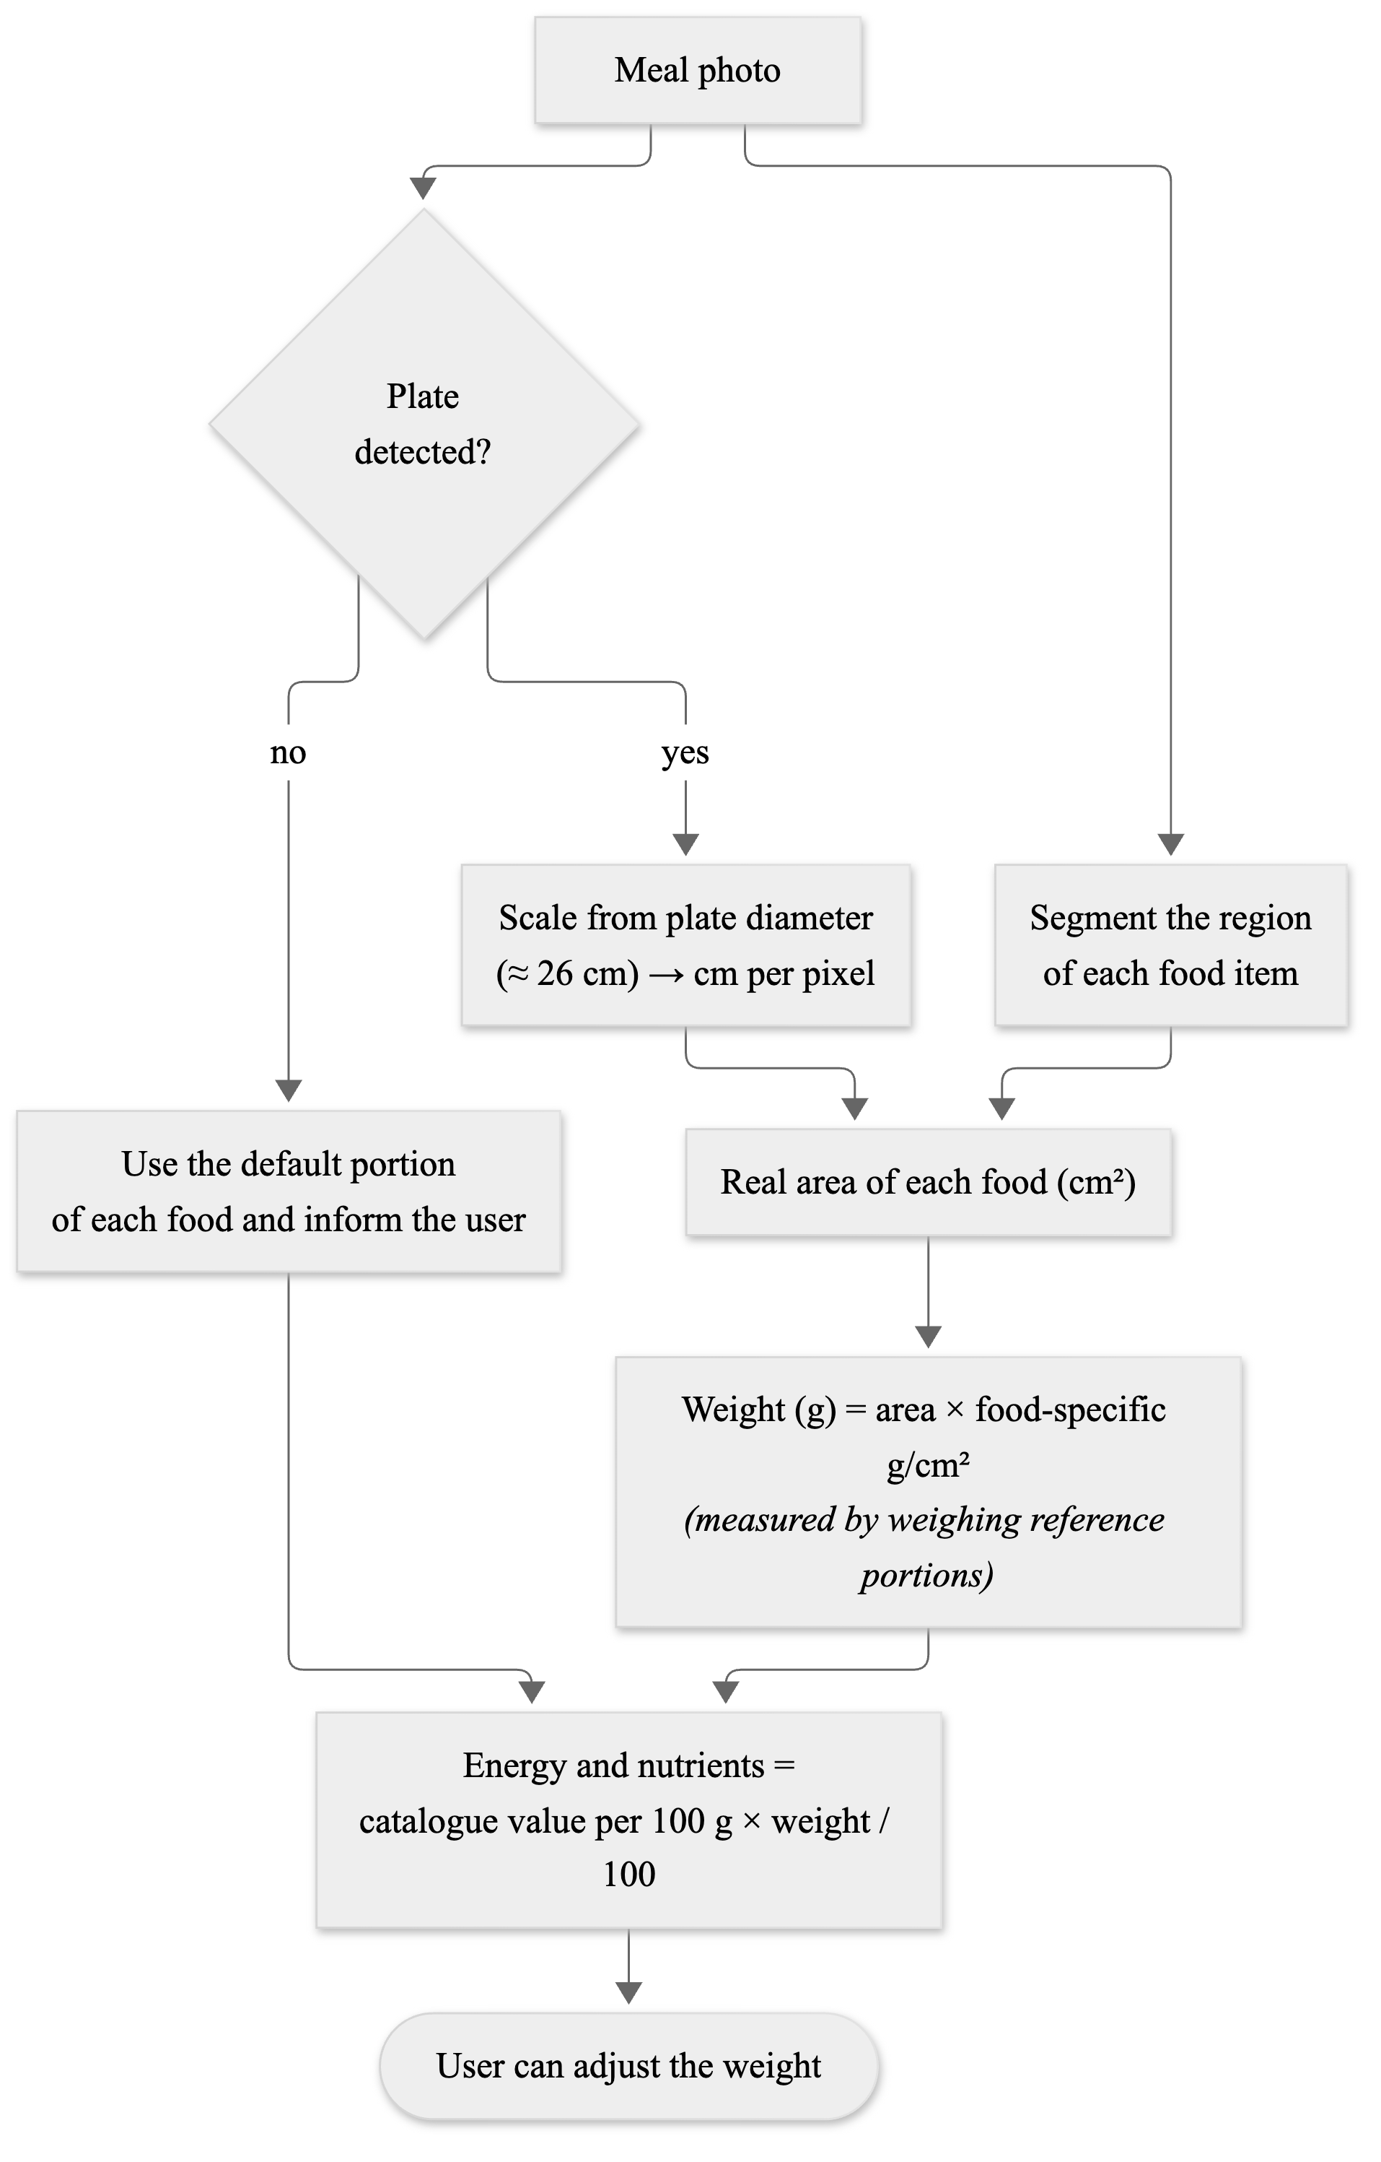
Figure 5.1. Plate-referenced portion estimation (Phase 2)
ID | Requirement | Priority
FR-6.1 | The system shall provide an estimated weight in grams for each recognized food item from a single photo. In Phase 1, the estimate is provided by the cloud recognition service. | Must
FR-6.2 | The user shall always be able to adjust the estimated weight with a slider or with portion units. | Must
FR-6.3 | The system shall detect the plate in the photo and use its known diameter (standard dinner plate, approximately 26 cm) as the scale reference to convert image measurements to real-world area. | Phase 2
FR-6.4 | The system shall segment the region of each food item on the plate and calculate its area. | Phase 2
FR-6.5 | The system shall convert the area of each food to weight using food-specific grams-per-area coefficients, which the team shall determine by photographing and weighing reference portions. | Phase 2
FR-6.6 | When the plate cannot be detected (e.g. bowls, packaged food, food without a plate), the system shall use the default portion of the food and inform the user. | Phase 2
Table 5.6. Portion Size Estimation requirements

5.7. Barcode Scanning
ID | Requirement | Priority
FR-7.1 | The system shall allow the user to scan the barcode of a packaged product; the system shall search the product in the Zindeo catalogue and, if not found, in Open Food Facts, and shall add found products to the catalogue. | Should
FR-7.2 | When a product is not found, the system shall allow the user to add it by photographing its nutrition label. | Could
Table 5.7. Barcode Scanning requirements

5.8. Dashboard and Progress Tracking
ID | Requirement | Priority
FR-8.1 | The system shall show the energy consumed and remaining for the current day. | Must
FR-8.2 | The system shall show the progress towards the protein, carbohydrate and fat targets. | Must
FR-8.3 | The system shall list the entries of the day grouped by meal. | Must
FR-8.4 | The system shall show the weekly average energy intake and the adherence to the targets. | Must
FR-8.5 | The system shall allow the user to record body weight and shall show the weight history as a chart. | Must
FR-8.6 | The system shall show the number of consecutive days with at least one entry (logging streak). | Should
FR-8.7 | The system shall provide detailed monthly nutrition reports to Premium users. | Could
FR-8.8 | The system shall synchronise weight and activity data with Apple Health and Health Connect. | Could
Table 5.8. Dashboard and Progress Tracking requirements

5.9. Notifications
ID | Requirement | Priority
FR-9.1 | The system shall send meal logging reminders at times chosen by the user. | Should
FR-9.2 | The system shall send weigh-in reminders. | Could
Table 5.9. Notifications requirements

5.10. Subscription and Payment
ID | Requirement | Priority
FR-10.1 | The system shall offer a free tier including all tracking features and a limited number of photo recognitions per day. | Must
FR-10.2 | The system shall offer a Premium subscription with unlimited photo recognitions and premium features. | Must
FR-10.3 | The system shall sell monthly and yearly subscriptions through App Store and Google Play in-app purchases. | Must
FR-10.4 | The system shall show the Premium offer when a free user reaches the daily recognition limit. | Must
FR-10.5 | The system shall verify purchases on the server; the client application shall not be able to grant Premium status by itself. | Must
FR-10.6 | The system shall allow the user to restore purchases on a new device. | Must
FR-10.7 | The system shall process renewal, cancellation, expiry and refund notifications from the stores. | Must
FR-10.8 | The system shall offer a free trial period for Premium. | Should
Table 5.10. Subscription and Payment requirements

5.11. Privacy, Consent and Data Management
ID | Requirement | Priority
FR-11.1 | Before collecting health-related data, the system shall present the information notice required by the Turkish Personal Data Protection Law (KVKK) [19] and obtain the user's explicit consent. | Must
FR-11.2 | The system shall ask separately and optionally for consent to use the user's meal photos for training Zindeo's models. Without this consent, photos shall not be stored after recognition. | Must
FR-11.3 | The system shall allow the user to withdraw any consent at any time from the settings. | Must
FR-11.4 | The system shall record each consent decision with its type, the version of the text shown and the time. | Must
FR-11.5 | The system shall show a health disclaimer stating that Zindeo does not provide medical advice. | Must
FR-11.6 | The system shall allow the user to export all personal data. | Should
Table 5.11. Privacy, Consent and Data Management requirements

5.12. Settings
ID | Requirement | Priority
FR-12.1 | The system shall allow the user to update personal data and goals. | Must
FR-12.2 | The system shall support metric and imperial units. | Should
FR-12.3 | The system shall support Turkish and English user interface languages. | Should
FR-12.4 | The system shall support light and dark themes. | Should
Table 5.12. Settings requirements

5.13. Fridge Ingredient Detection and Recipe Suggestions
ID | Requirement | Priority
FR-13.1 | The system shall allow the user to take a photo of the inside of a fridge and shall detect the ingredients in it (fresh produce and packaged products). | Phase 2
FR-13.2 | The system shall allow the user to confirm and edit the detected ingredient list. | Phase 2
FR-13.3 | The system shall suggest recipes that can be prepared with the ingredients and that fit the user's remaining daily energy and macronutrient targets. | Phase 2
FR-13.4 | The system shall allow the user to log a suggested recipe as a meal. | Phase 2
Table 5.13. Fridge Ingredient Detection and Recipe Suggestions requirements

5.14. Healthy Restaurant Map
ID | Requirement | Priority
FR-14.1 | With the user's permission to access location, the system shall show nearby restaurants on a map. | Phase 2
FR-14.2 | The system shall highlight restaurants that offer healthy options or dishes that fit the user's remaining daily targets. | Phase 2
FR-14.3 | The system shall show estimated energy values of restaurant dishes using the Zindeo catalogue. | Phase 2
Table 5.14. Healthy Restaurant Map requirements

5.15. Food Catalogue Administration
ID | Requirement | Priority
FR-15.1 | The content administrator shall add and update foods, nutrition values, portion units and standard recipes through version-controlled catalogue files that are loaded into the database. | Must
FR-15.2 | A food shall be published only after validation (all required nutrients present; energy consistent with macronutrients within 15%) and review by a second team member. Unpublished foods shall not be visible to users. | Must
FR-15.3 | Foods shall never be deleted from the catalogue; a removed food shall be marked as deprecated and linked to the food that replaces it. | Must
FR-15.4 | Each food shall have a permanent, human-readable code that is also used as the label of the corresponding recognition class. | Must
Table 5.15. Food Catalogue Administration requirements

5.16. Machine Learning Development
These requirements describe the work needed to produce Zindeo's own models. They are project requirements rather than end-user features, but they define deliverables that will be evaluated.
ID | Requirement | Priority
FR-16.1 | The team shall build a labelled Turkish food image dataset covering at least 100 dishes, combining public datasets whose licences allow commercial use with photos collected by the team and, with consent, by users. Datasets licensed for non-commercial research only shall be used for experiments only and shall not be used to train the product model. The licence of each public dataset (e.g. TurkishFoods-25, whose public copy is a re-upload by a third party) shall be confirmed with its original authors before it is used for the product model. | Must
FR-16.2 | The team shall write a labelling guideline. Each image shall be labelled with catalogue codes; a subset shall include weighed portions (grams) for evaluating portion estimation. | Must
FR-16.3 | The team shall define a fixed, held-out test set of Turkish dishes, which shall not be used for training, and shall measure top-1 and top-3 accuracy and the energy estimation error on it. | Must
FR-16.4 | The team shall evaluate candidate cloud vision-language models on the test set and select the Phase 1 recognition service based on the results. | Must
FR-16.5 | The team shall train a food recognition model with PyTorch, using transfer learning from mobile-friendly architectures (e.g. EfficientNet, MobileNetV3). | Phase 2
FR-16.6 | The team shall calibrate the model's confidence scores (e.g. temperature scaling) so that the uncertainty threshold in FR-5.4 is meaningful. | Phase 2
FR-16.7 | The team shall train a model for plate detection and food segmentation for portion estimation (FR-6.3–FR-6.5). | Phase 2
FR-16.8 | The team shall train an ingredient detection model for the fridge feature (FR-13.1). | Phase 2
FR-16.9 | The team shall compress the models (e.g. 8-bit quantization) and convert them to a mobile runtime. | Phase 2
FR-16.10 | The team shall compare the own models with the Phase 1 cloud service on the same test set and report the results. | Phase 2
Table 5.16. Machine Learning Development requirements

6. Data Requirements
Table 6.1 describes the main information that Zindeo stores. These entities will be the basis of the class diagrams in RSD Revision 2.0.
Entity | Description | Main attributes
User Profile | Personal and body data of a registered user. | sex, date of birth, height, activity level, goal, target weight, weekly rate, unit system, language, time zone
Nutrition Target | Daily targets valid from a given date; a new record is created at each recalculation. | effective date, energy, protein, carbohydrate, fat, BMR, TDEE, calculation method version
Food | An item in the catalogue: home dish, ingredient, packaged product or user-defined food. | code, kind, names (TR/EN), category, nutrition values per 100 g, barcode, brand, recognizable flag, status, data source
Food Category | Two-level hierarchy grouping foods (e.g. Soups › Lentil and legume soups). | code, names, parent category
Alternative Name | Other names and spellings of a food, used in search. | text, language
Portion Unit | A food-specific unit and its weight. | unit (bowl, slice, piece…), grams, label, default flag
Standard Recipe | Ingredients of a home dish used to calculate its nutrition values. | ingredient, raw amount, cooking yield factor
Confusion Group | A group of visually similar foods that are offered as alternatives. | code, member foods
Meal Entry | A food logged by a user. | date, meal, food, portion unit, quantity, grams, energy and macronutrients at logging time, source (search, photo, barcode, copy)
Weight Entry | A body weight measurement. | date, weight
Water Entry | Water intake. | date, amount (ml)
Recognition (Scan) | One photo recognition request. | time, engine (cloud / on-device), model version, status, photo reference (only with consent), duration, cost
Recognition Item | One food detected in a recognition. | candidates with confidence, estimated grams, final food and grams chosen by the user, corrected flag
Daily Recognition Usage | Number of recognitions used by a user on a day. | date, count
Subscription | A store subscription of a user. | platform, product, status, expiry date, original transaction ID
Consent | A consent decision of a user; records are only added, never changed. | type (health data, training photos, marketing), text version, granted or withdrawn, time
Table 6.1. Main data entities
The following rules apply to the data:
- Nutrition values in the catalogue are stored per 100 g of edible portion. Energy (kcal), protein, carbohydrate and fat are mandatory.
- The source of each nutrition value is recorded. The priority of sources is: TürKomp, the Turkish national food composition database [20]; USDA FoodData Central [21]; Zindeo standard recipes; product labels and Open Food Facts [22]; user input (only for the user's own foods).
- A user's data can be read and changed only by that user. Subscription status and recognition usage can be changed only by the server.
- When a user deletes the account, all personal data and photos of the user are deleted.

7. Behavioral Requirements
This section describes the states of the main objects whose behavior depends on their history. They will be modelled as UML state diagrams in RSD Revision 2.0.

7.1. Photo Recognition
A recognition starts in the Captured state when the user takes a photo. It moves to Uploading (Phase 1) and Recognizing. If the user has no remaining free recognitions, it ends in Quota Exceeded and the Premium offer is shown. If the service fails or does not answer in time, it ends in Failed, the used quota is returned and logging by search is offered. Otherwise it moves to Reviewing, where the user confirms or corrects the items. From Reviewing, it ends in Saved when the items are added to a meal, or in Discarded if the user cancels.

7.2. Subscription
A user starts with No Subscription. A purchase moves the subscription to Trial (if a trial is offered) or Active. A successful renewal keeps it Active. A failed renewal moves it to Grace Period, where Premium features remain available for the period defined by the store; if the payment is not completed, it moves to Expired. When the user cancels, the subscription remains Active until the end of the paid period and then becomes Expired. A refund moves it immediately to Refunded and Premium features are removed.

7.3. Meal Entry Synchronisation
An entry created without a connection is in the Pending Sync state and is shown to the user immediately. When the connection is restored, it is sent to the server and moves to Synced. If sending fails, it stays in Pending Sync and is retried. Sending the same entry twice shall not create a duplicate.

7.4. Weight Goal
A goal is Active after onboarding. Each new weight entry recalculates the targets. When the target weight is reached, the goal moves to Reached and the user is offered to switch to the maintain goal. The user may change the goal at any time, which creates a new Active goal.

8. Non-Functional Requirements
The non-functional requirements are grouped by quality attribute in Tables 8.1–8.10, using the same priorities as in Section 5.

8.1. Performance
ID | Requirement | Priority
NFR-1 | The application shall be usable within 2 seconds after a cold start on a mid-range phone. | Must
NFR-2 | Search results shall appear within 300 ms after the user types. | Must
NFR-3 | The result of a photo recognition shall be shown within 3 seconds in Phase 1 (cloud, typical 4G connection) and within 1 second in Phase 2 (on-device). | Must / Phase 2
NFR-4 | Logging a meal by search shall require at most 4 taps from the home screen; logging a meal by photo shall take less than 10 seconds for a typical user. | Must
Table 8.1. Performance requirements

8.2. Accuracy
ID | Requirement | Priority
NFR-5 | The on-device recognition model shall reach at least 80% top-1 accuracy over at least 100 Turkish dishes on the test set defined in FR-16.3. | Phase 2
NFR-6 | The mean absolute energy estimation error of a plate (recognition and portion estimation together) shall be below 25% on the weighed test subset. | Phase 2
NFR-7 | The accuracy of the Phase 1 cloud service shall be measured and reported on the same test set, as the baseline. | Must
NFR-8 | The calculation of targets and entry values shall exactly match the formulas in FR-2.4, FR-2.5 and FR-4.1; it shall be verified with unit tests on reference cases. | Must
Table 8.2. Accuracy requirements

8.3. Resource Usage on the Device
ID | Requirement | Priority
NFR-9 | The total size of the on-device models shall not exceed 30 MB. | Phase 2
NFR-10 | Photos shall be resized and compressed on the device before upload to reduce data usage and response time. | Must
Table 8.3. Resource Usage on the Device requirements

8.4. Usability and Accessibility
ID | Requirement | Priority
NFR-11 | The application shall support dynamic text size and screen readers, and shall meet WCAG 2.1 AA colour contrast. | Must
NFR-12 | All user interface texts shall be stored in translation files; Turkish characters shall be handled correctly in search and sorting. | Must
NFR-13 | A first-time user shall be able to complete onboarding in less than 2 minutes. | Should
Table 8.4. Usability and Accessibility requirements

8.5. Reliability and Availability
ID | Requirement | Priority
NFR-14 | The backend shall have a monthly availability of at least 99.5%. | Must
NFR-15 | When the recognition service is unavailable, all other features shall continue to work. | Must
NFR-16 | Production data shall be backed up daily. | Must
Table 8.5. Reliability and Availability requirements

8.6. Security
ID | Requirement | Priority
NFR-17 | All communication between the application and the backend shall be encrypted (TLS). | Must
NFR-18 | API keys of external services shall never be stored in the mobile application; external services shall be called only from the backend. | Must
NFR-19 | Access to user data shall be enforced at the database level, so that a user can access only his or her own records. | Must
NFR-20 | Recognition limits and subscription status shall be checked on the server. | Must
NFR-21 | Photos shall be stored in private storage and shall be accessible only through short-lived signed links. | Must
NFR-22 | Session tokens shall be stored in the secure storage of the operating system. | Must
Table 8.6. Security requirements

8.7. Privacy and Legal Compliance
ID | Requirement | Priority
NFR-23 | Body weight, height and nutrition records may be regarded as health data, which is special category personal data under KVKK [19]; they shall be processed only with explicit consent and with additional security measures. | Must
NFR-24 | Since the Phase 1 recognition service may be located outside Türkiye, the transfer of photos abroad shall be evaluated under KVKK and disclosed to the user. | Must
NFR-25 | Data deletion requests shall be completed within 30 days. | Must
NFR-26 | The application shall comply with the App Store Review Guidelines [23] and Google Play policies, including offering an equivalent privacy-focused login option alongside Google sign-in (Sign in with Apple, FR-1.1), in-app account deletion and in-app purchase for digital content. | Must
NFR-27 | The application shall provide a privacy policy, terms of use and a health disclaimer. | Must
Table 8.7. Privacy and Legal Compliance requirements

8.8. Health, Safety and Ethics
ID | Requirement | Priority
NFR-28 | The application shall not present itself as a medical device and shall not give medical advice. | Must
NFR-29 | The application shall not encourage unhealthy behavior: safety limits (FR-2.7) cannot be bypassed, and the user interface shall avoid language that shames the user for exceeding targets. | Must
NFR-30 | Datasets shall be used according to their licences; datasets licensed for non-commercial use only shall not be used in the product model. | Must
Table 8.8. Health, Safety and Ethics requirements

8.9. Platform and Environment
ID | Requirement | Priority
NFR-31 | The application shall run on iOS 16 or later and Android 9 (API level 28) or later, from a single code base. | Must
NFR-32 | The application shall be developed with React Native (Expo) and TypeScript. | Must
NFR-33 | The backend shall be developed on Supabase (PostgreSQL database, authentication, file storage and server functions), hosted in the EU (Frankfurt) region. | Must
NFR-34 | The models shall be developed with PyTorch and deployed with a mobile inference runtime. | Phase 2
Table 8.9. Platform and Environment requirements

8.10. Maintainability and Cost
ID | Requirement | Priority
NFR-35 | The recognition engine shall be accessed through a single interface, so that it can be replaced without changes in other parts of the application. | Must
NFR-36 | All database schema changes shall be made through version-controlled migration files. | Must
NFR-37 | The nutrition calculation method shall be versioned; the version used for each target shall be recorded. | Must
NFR-38 | The cost of each cloud recognition shall be recorded so that the cost per user can be monitored. | Must
Table 8.10. Maintainability and Cost requirements

9. Constraints and Assumptions

9.1. Constraints
- Time and team: the project is developed by a team of three students over two semesters, in parallel with other courses.
- Knowledge: the team has software development experience but no prior experience in deep learning; deep learning skills will be acquired during the project, with the guidance of the project advisor.
- Budget: the project has a student budget. Development uses free tiers of services; paid plans (backend, developer accounts, cloud recognition) are needed only near the public release.
- Computing resources: model training requires GPUs; free resources (e.g. Google Colab, Kaggle) and, if available, university resources will be used.
- Data licences: only datasets with suitable licences can be used for the product. The commercial use of TürKomp data requires permission.
- Store policies: App Store and Google Play rules on payments, account deletion and health claims must be followed.
- Device diversity: the models must work on mid-range phones without depth sensors.

9.2. Assumptions
- Permission to use TürKomp data can be obtained; otherwise, USDA data and Zindeo standard recipes will be used.
- A cloud vision-language model with acceptable accuracy, cost and terms for Turkish dishes is available for Phase 1.
- A sufficient number of users will give consent for the use of their photos for training.
- Most meals in Türkiye are served on plates of standard sizes, which makes the plate a usable size reference.

10. Glossary
Table 10.1 defines the terms used in this document.
Term | Definition
BMR | Basal Metabolic Rate: the energy the body uses at rest per day.
TDEE | Total Daily Energy Expenditure: BMR multiplied by an activity factor.
BMI | Body Mass Index: weight (kg) divided by the square of height (m).
Macronutrients | Protein, carbohydrate and fat; they provide 4, 4 and 9 kcal per gram respectively.
kcal | Kilocalorie, the unit of food energy.
Food catalogue | Zindeo's curated database of foods with nutrition values and portion units.
Portion unit | A household measure (bowl, slice, piece…) with a food-specific weight in grams.
Standard recipe | The reference recipe from which the nutrition values of a home dish are calculated.
Cooking yield factor | Ratio of the cooked weight of a dish to the total raw weight of its ingredients.
Confusion group | A group of visually similar foods with different nutrition values, offered as alternatives.
Confidence calibration | Adjusting a model's confidence scores so that they reflect the real probability of being correct.
Top-1 / Top-3 accuracy | The percentage of test images whose correct food is the first prediction / among the first three predictions.
Vision-language model | A large AI model that processes images and text; used as the Phase 1 recognition service.
On-device inference | Running an AI model on the phone instead of a server.
Quantization | Representing model weights with fewer bits (e.g. 8-bit integers) to make a model smaller and faster.
Segmentation | Finding which pixels of an image belong to each object.
Freemium | Business model in which the basic product is free and advanced features require a subscription.
KVKK | Kişisel Verilerin Korunması Kanunu, Turkish Personal Data Protection Law No. 6698.
Phase 1 / Phase 2 | The development phases of Zindeo, described in Section 1.4.
Table 10.1. Glossary of terms

11. References
[1] S. Bennett, S. McRobb and R. Farmer, Object-Oriented Systems Analysis and Design Using UML, 4th ed. McGraw-Hill, 2010.
[2] R. S. Pressman, Software Engineering: A Practitioner's Approach, 7th ed. McGraw-Hill, 2010.
[3] Zindeo Team, “Zindeo – Competitor Analysis, Literature, Datasets and Method Sources,” internal research document, Oct. 20, 2026.
[4] C. Güngör, F. Baltacı, İ. A. Erdem and M. E. Erdem, “Turkish cuisine: A benchmark dataset with Turkish meals for food recognition,” in Proc. 25th Signal Processing and Communications Applications Conf. (SIU), IEEE, 2017.
[5] Ş. Kayıkçı, Y. Başol and E. Dörter, “Classification of Turkish cuisine with deep learning on mobile platform,” in Proc. 4th Int. Conf. on Computer Science and Engineering (UBMK), IEEE, 2019.
[6] F. Göz et al., “A confidence-aware hybrid vision–language framework for food recognition and nutritional monitoring,” Nutrients, vol. 18, no. 15, 2026, doi: 10.3390/nu18152449.
[7] Y. S. Bıçakçı, “Performance comparison of multimodal vision-language models in classifying Turkish dishes,” Sakarya University Journal of Computer and Information Sciences, vol. 9, no. 1, 2026.
[8] L. Bossard, M. Guillaumin and L. Van Gool, “Food-101 – Mining discriminative components with random forests,” in Proc. European Conf. on Computer Vision (ECCV), 2014.
[9] Q. Thames et al., “Nutrition5k: Towards automatic nutritional understanding of generic food,” in Proc. IEEE/CVF Conf. on Computer Vision and Pattern Recognition (CVPR), 2021.
[10] A. Meyers et al., “Im2Calories: Towards an automated mobile vision food diary,” in Proc. IEEE Int. Conf. on Computer Vision (ICCV), 2015.
[11] Y. Liang and J. Li, “Computer vision-based food calorie estimation: Dataset, method, and experiment,” arXiv:1705.07632, 2017.
[12] X. Wu et al., “A large-scale benchmark for food image segmentation,” arXiv:2105.05409, 2021.
[13] J. Chen et al., “Evaluating the quality and comparative validity of manual food logging and artificial intelligence-enabled food image recognition in apps for nutrition care,” Nutrients, vol. 16, no. 15, p. 2573, 2024.
[14] M. Tan and Q. V. Le, “EfficientNet: Rethinking model scaling for convolutional neural networks,” in Proc. Int. Conf. on Machine Learning (ICML), 2019.
[15] A. Howard et al., “Searching for MobileNetV3,” in Proc. IEEE/CVF Int. Conf. on Computer Vision (ICCV), 2019.
[16] C. Guo, G. Pleiss, Y. Sun and K. Q. Weinberger, “On calibration of modern neural networks,” in Proc. Int. Conf. on Machine Learning (ICML), 2017.
[17] B. Jacob et al., “Quantization and training of neural networks for efficient integer-arithmetic-only inference,” in Proc. IEEE/CVF Conf. on Computer Vision and Pattern Recognition (CVPR), 2018.
[18] M. D. Mifflin, S. T. St Jeor, L. A. Hill, B. J. Scott, S. A. Daugherty and Y. O. Koh, “A new predictive equation for resting energy expenditure in healthy individuals,” American Journal of Clinical Nutrition, vol. 51, no. 2, pp. 241–247, 1990.
[19] Republic of Türkiye, Law No. 6698 on the Protection of Personal Data (KVKK), 2016.
[20] Republic of Türkiye Ministry of Agriculture and Forestry, TürKomp – National Food Composition Database. [Online]. Available: turkomp.tarimorman.gov.tr
[21] U.S. Department of Agriculture, FoodData Central. [Online]. Available: fdc.nal.usda.gov
[22] Open Food Facts. [Online]. Available: openfoodfacts.org
[23] Apple Inc., App Store Review Guidelines. [Online]. Available: developer.apple.com/app-store/review/guidelines

