**附5**

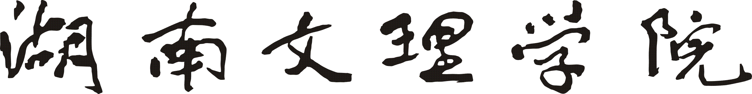

**毕业论文（设计）成绩评定表（一）**

|  |  |  |  |  |  |  |
| --- | --- | --- | --- | --- | --- | --- |
| **毕业论文（设计）题目** | | | **易物网** | | | |
| **学生姓名** | **夏增钊** | **专业班级** | | **计算机科学与技术17102班** | **学号** | **201717010231** |
| **指导教师评语：**    **建议成绩：**  **指导教师签名：**    **年 月 日** | | | | | | |



**毕业论文（设计）成绩评定表（二）**

|  |  |  |  |  |  |  |
| --- | --- | --- | --- | --- | --- | --- |
| **毕业论文（设计）题目** | | | **易物网** | | | |
| **学生姓名** | **夏增钊** | **专业班级** | | **计算机科学与技术17102班** | **学号** | **201717010231** |
| **评阅人评语：**  **建议成绩：**  **评阅人签名：**    **年 月 日** | | | | | | |



**毕业论文（设计）成绩评定表（三）**

|  |  |  |  |  |  |  |  |  |  |  |  |  |  |  |  |
| --- | --- | --- | --- | --- | --- | --- | --- | --- | --- | --- | --- | --- | --- | --- | --- |
| **毕业论文（设计）题目** | | | | | **易物网** | | | | | | | | | | |
| **学生姓名** | | **夏增钊** | | | | **专业班级** | | | | **计算机科学与技术17102班** | | | **学号** | | **201717010231** |
| **答辩时间** | | **2021.5.22** | | | | | | **答辩地点** | | | **E3 A517** | | | | |
| **答**  **辩**  **小**  **组**  **成**  **员** | **姓名** | | **职务（职称）** | | | | **姓名** | | **职务（职称）** | | | **姓名** | | **职务（职称）** | |
| **李果** | | **讲师** | | | | **刘波涛** | | **讲师** | | | **谭文学** | | **教授** | |
| **屠添翼** | | **讲师** | | | |  | |  | | |  | |  | |
|  | |  | | | |  | |  | | |  | |  | |
| **答辩小组评语：**    **建议成绩：**  **答辩小组组长签名：**  **年 月 日** | | | | | | | | | | | | | | | |
| **答辩委员会评定**  **最终成绩** | | | | **学院毕业论文（设计）工作小组审核意见：**  **组长签名：**  **年 月 日** | | | | | | | | | | | |
|  | | | |