毕业设计(论文)外文资料翻译

学院（系）： 计算机科学与技术学院
专 业： 计算机科学与技术
姓 名： 夏增钊
学 号： 201717010231
外文出处： arXiv.org
附 件： 1.外文原文；2.外文资料翻译译文。

指导教师评语：

签名：
年 月 日

catalogue

Tannistha Pal¹, Sudhanshu Shekhar Pandey², Arindam Deb³ 2
1. Introduction 3
1.1. Goal 3
1.2. Contribution 3
2. Literature Review 4
3. Proposed System 4
4. System Implementation 6
Admin 7
Vendor 9
Customer 9
5. Comparative Analysis 13
5.1. Customer Satisfaction 13
5.2. Comfortable and user friendly 14
5.3. Very less investment 14
6. Conclusion and Future Direction of Work 14
References 15

附件2：外文原文（复印件）
Journal of Physics: Conference Series

PAPER • OPEN ACCESS

HandCrafted: An Online Shopping Website of Handicratfs
To cite this article: Tannistha Pal et al 2021 J. Phys.: Conf. Ser. 1804 012079

View the article online for updates and enhancements.


This content was downloaded from IP address 106.17.6.156 on 21/05/2021 at 02:49
HandCrafted: An Online Shopping Website of Handicratfs

Tannistha Pal¹, Sudhanshu Shekhar Pandey², Arindam Deb³
^{1,2,3} Department of Computer Science & Engg. Dept., NIT Agartala, Agartala, 799046,
India

tannisthapaul@gmail.com sspandey14@gmail.com arindamdeb2013@gmail.com

Abstract. Online Shopping Website for Handicraft is a form of electronic commerce which allows consumers to directly buy goods (which are handmade) or ser-vices from a seller over the Internet. Most of the shopping sites are focusing on electronic gadgets, clothes etc. but no one particularly focusing on the products which is of handmade. Although Tripura is very famous for Hand made products and it supply all over the India, but people are not getting its product because of poor transport facilities. So, this paper focuses on devel-oping a shopping site for upliftment of handmade products of Tripura. So, it will be beneficial for our government, businessmen of Tripura as well as cus-tomers. This paper focuses on developing an website which will be useful to anyone who wants to purchase items using internet even living in small city or villages.

Keywords: Handicrafts, online shopping website, entity relationship.

Introduction
Online purchasing is nowadays widely used especially for fashion retail marketing. At present time companies are developing websites as Internet is the only way to gain profit. The main goal for retailers is to build a web site which is informational and transactional in nature and can be used for advertising and direct marketing, sales, customer support and public relations. As per the research paper [1], McKinsey & Company and Salomon Smith Barney, E-tailors who sell through catalogues, stores, and online, are proved to be more profitable in earning money from customers. According to [2], Jupiter Research observes that there was a gaining profit of 21 percent from year 2002 to 2003 from customers through online shopping. The factors in holiday sales is dependent on many factors such as, online bargains, timesaving, and much more. The top categories of Online Shopping according to comScore Networks [3][4] are:
  - Apparel and Accessories
  - Office Supplies
  - Home and Garden
  - Health and Beauty
  - Gifting
  - Sporting Goods

  - Toys and Game

  - Goal
This website is developed to help interested aspirants to learn about application designing using JavaScript, JSP, Bootstrap and HTML from their basic capabilities. This application allows understanding the basics about the appearance of a first web page and how a complete working application can be built from scratch. It also allows understanding the concept of user integrated graphics and how JavaScript can be embedded into HTML. Further, it gives insight about how the client-side language interacts with the server-side language and finally with the database. This shopping-cart application is designed primarily for interested candidates to learn and understand the concept of application development, and can also be used to teach e-commerce and web-application topics. The application can be downloaded and installed on different machines, and they can view the source code for all the different parts shown on the user interface to visually understand how a particular piece of code works. This shopping cart application is very versatile and can be enhanced by adding more functions and modified graphics for use with commercial purposes.

  - Contribution
The contribution of this paper lies in designing an Online Shopping Website for Handicraft application because by performing online shopping lots of time can be consumed rather than spending time at physical markets. Further, using the available stores to sell the products, there is also the possibility of designing one’s own customized Online Shopping Website for Handicraft application because custom- designed platforms are expensive. Moreover, this paper will not only help the students to understand the concepts of web-application designing but it will be very easy to incorporate the idea of using programming techniques from the available visuals to understand how a piece of code appears on a user interface. The languages used to build this application are JavaScript, HTML, and JSP they are found to be useful while working on the technologies.

Literature Review
Rohit Yadav et al. [5] argue that as by online shopping more customers may be at-tached and profit can also be earned more. Renee Garett et al. [6] propose that different organizations have different needs and thus seeks to implement web design for the maximization of their profit. Like, an online shopping website needs to fucus mainly on advertisement of their different products and make easy transactions along with security and attractive layouts. Punam Kumari et al. [7] describe the need of adding more web developing languages in the platform so that people can choose whatever language they find more feasible. Alla Moreva et al. [11] represent an efficient process of redisigning an website and effective methods of user testing using eye-tracking method. Prajaks Jitngernmadan et al. [13] describe how to implement a website for science and technology faculty and later use this platform for the purpose of advertising of the institution to the students.

Proposed System

  - SQL Report
Normalization of Database is the technique of organizing the columns and tables in such a way to reduce redundant data from a relational database. In this paper, second normal form is used which is based upon the primary key and first normal form.
Product. In Product table, Product Id is primary key and all fields depend upon the primary key and also satisfied the first normal form. The Product Table for this shopping website is depicted in Fig. 1

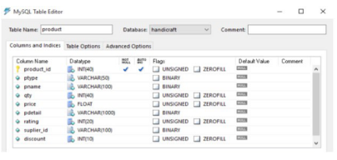
Fig.1.Product Table

User Detail. There are three types of table maintained for users. Admin,Vendor and Customer. Customer table contains twelve fields, first is User id which is primary key other than this all fields are depended on it. Fig. 2 represents User Table of the website.
Users. This table is only used for login purpose. It consists of seven fields in which user id is primary key. Fig. 3 depicts the Users Table.

  - Entity Relationship (ER) Diagram
Entity Relationship Diagrams is used to assemble the data into entries and represent the relationship and it also act as data model [6] [7]. This diagram helped an analyst to design a good database structure in an efficient way.
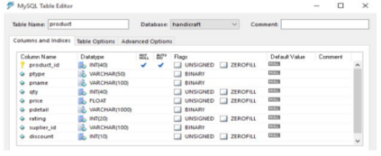

Fig.2. User Table

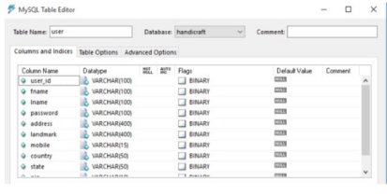
Fig.3. Users Table

Entity. A data entity is an important feature where the data can be stored. Entity is classified into 5 steps: locations, tangible things, roles, events or concepts. Sometimes entities are also called as instances.
Relationship. A data relationship is useful when there is an involvement between two entities.
Attribute. A data attribute defines a unique property which can be common to a particular entity. An attribute that uniquely identifies only one attribute is called a primary key. A Data Flow Diagram gives a pictorial information of the flow of data in a relational database and it is also used as introductory step to define the system. DFDs can also be accustomed for visualization purpose especially for designing a structure. Fig. 4 represents the Entity Relationship Diagram of our shopping website.

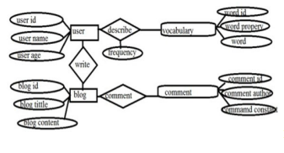

Fig.4. Entity Relationship Diagram

System Implementation
System implementation mainly deals with training of user, file conversion and preparation of website. In file testing process, first of all user acceptance is examined with training of users. System testing involves the accuracy of the system for accessing and fetching the information. This technique involves guidance against errors in the whole system and also provides the users a chance to gather experience through this procedure.
This online shopping website is supposed to be delivered in three phases, with each phase being an add-on that makes it more usable and acceptable.

  - Static decomposition and Dependency Description
This section contains the system use-case diagram for the online shopping-cart application and also has a detailed explanation for each use case in the system.
High level Use Case Diagram. The systems use case shows the user a detailed view of the system and how the actors would interact with each other and with the system. The explanation for each usecase is then provided below the system use case for the administrator as depicted in Fig. 5 and the user as mentioned in Fig. 6 helping the user to understand who are the actors are as well as giving the description for each usecase along with its pretend post-conditions that should be satisfied once the use case is implemented in the software. Fig. 5 demonstrates the use case of for an administrator where he or she has access to the application. The administrator can access the home page, select a category, or add / delete items to from the cart.
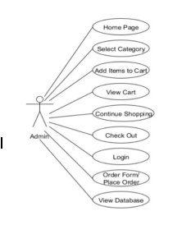
Fig.5. Use Case Diagram 1

Fig. 6 demonstrates the use case for users where they have access to the online shopping cart application. They can access the home page, select a category, add/delete items to/from the cart, view the shopping cart, and decide to either continue shopping or check out. They are required to go through the user authentication form (login) which would only allow them to place an order for the items they selected.

  - User Panel
There are three panels in this paper i.e. Admin Panel, Vendor Panel and Customer Panel. All are having their own level of privileges.

Admin
    - Admin can show all products, update, delete and add new products.
    - They can also provide privileges to vendors, customers as well as other admins. They can delete all the account.
    - Admin can also add product to home screen list. Fig. 7 represents adding new products to Admin Panel and Fig 8depicts list of products in Admin Panel.

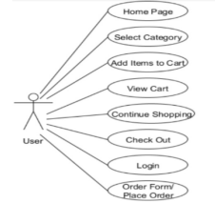

Fig.6. Usecase Diagram 2

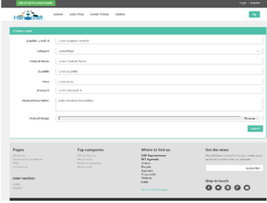

Fig.7. Add new Product

Vendor
    - Vendor can customize available products and also, they can approach admin to add some new products.
    - They are also responsible for delivery of products to the customer’s home.
    - They can facilitate products with extra discount so that they will get more star from customer.

Customer
    - Customer can view all products.
    - They can add it to Cart and Wishlist for future purchase.
    - They can delete and update it from Wishlist or Cart.
    - Customer can give stars and feedback to products and vendors in feedback form.
    - Transaction will be done by customers including all taxes and shipping charge.
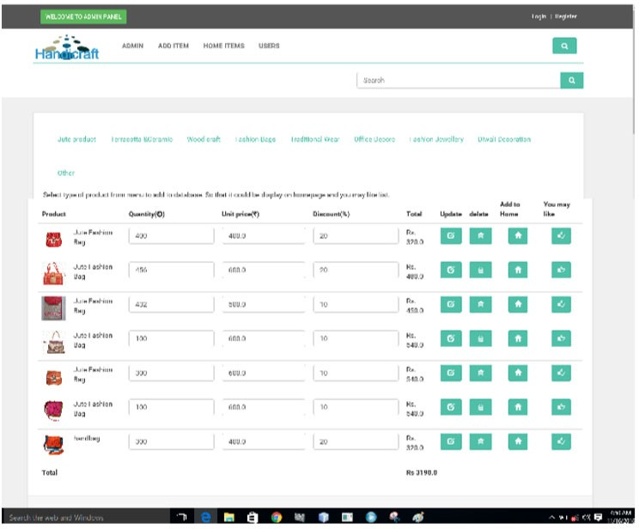
Fig.8. List of Products in Admin Panel

  - Email Verification
We have provided email id verification for this website. Here, if someone wants to register then he/she must have correct email id. If he/she is entering the wrong email id, then he/she cant sign up because we are sending the verification number on email id and then after we asked verification number from user in second sign up form. If user enters the correct verification number then only they can register otherwise not.
User Verification at Sign Up. There are three steps of registration process. Firstly, they have to provide valid email id and then a verification code will send to that email id. After that in next step they have to verify it with verification code. This application will check the user id in database, if someone wants to sign up. If the user has already registered with same email id, then he/she will get a message that this id is already registered and please register with another email id. Otherwise they can proceed to the next step. After verification of email id, they can enter their username and password.
User Verification at Login. At first, it checks email id of the user. If email id is not presented in database then it will generate an error message that you are invalid user otherwise it will check password. If password is correct then the user can login otherwise, it will again generate an error message that your password is wrong.
Without Login. We have given authority to the user that they can see all the products and details even user is not registered or login.
Fig. 9 depicts the home page of our website whereas Fig. 10 represents products master page. Fig 11 illustrates product details page and Fig. 12 outlines the login page of user. The website also developed shopping cart and wish list which have been potrayed in Fig. 13 and Fig. 14 respectively.

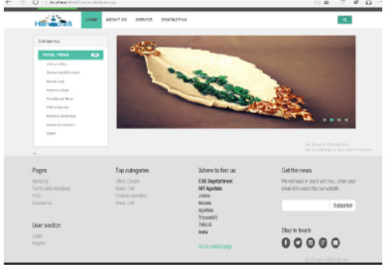
Fig.9. Home Page

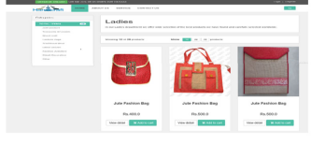

Fig.10. Product Master Pag

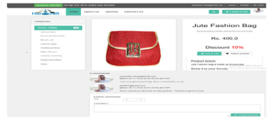
Fig.11. Product Detail Page
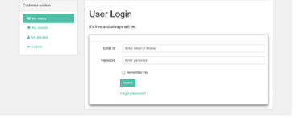
Fig.12. Login Page

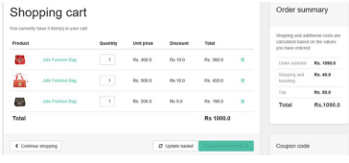
Fig.13. Basket Page

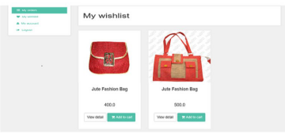
Fig.14. Wishlist Page

Comparative Analysis

After investigating many research papers, the proposed system performs effectively and has got some superior features than some prevailing methods [1-3][5-6][13].

  - Customer Satisfaction
The most prominent good thing about this handicraft web portal is the capacity to communicate with the clients. Such an engagement makes a difference retailer to meet the person clients and react to their responses suitably. This makes a difference client to urge their prerequisite for custom painstaking work. This has moreover driven to the online buyers being more satisfied.

  - Comfortable and user friendly
This handicraft web portals are designed in such a way that buyers can effectively make online buys of painstaking work. Clients can conduct buys within the same instrument that the information is given, so there's no detachment between the buying crave and the buying capacity.

  - Very less investment
This handicraft web portal does not require a retailer to contribute in warehouses, showrooms or other commercial properties at prime areas. Workmanship retailers work through their web destinations and in this way spare radically on the genuine bequest costs. Besides, support costs of a virtual workmanship store are irrelevant in comparison to a physical craftsmanship store.

Conclusion and Future Direction of Work
The Handicraft Shopping website is developed to give a platform of web-based application that would help in searching, viewing and selection of a product in a very ease manner. This website offers an efficient way for the users to search for products interactively and the search engine will feature the product based on the need of user [9]. The user has the option to write their own reviews and based on it the search engine will also classify the feedback as positive and negative reviews. Its drag and drop feature would make it easy to use. This website is developed by keeping in mind the easiness of interaction by the users so that they get a very user-friendly environment while surfing the website. Such compatibility of this website enables it to attract the users to visit the website more frequently. The salient features of this website are:
  - User will choose which courier service they want.
  - The simplicity and suitability of this website which makes it user-friendly.
  - Easy availability of products.
  - Quick display of products on the basis of price range.
The authors feel that some more salient features would round off the system. If the authors try to sell this system, then more system testing is needed for better performance and would also be advantageous for the hardware in case of a system failure. So, following things can be done in future.
- The current system can be further extended which will allow the users to save products in to wish list.
- Subscription can also be added where the users could get the newsletters letters especially when the price for a product drop from the original price.
- Post Requirements: In this, customer will be updated on their contact number as well as e-mail id.
- More products such as home-furnishing will be added and collaborated with more brands.

References
[1] Shankar Nayak Bhukya, M. Chaitanya, N Sri Nidhi and N.S Tanuja, "Detecting False Users in Online Rating & Secure Repuation", International Journal of Computer science & Engineering, 2017.
[2] Rajiv Patel and Amisha Saha, “E Coomerce and rural handicrafts artisans”,Journal of Voice of Research, Vol 2, pp.99–110 , 2016.
[3] Dilip Kumar and Rajeev PV, "Marketing Challenges of Handicraft Retailers in changing environment", International Journal of Business, Economics and Management, Vol-4, pp. 22- 23, 2014.
[4] Gaitri Kumari, Abhaya Ranjan Srivastava, "Role of e-tailing in boosting the Indian Handicraft Industry", International Journal of marketing & Financial Management, Vol.4, pp. 27-36, June 2016.
[5] Rohit Yadav, Tripti Mahara, "An Empirical Study of Consumers Intention to Purchase Wooden Handicraft Items Online: Using Extended Technology Acceptance Model", Journal of Global Business Preview, July 3, 2017.
[6] Renee Garett, Jason Chiu, Ly Zhang and Sean D. Young,"A Literature Review: Website Design and User Engagement", International Journal of Communication Media Technology,2016.
[7] Punam Kumari and Rainu Nandal, "A Research paper on website Development Optimization using Xampp/PHP", International Journal of Advanced Research in Computer Science,2017.
[8] Ch. Rajesh and KSV Krishna Srikanth , "Research on HTML5 in Web Development", International Journal of Computer Science and Information Technologies, Vol. 5 (2) pp. 2408- 2412,2014.
[9] Tannistha Pal and Aman Verma,” An Educational Website on Vocational courses for Govt. Vacancies”, Elsevier SSRN Digital Library, 2020.
[10] Chen Ping, "A Visual Communication Design Method for E-Commerce Websites," International Conference on Smart Grid and Electrical Automation (ICSGEA), Xiangtan, China, 2019, pp. 538-542, 2019.
[11] Alla Moreva, Vitaly Kompaniets and Natalia Lyz, "Development and Oculographic Research of the Website Design Concept for Inclusive Education," Ural Symposium on Biomedical Engineering, Radioelectronics and Information Technology (USBEREIT), Yekaterinburg, Russia,pp. 276-279,2019.
[12] Lingfang Huang, Li Zhu, Xiaodie Zhou and Junying Liu, "Research on Website Traffic Statistics System," 2020 12th International Conference on Measuring Technology and Mechatronics Automation (ICMTMA), Phuket, Thailand, pp. 957-961, 2020.
[13] Prajaks Jitngernmadan and Prawit Boonmee, "Key Factors of Usability of Science and Technology Faculties’ Website: Marketing Purpose," 4th International Conference on Information Technology (InCIT), Bangkok, Thailand, pp. 289-293, 2019.
[14] http://www.Bootstrap.com
[15] http://www.jsptut.com

目录
Handcrafted：Handcrafts的在线购物网站 3
摘要 3
关键词：工艺品，网上购物网站，实体关系 4
一、导言 5
1.1.目标 5
1.2.贡献 5
二、文献综述 7
三、拟议制度 8
四.系统实施 11
4.1.静态分解和依赖描述 11
4.2.用户面板 12
4.3.电子邮件验证 14
五、比较分析 18
5.1.顾客满意 18
5.2.舒适和用户友好 18
5.3.投资非常少 18
六、结论和今后的工作方向 19
1. 用户将选择他们想要的快递服务。 19
2.该网站的简单性和适用性使其用户友好。 19
3.产品容易获得。 19
4.根据价格范围快速展示产品。 19
参考文献 20

Handcrafted：Handcrafts的在线购物网站

Handcrafted：Handcrafts的在线购物网站

Tannistha Pal1,Sudhanshu Shekhar Pandey2,Arindam Deb3
1,2,3计算机科学与工程系。NIT Agartala,Agartala,799046，印度

tannisthapaul@gmail.com sspandey14@gmail.com arindamdeb2013@gmail.com

摘要
手工艺品网上购物网站是一种电子商务形式，它允许消费者在互联网上直接从销售商处购买手工制作的商品或服务。大多数购物网站都集中在电子产品、服装等方面，但没有人特别关注手工制作的产品。虽然Tripura以手工制作的产品闻名，并且在印度各地都有供应，但由于运输设施不佳，人们没有得到它的产品。因此，本文致力于开发一个提升Tripura手工产品的购物网站。因此，这将有利于我们的政府，三浦拉的商人和客户。本论文的重点是开发一个网站，它将对任何想要使用互联网购买物品的人，甚至居住在小城市或农村的人都是有用的。

关键词：工艺品，网上购物网站，实体关系

一、导言
在线采购是当今世界上广泛应用的一种方式，尤其是在时尚零售市场中。目前，企业都在开发网站，因为互联网是获取利润的唯一途径。零售商的主要目标是建立一个信息和交易性质的网站，可以用于广告和直接营销、销售、客户支持和公共关系。根据研究报告[1],麦肯锡公司和所罗门美邦,通过目录、商店和网上销售的电子裁缝,被证明在从顾客身上赚取金钱方面更有利可图。根据[2]，Jupiter Research观察到，从2002年到2003年，顾客通过网上购物获得了21%的利润。假日销售的因素取决于许多因素，例如，网上减价，节省时间，以及更多的因素。根据comScore Networks[3][4]，网上购物的最大类别是：服装和配件、办公用品、家和花园、健康与美丽、馈赠、体育用品、玩具和游戏

1.1.目标
这个网站的开发是为了帮助有兴趣的人学习应用程序设计使用JavaScript，JSP，引导和HTML从他们的基本能力。此应用程序允许了解有关第一个网页外观的基本知识，以及如何从头构建一个完整的工作应用程序。它还允许理解用户集成图形的概念以及如何将JavaScript嵌入到HTML中。此外，它还提供了有关客户端语言如何与服务器端语言以及最后如何与数据库交互的见解。这个购物车应用程序主要是为有兴趣的考生学习和理解应用程序开发的概念而设计的，也可以用来教授电子商务和web应用程序的主题。应用程序可以下载并安装在不同的机器上，他们可以查看用户界面上显示的所有不同部分的源代码，以直观地了解特定代码段的工作原理。这个购物车应用程序是非常多功能的，可以通过添加更多的功能和修改的图形来增强，以用于商业目的。

1.2.贡献
本文的贡献在于设计了一个适合手工艺品应用的网上购物网站，因为通过网上购物可以消耗大量的时间，而不是花时间在实体市场上。此外，利用现有的商店销售产品，也有可能设计自己的定制网上购物网站的工艺品应用，因为定制设计的平台是昂贵的。此外，本文不仅有助于学生理解web应用程序设计的概念，而且可以很容易地结合使用现有视觉资料中的编程技术来理解一段代码是如何出现在用户界面上的。用于构建此应用程序的语言是JavaScript、HTML和JSP，它们在处理这些技术时非常有用。

二、文献综述
Rohit Yadav等人[5]认为，通过网上购物，更多的顾客可能会被吸引，利润也会增加。Renee Garett等人[6]提出，不同的组织有不同的需求，因此寻求实现其利润最大化的网页设计。像，一个网上购物网站需要我们主要是在广告上的不同产品，使交易方便，安全和有吸引力的布局。punamkumari等人[7]描述了在平台中添加更多web开发语言的需求，这样人们就可以选择他们认为更可行的语言。Alla Moreva等人[11]代表了一个重新设计网站的有效过程，以及使用眼睛跟踪方法进行用户测试的有效方法。Prajaks-Jitengernmadan等人[13]描述了如何为科学和技术教师建立一个网站，然后利用这个平台向学生宣传学校。

三、拟议制度
3.1.SQL报表
数据库规范化是以这种方式组织列和表以减少关系数据库中的冗余数据的技术。本文采用基于主键的第二范式和第一范式。
产品：在产品表中，产品Id是主键，所有字段都依赖于主键，并且满足第一范式。该购物网站的产品表如图1所示。
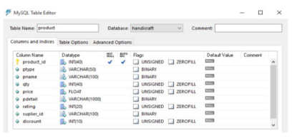
图1.产品表

用户详细信息。为用户维护的表有三种类型。管理员、供应商和客户。Customer表包含12个字段，第一个是userid，它是主键，除此之外所有字段都依赖于它。图2表示网站的用户表。
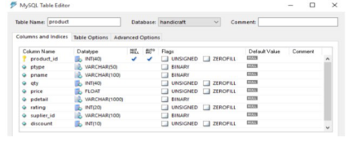
图2.用户表
用户：此表仅用于登录目的。它由七个字段组成，其中用户id是主键。图3描绘了用户表。
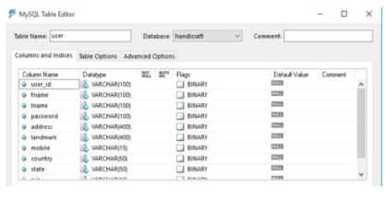
图3.用户表

3.1.实体关系（ER）图
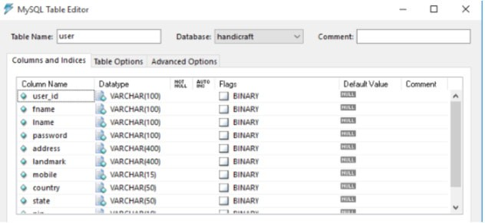
实体关系图用于将数据组合成条目并表示关系，它还充当数据模型[6][7]。此图帮助分析人员以有效的方式设计良好的数据库结构。
实体：数据实体是存储数据的重要功能。实体分为5个步骤：位置、有形的东西、角色、事件或概念。有时实体也称为实例。
关系：当两个实体之间存在关联时，数据关系非常有用。
属性：数据属性定义了一个唯一的属性，该属性可以是特定实体的公共属性。唯一标识一个属性的属性称为主键。数据流图给出了关系数据库中数据流的图形信息，也可以作为定义系统的介绍步骤。DFDs还可以用于可视化，特别是用于结构设计。图4是我们购物网站的实体关系图。

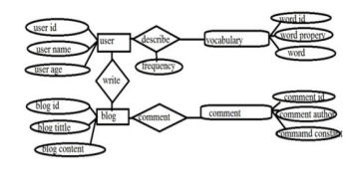
图4.实体关系图

四.系统实施
系统实现主要包括用户培训、文件转换和网站准备。在文件测试过程中，首先通过对用户的培训来检验用户的接受程度。系统测试涉及系统访问和获取信息的准确性。这项技术包括对整个系统错误的指导，也为用户提供了一个通过这一过程收集经验的机会。
这个在线购物网站应该分三个阶段交付，每个阶段都是一个附加组件，使其更易使用和接受。

4.1.静态分解和依赖描述
本节包含在线购物车应用程序的系统用例图，并对系统中的每个用例进行了详细说明。
高级用例图。系统用例向用户展示了系统的详细视图，以及参与者之间以及与系统之间的交互方式。然后在系统用例的下面为管理员（如图5所示）和用户（如图6所述）提供对每个用例的解释，帮助用户理解谁是参与者，并给出每个用例的描述以及一旦用例被激活就应该满足的假设条件在软件中实现。图5示出了管理员可以访问应用程序的应用程序的用例。管理员可以访问主页、选择类别或从购物车中添加/删除项目。

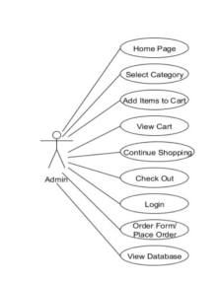
图5.用例图1

图6展示了用户可以访问在线购物车应用程序的用例。他们可以访问主页，选择类别，向购物车添加/删除项目，查看购物车，并决定继续购物或退房。他们需要通过用户身份验证表单（登录），该表单只允许他们为所选项目下订单。
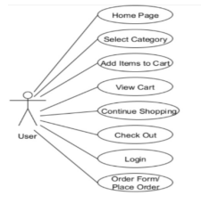
图6.用例图2

4.2.用户面板
本文分为三个面板：管理面板、供应商面板和客户面板。所有人都有自己的特权。
行政管理员：可以显示所有产品，更新，删除和添加新产品。它们还可以为供应商、客户以及其他管理员提供特权。他们可以删除所有帐户。管理员还可以将产品添加到主屏幕列表。图7表示向管理面板添加新产品，图8表示管理面板中的产品列表。
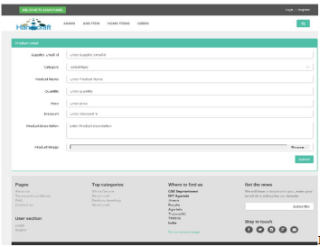
图7.添加新产品
卖家：供应商可以定制可用的产品，而且他们还可以通过管理员添加一些新产品。他们还负责将产品交付给客户的家。他们可以为产品提供额外折扣，这样他们将从客户那里获得更多的酬劳。
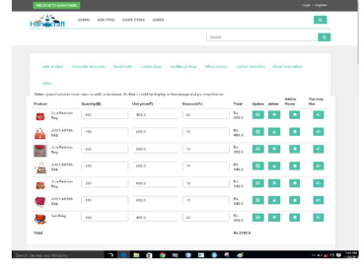
图8.管理面板中的产品列表
客户：客户可以查看所有产品。他们可以将它添加到购物车和愿望，以供将来购买。他们可以从Wishlist或Cart中删除和更新它。客户可以以反馈的形式向产品和供应商提供星级和反馈。交易将由客户完成，包括所有税费和运费。

4.3.电子邮件验证
我们已提供此网站的电子邮件id验证。在这里，如果有人想注册，那么他/她必须有正确的电子邮件id。如果他/她输入了错误的电子邮件id，那么他/她不能注册，因为我们正在发送电子邮件id上的验证号，然后在第二次注册表中询问用户的验证号。如果用户输入了正确的验证号，那么只有他们才能注册，否则就不能注册。
注册时进行用户验证。注册过程有三个步骤。首先，他们必须提供有效的电子邮件id，然后验证码将发送到该电子邮件id。之后，在下一步，他们必须验证码。如果有人想注册，这个应用程序将检查数据库中的用户id。如果用户已使用相同的电子邮件id注册，则他/她将收到一条消息，说明此id已注册，请使用其他电子邮件id注册。否则，他们可以继续下一步。验证电子邮件id后，他们可以输入用户名和密码。
登录时进行用户验证。首先，它检查用户的email id。若电子邮件id并没有出现在数据库中，那个么它将生成一个错误消息，表明您是无效用户，否则它将检查密码。如果密码是正确的，那么用户可以登录，否则，它将再次生成一个错误消息，您的密码是错误的。
没有登录。我们已经授权给用户，他们可以看到所有的产品和细节，即使用户没有注册或登录。
图9是我们网站的主页，而图10是产品主页。图11说明了产品细节页面，图12概述了用户的登录页面。网站还开发了购物车和心愿单，分别如图13和图14所示。
网站主页：可以浏览网站所有商品和网站最新消息；
产品主页：为一类商品地分类页面；
产品细节页面：详细地介绍了该商品，包括价钱、材质、制作工艺等；
登录页面：用户输入账号密码登录；
购物车：将自己所喜爱商品可加入购物车；
心愿单：可将自己想要的商品放入心愿单。
图9.主页

图10.产品母版页
图11.产品详情页

图12.登录页

13.购物车页

图14.愿望列表页

五、比较分析
通过对大量研究论文的研究，本文提出的系统性能良好，比现有的一些方法[1-3][5-6][13]具有一些优越的特性：

5.1.顾客满意
这个手工艺品门户网站最突出的优点是与客户沟通的能力。这样的约定使得零售商能够与客户见面，并对他们的回答做出适当的反应。这就使得不同的客户，敦促他们的先决条件，定制艰苦的工作。这也促使网购者更加满意。

5.2.舒适和用户友好
这种手工艺品门户网站的设计方式，使买家可以有效地进行网上购买的艰苦工作。客户可以在提供信息的同一工具内进行购买，因此在购买欲望和购买能力之间没有分离。

5.3.投资非常少
这一手工艺品门户网站不要求零售商在黄金地段的仓库、陈列室或其他商业场所提供服务。手工零售商通过他们的网络目的地工作，这样就大大节省了真正的遗产成本。此外，虚拟工艺商店的支持成本与物理工艺商店相比无关紧要。

六、结论和今后的工作方向
手工艺品购物网站的开发是为了提供一个基于web的应用平台，帮助人们以非常轻松的方式搜索、查看和选择产品。该网站为用户提供了一种交互式搜索产品的有效方式，搜索引擎将根据用户的需要对产品进行特色化搜索[9]。用户可以选择写自己的评论，搜索引擎也会根据这些评论将反馈分为正面评论和负面评论。它的拖放功能将使它易于使用。这个网站的开发是通过记住用户交互的方便性，这样他们在浏览网站时就可以得到一个非常友好的环境。该网站的这种兼容性使其能够吸引用户更频繁地访问该网站。本网站的显著特点是：
- 用户将选择他们想要的快递服务。

2.该网站的简单性和适用性使其用户友好。

3.产品容易获得。

4.根据价格范围快速展示产品。
作者认为一些更显著的特性将使系统更加完善。如果作者试图销售这个系统，那么就需要更多的系统测试来获得更好的性能，并且在系统出现故障的情况下对硬件也是有利的。所以，以后可以做以下事情：
1.当前系统可以进一步扩展，允许用户将产品保存在心愿列表中。
2.还可以添加订阅，用户可以在那里获得时事通讯信件，特别是当产品的价格从原来的价格下降。
3.岗位要求：更新客户的联系电话和电子邮箱。
4.增加家居等产品，与更多品牌合作。

参考文献
[1] Shankar Nayak Bhukya，M。Chaitanya，N Sri Nidhi和N.S Tanuja，“在线评级和安全信誉中检测虚假用户”，国际计算机科学与工程杂志，2017年。
[2] Rajiv Patel和Amisha Saha，“E Coomerce和农村手工业工匠”，《研究之声杂志》，第2卷，第99-110页，2016年。
[3] Dilip Kumar和Rajeev PV，“变化环境中手工业零售商的营销挑战”，《国际商业、经济和管理杂志》，第4卷，第22-23页，2014年。
[4] Gaitri Kumari，Abhaya Ranjan Srivastava，“电子尾矿在促进印度手工业发展中的作用”，《国际营销与财务管理杂志》，第4卷，第27-36页，2016年6月。
[5] Rohit Yadav，Tripti Mahara，“消费者在线购买木制工艺品意向的实证研究：使用扩展技术接受模型”，《全球商业预览杂志》，2017年7月3日。
][6] Renee Garett、Jason Chiu、Ly Zhang和Sean D。Young，“文献综述：网站设计与用户参与”，国际传播媒体技术杂志，2016年。
[7] Punam Kumari和Rainu Nandal，“基于Xampp/PHP的网站开发优化研究论文”，国际计算机科学高级研究杂志，2017年。
[8] Ch.Rajesh和KSV Krishna Srikanth，“网络开发中的HTML5研究”，《国际计算机科学与信息技术杂志》，第5卷（2）第2408-24122014页。
[9] Tannista Pal和Aman Verma，“政府职位空缺职业课程教育网站”，爱思唯尔SSRN数字图书馆，2020年。
[10] 陈平，“电子商务网站的视觉传达设计方法”，智能电网与电气自动化国际会议（ICSGEA），中国湘潭，2019年，第538-5422019页。
[11] Alla Moreva、Vitaly Kompaniets和Natalia Lyz，“全纳教育网站设计概念的开发和眼科研究”，乌拉尔生物医学工程、放射电子学和信息技术研讨会（USBEREIT），俄罗斯叶卡捷琳堡，第276-2792019页。
[12] 黄凌芳，朱丽，周小蝶，刘俊英，“网站流量统计系统研究”，第12届国际测量技术与机电一体化自动化（ICMTMA）会议，泰国普吉，第957-9612020页。
][13] Prajaks Jitengernmadan和Prawit Boonmee，“科技学院网站可用性的关键因素：营销目的”，第四届国际信息技术会议（InCIT），泰国曼谷，第289-293页，2019年。

[14]http://www.Bootstrap.com

[15]http://www.jsptut.com

