
InAmigos Foundation’s Project Udaan Empowering Women for a Better Tomorrow
In a world where progress is often measured in numbers and profits, there are still initiatives that choose to measure success in transformed lives. Project Udaan, an initiative by the inAmigos Foundation, stands as a powerful example of how focused social action can create meaningful, long-term change. Rooted in the belief that empowered women uplift families, communities, and entire societies


The Mission Behind Project Udaan

Project Udaan was launched with a clear and compassionate mission: to empower women from underprivileged backgrounds by equipping them with skills, confidence, and access to opportunities. Many women in marginalized communities face barriers such as lack of education, financial dependency, limited exposure, and societal constraints

The InAmigos Foundation strongly believes that empowerment goes beyond financial assistance. True empowerment involves education, skill development, emotional strength, and the confidence to make independent choices.
Creating Real Impact on the Ground
What makes Project Udaan impactful is its hands-on, community-driven approach. The program focuses on skill development workshops, awareness sessions, and livelihood training, enabling women to become financially independent and socially aware. From basic vocational skills to personal development and confidence-building sessions, Project Udaan addresses empowerment in a holistic manner.

The ripple effect of this empowerment is visible. When a woman becomes self-reliant, she influences her family’s mindset, supports her children’s education, and contributes positively to her community. This multiplier effect is at the heart of Project Udaan’s success.
Stories That Define Success
Behind every initiative are stories that give it meaning. Project Udaan has witnessed numerous inspiring journeys of women who transformed their lives through determination and support.
Many participants entered the program with hesitation and self-doubt. Some had never worked outside their homes, while others had discontinued education due to financial or social constraints
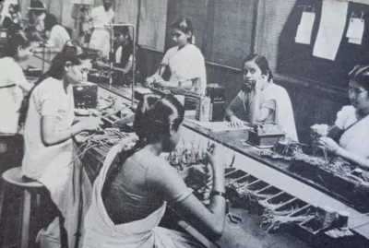
Several women have gone on to secure employment, start small businesses, or contribute economically to their households.
The Role of InAmigos Foundation
The InAmigos Foundation plays a crucial role in ensuring the sustainability and credibility of Project Udaan. Known for its commitment to social change, the foundation actively collaborates with volunteers, mentors, and partners to deliver impactful programs. Transparency, inclusiveness, and long-term vision are central to its approach.
By aligning Project Udaan with broader goals of women empowerment and social development, the foundation ensures that the initiative remains adaptable and relevant. The foundation’s emphasis on grassroots engagement allows it to understand real challenges and design solutions that truly matter.
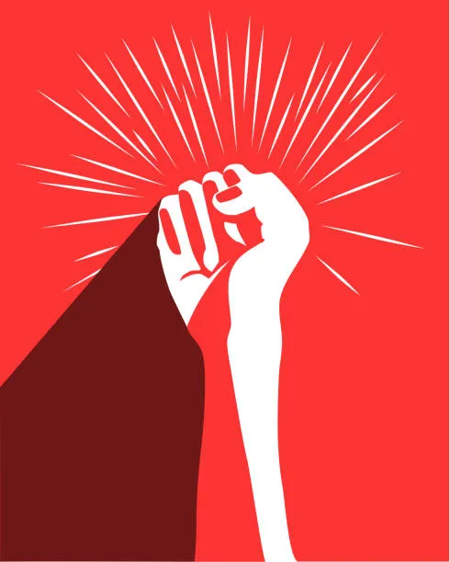

Looking Ahead: The Future of Project Udaan
While Project Udaan has already made a meaningful impact, its vision extends far into the future. The initiative aims to expand its reach to more communities, introduce advanced skill training, and build stronger networks for employment and entrepreneurship. There is also a focus on strengthening mentorship programs so that women continue to receive guidance even after completing their training.
In the long run, Project Udaan envisions creating a self-sustaining ecosystem where empowered women uplift others, creating a continuous cycle of growth and transformation. By investing in women today, the initiative is shaping a more inclusive and equitable tomorrow.

Hashtags
#InAmigosFoundation #ProjectUdaan #UdaanByInAmigos #InAmigosForChange #WomenWithInAmigos #EmpowerHer #RiseWithUdaan #TransformingLives

