MyDoc Backup ran and completed
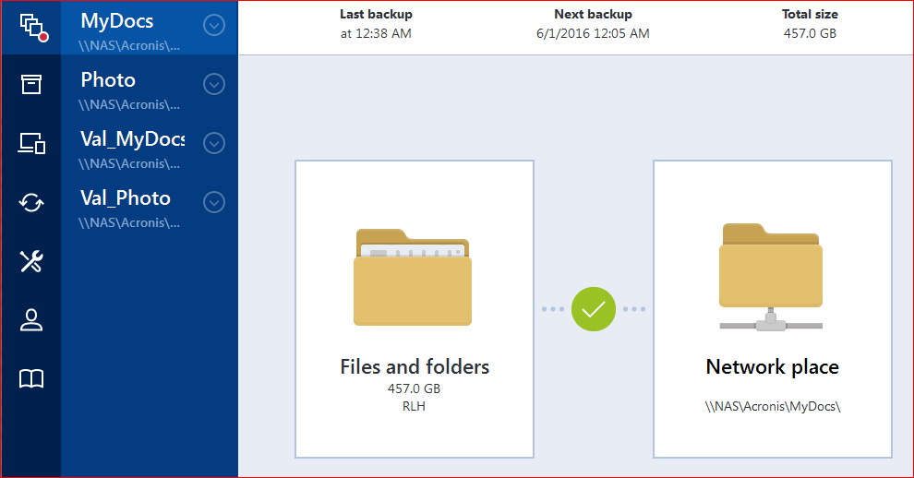
Log demonstrating success
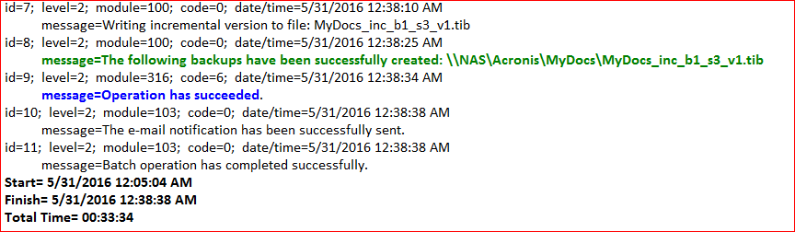

Automated Validation fails
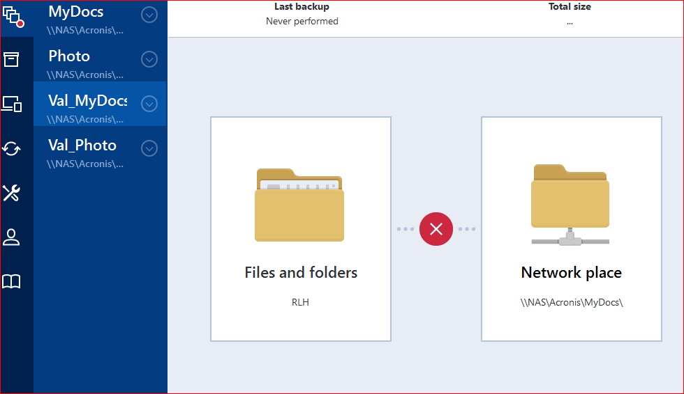
Log showing error
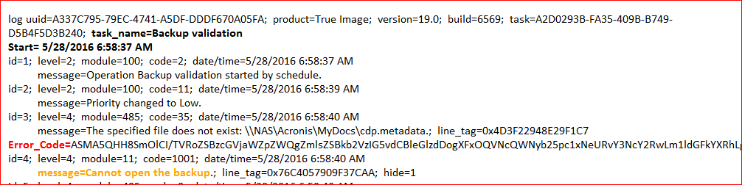

Log of manual Validation from prior day was successful. Assume that it would succeed if I ran it today also.
