IE221 – Probability
Team Work 4
Experimental Investigation of the Strong Law of Large Numbers, Central Limit Theorem, and Monte Carlo Estimation of π
Course: IE221 – Probability
Semester: Fall 2024–2025
Group: 18
Team Members:
Buğrahan Gönen (2311021032)
Mustafa Sait Bayraktar (2311021072)
Kerem Kaan Gökçe (2311021009)
Eren Görgülü (2311021004)

Abstract
Probability theory is fundamentally concerned with understanding the long-run behavior of random phenomena. Among its most important results are the Strong Law of Large Numbers (SLLN) and the Central Limit Theorem (CLT), which together explain why randomness becomes predictable as the sample size increases. This report presents a comprehensive simulation-based investigation of these two limit theorems using Java. The SLLN is examined through the convergence of cumulative sample means generated from independent and identically distributed Uniform(0,1) random variables. The CLT is demonstrated by analyzing the distributions of standardized sums for various sample sizes using histograms and Q–Q plots. Additionally, the Monte Carlo method is applied to estimate the value of π as a practical consequence of the law of large numbers. The simulations are supported by detailed graphical outputs and in-depth analysis, allowing both theoretical properties and empirical convergence behavior to be clearly observed and critically discussed.

1. Introduction
Randomness is an essential component of many natural and engineered systems. From measurement errors in engineering to fluctuations in financial markets, uncertainty is unavoidable. Probability theory provides a rigorous framework for modeling and analyzing such randomness. However, many probabilistic results are asymptotic in nature, meaning that their full implications only become apparent as the number of observations grows large.
Two of the most fundamental results governing long-run behavior are the Strong Law of Large Numbers (SLLN) and the Central Limit Theorem (CLT). Although both theorems describe convergence as sample size increases, they address fundamentally different questions. The SLLN explains why sample averages stabilize around the expected value almost surely, while the CLT explains why the distribution of sums (or averages) tends to become normal when properly standardized.
In parallel, Monte Carlo methods exploit randomness to solve deterministic problems numerically. These methods rely heavily on the principles formalized by the law of large numbers. Estimating π by random sampling within a geometric region is one of the most classical and intuitive examples demonstrating this principle.
The primary objective of this project is to experimentally verify SLLN and CLT through carefully designed simulations and to analyze their convergence behavior in practice. Unlike purely theoretical proofs, simulations provide tangible insight into how fast convergence occurs, how variability decreases with sample size, and why different visualization techniques are needed for different convergence concepts.

2. Literature Review and Conceptual Motivation
The Law of Large Numbers has its roots in the early development of probability theory, with foundational contributions from Jakob Bernoulli in the late 17th century. Bernoulli’s original formulation demonstrated that relative frequencies stabilize as the number of trials increases, laying the groundwork for modern statistical inference. Over time, the law was refined into multiple forms, including the Weak Law of Large Numbers and the Strong Law of Large Numbers, each associated with different modes of convergence.
The Central Limit Theorem is often regarded as the most important result in probability and statistics. Its power lies in its universality: regardless of the underlying distribution (provided certain conditions are met), the normalized sum of independent random variables converges to a normal distribution. This result explains why the normal distribution appears so frequently in practice and justifies many statistical methods used in engineering, economics, and the natural sciences.
Monte Carlo methods emerged prominently in the mid-20th century, particularly during the development of computational physics. These methods made it possible to approximate quantities that are analytically intractable by relying on random sampling and the law of large numbers. Today, Monte Carlo simulations are widely used in areas such as risk analysis, machine learning, numerical integration, and optimization.
Simulation-based verification of theoretical results plays a crucial role in education and practice. While mathematical proofs establish correctness, simulations reveal convergence rates, finite-sample behavior, and practical limitations. This project follows that philosophy by combining theory with numerical experimentation.

3. Theoretical Background
3.1 Strong Law of Large Numbers
Let $X_{1},X_{2},…$be independent and identically distributed random variables with finite expected value $μ=E[X_{1}]$. Define the sample mean as
$${\overset{ˉ}{X}}_{n}=\frac{1}{n}\sum_{i=1}^{n}{X_{i}}.$$
The Strong Law of Large Numbers states that
$$P\left(\underset{n→∞}{lim⁡}{\overset{ˉ}{X}}_{n} = μ\right)=1.$$
This means that, with probability one, the sequence of sample means converges to the true expected value. Almost sure convergence is a very strong form of convergence: once the sequence gets sufficiently close to the limit, it remains close indefinitely.
In this project, random variables are generated from the Uniform(0,1) distribution. For this distribution,
$$μ=0.5,σ^{2}=\frac{1}{12}.$$

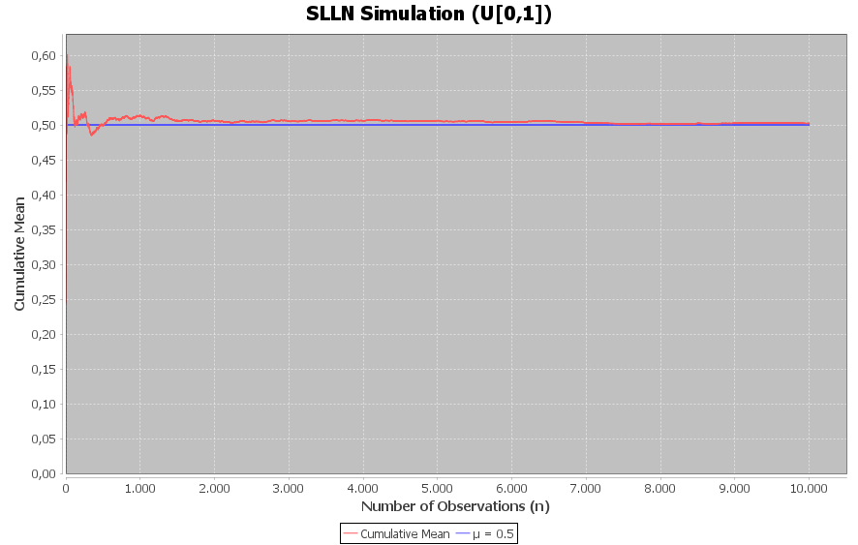

3.2 Central Limit Theorem
The Central Limit Theorem states that if $X_{1},…,X_{n}$are i.i.d. random variables with mean $μ$and variance $σ^{2}$, then the standardized sum
$$Z_{n}=\frac{S_{n}-nμ}{σ\sqrt{n}}$$
converges in distribution to a standard normal random variable as $n→∞$.
Unlike SLLN, CLT is not a statement about individual sample paths. Instead, it describes the limiting shape of the distribution of sums. This distinction is critical for understanding why CLT simulations require many replications and distribution-level visualizations. 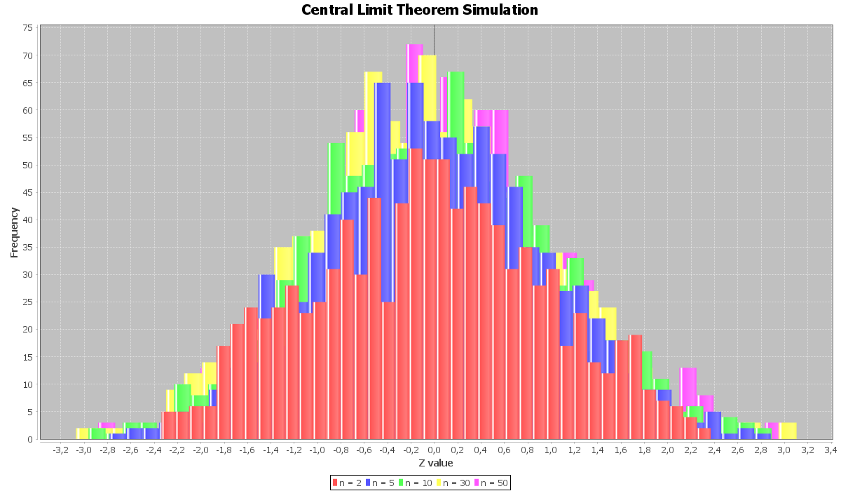
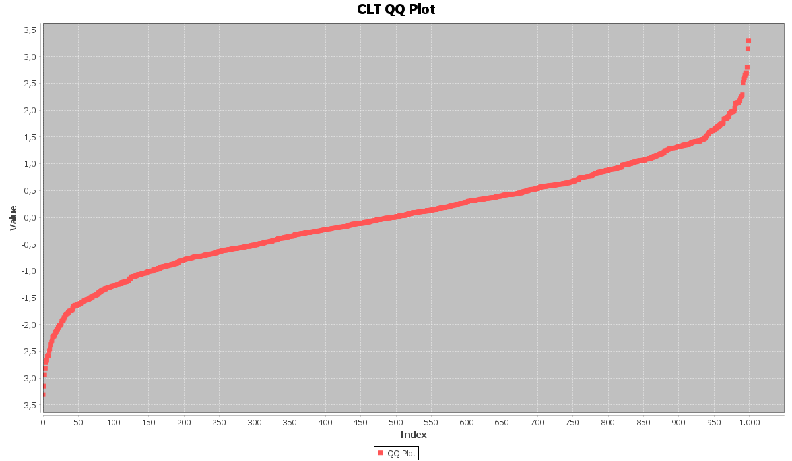

3.3 Monte Carlo Estimation of π
Monte Carlo estimation of π is based on geometric probability. Random points are uniformly sampled from the unit square $\left[0,1]×[0,1\right]$. The fraction of points lying inside the quarter unit circle $x^{2}+y^{2}≤1$provides an estimate of the circle’s area, which is $π/4$. Multiplying this fraction by 4 yields an estimator for π.
By the Strong Law of Large Numbers, this estimator converges almost surely to the true value of π as the number of sampled points increases. 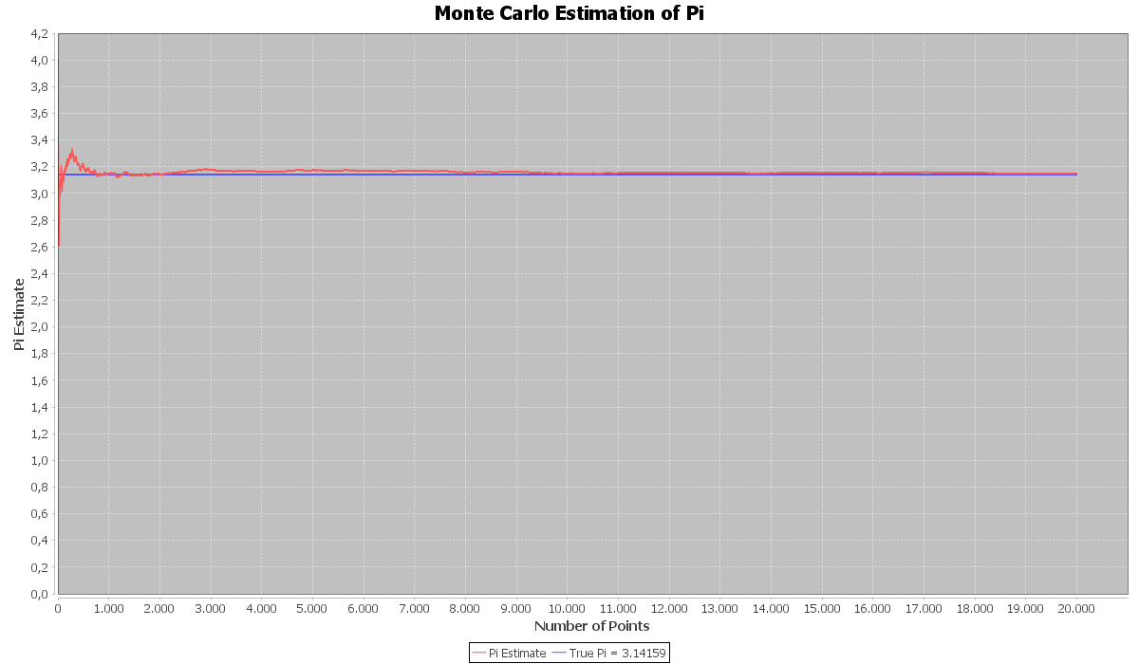

4. Modes of Convergence
A central theme of this project is the distinction between different modes of convergence. SLLN and CLT rely on fundamentally different convergence concepts, which directly influence how simulations must be designed and interpreted.
Theorem | Convergence Type | Interpretation
SLLN | Almost sure convergence | Sample paths converge to the expected value with probability 1
CLT | Convergence in distribution | Distributions of standardized sums converge to the normal distribution
Almost sure convergence implies convergence in probability, which in turn implies convergence in distribution. However, the reverse is not generally true. This hierarchy explains why SLLN provides a stronger guarantee than CLT, but CLT remains more broadly applicable in practice.

5. Methodology
5.1 Software and Tools
All simulations are implemented in Java using the Eclipse development environment. Random numbers are generated using the java.util.Random class. Visualization is performed using the JFreeChart library, and all figures are exported in PNG format.
5.2 Simulation Design Choices
Uniform(0,1) was chosen as the underlying distribution because it is simple, bounded, and non-normal, making it ideal for demonstrating both SLLN and CLT effects. Sample sizes and repetition counts were selected to balance computational efficiency with clear visualization of convergence behavior.

6. Results and Analysis
6.1 SLLN Results
The cumulative mean exhibits strong fluctuations for small sample sizes. As the number of observations increases, these fluctuations diminish and the mean stabilizes around 0.5. By n = 10,000, the cumulative mean remains very close to the theoretical expected value, providing strong empirical evidence of almost sure convergence.
6.2 CLT Results
Histograms of standardized sums show a clear progression toward a bell-shaped distribution as sample size increases. Q–Q plots further confirm this behavior by demonstrating increasing alignment with the theoretical normal quantiles. For larger n values such as 30 and 50, the standardized sums closely follow the standard normal distribution.
6.3 Monte Carlo Estimation of π
The Monte Carlo estimate of π is highly volatile for small numbers of points. As the number of samples increases, the estimate stabilizes around the true value of π. This behavior illustrates the practical implications of the law of large numbers and highlights the slow but steady convergence typical of Monte Carlo methods.

7. Discussion
The simulations demonstrate that convergence is not only a theoretical concept but also a practical phenomenon that can be observed numerically. However, the speed of convergence varies across theorems. Almost sure convergence in SLLN manifests as stabilization of sample paths, while convergence in distribution under CLT requires multiple replications to become evident.
Monte Carlo estimation further highlights the trade-off between accuracy and computational cost. Achieving higher precision requires substantially more samples due to the square-root rate of convergence.

8. Conclusion
This project provides a comprehensive simulation-based exploration of fundamental probability limit theorems. The results confirm theoretical expectations and demonstrate how different modes of convergence manifest in practice. By combining SLLN, CLT, and Monte Carlo estimation, the study illustrates the unifying role of large sample theory in probability and numerical computation.

Appendix A – Project Structure
IE221-Teamwork3-Group18
├─ src/simulation
│ ├─ SLLNSimulation.java
│ ├─ CLTSimulation.java
│ ├─ MonteCarloPi.java
│ └─ Utils.java
├─ results/figures
│ ├─ slln.png
│ ├─ clt_histograms.png
│ ├─ clt_qqplots.png
│ └─ pi.png
└─ README.md

