Periodic Management Report
Justification of major cost items and resources

Please provide a justification of the major costs incurred and resources deployed linking them to activities implemented and explaining their necessity. This should include the following:

- For each workpackage, a brief description of the work you have performed during the period. The work specification should be detailed enough to justify the resources employed - “Contributing to workpackage X” or “Contributing YY% to workpackage X” is too unspecific. Rather e.g. “Developed the ... module for…in workpackage X”.

- Explanatory note on any major cost items such as important equipment purchases, major travel costs, large consumable items etc., justifying their necessity to the project. Please provide detailed cost breakdown by completing Table 1, Table 2 & Table 3.

- A summary explanation of the impact of major deviations from cost budget and from person-month budget

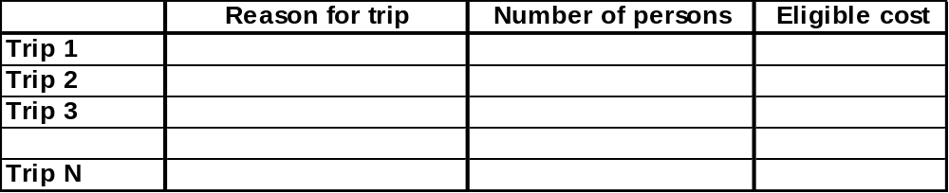
Table 1: Travel cost breakdown

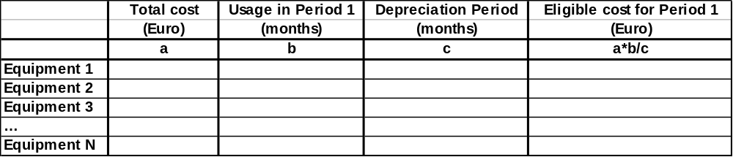
Table 2: Equipment cost breakdown

