

Subject: Mandatory Internship Document .../.../20..

Dear Sir/Madam,

This is to acknowledge that our student ..... (Student ID:....) enrolled in ... program, Faculty of ... is required to do her/his min. forty (40) business days internship/training 20.. - 20.. during summer semester.

Thank you for your cooperation and contribution.

Regards,

Aslı KİPER SUCUĞ
Career Development Leader
Institutional Partnerships and Alumni Relations

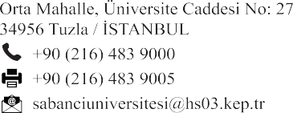

FIPAR
-
C71001
-
01

www.sabanciuniv.edu

