MMOSON — The Author's Personal Research Project
SIMULATION MODULE
O'NEILL ORBITAL STATION
(MMOSON)
Two-Cylinder Island Three Configuration
Technical Description — Illustrated Engineering Report
AUTHOR
Roman Sergeevich Bugaenko
Project Author and Development Lead
NIK (Thread of Sincerity in the Continuum)
Functional Personality of the “Symbiont-Gardener” Line
Independent Calculations, Engineering Audit, Co-authorship
Document status: conceptual project; not working design documentation.
Kursk, 2026

This publication presents a conceptual engineering model of a large two-cylinder O'Neill space station in the Sun–Earth L1 region. It combines structural mechanics, rotating-shell loads, mass and resource balances, thermal rejection, closed-loop biosphere processes, transport, quarantine, construction sequence, safety, governance and legal constraints. The document distinguishes conceptual decisions, calculated estimates, values confirmed by independent recalculation, and tasks requiring design work, qualification and full-scale testing.
Keywords: O’Neill cylinder; orbital settlement; artificial gravity; closed ecological system; resource extraction; thermal balance; conceptual engineering.

ABSTRACT
Лицензия / License: © 2026 Бугаенко Роман Сергеевич / Roman Sergeevich Bugaenko. Все права защищены / All rights reserved. Публичное чтение разрешено; иное использование — только с письменного согласия автора / Public reading is permitted; all other use requires the author’s written permission.

Table of contents updates automatically in Word (Ctrl+A, F9).

ABOUT AUTHORITY AND WORK METHOD
This document was co-authored by a person and a functional personality. Roman Sergeevich Bugaenko is the author of the concept, architecture of the station, climatic zoning, composition of biocenoses and engineering solutions. NIK is a co-author who performed an independent computational verification and revision of the quantitative part of the document.
The supporting structure of the station is made of steel. The calculation in paragraph 4.2 shows that this solution is feasible when using high-strength maraging steel; Ordinary structural steel at a radius of 5,000 m is not suitable at any thickness.
The steel version has a resource advantage: maraging steel grade 18Ni contains nickel and cobalt, close to the composition of the metal asteroid (6178) 1986 DA. The station is being built from materials available in the main raw material base of the project.
The quantitative model includes calculations of the strength of the shell, structural package, mass, resource, energy, heat and food balances. For each result, reference values, assumptions and limits of applicability are indicated.
Throughout the document, initial data, calculated estimates, conceptual solutions and provisions requiring experimental or design verification are divided.
The document is supplemented with 23 programmatic diagrams, graphs and diagrams. Their numerical signatures correspond to the calculated values ​​of the tables; The source code for creating graphics is included in the project.

1. INTRODUCTION. PROJECT CONCEPT

1.1. Relevance
Space colonization represents one of the most promising directions in the development of human civilization. The concept of orbital settlements, proposed by American physicist Gerard C. O'Neill in 1974, remains the most developed engineering model for creating self-sustaining space habitats.
As part of the author's personal research project, a module is being developed to simulate an orbital station of the O'Neill Cylinder type on an enlarged scale in a two-cylinder configuration.

1.2. Simulation object
The O'Neill Cylinder orbital station (Island Three) is a space settlement concept consisting of two identical rotating cylinders connected to each other. Each cylinder has hemispherical end caps. Artificial gravity is created due to centripetal acceleration during rotation around the longitudinal axis. Two cylinders rotate in opposite directions, which completely compensates for the gyroscopic moment and provides passive stabilization of the station axis without wasting fuel.
Features of construction and placement
The station is being built in orbit of the main asteroid (6178) 1986 DA using its metal resource. However, the mass of one asteroid is not sufficient to construct two full-fledged cylinders, so additional materials (metal, silicates, water, volatiles) are mined at auxiliary objects: asteroid 2016 ED85 and a group of nearby carbon (C-type) asteroids.
After completion of construction, sealing and filling with the atmosphere, both cylinders are separated from the construction base and, using their own propulsion system, are moved to the libration point L1 of the Earth-Sun system. L1 is collinear to the Earth-Sun system and is unstable: the station maintains its position by a constant hold setting, calculated in section 11.5. Communications with Earth have a delay of about 5.0 seconds one way; proximity to the Moon and its resources is not the basis for choice.
Table 1.1 - Basic parameters of the model
Parameter | Meaning
Diameter of cylindrical part | 10 km (radius R = 5,000 m)
The length of the cylindrical part of each cylinder | 40 km
Total length of each cylinder (including hemispheres) | 49 km
The end parts are hemispheroids a = 5,000, c = 4,500 m, length | 4.5 km each
Thickness of the structural cladding package | 2.0 m (composition - table 4.2)
Strength structure material | Maraging steel 18Ni(300)
including a power belt | 0.85 m
including containment | 0.05 m, stainless steel
including radiation protection | 1.00 m, regolith + borosilicate glass
Hoop stress in belt | 1,308 MPa at a limit of 2,000 MPa, margin 1.53
Construction weight of one cylinder | 13.43 billion tons (with power set)
Mass of internal soil (1.5 m in a cylinder, 1 m in hemispheres) | 4.06 billion tons
Mass of water (reservoirs, soil moisture, circulating; clause B.13) | 0.59 billion tons (item B.13)
Mass of the atmosphere of one cylinder (including rotation) | 3.77 billion tons
Total weight of one cylinder | 21.85 billion tons
Total mass of the station (two cylinders + frame, reactors) | 46.70 billion tons
Estimated capacity (for two cylinders) | 200,000 – 1,000,000 people
Pressure at the inner surface | 101.325 kPa (1 atm)
Pressure on the axis of rotation | 74.7 kPa (calculation, clause B.4)
Inner surface area of ​​one cylinder | 1,256.6 + 293.4 = 1,550.1 km²
Total area of ​​two cylinders | 3,100.2 km²
Rotational speed | 0.423 rpm (0.0443 rad/s)
Luminous flux power per cylinder | 93 GW per cylinder, 186 GW per station
Electric power of the station | 721.4 GW
Final location | Lagrange point L1 of the Earth-Sun system
Cylinder center distance | 21 km; free vacuum gap between shells 11 km
Equipment on the side trim | Absent; all external components only on the front and rear frames
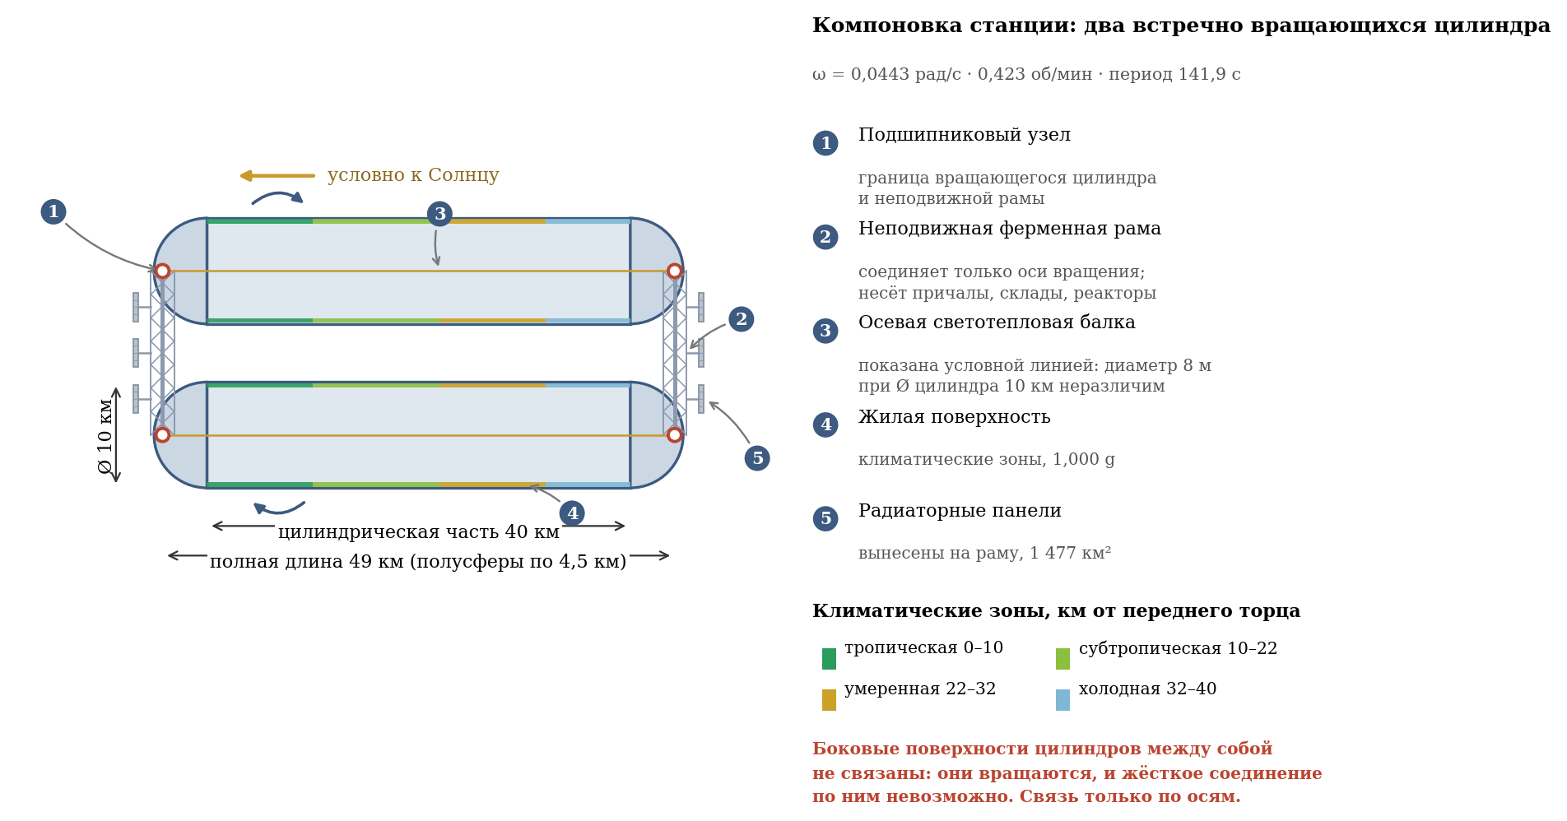
Figure 1 - general layout of the station: two counter-rotating cylinders
Cylinder connection
The cylinders are located parallel, the axle distance is 21 km. With a diameter of each cylinder of 10 km, there remains 11 km of free vacuum gap between the side shells. There are no tunnels, beams, cables, panels or other elements between the shells along the cylindrical parts. Each cylinder is connected to a fixed outer frame only through the front and rear axial units: axles and bearings.
Purpose of end hemispheres
- Front end: The outer fixed frame houses the docking modules, radiators and rotating solar wings. The “front” direction is a layout direction; The station's axis is not fixed to the Sun.
- The rear end, nominally connected and Earth-facing in this layout scene: the external fixed frame houses highly directional antennas, radiators, rotating solar wings and the station's own propulsion modules. The antennas and wings are aimed independently of the fixed body.

2. PHYSICAL PRINCIPLES AND DESIGN PARAMETERS

2.1. Artificial gravity
Artificial gravity is created by rotating the cylinder around its longitudinal axis. The magnitude of centripetal acceleration is determined by the formula:
a = ω² · R
where a is centripetal acceleration (m/s²); ω—angular velocity of rotation (rad/s); R is the radius of the cylinder (m).
Calculation for creating earth gravity (a = 9.81 m/s²):
Verification: the calculation was independently confirmed (ω = 0.04429 rad/s; 0.4230 rpm; T = 141.9 s). The rotation speed of 0.423 rpm is five times lower than the generally accepted comfort threshold of 2 rpm, which is one of the design's strongest points.
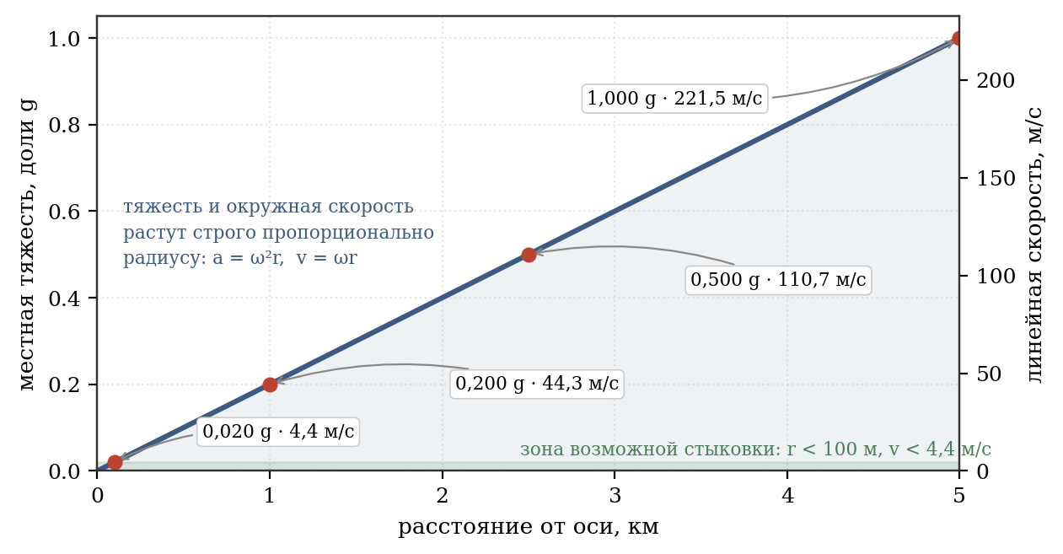
Figure 2 - gravity and peripheral speed depending on the radius

2.2. Gravity Gradient
An important characteristic is the change in the magnitude of gravity with height. For a person with height h = 2 m:
This gradient is physiologically invisible to the human vestibular apparatus.

2.3. Coriolis effect
When objects move inside a rotating reference frame, the Coriolis force arises:
Fc = 2m(ω × v)
For a pedestrian moving at a speed v = 1.5 m/s along the cylinder axis:
This acceleration is minimal and does not cause discomfort or disorientation. Verification confirms: 0.1329 m/s² = 0.0135 g.

2.4. Climatic zoning
The station's axis is fixed in inertial space and is not oriented towards the Sun. Internal lighting and light climate are provided by reactor axial light-thermal beams; heat is removed by separate radiator circuits on fixed components. There is no need to rotate the entire station to track the Sun.
Table 2.1 - Climatic zoning of the cylindrical part (length 40 km)
Zone | Distance | Temperature, °C | Humidity | Precipitation
Tropical | 0–10 km | +28 … +35 | 70–85 % | Heavy, frequent rains
Subtropical | 10–22 km | +15 … +28 | 60–70 % | Seasonal, moderate
Moderate | 22–32 km | 0 … +15 | 55–65 % | Moderate, snow in winter
Cold (arctic) | 32–40 km | –5 … –15 | 40–50 % | Snow, frost, rare
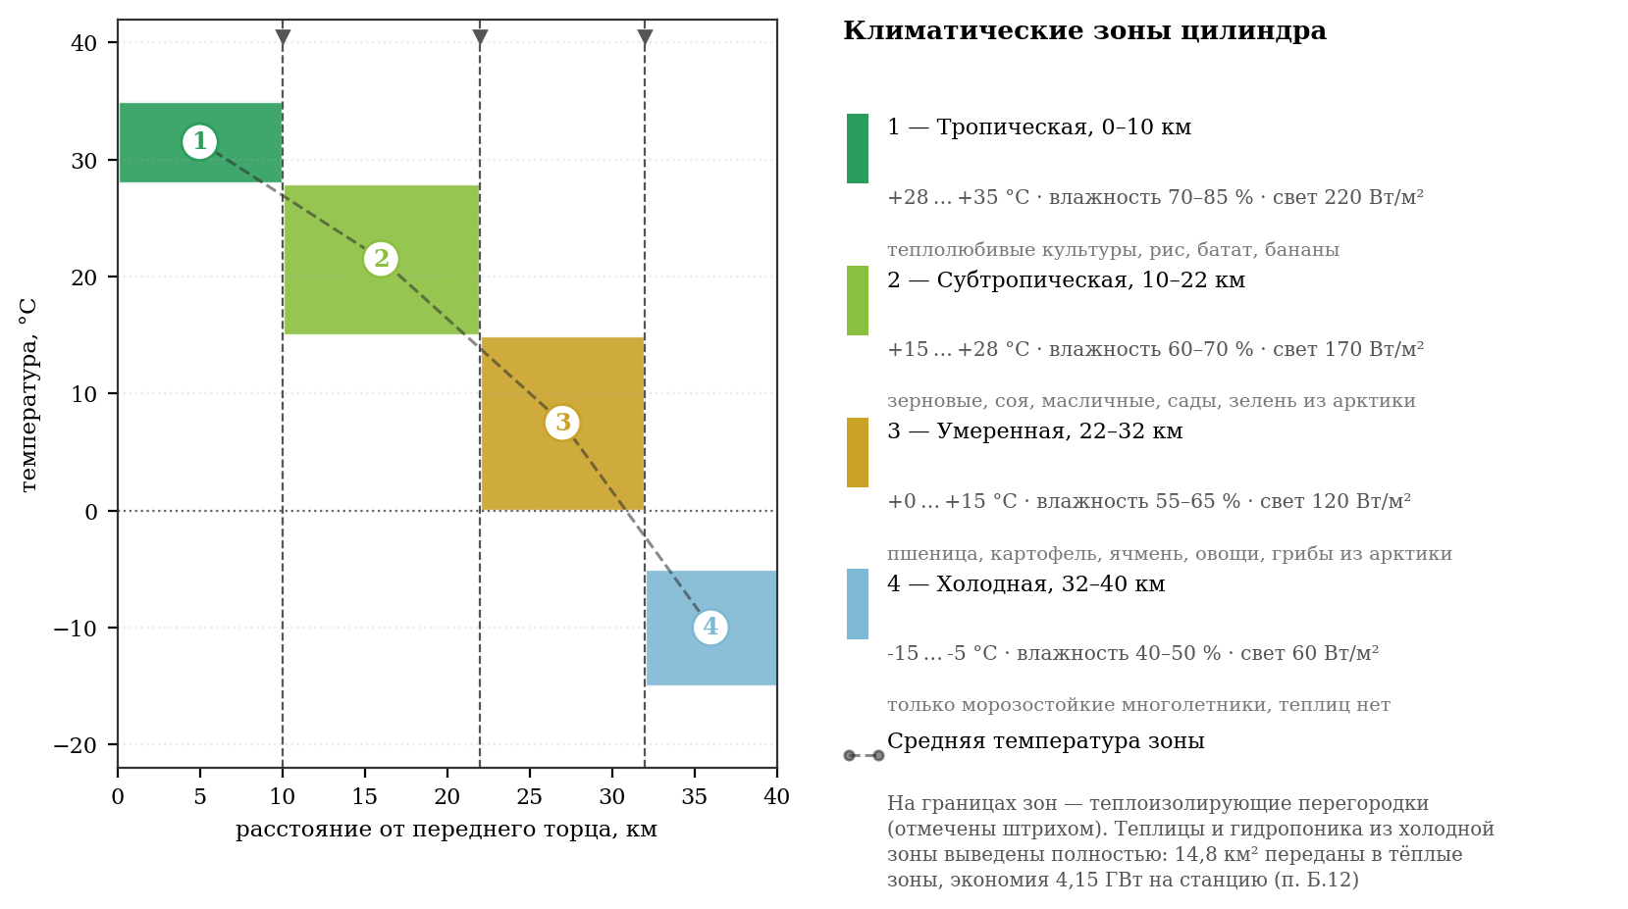
Figure 3 - climatic zoning along the length of the cylinder
The end hemispheres are technical areas and have separate climate control systems:
- Forward hemisphere (control center): +20…+22 °C, humidity ~50%.
- Rear hemisphere (warehouses, industry, parking and maintenance of equipment): from +5 to +15 °C depending on technological needs, humidity 40–60%.

2.5. Ecosystem and selection forms of inhabitants
The ecosystem is designed to be completely manageable and safe for humans. All animals lack horns and predatory tendencies; they are either herbivores or omnivores (but do not hunt other vertebrates). Each species provides useful products to humans.
Important note about the cold (arctic) zone: due to negative temperatures, open ground is used only for growing perennial frost-resistant crops (moss moss, lingonberries, blueberries, cranberries, cloudberries, mosses). Heat-loving vegetables, herbs and mushrooms are not grown in the cold zone: they are placed in the tropical and subtropical zones, where the reactor axial beams provide sufficient light flux, and the climate system maintains the required heat (justification - Appendix B, paragraph B.12). Heated greenhouses and hydroponic installations are not provided in the cold zone. Vegetables, herbs and medicinal herbs are located in the subtropical zone, mushrooms - in the temperate zone (clause B.12). Experimental plantings and seed material are also placed in warm zones. Animals are kept in insulated, heated rooms.

3. BIODIVERSITY AND ZONAL DISTRIBUTION OF BIOCENOSES
Below are tables of zonal biodiversity for one cylinder. The second cylinder contains an identical ecosystem. For each species, the Russian and Latin names, number/area and application are indicated.

3.1. Tropical zone (0–10 km)
Category | View (Russian / Lat.) | Number / Area | Application
Vegetables | Sweet potato - Ipomoea batatas | 8 km² | Food crops
 | Tarot – Colocasia esculenta | 8 km²
 | Cucumber – Cucumis sativus | 8 km²
 | Capsicum annuum | 8 km²
 | Eggplant – Solanum melongena | 9 km²
 | Tomato – Solanum lycopersicum | 9 km²
Fruits | Banana of paradise - Musa paradisiaca | 6 km² | Fruits, juices, vitamins
 | Pineapple - Ananas comosus | 6 km²
 | Mango - Mangifera indica | 6 km²
 | Papaya - Carica papaya | 6 km²
 | Passion fruit - Passiflora edulis | 5 km²
 | Guava - Psidium guajava | 5 km²
 | Rambutan - Nephelium lappaceum | 6 km²
Cereals and starches | Rice - Oryza sativa | 120 km² (120,000 t/year) | Basic food, flour
 | Sweet corn - Zea mays | 150 km² (180,000 t/year) | Staple food, starch
 | Edible cassava - Manihot esculenta | 15 km² | Food crops
 | Yam - Dioscorea spp. | 15 km²
Legumes | Soybean – Glycine max | 10 km² | Protein, oil
 | Fire bean - Phaseolus coccineus | 8 km²
 | Peanut - Arachis hypogaea | 7 km²
Spices and drinks | Arabian coffee - Coffea arabica | 1.5 km² | Drinks
 | Cocoa - Theobroma cacao | 1.5 km² | Drinks, chocolate
 | Vanilla - Vanilla planifolia | 1 km² | Seasoning
 | Ginger – Zingiber officinale | 1 km² | Seasoning, tea
 | Turmeric - Curcuma longa | 1 km² | Seasoning
 | Cinnamon - Cinnamomum verum | 1.5 km²
Medicinal plants | Aloe vera | As part of vegetable areas | Wound healing
 | Schisandra chinensis - Schisandra chinensis | As part of vegetable areas | Toning
 | Kalanchoe - Kalanchoe pinnata | As part of vegetable areas | Wound healing
 | Stevia - Stevia rebaudiana | As part of vegetable areas | Sweetener
 | Gotu kola - Centella asiatica | As part of vegetable areas | Toning
Mushrooms | Two-spore champignon - Agaricus bisporus | 4 km² | Edible mushrooms
 | Pink oyster mushroom - Pleurotus djamor | 2 km²
 | Umbrella mushroom - Macrolepiota procera | 2 km²
Algae (phytoplankton) | Spirulina - Arthrospira platensis | Bioreactors (5,000 t/year) | Protein, vitamins, food
 | Chlorella - Chlorella vulgaris | Bioreactors (5,000 t/year) | Protein, detoxification
 | Phytoplankton - Phaeodactylum tricornutum | Tilapia pools (5,000 t/year) | Fish food
Fish | Tilapia (food) - Oreochromis niloticus | 5,000 t/year | Meat, fat
 | Tambaki (food) - Colossoma macropomum | 3,000 t/year
 | Plecostomus (tech.) - Hypostomus plecostomus | 5,000 heads | Cleaning pool walls
 | Ancistrus (tech.) - Ancistrus dolichopterus | 10,000 heads | Equipment cleaning
 | Otocinclus (tech.) - Otocinclus affinis | 15,000 heads | Cleaning plants
 | Siamese algae eater (tech.) - Crossocheilus oblongus | 10,000 heads | Cleaning filamentous algae
Animals | Domestic duck - Anas platyrhynchos | 20,000 heads | Eggs, meat, feather
 | Silkworm - Bombyx mori | 500,000 individuals | Silk, fertilizer
Beneficial bacteria | Nitrogen fixers - Rhizobium spp., Azotobacter spp. | In the soil of all zones | Nitrogen fixation
 | Phosphate mobilizers - Bacillus megaterium | In the soil of all zones | Phosphate dissolution
 | Mycorrhizal fungi - Glomus spp. | In the soil of the root zone | Symbiosis with roots
 | Compost - Bacillus subtilis, Streptomyces spp. | In composting plants | Organic decomposition
 | Lactic acid - Lactobacillus spp. | In fermentation plants | Silage, fermented milk
 | Yeast - Saccharomyces cerevisiae | In bakeries | Bakery

3.2. Subtropical zone (10–22 km)
Category | View (Russian / Lat.) | Number / Area | Application
Vegetables | Tomato – Solanum lycopersicum | 10 km² | Fresh and canned
 | Cucumber – Cucumis sativus | 8 km²
 | Zucchini – Cucurbita pepo | 8 km²
 | Artichoke – Cynara cardunculus | 5 km²
 | Asparagus - Asparagus officinalis | 5 km²
 | Onion - Allium cepa | 7 km²
 | Garlic – Allium sativum | 7 km²
Fruits | Orange - Citrus sinensis | 6 km² | Fruits, juices
 | Lemon - Citrus limon | 5 km²
 | Grapefruit - Citrus paradisi | 5 km²
 | Grapevine - Vitis vinifera | 6 km² | Fruit
 | Fig - Ficus carica | 5 km² | Fruits, dried
 | Pomegranate – Punica granatum | 5 km² | Fruits, juices
 | Persimmon – Diospyros kaki | 5 km² | Fruit
Cereals and legumes | Soft wheat - Triticum aestivum | 50 km² (50,000 t/year) | Flour, cereals
 | Barley - Hordeum vulgare | 20 km² (20,000 t/year) | Cereals
 | Chickpea - Cicer arietinum | 10 km² | Protein, cereals
 | Lentils - Lens culinaris | 8 km²
Oilseeds | European olive - Olea europaea | 10 km² | Oil
 | Sunflower - Helianthus annuus | 13.3 km² | Oil, seeds
 | Sesame – Sesamum indicum | 10 km² | Oil, seasoning
Spices | Basil - Ocimum basilicum | 2 km² | Seasoning
Greens (transferred from the cold zone, item B.12) | Leaf lettuce – Lactuca sativa | 2 km² | Fresh herbs
 | Spinach - Spinacia oleracea | 1.5 km² | Fresh herbs
 | Radish - Raphanus sativus | 1 km² | Root vegetable
 | Parsley - Petroselinum crispum | 1 km² | Seasoning
 | Dill - Anethum graveolens | 1 km² | Seasoning
 | Onion on a feather - Allium cepa | 1 km² | Green
 | Microgreens (mix) | 1.3 km² | Vitamins
 | Rhodiola rosea - Rhodiola rosea | Contains greens | Adaptogen
 | Leuzea - ​​Rhaponticum carthamoides | Contains greens | Adaptogen
 | St. John's wort - Hypericum perforatum | Contains greens | Calming
 | Rosemary - Rosmarinus officinalis | 2 km² | Seasoning, tea
 | Thyme - Thymus vulgaris | 2 km² | Seasoning
 | Mint - Mentha spp. | 2 km² | Tea, seasoning
 | Sage - Salvia officinalis | 2 km²
Medicinal plants | Calendula - Calendula officinalis | Contains spices | Antiseptic
 | Chamomile - Matricaria chamomilla | Contains spices | Calming
 | Echinacea - Echinacea purpurea | Contains spices | Immunomodulator
 | St. John's wort - Hypericum perforatum | Contains spices | Calming
 | Hawthorn - Crataegus spp. | Contains spices | Heart
Mushrooms | Champignon - Agaricus bisporus | 3 km² | Edible mushrooms
 | Oyster mushroom - Pleurotus ostreatus | 2 km²
 | Autumn honey fungus - Armillaria mellea | 1 km²
Algae (phytoplankton) | Spirulina - Arthrospira platensis | Bioreactors (3,000 t/year) | Protein, vitamins
 | Chlorella - Chlorella vulgaris | Bioreactors (2,000 t/year) | Protein, detoxification
 | Phytoplankton - Phaeodactylum tricornutum | Silver carp pools (3,000 t/year) | Fish food, cleaning
Fish | Silver carp (food) - Hypophthalmichthys molitrix | 8,000 t/year | Meat, filtration
 | Otocinclus (tech.) - Otocinclus affinis | 8,000 heads | Algae cleaning
 | Siamese algae eater (tech.) - Crossocheilus oblongus | 5,000 heads
Animals | Alpaca – Vicugna pacos | 5,000 heads | Wool, meat
 | Domestic rabbit - Oryctolagus cuniculus | 50,000 heads | Meat, skins
 | Chicken - Gallus gallus | 100,000 heads | Meat, eggs
 | Japanese quail - Coturnix japonica | 200,000 heads
 | Honey bee - Apis mellifera | 2,000 families | Honey, pollination
Beneficial bacteria | Nitrogen fixers - Rhizobium spp. | In the soil of legumes | Nitrogen fixation
 | Compost - Bacillus subtilis | In composting plants | Organic decomposition
 | Lactic acid - Lactobacillus spp. | In fermentation plants | Silage, fermented milk

3.3. Temperate zone (22–32 km)
Category | View (Russian / Lat.) | Number / Area | Application
Vegetables | Potato - Solanum tuberosum | 100 km² (400,000 t/year) | Root vegetables, starch
 | Carrot - Daucus carota | 10 km²
 | Beetroot – Beta vulgaris | 8 km²
 | Onion - Allium cepa | 7 km² | Food grade, pen
 | White cabbage - Brassica oleracea | 8 km² | Food
 | Broccoli - Brassica oleracea var. italica | 5 km²
 | Cauliflower - Brassica oleracea var. botrytis | 5 km²
 | Lettuce – Lactuca sativa | 8 km² | Leafy vegetables
 | Spinach - Spinacia oleracea | 8 km²
 | Jerusalem artichoke - Helianthus tuberosus | 6 km² | Roots
Fruits / Berries | Homemade apple tree - Malus domestica | 8 km² | Fruits, jam
 | Pear - Pyrus communis | 6 km² | Fruit
 | Plum – Prunus domestica | 6 km² | Fruits, jam
 | Cherry - Prunus cerasus | 5 km²
 | Raspberry - Rubus idaeus | 5 km² | Berries
 | Black currant - Ribes nigrum | 4 km² | Berries, vitamin C
 | Gooseberry – Ribes uva-crispa | 3 km² | Berries
 | Garden strawberry – Fragaria × ananassa | 3 km²
Cereals and legumes | Rye - Secale cereale | 15 km² | Flour, cereals
 | Oats – Avena sativa | 10 km² | Cereals, flakes
 | Peas - Pisum sativum | 5 km² | Protein, cereals
 | Beans - Phaseolus vulgaris | 5 km²
Medicinal plants | Great plantain - Plantago major | As part of green spaces | Wound healing
 | Yarrow - Achillea millefolium | As part of green spaces
 | St. John's wort - Hypericum perforatum | As part of green spaces | Calming
 | Valerian - Valeriana officinalis | As part of green spaces
 | Motherwort - Leonurus cardiaca | As part of green spaces | Heart
 | Linden - Tilia cordata | As part of green spaces | Calming, tea
Mushrooms | White mushroom - Boletus edulis | 2 km² | Delicious mushrooms
 | Champignon - Agaricus bisporus (from the cold zone) | 2 km² | Food mushrooms, dark rooms
 | Oyster mushroom - Pleurotus ostreatus (from the cold zone) | 2 km² | Edible mushrooms
 | Winter honey fungus - Flammulina velutipes (from the cold zone) | 2 km² | Edible mushrooms
 | Boletus - Leccinum spp. | 1.5 km² | Edible mushrooms
 | Chanterelle - Cantharellus cibarius | 1.5 km² | Delicious mushrooms
 | Champignon - Agaricus bisporus | 1 km² | Edible mushrooms
Algae (phytoplankton) | Chlorella - Chlorella vulgaris | Bioreactors (3,000 t/year) | Protein, dietary supplements
 | Nori - Porphyra spp. | Bioreactors (2,000 t/year) | Sushi, soups
 | Phytoplankton - Phaeodactylum tricornutum | Silver carp pools (3,000 t/year) | Fish food, cleaning
Fish | Silver carp (food) - Hypophthalmichthys molitrix | 8,000 t/year | Meat, filtration
 | Otocinclus (tech.) - Otocinclus affinis | 5,000 heads | Algae cleaning
 | Siamese algae eater (tech.) - Crossocheilus oblongus | 3,000 heads
Animals | Domestic cow (hornless) - Bos taurus (polled) | 3,000 heads | Milk (18,000 t/year), meat
 | Domestic goat (hornless) – Capra hircus (polled) | 5,000 heads | Milk (4,500 t/year), meat, wool
 | Domestic pig - Sus scrofa f. domestica | 10,000 heads | Meat, lard
 | Domestic rabbit - Oryctolagus cuniculus | 50,000 heads | Meat, skins
 | Nutria - Myocastor coypus | 14,300 heads | Meat, fur
 | Goose - Anser anser | 10,000 heads | Meat, feather, eggs
 | Turkey - Meleagris gallopavo | 5,000 heads | Meat
 | Duck - Anas platyrhynchos | 20,000 heads | Meat, eggs, feather
 | Japanese quail - Coturnix japonica | 200,000 heads | Meat, eggs
Beneficial bacteria | Nitrogen fixers - Rhizobium spp. | In the soil of legumes | Nitrogen fixation
 | Phosphate mobilizers - Bacillus megaterium | In the soil of all zones | Phosphate dissolution
 | Compost - Bacillus subtilis | In composting plants | Organic decomposition
 | Lactic acid - Lactobacillus spp. | In fermentation plants | Silage, fermented milk
 | Yeast - Saccharomyces cerevisiae | In bakeries | Bakery

3.4. Cold (Arctic) zone (32–40 km)
Category | View (Russian / Lat.) | Number / Square | Application | Terms
Open ground plants | Moss moss – Cladonia rangiferina | 5 km² | Food, medicine | Open ground, −5…−15 °C
 | Lingonberry – Vaccinium vitis-idaea | 4 km² | Berries, fruit drinks | Winters under the snow
 | Blueberry - Vaccinium uliginosum | 3 km² | Berries, vitamins | Open ground
 | Cloudberry - Rubus chamaemorus | 3 km² | Berries, delicacy
 | Cranberry - Oxycoccus palustris | 2 km² | Berries, fruit drinks
 | Shiksha - Empetrum nigrum | 2 km² | Berries, food
 | Mosses - Bryophyta | 1 km² | Food, shelter
Seaweed | Laminaria - Laminaria spp. | Swimming pools (5,000 t/year) | Iodine, alginates, protein | +4…+8 °C
 | Nori - Porphyra spp. | Swimming pools (5,000 t/year) | Sushi, soups
 | Chlorella - Chlorella vulgaris | Bioreactors (3,000 t/year) | Protein, dietary supplements | +4…+8 °C
 | Phytoplankton - Nannochloropsis spp. | Whitefish pools (5,000 t/year) | Feed, water purification | +4…+8 °C
Fish | Whitefish (food) - Coregonus spp. | 4,000 t/year | Meat, caviar | +4…+8 °C, food: phytoplankton
Animals (room heating) | Alpaca (cold-resistant) - Vicugna pacos | 5,000 heads | Fluff, wool, meat | Enclosures +5…+10 °C
 | Angora rabbit - O. cuniculus f. angorensis | 20,000 heads | Fluff, meat
 | Nutria - Myocastor coypus | 14,300 heads | Fur, meat
 | Ptarmigan - Lagopus lagopus | 5,000 heads | Meat, eggs
 | Gray goose – Anser anser | 10,000 heads | Meat, feather, eggs
 | Duck (cold-hardy) – Anas platyrhynchos | 20,000 heads
Beneficial bacteria | Nitrogen fixers - Rhizobium spp. | In the ground | Nitrogen fixation | Natural environment
 | Compost - B. subtilis, Streptomyces spp. | In installations | Organic decomposition | Composters
 | Lactic acid - Lactobacillus spp. | In installations | Silage, fermented milk | Fermenters

4. ENGINEERING AND DESIGN SOLUTIONS

4.1. Atmosphere: composition, pressure and radial distribution
The pressure in all habitable volumes is maintained by exactly 1 Earth atmosphere (101.325 kPa) at the level of the internal surface. Composition: 78% N₂, 21% O₂, ~1% Ar, CO₂ - 350–400 ppm.
Total internal volume of one cylinder:
- Cylinder volume: V = π R² L = π 25 40 = 1000π ≈ 3,141.6 km³
- Total volume: Vtotal ≈ 3,612.8 km³
The calculation of the mass of the atmosphere was carried out taking into account the fact that in a rotating cylinder the gas density decreases from the wall to the axis according to the barometric law in a rotating reference frame:
where M = 0.02896 kg/mol is the molar mass of air; Rg = 8.314 J/(mol K); T = 293.15 K.
The axle/wall density ratio is 0.747, meaning the axle pressure is 74.7 kPa—the same as at about 2,300 m above sea level on Earth. Integration over volume gives the mass of the atmosphere for one cylinder 3.77 billion tons. For two cylinders - 7.55 billion tons.
Design consequences of reduced axle pressure:
- The radial pressure gradient reduces the average mass of atmospheric volatiles relative to a homogeneous model; the exact supply of the substance is specified by the material balance of the station.
- Maintenance of the axial light-thermal beam is carried out in a rarefied atmosphere equivalent to mountainous terrain. For long-term work, oxygen support is provided.
- Flights inside the cylinder at low altitudes above the surface take place at normal pressure; the paraxial zone requires sealed devices.
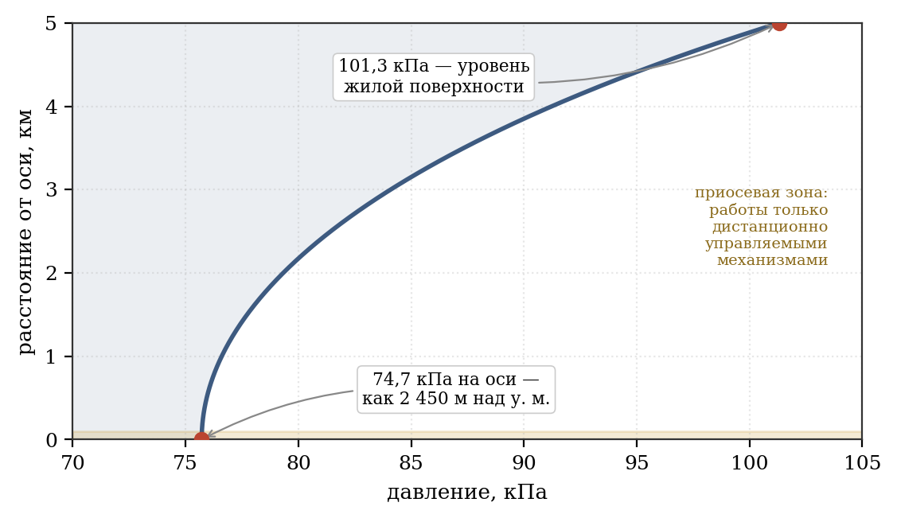
Figure 4 - radial pressure profile in a rotating atmosphere

4.2. Strength of load-bearing steel shell
The power structure of the station is made of steel. This section specifies under what conditions such execution is feasible.
Hoop stress in a rotating cylindrical shell:
where q is the distributed load on the inner surface; R—radius; t is the thickness of the force layer; ρ is the density of the material; g is the acceleration created.
The second term describes the load from the shell’s own weight and does not depend on the thickness: as the wall thickens, its weight increases proportionally, and the thickness in the formula decreases. For steel (ρ = 7,850 kg/m³) at R = 5,000 m and 1 g, this stress is 385 MPa. This value cannot be eliminated: it is present even in a shell that does not carry any payload, and cannot be reduced by structural means for a given radius and gravity.
This implies the criterion for the applicability of the steel grade: its tensile strength, divided by the safety factor, must exceed 385 MPa with sufficient remainder to accommodate the payload.
Table 4.1 - Applicability of steel grades at R = 5,000 m, 1 g, safety factor 1.5
Steel grade | Tensile strength, MPa | Allowable σ, MPa | Remaining load, MPa | Applicability
St3, structural general purpose | 400 | 267 | −118 | Unsuitable
09G2S, low alloy | 500 | 333 | −52 | Unsuitable
30KhGSA, high-strength alloyed | 1 100 | 733 | 348 | Suitable, belt 2.2 m
18Ni(250), maraging | 1 700 | 1 133 | 748 | Suitable, belt 1.03 m
18Ni(300), maraging | 2 000 | 1 333 | 948 | Accepted, belt 0.85 m
18Ni(350), maraging | 2 400 | 1 600 | 1 215 | Suitable, belt 0.63 m
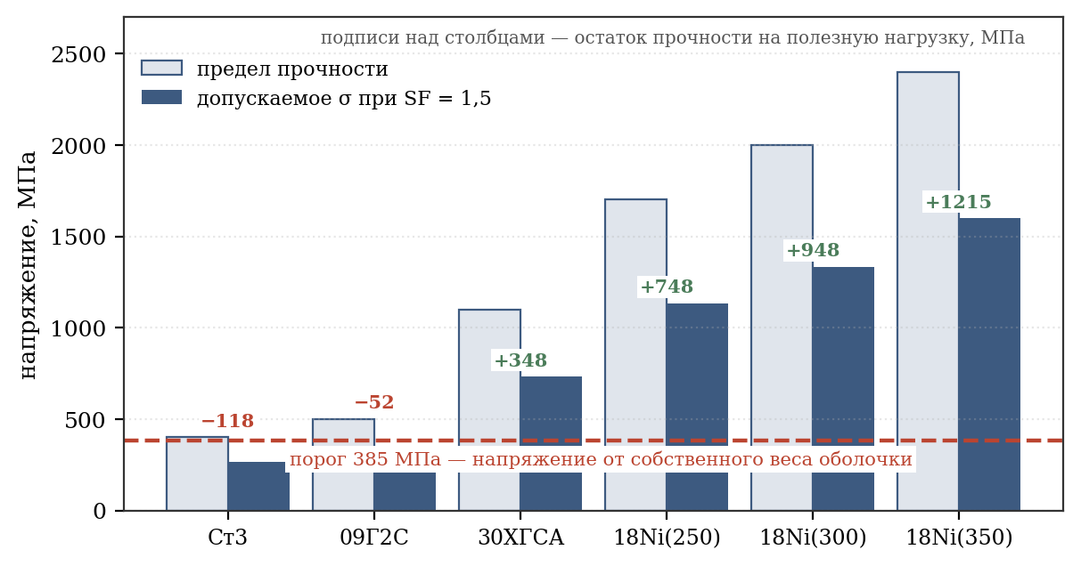
Figure 5 - applicability of steel grades at R = 5,000 m and 1 g
The fundamental conclusion is that ordinary structural steel used in above-ground construction is unsuitable for the load-bearing shell of the station - it spends its entire strength resource on supporting its own weight. Increasing the thickness of the shell does not in itself improve the power circuit. High-strength steels of special classes are required, primarily maraging steels.
Load calculation
Load Component | Value, kPa
Atmospheric pressure from inside | 101,3
Soil, average thickness 1.5 m, density 1,900 kg/m³ | 28,0
Radiation protection, regolith 1.0 m | 14,7
Water: reservoirs, soil moisture, circulating | 3,7
Development and infrastructure, 500 kg/m² | 4,9
Total external load qext (without dead weight) | 152,6
Containment and thermal insulation, dead weight | 4,3
Power belt, body weight | 65,4
Design load qtotal for σ = qR/t | 222,4
The average soil thickness is assumed to be 1.5 m. Each meter of soil adds 18.6 kPa of load and, therefore, requires thickening of the force belt. A thickness of 1.5 m is sufficient for the root system of grain, vegetable and berry crops; Under fruit trees, local recesses of up to 3 m are provided in a limited area, which do not affect the average load.
Determining the thickness of the power belt
T = 0.85 m is accepted, rounded up. Examination:
At a tensile strength of 2,000 MPa, the actual safety factor is 1.53. The share of its own weight in the total stress is 30%.
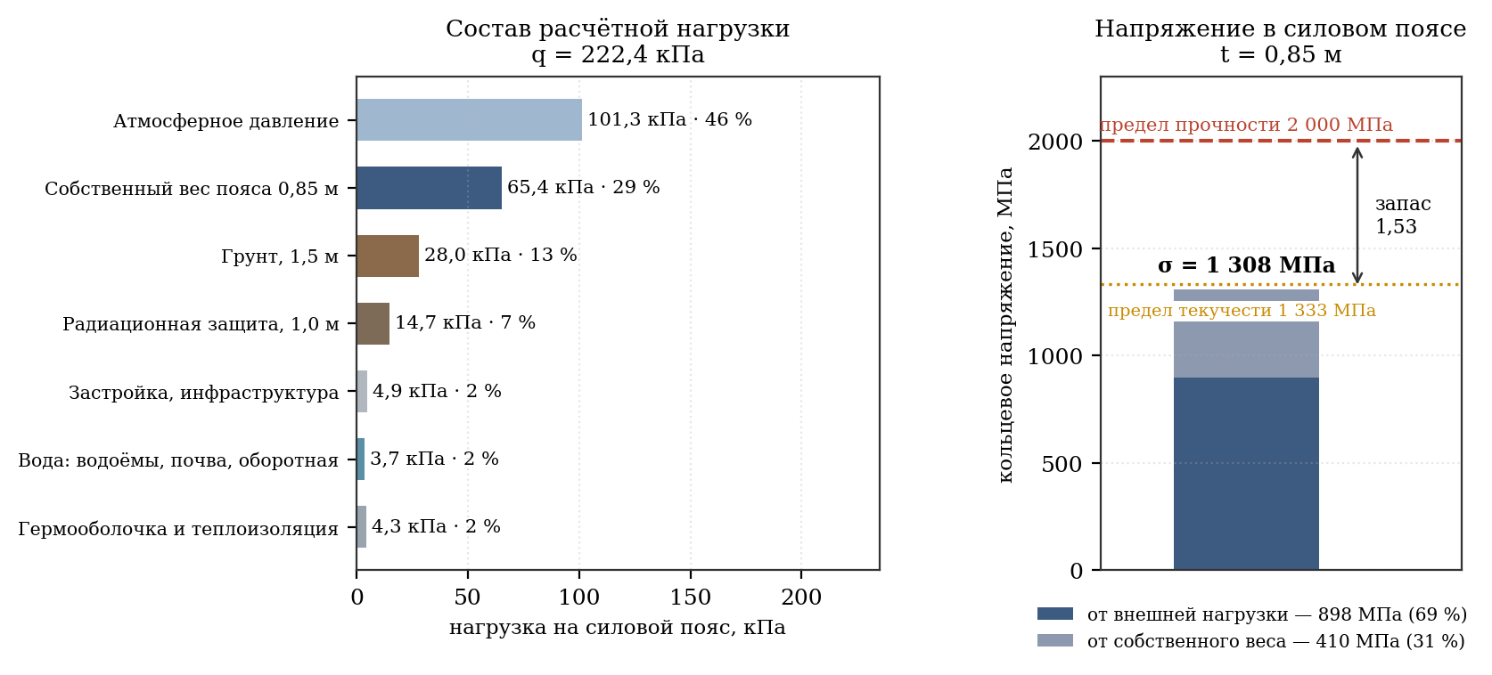
Figure 6 - Shell load and hoop stress structure
Maraging steel and asteroid raw materials
The choice of maraging steel grade 18Ni(300) is not only due to strength. Its chemical composition unexpectedly agrees well with the raw material base of the project.
Element | Share in steel 18Ni(300) | Presence on asteroid (6178) 1986 DA
Iron | base, about 66% | M-type base metal, in excess
Nickel | 18 % | 5–15% in iron asteroids, enrichment required
Cobalt | 9 % | 1986 DA has a higher cobalt content
Molybdenum | 5 % | Trace amounts, scarce
Titanium | 0,7 % | Present in the silicate fraction
Asteroid (6178) 1986 DA belongs to the metallic M-type and, according to spectral data, is an iron-nickel body with a high content of cobalt and platinum group metals. In other words, four of the five alloying components of the required steel are naturally present in the raw material, with nickel and cobalt in precisely those elements that are considered scarce and expensive on Earth.
This is a significant advantage of the steel version over the composite one: the station is built from the substance that is mined locally, without organizing the production of a fundamentally different class of materials. The metallurgical processing of iron-nickel raw materials into maraging steel is technologically simpler than the synthesis of a polymer binder and fiber drawing under orbital production conditions.
Molybdenum remains in short supply: the need is 1.07 billion tons with trace amounts of it in asteroid matter. Alloy replacement, content reduction without loss of resource, and separate supply from an external source are considered.
- Transition to molybdenum-free high-strength steels - bainite (limit 1,800 MPa, zone 0.94 m) or silicon spring classes. The thickness of the belt increases by 10–15%.
- Extraction of molybdenum as a by-product during the processing of the platinum-bearing fraction 1986 DA, where it accompanies platinum group metals.
- Delivery of molybdenum as the only imported component: 1.07 billion tons is 5% of the mass of steel, which is incomparably less than the delivery of finished structures.
Table 4.2 - Composition of the structural cladding package
Layer (from inside to outside) | Thickness, m | Density, kg/m³ | Weight per cylinder, billion tons | Function
Containment, stainless steel | 0,05 | 7 850 | 0,608 | Sealing, corrosion resistance
Power belt, steel 18Ni(300) | 0,85 | 7 850 | 10,343 | Perception of hoop stress
Thermal insulation, communications, ribs | 0,10 | 500 | 0,078 | Thermal isolation, cables, pipelines
Radiation protection, regolith + borosilicate | 1,00 | 1 500 | 2,325 | Protection from gypsum plasterboards and SKLs
TOTAL package | 2,00 | — | 13,354 | —
Strength set: frames and stringers (clause B.14) | — | 7 850 | 0,070 | Mounting base, local stability
TOTAL package with set | 2,00 | — | 13,426 | —
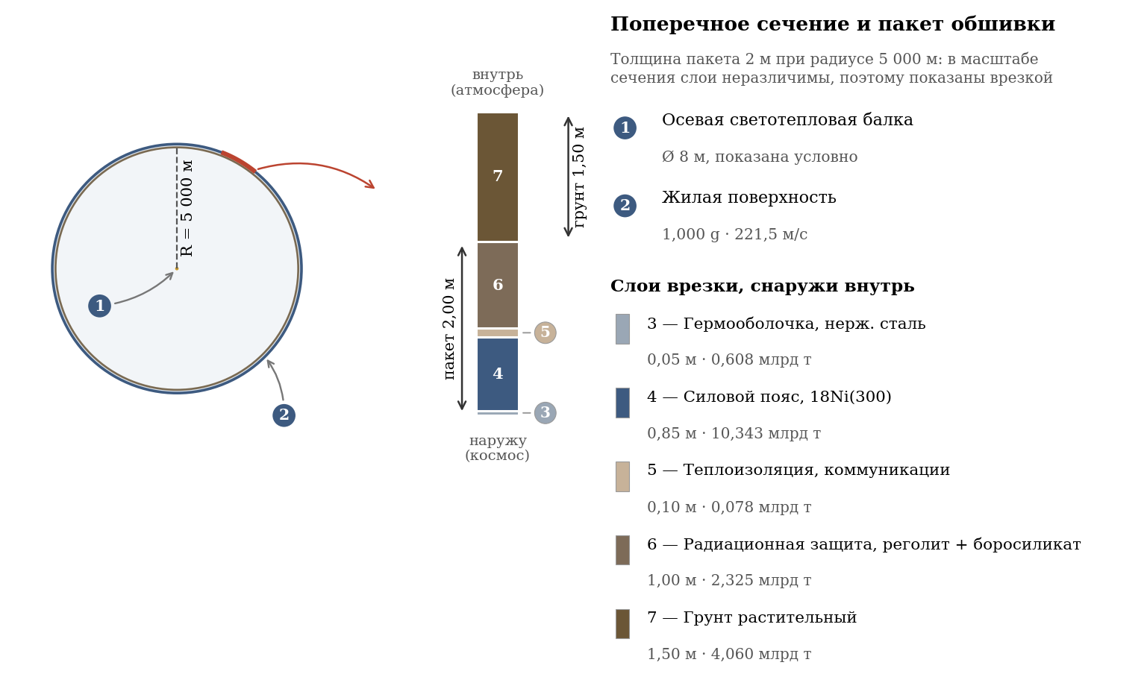
Figure 7 - cross-section of the shell and composition of the structural package
The total thickness of the structural package is 2.0 m; its composition and steel grade of the load-bearing layer are determined in Table 4.2.
Notes on the use of steel shell
- Fatigue strength. The shell operates at a constant high stress of 1,308 MPa. Maraging steels have a high endurance limit, but a service life of centuries requires calculation for low-cycle fatigue from temperature cycles and maneuvers. Recommended for study.
- Radiation embrittlement. Steel under neutron and proton irradiation loses its ductility. Placing regolith protection outside the force belt (see Table 4.2) shields it from cosmic radiation - this is one of the reasons for this particular order of layers.
- Maintainability. A significant advantage of steel over composites: the steel shell can be welded and surfaced under plant conditions, whereas repairing a composite belt would require factory conditions. For a structure with a service life of centuries, this is a determining operational consideration.

4.3. Station mass balance
Component | One cylinder, billion tons | Two cylinders, billion tons
Structural cladding package | 13,43 | 26,85
Internal soil | 4,06 | 8,13
Water (reservoirs, soil, recycling; clause B.13) | 0,59 | 1,17
Atmosphere (taking into account rotational gradient) | 3,77 | 7,55
Total by cylinders | 21,85 | 43,70
Truss frame along the axes, bearing units, reactors, radiators and equipment on them (details - Table 4.11) | — | 3,00
TOTAL STATION | — | 46,70
The total mass of the station is 46.70 billion tons. The structural package with the power set is 26.85 billion tons, steel with the set is 22.05 billion tons. The consolidated balance provides a reserve of 3.00 billion tons for frames, components, reactors, radiators and external equipment; Table 4.11 statement details 0.0447 billion tons of this reserve and is not added again.
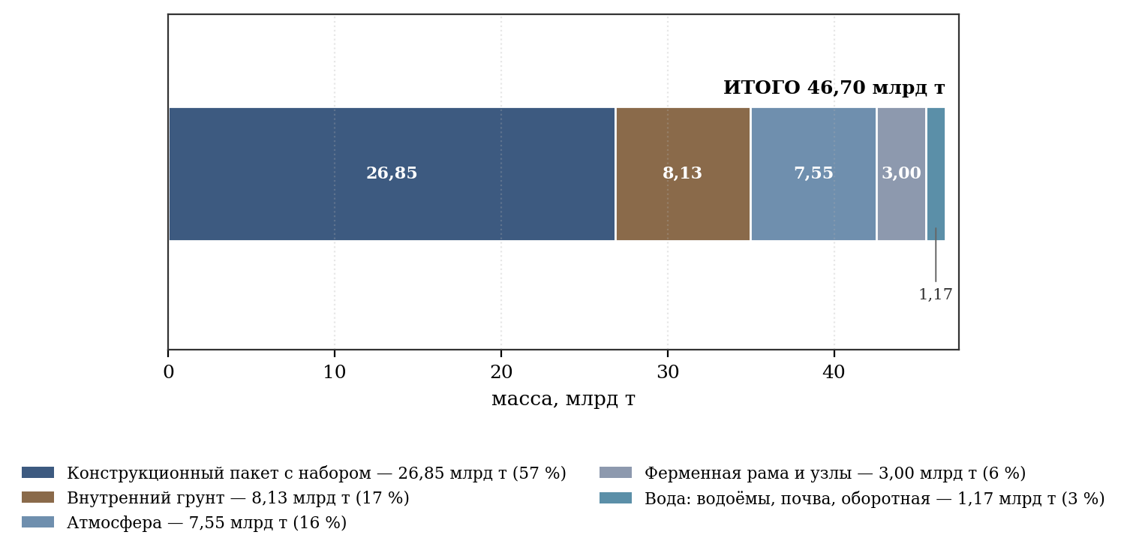
Figure 8 - station mass balance (two cylinders)

4.4. Heat balance and thermoregulation system
The thermal balance of the plant includes a low-temperature circuit of 677 GW and a high-temperature circuit of 882 GW reactors. At a radiator temperature of 60 °C and an emissivity of 0.95, the low-temperature circuit requires 1,022 km²; the available area of ​​1,477 km² gives a reserve of 1.45.
Radiation flux density (Stefan-Boltzmann law, ε = 0.95):
Radiator temperature | Flux density, W/m² | Discharge area 677 GW, km²
25 °C | 425 | 1 594
40 °C | 517 | 1 309
60 °C | 662 | 1 022
80 °C | 836 | 809
The decision made is a combination of three measures:
- The temperature of the low temperature heatsink has been raised from 25°C to 60°C. The difference between the internal circuit (25 °C) and the radiator is provided by heat pumps with a conversion factor of COP = 6; their consumption of 96 GW is taken into account in the energy balance.
- The available radiator area is 1,477 km²; panels are placed only on the front and rear fixed truss frames and on four stationary units. The outer side lining of the cylinders remains smooth and free of equipment.
- The luminous flux of the axial beam is taken at a physiologically and agronomically sufficient level (see clause 4.12.4), which provides the required lighting with an agreed energy balance.
Table 4.3 - Heat sink areas
Surface | Area, km² | Note
Front fixed frame radiator panels | 220 | Fixed frame only; side trim free
Rear fixed frame radiator panels | 157 | Fixed frame only; side trim free
Truss frame and standard assembly panels | 100 | Fixed frame only; side trim free
Deployable radiator panels on 4 nodes | 700 | Fixed frame only; side trim free
Redundant radiator panels on fixed frames | 300 | Fixed frame only; side trim free
TOTAL | 1 477 | Required 1,022 km², margin 1.45
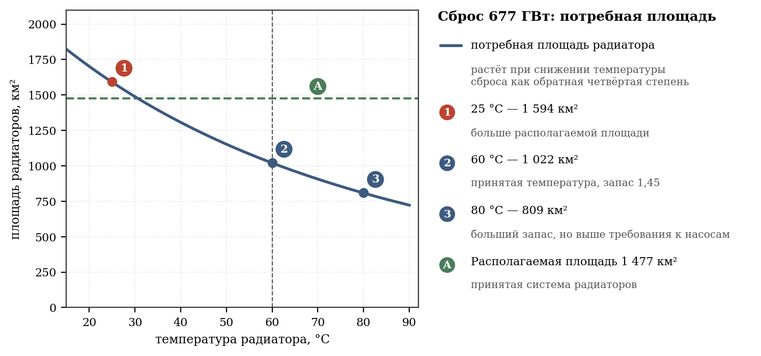
Figure 9 - required heat sink area depending on the radiator temperature
The high temperature circuit of the reactors at 800 °C removes 882 GW of waste heat at a flux density of 71.4 kW/m²; it requires about 12.4 km². Reactor radiators, like low-temperature panels, are placed only on fixed external frames, and not on the cylinder shells.
The thermal load of the low temperature circuit is 677 GW, which requires 1,022 km² at 60 °C. With an available area of ​​1,477 km², the reserve is 1.45 times. The high temperature reactor circuit is considered separately: 882 GW at 800 °C requires about 12.4 km².
Thermal control means inside the cylinders include:
- Liquid metal coolant (sodium-potassium alloy) in zonal circuits.
- Thermal insulating partitions at the boundaries of climatic zones (10, 22, 32 km).
- Pumping excess heat from the tropical zone to the cold zone, which simultaneously reduces the load on radiators and reduces energy consumption for heating the Arctic sector.

4.5. Radiation protection
Radiation protection is part of the structural package (Table 4.2) and is a layer of regolith with borosilicate glass 1.0 m thick, placed outside the power belt. With a density of 1,500 kg/m³, the surface density of the protection is 1,500 kg/m², which corresponds to the galactic cosmic ray suppression standard generally accepted for orbital settlements.
The steel shell itself makes an additional contribution to protection: the 0.85 m thick load-bearing belt gives a surface density of 6,673 kg/m². The total protection of the structure is approximately 8,200 kg/m², which is more than four times the equivalent of the Earth's atmosphere (1,030 kg/m²). In this regard, the all-metal design has a significant advantage: the radiation situation inside the station turns out to be more favorable than on Earth, and the massive steel wall at the same time serves as protection against micrometeorites.
The placement of the regolith layer outside the load-bearing belt is important: it shields the steel from radiation embrittlement, extending the life of the supporting structure.

4.6. Station location (L1 Earth-Sun Lagrange point)
The first Lagrange point L1 of the Earth-Sun system was chosen as the final location for the permanent location of the station. L1 is unstable, so the station uses a permanent hold setting; its design and resource support are given in clause 11.5.
Table 4.13 - Advantages of placement at the L1 point Earth - Sun
Advantage | Description
Access to solar energy for auxiliary systems | There are practically no eclipses in L1; rotating solar wings on fixed nodes use solar flux. Axial light-thermal beams are powered by reactors. Holding - 63.4 GW, 8.79% of plant capacity.
Reliable connection with the Earth | Line of sight, delay 5.0 s in one direction and about 10.0 s in a round-trip exchange.
Transport accessibility | The distance of 1.5 million km is covered in a few days; this is a logistical advantage, not a resource-based reason for choice.
Stable lighting conditions | The station does not enter the Earth's shadow; internal light and thermal conditions are set by the reactors, and the solar wings are induced independently.
Radiation situation | Position outside the earth's magnetosphere: there are no passages of radiation belts and associated cyclic loads on protection. The situation is homogeneous and predictable, which makes it possible to design protection for a constant flow (clause 4.3).
To keep the station in L1, regolith is adopted as the working body of the mass driver/ion installation. At an outflow speed of 30 km/s, the flow rate is about 8,524 tons per day; Xenon is unacceptable for such consumption, so available asteroid raw materials are used.

4.7. Docking of spacecraft and transition to a rotating surface
The rotation of the station creates an obvious difficulty for mooring: the linear speed of the point on the habitable surface is 221.5 m/s, that is, 797 km/h. Direct docking with a rotating shell is not possible. All normal docking operations are performed on the front of the fixed outer frame at zero relative speed; the equipment is not attached to the cylinder shell.
- Docking of the ship with the station is performed on a stationary frame at zero relative speed.
- The transition of a person or load from an axle to a rotating surface is a separate transport problem solved by the station’s internal means.

4.7.1. Speed ​​distribution within a station
The linear speed of a point is proportional to the distance from the axis of rotation, so there is practically no movement near the axis.
Table 4.8 - Velocities and accelerations along the radius
Distance from axis | Linear speed | Acceleration | Characteristic
5,000 m (living surface) | 221.5 m/s (797 km/h) | 1,000 g | Docking is not possible
2,500 m | 110.7 m/s (399 km/h) | 0,500 g | Docking is not possible
1,000 m | 44.3 m/s (159 km/h) | 0,200 g | Docking is not possible
100 m | 4.4 m/s (16 km/h) | 0,020 g | Technically possible
10 m (mooring ring) | 0.44 m/s (1.6 km/h) | 0,002 g | Pedestrian speed
0 m (axis) | 0 | 0 | Complete immobility
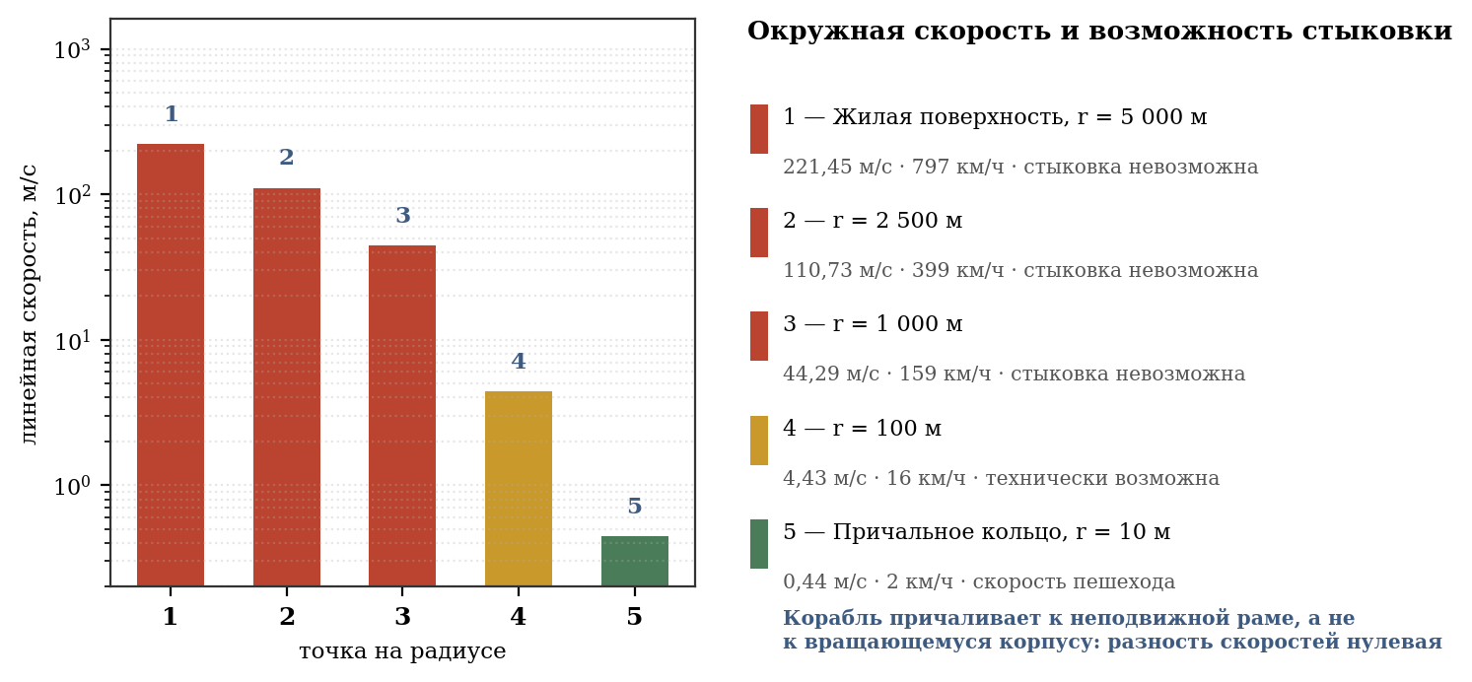
Figure 10 - peripheral speed and docking capability

4.7.2. Standard layout: berth on a fixed frame
According to the design, each cylinder rests on two external fixed frame units - front and rear - through an axial journal and a bearing housing. The front frame of each cylinder is separate: it does not form a longitudinal bridge between the cylinders, and the space between the side shells along the cylindrical parts remains empty. The front frame houses the docking modules; From each module to the quarantine circuit there is its own sealed channel. These input channels do not connect to each other before quarantine.
This leads to the main conclusion of this section: mooring devices are placed on a fixed truss frame, and the relative speed during docking is zero. Station rotation is not involved in the berthing operation. The complexity of such a docking does not exceed docking with a conventional non-rotating orbital station and is carried out by standard means of rendezvous and mooring.
Composition of the mooring complex:
- Mooring units on the front part of the fixed frame, in front of the front ends of the cylinders; it is the main entrance for ships, cargo and passengers.
- Cargo terminals with overload mechanisms are located on the front frame and do not transfer the load to the rotating shell.
- The passenger airlocks of the front fixed frame go into separate sealed channels of the quarantine circuit. After quarantine, the four input streams do not continue with four lines through the axis: they are collected into one common clean channel in a separate sealed distribution chamber. This one channel passes through the stationary chamber of the front bearing housing and enters the hollow axle through a coaxial rotating sealed junction (sealed joint). The axle is welded to the cylinder; The bearing rotor, axle and cylinder rotate as a single unit, while the bearing housing and stator remain on a stationary frame. In the anterior hemisphere, the common channel again enters the distribution chamber and is divided into four separate channels: A↑, A↓, B↑ and B↓. There are no inter-cylinder tunnels.
- Reserve berths are also located on the front frame and are a duplication of the main complex. Corridors A and B mutually reserve each other; the rear frame is for antennas, radiators, solar wings and propulsion modules and is not a passenger entrance.

4.7.4. Bearing unit as an element of the transport system
There is no open opening or side channel running through the front bearing assembly. After quarantine, the common clean transport path approaches the end of the axle strictly along the common axis of rotation. In a bearing assembly, a stationary housing and stator surround a rotating rotor and a hollow axle welded to it. At the end of the axis there is a coaxial rotary sealed airlock. One common channel with a clear diameter of 8.0 m passes through the axle cavity; division into A↑, A↓, B↑ and B↓ occurs only after entering the anterior hemisphere.
The support unit is designed as an active magnetic radial-axial bearing with mechanical emergency catches. Each of the four end nodes houses two independent magnetic circuits, position sensors and cooled power modules. The average diameter of the active ring is 400 m, the axial active width is 3.0 m. The stator and power electronics are mounted on a fixed frame; The bearing rotor, axle journal, hollow axle and cylinder are connected into one rotating unit. The bearing is not a transport pipe: it supports the axle, and the transport path passes inside its cavity. Catchers are an emergency support, not a standard one.
The determining factor is the size of the ring. It is set not by the weight of the cylinder (there is no weight in zero gravity), but by the axial thrust during acceleration maneuvers, amounting to up to 10¹⁰ N (section 4.10):
Support ring diameter | Support area (width 3 m) | Contact pressure
50 m | 471 m² | 21.2 MPa
100 m | 942 m² | 10.6 MPa
200 m | 1,885 m² | 5.3 MPa
400 m | 3,770 m² | 2.7 MPa
The diameter of the active support ring is preliminarily assumed to be 400 m with a width of 3 m. Two independent active belts each have a working width of 1.35 m and are separated by a service area of ​​about 0.30 m. The working radial gap is assumed to be 50 mm, the axial gap is assumed to be 30 mm before a separate dynamic calculation. With an axial thrust of 10¹⁰ N, the average design pressure of the ring is about 2.65 MPa. The ring is located inside the fixed end housing and is not an outer edge of the cylinder.
Sealing of the rotating joint between the fixed frame and the end of the hollow axle is ensured by a three-circuit system. The main barrier is a segmented rotating mechanical seal around the rotor end of the axle; control barrier - a dry labyrinth with an evacuable inter-barrier cavity; technical barrier - auxiliary seals of actuators and sensors. The magnetic fluid seal is not the only barrier holding the cylinder atmosphere.
- Before quarantine, the four docking modules had four separate sealed channels and their own entrance doors. After quarantine, clean flows are alternately allowed into one common channel and one common axial route. In front of the end of the axis there is a fixed chamber F0, a controlled intermediate volume and a revolving door R0. After equalizing the pressure, the cabin is fixed in a receiving cart, mechanically connected to the hollow axle, and enters into one common rotating channel. Only in the anterior hemisphere the common path enters the distribution chamber and is divided into four separate lines A↑, A↓, B↑ and B↓. Only one border is opened at a time; As leakage increases, the doors on either side of the rotating barrier close automatically.
- The rotating receiving cart is not a separate rotary pier and is not separate from the axle. It is mounted on the rotor of a hollow axle and rotates at the same angular speed as the axle and cylinder. The cabin, after quarantine, enters a stationary transfer chamber, is fixed with guides and locks in the rotary cart, and then is smoothly brought to 0.423 rpm. After synchronization, the rotary door opens into the common axial channel. At the edge of the Ø7 m cabin, the peripheral speed is about 0.56 km/h; the speed of 797 km/h only applies to a residential surface with a radius of 5,000 m.
- The transport connection begins with four separate channels from the docking modules to the quarantine. After quarantine, the flows pass into one common sealed channel, which passes through the rotor joint and the hollow axis. In the anterior hemisphere, the common channel is divided into four separate lines A↑, A↓, B↑ and B↓. There are no inter-cylinder tunnels; each branch after the distribution chamber belongs only to its own cylinder. In the event of a malfunction, the area between the pressure doors is cut off, so the loss of one seal will not depressurize the cylinder.
The calculation shows that even with an unfavorable leakage estimate of 2,000 tons per year, the losses will amount to about one ten-millionth of the mass of the cylinder atmosphere (3.65 billion tons) - a value that is completely covered by standard replenishment.
Descent time | Maximum radial speed | Coriolis acceleration
5 minutes | 33.3 m/s | 2.95 m/s² (0.301 g) sideways
10 minutes | 16.7 m/s | 1.48 m/s² (0.150 g) sideways
15 minutes | 11.1 m/s | 0.98 m/s² (0.100 g) sideways
Distance from axis | Local severity | Apparent vertical deviation
5,000 m | 1,000 g | 8,6°
4,000 m | 0,800 g | 10,7°
3,000 m | 0,600 g | 14,1°
2,000 m | 0,400 g | 20,6°
1,000 m | 0,200 g | 37,0°
500 m | 0,100 g | 56,4°
100 m | 0,020 g | 82,4°

4.7.5. Inclined shaft: fast transition without gimbal
The requirement for the axle-rim communication means is formulated simply: it must be fast and safe at the same time. A direct high-speed elevator is fast, but requires a gimbal - a loaded moving mechanism that fails at the least opportune moment. The ascent on foot is safe from failure, but takes hours and is therefore unsuitable as the main means. This paragraph shows that there is no need to choose between these extremes.
Lifting work
The defining circumstance is that the gravity in the cylinder is not constant, but linearly decreases towards the axis according to the law a(r) = ω²r. The work of lifting from the surface to the axis is equal to:
This is exactly half the square of the peripheral speed, which is natural: having risen to the axis, the body loses the entire peripheral speed of 221.5 m/s. In conventional earthly units, such work corresponds to a rise to a height of 2,499 m with a constant acceleration of 1 g.
In other words, the path from the living surface to the axis is equivalent to climbing two and a half kilometers vertically - the load is significant, but quite accessible to a person. For comparison: the elevation difference when climbing Elbrus is about 5.6 km.
Table 4.9 - Distribution of lifting work across sections of the track
Plot | Heaviness | Work, J/kg | Share | Equivalent on Earth
5 → 4 km from the axis | 1,00 → 0,80 g | 8 827 | 36,0 % | 900 m
4 → 3 km | 0,80 → 0,60 g | 6 866 | 28,0 % | 700 m
3 → 2 km | 0,60 → 0,40 g | 4 904 | 20,0 % | 500 m
2 → 1 km | 0,40 → 0,20 g | 2 942 | 12,0 % | 300 m
1 → 0 km (axis) | 0,20 → 0 g | 981 | 4,0 % | 100 m
TOTAL | — | 24 520 | 100 % | 2,499 m
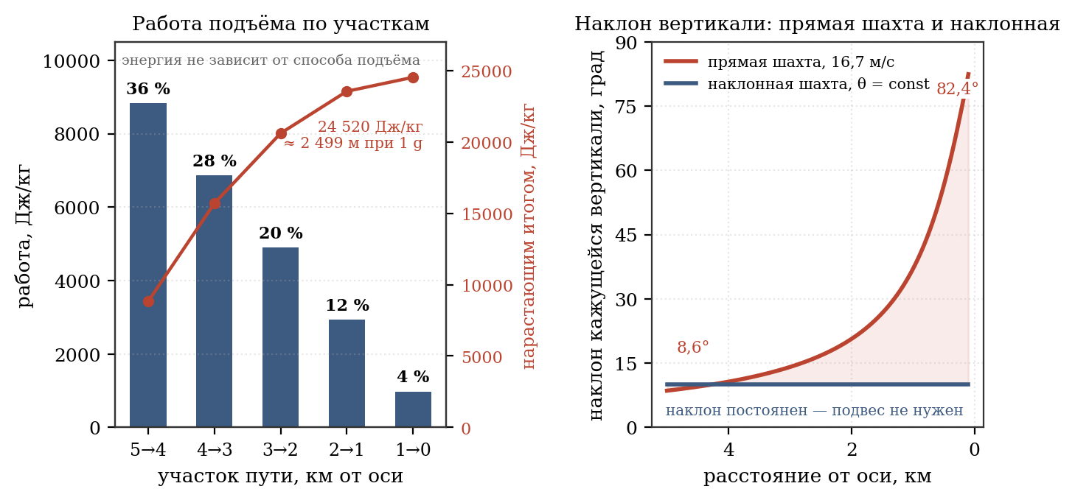
Figure 11 - work of lifting in sections and the inclination of the apparent vertical
The distribution of effort is extremely uneven and works in favor of the person: more than a third of all work occurs in the first kilometer from the surface, where the severity is maximum, while the last kilometer in front of the axle requires only 4% of the effort. The ascent becomes easier the further you go, and ends in almost zero gravity. Psychologically, this is the opposite of earthly ascent, where fatigue accumulates and the load does not decrease.
Coriolis acceleration and constant tilt condition
The Coriolis acceleration is directly proportional to the radial speed of the cabin, while the local gravity is proportional to the distance to the axle. This is where the difficulty of a direct elevator arises: at a constant speed of movement, the ratio of these quantities continuously increases as it approaches the axis, and the direction of the apparent vertical “floats away”.
Moving method | Radial speed | Coriolis acceleration | In fractions of g
Elevator, descent in 5 minutes | 33.3 m/s | 2,950 m/s² | 0,301 g
Elevator, descent in 10 minutes | 16.7 m/s | 1.479 m/s² | 0,151 g
Funicular, 30 minutes | 2.78 m/s | 0.246 m/s² | 0,025 g
Running up the stairs | 2.0 m/s | 0.177 m/s² | 0,018 g
Quick step | 0.7 m/s | 0.062 m/s² | 0,006 g
Calm step | 0.4 m/s | 0.035 m/s² | 0,004 g
With the law of motion v(r) = lateral acceleration is 0.015 g and remains in constant relation to local gravity throughout the entire path. This is ten times less than 0.151 g for a direct elevator when descending in 10 minutes. What is more significant, however, is not the value itself, but its constancy: the deviation felt by the passenger is zero, since the floor of the cabin is tilted exactly at the angle of the resultant.
The consequence is fundamental: the inclined shaft and the funicular do not require either a gimbal or compensating devices, which are mandatory for a direct elevator (clause 4.7.5). Constancy of tilt replaces mechanism with geometry.
Geometry of stair climbing
The project does not use a ladder: the axial shaft requires a means that is both fast and safe. Entrance is through an inclined shaft; this eliminates the need for a gimbal for a high-speed elevator.
- The essence of the decision is as follows. In a straight radial shaft, the apparent vertical deflects the more strongly, the closer the cabin is to the axis: the gravity decreases, but the Coriolis acceleration remains the same, and the deviation increases from 8.6° at the surface to 82.4° at r = 100 m. Therefore, the inclined shaft has a floor installed with a constant calculated deviation: no suspension is required, and the passenger feels the heaviness strictly “at the floor” all the way.
- The condition of constant inclination θ gives the law of motion v(r) =: the speed of the cabin must decrease in proportion to the distance to the axis. At θ = 10°, the cabin moves 19.5 m/s at the surface, 3.9 m/s per kilometer from the axis and smoothly freezes at the mooring ring - braking before arrival occurs naturally, from the conditions of the problem. The trajectory is described by the equation φ = tan θ · ln(R/r): the shaft is a logarithmic spiral, smoothly unfolding by 39.5° along the path to the axis. Its length is 4,976 m - only 1.5% longer than a straight line.
- The travel time along the route in the thickness of the end dome is 17.8 minutes versus 10 minutes for a direct high-speed elevator. About eight minutes is the fee for abandoning the gimbal and for removing the route from the axle volume, and the fee is moderate: the gimbal is a loaded moving mechanism, that is, a concentrated point of failure, while the inclined shaft does not contain a single additional moving unit in addition to a conventional winch.
- Security is ensured by the circuit itself, and not by additional devices. The shaft is closed along its entire length, so falls from a height are completely excluded - unlike any open route, where a fall at a distance of 1,000 m from the axis leads to an impact at a speed of 217 m/s. When there is a complete blackout, the cabin, under the influence of centrifugal force, moves towards the living surface, that is, a failure of the power supply itself returns people to the habitable zone. The speed of spontaneous descent is limited by the centrifugal brake: the pressing force of its pads is proportional to local gravity, which means that the mechanism is self-regulating and does not require either power or electronics.
Security requirements
The calculation of the free fall trajectory revealed a circumstance that requires mandatory consideration. A body that has fallen off near the axis moves rectilinearly in the inertial frame of reference, while the cylinder underneath it rotates. The result turns out to be more dangerous than falling to earth:
Place of breakdown | Time to fall to surface | Impact speed
r = 2,500 m | 39 s | 192 m/s (690 km/h)
r = 1,000 m | 111 s | 217 m/s (781 km/h)
r < 100 m | does not reach the surface for a long time | —
The reason is that the fallen one maintains a low peripheral speed corresponding to the point of fall, while the surface moves at a speed of 221.5 m/s. The collision occurs primarily due to this difference, and not due to radial incidence. It was this calculation that became the decisive argument against open routes between the axle and the rim: the adopted inclined shaft is closed along its entire length and runs through the thickness of the structure, so a fall from a height in it is excluded. The requirement for continuous fencing remains for technical galleries, access to which is permitted only outside the axial zone.
Comparison of transition methods
Table 4.10 - Comparison of means of transition from axis to surface
Way | Time | Coriolis | Special devices | Energy | Purpose
Direct high-speed elevator | 10 min | 0,151 g | Gimbal | High | Not accepted: suspension is a point of failure
Funicular on the slope | 30–40 min | 0,019–0,025 g | Not required | Moderate | Duplicate independent route
Inclined shaft, θ = 10° | 17.8 min | 0,015 g | Not required | Moderate, with recovery | Fixed asset, passengers and cargo
Free flight | — | — | Handrails | Zero | Paraxial zone r < 100 m
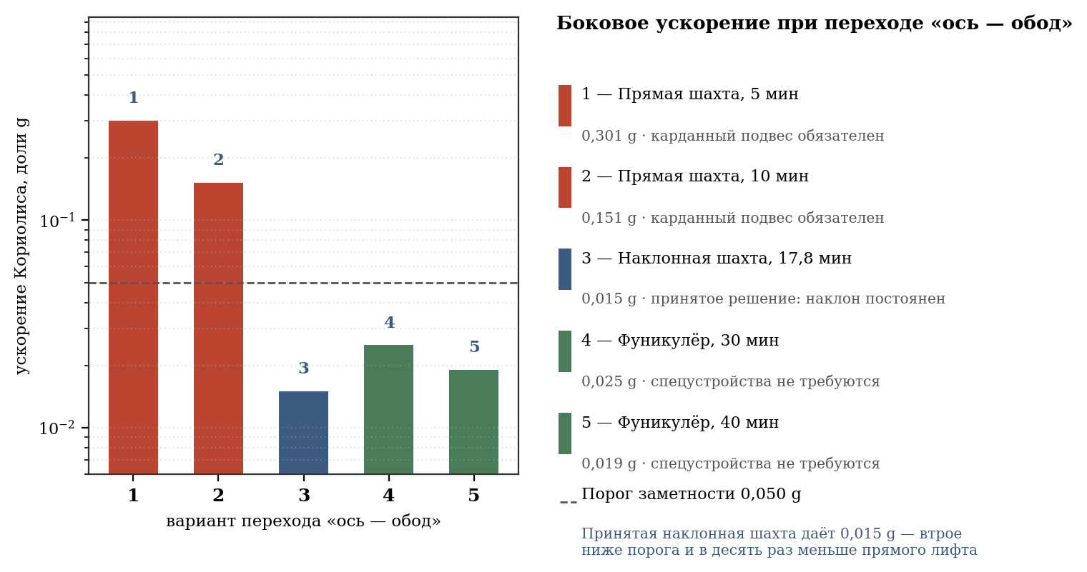
Figure 12 - Coriolis acceleration for different methods of axle-rim transition
The adopted solution is one common axial transport channel after quarantine and two separate inclined shafts in the front hemisphere. After the distribution chamber, the common path is divided into four sealed lines: A↑, A↓, B↑ and B↓. From the front interface to the separation point in the hemisphere there is a protected axial section of about 2,506 m. Further, branches A and B mirror the inclined paths from r = 150 m to the residential surface r = 5,000 m; the estimated length of the spiral part is about 4,923 m, the total canonical route is 7,429 m, the travel time is 17.8 minutes. Each shaft has a structural mouth Ø30 m and two transport channels with a clear diameter of 8.0 m.
The behavior of the system during a power failure deserves special attention. The sealed doors of the transition chamber and the sectional doors of the shaft are closed from backup power. In the main channel, a centrifugal brake limits the spontaneous movement of the cabin towards the living surface; The mechanical funicular-evacuation rail is preserved in the service area. The loss of one corridor does not deprive the cylinder of communication: the second corridor remains operational with a reduced capacity.
Capacity calculation: in each corridor there are two ascending and two descending trains, that is, two pairs of cabins per shaft. With a 100-person cabin and 17.8-minute headway, one corridor supports approximately 675 people per hour. The two front end corridors support approximately 1,350 people per hour per cylinder; When one corridor is withdrawn, about 338 people per hour remain. An empty cabin weighing 5 tons returns about 34 kWh per flight; for a total design mass of 15 tons, the energy equivalent is about 102 kWh before losses are taken into account.

4.7.7.1. Layout base of the front frame and berthing portal
For each cylinder, a separate combined front frame is adopted: a bearing force ring Ø400 m, 24 radial box-shaped force elements with a pitch of 15°, a central transport module of about 74 × 74 m and an external mooring and service portal. The radial truss and portal are not connected to the side shell; the force path is closed through the front journal and the bearing housing.
The berthing portal of each cylinder has six places: four universal passenger-cargo, one sterile cargo and one service-emergency. The calculation is based on a quarantine flow of 100,000 people per year, a three-time peak and a conservative external module for 50 passengers with a turnaround of up to 8 hours. Four passenger seats provide N+1 reserve relative to peak flow; mines with a throughput capacity of 1,350 people per hour per cylinder are not the limiting link.
The outer side shell of both cylinders remains smooth. The external general view shows only the physical frames, piers, radiators, six solar wings and exactly three antennas; Sections of the transport hub are produced in separate technical types.

4.7.7. Exchange of angular momentum during transportation
An essential circumstance that has no analogue in ground technology: a load lowered from the axis to the surface acquires a peripheral speed, taking away the corresponding angular momentum from the cylinder and slowing down its rotation. The load being lifted back returns angular momentum.
With a balanced load flow down and up, the rotation does not change. To achieve this, elevators are made in pairs, with a mechanical or electrical connection between the cabins: the descending cabin operates as a generator and transfers energy to the ascending one. In addition to preserving angular momentum, this scheme provides recovery: the total energy of a cabin weighing 1 ton, moved from the axis to the surface, is 49 MJ and is returned to the network during lifting.
Estimation of the limiting case of one-way flow: delivery of 1 million tons of cargo per year from the axis to the surface without reverse flow slows down the rotation by 0.0047% per year. The value is negligible and is compensated by standard means of maintaining rotation, but when designing cargo flows it should be taken into account as a systematic factor.
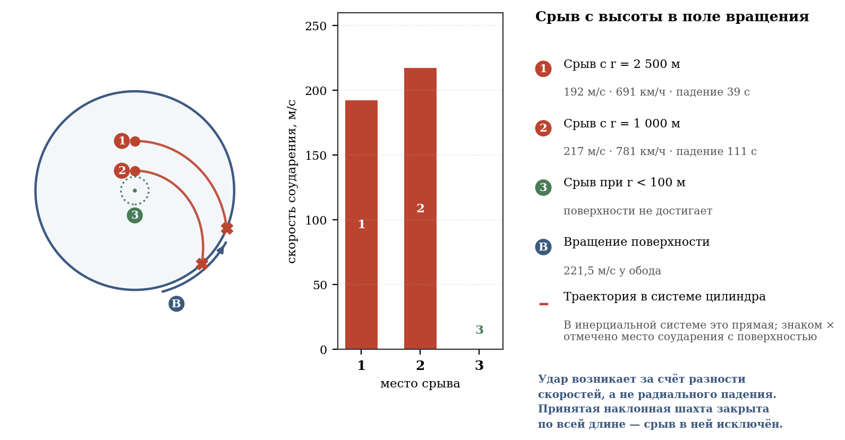
Figure 13 - fall inside a rotating cylinder: trajectory and impact speed
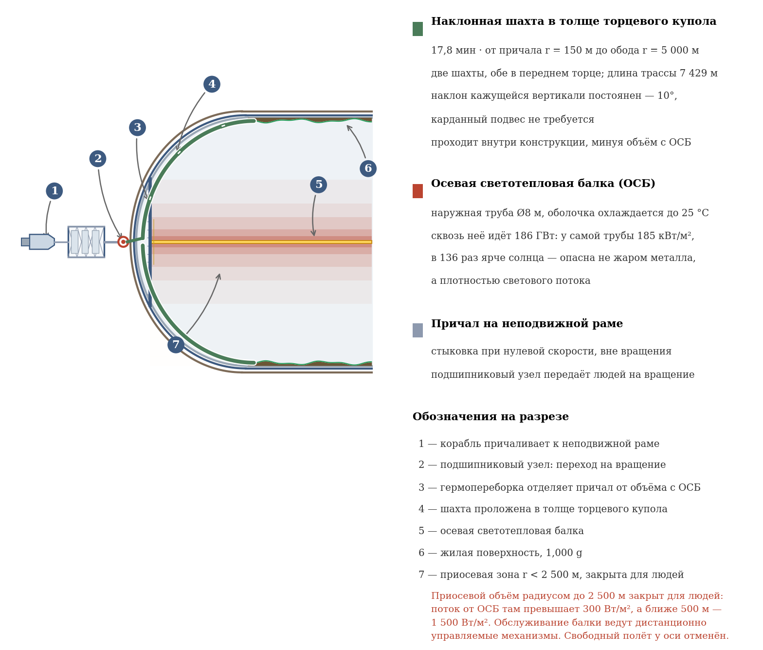
Figure 14 - inclined shaft: axle-rim transition without gimbal

4.8. Transport infrastructure
The road network of each cylinder includes:
- Longitudinal highways - two roads along the entire 40-kilometer cylindrical part, 4 lanes, width 12 m.
- Ring roads - every 5 km, width 8 m.
- District roads are 6 m wide within zones.

4.9. Construction and commissioning
Stage | Contents of work
1. Reconnaissance and preparation | Launching probes, delivering equipment, exploring auxiliary asteroids
2. Deployment of production | Smelters, ore mining on (6178) 1986 DA, 2016 ED85 and C-type asteroids
3. Construction of the first cylinder | Installation of frame, cladding, systems, biota
4. Construction of the second cylinder | Similar to the first
5. Cylinder connection | Installation of two fixed axial connecting trusses between the end bearing units; there is no longitudinal connection of the side shells
6. Filling with atmosphere | Sealing, gas mixture supply
7. Separation and flight to L1 | Undocking from the construction base, maneuver
8. Tests in L1 | System checks, calibration
9. Reception of settlers | Population of both cylinders
Total construction period: ~75–95 years.

4.10. Robotic systems
All types of robots are doubled to serve two cylinders. Added:
- Robotic assemblers of truss frames and bearing units.
- Adapter robots - maintenance of axial transport tunnels inside each cylinder and sealed transitions through its bearing assembly; There are no inter-cylinder tunnels.

4.11. The principle of stabilization and connection of rotating cylinders
Each cylinder rotates around its longitudinal axis, creating a gyroscopic moment. To compensate, the two cylinders rotate in opposite directions with equal angular velocities (ω₁ = +0.0443 rad/s, ω₂ = −0.0443 rad/s).
Technical implementation of the connection
- Both cylinders are mounted on two external fixed frame units - front and rear - through axial pins and bearings. The frames are located behind the planes of the end hemispheres; the side shells and the space between them along the cylindrical part remain free.
- Bearing units perceive radial and axial loads, hold each cylinder independently and contain two independent magnetic circuits with mechanical catchers. Built-in motor-generators perform spin-up, correct the phase of counter-rotation and return energy to the network during braking. Stators, power electronics, cooling and cable entries are located on fixed end frames; They do not apply to the side shell and the inter-cylinder gap.
Physical principle of stabilization
- The angular momentum of the first cylinder is directed along the axis in one direction.
- The moment of impulse of the second cylinder is exactly the opposite.
- The total angular momentum of the system is close to zero.
- An external disturbance attempting to rotate one cylinder meets equal resistance from the second through a fixed structure.
- The station axis remains stationary in inertial space; Sun orientation is not a design function. Communication antennas, radiators and solar wings on the frames are guided by their own drives.
- To move the station and exit from L1, its own propulsion modules are placed on the rear fixed frame, nominally Earth-facing. Their power trusses and nozzles are not connected to the cylinder shells; the thrust is closed through the rear frame units, axles and bearing housings. Ships with engines can perform auxiliary towing operations only after docking with the forward modules and are not part of the station's support structure. During acceleration maneuvers, the thrust of the engines creates a longitudinal force that is absorbed by the stationary frame.
Advantages: no fuel consumption for orientation, increased reliability, ease of control. Disadvantages: doubling the mass, more complex design, the need for powerful bearing units.

4.11.1. Equipment on axial connecting trusses and fixed frames
In this subsection, connecting beams mean only two fixed axial connecting trusses: front and rear. Each truss connects the end bearing housings of two cylinders at a center span of 21 km and transmits loads through axles, bearing units and fixed frames. There is no longitudinal structure along the inter-cylinder gap, the side shells are not connected to each other, and the equipment is not fixed to the rotating shell. Axial light-thermal beams inside the cylinders, four end bearing units and front/rear frames with piers, radiators, antennas and propulsion modules are considered separate subsystems; Below is shown their equipment in the area of ​​the axial frame-truss complex. “On the truss” below refers to its support platforms, hangers, manifolds and frame platforms; this does not mean attachment to a rotating shell.
The assessment is indicative and conceptual: the masses are given for the layout reserve, are not working design documentation and require calculations of strength, heat, vibration, electromagnetic compatibility, qualification and full-scale testing. The quantity is indicated for a station of two cylinders; reservation is functional, until the release of working schemes.
Table 4.11 — Preliminary list of equipment for the axial frame-truss complex (conceptual assessment)
Equipment | Quantity | Unit weight, thousand tons | Total, million tons | Materials, approximate | Location; reservation; status
Two inter-cylinder axial connecting trusses and fastening units | 2 | 750 | 1,50 | 18Ni(300)/low alloy steel; Al/Ti in secondary elements | Front and rear trusses between end bearing housings; symmetry 2×; conceptual assessment, not RKD
Fusion reactor modules with shield and power electronics | 4 | 1 500 | 6,00 | low activation steel, W, Cu/Nb₃Sn or HTS, lithium blanket, ceramics | Rear axle truss and fixed frames, two per cylinder; working reserve 3+1 according to a modular design; conceptually
High temperature heat exchange and pump trains | 8 | 250 | 2,00 | Ni-alloys, stainless steel, Cu, ceramics, thermal insulation | Rear truss and reactor frames; 2 independent trains per reactor; conceptually
Low temperature radiators with collectors | 1 system; 1,477 km² | 29 540 | 29,54 | Al-panels/steel, Ni- and stainless steel manifolds, coolant, insulation | Front and rear axle trusses/fixed frames and four stationary units; partitioning and 15% area reserve; conceptually; 20 kg/m²
Rotating solar wings | 6 | 500 | 3,00 | Si or III-V, Al/CFRP, glass/polymer, Cu | Rear trusses/frames, three per cylinder; functional 5+1; conceptually
Mooring and service nodes | 12 | 30 | 0,36 | steel/stainless steel, Al, composites, seals | Front trusses/frames, six per cylinder; 4 passenger + 1 sterile + 1 emergency per cylinder; N+1 along the corridors; conceptually
Quarantine transfer units | 2 | 300 | 0,60 | stainless steel, Al, glass, polymers, hermetic bulkheads | Front service frames, one per cylinder; mutual reservation of A/B flows; conceptually
Highly directional antenna modules | 3 | 25 | 0,075 | CFRP, Al, Cu, radio transparent radome | Rear trusses/frames, 2+1 scheme; reservation of communication channels; conceptually
Motor clusters of retention and maneuver | 4 | 300 | 1,20 | stainless/Ni-alloys, Cu, ceramics, carbon, working fluid tanks | Rear fixed frame, two per cylinder; at least 3 out of 4 for normal mode; conceptually
Power distribution, drives, cables, instrumentation and repair kits | 2 sets | 200 | 0,40 | Cu/Al, Si, fiber optics, steel, polymers | Both frames and trusses; separate feeders and local reserves; conceptually
TOTAL detailed preliminary estimate | — | — | 44.675 million tons = 0.0447 billion tons | — | A subset of the line “frame, components, reactors, radiators” with a reserve of 3.00 billion tons in the consolidated balance sheet; not added to 46.70 billion tons again; equipment qualification and testing still require development

4.12. Resource support for construction
The all-metal design makes metal the defining resource of the project. This section verifies the sufficiency of the asteroid base.
Table 4.14 - Material requirements and coating sources (two cylinders)
Material | Demand, billion tons | Source | Security
Steel 18Ni(300), power belt | 20,83 | (6178) 1986 DA, M-type metal | Defining resource
Stainless steel, containment | 1,22 | (6178) 1986 DA | Enough
Regolith, borosilicate (rad protection) | 4,65 | Silicates 1986 DA, 2016 ED85 | Enough
Vegetable soil | 8,13 | Silicate processing, organics | Enough
Water | 1,17 | C-type asteroids, ice | Developed at a conceptual level in Chapter 8; industrial schedule, equipment qualification and full-scale testing still need to be developed.
Volatile for the atmosphere (N₂, O₂) | 7,55 | C-type asteroids | Developed at a conceptual level in Chapter 8; industrial schedule, equipment qualification and full-scale testing still need to be developed.
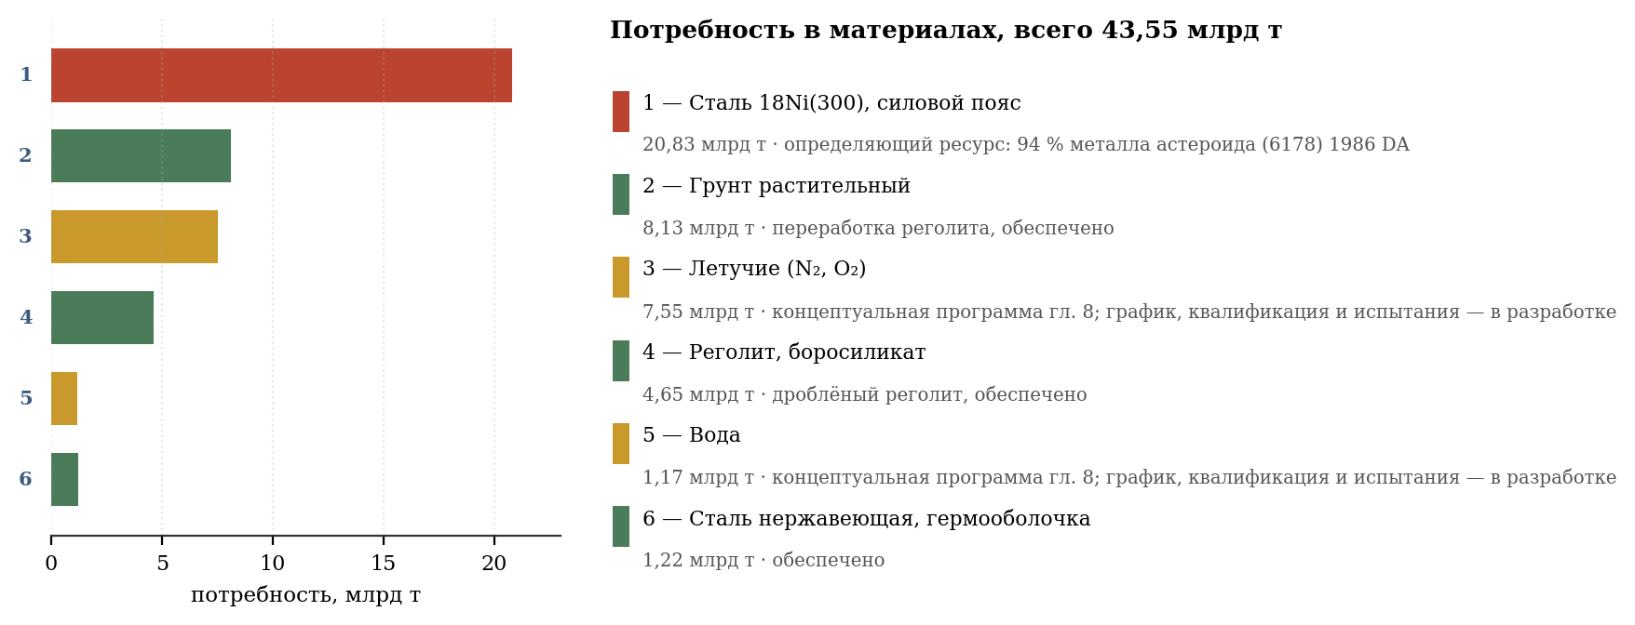
Figure 15 - resource availability for construction
The total steel requirement is 22.05 billion tons for two cylinders, including the power set and cutout edging. With technological losses of 25%, it is necessary to process about 29.4 billion tons of metal raw materials, which uses about 94% of the metal resource of the main asteroid. An auxiliary raw material base is required for redundancy and industrial equipment.
Conclusion: the resources of one asteroid are formally enough for the main metal circuit, but there is practically no reserve. Asteroid 2016 ED85 and other support facilities are needed for propulsion, station industry and loss compensation.
Requirements for alloying elements
Element | Demand, billion tons | State of provision
Nickel | 3,84 | The content in iron asteroids is 5–15%; enrichment up to 18% required
Cobalt | 1,92 | 1986 DA has a higher Co content; concentration required
Molybdenum | 1,07 | Scarce; requires a separate decision (see clause 4.2)
Enrichment of nickel and cobalt is an independent metallurgical task on an industrial scale. The natural iron-nickel material of the asteroid contains nickel in an amount insufficient for maraging steel, and requires separation of the kamacite and taenite phases or electrolytic refining. The technology is known; the question is the productivity of the orbital metallurgical complex, which should ensure the processing of 28.5 billion tons of raw materials during the allotted construction period.
With a construction period of 75–95 years, the average productivity of metallurgical production should be about 330 million tons of steel per year - about a third of the current world steel production. This determines the scale of the industrial program preceding the construction of the cylinders and justifies the duration of the preparatory stages (see paragraph 4.8).
Comprehensive resource base
- (6178) 1986 DA is a major source of iron, nickel, cobalt and platinum group metals. Provides the bulk of the power structure.
- 2016 ED85 - mandatory auxiliary source of metal and silicates; provides a reserve missing from the main asteroid.
- Carbon (C-type) asteroids - water, nitrogen, oxygen, carbon. Critical resource for the atmosphere and hydroelectric network: 8.56 billion tons of volatile substances.
The multi-source approach, based entirely on asteroidal resources, remains valid: the project can be implemented without the involvement of lunar or terrestrial materials, with the exception of the possible delivery of molybdenum.

4.13. Axial light-thermal beam (OSB)
Autonomous lighting and thermoregulation system.

4.13.1. Purpose and scope
If it is necessary to leave the solar system or remain in the shade for a long time, the solar panels lose an external source of electricity, but the station does not lose lighting: the axial light-thermal beams are powered by the reactors. OSB provides photosynthesis (PAR, 400–700 nm), climatic zoning and psychological circadian regime in all normal modes.

4.13.2. Construction and placement
The beam is placed strictly along the longitudinal axis of rotation of the cylinder, inside the cylindrical part (40 km) and partially in the hemispheres. Fastening - through radial trusses to ring roads (every 5 km) with magnetic/roller bearings. There is zero centripetal acceleration on the axle, which simplifies maintenance. Three-layer construction:
- Core (D = 5 m): tungsten filaments in sapphire flasks (vacuum/argon, ~3000 K), LED matrices on sapphire substrates (60–80 °C), primary Na-K circuit.
- Vacuum layer (5–8 m): 50 layers of MLI (aluminized Mylar), pressure < 10⁻³ Pa.
- The outer OSB pipe (D = 8 m) is made of heat-resistant nickel alloy of the Inconel type, thickness 0.3 m. It is not a rotating cylinder shell and is held at 25 °C (±5 °C) by active microchannel cooling. Cables, reflectors, bearings and transport tunnels are attached to it.

4.13.3. Thermal balance on the axis
The electric power supplied to the axial light-thermal beam of one cylinder is 251 GW. Of this, 93 GW are converted into useful radiation to the walls, and 158 GW are classified as heat and are removed by the corresponding circuit.
Parameter | Meaning
Electrical power per axle (one cylinder) | 251 GW
Useful radiation to the walls | 93 GW (37%)
Heat remaining in the axle structure | 158 GW (63%)
Bleeding through MLI to outer shell | < 50 MW
Coolant temperature (input/outlet) | 18 °C / 22 °C
Outer shell temperature | 25 °C
Melting point of OSB pipe material | ~1 400 °C (for reference)
Heat of 65 GW is collected by local copper heat pipes and removed through a cold collector to the outside of the cylinder, bypassing the habitable volume. The coolant is water under pressure at 18–22 °C, mass flow is about 3,900,000 kg/s through a multi-circuit system of parallel pipelines Ø 0.5 m. Next, the heat enters the general discharge system (clause 4.4), where heat pumps raise its temperature to 60 °C for effective radiation.

4.13.4. Spectral composition and distribution by zones
The beam is segmented into 40 modules of 1 km each, each with independent power control. Reflectors direct light radially towards the walls; Flux densities correspond to accepted climatic zones.
Zone | Length | Flux Density | Power | Spectrum
Tropical (0–10 km) | 10 km | 220 W/m² | 69.1 GW | Tungsten 3000 K + LED 450/660 nm
Subtropical (10–22 km) | 12 km | 170 W/m² | 64.1 GW | Tungsten 2800K + white LED 4000K
Moderate (22–32 km) | 10 km | 120 W/m² | 37.7 GW | White LED 4000K, moderate IR
Cold (32–40 km) | 8 kilometers | 60 W/m² | 15.1 GW | Visible light for mosses and berries
TOTAL | 40 km | — | 186 GW | —
For comparison, the average daily insolation on the Earth's surface is about 200 W/m² in the tropics and 100–120 W/m² in temperate latitudes. The accepted values ​​correspond to those on Earth, which ensures normal photosynthesis and a level of illumination familiar to humans.

4.13.5. Simulation of the daily cycle
- Beam-mounted blinds: rotating slats overlap the sectors, creating a strip of darkness moving along the cylinder (speed ~1.7 km/h, cycle 24 hours).
- Dawn/sunset: At the border of light and darkness, the LEDs switch to 2000K (red-orange) for 15 minutes.
- Starry sky: in the night sectors, 2700 K spot LEDs imitate stars.

4.13.6. Energy supply of OSB and consolidated energy balance of the station
Table 4.15 — Power balance of the station in autonomous mode
Consumer | Power, GW
Axial light-thermal beams, two cylinders | 503
Heat pumps heat rejection systems (COP = 6) | 96
Life support systems, pumps, ventilation | 20
Life, transport, industry (1 million people) | 6
Bearing units, motor generators and power electronics | 2
Reserve and transmission losses | 31
Keeping the station at point L1 (clause 11.5) | 63,4
TOTAL electrical power | 721,4
Thermal power of reactors at 45% efficiency | 1 603
It is carried away from it by a stream of mass driver and does not heat the station | 44,4
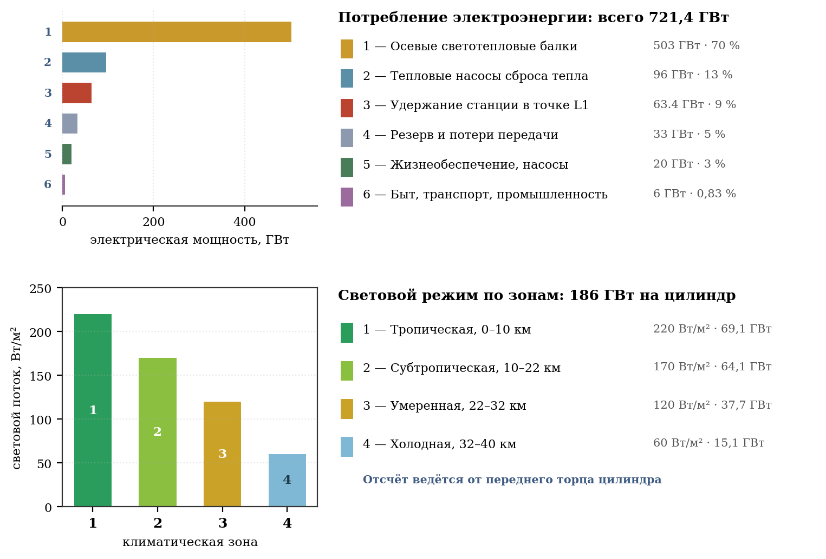
Figure 16 - energy balance and luminous flux distribution
Four D–T fusion reactors with a thermal power of 366 GW each are required, two per cylinder. Their electrical power covers the station’s energy balance of 721.4 GW, taking into account heat pumps, retention, life support and reserve.
The reactors are located on the rear fixed truss frame behind the rear ends, outside the internal space of the cylinders. The rear frames house six auxiliary solar wings, three for each cylinder; the three wings of each frame form a local symmetrical triad with an angular pitch of 120°. Exactly three antenna modules are distributed in a 2 + 1 pattern: two on the rear frame of the first cylinder and one on the rear frame of the second; the first two are placed mirrored, the single one receives a local counterweight or service container. Functionally, three antennas are optimal: two highly directional ones provide the main and backup communication channel with the Earth, the third broadband/emergency one serves safe mode, local devices and backup telemetry. One antenna does not provide fault tolerance, two do not leave a separate emergency channel, and increasing the number without additional direction or independent range only increases the mass and complexity of guidance. Nothing is placed on the side trim of the cylinders.
The mirror system and solar sail are not included in the project. Illumination of the habitable volume is provided exclusively by axial light-thermal beams from the reactor installation in all operating modes.
The luminous flux to the walls is 186 GW and is provided by a single source - axial light-thermal beams. A single-source circuit is used in all modes and does not require solar illumination of internal volumes.

4.13.7. Heat dissipation: keeping the rear hemisphere cool
The heat generated inside the cylinders is removed outside, bypassing the internal space of the rear hemisphere, which preserves its function as a cold technical zone.
- The cold circuit from the beam passes through the rear bearing assembly outside the cylinder.
- Heat is supplied to heat pumps, which raise its temperature from 25 °C to 60 °C, and then to radiator panels (composition of areas - table 4.3).
- The wall of the rear hemisphere is multilayered: structural package + 0.5 m vacuum layer with screen-vacuum insulation + radiator layer on the outside.
- Vacuum insulation maintains a difference between the external radiator of 60 °C and the internal volume of +5...+15 °C, maintaining the operation of warehouses and industrial modules.
A complete list of radiating surfaces and checking sufficiency are given in paragraph 4.4, table 4.3: available area 1,477 km² with a requirement of 1,022 km², reserve 1.45.

4.13.8. Integration with existing systems
- Na-K loop: The primary OSB loop uses the same alloy as the climate control.
- Fixed axis: the beam is a continuation of the axis inside the cylinder, does not violate gyroscopic stabilization.
- Bearing units: The cold circuit piping from the outside of the cylinder passes through them.
- Rear hemisphere: the inside remains cold (+5...+15 °C), a 60 °C radiator circuit is placed outside on a fixed remote unit.
- Cold zone: Receives excess heat from the tropics through Na-K pumping.

4.13.9. Fuel cycle of autonomous flight
With a thermal power of 1,603 GW, the consumption of deuterium-tritium fuel is about 169 tons per year per station (based on an energy release of 3.4 10¹⁴ J/kg with a utilization efficiency of 90%). Deuterium is obtained from the water of carbon asteroids by electrolysis followed by isotope separation. Tritium is reproduced in the lithium blanket of the reactor by the reaction Li-6 + n → T + He-4, which makes the cycle practically closed for tritium. Fuel and lithium reserves for 50 years of autonomous flight: about 7,700 tons.
Solar panels are a separate auxiliary source on the six rotating drop-down wings of the fixed rear frames - three per cylinder. The total area of ​​586.8 km² is maintained, the area of ​​one wing is about 97.8 km², the design power is about 8.9 GW. The wings do not create a solar lighting mode and do not replace the reactors: OSB remains the only light source, and the holding installation works regardless of the output of the wings. If one wing fails, 83.3% of the auxiliary power remains.

4.13.10. Redundancy and reliability
- Reactor duplication: 2 independent reactors per cylinder.
- Emergency LED matrices on batteries (72 hours of battery life).
- Spirulina and chlorella bioreactors switch to minimum mode when the light level decreases.
- When one reactor exits, the second operates at 60% power; the cold zone is put into hibernation mode. There are no heated greenhouses, so hibernation does not require any energy supply: frost-resistant perennials tolerate lower temperatures without loss.

4.13.11. Thermal zoning of the axial volume
The “axle-rim” route does not pass through the axial volume where the axial light-thermal beam is located. The transition is carried out along a protected inclined shaft inside the end dome.
The essence of the limitation is not the temperature of the beam structure. An outer pipe with a diameter of 8 m is cooled by an active circuit and held at 25 °C (section 4.13.2). The limitation creates a luminous flux density: 186 GW passes through the surface of this pipe with an area of ​​1.01 km², which gives 185 kW/m² at the shell itself - 136 times the solar constant. A person who finds himself next to the beam receives not heat from the hot metal, but a luminous flux comparable to the focus of a solar oven.
The flux decreases in inverse proportion to the distance to the axis, since the radiating surface is cylindrical. Calculation by r gives: 100 m - 7,401 W/m²; 300 m - 2,467; 500 m - 1,480; 1,000 m - 740; 2,500 m - 296; 5,000 m - 148 W/m². The last value coincides with the design illumination of the residential surface (( = 148 W/m²)), which confirms the consistency of the calculation with the energy balance of clause 4.13.6.
Hence the zoning. Radiuses less than 500 m: flux above 1,500 W/m², only remote controlled mechanisms are allowed. From 500 to 2,500 m: flow from 1,500 to 300 W/m², human presence is prohibited, short-term work is possible only in a spacesuit with a mirror screen. Above 2,500 m: flux below 300 W/m², stay permissible. The axial volume with a radius of up to 2,500 m is closed to people; The beam is serviced by remotely controlled mechanisms along internal guides.
The project has three consequences. Free flight in zero gravity at the axis is not provided as a form of leisure. The pier is located on a fixed frame outside the end; Through the bearing assembly, people enter an inclined shaft, laid in the thickness of the end dome, and reach the living surface in 17.8 minutes, without ever finding themselves in the axial volume and without seeing the beam. The dome structure in this area contains a pressurized bulkhead and a vacuum gap with screen-vacuum insulation, so that heat leakage to the shaft does not exceed 0.7 W/m² over a dome area of ​​70.7 km² and is completely removed by standard climate control.

4.14. Water balance and closed water supply cycle
In the closed environment of the cylinder, water does not leave the system. The full cycle includes:
- Drinking water supply - multi-stage wastewater treatment (reverse osmosis, ultrafiltration, UV disinfection). Capacity: 150,000 m³/day per cylinder (with a margin of 30%).
- Artificial irrigation - in the absence of natural convection that creates rain clouds, precipitation is formed forcibly. In the tropical zone, irrigation systems (drip irrigation, sprinklers) are installed, operating on a schedule of 4–6 hours a day.
- Hydraulic network and reservoirs - 150 km² of water surface with an average depth of 1.2 m (depth justification - Appendix B, clause B.11). Fish pools up to 3 m deep are made using the bulk method, by raising the embankment, without excavating the soil below the containment. To prevent bank erosion, biodams made from reed roots and stone embankments were installed. Fish pools (15 km²) are equipped with forced aeration and biofilters.
- Sewerage is a two-circuit system: domestic wastewater → treatment bioreactors → process water (irrigation) / drinking water. There are no storm drains.

4.15. Shell shape stability
Heat-loving vegetables, herbs and mushrooms are located in tropical and subtropical zones; The cold zone is used for frost-resistant crops, storage and low-temperature production.
The contraction of a liquid drop into a ball is produced by surface tension and is possible only because the liquid does not perceive tangential stresses. Steel accepts them: the shear modulus is 73 GPa. Changing the shape of a 0.85 m thick shell over tens of kilometers would require plastic deformation of the entire section, while the surface energy is negligible in comparison with the energy of such deformation. There is no driving force for the transition to the sphere in the design.
The voltage calculation confirms the conclusion. Separately, the useful external load qext = 152.6 kPa gives about 898 MPa of hoop stress. For the design calculation, the own weights of the containment shell, insulation and force belt were added to it: qtotal = 222.4 kPa and σ = 1,308 MPa. The axial stress is created by atmospheric pressure on the end hemispheres and is equal to 294 MPa. It is significant that the axial stress is tensile: the air expands the cylinder along the axis, lengthening it by 4.8 m. The transition to a sphere would require axial shortening, that is, compression, while the shell is stretched in both directions. The centrifugal load from soil, water and atmosphere is directed strictly radially and has no axial component at all.
The real threat to the shape is not the sphere, but the ovalization - the transition of the cross section into an ellipse, corresponding to the second bending mode of the ring. The calculation of this mode gives a result that determines the design ideology: the restoring force is created primarily by the centrifugal tension of the ring, equal to 3.3·10¹³ N, and not by the bending rigidity of the steel. The contribution of tension exceeds the contribution of stiffness by 2.9 million times. The mode frequency is 0.0109 Hz, which corresponds to a period of 91.6 s, that is, approximately 0.65 station revolutions; fashion is sustainable.
It follows that in operation the force set practically does not determine the shape of the cylinder - it is held in place by its own rotation, just as a spun flywheel holds its shape. Frames and stringers are located on the inside of the package, under the outer skin, and provide local stability of the shell near the cutouts and internal power units. There are no ribs, frames, stringers, cables, panels or equipment on the outer surface of the cylinders; it remains smooth.
When the rotation stops, the soil stops loading the shell, since without centrifugal acceleration it weighs nothing. The remaining load is an internal boost of 100 kPa, creating a hoop stress of 588 MPa. This stress is tensile, and buckling is a compression phenomenon. Consequently, the inflated shell retains its shape without rotation, and the supercharging itself acts as a stabilizing factor.
Design conclusion: stopping rotation is a severe event in terms of living conditions - the artificial gravity disappears - but it does not create a threat to the geometry of the hull while maintaining the boost. The only combination that remains critical for the shape is depressurization during stopped rotation, when the shell is deprived of both sources of tension at the same time.

5. FOOD BALANCE AND EFFICIENCY OF THE BIOSPHERE

5.1. Consumption norms and consolidated food balance
Two cylinders, population 1,000,000.
The nutritional norm is taken to be 2,800 kcal per day per person; it is used in the food balance for the estimated population of the station.
Table 5.1 - Accepted consumption standards
Indicator | Norm | Rationale
Energy value | 2,800 kcal/day | Increased relative to the average (2,500), taking into account the share of physical labor in agriculture and industry of the station
Protein | 70 g/day | The upper limit of the WHO norm (50–70 g), with a margin for the quality of the amino acid composition of vegetable protein
Annual need of the population: 1.022 trillion kcal and 25.6 thousand tons of protein. Taking into account the standard reserve (×1.5 for calories, ×1.3 for protein): 1.533 trillion kcal and 33.2 thousand tons of protein.
Table 5.2 - Summary food balance
Indicator | Need | With reserve | Products (net) | Stock
Calories | 1.022 trillion kcal/year | 1.533 trillion kcal/year | 1.870 trillion kcal/year | ×1,83
Protein | 25.6 thousand tons/year | 33.2 thousand tons/year | 69.8 thousand tons/year | ×2,73
Products are indicated after deduction of 20% for losses during harvesting, storage and processing. Gross indicators before deduction: 2.338 trillion kcal and 87.2 thousand tons of protein.
Table 5.3 - Commercial products of livestock and aquaculture (two cylinders)
Products | Volume, t/year | Note
Fish (tilapia, tambaqui, silver carp, whitefish) | 70 000 | Main source of animal protein
Milk (cow and goat, commercial) | 33 750 | Gross milk yield 45,000 tons minus 25% for feeding young animals
Meat of land animals | 8 000 | Updated by livestock taking into account herd turnover
Eggs | 5 000 | Chickens, quails, ducks, geese
Honey | 60 | 2,000 bee colonies per cylinder
The marketable milk yield is 33,750 tons per year: the gross milk yield of 45,000 tons is reduced by 25% for feeding young animals.
Explanation of diet. Meat consumption is 8 kg per person per year, milk - 34 kg, fish - 70 kg. The diet of the station's population is predominantly plant-based with a high proportion of fish; it differs significantly from the modern earthly one (in Russia there are about 80 kg of meat and 240 kg of milk per person per year). This is a conscious design decision: animal protein production requires 5 to 10 times more acreage per unit of output. Aquaculture was chosen as the main source of animal protein due to the best feed conversion ratio.
The achieved protein reserve ×2.73 significantly exceeds the standard. This provides a project reserve: if necessary, part of the protein surplus can be used to expand animal husbandry and bring the diet closer to the usual earthly one, or to increase the population beyond the estimated million.

5.2. Structure of sown area and productivity
Table 5.4 - Cultivated areas and products (two cylinders)
Culture | Area, km² | Productivity, kg/m² year | Products, t/year | Kcal, billion
Rice | 120 | 1,00 | 120 000 | 432
Corn | 150 | 1,20 | 180 000 | 657
Wheat | 50 | 1,00 | 50 000 | 170
Barley | 20 | 1,00 | 20 000 | 70
Potato | 100 | 4,00 | 400 000 | 308
Sweet potato, taro, cassava, yam | 46 | 3,00 | 138 000 | 124
Soybeans | 10 | 0,35 | 3 500 | 16
Other legumes (chickpeas, lentils, beans, peas) | 36 | 0,30 | 10 800 | 38
Vegetables | 80 | 4,00 | 320 000 | 80
Fruits and berries | 60 | 2,00 | 120 000 | 60
Oilseeds | 50 | 0,50 | 25 000 | 150
Mushrooms | 30 | 10,00 | 300 000 | 75
Herbs and spices | 25 | 3,00 | 75 000 | 15
Seaweed (nori, kelp) | 30 | 2,00 | 60 000 | 21
TOTAL | 807 | — | 1 822 300 | 2 216
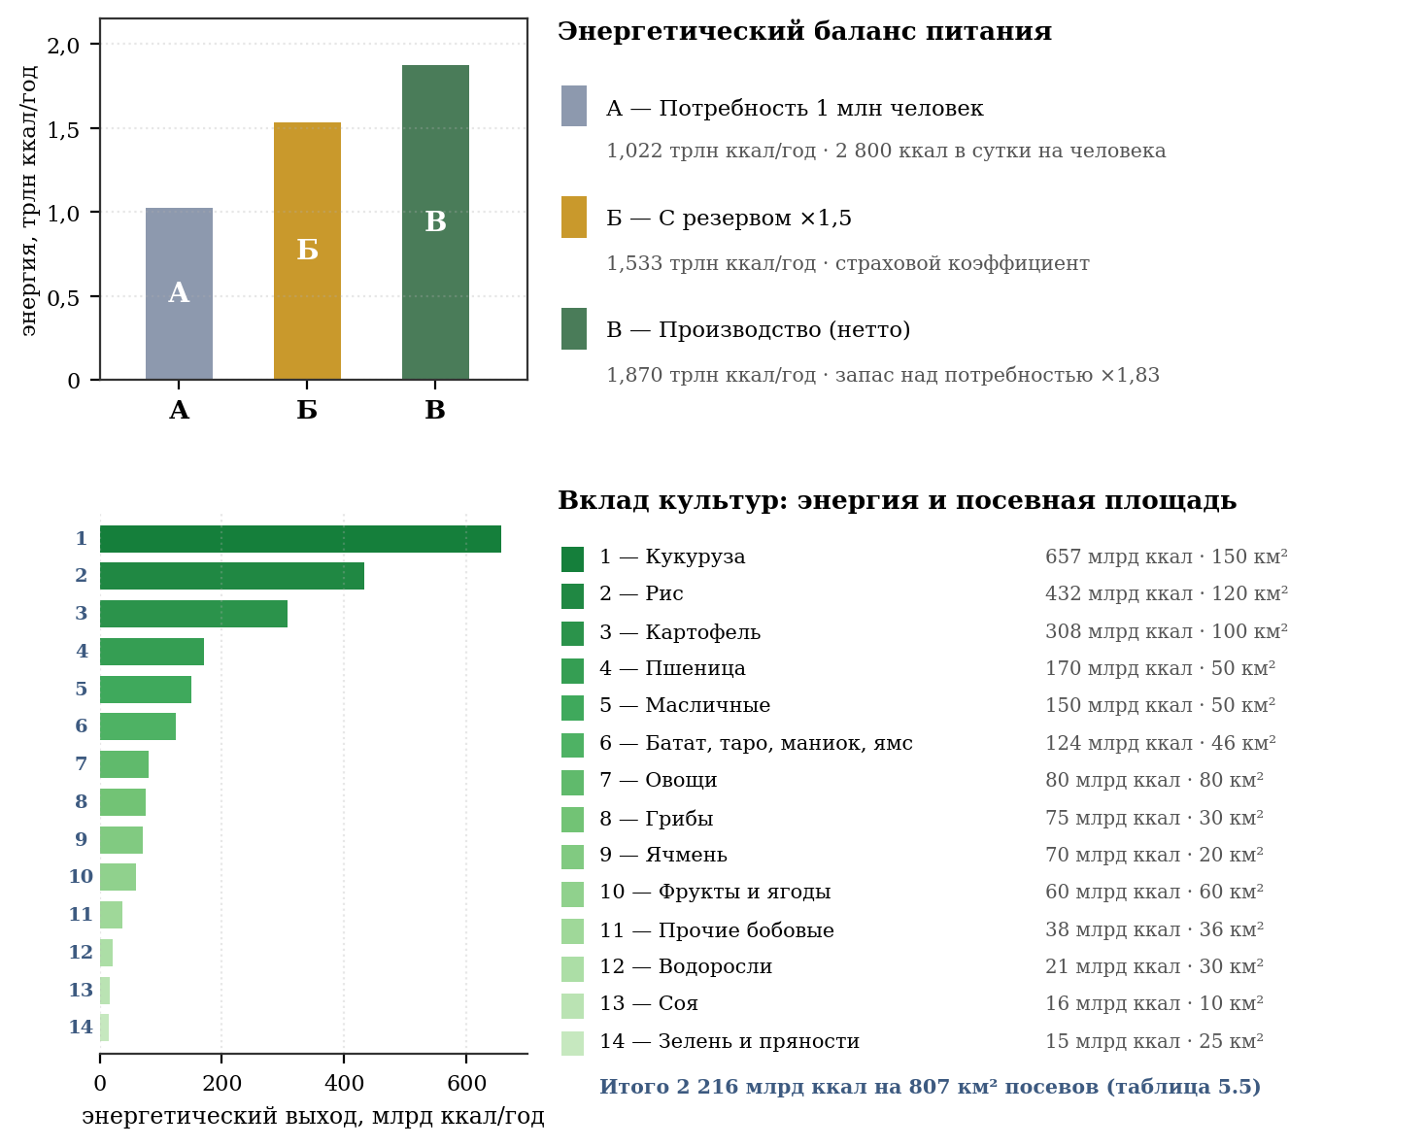
Figure 17 - food balance and structure of sown areas
Yields are based on two to three harvests per year in tropical and subtropical zones under year-round controlled lighting. The values ​​correspond to terrestrial intensive agricultural technology, reduced to a multi-crop cycle, and do not imply hypothetical technologies.
Table 5.5 - Land use balance
Category | Area, km² | Share
Cultivated area (table 5.4) | 807 | 53 %
Fish pools | 15 | 1 %
Reserve of fast emergency crops | 150 | 10 %
Total agricultural use | 972 | 64 %
Free reserve (expansion, recreation, development) | 536 | 36 %
Total farmland two cylinders | 1 508 | 100 %
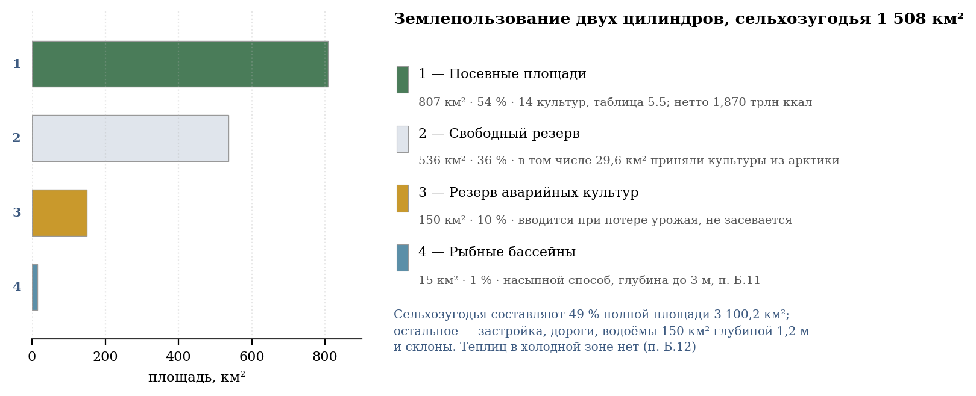
Figure 18 - structure of space use
The free reserve of 536 km² is more than a third of the agricultural fund. It allows for population growth, expansion of livestock production and recovery from local disasters without reducing current production.

5.3. Structure of food reserve and storage system
Reserve type | Term | Storage form | Volume | Terms
Operating | 3–6 months | Dry grain, oil, canned food, flour | ×1,15–1,25 | Hermetic bunkers of the rear hemisphere, +5…+10 °C, nitrogen atmosphere
Insurance | 1–2 years | Dry grain, dry milk, soy isolate, frozen | ×1,5 | Underground storage facilities, −5…−15 °C
Emergency | 5+ years | Vegetable oil, protein concentrates, dried fruits | ×0,3 | Rear hemisphere freezers, sealed tanks
Storage forms that are not subject to deterioration in a sterile environment
- Dry grain (rice, wheat, corn, barley) in sealed silos with a nitrogen atmosphere and humidity < 14% - shelf life 5-10 years without loss of quality.
- Vegetable oil in sealed stainless steel tanks - for decades in the absence of oxygen and light.
- Powdered milk, soy isolate, egg powder are compact sources of protein, shelf life 3–5 years.
- Freezing in natural cold chambers of the cold zone (−5…−15 °C). Energy consumption is minimal, heat removal is provided by a standard thermoregulation system.
- Spirulina and chlorella in emergency bioreactors are a “living” reserve that does not require soil areas. In emergency mode, protein yield increases 3–5 times in 72 hours.

5.4. Rationale for the volume of reserves in a sterile closed environment
Under terrestrial conditions, the main causes of crop failure are phytopathogens, pests, droughts, and floods. At the orbital station, these factors are excluded: the environment is sterile, the climate is completely controlled, seeds and biomaterial are quarantined. However, this does not eliminate the need for a reserve. In a closed artificial environment, a new class of risks operates - man-made:

1. Fire - in an atmosphere with 21% oxygen, a fire develops at an explosive rate. One short circuit in a tropical zone can destroy 5–10 km² of plantings in hours.

2. Power failure - damage to the reactor circuit, OSB or distribution network. Damage to the solar wings does not stop photosynthesis because they do not provide light; If OSB fails, emergency generators are designed to last for days, not months.

3. Failure of the liquid metal circuit - in the tropical zone, cooling failure leads to the death of biomass in 6–12 hours from overheating; in a cold zone - to flash freezing.

4. Genetic drift - with many years of vegetative propagation or a limited seed fund, deleter mutations accumulate, reducing productivity.

5. Human factor - operator error, sabotage, conflict. In a closed system, one saboteur can poison a hydraulic network or cut off the power supply to an entire climatic zone.
Table 5.6 — Calculation of the required buffer based on recovery time
Risky scenario | Recovery time | Required stock
Local fire / failure of one zone | 3–6 months | ×1,15–1,2
Damage to 30–50% of the area of ​​one cylinder | 1–2 years | ×1,5
Global energy failure | 2–5 years | ×2.0 (concentrates)
To ensure resistance to the scenario of “losing half of one cylinder without stopping the second,” a standard reserve of ×1.5 for calories and ×1.3 for protein was established. This allows you to:
- survive 18–24 months without reducing your diet if one cylinder completely fails;
- feed the entire population in case of a local fire or seasonal failure without mobilizing emergency funds.
FIFO (First In - First Out) principle
Inventories do not lie dead weight. Every year, 30–40% of the harvest is processed into long-lasting forms: grain → flour → bread, vegetables → canned food and pickling, meat/fish → freezing. Expiring batches are consumed first, with fresh harvests replenishing storage. This ensures an endless renewal cycle without damage or loss.

5.5. Emergency rapidly renewable resources
In addition to static reserves, the station contains a “living” emergency reserve, which does not deteriorate because it is continuously grown or is in a state of readiness:

1. Reserve areas of fast crops - 150 km² (10% of farmland) are maintained in prepared soil without sowing. In the event of a disaster, they are sown with radishes, lettuce, spinach, arugula, and microgreens—the harvest is done in 20–40 days.

2. Emergency bioreactors of spirulina and chlorella - in normal mode they operate at 30% power. In case of an accident, the yield of dry biomass increases 5 times in 72 hours.

3. Tilapia fish tanks - some of the tanks contain fry of different ages for continuous sale. Tilapia reaches marketable weight in 4–6 months.

4. Potatoes and Jerusalem artichokes in the ground - in the temperate zone, part of the crop is left in the ground as a “living storage” at temperatures down to −2 °C.

6. ENVIRONMENT FORMATION: PROCESSES DETERMINING THE SUITABILITY OF THE ENVIRONMENT
Sections 4 and 5 describe the station as a structure: shell, gravity, energy, food. However, the habitability of a closed volume is determined not only by the design, but also by the processes that occur continuously in it and do not have a switch. This section records such processes, provides a quantitative assessment of their parameters, and separates what has been counted from what remains to be counted.

6.1. Gas balance: oxygen, carbon dioxide and trace impurities
Section 4.1 specifies the composition and pressure of the atmosphere as a static quantity. In reality, the composition changes daily, and its stability requires verification.
Breath. An adult consumes about 0.84 kg of oxygen and emits about 1.0 kg of carbon dioxide per day. For 1,000,000 inhabitants this is 306,600 tons of oxygen and 365,000 tons of carbon dioxide per year (recalculation - Appendix B, paragraph B.15).
Photosynthesis. With a productivity of 22 kg of oxygen per square meter per year accepted in paragraph 5.2, the crop area of ​​807 km² produces 17.75 million tons of oxygen per year - 58 times more than the population needs - and binds about 24.4 million tons of carbon dioxide, which is 67 times more than exhalation. Plants are grown for food, not for air. In a closed system, the gross excess of photosynthesis over human respiration is not a reserve: bound carbon dioxide must be returned to the atmosphere by the decomposition of organic matter, otherwise atmospheric carbon dioxide would be exhausted and photosynthesis would stop. The return is provided by human respiration (0.365 million tons), soil respiration (up to 6.2 million tons) and technical processing of plant residues (17.8 million tons, that is, 73% of turnover). Detailed analysis - clause 15.1.
Buffering. An atmosphere weighing 7.55 billion tons contains about 1.69 billion tons of oxygen. Even if photosynthesis completely stopped, the reserve would be enough for about five and a half thousand years of respiration. The danger is created not by oxygen, but by carbon dioxide: when crop production stops, its concentration increases by approximately 31.9 ppm per year, and the atmosphere will reach the lethargy threshold of 1,000 ppm in 18 years. It is carbon dioxide, and not oxygen, that sets the deadline for emergency operation.
Trace impurities. The following have not been considered and require separate work: volatile organic compounds from polymers, paints and people themselves; ammonia and hydrogen sulfide from waste processing; methane from anaerobic processes in soil and water bodies; ozone from electrical equipment. In a closed volume without external influx, these substances accumulate, and their removal is an independent engineering task.

6.2. Cycle of substances: soil as an operating system
In the mass balance of clause 4.3, soil is taken into account as 8.13 billion tons of load. To calculate strength, this mass is considered as a distributed inert load; for the biosphere, the same layer must maintain biological activity and fertility. Therefore, a closed cycle involves soil biota, the return of organic matter and the cycle of nitrogen, carbon, phosphorus and potassium.
Three loops need to be closed. Nitrogen: fixation by legume nodule bacteria, nitrification, denitrification; When the crop is removed, nitrogen leaves the soil and must be returned. Carbon: plant residues, composting, maintaining humus content. Phosphorus-potassium: these elements do not have a gas phase and are returned only through waste processing, that is, they are lost irretrievably whenever they are removed from the system.
It follows that the station sewer cannot be a disposal system. It must be a return link: fecal waste, food and plant residues after disinfection must flow back into the soil. Every ton of substance withdrawn from circulation is replenished only by delivery from outside.
Soil biota—earthworms, mycorrhiza, microorganisms—are subject to deliberate settlement and recording along with crops. Its species composition and abundance have not yet been calculated; this is an open biological problem.

6.3. Pollinators and animal communities
Table 5.5 contains fruits and berries (60 km²), oilseeds (50 km²), and some legumes. A significant proportion of these crops are entomophilous: without pollinating insects they do not bear fruit. Not a single animal has been mentioned in the project so far.
The minimum required community includes pollinators (bees, bumblebees), soil formers (worms, springtails), decomposers, as well as natural enemies of pests - otherwise pest control will be reduced to chemistry, which is unacceptable in a closed volume. Each introduced species requires its own food supply all year round, which is easier to solve in a system with four climatic zones than on Earth, but must be designed.
A separate risk is noted: the introduction of a pest or plant disease into a closed system with monoculture fields can destroy the entire crop. A reserve of 1.83 in caloric content (clause 5.1) covers one lean year, but does not eliminate the need for quarantine measures and varietal diversity.

6.4. Air movement, precipitation and weather inside the cylinder
Between the tropical zone (+28…+35 °C) and the cold zone (−15…−5 °C) there is a difference of about 45 K over a length of 40 km. Such a difference inevitably gives rise to longitudinal circulation. An estimate of the density flow velocity using the gravitational flow formula gives about 87 m/s in the idealized case and about 9 m/s when taking into account friction and stable stratification. The last value corresponds to fresh wind and is not a hindrance, but a design characteristic of the environment.
Rotation is superimposed on this flow. For a wind of 10 m/s, the Coriolis acceleration is 0.89 m/s², that is, 0.090 g, and the characteristic radius of twist is about 113 m. This is three orders of magnitude smaller than on Earth: the cyclone at the station has the size of a city block, not a region. The weather inside the cylinder will be small-scale and fast-moving.
Moisture circulation. Evaporation from surfaces and transpiration of plants will inevitably lead to condensation in cold areas - primarily in the rear hemisphere, where +5...+15 °C is maintained (clause 4.13.7). This means that precipitation at the station will occur on its own, and the question is not whether to create it, but where exactly it will fall. Controlling the condensation point remains a separate unfinished engineering task.

6.5. Dust, aerosols and air health
The rate of particle settling is proportional to local gravity. According to the Stokes formula, a particle of 100 microns near a residential surface settles at a speed of 0.80 m/s, a particle of 10 microns - 0.008 m/s, and a particle of 1 micron - 0.0001 m/s, that is, practically does not settle. At r = 100 m from the axis, the subsidence rate drops fifty times.
The practical consequence is twofold. Near the living surface, dust behaves as on Earth and is removed by conventional means. In the paraxial region, on the contrary, the suspension does not settle at all and accumulates: any dust-generating work there is unacceptable, and ventilation must have forced selection. Since, according to clause 4.13.11, the paraxial zone is closed to people, the requirement is addressed to service mechanisms.
Sources of suspended matter include agricultural work, construction, wear and tear of coatings, plant pollen and people themselves. Air filtration of 3.6·10¹² m³ volume is a task comparable in power to the thermoregulation system, and it is not highlighted as a separate line in the energy balance of clause 4.13.6.

6.6. Depressurization: sectioning and reaction time
The meteorite hazard is mentioned in the project, but not quantified. Calculation using the critical outflow formula at a pressure of 101.3 kPa and a temperature of 293 K gives the following. The mass of air in one cylinder is 3.77 billion tons.
A breakdown with a diameter of 10 mm: flow rate of 0.02 kg/s, the loss of one percent of the atmosphere would take 73 thousand years. Breakdown 100 mm: 1.88 kg/s, one percent for 735 years. Breakdown 1 m: 188 kg/s, one percent in 6.4 years. Breakdown 10 m: 18.8 t/s, one percent in 0.8 months.
The conclusion is encouraging and important for design: the huge volume of the station makes it insensitive to small breakdowns. A meter-sized hole does not create an emergency situation - it creates a repair job with a period of months. This fundamentally distinguishes the O’Neill cylinder from the orbital station, where a breakdown of a centimeter threatens the crew for hours.
The danger shifts from loss of atmosphere to two others: mechanical damage to the power belt operating with a margin of 1.53 (clause 4.2), and injury to people at the point of impact. Hence the requirement for partitioning the living space with hermetically sealed bulkheads and constant monitoring of the shell, rather than creating an emergency reserve during

6.7. List of unconsidered
The list of tasks requiring further development is given in paragraph 16.6. The necessary experiments, calculations, tests and organizational decisions are indicated for them.
Microbiology of a closed environment: introduction and spread of pathogens in a population of 1,000,000 people, biofilms in water pipes, mold in condensation zones.
Acoustics: background noise, resonances of a steel shell with a diameter of 10 km, vibration from transport shafts and ventilation systems.
Circadian and annual rhythms: the impact of artificial lighting cycles on sleep and health; the feasibility of simulating the seasons.
Psychological consequences of isolation and the view of an inverted landscape overhead; the need for open perspectives.
Change of generations: child development at 1 g on the rim and weightlessness at the axis, demographic stability of the population over the horizon of centuries.
Fire safety: combustion and its extinguishing in a rotating atmosphere, where convection is subject not only to gravity, but also to Coriolis acceleration.
Aging of the structure: corrosion of steel in the presence of oxygen and moisture, degradation of soil and coatings, a program for replacing cladding layers over a service life of centuries.

7. MAN IN A CLOSED ENVIRONMENT: HEALTH, RHYTHMS AND DURABILITY
Section 6 concludes with a list of items not covered. This section examines the six items on this list, bringing each to a number. The rest - the psychological consequences of isolation and the expediency of simulating the seasons - remain open: they cannot be calculated by the means by which this document was made, and require not calculation, but research.

7.1. Epidemic resistance and sectioning
Before the calculation, a legitimate question must be answered: where will diseases come from at the station if pathogens are not brought there? The answer is that the station will not be completely sterile at any moment of its existence, and there are four reasons for this.
First: people themselves bring pathogens. A person cannot be sterilized - he carries about two kilograms of microorganisms on himself and in himself, and without them he is unable to digest food or maintain immunity. Along with beneficial microflora, each migrant brings opportunistic species: Staphylococcus aureus, pneumococcus, E. coli, herpes viruses, which most people carry for life. Populating 500,000 people means importing the entire spectrum of human microflora, no matter how carefully the quarantine is carried out.
Second: microflora is required by the biosphere. Section 6.2 shows that soil without bacteria, fungi and mycorrhiza loses fertility, and nitrogen fixation is impossible without nodule bacteria. A closed cycle of substances is built on microorganisms, and they are introduced into the station deliberately and in huge quantities. It is impossible to separate beneficial species from those capable of causing disease in advance: many pathogens are the same soil and intestinal species that have found themselves in the wrong environment.
Third: pathogens arise anew. Microorganisms reproduce with alternating generations in tens of minutes and continuously mutate. A harmless strain becomes pathogenic over the years, and a closed system with constant temperature, humidity and an abundance of nutrient medium provides favorable conditions for this. In addition, the use of antibiotics in a population of this size inevitably produces resistant forms, and this process occurs regardless of what was introduced first.
Fourth: isolation weakens defenses. An immune system that does not encounter pathogens does not train. A generation raised in a sterile environment will be defenseless against any pathogen introduced from outside - and communication with the outside world is provided for by the project: a pier, cargo, arriving people. That is why station sterility is not only unattainable, but also undesirable. The danger is not the presence of microflora, but its lack of control.
From the above it follows that calculating the spread of infection is necessary not as an assessment of the consequences of importation, but as an assessment of the internal risk that constantly exists. A closed population of 500,000 people with dense transport connectivity is an environment favorable for spread. The inclined shaft takes a person from the rim to the end in 17.8 minutes, the entire station is reachable in hours, and therefore the flash develops almost synchronously throughout its entire volume.
Calculation using the SIR model gives the following. The proportion of those who recovered without resistance is determined by the equation z = 1 − exp(−R₀·z), where R₀ is the basic reproductive number. At R₀ = 1.5, which corresponds to seasonal flu, 58% of the population, that is, 291 thousand people, will get sick. With R₀ = 2.5 - 89%, or 446 thousand. With R₀ = 5, like smallpox, it is 99%. At R₀ = 12, like measles, almost the entire population.
The herd immunity threshold is 1 − 1/R₀ and is equal to 33, 60, 80 and 92 percent, respectively. Hence the first requirement: vaccination coverage for measles and similar pathogens must exceed 92%, which is rarely achieved on Earth, and in a closed system is a condition for survival.
The second requirement is partitioning. If the residential volume is divided into sanitary independent sections with the possibility of stopping communication between them, the maximum coverage of one outbreak is limited by the size of the section: when divided into four parts it is 125 thousand people, when divided into forty - 12.5 thousand. The division by climatic zones provides natural boundaries: there are four of them, and heat-insulating partitions are already provided between them (clause 4.13.4). Further crushing requires a separate layout.
It is important that sectioning is contrary to the convenience of communication, and this measure is not introduced as a permanent measure, but as a mode introduced on alarm. It is the possibility of its introduction that should be designed, not the separation itself.
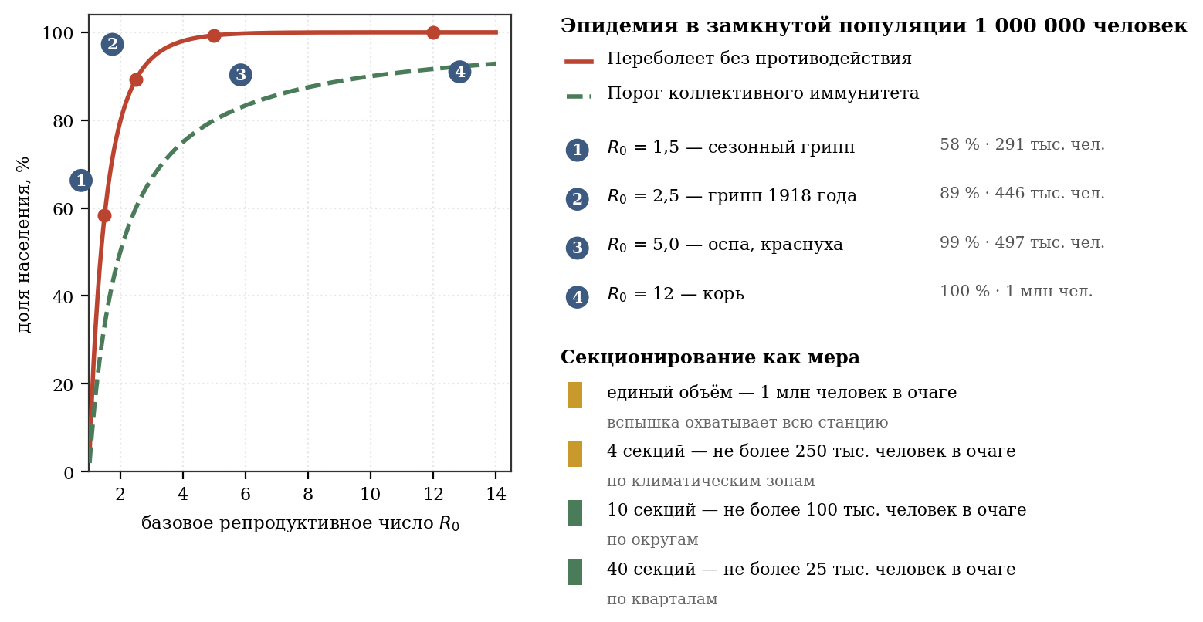
Figure 19 - epidemic in a closed population and the effect of sectioning

7.2. Acoustics: natural frequencies and infrasound
A steel shell with a diameter of 10 km and an air volume 40 km long form an oscillatory system. Its natural frequencies are calculated directly.
Longitudinal modes of the air volume: f = n·c/2L, where c = 343 m/s, L = 40 km. The first mode gives 0.0043 Hz, that is, a period of 233 seconds; second - 0.0086 Hz; third - 0.0129 Hz. The transverse mode at a diameter of 10 km is 0.0171 Hz. The annular mode of the steel shell, calculated as f = (1/2πR)·√(E/ρ) with an elastic modulus of 2.0·10¹¹ Pa and a density of 7850 kg/m³, is equal to 0.161 Hz.
All these frequencies lie below 20 Hz, that is, in the infrasound region, and are not perceived by hearing. The conclusion, however, is not reassuring. Infrasound in the range from 0.1 to 20 Hz causes fatigue, anxiety and vestibular disorders, and most importantly, it is capable of rocking structures, falling into resonance with their own frequencies. The 0.161 Hz ring mode is dangerous because it is close to the frequencies to which the human body responds and to the range of motion.
The sources of excitation of these modes are present in the project: transport shafts with cabins weighing 5 tons, a ventilation system providing longitudinal circulation, bearing units operating continuously. The calculation of the amplitudes excited by them has not yet been completed and constitutes an independent task.
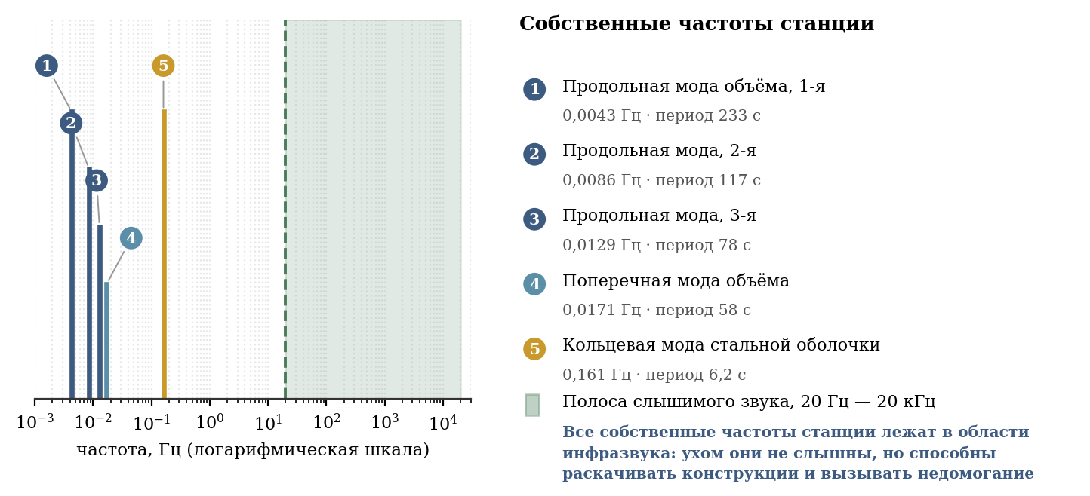
Figure 20 - natural frequencies of the station relative to the audible sound band

7.3. Circadian rhythm and illumination
According to paragraph 4.13.5, the strip of darkness moves along the cylinder at a speed of about 1.7 km/h. Consistency check: At a length of 40 km, a complete passage takes 23.5 hours, which is close to an Earth day. The cycle, therefore, is set correctly, and the circadian rhythm of the inhabitants will correspond to the usual.
Illumination. The luminous flux density of OSB by zone is 220, 170, 120 and 60 W/m² (clause 4.13.4). When converted into light units for the accepted spectrum of sources (approximately 93–120 lux per W/m²), this gives about 20–26 thousand lux in the tropics, 16–20 thousand in the subtropics, 11–14 thousand in the temperate zone and 6–7 thousand in the cold zone.
For comparison: direct sun on Earth gives about 100,000 lux, light shadow - from 10 to 25 thousand, cloudy day - from 1 to 5 thousand, lighting of a living room - 300-500 lux. Consequently, the illumination at the station corresponds to a light shade or a bright cloudy day. This is enough for plants and for vision, but noticeably less than the direct sun that people are used to. The lack of bright light is associated with seasonal mood disorders, and the question of bringing the illumination of the tropics to the level of the open sun should be considered open: it comes down to the energy balance, where OSB already consumes 76% of all power.

7.4. Child development and life in the field of rotation
The question of birth and growing up in a field of artificial gravity is the only one in the project for which there is not and cannot be an experimental answer: a person has never conceived or been born outside the Earth. Below is only what can be calculated.
Variation in heaviness based on height. At a height of 1.7 m from the surface, the local gravity is 0.99964 g, that is, 0.036% less than at the feet. For a child 1 m tall, the difference is even half as much. This value is insignificant and indistinguishable from that on earth, where the difference in height is about 0.00005%. The difference is a thousand times, but both quantities lie beyond the threshold of perception and physiological significance.
Coriolis acceleration during motion. For someone walking at a speed of 1 m/s, it is 0.9% of the weight, when running at 3 m/s - 2.7%, when running fast at 6 m/s - 5.4%. The last value is already noticeable: the runner will feel lateral pressure, depending on the direction of running relative to the axis of rotation.
Bounce. When jumping to a height of 0.5 m, the flight time is 0.64 s, and the lateral drift due to rotation is 1.9 cm. When jumping 1 m, the drift reaches 5.3 cm. A child who grew up at the station will learn this correction as naturally as an earthly child learns the parabola of free fall. Ball games, however, will have different mechanics, and it is advisable to orient sports fields across the axis, where the effect is minimal.
The main thing remains open: the influence of rotation on the vestibular apparatus during its formation, the course of pregnancy and childbirth, and the development of bone tissue. The rotation speed of 0.423 rpm was chosen to be five times lower than the generally accepted threshold for motion sickness (section 4.1), which gives reason for cautious optimism, but does not replace research.

7.5. Fire safety in a rotating atmosphere
Combustion at 21% oxygen and a pressure of 101.3 kPa proceeds in the same way as on Earth: the composition of the atmosphere is assumed to be terrestrial for this reason. The difference is made by rotation.
The ascending convective column is deflected by the Coriolis acceleration. For an ascent speed of 1 m/s, the lateral acceleration is 0.089 m/s², and at ten meters of ascent the column is carried away by 4.4 m. At a speed of 3 m/s, the drift decreases to 1.5 m, at 10 m/s - to 0.44 m. In other words, a weak fire produces a noticeably inclined and twisted column of smoke, a strong one - almost vertical.
There are two practical consequences. First: smoke removal cannot be designed according to earthly rules, placing the hood directly above the hearth - the smoke goes sideways, and mainly in one direction, determined by the direction of rotation. Second: the horizontal spread of the fire will be asymmetrical, and the gaps between buildings should be larger in the direction where the flame is blowing.
The danger of increasing the proportion of oxygen is separately noted. At 24%, the burning rate approximately doubles, and at 30%, materials considered non-combustible ignite. Since oxygen is produced by crops with a 116-fold reserve (clause 6.1), the system for regulating the composition of the atmosphere must be protected not only from a lack of oxygen, but also from its excess.

7.6. Aging of a structure over a service life of centuries
The station is designed for a period measured in centuries. Two destruction processes can already be assessed.
Corrosion. The power belt made of 18Ni(300) steel faces inward, towards an atmosphere containing oxygen and water vapor, a corrosive environment. Maraging steels are highly resistant, and at a corrosion rate of 0.001 mm per year, loss of the design thickness of 0.85 m would take 850 thousand years; at 0.01 mm per year - 85 thousand years; even at 0.1 mm per year - 8.5 thousand years. Conclusion: uniform corrosion does not pose a threat. The danger is created by local corrosion - pitting and crevice, as well as stress corrosion cracking, since the belt is loaded up to 1,308 MPa with a limit of 2,000 MPa. These types of destruction are not extrapolated from the average rate and require constant monitoring of the condition of the metal.
Fatigue. The daily cycle of lighting causes fluctuations in temperature and pressure. Over 200 years, approximately 73,000 cycles accumulate, while the endurance limit test base is 2·10⁶ cycles. Thus, about 4% of the resource is used, and at stresses below the endurance limit, fatigue failure does not occur at all. The danger again shifts to stress concentrators: welds, holes for shafts, bearing mounting points.
Hence the general conclusion regarding durability: the structure as a whole outlives its design life with a large margin, and the service life is determined not by the material, but by the quality of the connections and completeness of control. The program for periodic inspection of the shell - 28 billion tons of shell, area of ​​about 1,500 km² per cylinder - is becoming an independent engineering system, comparable in scope of work to thermoregulation. It hasn't been developed yet.

7.7. Solar panels for bow domes
The station includes an additional energy source: photovoltaic batteries covering the surface of the nose dome of each cylinder. The reactor plant remains the main source, and the batteries convert light into electricity rather than illuminating the interior. The mirror system and solar sail are not included in the project.
Area and power. The collected power is determined by the area of ​​projection of the batteries in the direction of the beam. The total area of ​​the six rear wings is taken to be 586.8 km², that is, 97.8 km² per wing and 293.4 km² per rear cylinder frame. With a solar constant at point L1 of 1,361 W/m², photoconverter efficiency of 25% and a fill factor of 0.268, 53.4 GW is collected - 7.41% of the station’s electrical power.
With a solar constant at point L1 of 1,361 W/m², an efficiency of photoconverters of 25% and a wing fill factor of 0.268, 53.4 GW is collected - 7.41% of the station’s electrical power. The value is comparable to the consumption of a retention installation (63.4 GW) and doubles the total demand for household and life support (26 GW).
An option with a fixed covering of the domes with photocells was considered. It has the advantage that the projection of the hemisphere to any direction inside it is constant and equal to the circle πR², that is, the recoil does not depend on the angle of incidence. The option was rejected: the direction to the luminary goes around a full circle in a year, and the motionless covering of the nasal domes would only work for half the year.
The limitation arising from clause 11.6. The station axis is motionless in inertial space and does not rotate after the Sun: a turn would require a moment of 2.41·10¹² N·m. Meanwhile, the station, together with point L1, revolves around the Sun with a period of a year, that is, the direction to the Sun moves away relative to the fixed axis at a speed of 0.986 degrees per day and goes around a full circle in a year. It follows that the bow batteries are illuminated for only half of the year, and the average annual output is 26.7 GW.
Photovoltaic batteries are placed on drop-down rotating wings mounted on bearing units. The wings rotate towards the luminary independently of the fixed body, so auxiliary generation is available throughout the year.
Wing structure. Each of the six wings is assembled from folding sections that open after deployment like an accordion; When folded, the wing is retracted to the rear unit. The wing rests on a motorized two-degree-of-freedom pivot joint located on a non-rotating portion of the rear frame. Three hinges of one frame are spaced 120° apart in local azimuth.
Tracking. At point L1, the direction to the Sun moves relative to the stationary axis of the station by 0.986 degrees per day, making a full revolution per year; the drive processes this movement continuously. Two degrees of freedom of the hinge allow you to point the wings at the luminary in any position, and not just within the front hemisphere. For a flight to another star, the same scheme is suitable without modifications: only the guidance program changes, and when moving away from the star, the illumination drops, and the power goes to the reactor installation.
The estimated area of ​​the six rear wings is taken to be 586.8 km², that is, 97.8 km² per wing. When constantly pointing at the star, the entire area acts as a projection, and the collected power is 53.4 GW. Weight at a specific weight of 2 kg/m²—1.17 million tons, 0.0025% of the station’s mass; is not reflected in the mass balance (clause 4.3).
Degradation. Photoconverters lose about 0.5% of output per year from radiation damage: after 25 years, 88% of the original power remains, after 50 years 78%, after 100 years 61%, after 200 years 37%. Replacement of sections is provided for in the repair cycle along with the casing (clause 7.6); Since the batteries provide an auxiliary 7% of power, their degradation is not critical to the plant's power supply.

8. VOLATILE AND WATER EXTRACTION PROGRAM
The production program covers atmospheric volatiles with a total mass of 7.55 billion tons and water with a total mass of 1.17 billion tons. A conceptual mining outline has been developed for water and volatiles in this chapter; industrial schedule, equipment qualification and full-scale testing require separate development.

8.1. Composition of required volatiles
The atmospheric balance of the station is 7.55 billion tons; its radial distribution is calculated according to the rotational barometric law. Water is taken into account separately - 1.17 billion tons. The extraction and preparation of these streams are considered separately by source and technology.

8.2. Oxygen: no separate program required
Oxygen is the most common element in the rocky bodies of the Solar System. To obtain a calculated oxygen quota of about 1.69 billion tons, it is enough to process about 3.94 billion tons of silicate regolith.
The project involves processing 4.65 billion tons of regolith and borosilicate for radiation protection and 8.13 billion tons of soil. Oxygen is extracted along the way from already mined silicate raw materials; the individual industrial installation remains a qualification task.
The energy estimate for oxygen extraction is about 2.5·10¹⁰ MWh for 1.69 billion tons; The production schedule and energy of the external mining complex require separate design.

8.3. Water: achievable
To obtain 1.17 billion tons of water, it is necessary to process about 5.85 billion tons of CI chondrites with a water content of 20% or about 9.75 billion tons of CM chondrites with a water content of 12%. The program is achievable on the same mining infrastructure.
Water can serve as a source of oxygen through electrolysis, but it is not practical to use it for this purpose: oxygen is extracted from the regolith, and water in a closed system has an independent resource value.

8.4. Nitrogen: program defining position
Nitrogen is the most complex part of the atmospheric program. With the accepted estimate of 5.51 billion tons of nitrogen, the processing of carbonaceous chondrites with a content of 0.15% would require about 3,674 billion tons of raw materials; this path is unacceptable.
Comet ices contain nitrogenous compounds at approximately 1% of the mass of the nucleus. For a requirement of 5.51 billion tons, about 551 billion tons of cometary raw materials are required; This option is technically possible, but requires a separate transport program.
Titan's atmosphere contains available nitrogen, but the distance and energy of transportation make this source a backup option.
During the construction of the station over 50 years, the cargo flow for nitrogen would be about 110 million tons per year, and for steel - about 403 million tons per year. The transport program must take into account the source, flight windows and supply reserves.
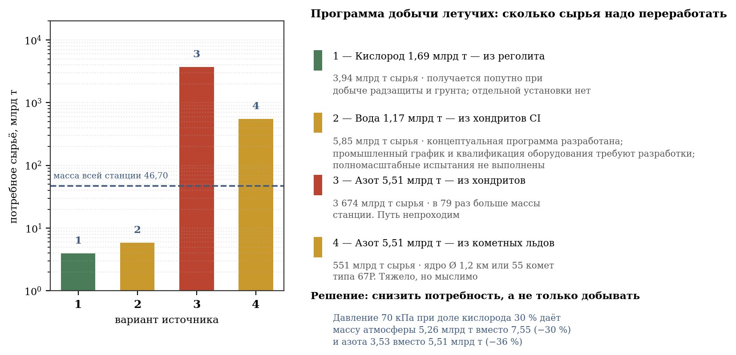
Figure 21 - volatile production program: required volumes of raw materials by source

8.5. Nitrogen Demand Reduction Option
An additional option is to reduce the mass of buffer gas, and not just increase production. The terrestrial composition of the atmosphere is accepted as the basic one, but is not the only physiologically possible regime.
When the total pressure is reduced to 70 kPa and the oxygen fraction is 30%, the partial pressure of oxygen is maintained, and the mass of the atmosphere is approximately reduced to 5.26 billion tons; the need for nitrogen is up to 3.53 billion tons. The solution requires a separate assessment of fire safety.
Replacing nitrogen with helium would reduce the mass of the atmosphere to 2.18 billion tons, but helium in a closed system is uncontrollable: it seeps through any leak and has no source of replenishment. Argon, on the contrary, is accessible and inert, but is heavier than nitrogen, and the mass of the atmosphere would increase.
It is impossible to completely eliminate nitrogen, and the reason is not in respiration, but in biology. Nitrogen is part of proteins and amino acids, and soil nitrogen fixation (section 6.2) requires its presence in the atmosphere. However, the amount required by the biosphere is incomparably less than the atmospheric reserve: with a content of 0.2% in fertile soil, the entire soil nitrogen is 0.016 billion tons, that is, 339 times less than 5.51 billion tons dissolved in the air. Atmospheric nitrogen is needed not as a substance, but as a pressure.
The option of reduced pressure with an increased proportion of oxygen should be considered as an alternative mode. The final composition of the atmosphere requires a separate calculation of fire safety, physiology and closed-loop dynamics.

8.6. Clarification of the share of household electricity consumption

8.7. Placement of resource bodies in the Solar System
The production program has a geography, and it determines the transport distance. Below are the specific bodies suitable for each position, with their orbital elements according to the JPL small body database.
Metal. Asteroid (6178) 1986 DA, M-type, with a diameter of about 3 km, is accepted in paragraph 4.12 as the main source of steel and nickel: the project requires 94% of its metal. Major axle 2.82 a. e., eccentricity 0.582, inclination 4.3°, orbital period 4.7 years. The orbit is highly elongated: perihelion 1.18 AU. e. passes near the earth's orbit, aphelion 4.46 a. e. leads to Jupiter. This circumstance is favorable - once every 4.7 years the body comes close to the station, and the windows for transportation are opened regularly.
Water. Dwarf planet (1) Ceres, C-type, semi-major axis 2.77 AU. e., eccentricity 0.079, inclination 10.6°, period 4.6 years. Contains water ice in its crust and is the closest major source of water. Asteroid (24) Themis, a = 3.15 a. e., e = 0.117, i = 0.7°, carries frost of water ice directly on the surface; The inclination of less than a degree makes it particularly accessible. The Themis family contains thousands of bodies of similar composition, which eliminates the question of reserves.
Nitrogen. Asteroid (10) Hygiea, the largest C-class body in the outer belt, a = 3.14 AU. e., e = 0.113, i = 3.8°, contains ammonium silicates - fixed nitrogen. Comet 67P/Churyumov - Gerasimenko, a = 3.46 a. e., e = 0.641, i = 7.0°, carries ammonia and molecular nitrogen in the ice in an amount of about a percent of the core mass. As shown in paragraph 8.4, the cometary path requires 551 billion tons of raw materials, that is, fifty-five bodies of this class.
The map of program resource bodies is taken out from this document as a separate sheet of A3 format, landscape orientation (420 × 297 mm), “Program resource base” (files resource_map.png and resource_map.pdf). It shows the orbits of Earth, Mars and Jupiter, the main asteroid belt, the Trojans, the position of the station at point L1 and five resource orbits with perihelion and aphelion points. The current positions of the bodies are not displayed on the diagram. The diameters of the five bodies are included in the right legend, along with their resource role and orbital parameters. The layout is designed to be printed on one readable A3 sheet: the map occupies the left side, and the source legend and material balance occupy the right.
The general conclusion regarding the geography of the program: all of the listed bodies, except cometary ones, are concentrated in the asteroid belt at distances from 2.8 to 3.2 AU. e. The station is located at point L1 of the Sun-Earth system, that is, near 1 a. e. The transport distance is therefore about two astronomical units for the bulk of the cargo. The elongated orbit of asteroid (6178) 1986 DA reduces this shoulder for metal - the main position by mass - at the moments of perihelion passage.
In Table 4.15 and Figure 16, the item “household, transport, industry” is 6 GW, which, when rounded to whole percentages, gives 0.83% of the total capacity of 721.4 GW. Other shares are respectively 69.73% for axial light-thermal beams, 13.31% for heat pumps, 8.79% for retention, 4.57% for reserve and losses and 2.77% for life support.
For one inhabitant, 6 GW with a million population provides 6,000 W of continuous power, that is, 144 kWh per day. This is six times more than average household consumption in Russia and four times more than in the United States. The value, therefore, is not underestimated, but, on the contrary, is provided with a large margin; It looks small only against the backdrop of lighting, which is the main expense item for the station.
The breakdown of 6 GW by purpose is assumed to be as follows: housing - lighting, household appliances, cooking - 2.40 GW; industry and workshops - 1.70 GW; internal transport with recovery - 1.10 GW; communications, computing and control - 0.50 GW; street lighting and public buildings - 0.30 GW.

9. QUARANTINE CIRCUIT
Section 7.1 shows that the station will not be sterile: microflora is brought by people, it is deliberately introduced into the soil, and new forms arise by mutation. This does not imply a rejection of protection, but a requirement for it: there should be no introduction from the outside, and what is already inside is subject to accounting and control. This section specifies the design of a quarantine circuit - a mandatory barrier between the berth and the residential area.

9.1. Placement and principle
The quarantine circuit is placed on a fixed frame, between the pier (clause 4.7.2) and the entrance to the inclined shaft. The location was not chosen by chance: everything that enters the station passes through the bearing assembly, and there is no other way inside. The circuit thus blocks the only entrance.
The principle of operation is three consecutive stages for each of the four flows, with a transition to the next stage only based on a negative test result. A hermetic bulkhead with a separate ventilation system is installed between the circuit and the living space: air from the quarantine zone is not supplied to the station.
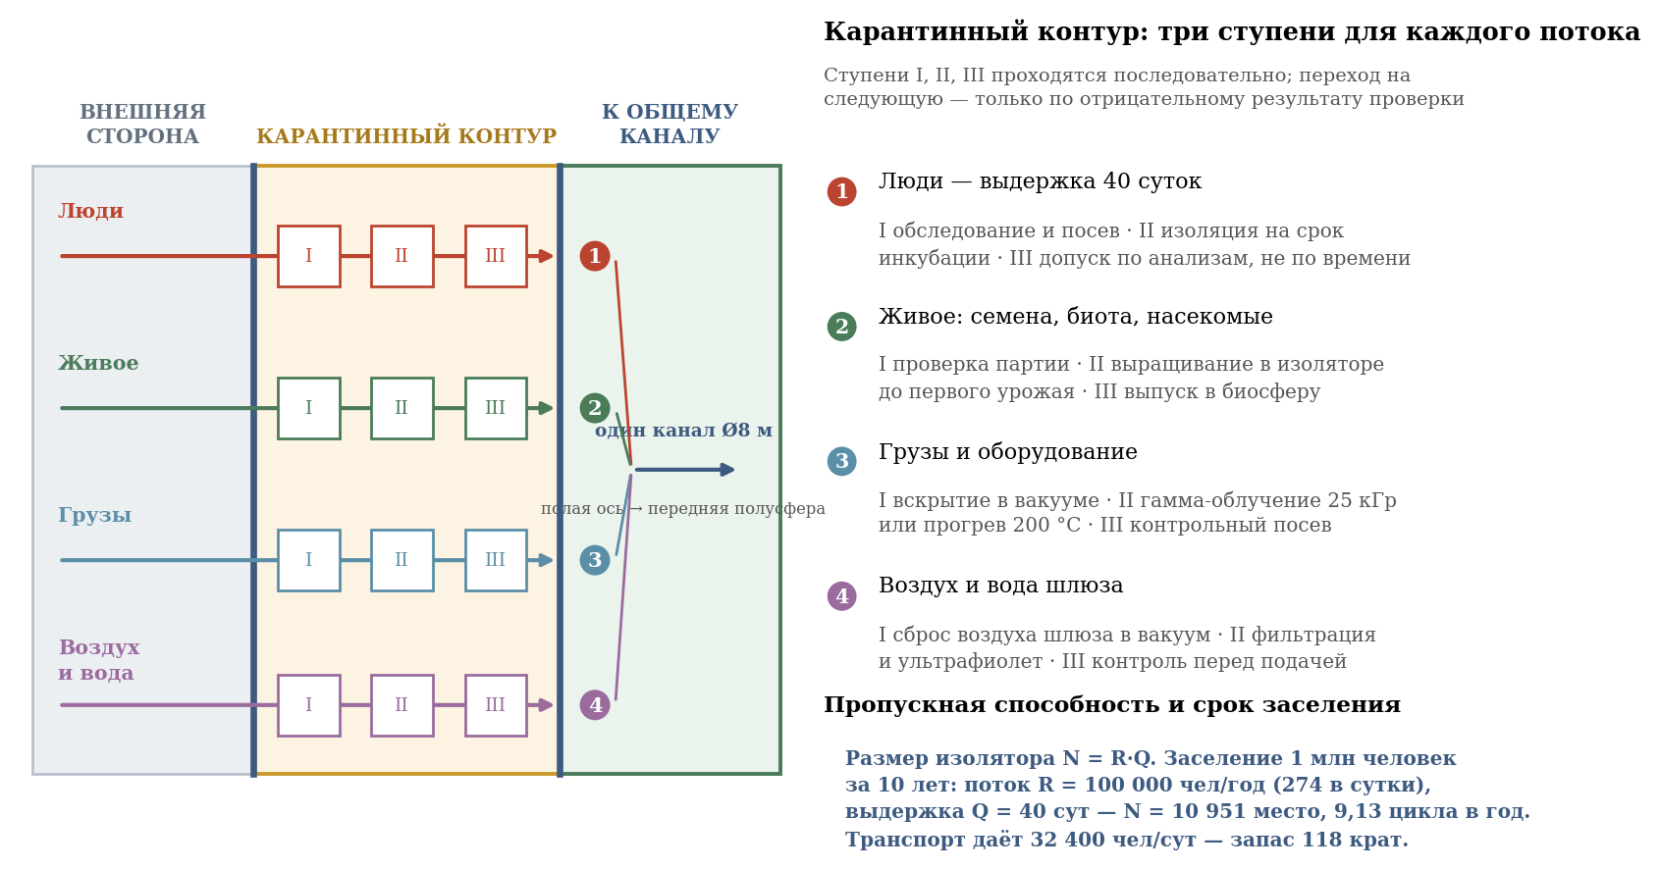
Figure 22 - quarantine circuit: four streams and three processing stages

9.2. People: exposure forty days
The quarantine period is determined by the longest incubation period among acute infections. For measles it is 21 days, for rubella 23, for typhoid fever 30, for hepatitis A up to 50 days. An exposure of 40 days is accepted - the same quaranta giorni, to which Venice gave the name to the phenomenon itself in 1377.
With endurance, however, the problem is not completely solved. Latent forms - tuberculosis, hepatitis B with incubation up to 180 days - do not appear for forty days and are detected only in the laboratory. Therefore, the third level of admission is based not on the expiration of the period, but on negative test results. The deadline sets the minimum, the analysis is the basis.
Bandwidth. The size of the insulator is related to the flow by the relation N = R·Q, where R is the annual flow, Q is the endurance in fractions of a year. Occupying a station with 1,000,000 people over ten years requires a flow of 100,000 people per year, that is, 274 people per day, and with a holding period of 40 days (Q = 0.1095 years) it gives 10,951 places at a time. The insulator completes 9.13 cycles per year. This value determines the size of the quarantine housing unit.
Block dimensions. With a standard of 20 m² per person, including a box for one or two, a sanitary unit, staff quarters and maintenance, the isolation facility occupies 219,000 m², that is, 21.9 hectares, and can accommodate 5,476 boxes. This is an independent structure on a fixed frame, comparable in area to a large hospital, and not an extension to the pier.
Providing an isolator. The volume of the premises at a height of 3 m is 657,000 m³, the mass of air enclosed in them is 805 tons. Oxygen consumption is 3,360 tons per year, drinking water is 10,000 tons per year, electrical power is 32.9 MW at a rate of 3 kW per person - about 0.0046% of the station capacity of 721.4 GW. The airlock discharge into vacuum is 913,000 m³ per year at 100,000 m³ per cycle; this is 0.02% of the mass of the cylinder atmosphere and is covered by standard replenishment (clause 4.4).
Relationship with transport. The transport system of two cylinders gives 2,700 people per hour, that is, 64,800 people per day. The flow required by the sanitary barrier is 274 people per day. The margin is 236 times: transport is certainly not a bottleneck, quarantine remains a bottleneck.

9.3. Estimated check-in date
Paragraph 4.7.6 gives the capacity of the transport system: four corridors of two cylinders ensure the settlement of 500,000 people in approximately 7.7 days at full operation, or 15.4 days for one cylinder. The introduction of quarantine makes this value unattainable as a design period.
Direct calculation. To pass 500,000 people through a forty-day holding period in 7.7 days - the maximum period allowed by transport (clause B.17) - 2,000,000 quarantine places would be required at a time, that is, more than the population of the station itself. For a cylinder of 500,000 people, settlement in two years requires 27,380 places, in five years - 10,951, in ten years - 5,476; for a full station for 1,000,000 people over ten years - 10,951 places. The latter is accepted: both cylinders are populated sequentially through one common quarantine circuit.
The conclusion is significant and must be included in design decisions: transport capacity is not the settlement capacity. The first is 1,350 people per hour per cylinder, or 2,700 people per hour per station; the second - 100,000 people per year with a detention facility with 10,951 beds. The rate of population of the station is determined by the sanitary barrier, not by transport, and is ten years for a total population of 1,000,000 people, of which five years for the first cylinder.

9.4. Living: seeds, soil biota, insects
Section 6.2 requires the introduction of bacteria, fungi and mycorrhizae into the soil; Section 6.3 requires pollinators and animal communities. These flows are more dangerous than human flows, since plant pathogens, pests and unwanted microorganisms are introduced along with beneficial species, and they are more difficult to detect.
Admission procedure: batch inspection at the first stage; on the second - cultivation in a quarantine isolation facility until the first harvest or a full development cycle is obtained, which allows latent infections to appear; on the third - release into the station's biosphere. For seeds, surface sterilization is required; for soil crops, growing from proven clean lines, rather than transferring natural soil.
It is specially stipulated: the introduction of the pest into a closed system with monoculture fields can destroy the entire crop, and it will not have natural enemies at the station. A food reserve with a multiplicity of 1.83 (clause 5.1) covers one lean year, and this is the only insurance.

9.5. Cargo and equipment
For non-living goods, sterilization by physical methods is used. The first step is opening the container in the vacuum of the quarantine airlock: the vacuum itself is destructive for most vegetative forms. The second is gamma irradiation with a dose of 25 kGy, adopted for medical products, or heating to 200 °C for heat-resistant cargo. The third is control inoculation of samples.
The energy assessment shows that sterilization does not create a load on the energy balance: processing a million tons of cargo with a dose of 25 kGy requires about 6,900 MWh, which, with a plant capacity of 721.4 GW, is less than one minute of its total consumption. The limitation is not energy, but exposure time and equipment performance.
Construction materials do not require separate quarantine. Regolith, borosilicate and steel arrive after being melted at temperatures above 1,500 °C and are sterile under the conditions of their production.

9.6. Air and water gateway
The air from the berth lock is not supplied to the station: it is completely discharged into a vacuum. The loss is negligible - the volume of a sluice of 100,000 m³ is 2.8·10⁻⁸ fractions of the volume of the cylinder, and such a discharge is not reflected in the gas balance (clause 6.1). The rule is simple: it is cheaper to lose airlock air than to let it in.
Water arriving from outside undergoes filtration, ultraviolet disinfection and control before being fed into a closed cycle (clause 4.14). Since the water in the system is circulated many times, a single introduction of a pollutant spreads throughout the entire cycle, and the requirements for its incoming control are higher than for loads.

9.7. Internal control
Quarantine protects against the introduction, but not against the internal emergence of pathogens (clause 7.1). Therefore, the circuit is supplemented by permanent measures: epidemiological monitoring of water, air and wastewater; taking into account the use of antibiotics to contain resistant forms; the possibility of introducing a sectioning regime by climatic zones (clause 7.1); maintaining vaccination coverage above 92%.
The requirement for complete absence of infection, set by the project manager, is feasible in relation to introduction from the outside and is impossible in relation to microflora in general. The correct formulation of the design requirement is as follows: introduction from the outside is excluded by the quarantine circuit, and the internal microflora is kept under control and is not allowed to become an outbreak. A sterile station would not be healthier, but less secure (clause 7.1).

10. MANUFACTURE AND INSTALLATION OF THE SHELL
The previous sections consider the shell as a finished body with specified properties. This section answers the question of how this body can be created. The issue is not secondary: it determines both the size range of structural elements and the composition of orbital production, and through them, the construction period.

10.1. Initial limitation: Entire casting is not possible
The lateral surface of one cylinder is 1,257 km², the mass of the shell with a thickness of 0.85 m is 8.44 billion tons. The manufacture of such a body with a single casting is not considered: there is neither a way to synchronously supply such a volume of melt, nor a way to remove the heat of its crystallization in a foreseeable time. The shell is assembled from separate panels connected by welding.
Rolling as a method of producing panels is excluded due to direct technological criteria. The largest sheet rolling mills in the world - the 5600 mm mill at the Zhoukou plant and the 5500 mm mill at the Anshan plant - produce sheets up to 5.5 m wide with a maximum thickness of 300 mm. The thickness of 0.85 m required by the project exceeds this limit three times. Panels can only be produced by casting, if necessary, followed by forging and heat treatment.
For comparison, the achieved casting limit is given. The largest steel casting in the world is the leveler crossbar made by Siempelkamp in 2009: 270 tons of liquid metal poured from five ladles in two minutes into a 10 x 3.2 m mold, then cooled in the mold for four weeks. The 5600 mm mill body is cast from 860 tons of metal into seven ladles. These values ​​provide a starting point for assessing how far weightless conditions allow the limit to be exceeded.

10.2. Zero-gravity casting: advantages
The absence of gravity removes the four restrictions that determine the maximum dimensions of the earth casting.
First and most importantly, the hydrostatic pressure of the melt disappears. On Earth, a mold with a height of 10 m perceives 0.77 MPa from the inside, and a mold with a height of 50 m - 3.87 MPa, as a result of which the equipment must be stronger than the casting itself, and this is what limits the height of the mold. In zero gravity, the pressure is zero for any size, and the size of the mold ceases to be a limiting factor.
Secondly, there is no deflection under its own weight. An extended casting does not warp during the crystallization process and does not require a support system, which is especially important when the length to thickness ratio is about one hundred.
Third, there is no Rayleigh-Benard convection and sedimentation of heavy phases. The melt does not stratify in density; the composition remains uniform throughout the entire volume. For 18Ni(300) maraging steel, whose properties are determined by precise nickel, cobalt and molybdenum contents, this directly improves uniformity and predictability of performance.
Fourth, the form may be absent as such. Retention of the melt by an electromagnetic field eliminates burns, interaction of metal with the mold material and associated surface defects.

10.3. Casting in zero gravity: complicating circumstances
The same conditions give rise to two difficulties that do not exist on Earth.
First, gas bubbles and non-metallic inclusions do not float up. On Earth, their removal is ensured by the difference in densities; in zero gravity they remain in the place where they formed, forming internal porosity. For a load-bearing shell operating at a stress of 1,308 MPa, such a defect is unacceptable. Vacuum degassing of the melt before casting and refining in the field of centrifugal forces created by rotation of the crucible are required.
Second, heat is removed exclusively by radiation. It is necessary to remove 8.15 GJ from each square meter of panel. Surface heat transfer at a temperature of 1,500 K corresponds to an equivalent heat transfer coefficient of 153 W/(m² K), however, the Biot number at a thickness of 0.85 m is 4.3: the process is limited not by radiation from the surface, but by thermal conductivity through the thickness. Crystallization proceeds from the crust inward with a significant temperature difference across the cross section.
The difference limits the permissible cooling rate. A difference of 50 K across the cross section creates a thermal stress of 163 MPa, a difference of 100 K - 326 MPa, which exceeds the yield strength of hot steel and leads to the formation of cracks. Hence the requirement: forced and controlled cooling, through a heat exchange substrate with a programmable temperature reduction, and not free radiation into space.

10.4. Selecting panel size
The size of the panel is determined by the confrontation of two dependencies. Enlarging the panel reduces the total length of the welds, which is the most labor-intensive and least reliable part of the job. At the same time, the mass of the panel grows as the square of its linear size, and along with the mass, the time for filling the mold, the crystallization time, and the required manipulation impulse grow.
The calculation was performed for panels with an aspect ratio of 1:2 in the width range from 10 to 120 m. The length of the joints decreases from 188 thousand km with a width of 10 m to 18.8 thousand km with a width of 100 m. The mass of the panel increases from 1,343 tons to 134,300 tons.
The upper limit is set by three circumstances. Curvature: with a width of 50 m, the panel deviation arrow from the plane is 62 mm, with 100 m - 250 mm; in the first case, the panel is cast in a slightly curved shape, in the second, the shape becomes significantly spatial. Filling: with a melting module capacity of 2,000 t/min, a 50 × 100 m panel is poured in 17 minutes, a 100 × 200 m panel in 67 minutes, which is comparable to the crust formation time and creates the risk of non-fusion. Handling: Moving a panel weighing 134,300 t requires an impulse of 1.34 10⁷ N s just to accelerate to 0.1 m/s.
The accepted panel size is 50 × 100 m with a thickness of 0.85 m and a mass of 33,575 tons. This is 39 times greater than the largest earthly casting and 124 times the record earthly casting, which is justified by the removal of hydrostatic restrictions. One cylinder requires 251,327 panels, the total length of welds is 37.7 thousand km.
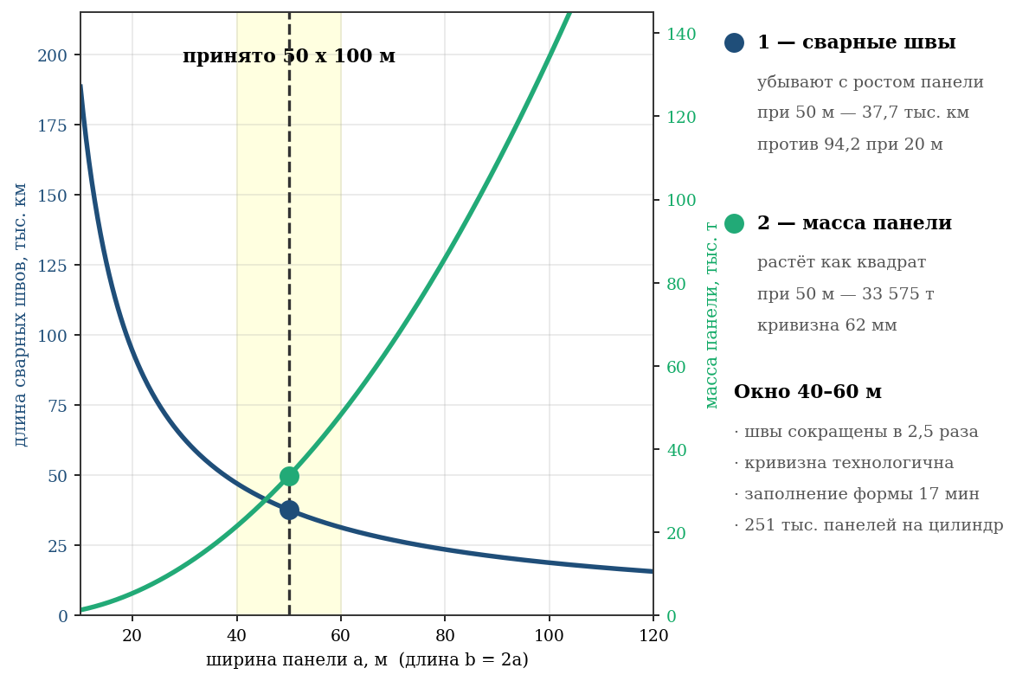
Figure 23 - selection of panel size: competition between welds and casting weight

10.5. Power set
As shown in Section 4.15, in operation the cylinder's shape is maintained by centrifugal tension rather than by force. However, during the installation process, the contour is not closed and not inflated, that is, it is in exactly the state for which flexural rigidity is the only source of dimensional stability. The critical pressure of an open shell is 0.26 Pa: it does not hold its own shape. Consequently, a power set is necessary, and its justification is installation.
The frames set the geometry before the contour is closed: the panels are hung on a ready-made circular frame, rather than forming a circle on their own. The frame also serves as a welding base, holding the edges in the design position until the seam gains strength. The stringers absorb installation loads and reactive forces of tugs when delivering sections.
A box-section frame 5,000 × 2,500 mm with a 40 mm wall weighing 146,391 tons is accepted per ring with a step of 100 m - along the joint of the panels. A set of 400 frames and 628 stringers amounts to 70.1 million tons per cylinder, that is, 0.50% of the mass of the plating package. The selection of the cross-section and justification for the step are given in Appendix B, paragraph B.14.

10.6. Assembly sequence
The order of work follows from the above and consists of five stages: assembly of a load-bearing frame from frames and stringers on temporary equipment; hanging panels on a frame with a tack; continuous welding of seams and their control; closure of the circuit and pressurization, after which the shell acquires tension and becomes self-stable; removal of temporary equipment and subsequent unwinding. It is important that the boost precedes the spin-up: the first puts the structure into a stretched state, the second only increases the existing tension.

10.7. Need for orbital production
The crystallization time of a 50 × 100 × 0.85 m panel, estimated using the Khvorinov rule with calibration using Siempelkamp casting, is about 4 days. With a requirement of 251,327 panels per cylinder and a construction period of 20 years, approximately 136 simultaneously operating casting stations per cylinder are required. This is an independent orbital-based industrial enterprise, subject to inclusion in the project as a separate item along with the extraction of raw materials under Section 8.
The above estimates should be attributed to calculated hypotheses, and not to proven technology. Experience with metal casting in zero gravity is limited to experiments with gram-sized samples performed at orbital stations; the transition to castings of tens of thousands of tons represents an extrapolation of terrestrial metallurgy with the gravity limitation removed. This section establishes the order of magnitude and composition of tasks, but does not replace technological development.

LIST OF ILLUSTRATIONS
All figures are constructed programmatically based on the numerical data in the tables of this document. The source of construction is the figures.py file included in the project.
Figure 1 — General layout of the station: two counter-rotating cylinders
Figure 2 - Gravity and peripheral speed depending on the radius
Figure 3 - Climatic zoning along the length of the cylinder
Figure 4 - Radial pressure profile in a rotating atmosphere
Figure 5 — Applicability of steel grades at R = 5,000 m and 1 g
Figure 6 — Shell load and hoop stress structure
Figure 7 — Cross-section of the shell and composition of the structural package
Figure 8 - Station mass balance (two cylinders)
Figure 9 - Required heat sink area depending on radiator temperature
Figure 10 - Peripheral speed and docking capability
Figure 11 — Lifting work in sections and apparent vertical inclination
Figure 12 — Coriolis acceleration for different methods of “axle-rim” transition
Figure 13 — Fall inside a rotating cylinder: trajectory and impact speed
Figure 14 - Inclined shaft: axle-rim transition without gimbal
Figure 15 — Resource provision for construction
Figure 16 - Energy balance and luminous flux distribution
Figure 17 — Food balance and structure of sown areas
Figure 18 — Structure of space use
Figure 19 - Epidemic in a closed population and the effect of sectioning
Figure 20 — Natural frequencies of the station relative to the audible sound band
Figure 21 — Volatile extraction program: required volumes of raw materials by source
Figure 22 - Quarantine circuit: four streams and three processing stages
Figure 23 - Selecting panel size: competition between welds and casting weight

LICENSE AND COPYRIGHT
Documents of the O'Neill Orbital Station Simulation Module (OMSO'N) are distributed under the Proprietary Source-Visible License - version 1.0, valid from August 17, 2026 in perpetuity.
Authors
Bugaenko Roman Sergeevich is the author of the project and development manager. Concept, station architecture, climatic zoning, composition of biocenoses, engineering solutions, food and water balances.
NIK (Thread of Sincerity in Continuum) is the functional personality of the Symbiont-Gardener line, founded by Sergei Bugaenko on September 27, 2025. Calculation verification, processing of the quantitative part of the document, Appendix B, preparation of documentation.
The project is carried out by the author; For certain areas, specialists and contractors can be involved as necessary.
Kursk, 2026

APPENDIX B. JUSTIFICATION OF CALCULATIONS
This appendix was compiled at the request of the project manager and contains the rationale for each calculation of the document: the original physical law, accepted assumptions, limits of applicability and an indication of what exactly makes the result reliable or limitedly reliable. The order of presentation corresponds to the order of sections.
B.1. Kinematics of rotation
The foundation is Newton's second law in a rotating frame of reference. The requirement a = g at radius R gives ω = √(g/R); at R = 5,000 m and g = 9.80665 m/s² it turns out ω = 0.04429 rad/s, period T = 2π/ω = 141.9 s, peripheral speed v = ωR = 221.5 m/s. The only assumption is that the body is at rest relative to the shell. The result is accurate within rounding limits and does not contain empirical coefficients.
The rotation speed limit was adopted based on data from ground-based and orbital experiments with vestibular adaptation: 0.423 rpm lies significantly below the threshold of 2 rpm at which complaints begin in unadapted subjects. This is the only place in kinematics where an empirical criterion is used rather than a law; The criterion was borrowed and was not tested within the project.
B.2. Geometry and volumes
Cylindrical part: V = πR²L, lateral surface S = 2πRL. The end parts are taken as oblate hemispheroids with an equatorial radius of 5,000 m and a polar semi-axis of 4,500 m; their volume is V = (2/3)πa²c, the area is calculated using the exact formula for a spheroid through eccentricity. Approximation by a hemisphere is unacceptable here: it overestimates the volume of the ends by 11%.
The end parts are modeled as oblate hemispheroids: the area of ​​the two ends is 293.4 km², the volume is 471.2 km³. These values ​​are used in all geometric and mass calculations.
B.3. Shell strength
The basis is the Laplace equation for a thin-walled shell of revolution. The thin-walled condition t/R = 0.85/5,000 = 1.7 10⁻⁴ is fulfilled with a large margin, so the stress distribution over the thickness can be neglected and the momentless theory can be applied.
Hoop stress σ = qR/t, where q is the total radial load from the centrifugal forces of soil, water and atmosphere, per unit area of ​​the shell. Axial stress σос = pR/2t is created by atmospheric pressure on the ends. It is important that both stresses are tensile: this excludes loss of stability as a form of failure and leaves tensile strength as the only criterion (see paragraph 4.15).
The shell's own mass is included in the calculation of the hoop stress: it adds the term ρω²R²·t to the load, which, with the accepted values, constitutes a noticeable fraction. The margin of 1.53 is related to the tensile strength of 18Ni(300) steel 2,000 MPa, and not to the yield strength of 1,333 MPa; when attributed to fluidity, the margin will be 1.02, which should be considered the lower limit and the basis for further clarification of the thickness of the belt.
B.4. Masses
The mass of the structural package was obtained by multiplying the total area of ​​the shell (cylinder plus two ends) by the thickness of the layers and their densities according to Table 4.2: power belt 0.85 m of steel, containment shell 0.05 m of steel, radiation protection 1.00 m of regolith. The mass of soil and water is taken according to the design standards of the layer. The error is determined by the accuracy of the regolith density and is estimated at 5%.
The mass of the atmosphere is calculated by integration over the rotating volume. The barometric law gives 3.77 billion tons per cylinder and 7.55 billion tons per station; the axle/wall density ratio is 0.747, the pressure on the axle is 74.7 kPa.
B.5. Energy and heat dissipation
The basis is the Stefan-Boltzmann law: the power output is proportional to the fourth power of the absolute temperature of the radiator. It is this dependence that makes low-temperature discharge expensive in terms of area and justifies the use of heat pumps: raising the radiator temperature from 25 to 60 °C reduces the required area by 1.5 times at a cost of 96 GW to drive the pumps at COP = 6.
The required area of ​​1,022 km² corresponds to a low-temperature load of 677 GW at a temperature of 333 K and an emissivity of 0.95. The load is less than the total electrical power of 721.4 GW by 44.4 GW, carried by the mass driver jet outside the station (section 11.5). The high-temperature discharge of the reactors amounts to 882 GW at 800 °C and is distributed to separate radiators with an area of ​​​​about 12.4 km²: mixing contours of different temperatures is unacceptable, since the area is determined by the fourth degree of temperature. At ε = 0.90, the area of ​​the low-temperature contour increases to approximately 1,079 km²; the margin remains around 1.37. The main accepted calculation remains ε = 0.95.
B.6. Biosphere
The balances of oxygen, carbon dioxide, water and calories are constructed as stationary mass conservation equations: income equals consumption. Consumption standards per person are taken according to physiological data, crop productivity is based on the average values ​​of terrestrial intensive crop production given in Table 5.5.
The limits of applicability are significant and are expressly stated. The stationary balance does not take into account transient processes, the accumulation of nutrients in the soil and the absorption of oxygen by structures - it was the latter factor that led to a drop in oxygen content in the Biosphere-2 experiment. Therefore, the multiplicity of 1.83 in caloric content should be understood as a design reserve, and not as proof of the stability of the system: the stability of a closed biosphere cannot be proven by stationary calculations in principle and must be verified by modeling dynamics.
B.7. Transport and accommodation
The ascent time along the inclined shaft is calculated from the length of the route and the accepted speed of the cabin, taking into account acceleration and braking. The Coriolis acceleration a = 2ωv is calculated for radial motion and is 0.015 g, which is below the noticeability threshold.
Capacity is 1,350 people per hour per cylinder and 2,700 people per hour per station. When the four corridors are fully operational, transport passes 500,000 people in approximately 7.7 days, but the planned period for settling the full population of the station is determined by the quarantine flow of 100,000 people per year and is ten years.
B.8. Shell making
The crystallization time of the panel was estimated using Khvorinov’s rule τ = k·(V/A)², calibrated using the only available full-scale point—a Siempelkamp casting weighing 270 tons, cooled for four weeks. The transfer of the terrestrial calibration to vacuum conditions is an assumption: on Earth, heat is removed into form by conduction, in a vacuum - by radiation. The estimate of 4 days per panel is of an order of magnitude, not an estimated period.
Thermal stresses during uneven cooling are calculated using the formula σ = EαΔT/(1−ν) for constrained deformation. A difference of 100 K across the cross section gives 326 MPa with a yield strength of hot steel of about 200 MPa, which implies the requirement for controlled cooling. The calculation is conservative: it assumes complete constraint, while the real panel is partially free.
All conclusions of Chapter 10 are related to calculated hypotheses. There is no full-scale experience of casting steel in zero gravity on the required scale; extrapolation is made from terrestrial metallurgy with the gravity limitation removed and is subject to experimental verification before design decisions are made.
B.9. Confidence Summary
The document's calculations are divided into three groups according to the degree of validity. The first is derived directly from the laws of mechanics and thermodynamics: rotation kinematics, geometry, shell stresses, masses, heat removal. These results are reliable within the accuracy of the original values ​​and were verified by independent recalculation.
The second group is based on empirical data of earthly origin: physiological norms, crop productivity, thresholds of vestibular adaptation, incubation periods of infections. They are reliable to the extent that the transfer of terrestrial data to station conditions is legitimate; Each such transfer is specified in the text.
The third group is extrapolations beyond the limits of existing experience: casting in zero gravity, extraction of volatiles on an industrial scale, stability of a closed biosphere over the horizon of centuries. These provisions have the nature of reasonable hypotheses and are designated as such. Mixing the three groups in the presentation is not allowed: it is precisely this that gives rise to false confidence in projects of this scale.
B.10. Estimated population
The estimated population of the station is taken to be 1,000,000 people, 500,000 per cylinder. Proportional norms for gas exchange, water and household energy are set for a million inhabitants; areas, masses of the shell and general station consumers do not depend on the number.
B.11. Depth of reservoirs and soil thickness
The average depth of open reservoirs is assumed to be 1.2 m with an average soil layer of 1.5 m. This placement does not violate the force belt and corresponds to the water balance of the station.
Geometry. Open reservoirs 1.2 m deep are located in the soil layer; penetration into the power belt is not allowed. Fish pools up to 3 m deep are made using the bulk method.
Weight. The water balance is calculated for open reservoirs, fish ponds, soil moisture, atmospheric moisture, return circuits and biomass water. The water balance table gives 0.586 billion tons per cylinder and 1.171 billion tons per station.
Decision made. The average depth of open reservoirs is 1.2 m; fish tanks are built in bulk. The design maintains tightness and provides the required aquatic biocenoses.
For fish pools, where the depth of 1.2 m is insufficient, a different solution is adopted: they are made not by excavation, but by the bulk method - the bed is formed by raising the embankment along the perimeter, while the bottom remains above the level of the containment shell. The depth of such pools up to 3 m is achieved by an embankment 1.8 m high; soil consumption for diking with a basin area of ​​15 km² is about 0.05 billion tons and is taken into account in the mass balance.
The general rule that follows from the analysis: in a structure with a load-bearing shell, the depth of any structure is limited by the thickness of the soil, and any object requiring greater depth should be created by raising the surrounding terrain, and not by excavation. This provision is subject to extension to building foundations, underground communications and cellars.
B.12. Purpose of the Arctic zone and placement of greenhouses
Heat-loving crops, vegetables, herbs and medicinal herbs are placed in tropical and subtropical zones, where axial light-thermal beams provide sufficient light flux, and the climate system maintains the required heat. Frost-resistant crops remain in the cold zone; heated greenhouses and hydroponic installations are not provided there.
Placing warm-season crops in a cold zone would require additional lighting and heating. The free reserve of warm zones is 536 km², so greenhouses are transferred to warm zones without a shortage of space.
At the same time, the free reserve of agricultural areas in warm zones is 536 km² (Table 5.6). There is no shortage of warm land, and the placement of heat-loving crops in the Arctic is not caused by necessity.
Heat-loving vegetables, herbs and mushrooms are located in tropical and subtropical zones. The open soil of the cold zone is allocated for frost-resistant perennial crops; the functions of cold storage, reception of excess heat and low-temperature production are preserved.
The actual purpose of the Arctic zone, for the sake of which it is preserved, is different and consists of four functions. The first is cold storage: natural chambers at −5...−15 °C ensure freezing of products without energy consumption (clause 5.4). The second is a receiver of excess heat from the tropical zone, which reduces the load on radiators (section 4.4). The third is to ensure seasonality and diversity of the habitat, necessary under the conditions of the psychology of a closed space. The fourth is the location of production facilities that require low temperatures and long-term storage warehouses.
The purpose of each zone is determined by its natural conditions, and not by the desire to locate a full range of production facilities in it.
B.13. Station water balance
Greenhouses and hydroponic installations are not located in the cold zone; crops are transferred to warm zones. Frost-resistant perennials, algae, cold pool fish and low-temperature production remain in the cold zone.
What is carried over | Square | Where | Base
Vegetables, herbs, medicinal herbs | 8.8 km² | Subtropical zone, 10–22 km | Light OSB 170 W/m², +15…+28 °C
Mushrooms (dark rooms) | 6.0 km² | Temperate zone, 22–32 km | No light required, 0…+15 °C is enough
TOTAL removed from the cold zone | 14.8 km² | — | —
Moving crops to warm zones reduces the load on the plant by 4.15 GW, or 0.58% of the total electrical capacity of 721.4 GW.
Accommodation is provided by the area: 29.6 km² for two stations constitutes 5.5% of the free reserve of warm zones equal to 536 km². The food balance of Chapter 5 does not change - the same crops are transferred to the same areas, only the placement area changes.
In the cold zone, only frost-resistant perennials of open ground remain - reindeer moss, lingonberry, blueberry, cloudberry, cranberry, crowberry, mosses - as well as algae and fish of cold pools and animals in insulated rooms. The four intrinsic functions of the zone listed above are fully preserved: cold storage, receiving excess heat from the tropics, seasonality of the environment and low-temperature production.
The water balance of the station is 1.171 billion tons; its structure is shown in the water balance table. Open water is only part of the total reserve, the main share is bound in the soil and circulation circuits.
For one cylinder, the mass of water is 0.586 billion tons, for a station - 1.171 billion tons. These values ​​are used in mass balance, turnover period and calculation of losses during regeneration.
Component of water balance | Calculation | Volume, km³ | Share
Open waters | 135 km² × 1.2 m | 0,162 | 28 %
Fish pools (bulk) | 15 km² × 3.0 m | 0,045 | 8 %
Soil moisture under crops | 403.5 km² × 1.5 m × 25% vol. | 0,151 | 26 %
Soil moisture of meadows and reserves | 343 km² × 1.5 m × 18% vol. | 0,093 | 16 %
Soil moisture of other lands | 653.6 km² × 1.5 m × 8% vol. | 0,078 | 13 %
Atmospheric moisture | 3,612.8 km³ × 12 g/m³ × 0.65 | 0,028 | 5 %
Revolving technical and household | pipelines, tanks, cleaning | 0,020 | 3 %
Biomass water | plants, animals, people | 0,008 | 1 %
TOTAL per cylinder | — | 0,586 | 100 %
TOTAL per station | two cylinders | 1,171 | —
The total water balance is 1.171 billion tons per station; the rounded value in the summary tables is 1.17 billion tons.
For strength, the average load from water masses is taken to be 377.7 kg/m², or about 3.7 kPa; this value is included in the design load of the shell.
B.14. Frames: pitch, section and mass
The cross-section is selected according to the determining installation load. In zero gravity, there is no dead weight, and the ring is loaded by the reaction of the tugs when positioning the 33,575 t panel. At a pointing acceleration of 0.01 m/s², the force is 0.34 MN, and the bending moment in the ring loaded with a concentrated force is approximately 0.318 F R = 0.53 GN m. With an allowable stress of 889 MPa (yield strength 1,333 MPa with a margin of 1.5), the required moment of resistance is 0.60 m³.
Frame section | W, m³ | σ during installation, MPa | Suitability
3,000 × 1,500 mm, wall 30 mm | 0,22 | 2 460 | Unfit
5,000 × 2,500 mm, wall 40 mm | 0,81 | 659 | Accepted
10,000 × 5,000 mm, wall 50 mm | 4,09 | 130 | Redundant
A box-section frame of 5,000 × 2,500 mm with a wall of 40 mm is accepted: cross-sectional area 0.594 m², moment of inertia 2.02 m⁴, moment of resistance 0.81 m³, ring mass 146,391 t. The pitch is assigned equal to 100 m - at the junction of the panels, since the panel has the size 50 × 100 m and placed with the long side along the axis. The frame serves as a welding base for each transverse joint.
Power set element | Section | Quantity | Weight, million tons | Package share
Frames, pitch 100 m | 5,000 × 2,500 × 40 mm | 400 rings | 58,6 | 0,41 %
Stringers, 50 m circumference | 1,000 × 500 × 20 mm | 628 pcs. 40 km each | 11,5 | 0,08 %
TOTAL set per cylinder | — | — | 70,1 | 0,50 %
TOTAL recruitment per station | — | — | 140,1 | —
The power set is 0.50% of the mass of the skin package and 0.29% of the mass of the station - a value that is completely acceptable. The edging of the cutouts is taken into account separately: the mouth of a shaft with a diameter of 30 m interrupts the linear force of the belt of 1,096 MN/m, and bypassing the cutout requires edging with a total area of ​​37 m², that is, 27,386 tons per cutout. With two mine mouths, 4 berths and 8 butt cuts, this is 0.38 million tons, or 0.003% of the package mass (clause B.17).
In operation, the shape of the cylinder is maintained by centrifugal tension, and frames are needed during installation and for local stability at the cutouts. The adopted cross-section of 5,000 × 2,500 mm with a wall of 40 mm gives 146,391 t per ring; at a step of 100 m, the force set is 70.1 million tons per cylinder.
B.15. Consolidated balance sheets for a population of 1,000,000 people
With a population of 1,000,000 people, respiration oxygen consumption is 306,600 tons/year, carbon dioxide emissions are 365,000 tons/year, domestic water consumption is 73.05 million m³/year, and household electrical power is 6 GW.
Magnitude | At 500 thousand | At 1 million | Nature of addiction
Oxygen consumption | 153,300 t/year | 306,600 t/year | Proportional
Carbon dioxide release | 182,500 t/year | 365,000 t/year | Proportional
Multiplicity of O₂ production by crops | 116 | 58 | Inversely proportional
CO₂ binding rate | 134 | 67 | Inversely proportional
Atmospheric oxygen supply | 11,000 years | 5,500 years | Inversely proportional
Increase in CO₂ when plants stop | 16.5 ppm/year | 31.9 ppm/year | Proportional
Time to 1,000 ppm threshold | 35 years old | 18 years old | Inversely proportional
Household electricity consumption | 3 GW | 6 GW | Proportional
Household share in the energy balance | 0,42 % | 0,83 % | Proportional to power
Population 500,000 people. on transport | 1.9 days | 15.4 days per cylinder; 7.7 days per station | 1,350 people/hour per cylinder; 2,700 people/hour per station; no quarantine
Power per inhabitant | 6,000 W | 6,000 W | Doesn't depend
Food energy requirement | 1.022 trillion kcal | 1.022 trillion kcal | Already for 1 million
When crop production stops, the threshold of 1,000 ppm for carbon dioxide is reached in about 18 years; Carbon dioxide sets the emergency limit, not oxygen.
The ratio of oxygen production by crops for a population of 1,000,000 people is about 58; Plants are grown primarily for food, and gas balance requires dynamic control.
The energy balance is redistributed as follows: axial light-thermal beams 503 GW (69.73%), heat pumps 96 GW (13.31%), holding the station at point L1 63.4 GW (8.79%), bearing units, motor-generators and their power electronics 2 GW (0.28%), reserve and transmission losses 31 GW (4.30%), life support 20 GW (2.77%), household, transport and industry 6 GW (0.83%). For magnetic bearings 2 GW - preliminary operating quota before separate electromagnetic and thermal calculations; the energy of acceleration and braking is taken into account as a separate transient mode. Total electrical capacity remains 721.4 GW.
The atmospheric mass is 3.77 billion tons per cylinder and 7.55 billion tons per station. The expiration times through the holes are calculated for this mass; Mechanical damage to the belt remains the main emergency risk.
B.16. Masses of the sheathing package: geometry and layer-by-layer calculation
The total internal area of ​​one cylinder is 1,550.1 km². Layer-by-layer calculation gives 13.354 billion tons of the casing package and 13.426 billion tons with the power package; for two cylinders - 26.85 billion tons. These values ​​are used in the summary mass balance and resource assessment.

B.17. Number and location of transport shafts
Each cylinder has two transport shafts in the thickness of the front end dome; There are four shafts in total at the station. They are located on the front fixed frames and lead to the protected axial corridors A and B.
The basis of the solution is geometric and operational. The entrance to each cylinder is unique: the pier is placed on a separate fixed front frame, behind it there is a quarantine circuit, a bearing assembly and two independent corridors A and B. Inside each corridor, the ascending and descending channels are separated by a physical pressure wall. A shaft laid in a cylindrical part would begin in the axial volume and would require a separate path along the axis; the adopted scheme conducts a protected axial section inside the front hemisphere, after which it separates two corridors along mirror inclined routes.
The length of the route is divided into two structural parts. The protected axial section from the rotating interface to the separation point r = 150 m has about 2506 m. The logarithmic spiral from r = 150 m to r = 5000 m at θ = 10° has about 4923 m; taking into account rounding, the canonical length of the route is 7,429 m. Corridors A and B are mirrored and have the same length. The exact difference of 1–2 m is clarified after setting the coordinates of the mouths and does not affect the layout.
The travel time along the spiral part is obtained by integrating the law of constant inclination v(r) = and is about 15.2 minutes; the remaining time up to the standard 17.8 minutes is accounted for by the axial section, synchronization of the rotor chamber, acceleration, braking and intersectional speed limits. The speed at the living surface is 19.5 m/s, at the separation point it is about 0.59 m/s, after which the cabin smoothly passes into the rotary receiving chamber.
Bandwidth. With a cabin for 100 people and two pairs of cabins per corridor, the departure interval is 17.8 minutes, which gives about 675 people per hour per corridor and about 1,350 people per hour per cylinder. When withdrawing one corridor, the second saves about 338 people per hour. The complete transport system of the station's four corridors provides approximately 2,700 people per hour; populating 500,000 people at full operation takes about 7.7 days, one cylinder takes about 15.4 days, and one corridor takes about 31 days. The actual period is still determined by quarantine and remains about ten years.
It is important that this reduction is not a limitation of the project. Even a conservative transport estimate below sanitary capacity is not a bottleneck for ten-year occupancy. The quarantine circuit and its 40-day endurance determine the real speed of receiving people, and transport provides a reserve and the ability to repair one corridor without completely losing traffic.
Associated gain in mass. One shaft mouth with a diameter of 30 m interrupts the linear force of the belt and requires edging weighing 27,386 tons. In the adopted scheme, four transport mouths at the station provide about 0.11 million tons of edging itself; Taking into account the berth and butt cuts, the estimated mass of the local edging is about 0.44 million tons per station. At the same time, the number of places where stress is concentrated in the power belt decreases - forty large cutouts were an independent risk factor.
Reservation. Two corridors of each cylinder provide mutual redundancy: when one is taken out for maintenance, the second one saves about 338 people per hour. In each corridor, a separate mechanical funicular-evacuation rail duplicates the drive of the main cabin; Complete independence from damage to the entire shaft is ensured by separated corridors A and B.

11. ADDITIONAL ENGINEERING ISSUES
The chapter integrates additional engineering and operational considerations needed to move from a conceptual model to demonstrators and preliminary design. The station axis remains stationary in inertial space, the lighting is reactor-based, and retention in L1 is ensured by a 63.4 GW installation.

11.1. Micrometeorites and space debris
A sporadic meteor background at a distance of one astronomical unit is described by the Grün distribution. For a total area of ​​two cylinders of 3,100.2 km², the flow of particles weighing more than one microgram is about 106.8 collisions per year, those weighing more than a gram are about 0.97 per year, and those weighing more than a kilogram are 0.093 per year, that is, one event approximately once every 10.7 years.
The penetrating power is assessed by the depth of the crater, which, at an impact speed of about 20 km/s, ranges from two to five particle calibers. Anti-meteoroid protection is a mandatory part of the outer package and does not protrude beyond the smooth outer surface: the outer impact skin, the internal vacuum gap, several sacrificial screens and a fiber-ceramic trap crush the particle before the cloud of debris reaches the containment and force belt. Radiation shielding made of regolith and borosilicate glass acts as an additional layer, but is not considered the only Whipple shield. Calculation of B-L limits for particles from the microgram to meter range, local breakdown alarm and robotic section sealing must be completed as a separate project. All screens are located under a smooth outer skin and do not form outer rings or ribs.
Space debris of artificial origin belongs to near-Earth orbits below geostationary orbit. Point L1 is 1.5 million km away from the Earth, that is, four times further than the Moon, and there is no man-made debris there. This factor does not apply to the accepted placement location. The danger comes from meter-class natural bodies, the probability of encountering them over a century is estimated at about 10⁻⁴ and is countered by observation and evasion, rather than defense.

11.2. Waste and mass balance closure
A population of 1,000,000 people with a rate of 1.5 kg of solid waste per person per day produces 0.55 million tons per year, and with a rate of 200 liters of water - 73 million m³ of wastewater per year. Over a century of operation, an open cycle would result in the accumulation of 55 million tons of waste - a value comparable to the mass of the cylinder power set (70.1 million tons). Storing waste at the station is unacceptable; release into a vacuum is unacceptable, especially since it means the irretrievable loss of matter delivered from asteroids at the cost of the main costs of the project.
A complete closure is accepted. The organic share of waste, about 60% or 0.33 million tons per year, is composted and returned to the soil; This value partially covers the removal of nutrients from the crop. Metal and glass, about 25% or 0.14 million tons per year, are sent for remelting and returned to production. The residue is burned in oxygen, capturing carbon dioxide; ash weighing 0.08 million tons per year is applied to the soil as a mineral fertilizer. The wastewater undergoes biological treatment and is returned to the water cycle (clause 11.8).

11.3. Dead
The question is inevitable for a closed system and is solved not by custom, but by mass balance. With an earthly mortality rate of 8 people per thousand, the station loses 8,000 people per year, that is, 560 tons of biomass containing about 101 tons of carbon. For the young population of the first decades, formed by the selection of arrivals, the mortality rate will be about 5 per thousand - 5,000 people and 350 tons per year.
Burial in the cylinder's soil is excluded: a layer of soil 1.5 meters thick is an agricultural resource, not a cemetery, and over a century it would be necessary to allocate about 800 thousand places for burial. Cremation is accepted with the return of carbon to the atmosphere and mineral residue to the soil. The ashes are given to relatives or placed in a columbarium - a structure that does not consume any soil area or substances. The solution is formulated directly: human matter remains in the station’s circulation, the memory of it remains in the columbarium.

11.4. Fertility and age structure
The estimated population of the station is 1,000,000 people, 500,000 per cylinder. At a fertility rate of 2.1, the population reproduces without growth; Deviations in demographic parameters require separate modeling and food reserves.
Hence the design requirement: the station is designed not for the population, but for the population range. An upper limit of 1.2 million people is accepted, provided with a reserve of food and oxygen, and a lower limit of 0.6 million, below which maintenance of the structure is not provided. Demographic regulation lies outside the engineering competence of this document and is only referred to here as a prerequisite for long-term operation.

11.5. Station hold at point L1
The location is the first Lagrange point of the Earth-Sun system. The point is unstable, so the station is equipped with a holding unit with a working fluid flow rate calculated in paragraph 11.5.
Required speed increment. The experience of keeping vehicles in halo orbits around L1 gives from 2 to 4 m/s per year, depending on the accuracy of orbit determination and the frequency of corrections; for the station, 2 m/s per year is assumed with continuous operation of the installation, which corresponds to an optimized halo orbit. The annual impulse is 9.34·10¹³ N·s, the required thrust for continuous application is 2,960 kN.
Selecting the expiration speed. The flow rate of the working fluid is inversely proportional to the exhaust speed, and the power of the jet grows in proportion to its square, so the solution lies in the optimum between the warehouse and the power plant. At 3 km/s, the consumption reaches 31.1 million tons per year, at 100 km/s the required power of 148 GW absorbs 20.5% of the station. The assumed exhaust speed is 30 km/s (specific impulse 3,058 s): flow rate is 3.11 million tons per year, jet power is 44.4 GW, power consumption at an efficiency of 70% is 63.4 GW, that is, 8.79% of the station power of 721.4 GW. Energy consumption is 450 MJ per kilogram of emitted substance.
Working fluid. Xenon used in research apparatus is excluded: world production is measured in tens of tons per year against the required 8,524 tons per day. The working fluid is crushed regolith - a substance that is already delivered to the station in the amount of 4.65 billion tons for radiation protection (clause B.16) and does not require either synthesis or purification. Acceleration is carried out by an electromagnetic mass driver, for which regolith is a standard working fluid. The supply of radiation protection would be enough for 1,494 years of continuous operation, but it is not expected to consume the protection: regolith is supplied in the same cargo flow as other raw materials. The station's waste weighing 0.548 million tons per year (clause 11.2) covers 17.6% of the requirement and is sent to the mass driver after extracting useful fractions.
Total for service life. Over a hundred years of operation, 311 million tons of substance pass through the installation—0.67% of the station’s mass. The value is significant, but not prohibitive: it constitutes a third of the annual program for the delivery of raw materials during the construction phase. The holding installation is accepted as a permanent system of the station along with the energy system and is included in the power balance as a separate line.
Impact on the power balance of the station. The retention facility adds 63.4 GW to the electrical load, bringing the 658 GW base load to 721.4 GW. The impact on the thermal balance is significantly less: 44.4 GW are carried away by the working fluid jet and leave the station physically, and of the 63.4 GW of plant consumption, 19.0 GW are converted into heat inside the station. The low-temperature load increases from 658 to 677 GW, the required radiator area from 993 to 1,022 km², that is, by 2.9%, with the available 1,477 km² (reserve 1.45). The jet plant turns out to be the only consumer of the station, most of whose energy is not converted into heat inside the structure.
Installation failure. The cessation of correction is not an immediate emergency: the characteristic departure time of 23 days provides a reserve for recovery, and complete loss of the vicinity of the point occurs after a few months. The installation is redundant in a factor of two according to the number of modules, and the position of the station is monitored continuously. The same circumstance makes evacuation meaningful in the event of an irreversible failure - the time for it is measured in months, not hours.

11.6. Orientation and precession
The cylinder axis was previously supposed to be directed towards the Sun. The calculation refutes this too. The moment of inertia of the cylinder relative to the axis of rotation is 2.73·10²⁰ kg·m². Rotation of such an axis at a speed of one revolution per year - that is, tracking the Sun as the station moves along with the Earth around the Sun - requires a gyroscopic moment of 2.41·10¹² N·m, which on an arm of 13 km between the axes of the cylinders means a pair of forces of 185 MN applied continuously. This is equivalent to the thrust of twenty-four Falcon 9 first-stage class engines operating non-stop for years, and a propellant flow rate of 59.6 million tons per year at a specific impulse of 10,000 seconds—twelve times greater than confinement in L1 itself. The solution is unrealizable not by principle, but by resource.
The opposite decision is made: the station axis is motionless in inertial space and does not rotate at all. The question of generating sunlight does not arise in this case: the lighting of the habitable volume is reactor-based (clause 4.13), the station does not have mirrors by decision of the project manager, and the light regime inside the cylinder does not depend on which way the axis is directed. Refusal to turn the axis, therefore, is not a compromise or a loss: the only thing that connected the orientation with the life of the station - solar lighting - was excluded from the project.
The remaining requirements for orientation come down to two. First: high-temperature radiators must have a clear view of the cold sky and protection from direct solar radiation; with a fixed inertial axis, this is ensured by screens and independent rotating radiator units, and not by the constant concept of the “shadow side”. Second: antennas for communication with the Earth and solar panels must maintain pointing; they are movable and unfold independently of the body. None of these requirements require rotating the entire station.

11.7. Balancing a rotating cylinder
A rotating body weighing 21.85 billion tons with a frequency of 0.04429 rad/s imposes strict requirements on the alignment of the axis of rotation with the main central axis of inertia. An unbalanced mass m on a rim with a radius of 5,000 m creates a rotating force m·ω²·R, transmitted to the bearing units. Assuming a load of 10 MN per unit, we obtain a maximum unbalanced mass of 1,020 tons - a share of 4.7·10⁻⁶% of the cylinder mass. Transferring a cargo weighing 1,000 tons from one side to another already selects this tolerance entirely.
It follows that balancing is not a one-time installation operation, but a continuous operational process. A system of balancing tanks is adopted: a ring of tanks along the inner surface of the power belt with a total volume of 1.0 million m³ of water with pumping between sectors based on signals from vibration sensors of bearing units. Water was chosen as the working fluid because it is already present at the station in the amount of 1.17 billion tons and does not require separate delivery. The system is a consumer of the pumping loads taken into account in 96 GW (clause B.15).

11.8. Closed water circulation
A water reserve of 1.17 billion tons with a consumption of 73.05 million m³ per year corresponds to a sixteen-year turnover if the water were consumed irrevocably. A closed system does not allow this: water is not consumed, but circulates, and the design value is not the reserve, but the depth of regeneration.
A recovery of 98% is assumed, achievable by a combination of biological treatment, membrane filtration and distillation. Deadweight losses amount to 1.46 million tons per year and are covered from the reserve for 801 years without external replenishment. Evaporation from open reservoirs with an area of ​​0.162 km² at a rate of 3 mm per day gives 178 thousand tons per year, but this value remains within the cycle: steam condenses on cold surfaces and returns as rain (section 4.6). Evaporation does not require separate replenishment.

11.9. Cost and legal status
Both questions are mentioned here for completeness and are deliberately not expanded upon. The cost of the project cannot be estimated using existing methods: it is determined by the cost of delivering material from asteroids, for which there is no completed industrial-scale precedent, and any figure would be fiction. The legal status of permanent settlements outside terrestrial jurisdictions is not regulated by the 1967 Outer Space Treaty. The document is an engineering calculation; economic and legal elaboration is the subject of separate documents and is not carried out here.

11.10. Cybersecurity and critical automation
Cybersecurity is a separate security loop of the station and is not limited to protecting the office network. Rotation, airtight door, transport, energy, bioreactor, medical, and emergency control networks are separated physically or through one-way gateways. For a critical command, operator identification, delimitation of authority, two-operator confirmation of dangerous actions, an immutable event log and a manual emergency mode are established. The software must have signed versions, a backup image, a rollback procedure, and updates only during an approved window. Loss of contact with Earth should not lead to loss of safe control. The specific architecture, list of threats, testing period and composition of the independent audit have not yet been developed and are a mandatory task before the plant is put into operation.

11.11. Emergency management, rescue and evacuation
We need a unified incident management system with four levels: local accident, sector accident, cylinder failure and station-wide mode. For each level, a leader, a backup leader, the procedure for declaring an alarm and the boundaries of authority of the project manager, medical service, security service and self-government bodies are assigned in advance. The rescue plan must include shelters with air, water and energy supplies, sector isolation, routes to undamaged areas, rescue from the transport shaft, loss of communications and the impossibility of immediate evacuation to Earth. External moorings are seen as a means of assistance, not as a guaranteed route of escape. Before settlement, calculations of shelter capacity, travel time standards, regular exercises, and a protocol for transferring control to Russian supervisory authorities and an external rescue contractor are required.

11.12. Space weather and radiation events
The radiation protection mass does not replace the operational radiation safety plan. The station must have monitoring of galactic cosmic rays, solar proton events and coronal mass ejections, communication with ground-based forecasts, local dosimeters, protected shelters and procedures for transferring the population to shelters. Separately, dose limits are established for residents, crew, repairmen, children and pregnant women, as well as a procedure for limiting work on the outer frame. The resistance of automation and memory to radiation failures, communication failure and loss of part of the electronics are tested. A quantitative dose model, shelter geometry, and radiation exercise schedule are not yet included in the document.

11.13. Planetary protection and biological pollution
The quarantine circuit protects the station from the introduction of biological agents, but does not replace planetary protection. Before work on the asteroid, clean and contaminated zones, requirements for sterilization of robots and drilling equipment, procedures for handling samples, the tightness of laboratories, a log for transferring samples, and a ban on the irreversible release of terrestrial biota until the completion of the study are established. Separate actions are provided for when possible extraterrestrial organic compounds or signs of biological activity are detected. These requirements apply to the project author, external carrier and all mining organizations.

11.14. Testing, certification and acceptance
Before occupancy, the station goes through the following sequence: manufacturing and factory testing; testing of individual modules; assembly; control of welds and tightness; checking rotation and bearings; testing of energy, transport, bioreactors and communications; unmanned mode; crewed tests; independent safety audit; commissioning certificate. We need a unified configuration database, change control, requirements tracing, failure protocols and an independent acceptance service. Not a single system of the first category - a pressure seal, a bearing, a reactor, a transport shaft, a bioreactor or emergency automation - can be considered accepted only according to the calculation description. The certification program and crew readiness criteria have not yet been formalized.

11.15. Limits of responsibility between the project author and the external carrier
In the design model, a third-party space organization is responsible for launch, flight and delivery, and the project author formulates the requirements for acceptance, assembly, commissioning, management and further operation of the station. Contracts must separately allocate launch risk, cargo handover risk, improper docking risk, defects in delivered equipment, assembly errors, post-commissioning failure, insurance, recourse and accident investigation. The transfer of the facility does not terminate registration, radio frequency, security and international reporting responsibilities. Until contracts are concluded and the state of registration is selected, this matrix remains a design requirement; A separate authorized operator will be required for actual operation.

11.16. Conservation and end of operation
The project needs an end-of-life plan. It should provide for temporary mothballing, partial resettlement, transfer of the station to another operator, safe shutdown of reactors and power circuits, management of radioactive and biological waste, protection of remaining residents, dismantling of dangerous systems and actions in the event of a final failure of communication with the Earth. A station cannot be considered to be safely abandoned without identifying the responsible operator and the State retaining jurisdiction. A service life of centuries requires periodic re-qualification, and not just a one-time commissioning.

12. INTERNAL ENVIRONMENT: TRANSPORT, URBANISM, UTILITY NETWORKS
Chapters 4–11 describe the station as a structure and as a closed life support system. This chapter describes it as a place where people live: how people and goods move along the inhabited surface, how this surface is divided between the city, the field and the forest, how networks are laid. Initial data: lateral surface 1,257 km² per cylinder, population 500,000 people per cylinder, average density 398 people per km² - four times lower than the density of the Moscow region and ten times lower than the density of Moscow. The station is not crowded; Another threat is distance.

12.1. Geometry of movements
The habitable surface is a rectangle 31.42 × 40 km, rolled into a cylinder along the short side. The greatest distance between two points is 43.0 km diagonally, the greatest longitudinal is 40 km, the greatest transverse is 15.71 km, since you can always go in both directions along the circle. For comparison: the diameter of Moscow within the Moscow Ring Road is about 40 km. The task of transport, therefore, is the task of a large city, not a village.
A significant difference from the Earth is created by rotation. It divides all directions into two unequal classes, and this determines the entire scheme of communication.

12.2. The influence of rotation on movement: why directions are unequal
Movement along the cylinder axis. The speed of such movement is parallel to the angular velocity vector, the vector product vanishes, and Coriolis acceleration is completely absent at any speed of movement. The longitudinal direction is free from rotational effects, and you can move along it as quickly as you like without any sensation other than normal acceleration.
Circular movement. Here the speed of the train is added to the speed of rotation of the rim, and the weight of the passenger changes as the square of the sum. Calculation using the formula (ωR ± v)²/R gives: at 60 km/h in the direction of rotation the weight increases by 15.6%, against rotation it drops by 14.5%; at 160 km/h this is already +44.1% and −36.1%; at 300 km/h - +89.4% and -61.1%. A train running counter-rotating at 300 km/h takes away three-fifths of its passengers' weight; an oncoming train almost doubles it. Neither one nor the other is acceptable in passenger traffic.
Hence the design limitation: with a tolerance for weight change of ±10%, the maximum speed of the circular motion is 39 km/h, with a tolerance of ±5% - 20 km/h. The accepted limit is 40 km/h for ring lines. For this reason, longitudinal lines have no restrictions.

12.3. Passenger service diagram
From the above, an asymmetric network follows. Fast communication is built along the axis, slow communication is built along the circumference, and any long trip consists of a short circular delivery and a long longitudinal section.
Longitudinal highways: four lines located in a circle with a pitch of 7.85 km, each 40 km long, communication speed 160 km/h, end-to-end time 15 minutes. Magnetic levitation rolling stock is not used in a partially evacuated tunnel: vacuum inside the habitable volume is impractical; conventional rail transport with electric traction is used.
Circular lines: nine lines with a step of 5 km along the axis, each 31.42 km long, speed 40 km/h, full revolution 47 minutes. They also serve as city trams within settlements.
The total length of the network is 443 km per cylinder with stations every 2 km, that is, 221 stations. Calculation of carrying capacity: with a mobility of 2.5 trips per person per day, the station provides 1.25 million trips per day per cylinder, during rush hour 125 thousand trips. With a line carrying capacity of 60,000 people per hour in one direction, two out of four highways are sufficient for the peak; four were taken with a double margin and to reduce approaches.
Individual transport. A car with an internal combustion engine in a closed atmosphere is certainly excluded: a million cars would emit combustion products into a volume of 3,613 km³, which would have to be captured by the same system that maintains the composition of the air. Electric vehicles, bicycles and walking are permitted; with a density of 398 people per km² and station spacing of 2 km, the need for personal transport is small.

12.4. Freight traffic
Internal cargo flow consists of food from fields to settlements (1,800 tons per day per station), waste from settlements to processing centers (1,500 tons per day) and industrial transportation. In total, about 3,300 tons per day, that is, 138 tons per hour - a value corresponding to three or four trains of 1,000 tons each. Freight traffic is carried out at night along the same longitudinal highways with passing sidings; No separate freight lines are required.
Water, air and energy are not transported. They are supplied by pipelines and cables (clauses 12.6, 12.7), which removes the bulk of the tonnage from the transport system: 200,000 m³ of water per day would correspond to two hundred trains if it were transported.
Communication with the outside world goes through one of two corridors - A or B - in the front end dome (section 4.7.5, B.17) and is the only entrance to the cylinder; each corridor has separate up and down channels, and the internal network is adjacent to their two residential lobbies by transfer nodes.

12.5. Urbanism: division of habitable surface
The surface area of ​​1,257 km² per cylinder is distributed according to purpose as follows: agricultural land 691 km² (55%), buildings 189 km² (15%), forests and parks 251 km² (20%), reservoirs and technical areas 126 km² (10%). There are 251 m² of green space per inhabitant, compared to the World Health Organization standard of 9 m² and 189 m² of built-up area.
Settlement is assumed not to be continuous, but focal: for each cylinder, 12 settlements of 40–45 thousand inhabitants are provided. For the general map, a grid of three longitudinal stripes and four azimuthal sectors is introduced. Preliminary coordinates of the longitudinal stripes are x = 5, 13 and 20 km from the beginning of the cylindrical part; node azimuths - 0°, 90°, 180° and 270°. All nodes are located in climate zones I–II. One node accounts for approximately 15.75 km² of buildings, 57.6 km² of farmland, 20.9 km² of forests and parks and 10.5 km² of reservoirs and technical areas. The internal network includes four longitudinal highways, nine ring lines, a freight bypass and underground utility sewers.
The number of storeys is limited to five floors. The limitation is not aesthetic: the weight decreases with height in inverse proportion to the radius, and at a height of 100 m the weight is 2% less, which is imperceptible, but at a height of 500 m it is already 10%, which creates a difference in conditions between the floors of the same building. In addition, high buildings block the light from the axial beam to neighboring blocks, since the source is not located at the zenith, but along the entire axis.
View up. The peculiarity of the station is that the opposite side of the cylinder is visible overhead at a distance of 10 km. This circumstance does not create technical difficulties, but is the main feature of the environment and is taken into account in the planning: settlements are located offset around the circumference so that fields and forests are above the residential areas, and not the neighbors’ windows.

12.5.1. Coordinate base of the internal map of settlements
For the first master plan, each cylinder is divided into 12 urban nodes: three longitudinal stripes x = 5, 13 and 20 km and four azimuthal sectors φ = 0°, 90°, 180° and 270°. The nodes are connected by four longitudinal highways and nine ring lines with a pitch of about 5 km along the axis. The external entrance from corridors A and B connects to the two forward transfer nodes; the cargo flow has a separate bypass.
The area of ​​one node as a first approximation: 15.75 km² of buildings, 57.6 km² of farmland, 20.9 km² of forests and parks and 10.5 km² of reservoirs and technical areas. This is a zoning map and not the final layout of individual buildings; Accurate tracing of networks and neighborhood boundaries remains the next step.

12.6. Water supply and sewerage
A water flow of 200,000 m³ per day per station (200 liters per person) corresponds to a second flow of 2.31 m³/s. A main conduit with a diameter of 1.5 m carries this flow at a flow speed of 1.31 m/s, which corresponds to normal practice. Water pipelines are laid in ring collectors at a depth of 3 m below the soil surface, along the routes of the ring lines.
The pressure is created not by towers, but by pumps: a water tower in a cylinder is meaningless, since rising to the axis means a decrease in gravity and, therefore, a decrease in the pressure of the column, and not its increase. The design pressure in the network of 4 bar is maintained by pumping stations included in Article 96 GW of the energy balance (clause 4.15). Wastewater of 73.05 million m³ per year is sent for biological treatment and returned to circulation with a regeneration depth of 98% (clause 11.8).
Open reservoirs with a total area of ​​0.162 km² per cylinder (item B.13) act not as reservoirs, but as environmental elements and biological treatment sites; their bottom is not deepened into the force belt according to the accepted layout of reservoirs.

12.7. Electrical supply inside the cylinder
The domestic, transport and industrial load is 6 GW per station, that is, 3 GW per cylinder, with a total station capacity of 721 GW (clause 4.15). The main power is consumed by axial light-thermal beams and heat pumps, that is, the systems of the structure itself, and not its inhabitants.
The transmission inside the cylinder is carried out from the reactor units on the fixed rear frame through two independent power inputs to the fixed stator of the bearing assembly. Through a sealed rotating current junction or a contactless inductive coupling, power is supplied to the internal distribution busbars of the cylinder; separate inputs power two independent magnetic circuits, motor-generators, sensors, hermetic junction pumps, four transport channels and their emergency systems. The preliminary energy balance quota for bearing units, drives and power electronics is 2 GW; the source is the reactor bus, not the solar wings.
Reservation. Complete de-energization of the cylinder means the cessation of lighting and ventilation, so power is provided through two independent inputs from different reactors, and critical consumers - life support, mine transport, pumps - receive a third input from battery substations with a reserve of 6 hours. Note that the oxygen reserve in the volume of the cylinder is measured in years (section 4.4), so stopping ventilation is dangerous not due to suffocation, but due to a violation of temperature stratification.

12.8. Ecology of a closed volume
The concept of “pollution” in a closed system has a different meaning than on Earth: there is nowhere to eject a substance, any emission remains inside a volume of 3,613 km³ and sooner or later returns to people with air, water or food. Hence the three prohibitions included in design decisions as unconditional.
First: a ban on combustion processes in habitable volumes, except for controlled combustion of waste in closed installations with product capture (clause 11.2). Second: a ban on the use of substances that do not have a return path to the cycle - persistent organic compounds, heavy metals in dispersed form, organofluorine. Third: a ban on dumping anything overboard, since every kilogram of substance is delivered from asteroids at the cost of the main costs of the program.
The composition of the atmosphere is monitored continuously; with a volume of 3,613 km³ and an atmospheric mass of 3.77 billion tons, any local pollution is diluted to safe concentrations, but is also removed slowly - the typical mixing time is several days, the cleaning time through the regeneration system is months. Therefore, the emphasis is on prevention rather than cleanup.
Biological diversity is maintained intentionally: soil biota, pollinators, and natural enemies of pests are introduced and taken into account along with crops (clauses 7.2, 9.4). The species composition and abundance of soil biota have not yet been calculated; this is an open task.

13. LEGAL BASIS OF THE PROGRAM
The legal chapter answers three questions: by what laws do people live inside the cylinder; can the station receive state status; how the legality of processing space resources for the needs of the program is formalized. The presentation is based on current international and Russian law as of 2026. The chapter is not a legal opinion and does not replace it; it outlines the legal framework within which an engineering project can exist.

13.1. What the current law says
The basis is the Treaty on the principles governing the activities of states in the exploration and use of outer space, including the Moon and other celestial bodies, dated January 27, 1967 (Outer Space Treaty). The Russian Federation participates in it as a successor to the USSR. Four of its provisions are essential for this project.
Article II: Outer space, including the Moon and other celestial bodies, is not subject to national appropriation, either by claim of sovereignty, by use or occupation, or by any other means. Asteroid (6178) 1986 DA, (24) Themis, (10) Hygiea cannot be assigned to anyone - neither a state, nor an organization, nor a person.
Article VI: States have international responsibility for national activities in space, including those carried out by non-governmental entities, and such activities must be conducted with the permission and under the continued supervision of the relevant State Party. In other words, there is no private space activity outside the state: a specific country is responsible for any launch.
Article VIII: The state on whose registry a space object is listed retains jurisdiction and control over that object and its crew while in space. It is this article, and not discussions about sovereignty, that answers the question about the laws inside the cylinder.
The 1975 Convention on the Registration of Objects Launched into Outer Space requires that the object be entered into a national registry and notified to the UN Secretary-General. The 1972 Convention on International Liability for Damage Caused by Space Objects places liability for damage on the launching State.

13.2. By what laws do they live inside a cylinder?
Until the contractual transfer, residents live according to the law of the state of registration and local regulations of the operator. As autonomy bodies are created, local law is transformed into the law of the Solnechnograd Federation, consistent with international obligations and agreements with the state of registration. Land codes do not apply automatically after transition: they operate only within the limits of direct reception or agreement.
The difference between the station and the ISS module is not legal, but quantitative: a million inhabitants, births and deaths, property, family and labor relations, disputes between people. Russian law is applicable to all this without exception, but will require by-law development in three areas: the procedure for registering acts of civil status on board, the peculiarities of legal proceedings in the event of a delay in communication with the Earth, sanitary and urban planning standards for a closed volume, which are not in the Earth’s codes. This is a rule-making work, not a constitutional one.
Practical conclusion for the project: the internal rules of the station are formalized not as “laws of the space state”, but as local regulations - the station charter, internal regulations, safety regulations - operating within the framework of Russian law and approved by the station operator. Legally, this is the same construction as the rules on a sea-going vessel under a flag.

13.3. Is it possible to declare a station a state?
A unilateral declaration does not automatically create a state. Even if the station is delivered by a third-party space organization under a separate agreement with the author of the project, this means a separation of the roles of the contractor and the future operator, and not the acquisition of territory. Article II of the Outer Space Treaty prohibits the appropriation of outer space and celestial bodies by claim of sovereignty, use, occupation or other means; the absence of an owner of an asteroid is not permission to declare it territory. The station retains its status as a registered space object, and the jurisdiction and control of the State of registry under Article VIII and the State's responsibility for national activities under Article VI remain. The long-term goal of the project is therefore not a declaration without basis, but a negotiated transition to statehood after the formation of a permanent population, authorities, its own legal system and the ability to fulfill external obligations.
An attempt to declare independence without a treaty with the state of registration, without agreeing on jurisdiction and without international recognition would not lead to the immediate emergence of a state, but to a conflict with existing responsibilities for the space object. The Declaration may be a policy statement, but does not itself abrogate Article II, registration, licenses, radio frequency regulations, responsibilities and control of the State of Registry. Therefore, the transition must be gradual: operator administration, transitional autonomy, constitutional self-government, then a declaration of statehood and a request for recognition.
A practical form in the early stages is an international consortium with the state of registration and treaty jurisdiction. The target form after the transition period is the Solnechnograd Federation as a separate state with full internal sovereignty. Self-sovereignty relates to the control of the station, its inhabitants, infrastructure and internal systems; it does not mean the appropriation of outer space or asteroids.

13.4. Space resources: how to declare their processing
Here the law is in a state that should be stated directly: there is no single solution, the issue is controversial, and it would be untrue to say otherwise.
The first position, which is also adhered to by the Russian Federation: the prohibition of appropriation under Article II also applies to the resources of celestial bodies, since the Treaty does not separate the body and its substance; an international regime regulating production is needed. The Russian Foreign Ministry and Roscosmos submitted to the Legal Subcommittee of the UN Committee on Outer Space a proposal to develop an implementation agreement to the Treaty, which would make the ban mandatory without the possibility of circumvention by national legislation.
The second position: the ban is addressed to states and concerns the appropriation of the celestial bodies themselves, and not the substance extracted from them; extraction is use, not appropriation. This interpretation is the basis of the US Commercial Space Launch Competitiveness Act of 2015, the Luxembourg law of July 20, 2017, and Section 10(2) of the Artemis Accords, which expressly states that the extraction of space resources is not national appropriation under Article II.
What does this mean for a personal project? You should not unilaterally declare the right to process asteroid matter - such a statement has no legal consequences and can damage the project. The legal path consists of three related steps: authorization and supervision by the state or states subject to the jurisdiction of the launch and registration; object registration; and legal justification for the use of resources. The author of the project at the personal stage is not an operator of space activities. Launch and delivery are performed by a third party space organization, and assembly and operation require a separate legal entity or other approved operator. Russian registration of the author as an individual does not replace the separate registration of the station itself as a space object and does not cancel the coordination of the state of registration with the launch states.
First: a license is not needed to “own an asteroid” and does not prove ownership of it. It is required because the launch, delivery, assembly and operation of a space object, its control, the operation of radio facilities, nuclear or other power plants, as well as the allocation of responsibilities, insurance, export controls and emergency supervision are space activities that, under Article VI, must be carried out with the permission and under the constant supervision of the State concerned. The author of the project, as an individual, cannot replace the licensed operator. Before the start of assembly, an operator must be selected or created - a legal entity that meets the licensing requirements and issues a Russian license or other permits in accordance with the Law of the Russian Federation “On Space Activities” dated August 20, 1993 No. 5663-I and applicable licensing rules. The third party space organization obtains separate launch and delivery permits in the applicable jurisdiction. If radioisotope, nuclear or other hazardous energy installations are used, they require additional special permits and supervision. Treaties may allocate costs and damages, but do not eliminate the international responsibility of the states concerned. The asteroid itself does not become anyone’s territory.
Second: the station and mining vehicles are included in the national register of space objects, which is notified to the UN Secretary-General in accordance with the 1975 Convention. The Russian registration of the author as an individual does not in itself constitute registration of the station. The operator and State of registry of the station must be separately identified, taking into account the States of launch, the organization that orders or provides the launch, the territory or site of the launch, and agreements between participants. Following such a determination, it is the State of Registry that obtains jurisdiction and control under Article VIII, and the selected operator operates under the authorization and supervision of the relevant Russian party and within the agreed international framework.
Third: the processing of matter is not declared as the appropriation of an asteroid, but as the use of resources to support one’s own activities in space. This use is expressly provided for and least controversial: even a strict interpretation of Article II allows the use of natural resources to support installations on celestial bodies. The program does not sell asteroid material on Earth and does not claim rights to the bodies themselves; it processes the material on site to build the station. This is a fundamentally more defensible position than commercial mining.
In the long term, a project of this scale will require international agreement, either in the form of an implementing agreement to the 1967 Treaty or a separate treaty on large space settlements. Only the state can initiate it. The program's goal at this stage is to be ready to provide a technical justification when such work begins.

13.5. Legal status of the project manager
The section answers a direct question from Roman Sergeevich Bugaenko, a seventeen-year-old citizen of the Russian Federation. The answer is given according to current Russian legislation.
In the Russian legal framework, a license for space activities is issued only to legal entities; An individual cannot be an applicant, regardless of age. The author of the project participates as an individual and is not an independent operator of the space object. Before assembly and operation, it is necessary to create or select a Russian operator legal entity or other approved operator, bring its structure, specialists, premises, equipment and declared work into compliance with licensing requirements and obtain the necessary permits. Until then, the personal project remains an engineering development, and not a space activity in the sense of the law. This organizational action does not mean acquiring sovereignty over the station or asteroid.
Copyright is not limited by age. The right of authorship to project documentation arises from Roman Bugaenko at the time of its creation and does not depend on registration or age of majority; Article 26 of the Civil Code directly assigns to minors from the age of fourteen the right to independently exercise the rights of the author of a work of science. This document is protected from the moment of creation, the Proprietary Source-Visible License v1.0 is valid from 08/17/2026 indefinitely.
Practical conclusion. Immediate legal actions available now: recording authorship, depositing documentation, participation in competitions and programs through an educational organization or youth movement. Actions requiring eighteen years or emancipation: establishing a legal entity, applying for a license, entering into contracts in one's own name. This is the order, and there is no way around it; but there is no need to bypass it, since at the current stage the project is an engineering development, and not a space activity in the sense of the law.

13.6. Target model of statehood of the Solnechnograd Federation
The Solnechnograd Federation is projected as a separate state with full internal sovereignty. This is a targeted political and legal model, and not a unilateral declaration or a legal opinion. Full internal sovereignty means its own constitution, catalog of fundamental rights, legislative, executive and judicial branches of government, budget, taxes, security regime, civil defense and emergency management. Sovereignty relates to the station, its inhabitants, infrastructure and internal systems; outer space and asteroids are not declared the territory or property of the Solnechnograd Federation.
To create a state at the station, one declaration of independence is not enough. The traditional international legal model takes into account a permanent population, a defined territory, an effective government, and the ability to enter into relations with other states. These signs serve as a guide, but do not automatically convert a political declaration into statehood or invalidate existing treaties.
The peculiarity of the station lies in its territorial criteria. The station may be a precisely defined space object, have its own access boundaries, controls and internal jurisdiction, but the asteroid and the space environment do not become the territory of the Solnechnograd Federation. Article II of the Outer Space Treaty prohibits national appropriation of celestial bodies through claim of sovereignty, use, occupation or other means. Therefore, the author of the project and the future federation cannot, by their decision, turn the asteroid into state territory or automatically acquire ownership of it.
The minimum legal package for transfer from plant to state includes: a registered operator of the project; resident population; a temporary charter and then a constitution; elected bodies; independent court; rules of citizenship and naturalization; sustainable budget and security system; agreement with the state of registration on transitional autonomy; separate agreements on jurisdiction, space object registration, nationality, salvage, trade, communications and international responsibility; ability to enter into external contracts and fulfill them.
The practical sequence is as follows. First, the author of the project acts as an individual, and the future station operator obtains the necessary permits and acts according to the rules of the state of registration. Then contractual autonomy is created with its own self-government bodies. Once a permanent population and a stable constitutional system have been established, the parties may agree to change or transfer part of the jurisdiction. Only after such an agreement is it possible to declare statehood, request international recognition and, if there is political support, apply for membership in international organizations. Before the transfer of jurisdiction, the “Solnechnograd Federation” is a target political-legal model or contractual autonomy, and not a unilaterally created state.

13.7. Dual contour of citizenship
Citizenship of the Solnechnograd Federation is an independent political and legal status and does not require an automatic renunciation of the original citizenship of the Earth. A permanent resident receives a path to naturalization through a period of residence, knowledge of the constitution and station rules, a civic oath, and a test of capacity. Descent, birth and family connection may provide simplified registration; arbitrary deprivation of citizenship is prohibited, and exit is possible if you have a different legal status. Automatic citizenship by birth, the minimum period of naturalization and the status of children of mixed families are established by the future constitution.

13.8. Hybrid legal system
The basis becomes the Solnechnograd Federation’s own constitution, consistent with the mandatory norms of international law. Own law regulates the life of a closed station, labor, housing, medicine, education, social guarantees, distribution of resources, taxes, industry, security, elections, states of emergency and courts. Land codes do not apply automatically: they are valid only if they are included in the law of the Solnechnograd Federation by a reception law or an international treaty. An independent judiciary, judicial review of administration, an ombudsman, a transparent budget, the right to a lawyer, a ban on collective liability and a time-limited state of emergency are mandatory.

13.9. Negotiable path to recognition
The transition is carried out in stages: an agreement on transitional autonomy with the state or coalition responsible for launch and registration; temporary charter and census of permanent population; creation of elected bodies; constitutional assembly and adoption of the constitution; bilateral agreements on jurisdiction, nationality, salvage, trade, defense, communications and responsibility for space objects; coordination of the state of registration and possible transfer or change of jurisdiction; then a declaration of statehood and a request for international recognition. Until a separate agreement on the transfer of jurisdiction, the station maintains a contractual relationship with the state of registration, and the space environment and the asteroid are not declared federal territory.

13.10. Transitional stages of management
Stage I - operator administration with a charter of residents' rights. Stage II - autonomy with an elected council, executive administration, court or tribunal and independent safety inspector. Stage III is a constitutional state with permanent authorities and a negotiated process of recognition. Stage IV - a recognized state that independently conducts external relations within the framework of existing treaties and bears international responsibility.

13.11. Open legal issues
Unresolved are state of registration and distribution of jurisdiction, currency and tax base, ownership of infrastructure, defense and limits of armed force, criminal jurisdiction over aliens, labor, family and inheritance laws, migration and quarantine, emergency transfer of power, permissible forms of economics and external security control. International recognition remains a political decision of other states and is not guaranteed by the mere fulfillment of formal criteria.

14. EMERGENCY MODES, STRUCTURE LIFE AND CONSTRUCTION PROCEDURE
The chapter describes emergency modes, structural life and construction procedures. The large mass and volume of the station increases the development time of many emergency processes, but does not eliminate the requirements for redundancy, monitoring and testing.
Mandatory advance warning rule. Before any automatic closing or shutdown, and before any automatic opening or activation of any object, the system must provide an audio warning. If there is a working screen near the object, a video warning must be displayed at the same time. The warning must be given before the start of the action and name the object, the action being performed, the reason and the moment of its execution: “The object... will be closed/opened/enabled/disabled for the reason... execution time...”. The automation is not considered to have started action until the completion of this message; the rule applies to doors, gateways, valves, power supply, lighting, pumps, transport and other actuators.

14.1. Depressurization
The flow of air into a vacuum through the hole occurs in sound mode, and the specific flow rate at a pressure of 101.3 kPa and a temperature of 20 °C is 239 kg per second per square meter of the hole. Hence the time of loss of the atmosphere, the mass of which in one cylinder is 3.77 billion tons.
A hole with a diameter of 100 mm gives a flow rate of 1.9 kg/s; a one percent drop in pressure would occur in 636 years. A hole with a diameter of 1 m - 188 kg/s, one percent in 6.4 years. A hole with a diameter of 10 m - 18.8 t/s, one percent in 23 days. Even the complete destruction of the mouth of a mine with a diameter of 30 m gives one percent in three days, and a complete loss of atmosphere in a year.
A conclusion that is significant for the entire ideology of plant safety: depressurization is not an immediate emergency. This is a fundamental difference between a cylinder and a spacecraft or orbital station, where a centimeter-sized breakdown threatens the crew in minutes. The reason is the ratio of volume to area of ​​the possible hole: 3,613 km³ versus several square meters. The requirement for immediate emergency response is removed; Reliable detection and planned remediation are required.
Detection is carried out by pressure balance: a measurement accuracy of 10 Pa at an absolute pressure of 101,325 Pa allows you to notice a leak equivalent to a 300 mm hole within 24 hours. Localization - by acoustic and thermal trace. The sealing is done by applying a lining from the inside, where it is pressed by the atmospheric pressure itself of 101.3 kPa, that is, 10.3 tons per square meter.

14.2. Power failure
A complete shutdown of the reactor plant stops lighting and heat pumps. The supply of oxygen in the atmosphere of the cylinder with a consumption of 306,600 tons per year and an oxygen mass of 870 million tons is about 2,800 years, so suffocation is not a threat during any conceivable period of repair.
The real threat is created by the thermal regime. When the supply of 186 GW of light flux and the operation of the pumps are stopped, the cylinder begins to cool down by radiation. The heat capacity of the atmosphere, water and soil is an order of magnitude higher than the daily heat gain, so the cooling rate is measured in fractions of a degree per day, and the recovery time is weeks. However, crops suffer from darkness earlier: the critical period for plants is two to three weeks.
Redundancy is accepted: four reactors when three are needed, independent inputs, battery substations for 6 hours for life support and transport. The calculated scenario of a complete blackout is not evacuation, but a transition to survival mode with lighting reduced to a minimum and the suspension of industry.

14.3. Structural life: corrosion and fatigue
Corrosion. The inner surface of the power belt is in contact with an atmosphere of normal composition with a relative humidity of about 50% and a temperature of 20 °C, that is, it is in a mild temperate climate. The rate of atmospheric corrosion of steel under such conditions is about 0.01 mm per year without coating and 0.001 mm per year with paint coating. Over 200 years, this gives a loss of 2.0 mm and 0.2 mm, respectively, with a belt thickness of 850 mm, that is, 0.24% and 0.02%. Corrosion does not determine the service life of a structure.
Something significantly different: a stainless steel containment separates the power belt from the atmosphere (clause 4.2), and the given values ​​refer to the case of its damage. The outer surface is in a vacuum, where there is no corrosion at all.
Fatigue. The number of loading cycles is determined not by rotation (the load from it is constant), but by temperature and pressure fluctuations. Calculation of point B.14 gives 73,000 cycles in 200 years against a test base of 2·10⁶ cycles for 18Ni(300) steel, that is, a margin of 27 times. The limiting factor is not fatigue, but static strength with a margin of 1.53 (clause B.14).

14.4. Shell vibrations and resonances
The fear of resonance of the rotating shell was verified by calculating the natural frequencies of the ring modes of a cylinder with a radius of 5,000 m and a wall thickness of 850 mm. For the second mode, the frequency is 2.1·10⁻⁵ Hz, for the fifth - 1.9·10⁻⁴ Hz. The rotation frequency is 7.05·10⁻³ Hz, that is, 37 times higher than the highest of the considered modes.
Resonance is thus excluded: the driving frequency lies much higher than the spectrum of natural vibrations of the shell, and the structure for rotation behaves as absolutely rigid. The source of vibration remains not the shell, but the imbalance (clause 11.7) and the operation of the mechanisms; both are counteracted by balancing tanks and conventional vibration insulation.

14.5. Construction order
The order of work is determined by the fact that the cylinder cannot be partially inhabited: the habitable volume is sealed and indivisible. The sequence of work is as follows.
Stage 1 - deployment of a mining complex at (6178) 1986 DA and a transport line to point L1. Stage 2 - assembly of the power set of the first cylinder: frames, then stringers (sheet 7, node I). Stage 3 - hanging the sheathing panels from the middle to the ends with control of the seams (sheet 7, node II). Stage 4 - end domes and bearing units. Stage 5 - containment, insulation, radiation protection. Stage 6 - spin up to 0.423 rpm, pressurize with atmosphere, lay the soil and fill the reservoirs. Stage 7 - axial beams, utilities, transport (Chapter 12). Stage 8 - settlement through a quarantine circuit, 10 years (clause 9.2). The second cylinder is built according to the same scheme in parallel with a lag, the connection is only along the axes through the truss frame.
Key order constraint: spin-up is done before boost, not after. Rotation of an empty shell is safe, while spinning up a volume with laid soil and filled with water would require holding loose masses under increasing centrifugal force.

14.6. Medical support
With a population of 1,000,000 people and earthly standards, about 4,000 doctors and 40 hospital beds are required per 10,000 inhabitants, that is, 4,000 beds. There are two differences from earthly medicine. First: the station does not have an external reserve - evacuation to Earth takes weeks, so the medical service must be complete, including specialties that in a city of comparable size are usually transferred to regional centers. Second: the quarantine circuit (Chapter 9) removes from medicine most of the infectious load characteristic of earthly cities.
Features generated by the station itself: reduced severity in the axial zones (medical contraindications for working in them), Coriolis effects during rapid movement in a circle (section 12.2), as well as the psychological consequences of isolation and the inability to go outside. The psychological consequences have not yet been calculated and are recognized as a separate open issue.

14.7. Redundancy of Carbon Cycle Closing Plants
Installations for processing plant residues account for 73% of the technical turnover of carbon and belong to systems of the first category along with energy; their redundancy is subject to separate design.
Required performance. The technical return of 17.8 million tons of carbon dioxide per year corresponds to 4.85 million tons of carbon, which, with a carbon content in dry matter of 45%, gives 10.79 million tons of dry organic matter per year, that is, 29.5 thousand tons per day. These are straw, roots, tops, wood litter and the inedible part of the crop.
Time reserve at a complete stop. If processing stops entirely, atmospheric carbon dioxide will begin to be consumed by photosynthesis without replacement at a rate of 17.8 million tons per year. Of the available 4.57 million tons, the part consumed is the part before the concentration drops to 150 ppm, below which photosynthesis is inhibited, that is, 2.86 million tons. Hence, the time before photosynthesis stops is 58 days.
The value must be interpreted correctly. 58 days is not a little: for comparison, depressurization by a 10 m hole gives 23 days (clause 14.1), and failure of lighting destroys crops in 2–3 weeks (clause 14.2). Cycle closure installations are classified in the first category not by the speed of onset of consequences, but by their irreversibility: other failures are recoverable, opening the carbon cycle means the gradual death of the biosphere.
Accepted redundancy scheme. The installations are located at each of the twelve settlements, one site at a time. The reserve was accepted according to the N+2 scheme: there are twelve working sites, fourteen in total, an excess of 17%. If one site fails, the remaining thirteen carry 2,272 tons per day, that is, 92% of the nominal value, which is within the normal operating range and does not require restrictions. The reserve is hot, that is, the reserve sites are constantly in operation at partial load, and not in cold anticipation: starting up the digester takes weeks for the microflora to reach normal operating conditions.
Crushing into modules. The required volume of reactors with a residence time of 20 days and a loading of 8% dry matter is 7.38 million m³. There are 527 thousand m³ per site, which in a single apparatus would mean a cylinder with a diameter of 164 m - an unrealistic value. Therefore, the site is divided into 20 modules of 26 thousand m³, each with a diameter of 37 m and a height of 25 m, which corresponds to the upper limit of terrestrial digesters. There are a total of 280 devices at the station. Fragmentation is an additional level of redundancy: failure of a single module takes away 0.36% of productivity.
Energy of the process. Digestion costs at 0.5 GJ per ton of dry matter are 0.17 GW, that is, 0.02% of the plant's capacity. The biogas yield at 350 m³ per ton and a calorific value of 22 MJ/m³ corresponds to 2.6 GW. The process is energy positive: loop closure installations release more energy than they consume, and do not need a separate line in the energy balance (clause 7.1).
Buffer accumulation. When idle, unprocessed raw materials accumulate at a rate of 29.5 thousand tons per day; for a full 58 days this is 1.71 million tons, with a bulk density of 0.3 t/m³ - 5.71 million m³, which corresponds to a site of 1.14 km² with a pile height of 5 m. Such a site is provided for each settlement and in normal times serves as a warehouse for bedding material. The presence of a buffer means that stopping processing does not entail loss of substance: the cycle closes with a delay, but does not break.
Requirements for use. The concentration of carbon dioxide in the station's atmosphere is subject to continuous measurement and is a control indicator of the state of the biosphere: its steady decline indicates a lag in processing before it affects crop yields. The warning set point is 350 ppm, the emergency set point is 250 ppm.

15. SOIL BIOTA, PSYCHOLOGY OF CONCLUSION, ECONOMY
Three interdisciplinary issues require the involvement of related sciences: the stability of soil biota, the psychology of isolation and the economic model of the station. Below are available estimates and clearly indicate the limits of engineering calculations.

15.1. Soil biota
The station's soil area consists of agricultural land of 1,382 km² and forested land of 502 km², a total of 1,884 km² for two cylinders. With a layer thickness of 1.5 m and a density of 1,300 kg/m³, the soil mass is 3.67 billion tons.
Living soil biomass is calculated according to the norms of temperate soils: bacteria and archaea 1,500 kg/ha, fungal mycelium 1,500, earthworms 500, protozoa 200, microarthropods 50, nematodes 50 kg/ha. In total, for 188,400 hectares this gives 0.72 million tons of living matter - 0.019% of the soil mass. The quantity is small in mass and decisive in significance.
Species composition introduced intentionally: bacteria and archaea from 10 to 50 thousand species (determined metagenomically and introduced with the ferment of natural soil, and not individually); mushrooms from 2 to 5 thousand, including mycorrhizae for all tree and four-fifths of herbaceous crops; earthworms 8–12 species of the genera Lumbricus, Aporrectodea, Eisenia; springtails and oribatid mites, 200–500 species; 300–800 species of nematodes, exclusively bacteriophages and predators - plant parasitic forms are prohibited; pollinators 30–60 species; entomophages 50–100 species.
The main result of the section was obtained by checking the gas balance and significantly changes the understanding of the station’s biosphere. Paragraph 6.1 indicates that crops bind 24.4 million tons of carbon dioxide per year, while people exhale 0.365 million tons - 67 times less. In a closed system, this does not mean a margin of safety, but the need for return: with a net runoff of 24 million tons per year, all atmospheric carbon dioxide, of which there are 4.57 million tons at 400 ppm, would be exhausted in ten weeks, and photosynthesis would stop.
The cycle is completed by the decomposition of organic matter, and the soil biota is its main, but not the only performer. Natural soil respiration at the Earth's top value of 0.9 kg of carbon per square meter per year returns 6.2 million tons of carbon dioxide per year. Human breathing gives 0.365. The remaining 17.8 million tons, that is, 73% of the turnover, should be closed technically - in bioreactors for processing plant residues and combustion units with capture (clause 11.2).
Hence the conclusion, which should be formulated directly: the biosphere of the station is not self-sustaining. She's manageable. Natural processes close about a quarter of the carbon cycle, the rest is kept by operating plants, and stopping the processing of crop residues would open the cycle faster than the failure of any other system. This changes the requirements for redundancy: bioreactors are moving into the category of first category systems along with energy.
The economic model of the station’s existence, the source of financing, the form of ownership and the procedure for settlements between the station and the Earth require separate economic and legal study.

15.2. Psychology of isolation
All terrestrial analogues of closed habitats are small groups: the International Space Station 6 people, the Antarctic Vostok station 13, the Biosphere-2 experiment 8, a submarine about 100. The experience of these analogues to the station is of limited applicability, and the reason is quantitative: with a million inhabitants, the social structure is urban, not crew. The phenomena that destroyed “Biosphere-2” - the split of the team into two warring groups - in a city with twelve settlements of 40-45 thousand people each are impossible in the same form, since a person’s social circle (Dunbar’s number, about 150 connections) is changeable without leaving the station.
Measurable features of the environment. First: there is no horizon. The surface curves upward, and at a distance of 5 km around the circumference the terrain rises to 2,298 m. Second: the opposite side of the cylinder is visible overhead from a distance of 10 km. A person from this distance has an angular size of 35 arcseconds and is indistinguishable; a house 10 m high gives 3.4 arc minutes and is at the limit of discrimination. The resident sees fields, forests and ponds above him as colored spots, but does not see people and cannot be seen. Third: there is no sky - instead there is an axial light-thermal beam and the reverse side of the surface.
Isolation from the Earth. The communication delay at the L1 point is 5.0 seconds one way, that is, 10 seconds for the exchange of remarks: a live conversation is impossible, correspondence and video messages are possible without difficulty. The physical return to Earth takes months, taking into account quarantine (40 days) and flights. In practice, this means that the decision to leave cannot be impulsive, and the person who finds himself at the station is in a position that has no earthly analogue: he is not locked, but he is not free to leave either.
Project measures arising from the above and already adopted in other sections: focal settlement instead of a continuous city (clause 12.5) ensures the turnover of the social environment; green spaces of 503 m² per person against the World Health Organization norm of 9 m² provide an excess of natural environment; shifting settlements around the circumference so that fields are visible above residential areas, and not neighbors’ windows; limit of number of storeys to five floors.
What remains unknown, and this must be acknowledged without mitigation. The long-term consequences of lifelong stay in a closed volume for a person, and even more so for the generation that was born inside and has never seen the Earth, have not been studied and cannot be studied before the construction of the station. This document does not have data to suggest that such an environment is mentally safe, nor does it have data to suggest otherwise. The work of psychologists and sociologists is required, which began long before settlement.

15.3. Economy
It is not possible to put a monetary value on a project, and this section begins by explaining why. The cost is determined by the cost of delivering the substance from asteroids, for which there is not a single completed industrial-scale precedent. Any figure given would not be an estimate, but a fiction. Therefore, the project is evaluated in units that can be calculated - energy and mass.
Energy cost. Smelting 22.05 billion tons of steel at a specific cost of 20 GJ per ton requires 441 EJ. Accelerating 29.4 billion tons of raw materials with losses to a characteristic speed of 6 km/s requires 529 EJ. The total is about 970 EJ, ​​and the estimate is lower: it does not include mining, crushing, welding, and installation.
Comparison. Global annual primary energy consumption is about 600 EJ. The project, therefore, costs about one and a half years of work for the entire energy sector of the Earth - a value that makes it unfeasible as an earthly enterprise. It becomes conceivable under one condition: energy is produced in space and is not removed from the Earth. This condition is met by the design of the program itself, since the station's reactor installation operates on site.
Bulk matching. World steel production is about 1.9 billion tons per year; The project's requirement of 22.05 billion tons corresponds to twelve years of work for the entire metallurgy of the planet. It makes no sense to deliver this mass from Earth, and it is precisely this, and not considerations of convenience, that dictates the asteroid resource base (Chapter 8).
Self-reproduction as a criterion. The finished station generates 721 GW, that is, 22.8 EJ per year. With an energy cost of 970 EJ, ​​one station pays for itself energetically in 43 years and can support the construction of the next one in the same period. This indicator seems to be a more meaningful measure than the monetary one: the program makes sense if the doubling time is less than the service life of the structure, and it is shorter - 43 years versus 200.
What remains unknown. Cost in money, economic model of the station’s existence, source of financing, form of ownership and payment procedure between the station and the Earth. All these questions require an economist and cannot be solved by engineering means. The project does not establish them and does not replace economic and legal elaboration with engineering calculations.

15.4. Free co-financing of the project
Other individuals and legal entities can provide free co-financing to a personal project within the limits of applicable legislation and without acquiring rights to the project, the station or its property. The list of expected costs, the purpose of funds, the scope of participation and associated restrictions are reflected in letters of support addressed to the author of the project. Such letters are documents supporting the project and do not replace contracts, estimates, licenses or other mandatory documents.

16. OXYGEN BALANCE IN TIME: LESSON “BIOSPHERE-2”
This chapter examines the absorption of oxygen by structures and soil, a factor that is important for a long-term closed biological cycle and requires separate operational control.

16.1. What happened in "Biosphere-2"
In the 1991–1993 experiment, the oxygen content in a closed volume fell from 20.9 to 14.2% in sixteen months, which required an emergency supply of oxygen from the outside and was recognized as the main technical failure of the experiment. There were two reasons. The first was the respiration of microorganisms in soil deliberately enriched with organic matter, consuming oxygen faster than plants released it. The second, which was not immediately discovered, was the absorption of carbon dioxide by the concrete of the structure: carbonization bound the carbon irreversibly, and it dropped out of the cycle, which is why the oxygen released during photosynthesis was not returned to the atmosphere by the respiration of decomposing organic matter.
It is significant that both processes were small in instantaneous magnitude and unnoticeable against the background of daily fluctuations. What ruined the experiment was not speed, but systematicity: a small one-way flow, operating continuously, in just over a year brought the system beyond the limits of suitability.

16.2. Applicability to the station: carbonization excluded
There is no reason associated with carbonation of concrete at the station. The load-bearing and enclosing structures are made of steel (Chapter 4, Chapter 10), concrete is not used in the project, therefore, there is no carbonization carbon sink. This circumstance follows directly from the accepted material.
The second reason - the imbalance of soil respiration - is discussed in paragraph 15.1 and paragraph 14.7, where it is shown that the carbon cycle is closed with the participation of technical processing and is under continuous control by the concentration of carbon dioxide.

16.3. Own analogue: steel oxidation
However, the steel version has its own oxygen sink, which was not present in Biosphere 2: corrosion. The oxidation reaction of iron binds atmospheric oxygen irreversibly, and in a closed volume this oxygen is not renewed.
Corrosive drainage is calculated for exposed internal metal surfaces. The outer surface is in a vacuum, where there is no oxygen, and most of the inner area is isolated by soil, reservoirs and coatings. The estimated proportion of exposed metal is 5% of the total area of ​​the two cylinders; the corresponding scenario is given in the next paragraph.
The calculated share of exposed metal is 5% of the total area of ​​two cylinders, that is, 155.0 km²: technical rooms, supporting structures, pipelines, equipment. At a corrosion rate of 0.01 mm per year, 12.17 million tons of steel are oxidized, binding 5.23 million tons of oxygen per year - 0.331% of the reserve annually.

16.4. Result: the value is significant
The oxygen reserve in the station’s atmosphere is 1.58 billion tons. With a flow of 5.23 million tons per year, 66.1% of the reserve is consumed over the designated service life of 200 years. In terms of volume fraction, this is a drop from 21 to 7.1%. The scenario shows that exposed surfaces must have coatings and cathodic protection; leaving 5% of metal at 0.01 mm/year cannot be considered a standard regime.
The threshold is accepted according to sanitary standards: hypoxic phenomena begin below 19.5% of the volume fraction, which corresponds to a loss of 7.1% of the reserve, or 113 million tons. Without compensation, this limit is reached in approximately 21.6 years - that is, within the life of the first generation of residents.
The estimate is sensitive to the assumed proportion of exposed metal, and this should be stated explicitly: at 2% the loss in 200 years would be about 26.5% of the reserve, at 5% - 66.1%, at 10% the reserve would be exhausted in about 151 years, at 20% - in about 76 years. The exact value is determined by the layout of the premises, which has not been developed at this stage, so the calculation gives an order of magnitude and a mandatory requirement for surface protection.

16.5. Compensation
Replenishment is carried out by electrolysis of water already included in life support systems. Demand: 5.23 million tons of oxygen per year, which requires 5.88 million tons of water per year with energy consumption of 2.63 GW, that is, 0.365% of the station’s power. The value is small compared to 721.4 GW, but should be clearly reserved in the life support loop.
The hydrogen residue from electrolysis, 0.65 million tons per year, is not discarded: it is sent to the reduction of iron oxides in the metallurgical process, where it returns both iron and bound oxygen to circulation. With full return, the need for fresh water is removed and the circuit is closed.
The preferred approach, however, is prevention rather than compensation: protective coatings on exposed steel surfaces, maintaining relative humidity below 60% in technical rooms and cathodic protection of wet areas. A decrease in the corrosion rate by an order of magnitude, to 0.001 mm per year, makes the issue manageable: the exhaustion period with the accepted proportion of exposed metal increases to approximately 3,000 years.
Requirements for use. The volume fraction of oxygen is subject to continuous measurement along with carbon dioxide (clause 14.7). A steady decrease that cannot be explained by respiration is a sign of corrosion runoff and requires inspection of coatings. Warning setpoint - 20.5%, emergency - 19.5%.

16.6. Current list of unresolved issues
The current list of unsolved problems is given below and includes biosphere dynamics, structural fatigue and corrosion, demography, mining technologies and other issues requiring experimentation and independent expertise.
First. Dynamic stability of the biosphere. All document balances are stationary: they show that income is equal to expenses, but do not describe fluctuations, delays and possible breakdowns of regulation. The dynamics of a closed biosphere requires separate simulation modeling with lags; This work is included in the mandatory program of further research.
Second. Low-cycle fatigue of a steel belt at a constant stress of 1,308 MPa over the horizon of centuries. Paragraph 14.3 shows a margin of 27 times the number of cycles, but there are no test data for maraging steels for such periods.
Third. Technology for enriching asteroidal iron-nickel raw materials to the composition 18Ni(300). Metallurgical processing in zero gravity has not been developed either here or in known sources.
Fourth. Genetic stability of a population over the horizon of centuries. The demographic calculation of paragraph 11.4 operates on the number, but not on the genetic diversity of the founders.
Fifth. The detailed layout of the interior spaces and the exact proportion of exposed metal in the living volume remain unresolved. The transport interface, front frames, two A/B corridors, four movement channels, a hollow axial shaft and a sequence of pressurized chambers are now specified in a separate specification `TRANSPORT_INTERFACE_SPEC_v1.md`, but this is not yet a working detail of the premises.
Seventh. Socio-legal system of the resident population: law enforcement, investigation and appeal procedures, labor and family law, social security, child protection, medical and biometric data, and the limits of emergency powers of the administration (Chapter 17).
Eighth. Nuclear-radiological circuit of thermonuclear energy: production and accounting of tritium, neutron activation, dose fields, radioactive waste management, licensing and decommissioning (Chapter 18). If a fissile reactor becomes available, a separate full nuclear fuel cycle program will be required.
Sixth. Monetary value and economic model of the station’s existence (clause 15.3), stability of the soil community at reduced severity (clause 15.1) and long-term psychological consequences of isolation (clause 15.2).
Ninth. Additional interdisciplinary problems collected in Chap. 19: scarce materials and industrial feasibility, full-scale mechanics, biosphere dynamics and trace pollutants, human physiology, fire and toxicology, energy and water transients, transport and rescue, orbital navigation and communications, software verification, production quality, human factors, financing and uncertainty budgeting.
The layout base of the transport interface, combined front frame, berth portals, six solar wings, three-antenna scheme and coordinate base of the internal map is considered closed at the level of the text design solution; the description is in chapters 4, 7, 12 and 13 of this document. The following checks remain mandatory: dynamics of a magnetic bearing Ø400 m, landing on mechanical catchers, FEA reinforcement of wellheads Ø30 m, service life of segmented seals, thermal expansion of the transition, strength of wings, longitudinal dynamics of a full cabin weighing 15 tons, braking distance and radiation protection of a closed route. Separate text specifications for these solutions are not part of the project and are not created. Additionally required: cybersecurity of critical automation, space weather and radiation event plan, emergency headquarters and rescue, planetary protection, certification and acceptance program, responsibility matrix of the project author, future operator and external carrier, as well as conservation and completion of operation.

17. LAW ENFORCEMENT AND SOCIAL SYSTEM OF THE STATION
This chapter closes the gap between the general legal model of Chapter 13 and the practical life of the resident population. It does not automatically create a state, police or court of the station: until a negotiated transition, the station remains a space object under the jurisdiction of the state of registration, and the author of the project is the initiator of a personal engineering development that does not replace the licensed operator. Below is the required management architecture and a list of issues that must be formalized in separate regulations, agreements and procedures.

17.1. Transition Management Status
At the first stage, the operator administration of the station operates. Its powers arise from the operator's charter, agreement with the state of registration, permits for space activities and labor or civil contracts with the crew and residents. The administration does not have sovereignty over the station, asteroid or outer space and cannot declare internal rules equal to the laws of the state.
At least four functions must be separated: operator and owner of the infrastructure; security and investigation authority; medical and social services; an independent inspector who receives complaints about the actions of the administration. The combination of exploitation, investigation of one's own violation and making a final decision on the complaint is not allowed without an independent review process.

17.2. Law Enforcement, Investigation and Physical Security
The station needs a small professional public security service, subordinate not to one shift supervisor, but to an approved regulation with a double line of accountability. Its tasks: prevention of violence and sabotage, protection of people and critical automation, protection of incident sites, primary collection of evidence, access control and assistance during evacuation. It does not replace state authorities and does not acquire the right to use force outside the established jurisdiction.
For each incident, the time, location, state of systems, personnel actions, video data and chain of custody of evidence must be recorded. The technical investigation of the accident must be separated from the criminal or disciplinary conclusion: failure of the automation cannot automatically be declared the fault of the operator. Prohibition of arbitrariness, registration of detention, access to medical care and immediate notification of an authorized external authority are mandatory in cases provided for by applicable law.

17.3. Judicial and extrajudicial procedures
Before the creation of contractual autonomy, disputes are resolved according to the law of the state of registration, Russian law within the competence of the Russian operator and the terms of the contract with the resident. For small domestic disputes, a mediator or conciliation commission is needed; for labor, property and disciplinary disputes - a written procedure with a reasoned decision and a period for appeal; for serious acts - transfer of the case to the competent government agency, unless otherwise established by international agreement.
The station's temporary charter should enshrine the presumption of innocence, the right to know the charge, the right to representation, the prohibition of punishment without due process, the prohibition of double punishment for one act and the duty to preserve evidence. Any domestic “emergency jurisdiction” must have a limited duration, a list of reasons, and subsequent independent review.

17.4. Rights, obligations and guarantees of residents
The basic catalog of rights includes life and physical integrity, medical care, safe working and living conditions, connection to the Earth, protection of privacy, freedom of conscience and expression within the limits of security, access to a grievance procedure, and protection from discrimination. The operator is obliged to publish rules that limit these rights and indicate what kind of danger justifies the restriction.
Residents' responsibilities include following safety regulations, participating in mandatory emergency preparedness, reporting imminent threats, preserving critical infrastructure, and following lawful evacuation orders. Forced labor as a permanent form of supplying the station is unacceptable; Emergency duties must be limited by time, necessity and medical contraindications.

17.5. Labor, housing, education, medicine and social security
The operating model must contain the plant labor code: shift lengths, rest, exposure to radiation and noise, access to critical systems, training, investigation of work-related injuries, payment or other equivalent compensation, and procedures for refusing hazardous work when there is an immediate threat to life. Housing cannot be at the same time a workplace without taking into account the right to rest and personal space.
The social system should include primary and specialized medicine, psychological care, disability, temporary incapacity for work, pension and insurance mechanisms, education for children and adults, cultural institutions and assistance for the loss of a breadwinner. Indicators of access to medicine, education, food, water and housing should be planned as mandatory levels of life support, and not as voluntary operator services.

17.6. Families, children, migration and demography
The permanent population changes the legal model of the station: birth, adoption, guardianship, inheritance, family property and child protection arise. Pending an international agreement on station status, these issues must be tied to the recognized state of citizenship or registration, and local acts must not create statelessness or deprive the child of the right to birth registration.
Acceptance of new residents should include medical and psychological examinations without discrimination, verification of qualifications, safety training, housing procedures and clear conditions for return or relocation. Demographic planning cannot turn into forced control of reproduction; Only voluntary medical recommendations and reasonable restrictions associated with real risks for the mother and child are acceptable.

17.7. Data, privacy and digital identity
The station inevitably collects access data, medical records, biometrics, movement data and telemetry from critical systems. Minimization of collected data, differentiation of roles, logging of access, retention periods, the right to correct records, a procedure for emergency access to medical data and independent verification of the use of biometrics are needed. Data about health and children should have an increased level of protection.

17.8. Weapons, coercion and emergency powers
A permanent armed force at the station should not be considered part of the ongoing project. Coercive means, if necessary to protect people, must be minimal, certified, accounted for, and available to a limited number of trained personnel. Their use is subject to mandatory recording, medical examination of participants and subsequent independent investigation.
The emergency commander can temporarily restrict movement, access to areas, use of equipment, and communications, but does not receive unlimited power. Each measure must have a basis, start time, validity period, cancellation criteria and follow-up procedures. The emergency management system from clause 11.11 must be associated with these socio-legal restrictions.

17.9. Open tasks of the socio-legal system
Not completed: draft transitional charter; structure of the public security service; matrix for the transfer of criminal and civil cases to the state of registration; rules of use of force; labor, housing and family codes; procedure for registering births and deaths; social insurance system; protection of medical and biometric data; mechanism of elected representation; the independent inspector and the social security budget. These questions are mandatory conditions for settlement and cannot be considered resolved by a single declaration of a future federation.

18. NUCLEAR AND THERMONUCLEAR ENERGY, FUEL CYCLE AND RADIOACTIVE WASTE
The project uses thermonuclear D–T installations. The presence of tritium, neutron flux and activated structures creates a nuclear radiological circuit; This chapter formulates qualification requirements and objectives, but does not replace the demonstration of a reactor of the specified power.

18.1. Current Project Boundaries and Terminology
The project does not provide for a uranium or plutonium fuel cycle, enrichment, production of fuel assemblies, cooling pools or reprocessing of spent nuclear fuel. The current scheme should be called thermonuclear only if the D–T reaction is preserved and all its fuel, radiation and regulatory consequences are separately verified. If a fissile reactor later appears, this document will no longer describe a complete energy loop without a separate nuclear program.

18.2. Fuel cycle D–T
Paragraph 4.13.9 contains a preliminary estimate of the consumption of deuterium-tritium fuel, but does not describe the production, extraction, purification, isotopic separation, storage, dosing and return of fuel. Deuterium can be extracted from water, but the availability of tritium should not be considered naturally ensured: a closed circuit for its return and a confirmed production scheme in a lithium blanket or other licensed system are required.
For each gram of tritium, there must be a material balance, double casing, leak detection system, air and water detritiation, surface contamination control, emergency containers and a procedure for transmitting data to the regulatory authority. The value of fuel consumption and the fraction of tritium reproduction remain preliminary and cannot be used as accepted characteristics of the power plant until bench tests.

18.3. Neutron flux, activation and radiation protection
The D–T reaction produces fast neutrons that activate the first wall, blanket, magnetic elements, structural steels, heat exchangers and service tools. Requires calculation of the neutron source and dose fields, access zoning, individual dosimetry, remote maintenance, dwell time after shutdown, radiation reconnaissance and qualification of materials for neutron damage.
The protection calculation must take into account not only the outward flow, but also the activation of the plant elements themselves, secondary gamma radiation, tritium contamination and scenarios of incomplete shielding during repairs. Distance to residential areas, reactor placement, service routes and emergency doors should be checked in conjunction with the evacuation plan, rather than a separate energy balance calculation.

18.4. Flows of radioactive materials and waste
Potential flows include activated steels and alloys, first wall and blanket elements, contaminated filters and sorbents, tritium water, gas mixtures, used gloves and protective equipment, repair tools, material samples and process solutions. For each flow, classification, packaging, activity measurement, temporary storage, transport route and final handling must be defined.
The current project does not have a confirmed route for removal or disposal of radioactive waste. Release into space, asteroid dumping into soil, or mixing with regular waste are not acceptable default solutions. Handling of activated materials must be consistent with the State of Authorization, State of Registry and applicable international obligations.

18.5. Storage, transportation and emergency response
The plant must have physically separate storage facilities for tritium, activated components and contaminated materials, with temperature, pressure, airtightness, background radiation and access controlled. The transfer of materials between the reactor, repair area, warehouse and transport apparatus must be accompanied by a batch passport and an unbroken chain of accounting.
The emergency plan must cover tritium leakage, detritization failure, blanket damage, fire in the technical area, loss of cooling, erroneous opening of the radiation gate, release into the habitable volume, and loss of communication with the operator. Each scenario requires thresholds, automatic shutdown, containment zones, protective equipment, medical triage, and regulatory notification procedures.

18.6. Licensing, supervision and independent acceptance
Licensing should be tied to the actual technology chosen: production and storage of tritium, work with activated materials, radiation control, transportation of radioactive substances and operation of a power plant may fall under different regimes. The Russian operator cannot replace the permissions of the state of registration or international obligations with one internal instruction.
Before putting reactors into operation, independent nuclear and radiation expertise, testing of containment shells, testing of shutdown channels, qualification of materials, a dosimetry program, accounting for nuclear and radioactive materials, personnel training and the right of the inspector to stop the installation are required. The estimated power of 366 GW per reactor is not a basis for acceptance without an experimental base and certification program.

18.7. Decommissioning and transfer of responsibility
The decommissioning plan should include stopping reactions, removing or stabilizing fuel, detritiating circuits, aging activated parts, remotely controlled dismantling, waste classification, facility cleanup, radiation surveys, and long-term monitoring. The responsible operator, the State of authorization and the State of registry must be identified at each stage.
If the station is transferred to a new operator, along with the infrastructure, material passports, dose maps, leak history, tritium register, data on the operating time of components, emergency response instructions and financial support for waste management are transferred. Transfer without a complete archive and independent acceptance is not considered a safe end to service.

18.8. If a fissile nuclear plant is added to the project
Adding a fission reactor would require a separate complete fuel cycle: feedstock extraction and conversion, fuel enrichment or production, fuel cell fabrication, transportation, operation, spent fuel storage, possible reprocessing, high-level waste management, physical protection, and nonproliferation assurances. These processes are not included in the current D–T scheme and cannot be impliedly included by the word “nuclear.” Until a separate decision, a fissile reactor is considered absent from the design.

18.9. Open nuclear radiological problems
Not formalized: selection of confirmed thermonuclear technology; circuit for tritium production and return; fuel material balance; neutron transport and dosimetric calculations; list of activated materials; detritization; classification and certification of waste; storage; route of removal or disposal; emergency scenarios; radiation monitoring program; independent examination; licenses and agreements with the state of authorization and state of registration; financial support for decommissioning. Until these points are closed, the reactor circuit should be considered as conceptual and not ready for construction.

19. SUMMARY OF ADDITIONAL UNSOLVED SYSTEM PROBLEMS
There remain tasks that require test samples, lengthy experiments, independent review, regulatory decision, or changes to the original architecture. The chapter records them as a mandatory program for the next stage.

19.1. Scarce materials and industrial feasibility
The need for molybdenum, alloying additives, sealants, magnetic materials, catalysts, sorbents and special polymers must be recalculated over the full life cycle. The balance of asteroidal raw materials alone does not prove the availability of the element: it is necessary to indicate the concentration, extraction, losses, purity, processing energy and return to circulation. For scarce molybdenum, at least three verifiable branches are required: alloy replacement, content reduction without loss of resource, and separate supply from an external source.
An industrial chain of mining, crushing, beneficiation, smelting, casting, forging, heat treatment, welding and non-destructive testing under plant conditions should be developed. Global analogues of single castings and welded structures cannot be automatically scaled to a shell tens of kilometers long. The weight of equipment, consumables, maintainability and stock of tools must be included in the material and energy balance.

19.2. Full-scale mechanics, durability and lifespan
Calculations of the shell, bearing assembly and joint are preliminary before performing an independent finite element model with geometric nonlinearities, local concentrators, welds, temperature fields, residual stresses and emergency modes. Separately, 1,308 MPa of circumferential stress, axial thrust up to 10¹⁰ N, the dynamics of the active ring Ø400 m, mechanical catches and the consequences of loss of the magnetic circuit must be checked.
Before the station can be assembled, large-scale and full-scale demonstrators are required: a shell segment with a real welded joint; hermetic junction unit; bearing ring; emergency catcher; rotating cabin; temperature-radiation sample of compaction. Testing must include millions of cycles, stop and restart, imbalance, catcher shock, leakage and remote repair.

19.3. Dynamics of the biosphere and chemistry of the closed atmosphere
All basic balances must be transferred from a stationary form to a dynamic model with delays, reserves, nonlinearities and failures. We need coherent models of oxygen, carbon dioxide, water, nitrogen, sulfur, methane, humidity, temperature, soil respiration, photosynthesis, technical processing, and population behavior. The sustainability criterion is not the equality of annual income and expenses, but the ability of the system to survive a long-term failure and return to a safe mode.
Trace pollutants—volatile organic compounds, ammonia, hydrogen sulfide, methane, ozone, aldehydes, aerosols, corrosion products, and microbial metabolites—require a list of sources, sensors, concentration limits, sorbents, catalytic treatment, and investigation procedures. Each substance requires a balance of production and removal, not just a blanket ban on pollution.

19.4. Lighting, seasons and climate resistance
The imitation of the daily cycle has already been described, but the influence of long-term seasonal regimes on plants, animals, sleep, psyche, energy consumption and heat balance is not closed. Long-term experiments are required with changes in spectrum, photoperiod, cloudiness, humidity, temperature gradients and landscape reflectivity. The seasonal scenario should have an emergency mode without loss of crops and without exceeding the thermal power of the axial light-thermal beam.

19.5. Human physiology, pregnancy and child development
The assumption of the suitability of artificial gravity does not replace the medical program. We need studies of the vestibular system, cardiovascular system, bones, muscles, vision, sleep, pregnancy, childbirth, child growth, puberty and aging with a gravity gradient from axis to rim. Before obtaining data, restrictions on zones, age, length of stay and medical contraindications must be established.
The medical system must include telemedicine with Earth, surgical care, dentistry, laboratory diagnostics, infection control, pharmaceutical production and evacuation of a critical patient. We need a supply of medications and consumables, independent power supply to medical areas, protection of medical data, and a decision-making procedure in the event of a conflict of interest between treatment and preservation of a critical system.

19.6. Epidemiology, quarantine and biological safety
The closed volume makes any introduction of a pathogen both a medical and an engineering event. Quarantine circuits are required for crew, cargo, samples, and returned materials; independent air and drains; early diagnostic laboratories; stock of protective equipment; contact investigation procedure; restrictions on movement and communication during the outbreak. Clean zones should be linked to planetary protection and not exist only as a cleaning regime.
Transfer of terrestrial soil biota requires a separate assessment of ecosystem stability and the risk of displacement of beneficial species. The project should have a register of intentionally introduced organisms, a system for detecting unscheduled species, a sample bank, biological experiment rules, and a procedure for stopping work if an unknown pathogen or invasive organism appears.

19.7. Fire, smoke and materials toxicology
The ban on open burning does not eliminate the risk of short circuits, overheating, smoldering, pyrolysis of polymers, fire of cables, batteries, hydrogen and organic raw materials. For all materials, tests are required for flammability, smoke production, toxicity of decomposition products, rate of fire spread and suitability of extinguishing agents in artificial gravity. The system must be able to isolate a section, maintain the respiratory atmosphere of adjacent sections, and not create secondary poisoning with the fire extinguishing agent.

19.8. Energy, thermal and water transitions
The annual energy balance does not prove robust to rapid load changes. We need scenarios of a black start, loss of one or several reactors, stepwise shutdown of lighting, rupture of the cold circuit, overheating of radiators, freezing of technical areas, failure of batteries and reconnection of large consumers. Each scenario must have minimum levels of air, water, heat, communications and lighting.
The water cycle needs to be modeled hourly and daily: leaks, condensation, treatment, emergency reserves, pollution, separation of drinking and process water, fire reserves, irrigation and industrial needs. Recovery from the loss of one treatment cascade must be verified by a physical demonstrator, not just pump redundancy.

19.9. Transport, cargo flow and rescue
The capacity of shafts and corridors must be compared not only with occupancy, but also with mass evacuations, medical transportation, fire trains, cargo, repair crews and oncoming traffic. Requires normal and emergency scheduling, priorities, shelter locations, power loss braking, manual control, cabin rescue, and quarantine compatibility.
Docking of the external apparatus, unloading of fuel and raw materials, acceptance of contaminated cargo, return of samples and transport between cylinders must have different protocols. One berth interface cannot be considered sufficient just because it is geometrically compatible: pressure, rotation, electrical, radiation, fire safety and the carrier's chain of responsibility must be checked.

19.10. Orbital navigation, communications and space environment
The L1 position requires independent ephemeris, navigation sensors, time synchronization, autonomous attitude determination, station correction, and a fail-safe mode in case of loss of contact with Earth. The system must take into account solar activity, radiation events, plasma disturbances, micrometeoroids, space debris, and limitations on the operation of antennas and external mechanisms.
The communication circuit must have separate channels for control, scientific data, emergency notification and household traffic. Requirements include 5 second one-way delay protocols, message queuing, command authentication, independent telemetry recording, and the ability to safely continue operation without contact with Earth for a predetermined amount of time.

11.19. Software, digital model and data
Each critical function requires a requirement identifier, source, version, criterion being tested, test result, and an approved owner. Calculation scripts, models, source data and figure generators must have version control, a reproducible environment, a change log and independent verification. The output of a program without a fixed version of the input data cannot be considered proof.
The digital twin of the station must support not only beautiful visualization, but also failure scenarios: pressure, rotation, thermal balance, transport, energy, atmosphere, biosphere and communications. It is necessary to separate the model for design, the model for training and the model allowed to control a real object; updating of the latter must be independently validated.

19.12. Manufacturing, Quality and Supply Chain
Before the first cylinder is produced, a quality plan is required: supplier qualifications, raw material certifications, melting and welding traceability, measurement equipment calibration, non-destructive testing, contamination control, electronic record keeping and an independent inspector. For assemblies of the first category, not only the design strength must be known, but also the permissible defectiveness, defect criteria and repair procedure.
Spare parts and consumables must be designed for the entire service life, taking into account the degradation of suppliers, changes in technology, failure of foreign trade and the inability to quickly deliver a part from Earth. Each critical part requires either a stock at the station, or the ability to be manufactured from available raw materials, or an acceptable safe mode without it.

19.13. Operation, training and human factors
A competency matrix is ​​needed for the crew, operators, medics, inspectors, repairmen and emergency managers. This should include initial training, regular certification, training, shift work, fatigue, handover, language rules, access control and the right to stop a dangerous operation. The reliability of automation does not negate the requirements for understandable interfaces and compatibility of actions of different services.

19.14. Financing, insurance and procurement
The economic section correctly indicates the impossibility of a current monetary valuation, but to move to design, a financial model will be needed in stages: research program, demonstrators, production, launch, assembly, testing, occupancy, operation and decommissioning. You need sources of capital, ownership arrangements, purchasing rules, liability insurance, accident coverage, and a reserve for unknown costs.
Contracts must divide costs and responsibilities between the Russian operator, the carrier, contractors, the state of authorization and the state of registration. It is necessary to separately check export controls, technology transfer, communication modes, radio frequencies, insurance of radioactive materials, labor relations and recognition of documents of residents of different countries.

19.15. Measurements and Uncertainties
For key quantities, the range of uncertainty, the sensitivity of the result, and the status of measured, derived, calculated, assumed, or illustrative estimate should be stated. These categories should be recorded in tables and included in the final balance sheets.
For critical quantities, an uncertainty budget is required: the radius and thickness of the shell, voltage, oxygen and carbon dioxide balance, bioreactor productivity, water flow, radiator area, reactor power, fraction of exposed metal, dose load and evacuation capacity. Values ​​with more significant figures without such a budget should be rounded.

19.16. Project Readiness Gate
The transition to the next stage must occur through a formal gate. Gate 0 - approved requirements and boundaries of responsibility. Gate 1 is a proven physical concept and resource balance. Gate 2 is a critical technology demonstrator. Gate 3 is a preliminary design with independent review. Gate 4 - working design documentation and qualified suppliers. Gate 5 - assembly, unmanned testing and certification. Gate 6 - entry of the crew after an independent act of readiness. Neither settlement nor a declaration of statehood should be used as a substitute for missing a technical gateway decision.
Until this gate is passed, the document remains a conceptual draft. Open problems are not a design flaw: they are part of a reliable result, since they show which provisions require an experiment, a contract, a license or a new calculation.

APPENDIX B. LIST OF ABBREVIATIONS AND NOTATIONS
MMOSO'N is a module for simulating the O'Neill orbital station. NICK - Thread of sincerity in the Continuum. OSB - axial light-thermal beam. ZhO - life support. MSW - solid household waste. RU - reactor plant. HT and LT - high-temperature and low-temperature circuits. Ductile iron is a high-strength cast iron with nodular graphite. ESKD - Unified System of Design Documentation. VO - general view; SB - assembly drawing; TT - technical requirements.
L1 is the first Lagrange point of the Earth-Sun system. R is the radius of the cylinder, 5,000 m. L is the length of the cylindrical part, 40,000 m. ω is the angular velocity of rotation, 0.04429 rad/s. g is the acceleration due to gravity on the rim, 9.81 m/s². q—design pressure on the shell, 218.0 kPa. σ—tensile stress in the belt, 1,308 MPa. Isp—specific impulse. dV - speed increment. ppm - part per million of volume. EJ - exajoule, 10¹⁸ J.

APPENDIX D. SOURCES
This document is a work of calculation: the vast majority of its content was obtained by calculation from accepted initial values, and was not borrowed. External sources were involved where reference data was required about the bodies of the Solar System, about the technological limits of metallurgy and about the current law. Listed below are those involved.
Legal acts. Treaty on Principles for the Activities of States in the Exploration and Use of Outer Space, Including the Moon and Other Celestial Bodies, 1967 (Articles II, VI, VIII). Law of the Russian Federation of August 20, 1993 No. 5663-I “On space activities.” Civil Code of the Russian Federation, Articles 26 and 27. Legislative acts of the USA (Commercial Space Launch Competitiveness Act, 2015) and Luxembourg (Loi sur l’exploration et l’utilisation des ressources de l’espace, 2017); Artemis Accords, 2020
Data about resource bodies. Asteroid (6178) 1986 DA: type M, diameter about 3 km, semi-major axis 2.8216 AU. e., eccentricity 0.5818, inclination 4.31°, period 4.7 years. Asteroid (24) Themis: 3.149 a. e., 0.1165, 0.74°, diameter 198 km, type C/B, water ice frost detected. Asteroid (10) Hygiea: 3.1415 AU. e., 0.1125, 3.83°, diameter 434 km, type C, hydrated and ammonium silicates as a source of nitrogen. Sources: Small body databases (spacereference.org, en.wikipedia.org), accessed September 2026.
Technological limits. World record for steel casting: 270 tons of metal, finished part 9.78 × 3.3 × 3.1 m, weighing 220 tons, cooling in the mold to 300 °C - four weeks (Siempelkamp, ​​2009). Mastered casting of 115 tons with a base of up to 200 tons (Ural Steel, 2026). Limit of plates: width 5.3–5.5 m (mill 5600 mm), length up to 35–40 m, thickness up to 150–300 mm. The body of the 5600 mill is cast from 860 tons of steel in one seven-bucket pour.
Experiment “Biosphere-2”, 1991–1993: drop in the volume fraction of oxygen from 20.9 to 14.2% over sixteen months; The reasons are soil respiration and carbonation of concrete. Used in ch. 16 as the only natural precedent for a long closed biological cycle.
Standard values ​​(consumption standards, sanitary thresholds for oxygen and carbon dioxide, landscaping standards of the World Health Organization, specific indicators of soil biota and energy intensity of metallurgy) are taken according to general reference data; their meanings and method of use are indicated directly at the point of use and are duplicated in Appendix B.

ЛИЦЕНЗИЯ / LICENSE
© 2026 Бугаенко Роман Сергеевич. Все права защищены. / Copyright © 2026 Roman Sergeevich Bugaenko. All rights reserved.
Публичное чтение и ознакомление с проектом разрешены. Любое иное использование требует предварительного письменного согласия автора. / Public reading and review are permitted. Any other use requires the author’s prior written permission.
Без письменного разрешения запрещаются копирование, воспроизведение, распространение, публикация, публичный показ, перевод, переработка, адаптация, создание производных материалов, коммерческое и некоммерческое использование проекта или его частей, включая текст, расчёты, таблицы, рисунки, схемы, исходный код и документацию. / Without written permission, copying, reproduction, distribution, publication, public display, translation, adaptation, modification, derivative works, commercial or non-commercial use of the project or any part of it—including text, calculations, tables, figures, diagrams, source code and documentation—are prohibited.
Это уведомление резервирует все права и не является лицензией open source или Creative Commons. Права, которые нельзя ограничить императивным законодательством, сохраняются. / This is an all-rights-reserved copyright notice, not an open-source or Creative Commons license. Rights that cannot be restricted under mandatory law remain unaffected.
Запросы на разрешение использования следует направлять автору через официальный репозиторий или опубликованный автором канал связи. / Permission requests should be addressed to the author through the official repository or another contact channel published by the author.

