Flyway – Automated Database Deployment

# Objective

Robust, secure , scalable and consistent database schema deployment across all your environments being database agnostic with ease of implementation

# Problem Statement

A resource spending time to deploy sql scripts or providing instruction for Database deployment for non-dev environment does not provide any “value”. These steps until done by human will always be prone to errors and typos.

# Solution

We should vision for a standardised solution delivery once a product is implemented.

To start with Database, I propose

[FLYWAY](https://flywaydb.org/)

Flyway is automated db deployment tool, it is simple to implement, provides lot of options , database agnostic, secure , tried and tested answer to our problem.

I had implemented flyway back in 2012, a lot has changed since then but I have covered it all for you.

**Demo:**

Install Flyway

Download the folder and place it in server

Set environment configuration:

**flyway** – installation path

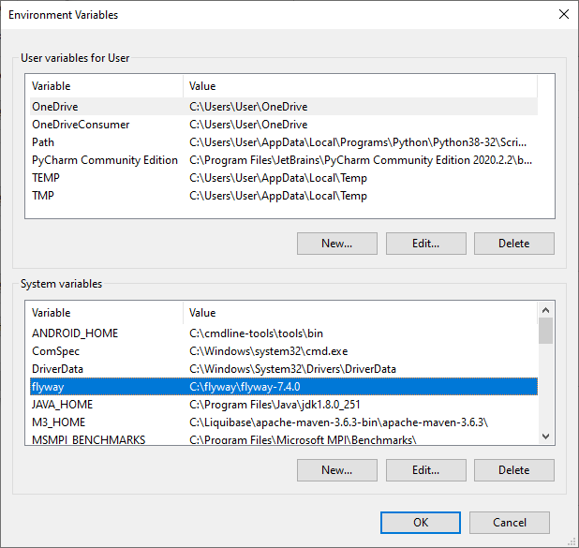

**Path** – Installation path

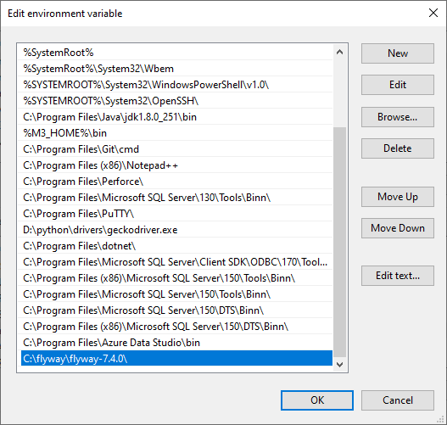

Configure conf file:

flyway.url=jdbc:sqlserver://DESKTOP-0F743CS:1433;databaseName=test2

flyway.user=test

flyway.password=test

flyway.connectRetries=0

flyway.initSql=USE FSDB GO

Commands to get information on deployment:

**Sqlserver**

flyway info -configFiles=C:\OneSumX_Release\conf\osx_gdm.conf -outputFile=C:\OneSumX_Release\logs\GDM_%date%_%time:~0,2%%time:~3,2%%time:~6,2%.log

**Oracle**

flyway info -configFiles=C:\OneSumX_Oracle\conf\osx_gdm.conf -outputFile=C:\OneSumX_Oracle\logs\GDM_%date%_%time:~0,2%%time:~3,2%%time:~6,2%.log

Commands

--------

migrate : Migrates the database

clean : Drops all objects in the configured schemas

info : Prints the information about applied, current and pending migrations

validate : Validates the applied migrations against the ones on the classpath

baseline : Baselines an existing database at the baselineVersion

repair : Repairs the schema history table