**Name: Kunal Khairnar**

**Roll No: 21**

**Batch: B2**

File Handling:

1) User to File

import java.io.*;

import java.util.Scanner;

public class user_to_file{

public static void main(final String[] args) {

try {

final Scanner scan = new Scanner(System.in).useDelimiter("\\n");

System.out.print("Enter File Name you want to write to: \n");

final String source = scan.next();

final File writefile = new File(source);

if (!writefile.exists()) {

System.out.println("File Not Found");

} else {

final FileWriter writer = new FileWriter(source, true);

final BufferedWriter bufferedWriter = new BufferedWriter(writer);

System.out.print("Enter content: \n");

final String data = scan.next();

bufferedWriter.write(data);

bufferedWriter.newLine();

bufferedWriter.close();

}

scan.close();

} catch (final Exception e) {

System.out.println(e);

}

}

}

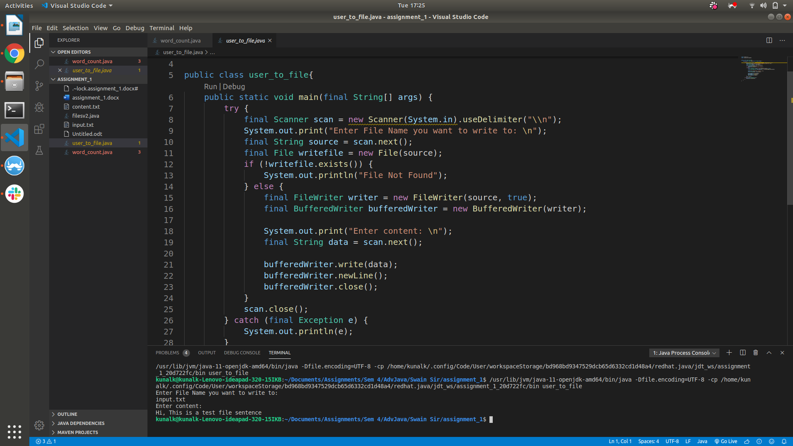

2) file to file copy:

import java.io.*;

import java.util.Scanner;

public class filesv2 {

public static void main(String[] args) {

try{

Scanner scan = new Scanner(System.in);

System.out.print("Enter Source File Name:");

String source=scan.next();

File srcfile=new File(source);

if(!srcfile.exists()){

System.out.println("File Not Found");

}

else{

FileInputStream FI=new FileInputStream(source);

System.out.print("Enter Target File Name:");

String destination=scan.next();

File tfile=new File(destination);

if(tfile.exists()){

System.out.println("File already exists");

}

else{

FileOutputStream FO=new FileOutputStream(destination);

int b;

while((b=FI.read())!=-1)

{

FO.write(b);

}

System.out.println("\nFile Copied.");

FO.close();

}

FI.close();

}

scan.close();

}catch(Exception e){

System.out.println(e);

}

}

}

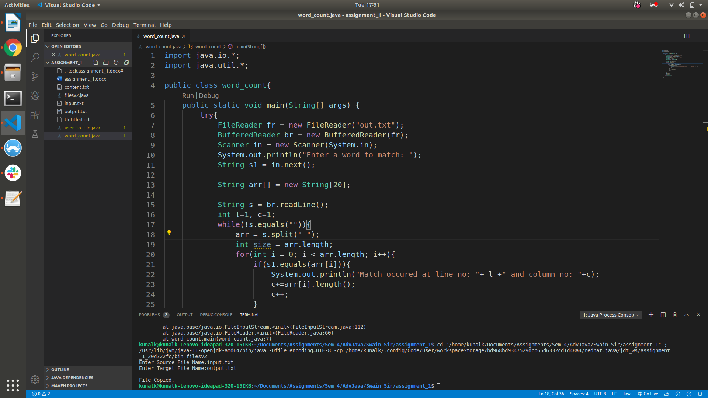

3) word count:

import java.io.*;

import java.util.Scanner;

public class Count{

public static void main(String args[]){

FileReader fr = null;

BufferedReader br = null;

try{

fr = new FileReader("input.txt");

br = new BufferedReader(fr);

int count=0;

int wcount=0;

String s;

String words[]=null;

int c;

Scanner sc = new Scanner(System.in);

System.out.println("[1]:Count lines");

System.out.println("[2]:Count words");

c=sc.nextInt();

switch(c){

case(1):{

while((s=br.readLine())!=null){

count++;

}

System.out.println("Number of lines in the file: "+count);

break;

}

case(2):{

while((s=br.readLine())!=null){

words=s.split(" ");

wcount=wcount+words.length;

}

System.out.println("Number of words in the file: "+wcount);

break;

}

}

sc.close();

br.close();

fr.close();

}

catch(IOException e){

System.out.println(e);

}

}

}

