|  |
| --- |
| https://i.gyazo.com/0af3abf7f193a30ef795f91c92357432.png |
| TechstraOne |
| Assessment 3: Our IT Project |
|  |
| **Timothy James Hall S3851553**  **Benjamin McDonald S3851983**  **Andrew Wendt S3858515**  **Rebecca Barnett S3856827** |
|  |

|  |
| --- |
| TechstraOne is a group of like-minded students from RMIT coming together with the goal of producing a project with real world purpose and to demonstrate our commitment to developing the necessary skills required for the Information Technology industry in the 2020’s. |

**29-Apr-20**

Table of Contents

1. Introduction 2

2. Team Profile 3

2.1 Team Introduction 3

2.2 Group Processes 4

2.3 Team Career Plans 5

2.3.1 Ideal Jobs 5

2.3.2 Overview of required skills 7

2.3.3 Career Plans 7

3. Project Tools (Tim – need to slightly update for A3) 8

4. Team Project – CollectStra 9

4.1 Project Overview 9

4.2 Project Motivations 9

4.3 Current Landscape (Andrew) 9

4.4 Project Aims (Bec) 10

4.5 Project Plans and Progress (Ben) 10

4.6 Project Roles (Tim) 12

4.7 Project Scope and Limits 12

4.8 Project Tools and Technologies (Tim) 12

4.9 Project Testing (Adrian Ferrara) 12

4.10 Timeframe 13

4.11 Project Risks (Adrian Foti) 15

4.12 Group Processes and Communications 15

4.13 Skills and Jobs (Tim) 15

5. Conclusions (Bec) 16

6. Reflection 17

6.1 Individual Reflections 17

6.2 Group Reflection 17

References 18

# 1. Introduction

The TechstraOne team was formed by students from RMIT who shared an interest in creating a project that would allow us to develop and demonstrate skills relevant to our interests in Information Technology. The students met during the Introduction to Information Technology course as part of the Bachelor of Information Technology offered by RMIT.

In the following report, we will discuss in detail our project plan for a collectables trading app and discuss the prototype we are creating. Our project aims to develop our desired skillsets and target industry trends.

# 2. Team Profile

## 2.1 Team Introduction

#### Timothy Hall S3851553

Tim has always had an interest in IT from a very young age and continued to follow this interest by pursuing a role in IT in the Navy.

Completing 15 years of service following this interest he has found his passion for IT revolves around networking. Tim has continued to follow his passion by completing his CISCO CCNA qualification and continues to educate himself. With his 15 years of experience in the Navy, Tim brings project and team management skills as well as a raft of IT knowledge to TechstraOne to help see the goals of the company come to life.

During his spare time Tim is an amateur home chef and loves to go to the gym and rock climbing with his partner Tiffany.

#### Benjamin McDonald S3851983

Ben is a student at RMIT studying a Bachelor of Information Technology. Prior to beginning his degree, Ben had pursued a career as an audio visual technician working for companies in Canada and Australia.

Working in the AV industry for seven years helped Ben develop his knowledge of networking as well as hardware and software. This led to an interest in IT and AI (Artificial Intelligence) and the possibilities of what AI could hold not only for the AV industry but for every industry.

Ben strives to work as an AI developer, working with the top teams on creating sentient AI, as well as working on smaller AI inclined projects. Ben is semi-fluent in HTML, CSS, and is currently learning java script and python which will all be of benefit to the TechstraOne team.

#### Andrew Wendt S3858515

Andrew’s career started out at a data centre, where he administrated the facilities access control and building management systems.

He successfully completed a certificate 4 in IT networking and a certificate 3 in electronics, he applied the knowledge he learnt by becoming a technical specialist for an electronic security company. He has worked in the field for 5 years, with his responsibilities and experience including fitting off field devices, running cables to programming advance access control systems, IP CCTV, biometrics and intercom systems.

One of Andrew’s goals is to further his knowledge with cyber security - a career in cyber security is very interesting to him. Andrew brings an array of technical knowledge to TechstraOne, including IT networking, electronics and hardware, Linux based operating systems, SQL database management and cisco routing and switching.

#### Rebecca Barnett S3856827

Rebecca has been interested in Software & Website Development for many years, teaching herself how to code HTML in high school before choosing to commence a Bachelor of Technology degree after graduating.

Although her life took a different career path early on - working as a retail manager for fifteen years, Rebecca has always had a passion for technology and is excited to pursue new opportunities in Information Technology, hoping to work as part of a Software Development team in the future.

Rebecca enjoys the problem solving aspects of Information Technology and loves pursuing the “ah-ha!” moment of getting something difficult to work. Rebecca loves to break down problems into manageable parts and can spend endless time perfecting her work whether it is when coding or writing documentation.

Rebecca brings some project management and Java development experience to TechstraOne, which she acquired whilst studying for her Diploma of Information Technology and from a six month industry based scheduling software project. She considers herself excellent at documentation and enjoys producing reports and experimenting with data to create graphs and charts.

In her spare time Rebecca enjoys strategy games, reading and going for long drives with her husband David.

## 2.2 Group Processes

In our first assignment together, the TechstraOne team collaborated via Microsoft Teams to produce a report and website based around our project. Weekly meetings were held and we communicated daily via chat. In addition to Microsoft Teams we also used a GitHub repository for sharing code and a master version of our report file.

Overall the team was mostly happy with the quality of work we produced for Assignment 2. For Assignment 3, we plan to better utilise our limited time together by introducing deadlines for all deliverables so we can better target areas that need further attention earlier.

We also plan to better use our repository on GitHub and ensure that all team members are comfortable with pulling the repository and pushing updates.

## 2.3 Team Career Plans

### 2.3.1 Ideal Jobs

The Ideal jobs of the group have vast differences and contrast amongst each team member. Most members have chosen a career that can be achieved sometime in the near future following the end of their bachelor’s degree or soon after. These positions would be a great start to anyone’s career in the extensive world of Information Technology.

#### Timothy Hall – Senior Network Engineer

Timothy’s Ideal job for the future would be a Senior Network Engineer at Fujitsu Located in Sydney. The job includes becoming a manager and become part of a group of network engineers to design and develop various network designs to meet the constraints of the employer. This would also entail passing on valuable knowledge to the team via mentoring and guiding and providing the team with seamless opportunity for professional development. This position will require prior experience such as

* CISCO CCNP Enterprise/Security, CISCO CCDE, CISCO VOIP services.
* 3-4 years working in ISP or corporate level network engineer roles in a various amount of positions.
* The ability to produce a variety of documents from high level technical documentation as well as more simple operating practices for users on various network topics.
* Understanding of virtualisation with Microsoft Hyper-V or VMware.
* High understanding of routing concepts including BGP and OSPF.
* Certification in current ITIL practices.
* Knowledge of satellite and cellular technologies.

A position like this is of high importance to the fundamentals of a workplace. This job can be very attractive to those who are looking to take charge of team and guide them in a direction toward success. This jobs wage is also around a median of $106k in the state of Victoria.

#### Benjamin McDonald – Artificial Intelligence Architect/Software Engineer

#### Benjamin’s Ideal job is to become a Software Engineer – Java Developer at VROC. This job involves plenty of teamwork working with a vast team of developers to improve their data processing framework to make use of the latest data programmes and technologies. This position would help the employee on how to overall improve extensive AI Technologies and would present great opportunity to develop and work with AI technology. The skills and prerequisites needed for this position are quite extensive in terms of experience and would be needed prior to applying for this job. These would include:

• Moderate skill and experience with JavaScript, TypeScript, REST, API design, Grafana Plugin Development as well as Angualr.js

• Past experiences in coding and creating prototypes for different projects

• Working in a fast-paced environment.

• Have a decent understanding of current and upcoming trends across new fields for technology solutions in the big data and AI industries.

#### Benjamin McDonald (Continued)

#### This job can be appealing to a person who is looking to get into a very unique field of IT. This can keep the person very interested and engaged by learning the behaviour of AI and developing and maintaining certain projects. The salary included in this type of position is quite sustainable and appealing averaging at a median of $78k-$111k in and around Australia.

#### Andrew Wendt – Network Security Engineer

Andrew’s ideal job would be a Network Security Engineer, working on the design of large networks with security as the priority. Andrew already possesses some Networking and Cisco qualifications and has some exposure to small and large infrastructure. A Network security position that Andrew is interested lists the following required skill set:

* Network Security
* Palo Alto Certification
* Linux Based Operating Systems
* Python for networks
* Virtualisation
* SQL Database Administration
* Azure applications
* Cloud based technologies

#### Rebecca Barnett – Software Developer

Rebecca’s ideal job would be a full-time position on the Gold Coast. It would be to develop software for a company called In the Code Pty Ltd. They are offering a position for junior to intermediate software developers with ideally some experience in a MEAN stack development. However, this is not all necessary. This position will also require a great attitude with willingness to learn and develop your own skills as well. The skills and experience that would be needed for this position include:

* MEAN stack (JavaScript & Java)
* Native iOS (Objective C)
* Native Android (Java)
* Effective problem-solving skills.
* A great attitude towards tasks provided.
* A willingness to co-operate, listen and learn.

This position has its responsibilities such as completing tasks withing a time frame and sticking to specific deadlines, further testing on the existing projects and the ability to start on completely new range of projects also with respective due dates. This job may be very appealing to Rebecca because it could be both challenging and rewarding to be able to solve problems withing the set task. Also, the company In the Code Pty Ltd claims to be a relaxed and flexible work environment which can be essential when looking for a new job in the workforce. The salary of this position can also be appealing, its average being around $100k per year being the most common salary in the state of Queensland in Australia.

### 2.3.2 Overview of required skills

The ideal jobs among our group have plenty of similarities in the way that most of these positions require prior knowledge and high skill in coding such as JavaScript and CSS. Rebecca and Benjamin would both need to know the fundamentals of coding including the ability to comprehend and write the respective coding language to a high standard. All Ideal jobs have a similar pay grade the average being around the $90-$110k margin. Also, all jobs are to include the trait of good communication practices and the ability to work within a positive team-based environment.

There is plenty of difference in the jobs our group members are striving towards. This would include Benjamin’s deep interest in Artificial Intelligence and the measurement of its behaviour. Tim’s is interested in gaining a Senior Network management position and Andrew is interested in Network Security. These jobs are quite different to Rebecca’s interest in a software development position.

Overall, the careers of our group members are quite vast with some choosing to focus on web development and others preferring the development of software. Developing moderate to high skill in coding languages would be ideal for most employers in the Information Technology industry.

With the team having different passions for specialties such as the extensive and growing mystery behind Artificial intelligence, Networking and Security, Developing software or landing a management position shows just how vast the Information Technology sector is and the possibilities of career advancement is endless.

### 2.3.3 Career Plans

The ideal job of each team member spans multiple fields of interest in information technology. Where Andrew and Timothy will require specialised certifications and qualifications in Networking such as CISCO recognition and Palo Alto certification for networking hardware and telecommunications equipment, Rebecca and Benjamin will need to focus on Software Development technologies and programming languages such as learning Java, Python as well as database languages such as SQL.

Many members of TechstraOne plan to learn the required skills for their ideal jobs during the course of the Bachelor of Information Technology degree studies.

Tim already has a lot of experience in many of his fields of interest, and is now seeking formal qualifications to solidify his knowledge and develop new skills.

Ben plans on perusing a Master’s degree in Artificial Intelligence after completing his Bachelors.

Andrew intends to do work experience or an internship in Cyber Security after completing his Bachelor’s in order to gain relevant experience.

Rebecca plans on continuing the build her project portfolio whilst completing her Bachelors and may look for relevant work experience when confident in her abilities.

All team members hope to learn something relevant to their ideal careers during their project work with TechstraOne.

# 3. Project Tools (Tim – need to slightly update for A3)

#### Team Website

Techstra One’s webpage is hosted on GitHub pages and can be found [here](https://bugzy088.github.io/Techstra-One/). This page will be the main front of the project which is developing our collectable trading software. At present it has a basic breakdown of what the project is as well as a profile page of all the members who make up part of the Techstra One team along with their individual webpages.

#### GitHub

To host the website files and pages GitHub was chosen to be our repository. As it has inherent integration with GitHub Pages and the fact that it was a simple and easy product for the team to use.

From an early point Tim was the only one who was using the repository as he was the one creating the webpage but as you can see in the below image (figure 3.2.1.1) he (Bugzy088) wasn’t the only one to use it.

#### Canvas

To form the team for this group RMIT’s Canvas was used initially to setup the team. However, due to Canvas’ limited communication features and file sharing the team decided to move to Microsoft Teams for all future collaboration on this project.

#### Microsoft Teams

Microsoft Teams was our primary collaboration tool. We used it extensively for its chat, file sharing and conferencing features. Most of the discussion was done in the ‘Chat’ feature with individual posting their own files (seen in figure 3.3.1.1) to the A2 Report and Website Team pages as required depending on what we were discussing or sharing.

#### Overview of Project Tools

Looking over the past 3 weeks with how the group has interacted with each other using the various tools mentioned above, there are definitely some things we have done well and some areas that need to be improved on for future work.

The things we have done well were deciding to move on from using Canvas early on and moving to Microsoft Teams as it is a better collaboration tool, as it has integration with nearly all the Microsoft Office applications. Not only has that, but it all so file sharing with version control via SharePoint and conferencing capabilities.

Areas that we need to improve on for future work is that we need to use version control to our advantage. While Microsoft Team’s does have the feature through SharePoint everyone in the team just ended uploading their individual files instead of just updating one parent document. Rebecca moved away from Microsoft Teams for updating files to GitHub as the version control seems easier as she has used it before. The other problem was that Microsoft Teams was new to some people so they did not know that they could do this.

As a team moving forward on future work, we need to help each other reduce the workload by working smarter by using one parent document. Also, if there is some education that needs to be passed on to those that do not know, then we must take the time to teach them which will benefit all of use in the long run.

# 4. Team Project – CollectStra

## 4.1 Project Overview

Our platform, CollectStra, will add popular social media-like connectivity to a hobby enjoyed by many people; collecting trading cards, comic books and other kinds of media. We intend to make CollectStra an easy and fun way to manage someone’s collection and to help them connect with other users with similar interests.

By utilising available online databases we intend to have accurate, up-to-date information about each item. By connecting to other service’s API’s we aim to provide utility to each user, allowing them to easily view information on price and availability about the items they hold or wish to acquire.

Finally, we want to add life to the collectables market. We intend to make it easy for users to find out what niche events are on in their local area that they may be interested in and help them to meet other people who are as excited as they are about their collections.

## 4.2 Project Motivations

Our main motivation for this project is to create something useful for a hobby that many of the team find interesting and have taken part of in the past. It is our belief that the collectables industry is under represented by the app market and that there is demand for a social media-like platform where multiple categories of collections could be represented together.

Adding social media elements to existing platforms is certainly a popular trend in the IT industry at the moment with many websites adding enhanced user experiences by offering interactions between its users and connectivity to external social media sites.

The TechstraOne team is hopeful that this project will test their existing capabilities and enable them to develop new skills which will be of benefit for future projects.

## 4.3 Current Landscape

#### The Competition

TechstraOne has conducted research into similar trading applications and have found some worthy competitors. TechstraOne continues to develop ideas that go beyond the boundaries of our competitors. Here is a list of some of the following marketplace-based collecting applications.

* eBay.
* Colliibo.
* Unboxed.
* Gemr.
* Retro Game Collector.
* Key Collector Comics App.

#### How is our application different?

Our application is more than just a selling platform for traders alike, the application is suitable for all ages and different gaming and trading memorabilia types. The social aspect of the application intends to captivate users with selling incentives and a points reward system.

The application will have an inbuilt trading feed, displaying recent transactions. The application also looks to partner with Comic Con and other conventions. The features include:

* **Social Aspect -** TechstraOne believe that this application is more than a marketplace to sell and buy from. TechstraOne is very motivated to create a safe and interesting social aspect, allowing likeminded individuals to communicate with each other. Users can view profile feeds, view listed items and the ability to follow and message.
* **The feed** – A display of recent transactions, with users linking their profiles to the feed so other users can look at the type of items they sell.
* **Rewards systems -** When a trader sells or trades an item, they will be rated with a rewards system. This system will allow buyers to rate and review sellers’ profiles, traders and sellers will also be able to review their customer’s profiles. The intention of this system is to create a trustworthy selling platform for both traders and consumers.
* **Events Calendar** - In this feature TechstraOne will display upcoming events and provide information about locations and areas for other users to trade their memorabilia.
* **Connectivity** - The application will be accessible from a web page browser and Android devices. Mobile devices can use in-app cameras to upload the sellable items
* **Application -** The application will have a variety of features, these will include searching for a specific item, filtering by price, location and quality
* **Transactions -** The transactions can be delivered both in local currency online and in some types of crypto-currencies.

The application will also use data analytics from other sales platforms such as eBay, gumtree and others to gain better information on price and availability. In order to achieve this TechstraOne wishes to partner with these companies, keeping in mind the possibilities of legal agreements and other regulations.

## 4.4 Project Aims

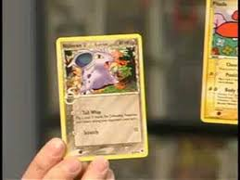The aim of this project is:

***“To create an easy and fun platform in which a user can manage their collections in a highly social environment*.”**

This means we want to make it possible for collectors of all types to come together and celebrate their unique items as well as meet others who share their passions.

*Figure 4.4.1. A Pokémon card.*

This will involve the following goals:

* **Create an easy to use Graphical User Interface (GUI).**

An attractive, intuitive GUI will help attract and retain users and allow them to make the most of the platform’s functionalities.

* **Connecting to third-party marketplace API’s and databases to get item information.**

By utilising third-party data our platform will be able to provide accurate, up to date information about items to our users as well as display market price fluctuations on collectables.

* **Allowing users to connect with their friends.**

By enabling our collectors to share their collections with each other we can help users connect with like-minded people and add an extra level of excitement to acquiring new items.

* **Suggesting items and events that users may find interesting.**

Utilising existing databases and identifying what is missing from user’s collections we plan to be able to provide personalised recommendations to each user on items they may be interested in as well as suggesting events that they may wish to attend.

* **Partner with conventions and publishers**

Creating partnerships with publishers and event organisers will allow us to better promote our platform and offer exclusive benefits to our users such as early access to products and exclusive updates.

* **Establish market dominance.**

We plan to attract users by making our platform intuitive to use and by utilising the most up to date data available from publishers and developers. By adding social media elements to the platform and rewarding users for increasing their collections we hope that the platform will have a fun factor which will make us stand above our competitors.

## 4.5 Project Plans and Progress (Ben)

### Project Conception

(how did we come up with this idea)

### Planned Features

(just details on what’s within our scope)

### Planned Features Implementation

#### SQL Database

**CollecStra-One Database Connection Method**

The CollecStra application will use the JDBC driver connection method, below are some steps on how to achieve this. The CollecStra application will connect to a SQL Database using the JDBC driver API (Application Programming Interface.) This connection method is the most preferred for the connection to Java based applications. The intention is for the application to operate smoothly and provide ease of administration for system administrators and Developers. TechstraOne have decided that these connection methods and operating systems are most suited to the needs of the application.

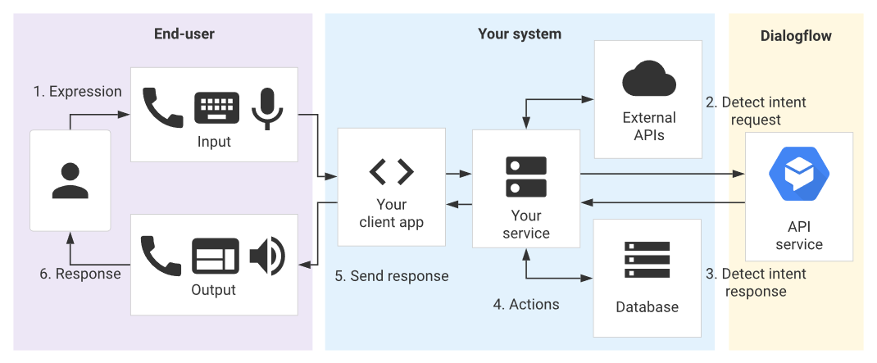Initially CollecStra will use the express version of SQL, this version is limited to 10Gb in storage. TechstraOne will use data growth analysis from Alpha and Beta testing, the data captured in the analysis will indicate how the databases will behave, this information will provide insight into upgrading licensing and databases. The SQL databases will store encrypted user-based data, photos of card holders, and trading repositories.

*Figure 4.5.1. Connection Flowchart.*

**The API**

The JDBC driver is free software that enables a Java application to interact with SQL Databases, the API is a set of classes that implement JDBC interfaces to process JDBC calls and return sets to a Java application. The database stores the data retrieved by the application using the JDBC Driver.

In the future TechstraOne will also investigate the possibility of connecting CollectStra databases into third-party databases (pending legal rights and third-party agreements.) TechstraOne will use the data obtained from third parties’ databases to provide up to date and accurate pricing for sales and trading information.

Techstra have envisioned a timeline for the application and what the application may be able to do in the future. TechstraOne would like to incorporate database automation, machine learning and potentially using Artificial Intelligence (AI) for uploading cards, or the possibility to have in app games or “battles”. TechstraOne have acknowledged the importance of streamlined and effective business practices, we believe that with automation, machine learning and AI we can increase overall productivity and promote positive end user feedback.

**Connection Process**

In this paragraph TechstraOne will provide some basic code and procedures followed by some photos for reference on how TechstraOne connects its application to databases. (Screenshots will be gathered using TechstraOne’s database administrators’ virtual machines)

* Loading and registering the JDBC Driver into the application using Java, this is loaded into the memory at runtime.
* Oracle drive – class.forName(“oracle.jdbc.driver.OracleDriver”);
* DriverManager.registerDrive() this class is inbuilt as a static member; the below code is used to register the Oracle driver.

(DriverManager.registerDriver(new oracle.jdbc.driver.oracleDriver())

* Connecting to the database

Connection con = (String url = “ jdbc:sql:thin:@localhost:1521:ams”)

* Defining a statement, this line of code will define the methods of communication between the application and the SQL.

Statement st = con.createStatement();

* Executing the query, query for retrieving data and query for updating/ inserting table in a database.

int m = st.executeUpdate(sql);

if (m==1)

System.out.println("inserted successfully : "+sql);

else

System.out.println("insertion failed");

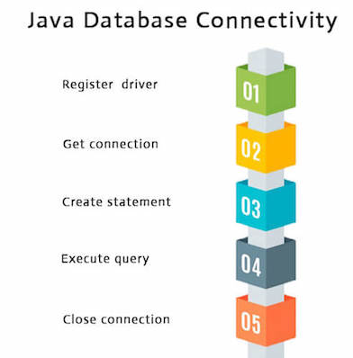

*Figure 4.5.2. Summarised Connection Steps.*

In figure 4.5.3 code for the database connection process is shown.

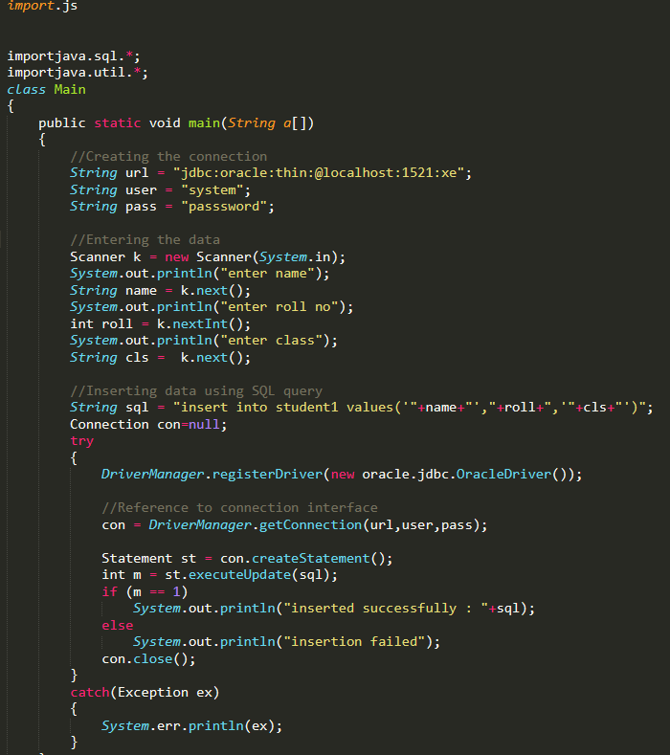

*Figure 4.5.3. Database Connection Process.*

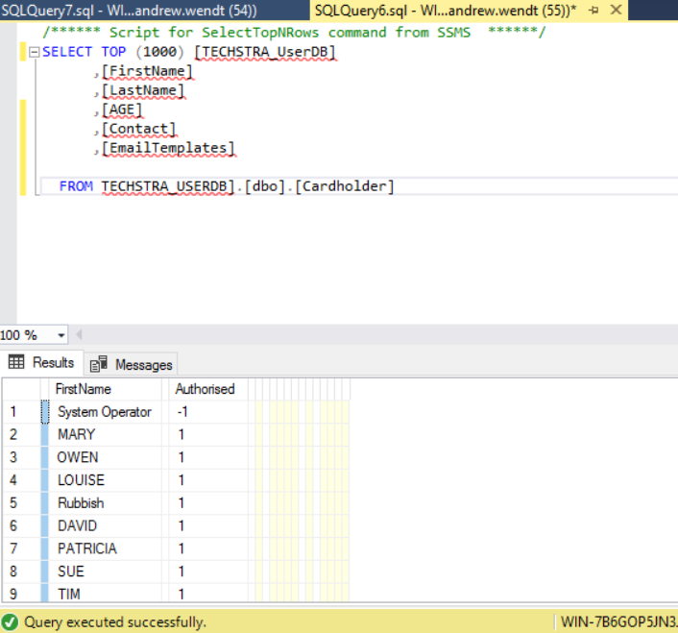Below (figure 4.5.4) is an example of our database, this table below displays users that have connected to the database, this is where their information is saved.

*Figure 4.5.4. Connected Users Table.*

#### Project Deliverables

(java app, database, website)

#### Project Leads

(what ideas did we follow, eg. Connecting to an API. Did it work out?)

#### Future Features

(Include our lofty ideas for the future of the app – discussed in A2)

#### Future Features Implementation (will we need funding, additional resources ect.)

(some of this was discussed in A2)

#### Project Feasibility

(How feasible are our goals for this project)

Here you should give as much detail as you can about what your project will do, and how you will do it. This should also include how far you have got with developing any features or outcomes from your project. Tell us about the “story" of your project – how it began, how it has progressed, and what stage of the plan you are up to. Include any dead-ends you may have followed, decisions made, and changes that have been made to the project plan. This will need to include a significant amount of detail, so that it is easily seen what precisely you have done and are planning to do. If it helps, imagine the information that would be required if you were to hand this project over at the end of the semester to a new team to complete the job. What would you want to know, if you were one of the people taking over? There is no set length for this section, but it is hard to believe that less than two pages could be adequate. Three or four pages is far more likely.

## 4.6 Project Roles

With regards to the roles for the Techstra One team we have not defined roles to anyone. We went assigned tasks based off what needed to be done for the assessments and who was comfortable with doing certain parts based on any previous experience. Noting the tasks that we have individually taken on the following are the roles we could be assigned based on these.

Rebecca has taken on the role as the Project Manager along with some App development work. Rebecca is the mastermind behind our reports layout and ensuring we are meeting our set deadlines. She is also assisting in the development of our App with the feed feature.

Benjamin has taken on the role as Application Developer and is developing the application in Java. He is ensuring that we can have basic functionality for viewing in Assessment 5.

Andrew has some SQL database experience, so he is working on integrating that into our application to manage our user, collection, and trade databases. Additionally, he is working on getting API working to pull data from 3rd party source into our app with regard to certain collectibles.

Tim has become the team’s Web Developer and has actively updated Techstra One’s webpage when required. He is also the team’s application GUI designer. Using online tools to create the basic layout of the application for the purpose of demonstrating how it will look like.

On top of what is mentioned above everyone in the team has been actively involved with this report. No one was assigned the role of making this report on their own. Everyone took individual segments and we combined them to make this one report.

## 4.7 Project Scope and Limits

For the first phase of this project ending on the 24/05/2020 the following deliverables with the listed functionalities are planned:

* Mock Graphical User Interface design
* Java Application with the following functionalities:
  + Ability to add and remove users
  + Ability to add and remove items
  + Ability for users to add and remove items to their profile
  + Ability to search and view items
  + Chat functionality between users
  + Ability to connect to a collectables’ API in order to retrieve item details
  + A “feed” of information displayed on the main screen of the GUI

For future phases of the project the following functionalities are planned:

* Calendar functionality to show upcoming events
* Location Services for notifying users of upcoming events and similar nearby users
* Ability to trade & buy items
* Functioning Website version of the application
* Ability to upload pictures via phone camera access
* Ability to identify items via image recognition
* Rewards System

## 4.8 Project Tools and Technologies

The following software and tools would be required for CollectStra to come to life.

#### Software

**Eclipse IDE 2019 version 12** – Eclipse IDE is a free open source integrated development environment that we are using to develop our app using the Java programming language. It has the ability to add in extensible plugins to add extra functionality as required. Eclipse IDE uses an Eclipse Public Licence (EPL) 2.0 that is free for everyone to use and is business-friendly as it has weaker copyleft provisions than previous versions of Eclipse which used their EPL 1.0 which has stricter copyleft provisions. EPL and copyleft means that any changes and additions to original work must be licensed under the same terms and conditions of the EPL, which includes the requirement to make source code available.

**SQL 2014 Express** – Microsoft SQL 2014 Express was the software chosen to host our databases which will contain all of our user and collection data. This version of SQL enables us to have one database and a maximum of 10GB. Once some analysis is done we will move to Azure SQL which does require a licence to use and the licence cost is incorporated into the price of Azure SQL hosting.

**FluidUI** – FluidUI is an online Application GUI designer. This application was used extensively to create the mock-up of how the CollectStra application will look like once it is developed. This app is free to use however, it does have a paid option which provides greater options in the design phase but it was not required for the CollectStra design.

#### Hardware

**Microsoft Azure** – Using cloud computing means we do not need to have any physical equipment to get our application up and running. With the expandability of what cloud computing brings means we can start off with a small footprint and then expand as required to meet our business requirements based off our number of users.

Using the Microsoft Azure SaaS calculator, the most basic plan available (A1v2) which has 1 CPU Core, 2GB of RAM and 10GB of storage would cost ~$76.2 per month and we could use this as a test to see how the app goes. If required we can get a memory intensive SaaS which is for large databases. The minimum level to start with costs ~$349.8 per month which has 490GB of storage, 14GB of RAM and 2 CPU Cores.

On top of this is the requirement for us to have an SQL server to host our databases. Again using Microsoft’s Azure cloud infrastructure the cheapest option would cost ~$363 per month which provides 2 VCores, 10.2GB of RAM but we will have to purchase storage with the minimum being 5GB costing ~$1 per month. All of this can scale up easily depending on what our requirements are.

#### Previous Experience

The team has had some minor experience in the past with SQL and Java. Benjamin and Rebecca both have previous experience using Java as a coding language. Benjamin is currently conducting Introduction to Programming which is working in Java and Rebecca has worked with Java previously when she was completing her Diploma in IT a few years ago. With both members having some Java knowledge is one of the reasons we chose Java and because it is popular in the application development space.

In Andrew’s current job he has experience with SQL particularly with SQL queries and database administration tasks. So using his knowledge we have decided to use SQL as our database software of choice.

## 4.9 Project Testing

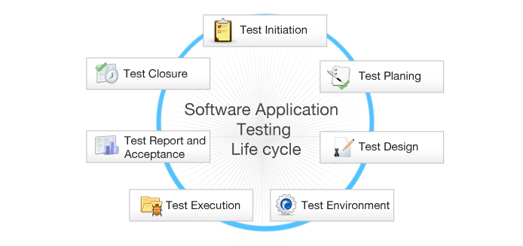

Testing phase figure 1.5

Project testing sequence, extensive testing and development is crucial to the success of our application. To ensure that all issues are settled before deployment here are some procedures that we will be implementing throughout testing and development phases.

**Initiation**; In this stage of testing, TechstraOne will conduct a project management plan, ensuring that all potential risks and issues can be addressed during these stages. It is important that during this stage of the project everyone who needs to be involved is properly engaged to ensure continuity for further stages.

**Test Planning**; how and what we will test to ensure that all parts of the application are covered, ensuring that potential issues or concerns can addressed and rectified in the development stage of the project.

**Test Design**; A test design document will ensure that all elements of the application are tested, and peer reviewed for quality assurance (QA)

**Test Environment;** In this stage of testing, our system administrators will set up a Development Environment (DEV) this environment will be hosted by VMware using virtual machines, TechstraOne have decided that a virtual environment both in testing and production is crucial to the development and success of the application.

The virtual environment will include application servers, database servers and backup servers. Our system administrators will test server load, database connections and backup capabilities. Our application developers will test functional testing in the source code, using ‘black-box’ testing for software. These testing methods will operate in parallel with our testing procedures and design.

**Test Execution;** Executing the code in the DEV environment, in the Alpha stage of testing TechstraOne will follow our strict ‘Test Design’ document ensuring that all elements are tested, documenting each change and ensuring that all issues are captured before the Beta stages of our application.

**Test Report and Acceptance;** In this phase our developers will assess the results and use the data captured from the Alpha phases to continue the next stage of our design. The acceptance phase of testing is to ensure that all data has been reviewed and assessed by all the appropriate stages. Using the test report and data obtained by the testing phase TechstraOne will be able to move forward to ensure that all elements will work correctly.

**Test Closure;** at the end of the acceptance phase Developers alongside with system administrators and project managers will review and assess the data that was captured during the Alpha stages. The project managers will explain lessons learnt, and this information will assist the Beta stage of testing.

TechstraOne have designed our testing procedures for both Alpha and Beta testing phases. The Beta testing phase will be used to assess the operational functions of the application. TechstraOne will select end users that operate android mobile devices. In this phase TechstraOne will assess user data, obtain customer feedback and initiate extensive load testing for further developments.

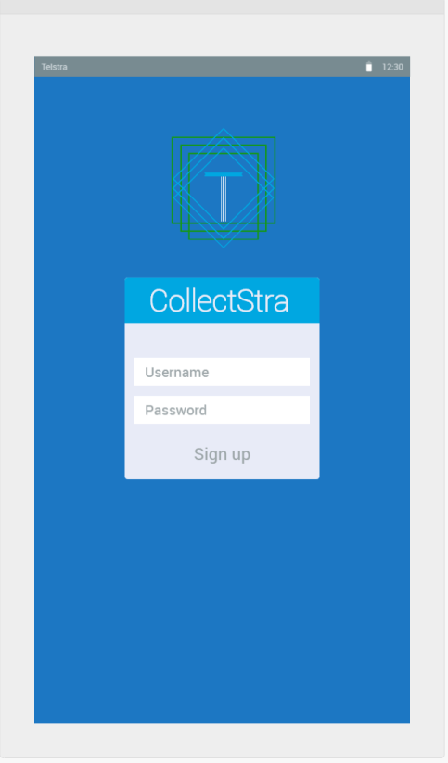

Application Login Screen figure 1.6

#### Roadmap

The application is currently designed to operate in Java, but TechstraOne are looking to accommodate all operating systems, including Apple based operating systems. TechstraOne plan to use Complier software that will compile Java code to Objective-C code.

After the Beta stage TechstraOne will make the application available for download on the Google-play store, the application will then go into an operational phase and will be tested and subject to review asking for feedback for future research and development.

TechstraOne are producing a future business case, using the potential success of the application at its foundation, TechstraOne hopes that it may be a lucrative business opportunity for larger companies to partner up and promote their brand through this app.



TechstraOne Roadmap figure 1.7

## 4.10 Timeframe

|  |  |  |  |
| --- | --- | --- | --- |
| Week | Schedule | Team Members | |
| 1 | * Team meeting: Finishing touches on Assignment 2 | | All |
| * Work on Project Plan and Details | | All |
| * Completion of Assignment 2 | | All |
| 2 | * Team meeting to discuss tools and technologies moving forward | | All |
| * Assignment requirements review | | All |
| * Project implementation brainstorming | | All |
| 3 | * Team meeting: Project breakdown and team member assignments | | All |
| * Scope and Project Timeframe | | Rebecca |
| * Team meeting: Project Plans and Progress section discussion | | All |
| 4 | * Team meeting: Discuss progress | | All |
| * Project Landscape | | Andrew |
| * Project Plan Outline | | Benjamin |
| * Project Testing Plan | | Andrew |
| * Group Processes and Communications | | Rebecca |
| * Skills and Jobs | | Timothy |
| * Video Storyboard | | Ben & Tim |
| * Java application classes and methods defined | | Benjamin |
| * SQL database populated via API integration | | Andrew |
| 5 | * Team meeting: Discuss progress and identify shortfalls | | All |
| * Mock GUI completed | | Timothy |
| * Plans and Progress Report | | Benjamin |
| * Define Roles for future project development | | Timothy |
| * Tools and Technologies required for project Report | | Timothy |
| * Project Risks Report | | Rebecca |
| * Java application 1.0 | | Benjamin & Rebecca |
| * Team website updated | | Timothy |
| * Report Finalised | | All |
| 6 | * Team meeting: Finalising Submission, Discuss video demonstration of project progress | | All |
| * Record video of project | | All |
| * Project Testing | | All |
| * Assignment 3 Submission | | All |
| * Assignment 5 Submission | | All |
| 7 | * Team meeting: Develop project plan for further feature implementation | | All |
| * Project plan report | | All |
| * Feasibility study of further functionalities | | All |
| 8 | * Team meeting: Team member assignments | | All |
| * Implementation of Calendar feature | | Benjamin & Rebecca |
| * Website design | | Timothy |
| * Java GUI design | | Benjamin |
| Week | **Schedule** | | **Team Member** |
| 9 | * Team meeting: Discuss progress | | All |
| * Implementation of advanced item feature: Buy & Trade | | Benjamin & Rebecca |
| * Website phase one functionalities implemented | | Timothy & Andrew |
| 10 | * Team meeting: Discuss progress | | All |
| * Implementation of picture upload functionality within Java application. | | Benjamin & Rebecca |
|  | * Website buy & trade functionality added | | All |
|  | * Project Testing | | Andrew |
| 11 | * Team meeting: Discuss progress. Brainstorm rewards system. | | All |
| * Implementation of rewards system on Java app | | Benjamin & Rebecca |
| 12 | * Team meeting: Discuss progress | | All |
| * Implementation of rewards system on website | | Timothy & Andrew |
| 13 | * Team meeting: Discuss progress | | All |
| * User testing & feedback | | All |
| 14 | * Team meeting: Discuss progress. Research Advanced Feature: Location Services | | All |
| * Project plan: User feedback & improvements | | All |
| 15 | * Team meeting: Discuss progress. Research Advanced Feature: Image Recognition | | All |
| * Implementation of user feedback suggestions | | All |

## 4.11 Project Risks

The following risks have been identified for the project:

#### External databases might fail

Due to the extensive amount of categories and individual items we would like to include in CollectStra during our first phase we will be relying on external sources, databases and the use of each platforms API to populate CollectStra’s database. If an external source becomes offline or unavailable there is a risk CollectStra may not be able to access this data. Poor bandwidth and a slow connection could also leave the CollectStra platform running sub-optimally. Ideally to manage this, the team would like to store as much data as possible in our own database on our own servers.

#### The CollectStra server might fail

The server on which CollectStra and its database is stored also risks unforeseen downtime and connection issues. When pulling data from external sources, data transfers could be interrupted and database records corrupted. To minimise this the TechstraOne team plans on only using well regarded hosting services such as Amazon’s web services or Google Cloud.

#### Inaccurate data from external sources

Relying on external sources for our data may leave us with inaccurate information on items in our database. To minimise this risk regular audits and reviews will be necessary to ensure data is accurate and complete.

#### Failure to access data via Application Programming Interfaces (API)

As the TechstraOne team has limited experience using API’s and as there is a large amounts of different syntaxes, languages and standards used by different publishers to access their data there is a risk we may not be able to access the information we require.

#### Lack of accessible Databases & API’s

There may be no way to access some publisher’s libraries and databases if they are not available online or require payment to access. Similarly, there may not be API’s available for every database we would like to incorporate and so alternative methods to access these databases would be required – for example importing CSV (comma separated value) files, which may or may not work.

#### Lack of required skill set

As the TechstraOne team is relatively inexperienced with developing a project of this scale, it may take longer than anticipated or may not be possible to develop the required skill set to complete this project. As a contingency plan the team may be required to seek help from others with more experience which could impact the development schedule.

#### CollectStra may not run on all platforms

During development extensive testing will be performed on PC and Mac devices to guarantee performance however it is beyond TechstraOne’s ability to guarantee the CollectStra platform will work on all devices.

#### Unexpected issues and security vulnerabilities

Even with thorough testing in place there is a risk that CollectStra could be deployed with unresolved bugs and issues. This could potentially be problematic coupled with our intentions of offering a secure payment gateway to users in order to buy and sell items. To minimise this risk it will be preferable to utilise third party platforms from a reputable source for any exchange of payment and data encryption for any personal information stored in our own databases.

#### Distributed Denial of Service Attacks

A large amount of connections being attempted at the same time could overwhelm our servers and bring the platform offline and could come from a malicious source, a compromised system or unintentionally if too many of our users try to connect at once. To minimise this risk, stress testing should be scheduled before launch and our servers should have an appropriate amount of bandwidth available.

#### Poor uptake

The more people using CollectStra the better the experience will be for all of them. Without a significant amount of people being involved from launch day users may not get to appreciate the full range of features available and user retention might suffer as a result. This is why it will be important to heavily promote CollectStra prior to launch and offer incentives to get users to sign up.

## 4.12 Group Processes and Communications

The TechstraOne team will hold a compulsory weekly team meeting on Monday nights at 7:30pm via Microsoft Teams. Depending on the workload for the week an additional meeting will be held on Wednesday nights at 7:30 as needed but will not be compulsory.

Regular communication amongst the team will be via Microsoft Teams text-based chat and team members are encouraged to share their progress and comment on other team member’s submissions via Teams. Team members are expected to upload their work weekly via GitHub or Microsoft Teams file share.

If a team member is unable to attend a compulsory team meeting they are expected to provide advanced notice. If a team member fails to communicate with the team for longer than one week the team will be forced to notify the course coordinators about their absence.

## 4.13 Skills and Jobs

If we were to have four additional people working on the project to take it further whilst aligning with our future features, we would hire a Mobile Application Developer, Mobile Application Marketing Manager, Database Engineer and Security Specialist. Having these 4 specialists would enable us to move forward whilst having the right skills to pursue a vision of where this app can go.

#### Mobile Application Developer

The App Developer will be required to be able to continue with the code we have already started in Java and then continually add what is required to meet our future features. They must be proficient in the use of Eclipse IDE as well as be able to migrate the App over to iOS to ensure that we cover all mobile devices. They should also have an understanding on how to integrate new features like online payment, Camera Access and Biometric logging in.

#### Mobile Application Marketing Manager

The Mobile Application Marketing Manager will be responsible for creating and managing all marketing aspects of CollectStra. They will liaise with collectable industry partners to organise events and opportunities to provide benefits for people to use CollectStra as their collecting application of choice. The Marketing Manager will provide insight into how to make the application profitable whether that is through adding advertising or though adding a management fee to trades.

#### Database Engineer

The Database Engineer will be required to develop, manage and maintain all of our databases in relation to user account data and the collection aspect of CollectStra. They will be required to manage SQL databases on Azure cloud infrastructure and assist the App Developer with integration between SQL and the App. Also, they will work with the Security Specialist to ensure that the data within the database is secured and protected from any threat.

#### Security Specialist

The Security Specialist is vital to ensure that CollectStra data is secure and meets industry best practices when it comes to managing people’s personal data that give to us. They will be required to have knowledge on how to work with Microsoft Azure cloud infrastructure along with Android and iOS App security and have experience with directing best practices with the Mobile App Developer to ensure that the security of user data is at the forefront as well as working with marketing to ensure our customers know that their data and accounts are secure.

# 5. Conclusions (Bec)

After analysing the personalities, desired skills and career plan of each team member we are confident that producing a project such as this is an excellent platform to begin to acquire the skills and knowledge we will require in the future.

By utilising each other’s existing skillsets and focusing on technologies that are of interest to us and developing areas where we fall short, we plan on coming away from this project with a tangible asset to add to our portfolios.

Our project will offer unique features that will set it apart from other available apps and we are confident that we can develop or acquire the skillset required to see its success.

# 6. Reflection

## 6.1 Individual Reflections

#### Timothy Hall

Reflecting on how the group has performed over the course of Assignment 3 and 5 we have definitely improved over Assignment 2. We took the parts we poorly (task assignment and due dates) and made sure we divided up the tasks fairly and set deadlines for everything.

During these 2 Assignments we had two members who stopped communicating and contributing to the team. After multiple attempts at re-establishing communication with them the team decided to continue without. While this wasn’t a difficult process the problem was that we had all this extra work that needed to be completed so that provided extra stress on the team and this was evident as the deadlines for some tasks started to slide.

Many members of the team were studying other subjects at the same time or had work commitments which mean which meant their time was not focused on this one assignment. Other points could be that we as a team set our bar to high and the amount of time we had to work on our project and what we wanted to produce were out of range with the short amount of time we had to work on this project. But, with none of us having experience in this field it has been a major learning point for all of us should any of us plan on developing an app later on.

During this unit I have enjoyed working with Group #23 and look forward to working with any of them in future units with the IT degree.

#### Benjamin McDonald

#### Andrew Wendt

#### Rebecca Barnett

## 6.2 Group Reflection

#### What went well?

#### What could have been improved?

#### What was surprising?

#### What have we learned about group work?

# References

Hobbydb. (2020), Built by collectors for collectors, discover the ultimate home for collectors and fans worldwide. [online] Available at: https://www.hobbydb.com/ [Accessed 18 April 2020]

RMIT. (2020) Course Material from COSC2196 Introduction to Information Technology [online] Available at https://rmit.instructure.com/courses/70682/modules [Accessed 2nd April 2020]

(Database Connection Process) Explaining how to connect to Connection of application to database https://docs.oracle.com/javase/tutorial/jdbc/basics/connecting.html.

(Accessed 10/05/2020 – Online)

(Testing Methods) Testing of application methods, direct reference of ‘Black-Box’ testing https://usersnap.com/blog/web-application-testing/.

(Accessed 10/05/2020 – Online)

Figure 1.1 (API connection process) https://aws.amazon.com/api-gateway/

(Accessed 12/05/2020 – Online)

Figure 1.2 (Java database connection process code) has been edited to suit our application https://www.javatpoint.com/steps-to-connect-to-the-database-in-java

(Accessed 12/05/2020 – Online)

Figure 1.3 (Referencing code for screenshot on ‘Sublime’ application.)

https://docs.oracle.com/javase/tutorial/jdbc/basics/connecting.html

(Accessed 12/05/2020 – Online)

Figure 1.4 – (Andrew Wendt) – Screenshot of test SQL database, displaying user table fields.

Figure 1.5 – (Testing Methods)

https://www.fiverr.com/pinkpinkey/do-software-testing-includes-functional-testing

(Accessed 12/05/2020 – Online)

Figure 1.6 – (TechstraOne application GUI) (Created by Tim Hall, using application https://www.fluidui.com/ for reference.)

Figure 1.7 (Basic road map for start and end goals.)

https://www.istockphoto.com/au/illustrations/road-map?mediatype=illustration&phrase=road%20map&sort=mostpopular

(Accessed 12/05/2020 – Online)