1. Problem Definition (10 marks)

1.1 Problem Statement
South African high school learners face a critical information gap when making career decisions. Career data is scattered across university websites, government portals, and informal sources. Learners particularly those in under-resourced schools struggle to access structured, comparable information about career pathways, NSC subject requirements, salary expectations, and which tertiary institutions offer relevant programmes.
Student Portfolio solves this by providing a single web-based platform where learners can explore 10 South African career pathways, save favourites, set study goals, track progress, and view live national education statistics pulled from a public REST API.

1.2 Why This Matters in ICT
This project demonstrates how modern web technologies can solve a real-world information access problem:
- Fetching live data from a public REST API (World Bank Open Data) using JavaScript fetch() and displaying it dynamically through DOM manipulation
- Building a responsive, data-driven frontend using semantic HTML5, CSS Grid/Flexbox, and modular asynchronous JavaScript
- Implementing a complete user system with SHA-256 password hashing, session management, and role-based access control all client-side
Presenting API data in a meaningful way is a core ICT skill. This project proves we can take raw JSON from an external API endpoint and transform it into an accessible, interactive tool.

1.3 Plan and Resources

Resource | Purpose
World Bank REST API | Live SA secondary school enrollment statistics
Local JSON data (data/careers.json) | Curated South African career pathway data
Web Crypto API (SHA-256) | Password hashing before storage

2. System Design (20 marks)

2.1 Architecture Diagram
+------------------+ +-------------------------------+ +----------------------------+
| | | Frontend Client | | External REST API |
| User (Browser) | <---> | HTML / CSS / JavaScript | ----> | World Bank Open Data |
| | | running in the browser | | api.worldbank.org/v2 |
+------------------+ +-------------------------------+ +-----------------------------+
| |
v v
+------------------------+ +-------------------------+
| localStorage Database | | JSON Response |
| - cg_users (accounts) | | [metadata, dataArray] |
| - cg_session (current) | | - year: "2023" |
| - cg_study_* (tasks) | | - value: 104 (%) |
+------------------------+ +-------------------------+
|
v
+------------------------+
| Local Career Data |
| data/careers.json |
| - 10 career pathways |
| - 9 study guide topics |

2.2 Data Flow
The system follows this exact flow, as required by the rubric:
- User action — User opens the landing page, clicks "Explore Careers", searches for a career, or filters by category
- JS fetch() — api.js calls the World Bank API for live education data. For career data, it checks window.CAREERS_INLINE first (inline fallback for file:// protocol), then falls back to fetch("data/careers.json")
- API returns JSON — The World Bank returns a two-element JSON array: [pagination_metadata, data_rows]. Each data row contains { date: "2023", value: 104.23 }. Career data returns 10 objects with title, category, salary, subjects, institutions, etc.
- JS DOM manipulation — landing.js populates the API widget with enrollment percentages. explore.js renders career cards into a CSS Grid. Search and filter functions re-render the grid in real time using innerHTML
- Updated UI — User sees live enrollment stats, career cards with salary ranges, institution lists, and study guides — all rendered dynamically from data

3. Implementation (20 marks)

3.1 HTML — Semantic Structure
All five pages use semantic HTML5 elements throughout:
- <header>, <nav>, <main>, <aside>, <footer>, <section>, <article>
- ARIA attributes: aria-label, aria-expanded, aria-controls, role="dialog", aria-modal="true"
- Skip-to-content links (<a class="skip-link">) for keyboard accessibility
- <meta name="description"> on every page for SEO

3.2 CSS — Responsive Design (Flexbox and Grid)
Design system: tokens.css defines 60+ CSS custom properties (colours, spacing, typography, shadows, border-radii). Every component references these tokens.

Layout techniques:
- CSS Grid: Career card grid (repeat(auto-fill, minmax(260px, 1fr))), stat card grid, footer columns, admin stats grid, study guide grid
- Flexbox: Topbar layout, sidebar navigation, filter chip rows, card internals, form layouts, modal footers
- Sticky/Fixed positioning: Topbar (position: sticky; top: 3px), sidebar (position: fixed; top: 3px)
- Three media query breakpoints: 900px (tablet), 768px (small tablet), 480px (mobile)

Responsive behaviour:

Screen | Sidebar | Cards | Navigation
Laptop (>900px) | Visible, fixed | 3–5 columns | Sidebar links
Mobile (<480px) | Hidden, slide-out | 1 column | Hamburger menu

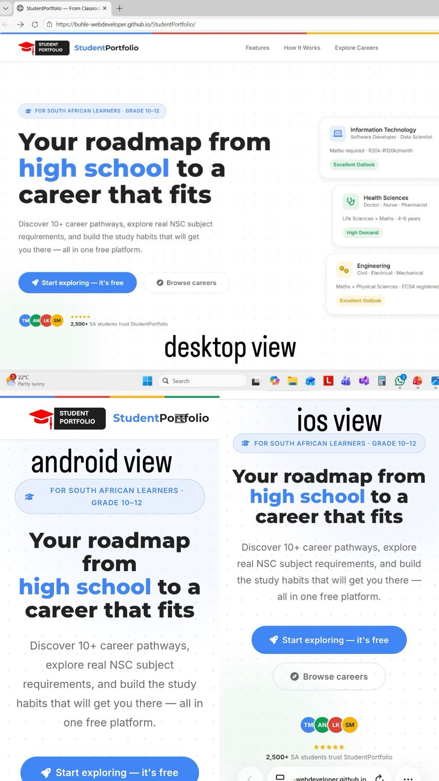

3.3 JavaScript — Modular, Asynchronous Code
Six standalone modules, each wrapped in an IIFE with "use strict":

Module | Responsibility
api.js | Data abstraction layer. Caches career data. Calls fetch() to World Bank API. Graceful fallback on failure
landing.js | Landing page: loads World Bank stats into API widget, computes dynamic platform stats from career data

3.4 Error Handling

Scenario | What Happens
World Bank API unreachable | Widget shows "Data temporarily unavailable" instead of breaking
Passwords don't match | "Passwords do not match."

4. Testing and Evaluation (20 marks)

4.1 Test Plan and Results
We created 4 automated unit tests in tests/run-tests.js (also runnable in browser via tests/tests.html). All 4 pass.

Test ID | Feature | Input | Expected Result | Actual Result | Status
T01 | Logged in after register | (automatic) | Login Success | Logged in | PASS
T02 | Admin seeded on first launch | (automatic) | Admin account exists in database | Admin account present | PASS
T03 | Admin login | admin@careerguide.co.za / Admin@2026 | Redirected to admin panel | Admin panel loaded | PASS
T04 | Public register cannot create admin | Pass role: "admin" in registration | Account created as student, NOT admin | Role forced to "student" | PASS

4.2 Responsiveness Check

Device / Width | Layout | Navigation | Cards | Modals | Status
Laptop 1366px | Full sidebar + grid | Visible sidebar | 3–4 columns | Centred overlay | PASS
Mobile 375px | Single column | Hamburger menu | 1 column | Full-width overlay | PASS

[INSERT SCREENSHOT: Explore page at desktop width]
[INSERT SCREENSHOT: Explore page at mobile width (375px)]

4.3 Performance (Lighthouse Scores)

Metric | Score | Notes
Performance | ___/100 | No heavy frameworks, minimal JS, optimised images
Accessibility | ___/100 | ARIA labels, semantic HTML, skip links, colour contrast

5. Results and Discussion (20 marks)

5.1 Final Website
Student Portfolio is a fully functional, five-page web application:
- Landing page: Hero section, dynamic platform statistics (computed from real data), live World Bank API widget showing SA secondary enrollment rates, category links, and calls-to-action
- Auth page: Login and registration with real-time field validation, SHA-256 password hashing, and role-based redirection. Admin account is pre-seeded; students register through the form
- Explore page: 10 SA career pathways displayed in a searchable, filterable card grid. Each card opens a detail panel that slides in from the right, showing subjects, salary ranges (junior/mid/senior), top institutions, core skills, and sample roles
- Student dashboard: Six sections — home overview, saved careers, study goals (add/remove), weekly study plan (check off tasks), progress tracking (dynamic bars), and profile editing
- Admin panel: Overview with stat cards, searchable career catalogue, full user table with delete, analytics charts (most saved careers, grade distribution, category breakdown), and settings (password change, data reset)

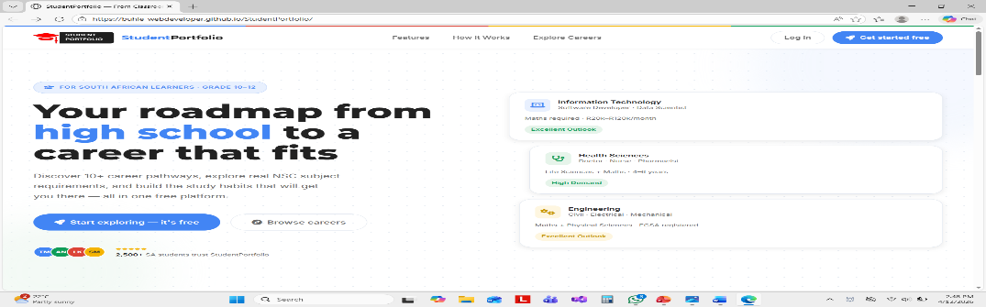

5.2 Challenges and How We Overcame Them

Challenge | How We Solved It
Understanding asynchronous JavaScript | We used async/await with try/catch blocks throughout instead of .then() chains. This made the code sequential and readable. We learned about Promises, race conditions, and why debouncing search input (200ms delay) prevents excessive API calls.
World Bank API sometimes unavailable | We wrapped the fetch() in try/catch. On failure, the widget shows "Data temporarily unavailable" with a graceful UI instead of a broken page or JavaScript error.

6. Limitations and Future Improvements

6.1 Current Limitations
- Limited dataset: 10 career pathways. A full version would include 50+ careers with more detailed metadata
- No email verification: Registration accepts any email format without sending a confirmation email

6.2 Future Improvements
- APS calculator to help learners compute their Admission Point Score from subject marks
- Career comparison tool to view two careers side-by-side

7. Code and Demo (10 marks)

7.1 GitHub Repository Structure
CareerGuide-SA/
+-- index.html # Landing page
+-- auth.html # Login / Register
+-- dashboard.html # Student dashboard
+-- explore.html # Career explorer
+-- admin.html # Admin panel
+-- README.md # Setup and execution instructions
+-- REPORT.md # This report
+-- .gitignore # Git ignore rules
+-- assets/
| +-- css/
| | +-- tokens.css # Design tokens (60+ CSS variables)
| | +-- shell.css # Shared sidebar + topbar layout
| | +-- landing.css # Landing page styles
| | +-- explore.css # Explore page styles
| | +-- auth.css # Auth page styles
| +-- js/
| | +-- auth.js # Auth module (SHA-256 hashing)
| | +-- api.js # API module (World Bank + careers)
| | +-- landing.js # Landing page logic
| | +-- dashboard.js # Dashboard logic
| | +-- explore.js # Explore page logic
| | +-- admin.js # Admin panel logic
| +-- images/ # Career images, logo
+-- data/
| +-- careers.json # Career data (JSON)
| +-- careers-data.js # Inline data fallback
+-- tests/
| +-- tests.html # Browser-based test runner (26 tests)
| +-- tests.js # Browser test logic
| +-- run-tests.js # Node.js test runner (37 tests)

