**Audio Processing**

Exercise 1

Anh Huy Bui

293257

**Problem 1:**

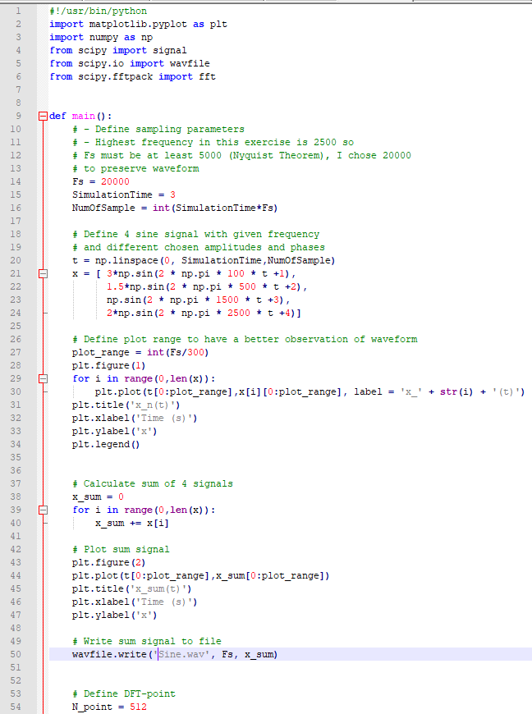

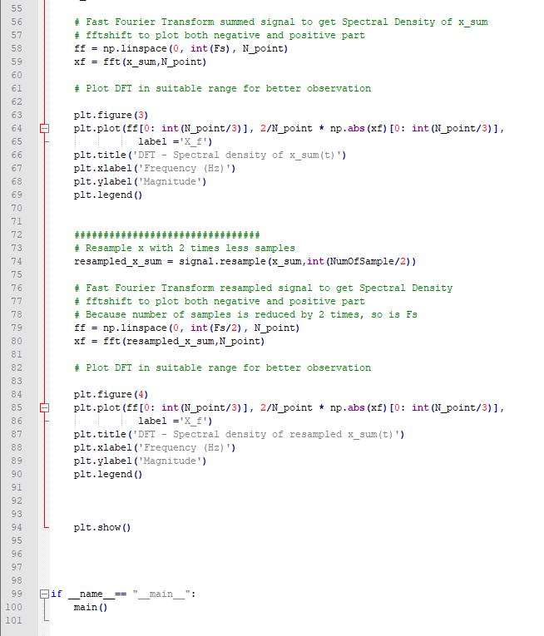

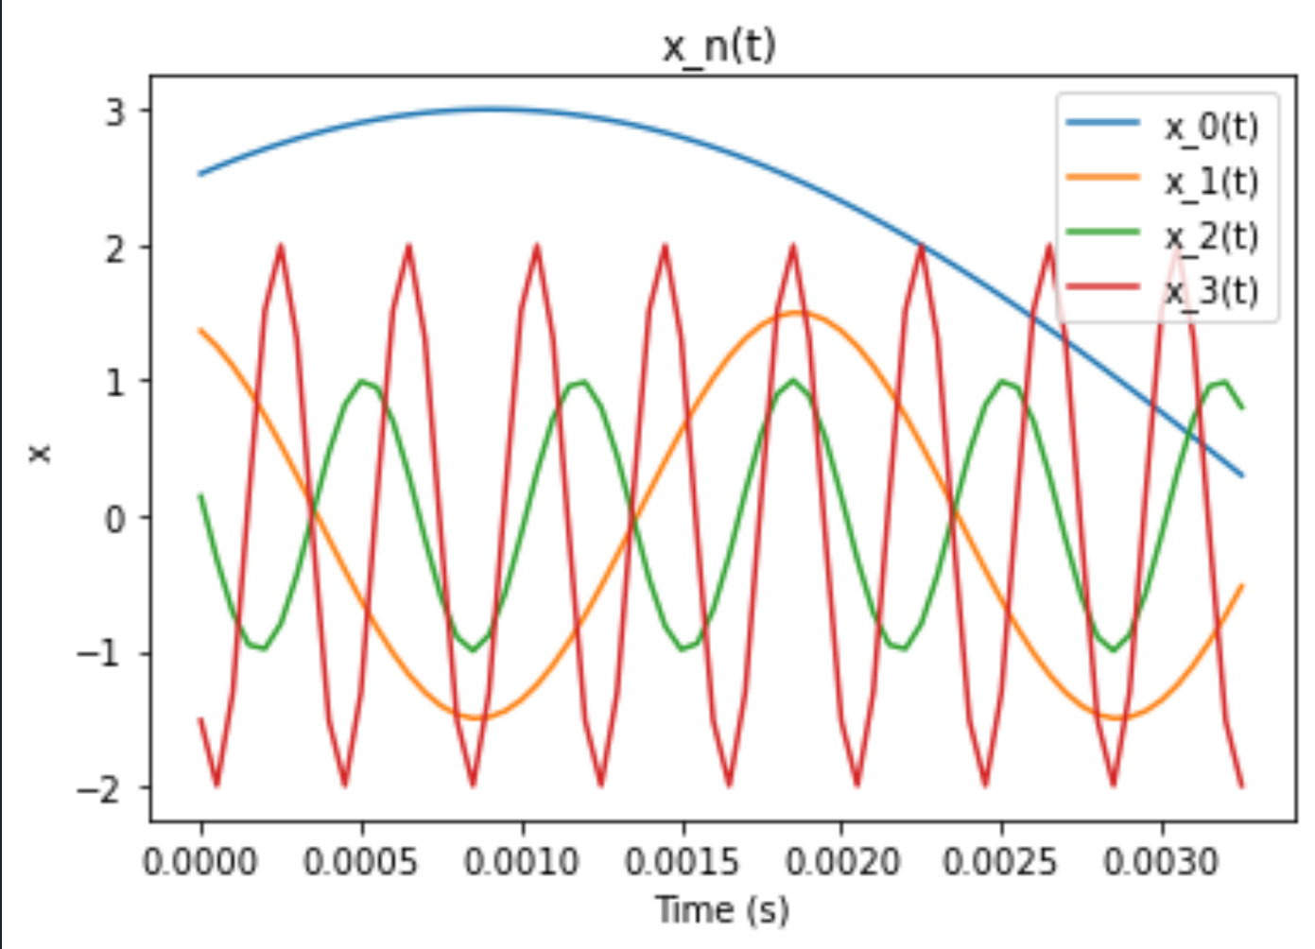

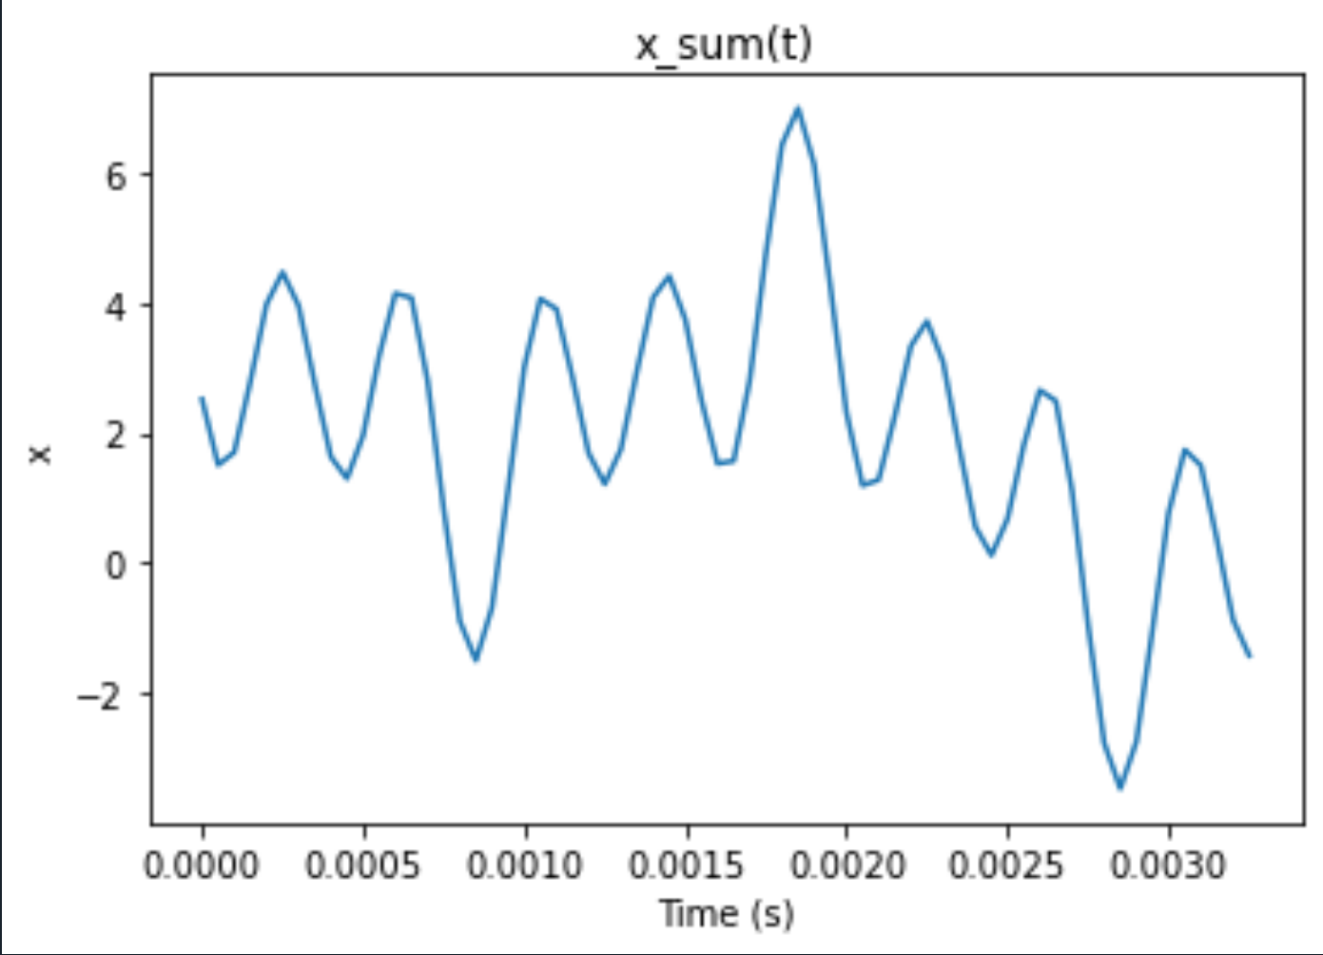

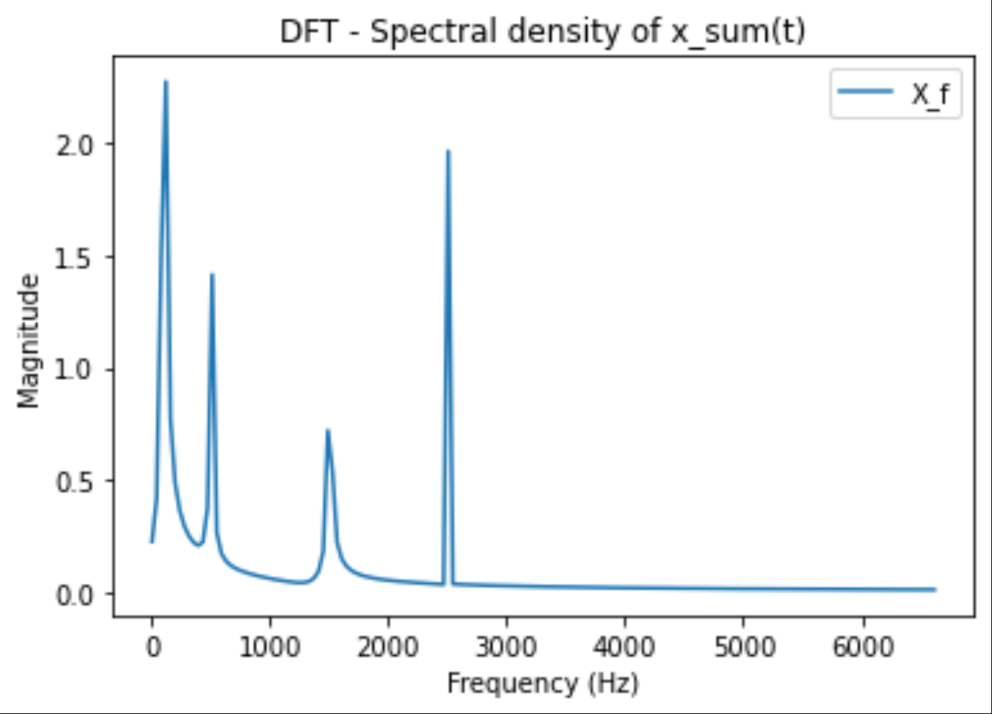

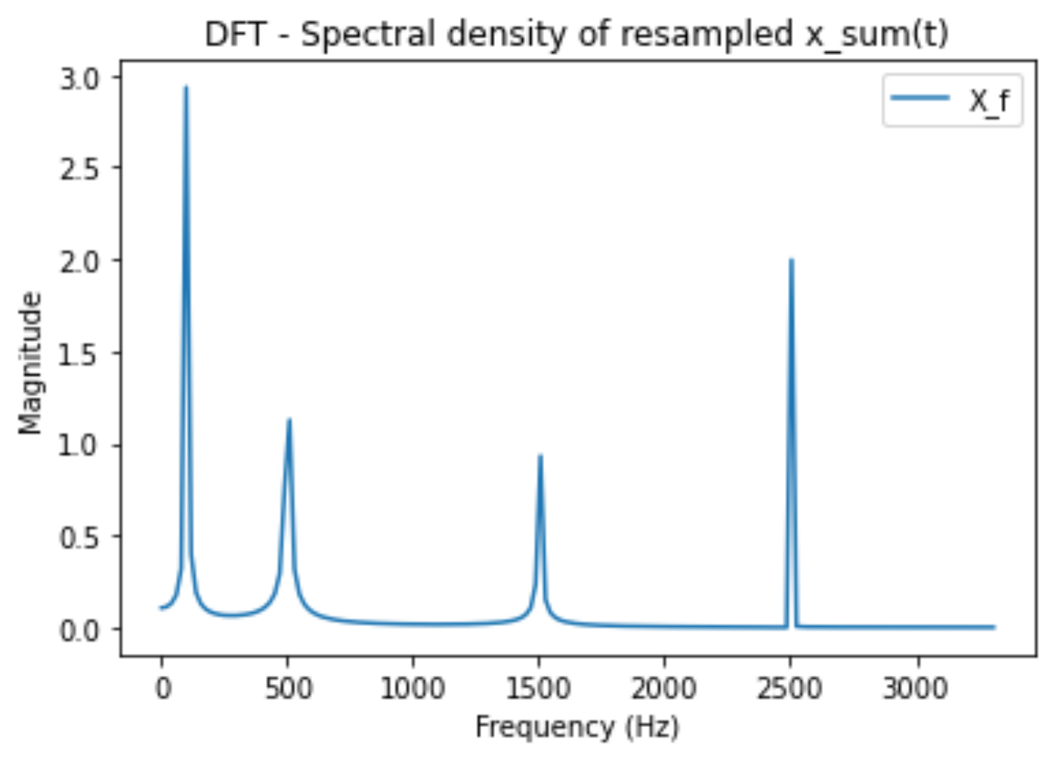

Comment:

The highest frequency in DFT plot is the sampling frequency Fs and the lowest frequency is Fs/N. So with a fixed number of N, higher Fs results in lower frequency resolution.

In resampled version, DFT plot is same as original one with sampled with Fs’ = Fs/2. As can be seen from 2 plots, the resampled one are more precise, especially in range about 0-1000Hz. It can be because of above reason, the resampled one has lower Fs so higher frequency resolution.

**Problem 2:**

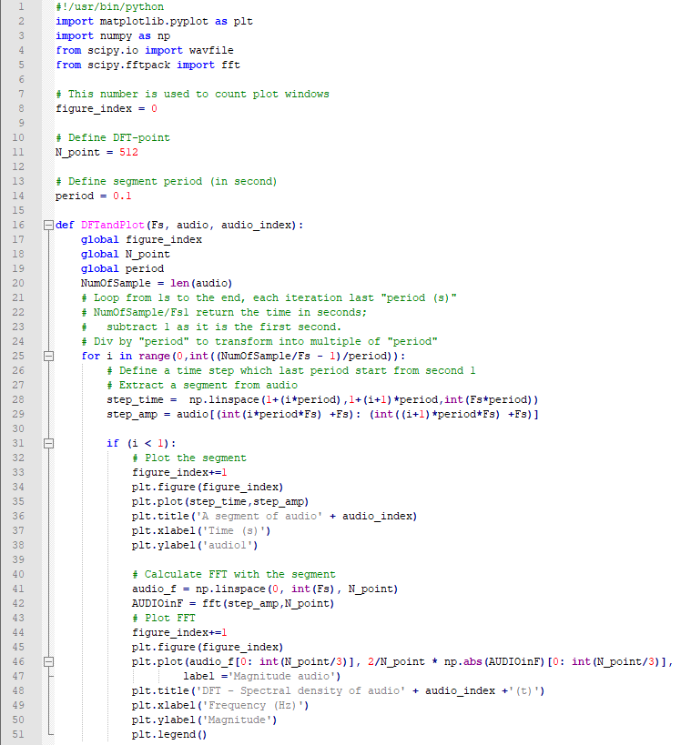

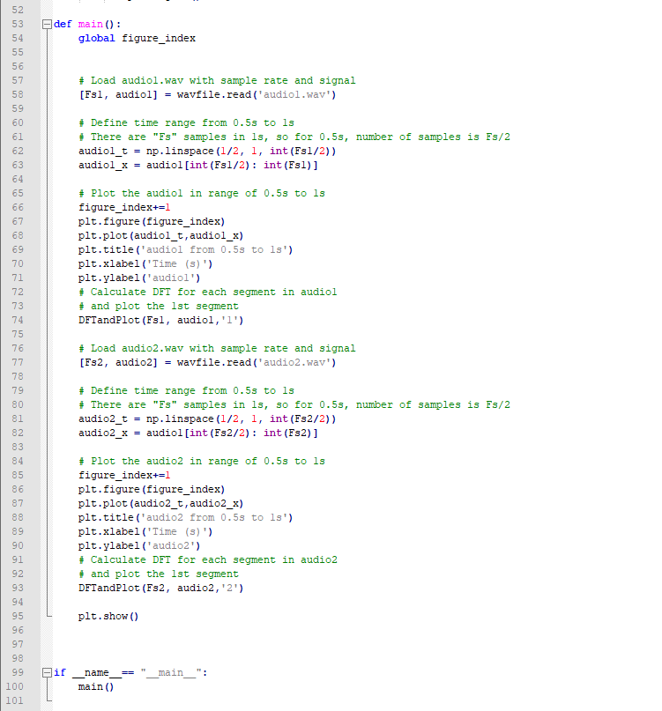

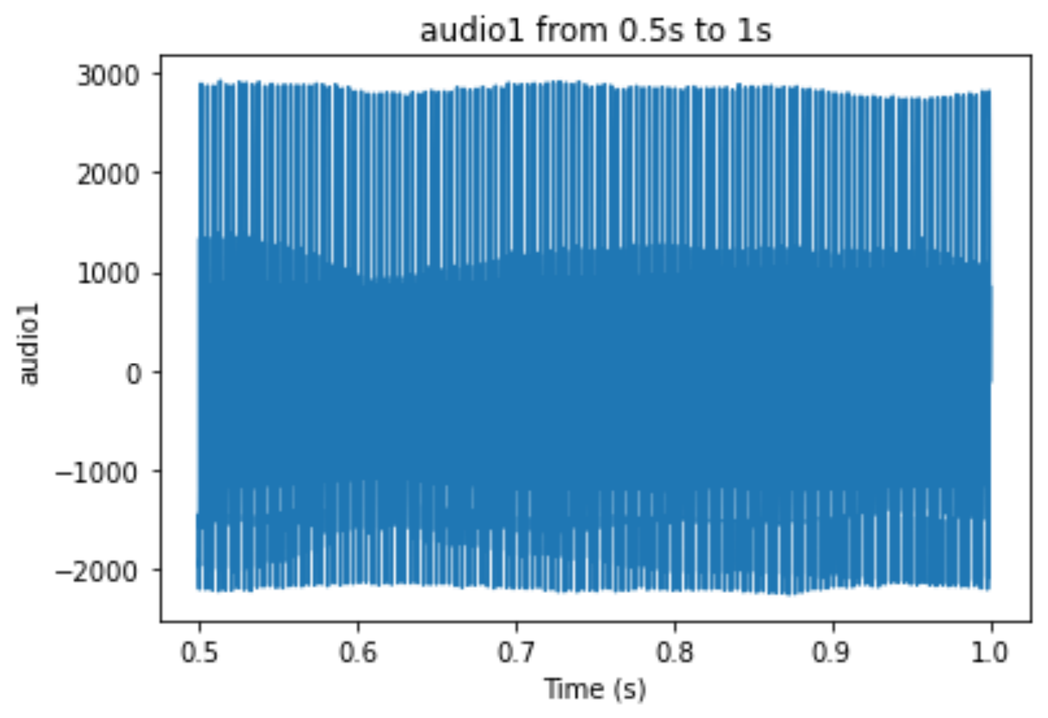

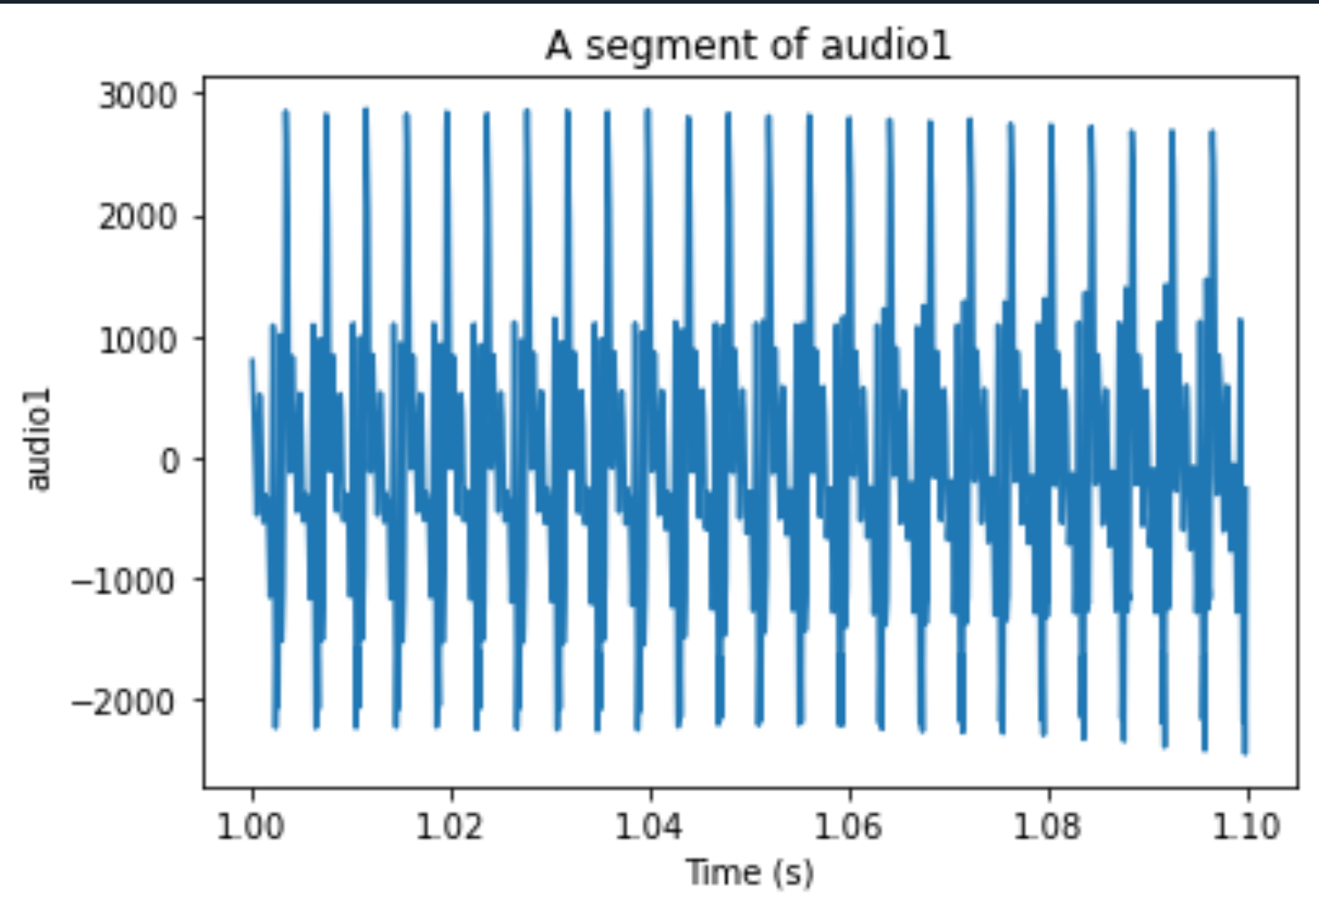

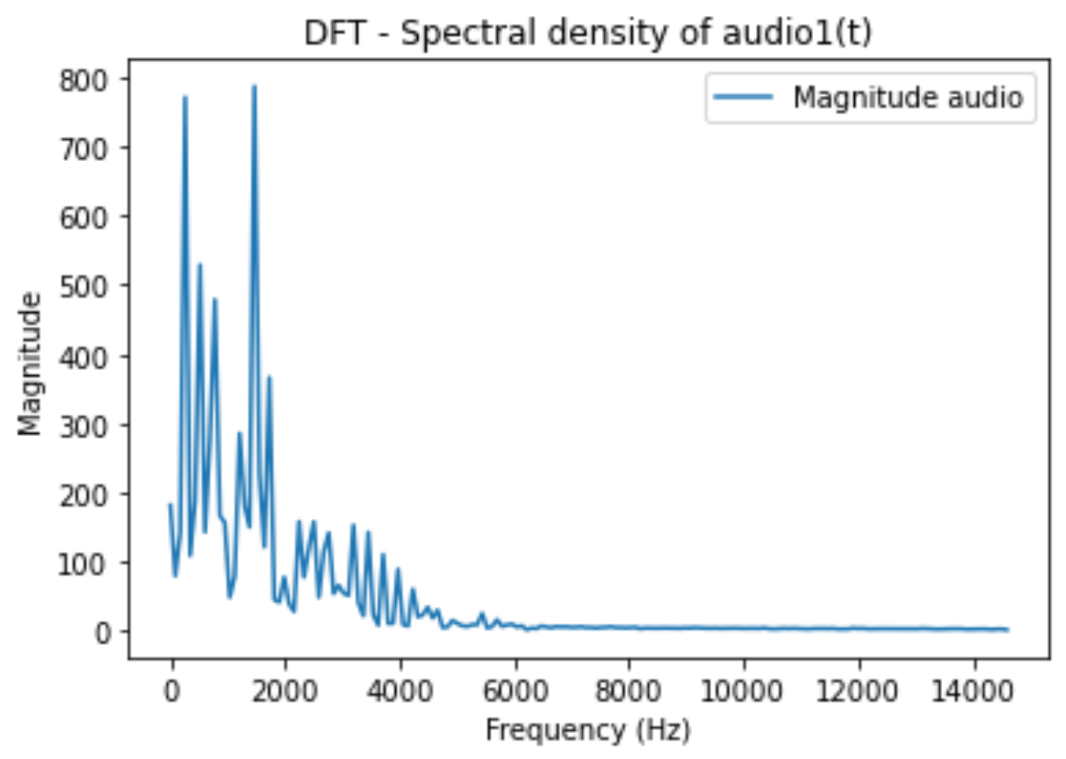

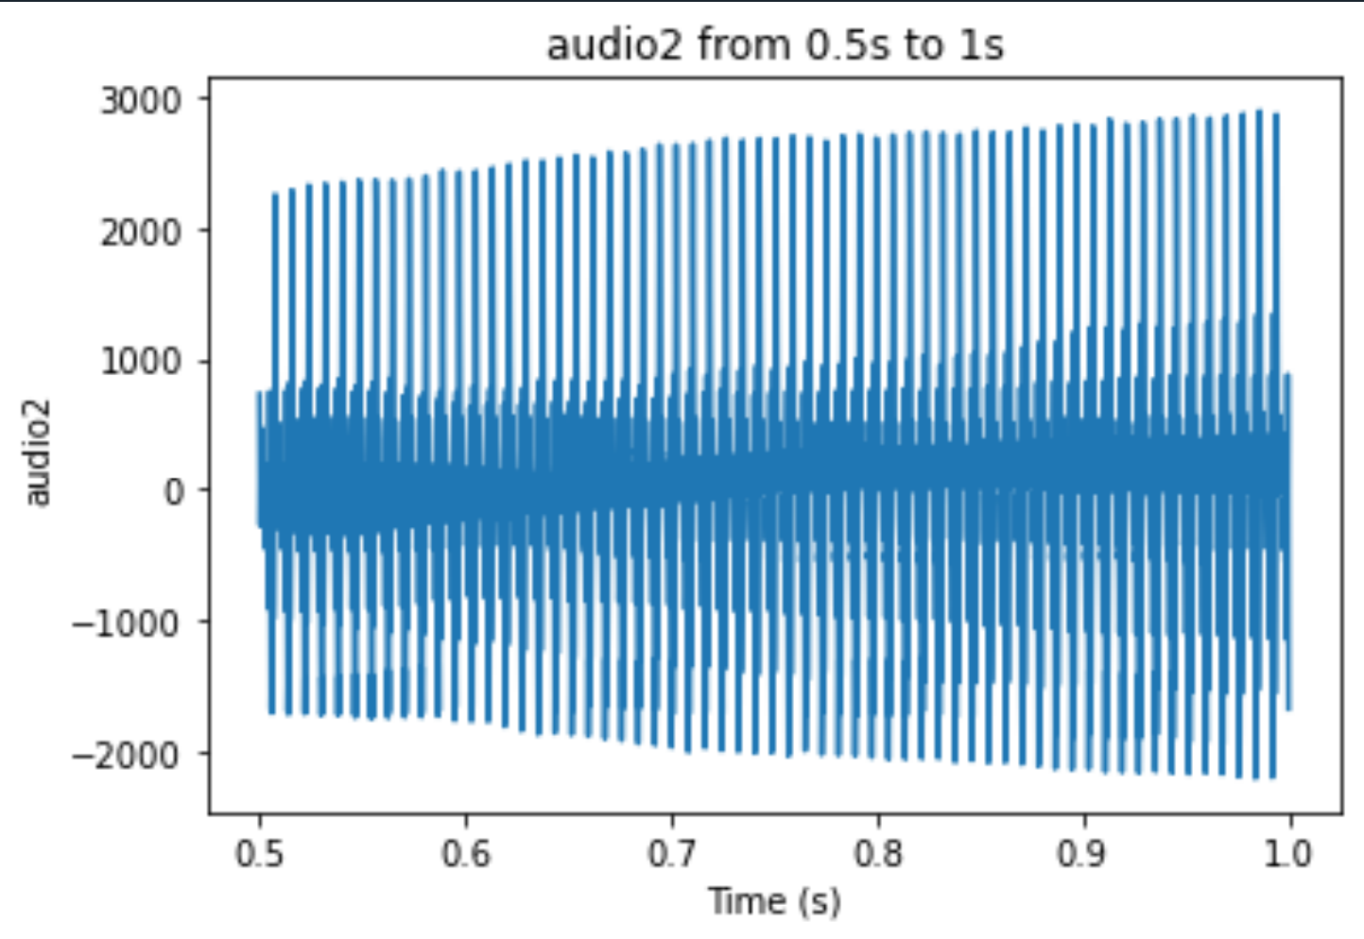

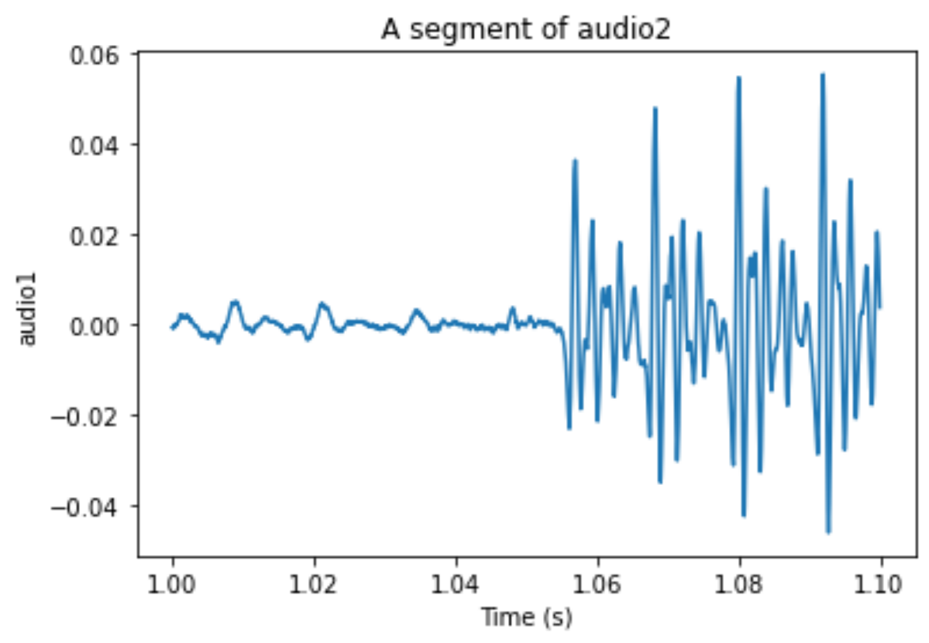

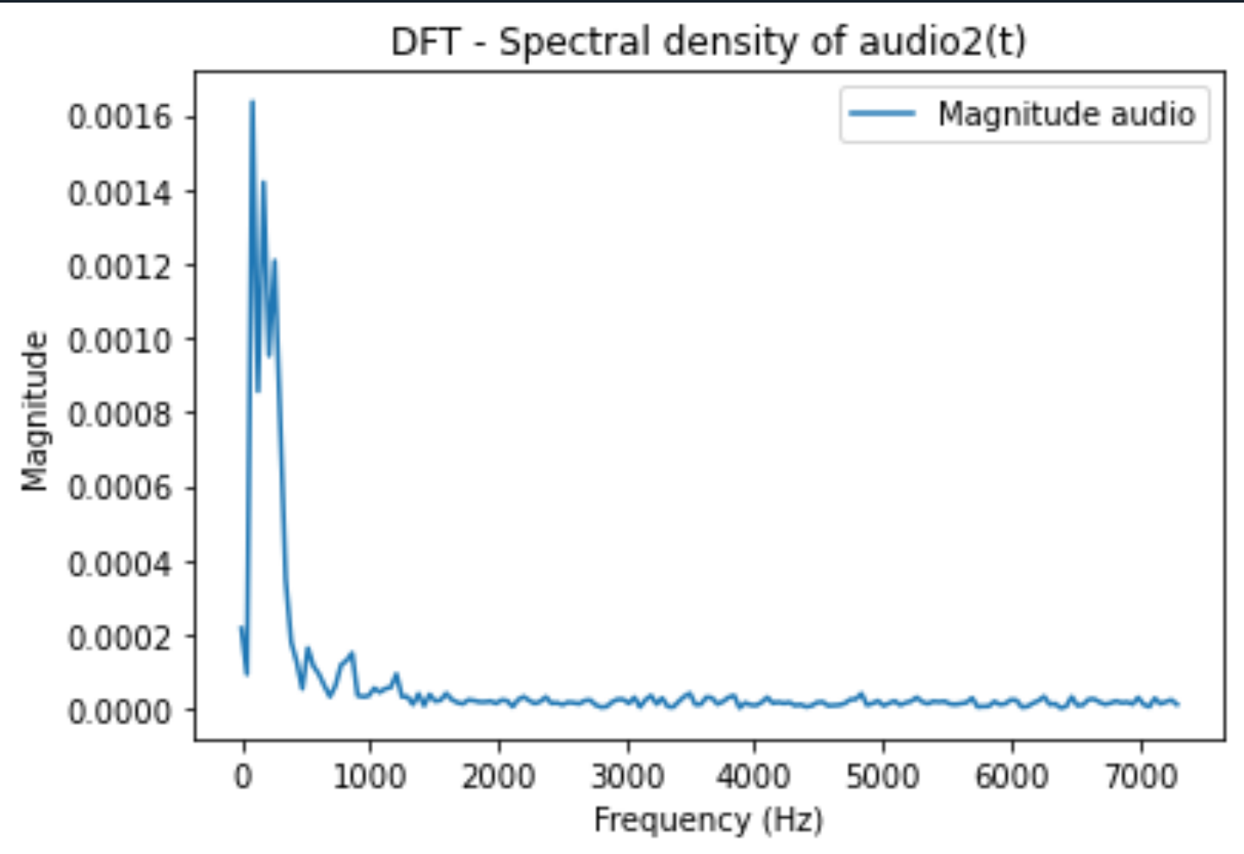

Comment:

The DFT plots of both signals indicate that the 2 audios consist of multiple sinusoid waves with different frequencies within. This is described by the fluctuation of DFT plot throughout frequency range, despite the highest around 0 – 500 Hz. On the other hand, sinusoids’ DFT just shows that there are only 4 signals clearly seen in the sine.wav