**Audio Processing**

**Ex04 – Report**

Student: Anh Huy Bui

ID: 293257

**Problem 1:**

* **Filter order = 8**

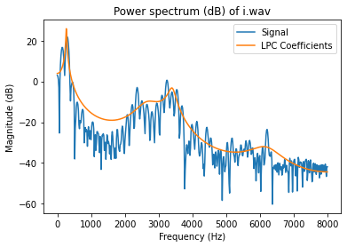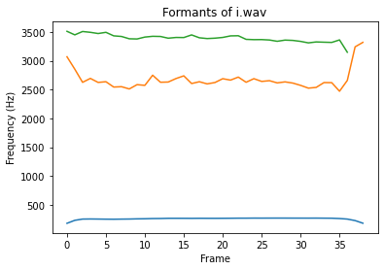

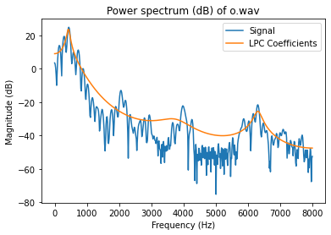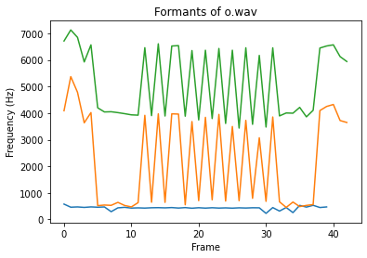

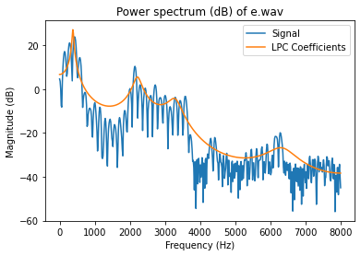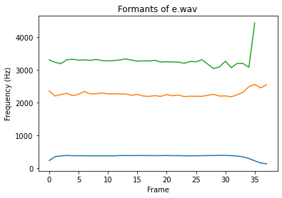

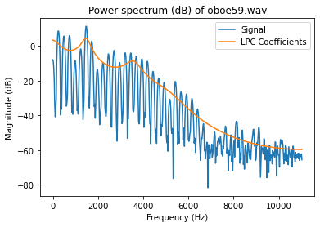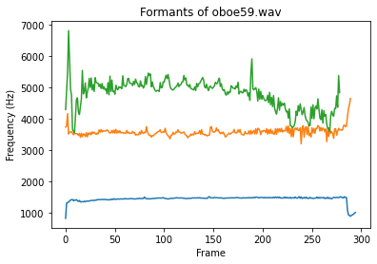

* **Filter order = 16**

* **Filter order = 20**

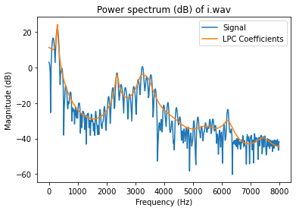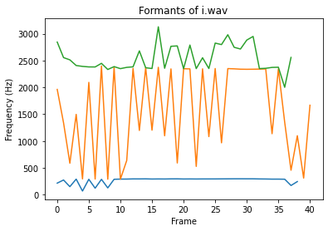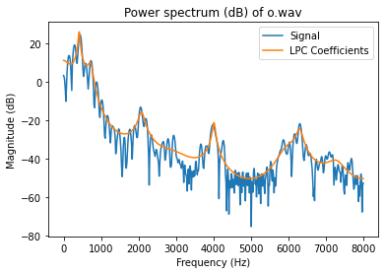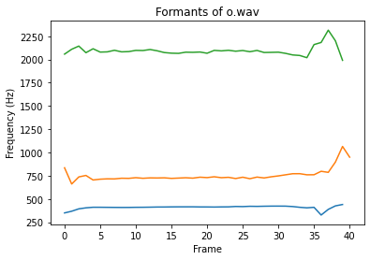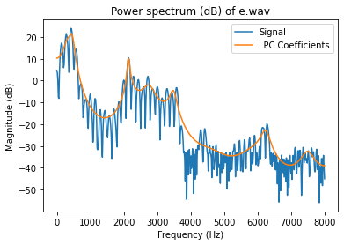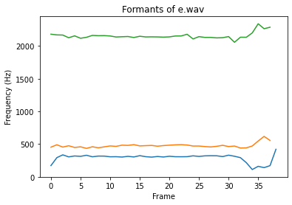

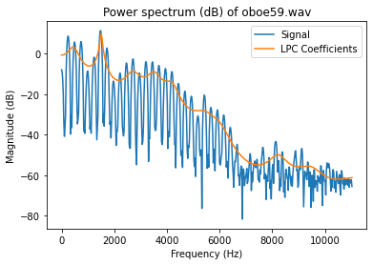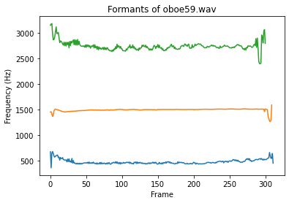

|  |  |  |  |  |
| --- | --- | --- | --- | --- |
|  | i | o | e | oboe |
| Order = 8 | 259.53538  2674.1015  3392.5319 | 434.18361  2250.6473  5142.8207 | 352.29864  2265.0264  3275.0652 | 1440.0622  3581.6966  4793.3522 |
| Order = 16 | ***286.0335***  ***2360.9112***  ***3287.9208*** | 385.22134  688.1659  2195.7403 | ***418.7426***  ***2177.6947***  ***2768.6828*** | 437.0447  1484.6430  2885.2586 |
| Order = 20 | 268.5158  1568.9482  2538.6713 | ***409.2858***  ***754.1582***  ***2093.8191*** | 291.0970  475.9952  2155.8655 | 471.8560  1490.7389  2741.8838 |
| Reference | 294  2343  3251 | 406  727  2090 | 434  2148  2763 |  |

*(Bold indicates best suit to reference value)*

Model order and peaks:

As can be seen from the left graphs, higher value of filter order results in more accurate LPC model, which stick sharply with signal DFT. In other words, lower value cause lost in information (signal peaks). However, too high value may contain too much information to process. As in this case, we only want to keep 3 first peaks, so it will be the best if those peak can represent the main frequency of the signal, yet high value of order gives some addition peaks (not the main one), so with only 3 peaks recorded, they cannot represent the whole signal. For example: Vowel “e” with order = 20 from the table is completely different from reference.

**Problem 2:**

Roots of the LP polynomial got from np.roots are used to calculate the angle/frequency at which the magnitude of transfer function returns maximum.

Conclusion:   
I have plotted additional figures to display different effects of different orders.

In my opinion, when observing these figures, especially the “i” of order = 20, I find that peaks of “i” closest to reference is when order = 16. With an increase order, the formants is not stable throughout the whole “i” signal. Similar to “o” when it comes to too low (order = 8).

Bonus:

An oboe is a wind instrument, so it returns somewhat similar to speech processing. However, its FFT shows that the frequencies vary much faster then voice signal. It also requires a different order to get the best peaks. Formants figures always show that there is some minor variation of peaks throughout the whole signal.