Name: Bui Anh Vu

Email: [buianhvu.hust@gmail.com](mailto:buianhvu.hust@gmail.com)

Weekly Report

Topic: Image Classification Using K-Means Algorithm

1. Problem defining

Given an image



Using K-Means clustering algorithm to distinguish every segment in the picture.

1. Solving

The idea is quite simple, an image is constructed from many pixels. Generally speaking, each pixel is built from a set of three numbers – RGB red, green, and blue.

From that list of pixels, I first randomly pick K pixels for the initial centroids; hence, we have K clusters.

Traverse all the elements in the list of pixels, and calculate the distance from one pixel to each of K centroids, if the distance is smallest among all, that pixel belong to the cluster of that centroid.

To stop the loop, we have a quantity called cutoff, if the biggest difference between a pair of old centroid and new centroid (there are k pairs) is smaller than cutoff, the we stop the process of finding new centroids.

Replace all the pixels with its centroid and we are done.

1. Result

With K = 3



K = 4

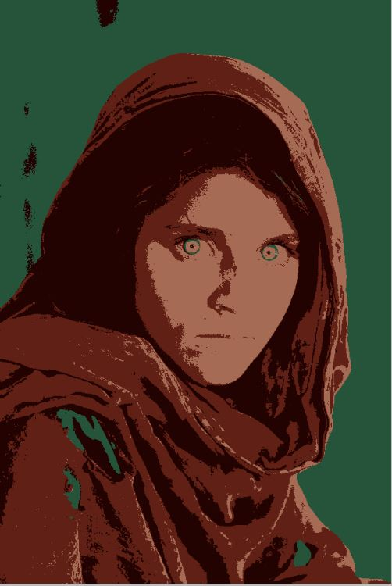

K = 5

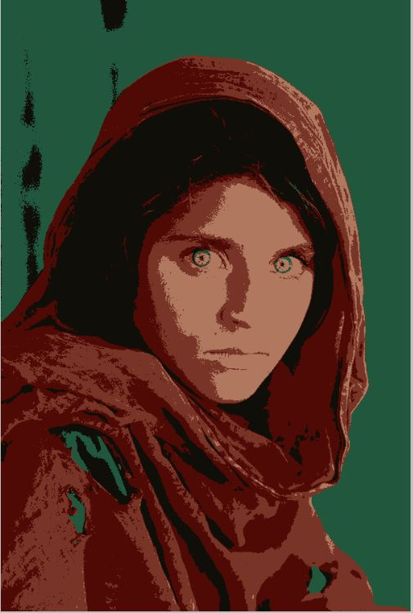

K = 8

