Quy trinh su dung Github:

B1: Clone [https://github.com/buibao/ProjectCharaContent.git](https://github.com/buibao/ProjectCharaContent.git?fbclid=IwAR1XfxeSHZ_OwVFVEcgjRz_UmIEjRMHhqY5HVQ7Ib0TzTaK2vIcPdMT4Rkc)

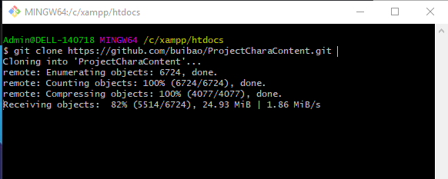

B2: Create new branch from develop

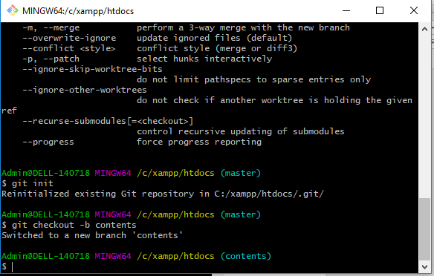

* After cloning resp , type **git init** to start using git, then type **git checkout -b <branch_name>** to create new branch from master (it will fetch the latest source of system to develop new function from it)
* And switch Sublime to develop

B3: Commit and Push Changes from local branch

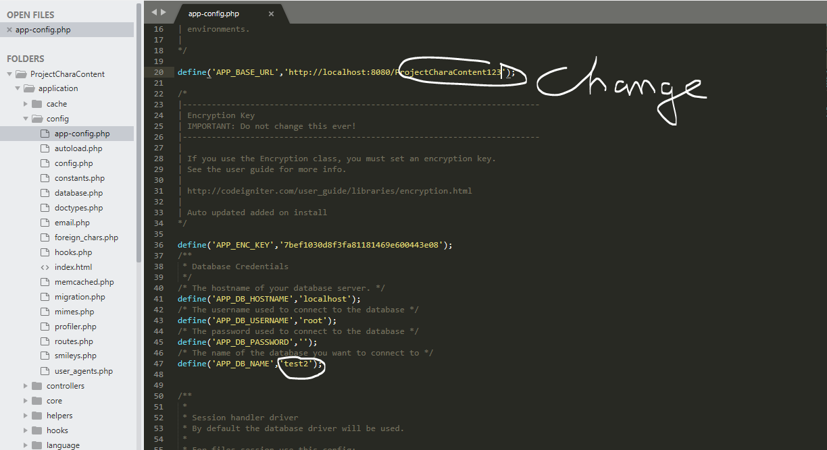

* Then the changes had done and tested on local, switch to gitbash to push to git

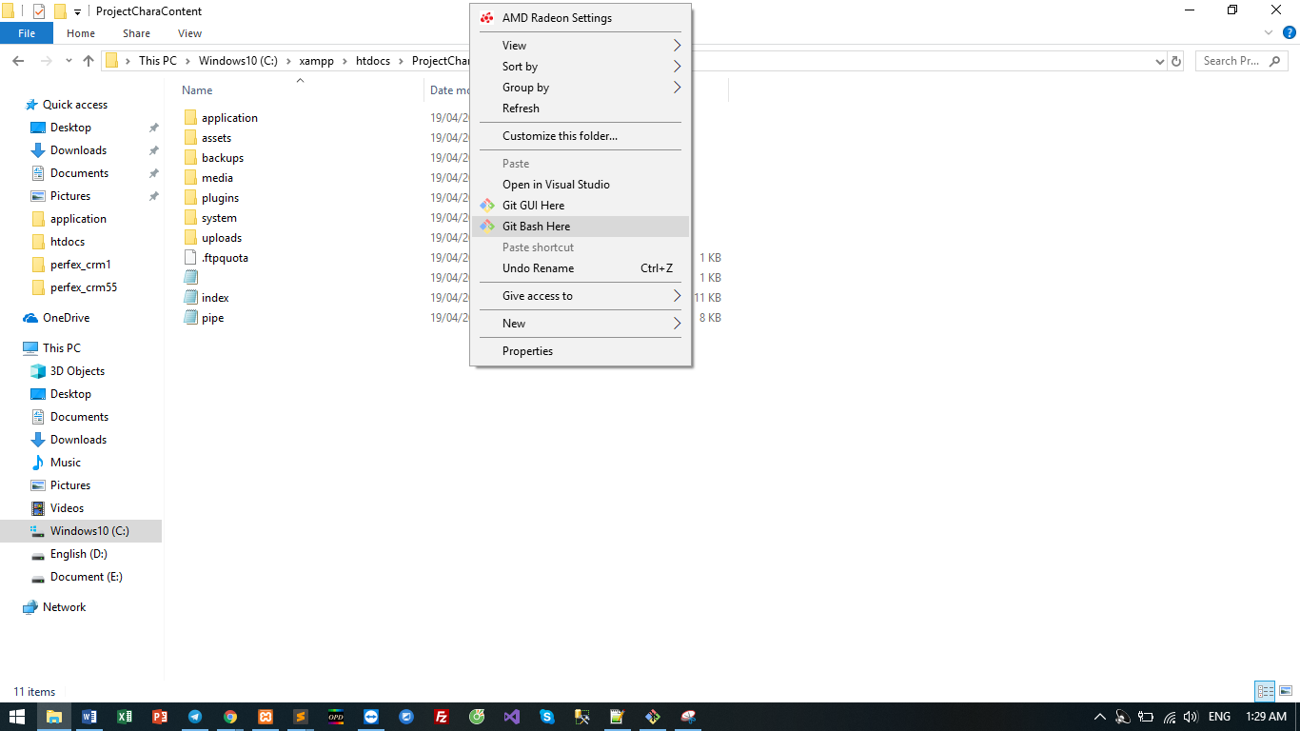

* Switch Gitbash to compare (check again) the changed lines in source before pushing

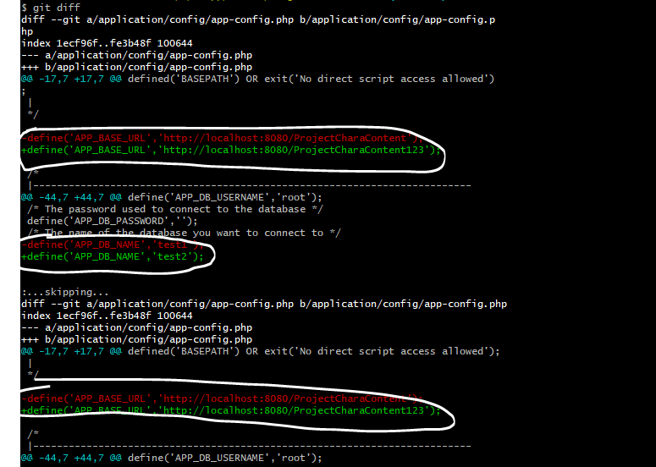

* After checking, commit and push local branch (contents) to github

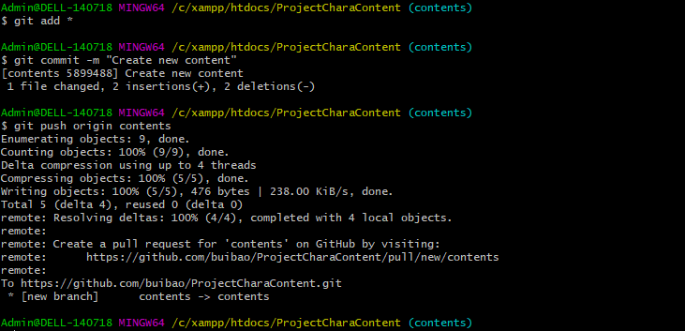

B4: Create pull request for reviewing source

