lab7_c

- AI tools used: Google Gemini
- Prompts used:
Draw a block chart of the modules, the functions, the dependencies between the functions, and explain the program structure as in the attached file “lab7_b.py” and “puzzle.py”. Use the continuous arrow line to represent “function call”.

AI’S ANSWER:

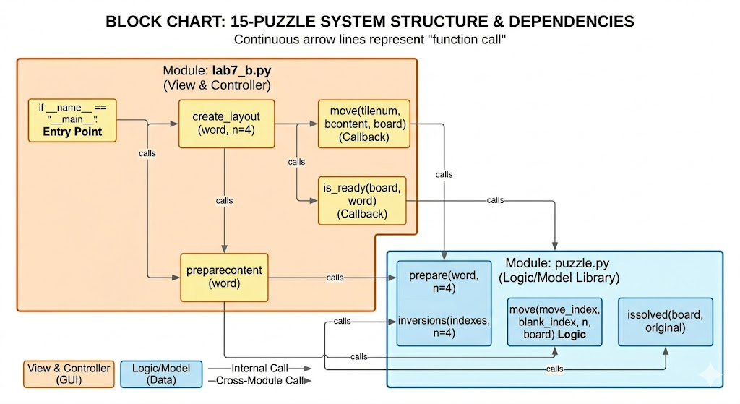

Program Structure Explanation:
The application adheres to a clean Separation of Concerns (SoC), decoupling the user interface from the core game rules. This is achieved through two modules:
1. Module: puzzle.py (The Model/Logic Library)
This module contains the pure logical rules of the 15-puzzle, independent of any graphical representation. It treats the board as a one-dimensional list.
- prepare(word, n=4): The initialization function. It receives a word and generates a shuffled, solvable sequence of indexes. It repeatedly shuffles until inversions() returns an even count (the condition for solvability on a $4 \times 4$ grid starting with the blank space at the end).
- inversions(indexes, n=4): A helper function that counts "inversions" (a scenario where a higher numbered tile appears before a lower one), which dictates mathematical solvability.
- move(move_index, blank_index, n, board): The core decision-making function. It takes the index of the clicked tile and the blank tile, validates if they are adjacent (up, down, left, right), and if legal, performs the data swap in the list.
- issolved(board, original): Determines the win condition by comparing the current board sequence (ignoring the blank) with the original target tuple.
2. Module: lab7_b.py (The View & Controller)
This module manages the window lifecycle and user interactions using the tkinter library. It acts as the "Controller," bridging user clicks to the logic library and updating the "View."
- Entry Point (if __name__ == "__main__":): Initiates the application by calling create_layout with a target 15-letter string.
- create_layout(word, n=4): The main setup function. It builds the window, configures the style, creates the list of 16 buttons (bcontent), and arranges them in a grid. Crucially, it defines the command callback for each button, linking user clicks to the move() and is_ready() functions.
- preparecontent(content): Acts as a bridge. It calls puzzle.prepare() to get the solvable sequence, converts the resulting data, and explicitly inserts the empty string to represent the "blank" space (setting it at a fixed index 10).
- move(tilenum, bcontent, board): The primary callback. When a tile is clicked, it asks puzzle.move() if the swap is valid. If successful, it updates the visual state by swapping the button text and updating the global empty index, while also toggling the DISABLED status.
- is_ready(board, word): A secondary callback triggered after every move attempt. It asks puzzle.issolved() if the win condition is met and displays a congratulations message box if true.

