

**Database Design & Implementation**

**COMP1302 Coursework**

**Student Name: Duong Bui Dinh**

**Student Roll Number: GT00010**

**Instructor: Vung Pham Van**

Contents

Introduction 2

D1 Assumption & Business rules 2

D2 Conceptual model 3

D3 Logical relation schema 4

Database description 6

D4 Normalization check 11

D5 Create Database 11

D6 SQL Code 11

A1 11

A2 11

A3 12

A4 14

D7 Registration Form 15

D8 A5-Form Report 15

D9 A6-Master Detail Form 18

References 19

# 

# Introduction

Designing database is an important stage in software development. This document is a report after designing database for Web Online Diary. All stages of this designing are follow with the common designing stages of designing database: Conceptual Model, Logical Model with Normalization and Physical Model.

# D1 Assumption & Business rules

There are some assumptions to make some business rules clearly.

1. Each Blogger can have more than one blog. Each blog must belong to one blogger.
2. Each Blogger can post entry on his/her blog and other’s blog.
3. One blogger can have many bankcards, or credit cards. However, there is only one bankcard or credit card is used for payment.
4. Each Bank Card or Credit Card must belong to a blogger.
5. Each entry has to pay for a payment. Each payment has to belong to an Entry.
6. Each Payment has a price, the price can change at any time, at this time, the price is two $ per one payment for entry.
7. An Entry has many comments; every comment can also have comments on it. All comments have to be categorised.
8. One question can be answered by concerned blogger and other bloggers.
9. Each Answer must belong to a Blogger
10. One blog has unique blog title in entire database.

# D2 Conceptual model

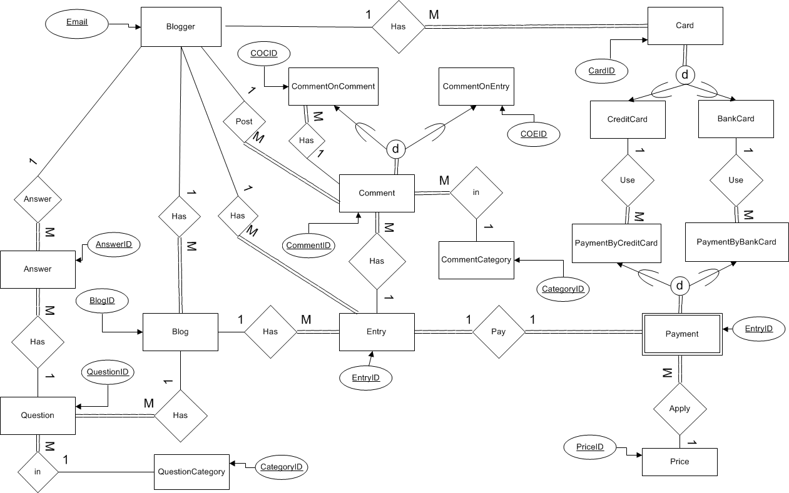Figure 01: Conceptual model diagram (Chen’s Notation)

This EER diagram shows data model of Web Online Diary. It contains Entities, relationships and primary key for each Entity. Attributes of Entities are show in Logical stage.

# D3 Logical relation schema

This following Logical Relation is the result of mapping process from EERD above to relational schema.

It shows attributes of each entity in EERD above and links between relations (tables).

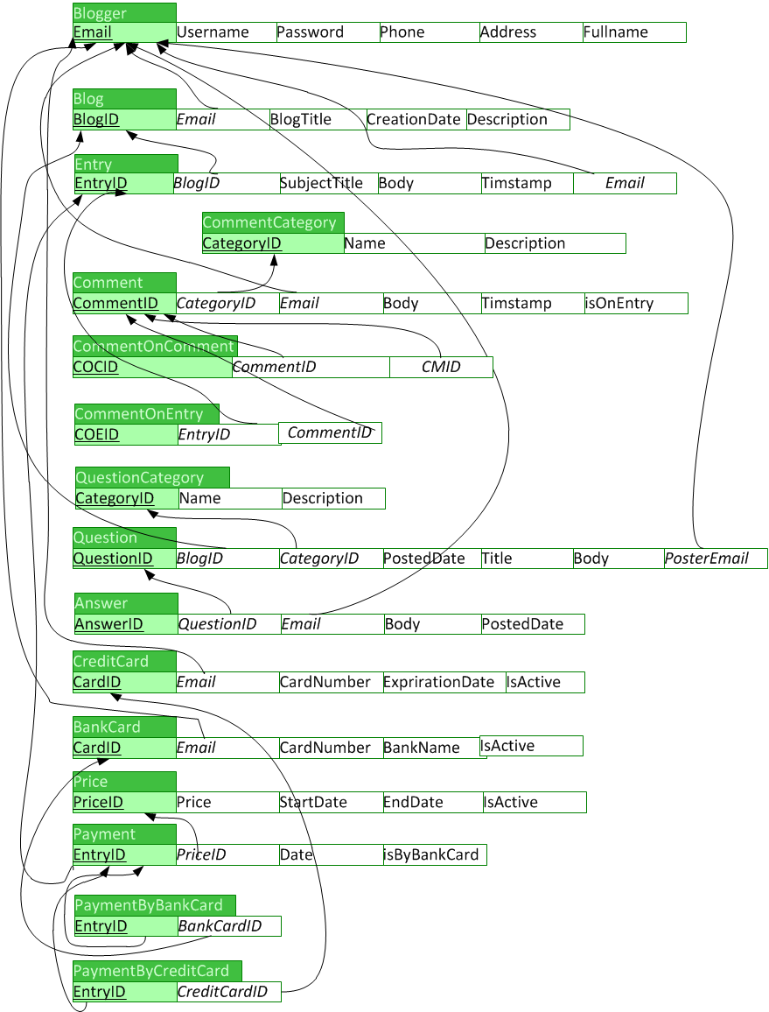Figure 02: Relation schema shows links between relations

Database description

This is description for database.

|  |  |  |  |
| --- | --- | --- | --- |
| **Blogger** | | | |
| Column | Data Type | Constraint | Description |
| **Email** | Text | Primary key | Identify blogger |
| Username | Text | Unique, Not null | Alias name |
| Password | Text | Not null | Password |
| Phone | Text | Not null | Phone |
| Address | Text | Not null | Address |
| Fullname | Text | Not null | Full name |

|  |  |  |  |
| --- | --- | --- | --- |
| **Blog** | | | |
| Column | Data type | Constraint | Description |
| **BlogID** | Number | Primary key | Indentify blogger |
| *Email* | Text | Foreign Key | References to **Blogger** table |
| CreationDate | Date/time | Not null | Creation date of blog |
| Description | Text | Not null | Description of blog |
| BlogTitlte | Text | Not null, unique | Title of blog |

|  |  |  |  |
| --- | --- | --- | --- |
| **Entry** | | | |
| Column | Data Type | Constraint | Description |
| **EntryID** | Number | Primary key, identity | Identify an entry |
| *Email* | Text | Foreign key | References to **Blogger** table |
| *BlogID* | Number | Foreign key | References **Blog** table |
| SubjectTitle | Text | Not null | Title of entry |
| Body | Text | Not null | Content of entry |
| Timestamp | Date/time | Not null | Posted time |

|  |  |  |  |
| --- | --- | --- | --- |
| **CommentCategory** | | | |
| Column | Data type | Constraint | Description |
| **CategoryID** | Number | Primary key, identity | Indentify a category |
| Name | Text | Not null | Name of category |
| Description | Text | Not null | Description of category |

|  |  |  |  |
| --- | --- | --- | --- |
| **Comment** | | | |
| Column | Data type | Constraint | Description |
| CommentID | Number | Primary key | Primary key |
| *CategoryID* | Number | Foreign key | References to **CommentCategory** table |
| Body | Text | Not null | Content of comment |
| Timestamp | Date/time | Not null | Posted time |
| *Email* | Text | Foreign key | Reference to **Blogger** table |
| isOnEntry | Yes/No | Not null | Determine what kind of comment |

|  |  |  |  |
| --- | --- | --- | --- |
| **CommentOnEntry** | | | |
| Column | Data type | Constraint | Description |
| *COEID* | Number | Primary key |  |
| *CommentID* | Number | Foreign key | Reference to **Comment** Table |
| *EntryID* | Number | Foreign key | References to **Comment** table |

|  |  |  |  |
| --- | --- | --- | --- |
| **CommentOnComment** | | | |
| Column | Data type | Constraint | Description |
| *COCID* | Number | Primary key |  |
| *CommentID* | Number | Foreign key | Reference to **Comment** table |
| *CMID* | Number | Foreign key | References to **Comment** table |

|  |  |  |  |
| --- | --- | --- | --- |
| **QuestionCategory** | | | |
| Column | Data type | Constraint | Description |
| CategoryID | Number | Primary key, identity | Primary key |
| Name | Text | Not null | Name of category |
| Description | Text | Not null | Description of category |

|  |  |  |  |
| --- | --- | --- | --- |
| **Question** | | | |
| Column | Data Type | Constraint | Description |
| **QuestionID** | Number | Primary key, identity | Primary key |
| *BlogID* | Number | Foreign key | References to **Blog** table |
| *CategoryID* | Number | Foreign key | References to **Category** table |
| PostedDate | Date/time | Not null | Posted time of question |
| Title | Text | Not null | Title of question |
| Body | Text | Not null | Content of question |
| *PosterEmail* | Text | Foreign key | Indentify the person who post this question, references to **Blogger** table |

|  |  |  |  |
| --- | --- | --- | --- |
| **Answer** | | | |
| Column | Data type | Constraint | Description |
| **AnswerID** | Number | Primary key | Primary key |
| *QuestionID* | Number | Foreign key | References to **Question** table |
| Body | Text | Not null | Content of answer |
| PostedDate | Date/time | Not null | Posted time of answer |
| Email | Text | Foreign key | References to **Blogger** table |

|  |  |  |  |
| --- | --- | --- | --- |
| **CreditCard** | | | |
| Column | Data type | Constraints | Description |
| **CardID** | Number | Primary key | Primary key |
| *Email* | Text | Foreign key | References to **Blogger** table |
| CardNumber | Text | Not null | Serial number of credit card |
| ExpirationDate | Date/time | Not null | Expiration Date |
| isActive | Yes/No | Not null | Determine if the card is using |

|  |  |  |  |
| --- | --- | --- | --- |
| **BankCard** | | | |
| Column | Data type | Constraint | Description |
| **CardID** | Number | Primary key | Primary key |
| *Email* | Text | Foreign key | References to **Blogger** table |
| CardNumber | Text | Not null | Serial number of bank card |
| BankName | Text | Not null | Name of bank |
| IsActive | Yes/No | Not null | The card is using |

|  |  |  |  |
| --- | --- | --- | --- |
| **Price** | | | |
| Column | Data type | Constraint | Description |
| **PriceID** | Number | Primary key | Primary key |
| Price | Number | Not null | Price of payment for each entry |
| StartDate | Date/time | Not null | Date are being to apply the price for payment |
| EndDate | Date/time | Allow null | End date of price |
| IsActive | Yes/No | Not null | Determine what price are using |

|  |  |  |  |
| --- | --- | --- | --- |
| **Payment** | | | |
| Column | Data type | Constraint | Description |
| ***EntryID*** | Number | Primary key, foreign key | Reference to **Entry** table |
| *PriceID* | Number | Foreign key | References to **Price** Table |
| Date | Date/time | Not null | Date of payment |
| IsByBankCard | Yes/no | Not null | Determine type of payment |

|  |  |  |  |
| --- | --- | --- | --- |
| **PaymentByCreditCard** | | | |
| Column | Data type | Constraint | Description |
| ***EntryID*** | Number | Primary key, foreign key | Reference to **Payment**  table |
| CreditCardID | Number | Foreign key | References to **CreditCard** table |

|  |  |  |  |
| --- | --- | --- | --- |
| **PaymentByBankCard** | | | |
| Column | Data type | Constraints | Description |
| *EntryID* | Number | Primary key, foreign key | References to **Payment**  table |
| *BankCardID* | Number | Foreign key | Reference to **BankCard** table |

# 

Figure 03: Database relationship

**Note**: the table Comment_1 in figure 03 is actual the table Comment. Column CmID and COCID in table CommentOnComment references to CommentID in table Comment together. But Access Database Relationship does not support reference like this. So it automatically generates this Comment_1 table to show relationship.

# D4 Normalization check

“The Relational Schema satisfies 3NF criteria”

# D5 Create Database

Database has been created in MS Access.

# D6 SQL Code

## A1

“List the titles and creation dates of all Blogs, as well as the total number of Blog entry associated with that blog” (Coursework requirement)

We can deal this requirement by using subquery, and **Count**() function.

**SELECT** b.BlogTitle, b.CreationDate, (**SELECT COUNT(*) FROM** Entry e **WHERE** e.BlogID=b.BlogID) AS TotalEntry **FROM** Blog AS b;

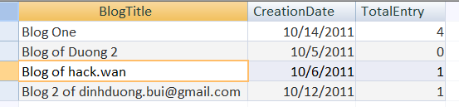

Figure 04: The result of A1 Query

## A2

“Provide a list of all Bloggers (i.e. emails) who created entries on a given calendar month along with the total amount that each Blogger paid during that month.” (Coursework requirement)

There are some steps to deal with this requirement:

1. **INNER JOIN** all tables related each other’s: **Blogger, Entry, Payment, Price**
2. Filteronly rows suitable with condition (in a given month- input value).
3. Using **Sum()** functionfor **Price** columnand **Group By** blogger email

**SELECT** bl.Email, bl.Fullname, **Sum**(pr.price) AS Amount

**FROM** **Price** AS pr **INNER JOIN** (**Blogger** AS bl **INNER JOIN** (**Entry** AS e **INNER JOIN** **Payment** AS p **ON** e.EntryID = p.EntryID) **ON** bl.Email = e.Email) **ON** pr.PriceID = p.PriceID

**WHERE** (((Month([p].[Date]))=[Enter a month]))

**GROUP** **BY** bl.Email, bl.Fullname;

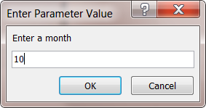

Figure 04a: Input form

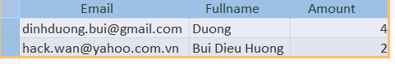

Figure 04b: the result of A2 Query

## A3

“Produce, for the first comment made on a given Blog entry, any further comments made on that original comment only. The user should be prompted for the Blog entry’s unique identifier” (Coursework requirement)

There are some steps to deal this requirement:

1. Find the first **Comment (**get **CommentID)** on a given **Entry**
   1. **INNER JOIN** **Comment** and **CommentOnEntry** table, filter only rows with condition ( given **EntryID)** then Using **Min**() function with **Timestamp** column to get the **Timestamp** of the **first** **Comment** for the given **Entry.**
   2. **INNER JOIN** **Comment** and **CommentOnEntry** table , get the fisrt **Comment** on **Entry** by comparing the condition is **Timestamp** above and filter by **EntryID** (supplied fisrt time) => got first **Comment** for given Entry, then **Select** only **CommentID**
2. Get all **CommentOnComment** for the first **CommentOnEntry**
   1. **INNER JOIN CommentOnComment** and **Comment** table
   2. Filter all **CommentOnComment** with condition is column **CMID** equals to **CommentID** above

## 

**SELECT** Comment.CommentID,Body, Timestamp,Email

**FROM** Comment **INNER JOIN** CommentOnComment **ON** Comment.CommentID = CommentOnComment.CommentID

**WHERE** CommentOnComment.CMID=

(**SELECT** CE.CommentID

**FROM** Comment C **INNER JOIN** CommentOnEntry CE **ON** C.CommentID = CE.CommentID

**WHERE** ((C.timestamp=(**SELECT** **Min**(timestamp)

**FROM** Comment AS C **INNER JOIN** CommentOnEntry AS CE ON C.CommentID = CE.CommentID

**WHERE** (((CE.EntryId)=[Enter EntryID]))))));

## C:\Users\SONY\AppData\Local\Temp\SNAGHTML1baff4d.PNG

Figure 05a: Input entry ID

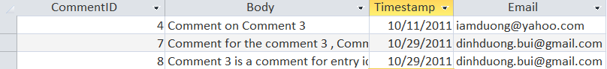

Figure 05b: All the Comments comment on the first Comment of Entry has EntryID=3

## A4

“Produce, on demand for a particular date range, a list of all Blog titles, creation date and their creators email addresses, The user should be prompted for the start and end date of the required period” (Coursework requirement)

There are some steps:

1. Get input value: **Start Date** and **End Date**

2. Select in Blog table what we need with comparing the condition

**SELECT** b.BlogTitle, b.CreationDate, b.Email

**FROM** Blog AS b

**WHERE** b.CreationDate>=[Start date] And b.CreationDate<=[End date];

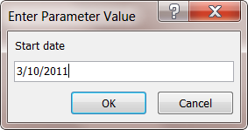 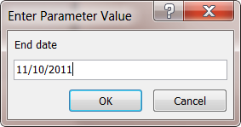

Figure 06a: Input start date Figure 06b: input end date

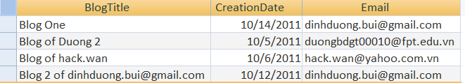

Figure 06c: the result of A4 query

# D7 Registration Form

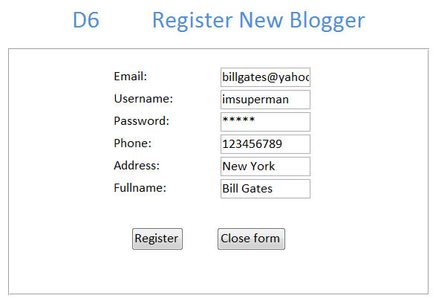

Figure 07: Registration Form

The form allow user to register to become a new Blogger.

When user fills full required data into the form, then click on **Register** button, this data will be inserted into Blogger table.

# D8 A5-Form Report

“Given a particular Blogger list in a reverse order of a Blog entry (i.e. most recent entry first), the poster of the Blog entry and the creation time and date of the entry and the subject and the text of the entry for a particular Blog title.” (Coursework requirement)

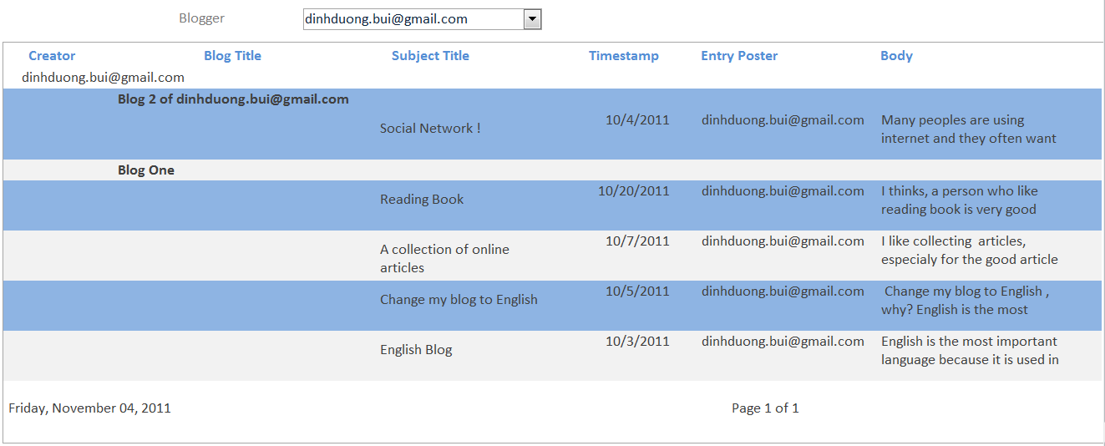

Figure 08: Chose a blogger to view report

When user selects a Blogger, the report will show all Entries of the Blogger. All Entries are grouped for each Blog

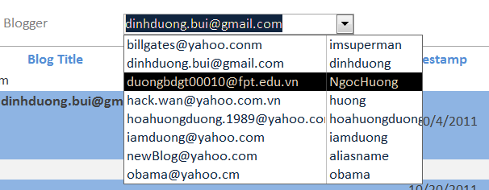

Figure 08b Description

When user clicks on the Combo Box, A Drop Down List will show all Bloggers. Then User can choose one of the Bloggers.

Figure 08b: Drop Down List shows all Bloggers

# D9 A6-Master Detail Form

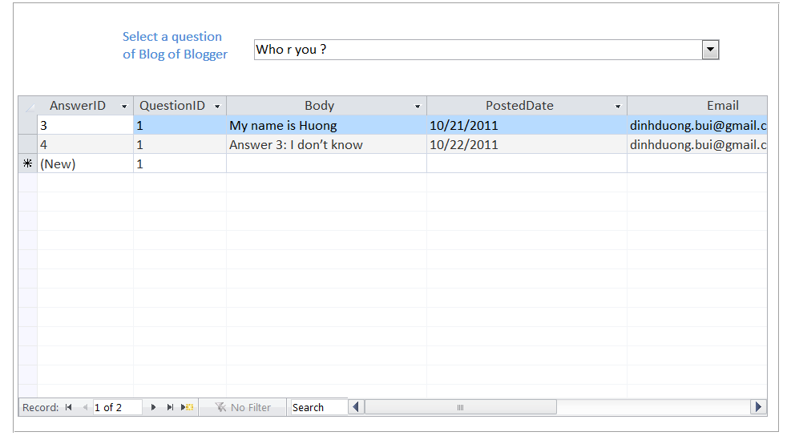

Figure 09 Description

The master-detail form provides a list of all answers made on a given question for a given Blogger

Figure 09: Master-Detail Form

Figure 09b Description

When user clicks on the Combo box, A Drop Down List allow user to select a Question for a give Blogger and Blog

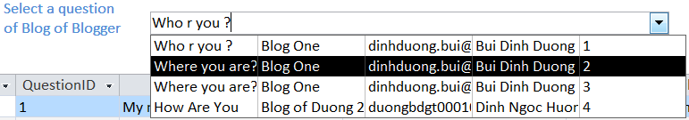

Figure 09b: Drop Down List for user selects a Question group by Blogger and Blog.

# References

Coursework Requirement:

<https://cms1.gre.ac.uk/collaborativeprogrammes/students/courseworks/coursework%202011-2012/Nov-Dec%202011/CW_COMP1302_190002_ver1_1011.pdf>