**VIETNAM NATION UNIVERSITY HO CHI MINH CITY**

**UNIVERSITY OF INFORMATION TECHNOLOGY**

**SOFTWARE ENGINEERING FACULTY**

-----🙞🙜🕮🙞🙜-----

**INTRODUCTION TO**

**SOFTWARE ENGINEERING**

**PROJECT**

**CAFÉ MANAGEMENT SYSTEM**

|  |  |  |
| --- | --- | --- |
| **Lecturer:** | **Ms. Thai Thuy Han Uyen**  **SE104.N23.PMCL** | |
| **Class:** |
| **Students:** | **Doan Quang Hung** | * **21520884** |
|  | **Bui Dinh Quan** | * **21522487** |
|  | **Vo Thi My Thuan** | * **20521996** |

**6 – 2023**

**TABLE OF CONTENTS**

**Chapter 1. Introduction** 1

**1.1.** **Introducing the topic** 1

**1.2.** **Reason for choosing the topic** 1

**Chapter 2. CAFÉ MANAGEMENT SYSTEM** 2

**2.1.** **System Requirements** 2

**2.1.1.** **List of requirements** 2

**2.1.2.** **Requirements specification** 4

**2.2.** **Use Case Model** 5

**2.2.1.** **General use case diagram** 5

**2.2.2.** **Specific use case diagram** 6

**2.2.3.** **Use case description** 11

**2.3.** **Activity Diagram** 18

**2.3.1.** **Order drink** 18

**2.3.2.** **Switch tables** 19

**2.3.3.** **Edit account profile** 20

**2.3.4.** **Add a new staff account** 21

**2.4.** **Class Diagram** 22

**2.5.** **Database Design** 23

**2.6.** **Interface Design** 23

**2.7.** **Settings** 27

**2.8.** **Testing** 27

**2.8.1.** **Login** 27

**Chapter 3. Conclusion** 27

**3.1.** **Result** 27

**3.2.** **Advantages and Disadvantages** 28

**3.3.** **Future developments** 28

**3.4.** **Development direction** 28

# **Chapter 1. Introduction**

1. **Introducing the topic**

- In today's life, it is not difficult to find a restaurant, cafe, in addition to the need to drink and enjoy strange drinks, you can also chat with friends, family, study groups at school. The cafe is also very popular with young people. And to meet that need of people, today the coffee shop business is not too strange to everyone. Cafes sprang up like mushrooms, all kinds and forms to attract customers. In addition, drinks are also an important part leading to the number of customers coming to the restaurant more or less.

- For a long time, coffee has been a drink for working people and office people. But recently, coffee is equally popular with young people. The introduction of coffee has formed a hobby of drinking coffee among young people.

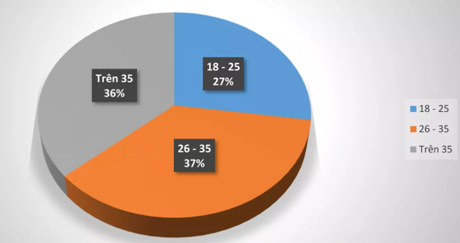

*Statistical chart of the number of coffee users by age*

1. **Reason for choosing the topic**

* Opening a cafe requires a lot of factors: financial, physical, geographical advantages to help the business develop. Besides, how to manage your cafe is also a big question to be solved. So how and how to manage the cafe? How is management called convenience? Less effort, but effective results.
* That is one of the biggest reasons that management software was born and answered the above questions to make the business of an individual or an organization more convenient and time-saving. for the management of his "brainchild".
* Software support in managing operations such as cash register, invoice printing, statistics, employee management, salary, .. Coffee shop sales management software helps users save time Time, fast, simple operation, easy to use and manage.
* Build a suitable and easy-to-use new system for software users. Understand the sales management system, which areas to manage to build the application to suit practical needs.
* Helps to manage the restaurant's system more optimally, the management is easier and more convenient.
* Help yourself to have more creative and thinking abilities through designing user-interactive interfaces, applying knowledge into practice.
* This software was created in the hope of bringing convenience to users as well as helping shop owners to review their business in general.
* The software also brings economic benefits when it is a solution to make management simple and friendly for everyone.

# **Chapter 2. CAFÉ MANAGEMENT SYSTEM**

1. **System Requirements**
2. **List of requirements**

|  |  |  |  |  |
| --- | --- | --- | --- | --- |
| **ID** | **Name of requirement** | **Priority** | **Diagram** | **Test case** |
| 1. **Account** | | | | |
| 1.1 | Login | High | 2.2.2.1 |  |
| 1.2 | Register | High |  |  |
| 1.3 | Type of account | High |  |  |

|  |  |  |  |  |
| --- | --- | --- | --- | --- |
| 1. **Category** | | | | |
| 2.1 | Show category | Medium |  |  |
| 2.2 | Add category | High | 2.2.2.4 |  |
| 2.3 | Update category | High | 2.2.2.4 |  |
| 2.4 | Delete category | High | 2.2.2.4 |  |
| 1. **Product** | | | | |
| 3.1 | Show drink | Medium |  |  |
| 3.2 | Add drink | High | 2.2.2.5 |  |
| 3.3 | Update drink | High | 2.2.2.5 |  |
| 3.4 | Delete drink | High | 2.2.2.5 |  |
| 1. **Customer** | | | | |
| 4.1 | Add customer | Medium | 2.2.2.7 |  |
| 4.2 | Delete customer | Medium | 2.2.2.7 |  |
| 1. **Table** | | | | |
| 5.1 | Show table | Medium |  |  |
| 5.2 | Add table | High | 2.2.2.6 |  |
| 5.3 | Update table | High | 2.2.2.6 |  |
| 5.4 | Delete table | High | 2.2.2.6 |  |
| 1. **Order drink** | | | | |
| 6.1 | Use at café | Medium | 2.2.2.2 |  |
| 6.2 | Take away | Medium | 2.2.2.2 |  |
| 1. **Review** | | | | |
| 7.1 | Create bill review | High | 2.2.2.8 |  |

1. **Requirements specification**
2. **Account**

* Login
* Register:
* Username: at least 1 character, at most 20 character
* Display name: at least 1 character, at most 20 character
* Password: at least 1 character, at most 20 character
* Type of account:
  + Admin: can edit all of data
  + Staff: can only take order and process

1. **Category: data about drink category**

* Show category
* Add category: add a new category
* Must have name
* Update category:
* Change information about category
* Delete category

1. **Product**

* Show drink
* Add drink: add a new drink
* Must have name
* Drink category
* Price
* Update drink:
* Change information about category
* Delete drink

1. **Customer**

* Add a customer:
* username: at least 1 character, at most 20 character
* point: initialize 0, use to discount

1. **Table**

* Show table
* Add table:
* Must have name
* its status occupied or not
* number of a table has
* Update table:
* Change its information
* Delete table

1. **Order drink**

* Use at café: when customer take a table in café so it can’t be ordered by other customer
* Take away

1. **Review**

* Create bill review: create a bill review in a period

1. **Interface requirement**

* Because it is used by staff, it’s not necessary to make the application so pretty. But it must be user-friendly. The language in the application must be Vietnamese.

1. **Use Case Model**
2. **General use case diagram**

**List of actor in model:**

|  |  |  |
| --- | --- | --- |
| **No.** | **Actor** | **Content** |
| 1 | Admin | Staff who manage all information about café |
| 2 | Staff | People who sell drink, can add customer |
| 3 | Customer | People who buy drink, they can have account or not |

**Use case diagram:**

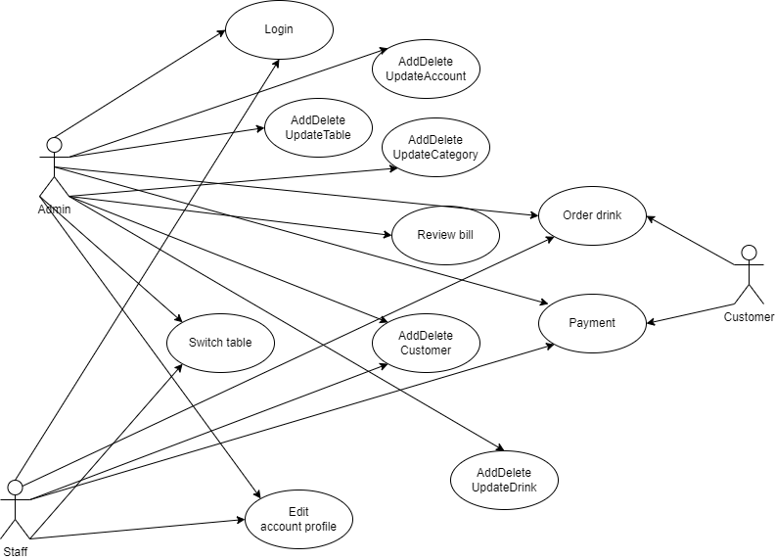

1. **Specific use case diagram**
2. **Login**

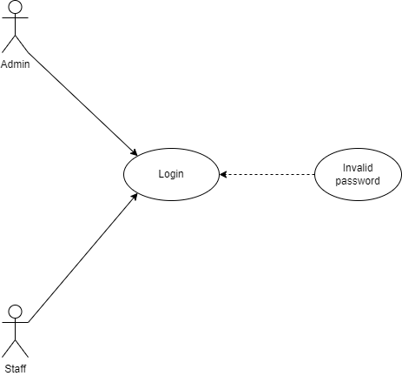

1. **Order drink**

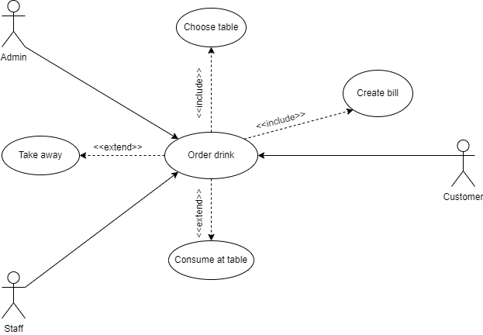

1. **AddDeleteUpdateAccount**

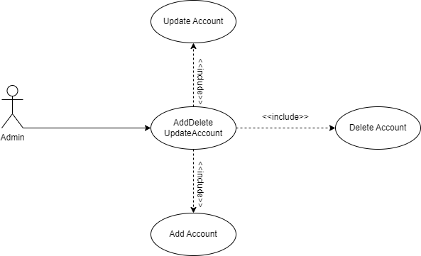

1. **AddDeleteUpdateCategory**

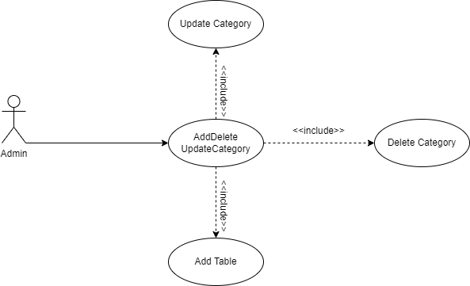

1. **AddDeleteUpdateDrink**

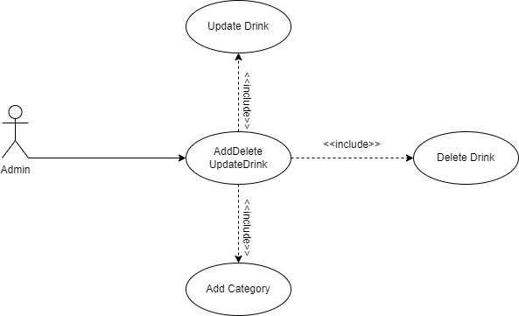

1. **AddDeleteUpdateTable**

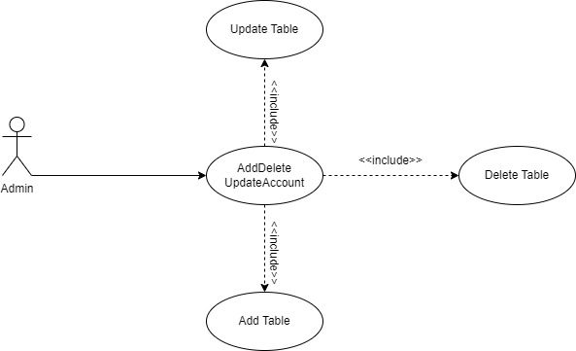

1. **AddDeleteCustomer**

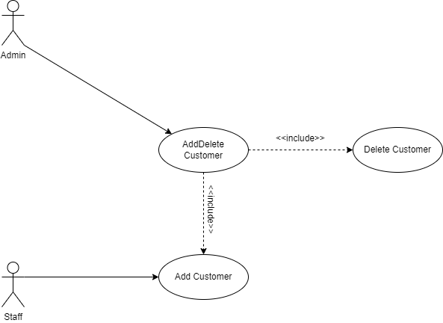

1. **Review bill**

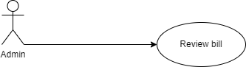

1. **Switch tables**

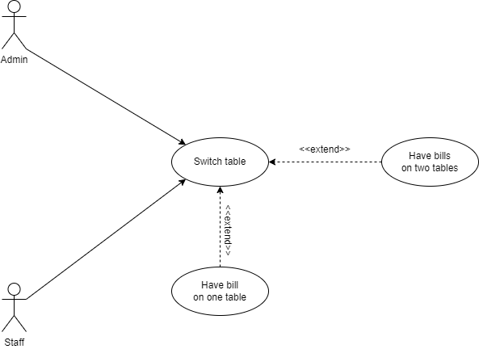

1. **Payment**

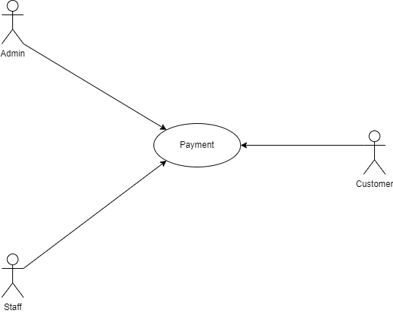

1. **Edit account profile**

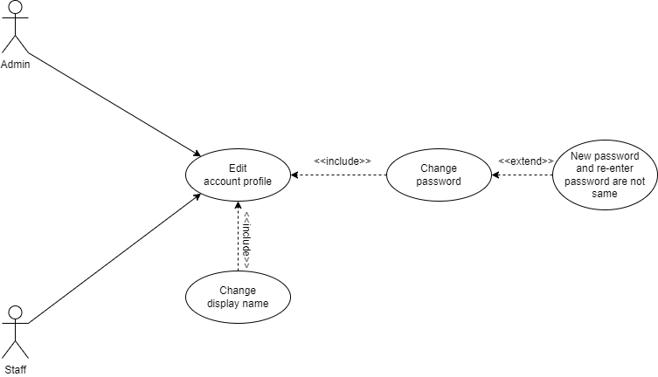

1. **Use case description**
2. **Login**

|  |  |  |
| --- | --- | --- |
| Nr. | Section | Content/Explanation |
| 1 | Name | Login |
| 2 | Authors | Quang Hung, Dinh Quan, My Thuan |
| 3 | Priority | High |
| 4 | Person responsible | Quang Hung |
| 5 | Description | Staff login to sell or manage information in case of he/she is a admin |
| 6 | Actors | Admin, staff |
| 7 | Pre-conditions | Not have |
| 8 | Post-conditions | It opens a new window to work |
| 9 | Main scenario | This use-case starts when a staff member needs to login.  System requires username and password.  Actor enters the username and password.  System checks the username and password and allows actor login |
| 10 | Exception scenarios | If actor enter wrong username or password, system informs a message to actor |

1. **Order drink**

|  |  |  |
| --- | --- | --- |
| Nr. | Section | Content/Explanation |
| 1 | Name | Order drink |
| 2 | Authors | Quang Hung, Dinh Quan, My Thuan |
| 3 | Priority | High |
| 4 | Person responsible | Dinh Quan |
| 5 | Description | A customer order some drink |
| 6 | Actors | Admin, staff, customer |
| 7 | Pre-conditions | The staff must login |
| 8 | Post-conditions | The application extract a bill |
| 9 | Main scenario | If the customer orders drinks to consume at a table, the staff or admin will choose the table and create a bill on it. If the customer orders drinks with attention to take away, the staff or admin only need to create a bill |
| 10 | Exception scenarios | The customer cancels the order |

1. **AddDeleteUpdateAccount**

|  |  |  |
| --- | --- | --- |
| Nr. | Section | Content/Explanation |
| 1 | Name | AddDeleteUpdateAccount |
| 2 | Authors | Quang Hung, Dinh Quan, My Thuan |
| 3 | Priority | High |
| 4 | Person responsible | My Thuan |
| 5 | Description | An admin add, delete or update staff account |
| 6 | Actors | Admin |
| 7 | Pre-conditions | The admin must login |
| 8 | Post-conditions | List account may change |
| 9 | Main scenario | To add a new account, the admin must enter username, display name, type of account and password is default password  To update an existing account, the admin must choose this account and enter new display name  To delete an existing account, the admin must choose this account and delete it |
| 10 | Exception scenarios | When the admin enters an existing username, it can’t add this account  When the admin misses username, display name or type of account in case of adding or updating, it informs a message  When the admin deletes his/her account, it informs an error message |

1. **AddDeleteUpdateCategory**

|  |  |  |
| --- | --- | --- |
| Nr. | Section | Content/Explanation |
| 1 | Name | AddDeleteUpdateCategory |
| 2 | Authors | Quang Hung, Dinh Quan, My Thuan |
| 3 | Priority | High |
| 4 | Person responsible | Quang Hung |
| 5 | Description | An admin add, delete or update category |
| 6 | Actors | Admin |
| 7 | Pre-conditions | The admin must login |
| 8 | Post-conditions | List category may change |
| 9 | Main scenario | To add a new category, the admin must enter category name  To update an existing category, the admin must choose this category and enter new name  To delete an existing category, the admin must choose this category and delete it |
| 10 | Exception scenarios | When the admin misses name in case of adding or updating, it informs a message  The admin can’t delete a category that has some drinks |

1. **AddDeleteUpdateDrink**

|  |  |  |
| --- | --- | --- |
| Nr. | Section | Content/Explanation |
| 1 | Name | AddDeleteUpdateDrink |
| 2 | Authors | Quang Hung, Dinh Quan, My Thuan |
| 3 | Priority | High |
| 4 | Person responsible | Dinh Quan |
| 5 | Description | An admin add, delete or update drink |
| 6 | Actors | Admin |
| 7 | Pre-conditions | The admin must login |
| 8 | Post-conditions | List drink may change |
| 9 | Main scenario | To add a new drink, the admin must enter drink name, its category and price  To update an existing drink, the admin must choose this drink and enter new name, category or price  To delete an existing drink, the admin must choose this drink and delete it |
| 10 | Exception scenarios | When the admin misses name, category, price in case of adding or updating, it informs a message  The admin can’t delete a drink included in any uncheck-out bill |

1. **AddDeleteUpdateTable**

|  |  |  |
| --- | --- | --- |
| Nr. | Section | Content/Explanation |
| 1 | Name | AddDeleteUpdateTable |
| 2 | Authors | Quang Hung, Dinh Quan, My Thuan |
| 3 | Priority | High |
| 4 | Person responsible | My Thuan |
| 5 | Description | An admin add, delete or update table |
| 6 | Actors | Admin |
| 7 | Pre-conditions | The admin must login |
| 8 | Post-conditions | List table may change |
| 9 | Main scenario | To add a new table, the admin must enter table name and number of people it can have  To update an existing table, the admin must choose this table and enter new name, number of people it can have  To delete an existing table, the admin must choose this table and delete it |
| 10 | Exception scenarios | When the admin misses name, number of people it can have in case of adding or updating, it informs a message  The admin can’t delete a table that has any uncheck-out bill |

1. **AddDeleteCustomer (*)**

|  |  |  |
| --- | --- | --- |
| Nr. | Section | Content/Explanation |
| 1 | Name | AddDeleteCustomer (*) |
| 2 | Authors | Quang Hung, Dinh Quan, My Thuan |
| 3 | Priority | High |
| 4 | Person responsible | Quang Hung |
| 5 | Description | An admin add, delete or update customer  An staff add a new customer |
| 6 | Actors | Admin, staff |
| 7 | Pre-conditions | The admin or staff must login |
| 8 | Post-conditions | List customer may change |
| 9 | Main scenario | To add a new customer, the admin or staff must enter customer name  To delete an existing customer, the admin must choose this customer and delete it |
| 10 | Exception scenarios | When the admin or staff misses name in case of adding, it informs a message |

(*) We don’t add ‘Update Customer’ because we use Username as primary key in database and it’s not necessary to add another attribute to use as primary key

1. **Review bill**

|  |  |  |
| --- | --- | --- |
| Nr. | Section | Content/Explanation |
| 1 | Name | Review bill |
| 2 | Authors | Quang Hung, Dinh Quan, My Thuan |
| 3 | Priority | High |
| 4 | Person responsible | Dinh Quan |
| 5 | Description | An admin review bill in a period |
| 6 | Actors | Admin |
| 7 | Pre-conditions | The admin must login |
| 8 | Post-conditions | Not have |
| 9 | Main scenario | The admin chooses a period to review bill |
| 10 | Exception scenarios | Not have |

1. **Switch tables**

|  |  |  |
| --- | --- | --- |
| Nr. | Section | Content/Explanation |
| 1 | Name | Switch tables |
| 2 | Authors | Quang Hung, Dinh Quan, My Thuan |
| 3 | Priority | Medium |
| 4 | Person responsible | My Thuan |
| 5 | Description | An admin or staff switches two tables |
| 6 | Actors | Admin, staff |
| 7 | Pre-conditions | The admin or staff must login |
| 8 | Post-conditions | The bills of this two tables exchange |
| 9 | Main scenario | The admin or staff chooses two table and switches |
| 10 | Exception scenarios | If both of tables don’t have bill, nothing happens |

1. **Payment**

|  |  |  |
| --- | --- | --- |
| Nr. | Section | Content/Explanation |
| 1 | Name | Payment |
| 2 | Authors | Quang Hung, Dinh Quan, My Thuan |
| 3 | Priority | High |
| 4 | Person responsible | Quang Hung |
| 5 | Description | When a customer pay his/her bill |
| 6 | Actors | Admin, staff, customer |
| 7 | Pre-conditions | The admin or staff must login |
| 8 | Post-conditions | The bill is check-out |
| 9 | Main scenario | The admin or staff chooses the bill. If the customer has a customer account, the admin or staff will enter this account. The admin or staff asks the customer if he/she wants to use point or he/she has a discount |
| 10 | Exception scenarios | Not have |

1. **Edit account profile**

|  |  |  |
| --- | --- | --- |
| Nr. | Section | Content/Explanation |
| 1 | Name | Edit account profile |
| 2 | Authors | Quang Hung, Dinh Quan, My Thuan |
| 3 | Priority | High |
| 4 | Person responsible | Dinh Quan |
| 5 | Description | When the admin or staff want to changes his/her account profile |
| 6 | Actors | Admin, staff |
| 7 | Pre-conditions | The admin or staff must login |
| 8 | Post-conditions | The account profile will change |
| 9 | Main scenario | The admin or staff enters password and changes his/her account profile |
| 10 | Exception scenarios | If the admin or staff enters a wrong password, it informs a message  If the admin or staff wants to change password and he/she enters new password and re-enter password wrong, it informs a message |

1. **Activity Diagram**
2. **Order drink**

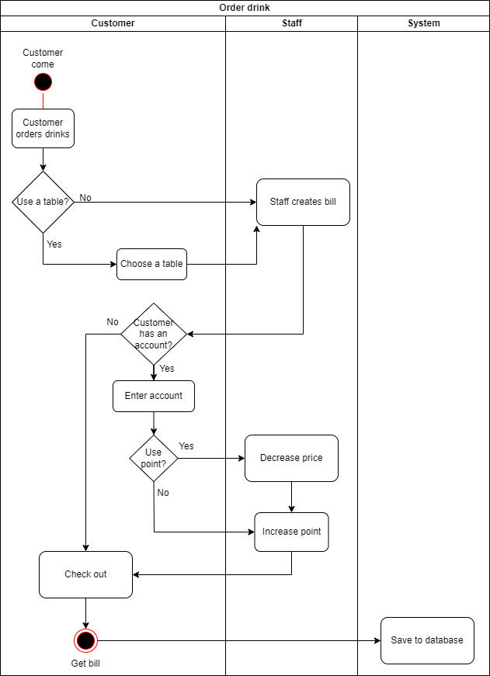

1. **Switch tables**

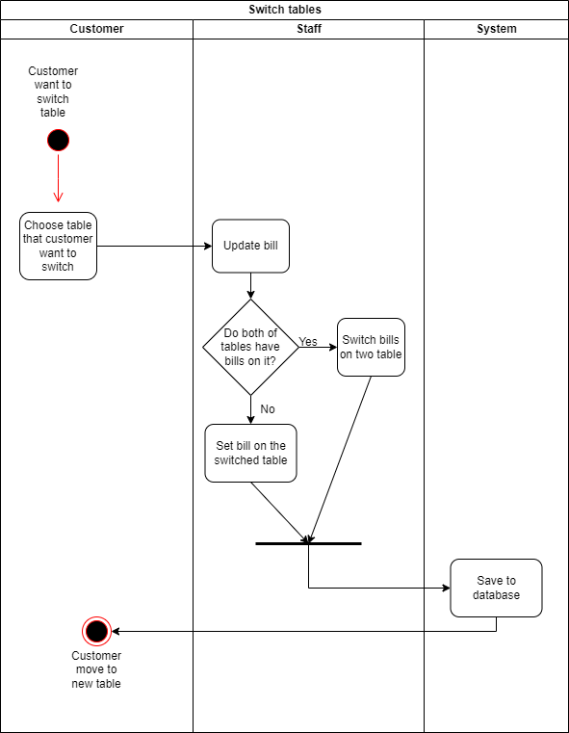

1. **Edit account profile**

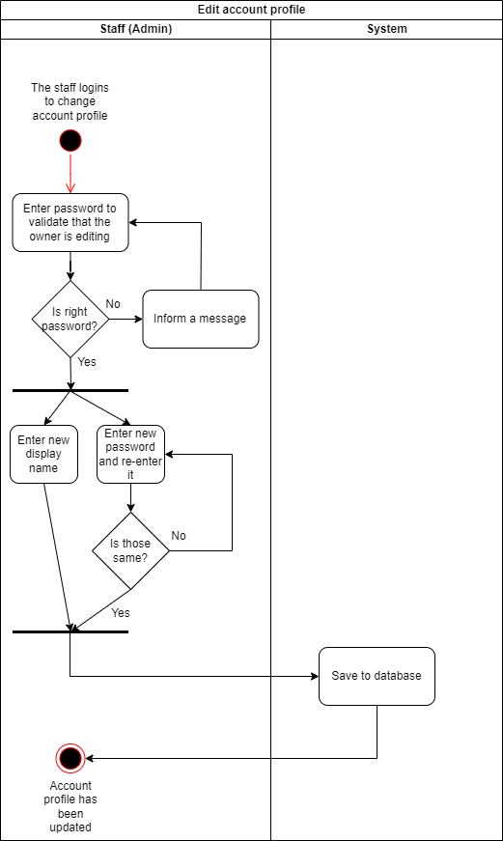

1. **Add a new staff account**

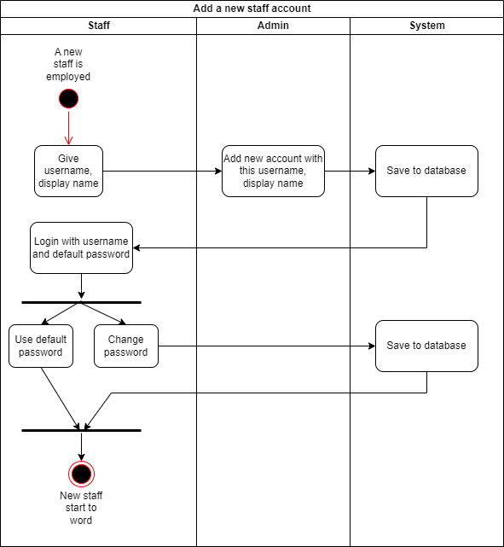

1. **Class Diagram**

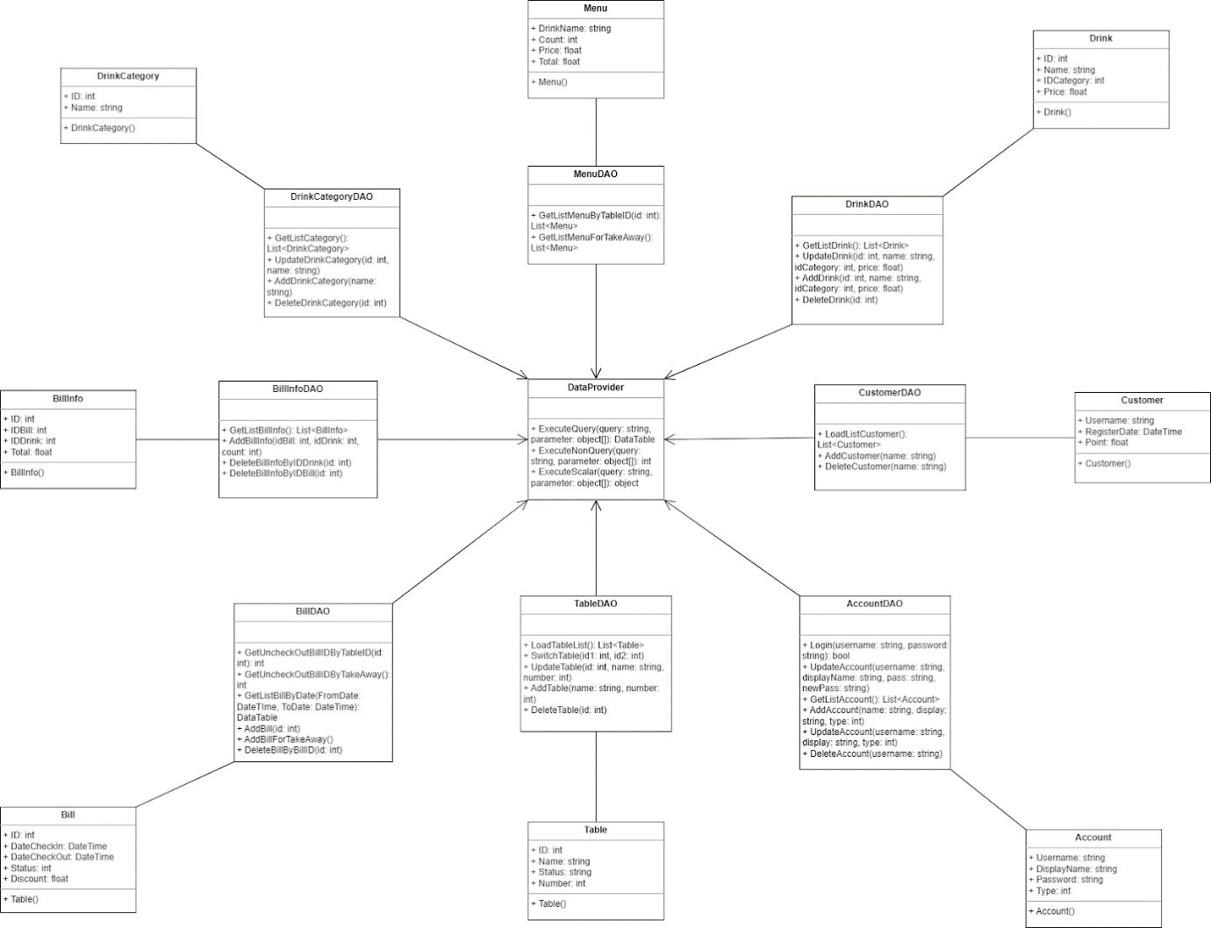

* Class DataProvider contains 3 functions that execute commands communicating with database
* Class Menu, Drink, Customer, Account, Table, Bill, BillInfo, DrinkCategory are layer that transfer data type from database to that high-level programming language can understand
* Class MenuDAO, DrinkDAO, CustomerDAO, AccountDAO, TableDAO, BillDAO, BillInfoDAO, DrinkCategoryDAO manipulate data by functions in class DataProvider

1. **Database Design**

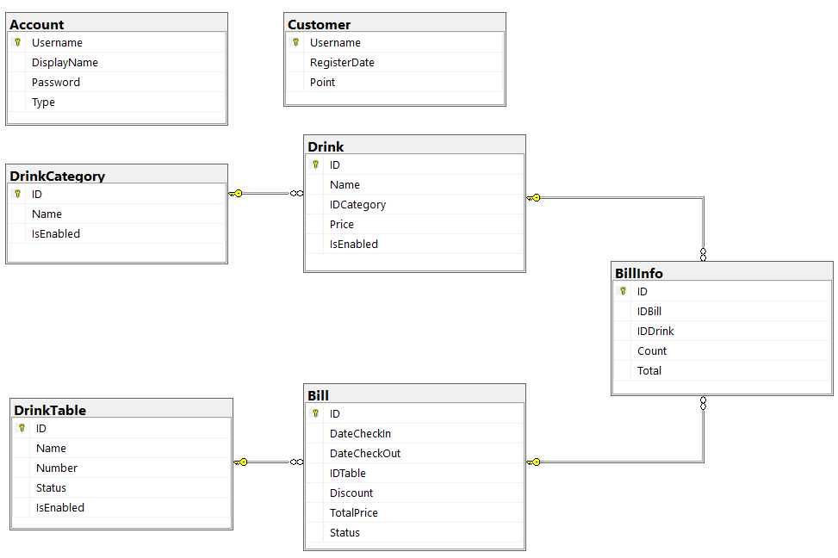

1. **Interface Design**

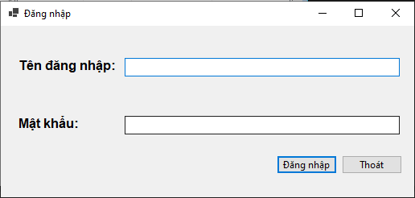

Above, you enter username and password and click “Đăng nhập” to login. If you enter the correct username and password, you can access the app and can create, check out bills and switch tables here.

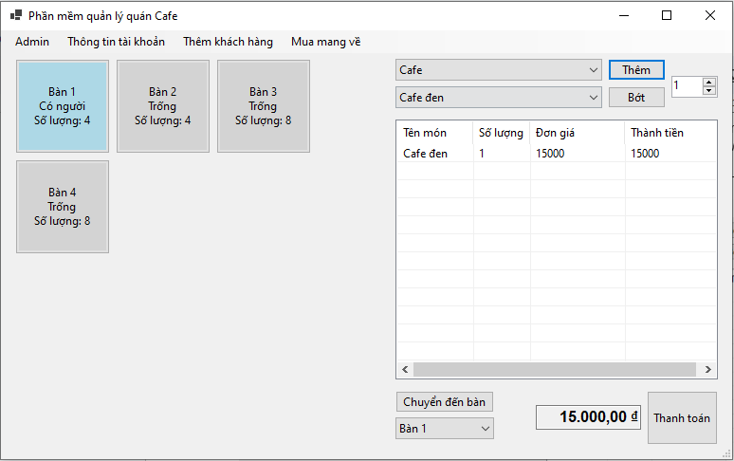

Click “Mua mang về” Tool strip if the customer want to take away

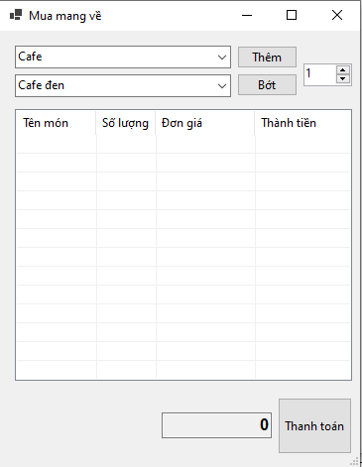

If customer want to check out, you click “Thanh toán” and the app switches to Check-out Form.

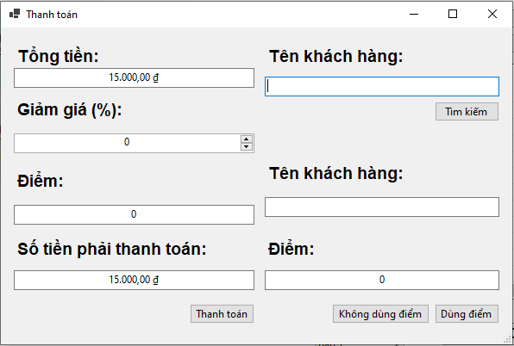

As a staff, you can add a new customer by click “Thêm khách hàng” tool strip

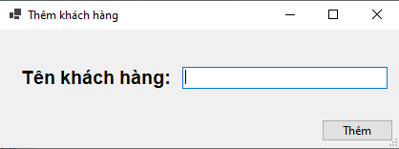

You also can edit your account profile such as password, display name by click “Thông tin tài khoản” tool strip then click “Thông tin cá nhân”

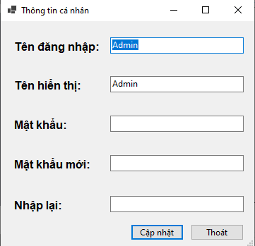

If you are an admin and want to edit some information or review bill, you can click “Admin” Tool strip



If you are a staff, you can’t click “Admin” Tool strip



Then you can review bill, edit drink, category, table, account or customer

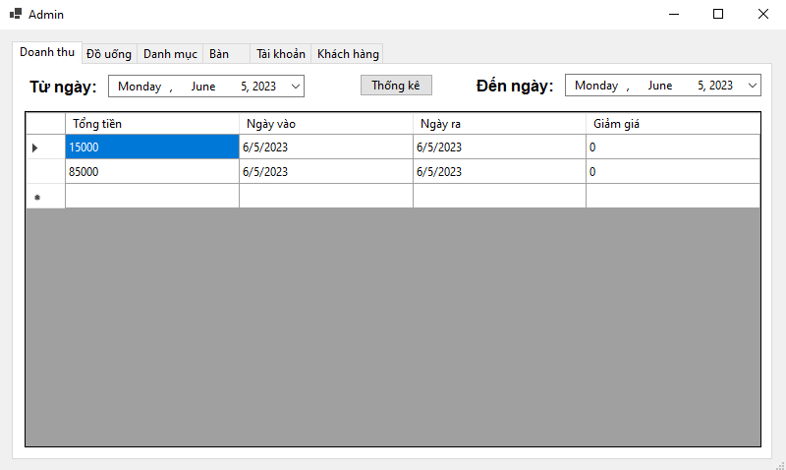

1. **Settings**

* The development environment plays a crucial role in software engineering as it provides the necessary tools and resources for developers to efficiently build and test software application
* Following is environment that we use to build our project:
* We use Window 10 and we don’t have any specific requirement in operating system
* Microsoft SQL Server is database management system we choose to store and retrieve data
* We create a Window Forms application with C#, Window Forms is a free and open-source graphical class library providing a platform to write client applications for desktop, laptop and tablet PCs and C# is a high-level programming language and a object-oriented programming language to write applications
* The development tools we use are Visual Studio Code - a lightweight and extensible IDE for multiple programming languages and SQL Server Management Studio (SSMS) - a graphical tool for managing SQL Server database

1. **Testing**
2. **Login**

|  |  |  |  |  |
| --- | --- | --- | --- | --- |
| **Conditions** | **Rule 1** | **Rule 2** | **Rule 3** | **Rule 4** |
| Username (T/F) | F | T | F | T |
| Password (T/F) | F | F | T | T |
| Output | “Sai tên tài khoản hoặc mật khẩu” | “Sai tên tài khoản hoặc mật khẩu” | “Sai tên tài khoản hoặc mật khẩu” | Home page |

# **Chapter 3. Conclusion**

1. **Result**

With this project, we have done an application to manage a café with some basic functions: manage data relating to the café such as staff, drink, customer…;  sell drinks to customers, create bills and review it. We have enhanced our programming skill and can use Window Form, C# to create an application. We also understand how to connect the database with higher levels - it isn’t taught in our previous subjects. Moreover, after this project, we have an overview of a process making a software product and the importance of writing documentation during this process

1. **Advantages and Disadvantages**

Following is advantage during process making project:

* The system we build doesn’t have so complicated structure
* We have some references on the internet

1. **Future developments**

Besides advantage, we have dealt with some disadvantage

* It’s the first time we have worked with Window Form and C# so we have made a lot of time to code and found solution when we have any problem
* Although we have some references, we don’t have the suitable structure of a café. So the structure we build in database will has some defects when we use in reality

1. **Development direction**

We can improve our database structure by adding more information about staff such as register date; customers such as birthdays to give them a voucher; number of goods we need to buy. Our application doesn’t have any functions only related to café, so we can use it in restaurants, shops…