

COMP1787 – REQUIREMENTS MANAGEMENT COURSEWORK

**Student name: Bui Duc Canh**

**Student ID:** GCH200582

**Date:** 16 April 2024

Table of Contents

Table of Contents 1

List of Table 2

Introduction 2

Section A – Management Summary 3

A.1 Overview of Agile Methodology 3

A.2 Overview of Section B and C 7

Section B – Interpreting High-Level Requirements: Using MoSCoW Analysis to Prioritize 7

B.1 Assessing the “Based Line Requirements” 7

B.1.1 Spotting Unsuitable High-Level Requirements 7

B.1.2 Rewriting High Level Requirements for System Development 9

B.2 Implementing MoSCoW / TimeBox Rules to Prioritize Updated High-Level Requirements 12

B.2.1 Setting Up High-Level Requirements with Priorities. 12

B.2.2 Justification of the Process of Making Decisions 14

Section C –Legal, Social, Ethical and Professional Issues 15

C.1 Key Issues for System developers: LSEPI. 15

C.1.1 Legal Issues 15

C.1.2 Social Issues 15

C.1.3 Ethical Issues 15

C.1.4 Professional Issues 16

C.2 Professional Body (British Computer Society) 16

In conclusion 17

References 19

**List of Figures**

Figure 1: Agile Methodology 3

Figure 2:Based Line List Requirement 8

# List of Table

Table 1: List of requirements that not suitable 9

Table 2: Final High-Level Functional Requirements 11

Table 3: Prioritization High Level Requirements based on MoSCoW Rules 13

Table 4: Sprint Timebox 14

# Introduction

“Requirements management is the process of how companies define, manage, verify, and validate ideas and meet stakeholder needs at every step of the product lifecycle beginning as early as idea creation through product development and commercialization”(Oracle, 2024). Requirements management encompasses techniques for documenting, analyzing, prioritizing, and gaining consensus on requirements to ensure engineering teams always have up-to-date and approved requirements. According to IBM (2024), clear, concise, and error-free requirements aid engineering teams in identifying errors early, thereby reducing project costs and risks. However, Oracle (2024) notes that due to the detrimental effects of poor requirements management, only a few companies have implemented dedicated processes for requirements management. Even fewer effectively adopt best practices in lean systems engineering. These companies often resort to a disconnected document-based approach for capturing and communicating requirements. Critical requirements are scattered across various documents, spreadsheets, presentations, shared drives, emails, and even paper. Consequently, visibility, traceability, collaboration, requirements change control, and impact analysis are compromised. An outdated approach can result in slower time-to-market, failures, increased costs due to wasted cycles, and lost revenue.

The goal of this course is to apply theoretical knowledge and understand the significance of requirements management through the solution of a fictional business case study. Students are specifically expected to manage the company's needs using the Agile development methodology and to perform a thorough examination of them. The management briefing, high-level needs analysis, and discussion of legal, social, ethical, and professional issues will be the duties that are provided in the following order. The work's complete specifications are listed below.

# Section A – Management Summary

The Management Director of Green Grocery chose to provide Agile methodology ideas to the System Concepts development team in the Case Study provided for coursework. The author gives a summary of the Agile methodology's benefits and drawbacks in section A.1. A decision about Agile's applicability for Green Grocery's online platform is reached in light of this investigation. In section A2, the writer provides an overview of the topics that will be covered in sections B and C.

# A.1 Overview of Agile Methodology

The agile methodology is a project management approach that involves breaking the project up into several phases and promoting ongoing development for each one. The team works together to accomplish several project goals at the outset by cycling through the planning, review, and execution phases of the project. (Indeed, 2023)

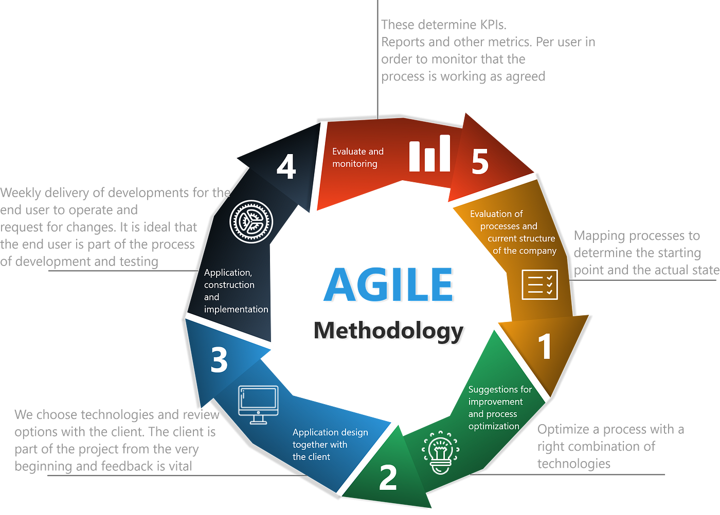

Figure 1: Agile Methodology

Pros of Agile development methodology (Indeed, 2023):

* **Prompt Product Release**: Agile methodology is designed to expedite product delivery to customers by concentrating on immediate marketability. Even if initial planning isn't as comprehensive, yielding products that aren't perfected, the Agile process embraces continuous enhancement through prompt feedback cycles. It’s an ideal approach for departments looking to release reliable products swiftly and improve over time.
* **Flexibility**: The Agile framework is characterized by its flexibility, with its iterative nature allowing for frequent minor enhancements that ultimately result in a consistently evolving project without disrupting production. This method facilitates departments in adapting swiftly to change, catering even to client preferences showing minor variations.
* **Collaborative Environment**: The Agile methodology fosters a collaborative setting, involving considerable interaction between clients and employees. Managers in an Agile environment encourage creativity to tackle emerging challenges. Such a setting allows for collaborative efforts to refine the product with each constructive feedback received.
* **Enhanced Problem-Solving Capability**: Agile allows team members to address issues on the fly, with testing conducted in tandem with development. This segmentation of production and troubleshooting leads to more focused issue identification and resolution, enabling departments to implement fixes efficiently before proceeding to subsequent production phases.
* **Increased Visibility**: With the Agile method, every cycle of production is a window into potential areas of refinement and challenges that may arise. Employees are encouraged to swiftly improve and rectify issues, shortening the cycle between detecting an improvement opportunity and its implementation.
* **Ongoing Process Refinement**: As Agile is predicated on the notion of continuous development, any process enhancements directly influence the ensuing product’s quality. Management urges staff to swiftly act on feedback, allowing for constant refinements even as products are being marketed, enhancing departmental productivity over time.

Cons of Agile development methodology (Indeed, 2023):

* **Shifting Focus on Multiple Objectives**: Agile's multi-goal orientation can result in uneven distribution of attention among objectives, which may lead to both a diffusion of team focus and unreliable timelines or cost predictions. Implementing systematic goal-discussion meetings can help in preempting the costs and delays brought about by shifting goals. Moreover, forming policies on departmental expenditure can prevent unforeseen expenses and contribute to better budget management.
* **Documentation Taking a Backseat**: Agile places emphasis on progress and adaptive planning, often overshadowing the need for meticulous documentation. Consequently, essential documentation tasks like maintaining records and managing invoices may suffer delays. To ameliorate this issue, it's advisable to commit to regular monthly updates of documentation, which would assist in maintaining up-to-date records. Prioritizing documentation more heavily in the overall schedule can reassert its critical role within the Agile approach.
* **Lower Predictability**: The dynamic nature of Agile, with its reliance on consumer feedback and iterative improvements, makes it challenging for departments to predict outcomes, such as profitability, before the production phase kicks off. Agile's focus on rapid delivery of acceptable products may lead to emerging issues being less visible in advance. Nonetheless, diligent documentation of any challenges encountered, along with the efficient utilization of feedback throughout production, could lead to a gradual improvement in predicting potential product issues.

In order to broaden its customer base and increase the accessibility of sustainable products, Green Grocery intends to introduce an online platform in three months. The flexibility of the Agile Methodology makes it a good technique for quickly adapting to changing customer needs. The improved communication within the development team promotes transparency and alignment, which guarantees that project milestones are successfully reached. Agile places a strong emphasis on early value delivery, which enables Green Grocery to offer a minimal viable product and continuously improve the platform in response to customer input. Alignment with client preferences is ensured through active customer participation throughout the development process. Notwithstanding obstacles such as vague requirements and scope creep, Agile Methodology exhibits potential for the prosperity of Green Grocery.

# A.2 Overview of Section B and C

In this case study, employees of Green Grocery participate in a Facilitated Workshop led by System Concepts consultants to create "Based Line Requirements". It is the author's responsibility to weed out superfluous requirements and compile a table of eight to ten essential functional requirements for system development. MoSCoW and the Timebox Rule must be used to prioritize these requirements, and their implementation must be explained. A summary of the British Computer Society and an analysis of Legal, Social, Ethical, and Professional Issues are presented in Section C, with particular reference to Green Groceries, a medium-sized organic grocery store, and System Concepts, an Agile software development consultancy.

# Section B – Interpreting High-Level Requirements: Using MoSCoW Analysis to Prioritize

# B.1 Assessing the “Based Line Requirements”

# B.1.1 Spotting Unsuitable High-Level Requirements

High-level requirements definition. High-level requirements in agency project management offer a broad overview of the goals, objectives, and intended outcomes of a project. Rather than detailing every intricate aspect, they provide a general outline that captures the essence of what the project aims to accomplish. (teamwork.com, What are high-level requirements in agency project management?)

The criteria that are inappropriate to be taken into consideration at the High-Level requirements are listed below, following the table of "based line requirements" in the coursework brief:

Figure 2:Based Line List Requirement

|  |  |
| --- | --- |
| **ID** | **Reason** |
| **2** | It is more of an aim or target connected to upholding an eco-friendly and healthy work environment. |
| **4** | It's not so much a functional need as it is a special occasion or assignment meant to highlight the corporate culture. |
| **9** | It is not a functional need, but rather a statement about the culture and policies of the firm. |
| **16** | Rather than describing a precise practical requirement, it describes a design or branding guideline. |
| **17** | Rather than being a functional need, it has more to do with workplace culture and team activities. |

Table 1: List of requirements that not suitable

# B.1.2 Rewriting High Level Requirements for System Development

There are five requirements in the previous section that are inappropriate for high-level evaluation. The author provides 10 high-level functional needs that are necessary for developing Green Groceries' online platform based on "Based Line List Requirements" after this section, which is the rewrite:

|  |  |  |
| --- | --- | --- |
| **ID** | **High-Level-Requirements** | **Reason** |
| **1** | Give order processing clerks the ability to use the website to handle phone purchases in place of the present paper-based procedure. | It increases productivity by decreasing human errors and enabling clerks to view and manage orders instantly. |
| **3** | Facilitating simple account information updates for clients to guarantee accuracy. | Reduces communication and order fulfillment problems, increases customer happiness, and makes it simple to keep correct records. |
| **6** | Give consumers the option to create an account. | The aim is to provide customized experiences, streamline order monitoring, and cultivate client loyalty by means of focused promotions and outreach. |
| **7** | Give the customer a choice of delivery times to allow them schedule flexibility. | To increase client pleasure and convenience by letting them choose the best delivery times. |
| **8** | Permit users to change the items in their shopping carts as needed. | To provide the buying process flexibility in order to satisfy shifting preferences and lessen annoyance. |
| **11** | For simplicity, allow customers to enter different delivery and billing addresses. | To be flexible for clients, allowing for situations like gift deliveries or delivering to different addresses. |
| **14** | Give clients the choice to stop receiving marketing communications. | To honor client preferences, lessen the possibility of offending them with unsolicited communications, and build trust by honoring their right to privacy. |
| **15** | To ensure security, encrypt all user data, including payment and personal information. | To preventing unwanted access, preserving client confidence, and adhering to data protection laws. |
| **18** | For marketing purposes, create a page with offers or discounts. | To boost sales, entice consumers with incentives, and promote brand involvement. |
| **20** | To serve a diverse clientele, accept a choice of payment methods. | To maximize revenue prospects by increasing the possibility of completing transactions and broadening the client base by catering to the tastes of divers. |

Table 2: Final High-Level Functional Requirements

# B.2 Implementing MoSCoW / TimeBox Rules to Prioritize Updated High-Level Requirements

# B.2.1 Setting Up High-Level Requirements with Priorities.

MoSCoW prioritization, sometimes referred to as the MoSCoW method or MoSCoW analysis, is a widely used method for managing requirements in prioritization. Four kinds of projects are represented by the abbreviation MoSCoW: must-have, should-have, could-have, and won't-have, or won't have right now (producplan.com, MoSCoW prioritization):

* **Must Have (M):** These are non-negotiables. The project or iteration cannot be considered successful without these elements. For example, in a healthcare app, adherence to compliance and security measures is crucial and hence, a must-have.
* **Should Have (S):** These items are important but not vital. If a should-have is omitted, the project can still succeed, but it might lack some features that could possibly give it a stronger competitive edge or improve user satisfaction significantly.
* **Could Have (C):** Commonly referred to as "nice-to-haves," these features are considered beneficial but less critical. These can enhance the product further but their absence won't have as much impact as omitting a should-have.
* **Won't Have (W):** This category helps in setting clear boundaries for scope and managing stakeholder expectations. It's about acknowledging and documenting what won't be done in the current iteration. This is useful to fend off scope creep and concentrate on the current priorities.

In Agile methodologies, a timebox is a predefined period for completing specific tasks, used to manage project duration. Timeboxing is commonly used in Agile frameworks like Scrum. In this case-study, 10 High-Level requirements are organized using MoSCoW and Timebox rules.

|  |  |  |  |
| --- | --- | --- | --- |
| **ID** | **Requirements** | **MoSCoW Categories** | **Sprint** |
| **6** | Give consumers the option to create an account. | Must Have | 1 |
| **7** | Give the customer a choice of delivery times to allow them schedule flexibility. |
| **8** | Permit users to change the items in their shopping carts as needed. |
| **11** | For simplicity, allow customers to enter different delivery and billing addresses. |
| **15** | To ensure security, encrypt all user data, including payment and personal information. |
| **20** | To serve a diverse clientele, accept a choice of payment methods. |
| **1** | Give order processing clerks the ability to use the website to handle phone purchases in place of the present paper-based procedure. | Should Have | 2 |
| **3** | Facilitating simple account information updates for clients to guarantee accuracy. |
| **14** | Give clients the choice to stop receiving marketing communications. |
| **18** | For marketing purposes, create a page with offers or discounts. | Could Have | 3 |

Table 3: Prioritization High Level Requirements based on MoSCoW Rules

|  |  |  |  |
| --- | --- | --- | --- |
|  | No requirements | Won’t Have |  |

|  |  |  |  |
| --- | --- | --- | --- |
| **Sprint** | **Sprint Durations** | **Start Date** | **End Date** |
| Sprint 1 | 2 weeks (14 days) | March 1 | March 15 |
| Sprint 2 | 2 weeks (14 days) | March 16 | March 29 |
| Sprint 3 | 2 week (14 days) | March 30 | April 13 |

Table 4: Sprint Timebox

# B.2.2 Justification of the Process of Making Decisions

The author lists the essential functional requirements and creates a hierarchy of needs that are divided into categories that include Must Have, Should Have, Could Have, and Won't Have. Completing the Must Have requirements by Sprint 01 is essential to the project's success.

Should Have requirements can wait until After Must Have and Should Have needs are met; they are significant but not necessary. They can be addressed in Sprint 3. The scheduling for the three sprints, each lasting two weeks, is displayed in table above.

# Section C –Legal, Social, Ethical and Professional Issues

# C.1 Key Issues for System developers: LSEPI.

# C.1.1 Legal Issues

# In the case study, relevant legal concerns include:

# Determination of Jurisdiction and Applicable Laws

# Contractual Agreements

# Protection of Intellectual Property Rights

# Data Privacy and Compliance

# Cybersecurity Measures

# Liability and Indemnification Provisions

# Termination Agreements and Exit Strategies

# Adherence to Regulatory Requirements

# Clear contractual arrangements are crucial in the Green Groceries Case Study to address potential ambiguities regarding ownership of intellectual property, such as software code, design elements, and branding assets.

# C.1.2 Social Issues

# Social issues encompass broader societal concerns, including:

# Promotion of Food Security

# Impact on Local Communities

# Accessibility and Inclusion

# Health and Nutritional Implications

# Welfare of Workers

# Cultural Sensitivity and Respect

# Education and Awareness Initiatives

# Enhancing consumer-producer relationships and contributing to community well-being are exemplified in the Green Groceries case study through features like direct interaction with farmers or suppliers, fostering community engagement.

# C.1.3 Ethical Issues

# Ethical considerations involve principles guiding moral behavior and decision-making, such as:

# Transparency and Accountability

# Environmental Sustainability

# Fair Treatment of Workers

# Protection of Data Privacy

# Ensuring Accessibility

# Ethical Use of Technology

# Impact on Communities

# Privacy and transparency concerns emerge in the Green Groceries case study when customer data is collected without transparent communication or opt-out options, highlighting ethical issues.

# C.1.4 Professional Issues

# Professional issues encompass conduct, skills, and responsibilities within a profession or industry, including:

# Effective Communication and Collaboration

# Upholding Professionalism and Ethics

# Efficient Project Management and Planning

# Maintaining Competency and Skill Development

# Professional Development and Training Opportunities

# Ensuring Quality Assurance and Testing

# Commitment to Continuous Improvement

# Tensions and communication breakdowns with Green Groceries arise in the Green Groceries case study when System Concepts face difficulties meeting project deadlines and budget constraints, underscoring professional challenges.

# C.2 Professional Body (British Computer Society)

The British Computer Society, which has over 65,000 members in 100 countries, is the premier professional association for IT professionals. It offers multiple certifications for IT workers and users, and it is eligible for Chartered IT Professionals (CITP). The society, which has over 40 local branches and 15 foreign sections, offers networking opportunities and informs members about recent advancements in a range of IT-related fields. (www.beds.ac.uk. (n.d.). British Computer Society)

BCS also provides four parts to their Code of Conduct that professional bodies use to select and decide on their membership (BCS, 2022):

* **Public Interest**: A major duty to the public, their employers, clients, and the profession is demanded of all BCS members. They ought to behave in a way that protects the profession's honor and integrity and guarantees that the interests of the public are met.

In case study Green Grocery demonstrates how the "Public Interest" principle is upheld by strict data protection regulations, open sourcing, accessibility, and environmental effect reduction. Their dedication to data security, accessibility, openness, and sustainability shows that they care about the interests of society, encouraging fair access to environmentally friendly goods while maintaining user privacy.

* **Professional Competence and Integrity**: You are competent and have integrity, but you also recognize that you are not an expert in everything. For this reason, you are always learning and developing, and you never embark on projects for which you lack the necessary knowledge or resources.

In case study, Green Groceries prioritizes honesty, responsibility, and continuous training for its staff. It also employs strict development techniques and outsourcing to qualified professionals to guarantee the quality of its web platform.

* **Duty to Relevant Authority**: You always act in the best interests of your customer or organization, working with the utmost care and dedication. You accept accountability for your deeds, both individually and collectively, while upholding moral principles and discretion.

Green Groceries maintains open lines of communication with authorities to ensure that its activities are in line with industry standards and complies with all legal and regulatory obligations on its web platform. In order to maintain integrity and confidence with regulatory agencies, the organization reports incidents or breaches quickly and aggressively addresses regulatory issues.

* **Duty to the Profession**: As a member of BCS, you represent the IT sector and should utilize your voice to constructively influence public perception of it. You assist other members and your IT colleagues in developing both personally and professionally.

As a business committed to upholding its "Duty to the Profession," Green Groceries actively advances the computer industry by encouraging ethical standards, teamwork, and knowledge exchange. By engaging in professional forums and providing support for educational programs, they contribute to enhancing the integrity and prestige of the computer profession.

# In conclusion

The reports, which offer a management summary to evaluate the appropriateness of Agile methodology for Geen Grocery's online platform, have complied with the guidelines. Inappropriate high-level needs were noted, supported, and updated in section B. In compliance with MoSCoW regulations, a revised high-level requirement was made available. In Section C, the Legal, Social, Ethical, and Professional Issues were explained. Four important BCS Code of Conduct principles were also explained, along with the goal of professional associations such as the British Computer Society.

# References

Oracle.com. (2022). *What is Requirements Management | Oracle Vietnam*. [online] Available at: https://www.oracle.com/vn/scm/product-lifecycle-management/requirements-management/#link1 [Accessed 16 Apr. 2024].

IBM (n.d.). *What Is Requirements Management*. [online] www.ibm.com. Available at: <https://www.ibm.com/topics/what-is-requirements-management>.

Indeed Editorial Team (2023). *14 Pros and Cons of Agile Methodology (Plus Definition)*. [online] Indeed Career Guide. Available at: <https://www.indeed.com/career-advice/career-development/pros-cons-of-agile-methdology>.

‌www.teamwork.com. (n.d.). *What are high-level requirements in agency project management?* [online] Available at: <https://www.teamwork.com/glossary/high-level-requirements/>.

‌www.productplan.com. (n.d.). *What is MoSCoW Prioritization? | Overview of the MoSCoW Method*. [online] Available at: <https://www.productplan.com/glossary/moscow-prioritization/#:~:text=MoSCoW%20prioritization%2C%20also%20known%20as>.

‌www.beds.ac.uk. (n.d.). *British Computer Society - Computer Science and Technology | University of Bedfordshire*. [online] Available at: <https://www.beds.ac.uk/cstlabs/societies/british-computer-society/>.

‌BCS (2022). *BCS Code of Conduct | BCS*. [online] www.bcs.org. Available at: https://www.bcs.org/membership-and-registrations/become-a-member/bcs-code-of-conduct/.