

**Group Report**

*COMP1640 - Enterprise Web Software Development*

**Group Name :** Group 5- TCH2403

**Member 1 :** Le Thanh Dat-GCH190214

**Member 2 :** Bui Duc Canh-GCH20

**Member 3 :** Do Le Duy-GCH20

**Member 4 :** Dinh Xuan Truong-GCH20

**Instructor :** MSc. Pham Duc Tho

**Table of Contents**

❖ **General Information** 3

**1.** **Introduction** 4

**2.** **Requirement Analysis** 4

**3.** **Database** 4

**4.** **Design** 4

**5.** **Implementation** 4

**6.** **Testing** 4

**7.** **Methodology** 4

**8.** **Conclusion** 4

❖ **Bibliography** 4

**Table of Figures**

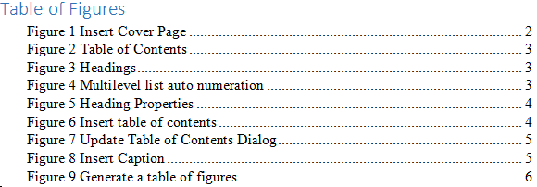

**List of Tables**

Table 1 - Project Information 3

Table 2 - Group Information 3

# **General Information**

|  |  |  |  |
| --- | --- | --- | --- |
| Group name | Group 1/2/3, etc. | | |
| Repository URL | *GitHub/Gitlab link, etc.* | | |
| Group Board URL | *Trello/Jira link, etc.* | | |
| Web Hosting URL | [*www.mywebapp.com*](http://www.mywebapp.com) | | |
| Test accounts | *Role* | *Username* | *Password* |
| admin | admin | 123456 |
| manager | manager | 123456 |
| *…* | *…* | *…* |
| Screen cast URL | *YouTube link* | | |
| Backlog URL | *Google Docs/Sheet link* | | |
| Test plan URL | *Google Docs/Sheet link* | | |
| Front-End Technology | *ReactJS, AngularJS, VueJS, etc.* | | |
| Back-End Technology | *.NET/.NET Core, Laravel, Symfony, ExpressJS/NodeJS, etc.* | | |
| Database | *MySQL, MongoDB, SQL Server etc.* | | |

Table 1 - Project Information

|  |  |
| --- | --- |
| Full Name | Role |
| Member 1 | Scrum Master/tester |
| Member 2 | Front-end Developer |
| Member 3 | Back-end Developer |
| Member 4 | Business Analyst |
| Member 5 | UI/UX Designer |

Table 2 – Member Role

# **Introduction**

Introduce about project, purpose of this report, introduce some main sections, ...

# **Requirement Analysis**

functional + non-functional, use-case diagram + specification

# **Database**

database normalization, data security, data validation, ERD, class diagram, database diagram

# **Design**

sitemap, wireframes,  flowcharts, mockup (Figma), activity diagram, sequence diagrams

# **Implementation**

overview about selected techniques (FE+BE+DB), system structures , features introduction & explanation for outstanding/important code snippets, final web screenshots

# **Testing**

Test overview, Test plan, test scenarios, test cases, test logs, test evidences, test result evaluation

# **Methodology**

user stories, product backlog, sprint backlogs, burndown chart, meeting minutes, team challenges

# **Conclusion**

summarize have been presented in this report/what have done in this project, overall evaluation for web application/Agile methodology, future improvements

# **Bibliography**

