## Algorithms

### Suggest Appropriate Goods/Route

#### Definition

* Goods owner want to find route passing nearly and choose truck driver for make deal.
* Truck driver want to get the goods nearly the route and choose the goods owner for make deal.

#### Requirement

* Goods which have category contains list category of truck driver can carry.
* The range of date between goods and route must have intersection.
* Weight of goods must be less than payloads of truck driver.
* Result should be sorted by shorted driving distance.
* Driving distance from route of driver to goods should be shorter than 50km or shorter as goods owner expect.
* Use Google Maps API to get actual distance from route to pick up address of goods and delivery address of goods.

#### Solution

* *Reference to attachment flow chart: “Suggest Appropriate Goods/Route” flow chart*

#### Complexity

### Make deal process and handling conflict

#### Make deal process



* First, goods owner can get suggestion driver from system matching.
* Next, goods owner make an offer as a deal and system notify this offer to truck driver, at the time, deal status is PENDING and create by is owner. If goods owner cancel this deal before truck driver bid, deal status would be CANCEL. If goods owner decline the bid from truck driver, deal status would be DECLINE.
* Finally, one of both satisfied with the price and decides to agree the deal, at this time deal status would be ACCEPT.

#### Requirement

* Goods owner and goods owner can making or receiving multiple deal for an offer.

#### Define problem

* Because goods of owner can deal with multiple truck driver but one deal is accept, another deal must be change to cancel or decline status.

#### Solution

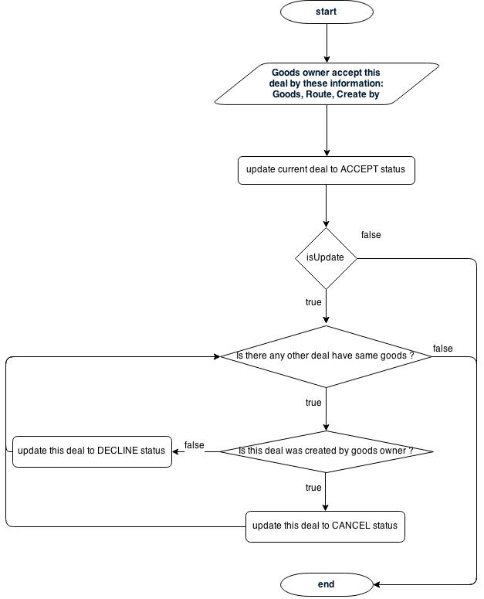

### Payment process and managing order status

#### Payment process and order status



* When truck driver/ goods owner accepts a deal, an order is created with status UNPAID. This requires goods owner to prepay the order in order to have their good delivered.
* From the day the order is created to 1 day before truck driver begins to pick up the goods, if goods owner must prepaid the order, order’s status is changed to PAID and the goods is ready to be delivered. Otherwise, goods owner want to cancel, order status is CANCELLED and system fine this mistake of owner and refunds remain.
* On good’s pickup date, order status is automatically changed to DELIVERING.
* On good’s delivery date, order status is automatically changed to DELIVERED.
* From good’s delivery date to 3 date after, goods owner has the right to report missing/broken good. If there is no report, order status is changed to FINISH and money is sent to truck driver. Otherwise, staff will check the situation carefully; if it right, staff change order status is REFUND, system will sent money back to goods owner.

#### Requirement

* System receive the money from Goods Owner then verify the shipping information to paid for Truck Driver or refund to Goods Owner

#### Define problem

#### Solution