**MINISTRY OF EDUCATION AND TRAINING**

**FPT UNIVERSITY**

Capstone Project Document

**Freight Truck Services**

|  |  |
| --- | --- |
| **GROUP 1** | |
| **Group member** | Bui Duc Huy – Leader – HuyBDSE61006  Nguyen QuangThien– Member – ThienNQSE61000  Dang PhuThinh– Member – ThinhDPSE60879  Nguyen DuyKhuong – Member – KhuongND60493 |
| **Supervisor** | KieuTrongKhanh |
| **Ext. Supervisor** | N/A |
| **Capstone Projectcode** | FTS |

-Ho Chi Minh City, ***January 6, 2015***

# Table of Contents

Table of Contents 3

List of Tables 6

List of Figures 7

Definitions, Acronyms, and Abbreviations 7

A. Introduction 8

1. Project Information 8

2. Introduction 8

3. Current Situation 8

4. Problem Definition 8

5. Proposed Solution 8

5.1 Feature functions 8

5.2 Advantages and disadvantages 9

6. Functional Requirement 9

7. Role and Responsibility 10

B. Software Project Management Plan 11

1. Problem Definition 11

1.1 Name of this Capstone Project 11

1.2 Problem Abstract 11

1.3 Project Overview 11

2. Project organization 11

2.1 Software Process Model 11

2.2 Roles and responsibilities 11

2.3 Tools and Techniques 12

3. Project Management Plan 12

3.1 Software Development Life Cycle 12

3.2 All Meeting Minutes 12

4. Coding Convention 12

C. Software Requirement Specification 12

1. User Requirement Specification 12

1.1 Guest Requirement 12

1.2 Member Requirement 12

1.3 Partner Requirement 12

1.4 Staff Requirement 12

1.5 Admin Requirement 12

2. System Requirement Specification 12

2.1 External Interface Requirement 12

2.2 System Overview Use Case 12

2.3 List of Use Case 12

3. Software System Attribute 13

3.1 Usability 13

3.2 Reliability 13

3.3 Availability 14

3.4 Security 14

3.5 Maintainability 14

3.6 Portability 14

3.7 Performance 14

4. Conceptual Diagram 14

Data Dictionary 14

D. Software Design Description 14

1. Design Overview 14

2. System Architectural Design 14

2.1 Web Application architecture description 14

2.2 Mobile Application architecture description 14

3. Component Diagram 14

4. Detailed Description 15

4.1 Class Diagram 15

4.2 Class Diagram Explanation 15

4.3 Interaction Diagram 15

5. User Interface Design 15

5.1 Guest Interface Design 15

6. Database Design 15

6.1 Logical Diagram 15

6.2 Data Dictionary 15

7. Algorithms 15

7.1 Document Breakdown 15

7.2 String Comparison 16

E. System Implementation & Test 16

1. Introduction 16

1.1 Overview 16

1.2 Test Approach 16

2. Database Relationship Diagram 16

2.1 Physical Diagram 16

2.2 Data Dictionary 16

3. Performance Measures 17

3.1 Clustering Performance 17

4. Test Plan 17

4.1 Features to be tested 17

4.2 Features not to be tested 17

5. System Testing Test Case 18

5.1 Guest Test Case 18

F. Software User’s Manual 18

1. Installation Guide 18

1.1 Setting up environment at server side 18

1.2 Deployment at server side 18

1.3 Setting up the environment at client side 19

2. User Guide 19

G. Appendix 19

# List of Tables

# List of Figures

# Definitions, Acronyms, and Abbreviations

|  |  |  |
| --- | --- | --- |
| **No.** | **Abbreviation & Acronym** | **Definition** |
|  |  |  |

# Introduction

## Project Information

* Project name: Freight Truck Services
* Project Code: FTS
* Product Type: Website & Android Application
* Start Date: Jan 6th, 2015
* End Date:May 2nd, 2015

## Introduction

Nowadays, trucks are used to carry goods across the country. However, after they deliver the goods, the trucks usually come back empty. Our project looks to solve this problem by proposing a solution: when drivers come back after a delivery, they will also pick up and deliver additional goods from other owners on their way. Weprovide the mobile application for drivers to search for goods when they return and for good owner to send their request for delivery.

## Current Situation

Truck driver only deliver goods for one owner at a time. Therefore, when they finish deliver goods to the owner, they usually return home without anything. Sometimes good owners and truck drivers make verbal agreement without delivery contract. Therefore, there is no guarantee that items will be delivered safely.

* **Backload4u.co.nz, Freightfinder.com:**is a website based on this idea and work very well in New Zealand and U.S. However there are some limitations: not support mobile devices; information of truck drivers and owner operators are public on the website unregisteredusers, which does not warrant the deal between truck drivers and owner operators. These websites don't allow real-time dealing, too.

## Problem Definition

The problem ariseswhentruck has delivered goods, it usually return with empty container on the waywhileownersalways want tooptimizeshippingcostsandneedto ensurethe safety ofyouritems, buttheycan onlycontacteach otherthrough phone callsbasedon the relationshiphad knownbefore.

## Proposed Solution

Our system supports two types: the mobile application for truck drivers, goods owners; the website application for admin, staff, and goods owners. There are following functions in the system:

### **Feature functions**

Admins can

* Manage accounts.
* Manage configuration.

Staff can

* Tracking orders and transactions.

System can

* Support the suggestion to driver in making decision choosing the goods owners.
* Give the optimal road to drivers.

Truck drivers can

* Post their road, container size, contact info…
* Make arrangement with goods owners and delivery items on their way back.

Goods owners can

* Search for drivers.
* Request for delivery and make a deal with truck drivers.
* Track their order’s status.

### Advantages and disadvantages

Advantages:

- Guarantee the goods are delivered with care.

- Increase income for truck drivers.

- Goods owners can find appropriate drivers quickly.

Disadvantages:

- Truck driver must have smartphone with GPS.

- Internet must be available so users can utilize all features.

## Functional Requirement

### Account management:

* Admins can manage users’s account.
* Truck drivers and good owners can create and manage the properties of their account.

### User information

* Truck drivers can input their phone number, container size, bank account, e-mail address.
* Goods owners can phone number, address, bank account, e-mail address.

### Search

* Truck drivers can search for goods based on their pre-defined road.
* Goods owners can search for truck by criteria.

### Suggestion

* System can support truck drivers in choosing the goods owners and suggest truck drivers for goods owners after they post their goods.
* System can suggest the optimal road for drivers.

### Mobile device

* Truck drivers can publish the destination with specified date, container size, contract information…
* Define the proposed road and/or adjust depending on the goods owners.
* Goods owners can make deal with truck drivers and make the order to deliver their goods.

## Role and Responsibility

|  |  |  |  |  |
| --- | --- | --- | --- | --- |
| No | Full Name | Role | Position | Contact |
| 1 | KiềuTrọngKhánh | Project Manager | Instructor | KhanhKT@fpt.edu.vn |
| 2 | BùiĐứcHuy | Developer | Leader | HuyBDSE61006@fpt.edu.vn |
| 3 | NguyễnQuangThiện | Developer | Member | ThienNQSE61000@fpt.edu.vn |
| 4 | ĐặngPhúThịnh | Developer | Member | ThinhDPSE60879@fpt.edu.vn |
| 5 | NguyễnDuyKhương | Developer | Member | KhuongND60493@fpt.edu.vn |

Table 1: Roles and Responsibility

# Software Project Management Plan

## Problem Definition

### Name of this Capstone Project

Freight Truck Services

### Problem Abstract

Transportation is one of the most important acitivity of human. It reflects the economic development of a country. Every year in Vietnam, there are thousands of trucks transferring goods around the country, but they often come back with empty containers. If we can optimize these empty containers, we can give truck drivers a chance to increase their income. To make it real, we propose an idea where we are the connector between truck drivers with empty containers and good owners where they can cooperate with better price and benefits. We will develop a system suggesting goods for truck drivers, tracking goods for goods owners, helping truck drivers and goods owners make deals and contracts with the best price possible.

### Project Overview

#### Current Situation

On the market right now already have somesystems, which havebeenimplementedthis idea butthere aresomelimitations such asnomobileapp, intuitiveinterface, noproposal information functional, suggest routerto the user… Thourght the market research in Viet Nam, we did not found any similar system. Our solution will solve oustanding goods problem of owner and inscrease the profit of truck driver.

In additional, we also provide a service on mobile application which can help truck driver receive the suggestion fromsystem, view the good information. After that, driver can make a deal with good owner, load balancing by the best routeoptimizing which system suggested; good owner can view the information of truck driver, deal again and tracking the delivery information.

#### The Proposed System

##### Website Application

##### Admin

* + - Admins can manage accounts in the system.
    - Admins can configure some value of system and algorithms to apply default to all new users’ accounts.

##### Staff

* + - Manage status of deal
    - Tracking the delivery information

##### Goods owner

* + - Goods owner can manage load and personal information.
    - Make deal with truck driver after reveived or search road information.

##### System

* + - System can give suggestions about the road information of the truck driver to goods owner, or suggest load information of goods owner to truck driver after they posted items.
    - System can optimize the road when driver registered multiple loads.

##### Mobile Application

##### Truck driver

* + - Truck driver can manage roadand personal information.
    - Make deal with goods owner after reveived load information from system.

##### System

* + - System can push notification from server to user when dealing.

#### Boundaries of the System

* The system can be used by every people with a smart phone or a laptop/computer with Internet connection.
* The system is **not intended** for managing these aspects:
  + Managing money account.
* The complete product includes:
  + The website for administrator and goods owner.
  + Mobile application for driver and goods owner.
  + All the process document involved.
* The language of the system is Vietnamese.

#### Development Environment

##### Hardware requirements

**For Server**

|  |  |  |
| --- | --- | --- |
| Windows | Minimum Requirements | Recommended |
| Internet Connection | Cable, Wifi (4 Mbps) | Cable, Wifi (8 Mbps) |
| Operating System | XP, Vista, 7, 8 | XP, Vista, 7, 8 |
| Computer Processor | Intel® Core 2 Duo | Intel® Core(TM) i5 CPU , M 460 @ 2.53GHz |
| Computer Memory | 1GB RAM | 3GB or more |

Table 2: Hardware Requirement for Server

**For Mobile Application**

|  |  |  |
| --- | --- | --- |
| Windows | Minimum Requirements | Recommended |
| Internet Connection | Cable, Wifi (4 Mbps) | Cable, Wifi (8 Mbps) |
| Operating System | XP, Vista, 7, 8 | XP, Vista, 7, 8 |
| Computer Processor | Intel® Core 2 Duo | Intel® Core(TM) i5 CPU , M 460 @ 2.53GHz |
| Computer Memory | 1GB RAM | 3GB or more |

**Table 3: Hardware Requirement for Mobile**

##### Software requirements

* SQL Server 2008 R2 Express: create and manage the database for system.
* Eclipse Luna 4.4.1, JDK 7 update 51, Apache Tomcat 7; Android SDK 14, ADT 23.0.2: implement website, web services and mobile application.
* GitHub&TortoiseSVN: used for source control.
* StarUML: used to create models and diagrams.
* Skype: used for communication and meeting.

## Project organization

### Software Process Model

Requirements definition

System and software design

Implementation and unit testing

Integration and system testing

Operation and maintenance

**Figure 1:**Warterfall process model

Reference: Software processes in book Software Engineering 8th – Ivan Sommerville.

### Roles and responsibilities

|  |  |  |  |
| --- | --- | --- | --- |
| **No** | **Full name** | **Role in group** | **Responsibilities** |
| 1 | KieuTrongKhanh | Project manager | * Specify user requirement * Control the development process * Give out technique and business analysis support |
| 2 | Bui Duc Huy | Team leader, BA, DEV, Tester | * Managing process * Support team members with technical problems. * Designing database * Clarifying requirements * Prepare documents * GUI design * Create test plan * Coding * Testing |
| 3 | Nguyen QuangThien | Team member, BA, DEV, Tester | * Designing database * Clarifying requirements * Prepare documents * GUI design * Create test plan * Coding * Test |
| 4 | Dang PhuThinh | Team member, BA, DEV, Tester | * Designing database * Clarifying requirements * Prepare documents * GUI design * Create test plan * Coding * Test |
| 5 | Nguyen DuyKhuong | Team member, BA, DEV, Tester | * Designing database * Clarifying requirements * Prepare documents * GUI design * Create test plan * Coding * Test |

Table 4: Roles and Responsibility Details

### Tools and Techniques

* Front – end technologies: HTML5, CSS3, JavaScript, jQuery, AJAX.
* Back – end:
  + Website:J2EE MVC.
  + Web Service: Web API RESTful.
  + Mobile App: Android – Java.
* Web Server: Apache Tomcat 7.0.
* Database Management System: MS SQL Server 2008 R2 Express.

## Project Management Plan

### Software Development Life Cycle

|  |  |  |  |  |  |
| --- | --- | --- | --- | --- | --- |
| **Phase** | **Description** | **Deliverables** | **Resource needed** | **Dependencies and Constrains** | **Risks** |
| Requirements Definition | * Collect requirements from customer * Identify and clarify requirements for the system in general | * Introduction of proposed system. * Main functions. | 20 man-days | N/A | Misunderstand the requirements.  Unclear scope of project |
| System and Software Design | * Choose the software development model * Research technology needed for project * Design main structure of system | * Project management plan. * Demo technology * Use case * ERD * SRS | 20 man-days | Depend on “Requirements Definition” | Lack of experience.  Technology is difficult to use  Not cover all use case of project |
| Implementation and Unit Testing | * Coding core functions first * Coding other functions * Update user interface * Unit test | * System design description * Main user’s functions on web and mobile * Suggestion of system * Test case | 50 man-days | Depend on “System and Software Design” | Lack of experience.  Not found suitable suggestion algorithm  Web interface not friendly |
| Integration and System Testing | * Integration test * System test | * Test case | 20 man-days | Depend on “Implementation and Unit Testing” | Lack of experience.  Test case not cover all situation. |
| Operation and Maintenance | * Deploy on server and mobile | * Installation Guide * User’s Guide | 10 man-day | Depend on all previous phase | Lack of experience. |

Table 5: Software Development Life Cycle Detail

### Phase Detail

#### Phase 1: Requirement definition

|  |  |  |
| --- | --- | --- |
| **Task** | **Description** | **Author** |
| 1.Collectrequirements | Find whichsystems currently provide similarservice,their strengths and weakness. | HuyBD, ThienDQ, ThinhDP, KhuongND |
| 2.Identify and clarify mainfunctions. | Definewhichmainfunctions system shouldprovide. | HuyBD, ThienDQ, ThinhDP, KhuongND |
| 3.Create System  Introduction. | Complete IntroductionReport. | HuyBD |
| 4. Software Project ManagementPlan. | Prepare Project ManagementPlan. | HuyBD |
| 5.Website Prototype. | Builda prototypeofproposed system (Website/Mobile). | ThienDQ, ThinhDP, KhuongND |
| 6. SRS | Create SRS document. | HuyBD, ThienDQ, ThinhDP, KhuongND |

Table 6: Requirement Definition

#### Phase 2: System and software design

|  |  |  |
| --- | --- | --- |
| **Task** | **Description** | **Author** |
| **1.Architecture Design** | Implementfunction import and breakdown data fromdocx files. | HuyBD, ThienDQ, ThinhDP, KhuongND |
| **2. DetailedDesign** | Compare new document with existed documents ofsystem. | HuyBD, ThienDQ, ThinhDP, KhuongND |
| **3. Database Design** | Get jobs fromother server to recommendation. | HuyBD, ThienDQ, ThinhDP, KhuongND |
| **4.Technology research** | Createsearchengine forbasic search andadvance search. | HuyBD, ThienDQ, ThinhDP, KhuongND |
| **5. Design Document** | Createsoftware designdocument | HuyBD, ThinhDP |

Table 7: System and Software Design

#### Phase 3: Implementation and unittesting

|  |  |  |
| --- | --- | --- |
| **Task** | **Description** | **Author** |
| **1.Front-end web functions** | Implementfront-end functions on web | KhuongND, HuyBD |
| **2.Back-end web functions** | Implementback-end functions on web | HuyBD, KhuongND |
| **3.Mobile functions** | Implementmobile application | HuyBD, ThienDQ, ThinhDP |
| **4. Suggestionalgorithms** | Research and implement suggestion algorithms | HuyBD |
| **5.Unit testing** | Write testcaseandtesting for webfunctions | HuyBD, KhuongND |
| Write testcaseandtesting for mobile functions | ThienDQ, ThinhDP |

Table 8: Implementation and Unit testing

#### Phase 4: Integration and system testing

|  |  |  |
| --- | --- | --- |
| **Task** | **Description** | **Author** |
| **1.Integrationtesting** | Write testcaseandtesting system | HuyBD, ThienDQ, ThinhDP, KhuongND |
| **2.Alpha testing** | Doalpha test with customer | HuyBD, ThienDQ, ThinhDP, KhuongND |

Table 9: Integration and system testing

#### Phase 5: Operation and maintenance

|  |  |  |
| --- | --- | --- |
| **Task** | **Description** | **Author** |
| **1.Installationguide** | Write installation guide | HuyBD |
| **2.User Manual** | Write user manual | HuyBD, ThienDQ, ThinhDP, KhuongND |

Table 10: Opration and maintenance

### All Meeting Minutes

Refer to **Meeting Minutes** folder.

## Coding Convention

* Naming Convention.
* Use camel case for both variable and function name.
* Use Pascal case for class name.
* Indentation.
* Four spaces should be used as the unit of indentation. The exact construction of the indentation (spaces vs. tabs) is unspecified. Tabs must be set exactly every 8 spaces (not 4).
* Avoid lines longer than 80 characters.
* Declaration.
* One declaration per line is recommended since it encourages commenting.
* In absolutely no case should variables and functions be declared on the same line.
* Code Examples

Follow “Code Conventions for the Java TM Programming Language, by Sun Microsystems, rev April 20, 1999”.

<http://www.oracle.com/technetwork/java/codeconventions-150003.pdf>

# Software Requirement Specification

## User Requirement Specification

### Guest Requirement

Guest is a person who doesn’t login to the system. Guest can use some functions in the system. These are some functions guest can use:

* Register as owner.
* Register as driver.
* Login.
* Forgot password.

### Member Requirement

Member is guest who uses his account to login to the system. Member can use additional functions, such as:

* Update profile.
* Logout.

### Driver Requirement

* Manage route information.
* Get suggestion goods.
* Make deal with owner.
* Manage deal.

### Owner Requirement

* Manage goods information.
* Get suggestion route.
* Make deal with driver.
* Manage deal.

### Staff Requirement

Staff is manager of the system. Staff can use these functions:

* Confirm delivery status.
* Create new member account.
* Manage member account.

### Admin Requirement

Admin is the person who manages the system. Admin is super user which can use the following functions:

* Manage staff account.

## System Requirement Specification

### External Interface Requirement

#### User Interface

* The user interface uses language Vietnamese

#### Hardware Interface

* N/A

#### Software Interface

* Firefox (v30 or above), Chromes (v14 or above) browser, enable JavaScript.
* Smartphone with Android 4.0 or above.

#### Communication Protocol

* Website using HTTP protocol for communication between the web browser and the web server.
* Mobile app using HTTP protocol for communication between app and web service.

### System Overview Use Case



Figure 2: System Overview Use Case

### List of Use Case

#### <Guest>Overview Use Case

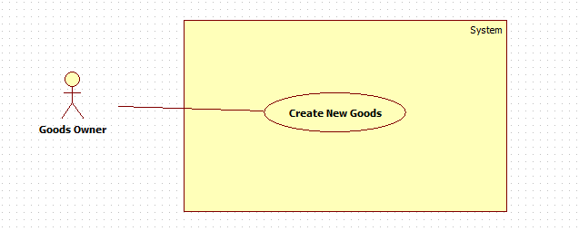

|  |  |  |  |
| --- | --- | --- | --- |
| **USE CASE – CPS001** | | | |
| **Use Case No.** |  | **Use Case Version** | 2.0 |
| **Use Case Name** | Create New Goods | | |
| **Author** | ThinhDP | | |
| **Date** |  | **Priority** | High |
| **Actor:**Goods owner  **Summary:**This use case allows goods owner to post new goods.  **Goal:**Add new goods to database  **Triggers:**Goods owner click on “Đăng hàng” button in action bar.  **Preconditions:**   * User must log in to the system with role goods owners.   **Post Conditions:**   * **Success:**New goods will be added to database. Success message will be shown. * **Fail:** Error message will be shown.   **Main Success Scenario:**   |  |  |  | | --- | --- | --- | | Step | Actor Action | System Respone | | 1 | Goods owner clicks “Đăng hàng” button. | System navigates to “Tạo hàng”page.   * Loại hàng: drop down list,required, (Thức ăn, Nội thất, Gia dụng, Vật liệu). * Khối lượng: textbox, min length: 1, max length: 5, min value: 500, max value: 45000, required. * Ngày gửi hàng: datepicker,date range: current date to current date + 1 month, required. * Ngày giao hàng: datepicker, date range: current date to current date + 1 month, required * Địa điểm nhận hàng: textbox, min length: 1, max length: 100, required. * Địa điểm giao hàng: textbox, min length: 1, max length: 100, required. * Ghi chú: textbox, min length: 1, max length: 250, not required * Giá tiền: textbox, min length:1, max length: 10, required * Tạo hàng: button | | 2 | Input field.  [Alternative 1,2] |  | | 3 | Click on “Tạo hàng” button | New goods will be added to database and show “Bạn đã thêm hàng thành công”.  [Exception 1,2,3,4,5,6,7,8,9,10,11,12,13] |   **Alternative Scenario:**   |  |  |  | | --- | --- | --- | | Step | Actor Action | System Respone | | 1 | Goods owner clicks on Map ImageButton next to“Địa điểm nhận hàng” | System navigates to “Địa điểm” page:   * Google map * Đồng ý: button | | 2 | Owner choosesappropriate position | System will update new location | | 3 | Click on “Đồng ý” | Location will be saved to database. | | Step | Actor Action | System Respone | | 1 | Goods owner clicks on Map ImageButton next to“Địa điểm giao hàng” | System navigates to “Địa điểm” page:   * Google map * Đồng ý: button | | 2 | Owner chooses appropriate position | System will update new location | | 3 | Click on “Đồng ý” | Location will be saved to database |   **Exceptions:**   |  |  |  | | --- | --- | --- | | No | Actor Action | System Response | | 1 | Click on “Tạo hàng” button | “Khối lượng” is empty or longer than 5 words. Show error message: “Khối lượng giới hạn từ 1 đến 5 ký tự”. | | 2 | Click on “Tạo hàng” button | “Ngày gửi hàng” is empty. Show error message: “Vui lòng chọn ngày gửi hàng”. | | 3 | Click on “Tạo hàng” button |  | | 4 | Click on “Tạo hàng” button | “Ngày giao hàng” is empty. Show error message: “Vui lòng chọn ngày giao hàng”. | | 5 | Click on “Tạo hàng” button |  | | 6 | Click on “Tạo hàng” button | “Địa điểm nhận hàng” is empty or longer than 100 words. Show error message: “Địa điểm nhận hàng giới hạn từ 1 đến 100 ký tự”. | | 7 | Click on “Tạo hàng” button | “Địa điểm giao hàng” is empty or longer than 100 words. Show error message: “Địa điểm giao hàng giới hạn từ 1 đến 100 ký tự”. | | 8 | Click on “Tạo hàng” button | “Giá tiền” is empty or longer than 10 words. Show error message: “Giá tiền giới hạn từ 1 đến 10 ký tự”. | | 9 | Click on “Tạo hàng” button | “Khối lượng” value is smaller than 1 and bigger than 90000. Show error message: “Khối lượng giới hạn từ 1 đến 90000 kg”. | | 10 | Click on “Tạo hàng” button | “Ngày giao hàng” is earlier than “Ngày gửi hàng”. Show error message: “Ngày gửi hàng phải sớm hơn ngày gửi hàng”. | | 11 | Click on “Tạo hàng” button |  | | 12 | Click on “Tạo hàng” button |  | | 13 | Click on “Tạo hàng” button | “Ghi chú” is empty or longer than 250 words. Show error message: “Ghi chú chỉ có giới hạn từ 1 đến 250 ký tự”. |   **Relationships:** N/A  **Business Rules:**   * Goods are added to database with status “Created” * System will notifes owner if the goods is added successfully or not. * Delivery date must be later than pickup date. If pickup date is current date, pickup time must be later than current time 6 hours. If delivery date is pickup date, delivery time must be later than pickup time 15 hours. * “Khối lượng” is weighted by kg and limited from 1 to 90000. * “Giá tiền” is calculated by thousand. * Owner can edit marker if marker is not correct. If owner does not edit marker, the address that owner input will be used as marker. | | | |

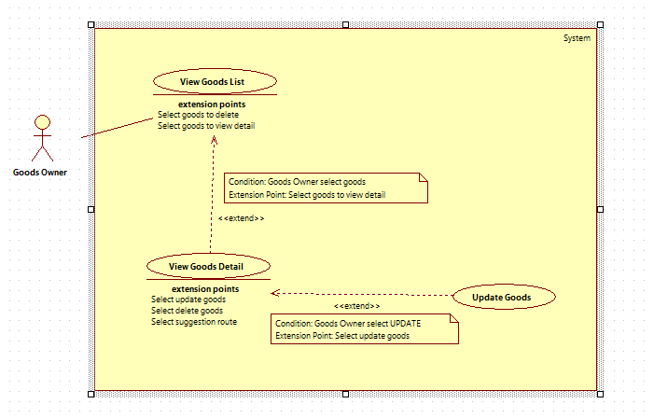

|  |  |  |  |
| --- | --- | --- | --- |
| **USE CASE – CPS001** | | | |
| **Use Case No.** |  | **Use Case Version** | 2.0 |
| **Use Case Name** | Update Goods | | |
| **Author** | ThinhDP | | |
| **Date** |  | **Priority** | High |
| **Actor:** Goods owner  **Summary:** This use case allows goods owner to update existed goods  **Goal:** Update existedgoods  **Triggers:** Goods owner click on a goods in “Hàng hóa” tab  **Preconditions:**   * Goods exists in database. * User must log in to the system with role goods owners. * Goods is not in deal.   **Post Conditions:**   * **Success:**Goods will be updated with new information * **Fail:** Goods will not be updated. Error message will be shown.   **Main Success Scenario:**   |  |  |  | | --- | --- | --- | | Step | Actor Action | System Respone | | 1 | Goods owner click on a goods in “Hàng hóa” tab, then swipe to “Thông tin” tab. | System navigates to add goods page.   * Loại hàng: drop down list, required, (Thức ăn, Nội thất, Gia dụng, Vật liệu). * Khối lượng: textbox, min length: 1, max length: 5, min value: 1, max value: 90000, required. * Ngày gửi hàng: datepicker, date range: current date to current date + 1 month, required. * Thời gian gửi hang: timepicker, min time: current time + 6 hour, required * Ngày giao hàng: datepicker, date range: current date to current date + 1 month, required * Thời gian giao hàng: timepicker, required. * Địa điểm nhận hàng: textbox, min length: 1, max length: 100, required. * Địa điểm giao hàng: textbox, min length: 1, max length: 100, required. * Ghi chú: textbox, min length: 1, max length: 250, not required * Giá tiền: textbox, min length:1, max length: 10, required * Cập nhật: button * Xóa: button | | 2 | Modify field.  [Alternative 1,2] |  | | 3 | Click on “Cập nhật” button | New goods will be added to database and show “Bạn đã cập nhật hàng thành công”.  [Exception 1,2,3,4,5,6,7,8,9,10,11,12,13,14,15,16,17,18,19,20] |   **Alternative Scenario:**   |  |  |  | | --- | --- | --- | | Step | Actor Action | System Respone | | 1 | Goods owner clicks on Map ImageButton next to“Địa điểm nhận hàng” | System navigates to “Địa điểm” page:   * Google map * Đồng ý: button | | 2 | Owner drags marker to appropriate position | System will update new marker’s latitude and longitude | | 3 | Click on “Đồng ý” | Marker position will be saved to database, | | Step | Actor Action | System Respone | | 1 | Goods owner clicks on Map ImageButton next to“Địa điểm giao hàng” | System navigates to “Địa điểm” page:   * Google map * Đồng ý: button | | 2 | Owner drags marker to appropriate position | System will update new marker’s latitude and longitude | | 3 | Click on “Đồng ý” | Marker position will be saved to database, |   **Exceptions:**   |  |  |  | | --- | --- | --- | | No | Actor Action | System Response | | 1 | Click on “Tạo hàng” button | “Khối lượng” is empty or longer than 5 words. Show error message: “Khối lượng giới hạn từ 1 đến 5 ký tự”. | | 2 | Click on “Tạo hàng” button | “Ngày gửi hàng” is empty. Show error message: “Vui lòng chọn ngày gửi hàng”. | | 3 | Click on “Tạo hàng” button | “Thời gian gửi hàng” is empty. Show error message: “Vui lòng chọn giờ gửi hàng”. | | 4 | Click on “Tạo hàng” button | “Ngày giao hàng” is empty. Show error message: “Vui lòng chọn ngày giao hàng”. | | 5 | Click on “Tạo hàng” button | “Thời gian giao hàng” is empty. Show error message: “Vui lòng chọn giờ giao hàng”. | | 6 | Click on “Tạo hàng” button | “Địa điểm nhận hàng” is empty or longer than 100 words. Show error message: “Địa điểm nhận hàng giới hạn từ 1 đến 100 ký tự”. | | 7 | Click on “Tạo hàng” button | “Địa điểm giao hàng” is empty or longer than 100 words. Show error message: “Địa điểm giao hàng giới hạn từ 1 đến 100 ký tự”. | | 8 | Click on “Tạo hàng” button | “Giá tiền” is empty or longer than 10 words. Show error message: “Giá tiền giới hạn từ 1 đến 10 ký tự”. | | 9 | Click on “Tạo hàng” button | “Khối lượng” value is smaller than 1 and bigger than 90000. Show error message: “Khối lượng giới hạn từ 1 đến 90000 kg”. | | 10 | Click on “Tạo hàng” button | “Ngày giao hàng” is earlier than “Ngày gửi hàng”. Show error message: “Ngày gửi hàng phải sớm hơn ngày gửi hàng”. | | 11 | Click on “Tạo hàng” button | If “Ngày gửi hàng” is current date and “Thời gian gửi hàng” is not later than current time 6 hours. Show error message: “Thời gian gửi hàng phải trễ hơn hiện giờ 6 tiếng“ | | 12 | Click on “Tạo hàng” button | If “Ngày nhận hàng” is the same as “Ngày giao hàng” and “Thời gian giao hàng” is not later than “Thời gian nhận hàng” 15 hours. Show error message: “Vui lòng chọn thời gian giao hàng trễ hơn thời gian gửi hàng 15 tiếng”. | | 13 | Click on “Tạo hàng” button | “Ghi chú” is empty or longer than 250 words. Show error message: “Ghi chú chỉ có giới hạn từ 1 đến 250 ký tự”. |   **Relationships:** extended by View Goods Detail  **Business Rules:**   * Goods must exist in database. * When goods status is “2”, owner will not be able to edit field in information’s page or press “Cập nhật” button. * Delivery date must be later than pickup date. If pickup date is current date, pickup time must be later than current time 6 hours. If delivery date is pickup date, delivery time must be later than pickup time 15 hours. * “Khối lượng” is weighted by kg and limited from 1 to 90000. * “Giá tiền” is calculated by thousand. * Owner can edit marker if marker is not correct. If owner does not edit marker, the address that owner input will be used as marker. | | | |

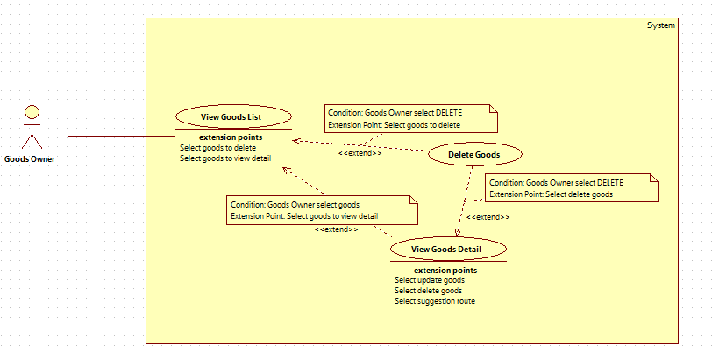

|  |  |  |  |
| --- | --- | --- | --- |
| **USE CASE – CPS001** | | | |
| **Use Case No.** |  | **Use Case Version** | 2.0 |
| **Use Case Name** | Delete Goods | | |
| **Author** | ThinhDP | | |
| **Date** |  | **Priority** | High |
| **Actor:** Goods owner  **Summary:** This use case allows goods owner to delete goods.  **Goal:** Goods will be removed from the system.  **Triggers:** Goods owner click “Xóa hàng” button in goods information page  **Preconditions:**   * User must log in to the system with role goods owners. * Goods exists in the system. * Goods is not in deal with any drivers.   **Post Conditions:**   * **Success:**Goods will be deleted from database * **Fail:** Goods is not deleted. Error message will be shown   **Main Success Scenario:**   |  |  |  | | --- | --- | --- | | Step | Actor Action | System Respone | | 1 | Goods owner click on a goods in “Hàng hóa” tab, then swipe to “Thông tin” tab. Goods owner clicks “Xóa hàng” button. | System shows comfirm pop-up: “Bạn có muốn xóa hàng không?”   * Đồng ý: button * Hủy: button | | 2 | Click on “Đồng ý” button.  [Exception 1] | Goods from database |   **Alternative Scenario:**   |  |  |  | | --- | --- | --- | | No | Actor Action | System Response | | 1 | Click on “Hủy” button | Pop-up is turn-off. Goods is not deleted |   **Exceptions:**   |  |  |  | | --- | --- | --- | | No | Actor Action | System Response | | 1 | Click on “Đồng ý” button | Goods is not deleted. Show error message: “Chức năng hiện đang bị lỗi. Xin thử lại sau” |   **Relationships:** extended by View Goods List, extended by View Goods Detail  **Business Rules:**   * Goods must exist in database. * When goods status is “2”, owner will not be able to press “Xóa” button. * Goods status is changed to “0” | | | |

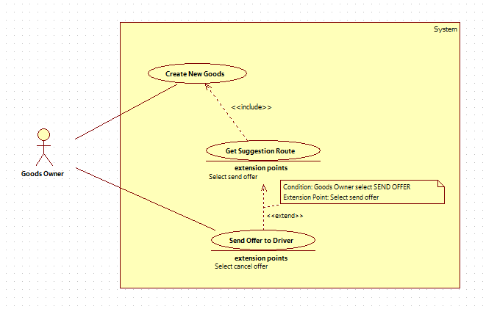

|  |  |  |  |
| --- | --- | --- | --- |
| **USE CASE – CPS001** | | | |
| **Use Case No.** |  | **Use Case Version** | 2.0 |
| **Use Case Name** | Send offer to driver | | |
| **Author** | ThinhDP | | |
| **Date** |  | **Priority** | High |
| **Actor:** Goods owner  **Summary:** This use case allows goods owner to send new deal to truck driver.  **Goal:** To start a new deal with truck driver.  **Triggers:** Goods owner clicks “Đề nghị” button in truck driver’s information page.  **Preconditions:**   * User must log in to the system with role goods owners. * Goods and route is active. * You are not dealing about specific goods with truck driver.   **Post Conditions:**   * **Success:**New deal is sent to truck driver. Success message is shown * **Fail:** Error message is shown   **Main Success Scenario:**   |  |  |  | | --- | --- | --- | | Step | Actor Action | System Respone | | 1 | In driver suggestion page, owner click on a driver he wants to deal | System navigates to dealing’s information page. | | 2 | Owner clicks on “Đề nghị” button  [Alternative 1] | A new deal is sent to truck driver. Success message is shown: “Đề nghị đã được gửi”  [Exception 1] |   **Alternative Scenario:**   |  |  |  | | --- | --- | --- | | No | Actor Action | System Response | | 1 | Goods owner click “Hủy” button | System returns to previous page. No deal is sent. |   **Exceptions:**   |  |  |  | | --- | --- | --- | | No | Actor Action | System Response | | 1 | Owner clicks on “Đề nghị giao dịch” button | New deal is not sent. Show error message: “Đề nghị đã không được gửi. Xin thử lại sau” |   **Relationships:** extended by View Suggestion Route  **Business Rules:**   * Goods owner can send deal to as many driver as he wants. * System must make sure both goods and route are available before offer is sent. If route is not available, system will notify owner. * New offer is saved to database with pending state. If offer is sent, system will notify driver about new deal. If notification is failed to send, system will resent it one more time. If notification is failed to send twice, driver will be removed from suggestion list. | | | |

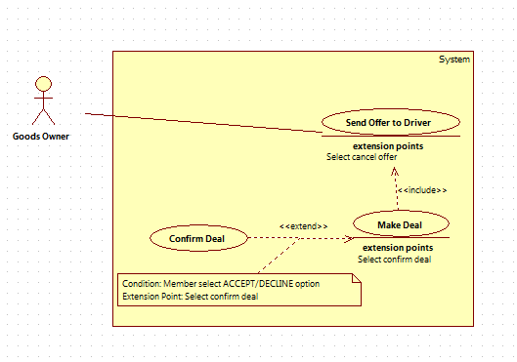

|  |  |  |  |
| --- | --- | --- | --- |
| **USE CASE – CPS001** | | | |
| **Use Case No.** |  | **Use Case Version** | 2.0 |
| **Use Case Name** | Confirm deal | | |
| **Author** | ThinhDP | | |
| **Date** |  | **Priority** | High |
| **Actor:** Goods owner  **Summary:** This use case allows goods owner to accept or decline a deal sent from truck driver.  **Goal:**The deal will be accepted or declined by owner.  **Triggers:** Goods owner click “Chấp nhận” or “Từ chối” button.  **Preconditions:**   * Goods owner must log in to the system with role goods owners. * The deal still exists.   **Post Conditions:**   * **Success:**The deal sent from truck driver is accepted * **Fail:** Deal is not accepted. Error message is shown   **Main Success Scenario:**   |  |  |  | | --- | --- | --- | | Step | Actor Action | System Respone | | 1 | Goods owner clicks “Chấp nhận” button.  [Alternative 1] | Deal is accepted. Message is shown: “Đề nghị đã được chấp nhận”.  [Exception 1] |   **Alternative Scenario:**   |  |  |  | | --- | --- | --- | | No | Actor Action | System Response | | 1 | Goods owner clicks “Từ chối” button. | Deal is declined. Message is shown: “Đề nghị đã được từ chối”.  [Exception 2] |   **Exceptions:**   |  |  |  | | --- | --- | --- | | No | Actor Action | System Response | | 1 | Goods owner click “Chấp nhận” button. | Deal is still not accepted. Error message is shown: “Đề nghị vẫn chưa được chấp nhận. Xin thử lại sau”. | | 2 | Goods owner clicks “Từ chối” button. | Deal is still not declined. Error message is shown: “Đề nghị vẫn chưa được từ chối. Xin thử lại sau” |   **Relationships:** extended by Make Deal  **Business Rules:**   * When deal is accepted, system will change status to accepted, deal will be added to Order table. * When deal is declined, system will changed status to declined. * When deal is accepted or decline, success message will be shown. When error happens, error message will be shown. * System owner accepts deal, system will check if deal is cancelled or not. If yes, error message will be shown to owner. * System will notify driver when deal is accepted or declined. | | | |

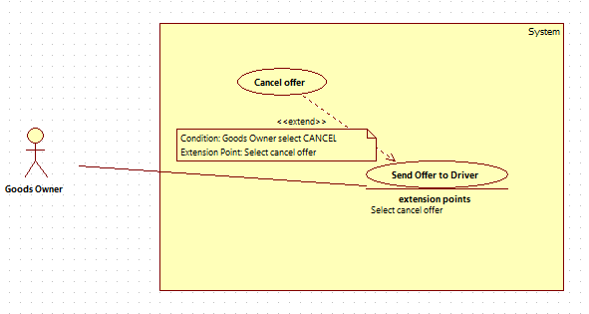

|  |  |  |  |
| --- | --- | --- | --- |
| **USE CASE – CPS001** | | | |
| **Use Case No.** |  | **Use Case Version** | 2.0 |
| **Use Case Name** | Cancel Offer | | |
| **Author** | ThinhDP | | |
| **Date** |  | **Priority** | High |
| **Actor:** Goods owner  **Summary:** This use case allows goods owner to cancel the deal he sent to driver.  **Goal:** The deal will be cancel.  **Triggers:** Goods owner click “Hủy đề nghị” in deal information page.  **Preconditions:**   * Goods owner must log in to the system with role goods owners. * Driver hasn’t accepted the deal yet.   **Post Conditions:**   * **Success:** A deal sent by owner will be cancel * **Fail:** Deal is not cancel. Error message is shown   **Main Success Scenario:**   |  |  |  | | --- | --- | --- | | Step | Actor Action | System Respone | | 1 | Goods owner clicks “Hủy đề nghị” button. | System show confirmation message: “Bạn có muốn hủy đề nghị không?” | | 2 | Goods owner clicks “Có” button  [Alternative 1] | Offer is cancelled. Success message is shown: “Bạn đã hủy đề nghị thành công.”  [Exception 1] |   **Alternative Scenario:**   |  |  |  | | --- | --- | --- | | No | Actor Action | System Respone | | 1 | Goods owner clicks “Không” button. | Offer is not cancelled. |   **Exceptions:**   |  |  |  | | --- | --- | --- | | No | Actor Action | System Response | | 1 | Goods owner click “Hủy đề nghị” button | Deal is still not accepted. Error message is shown: “Đề nghị vẫn chưa được hủy. Xin thử lại sau” |   **Relationships:**extended by Send Offer To Driver  **Business Rules:**   * System can only cancel deal when it’s not accepted by driver yet. If deal is already accepted, error message will be shown to owner. * When deal is cancel, it will be removed from “Giao dịch” tab * When deal is cancel, driver will be notified about it. * Offer is marked as cancelled in database. | | | |

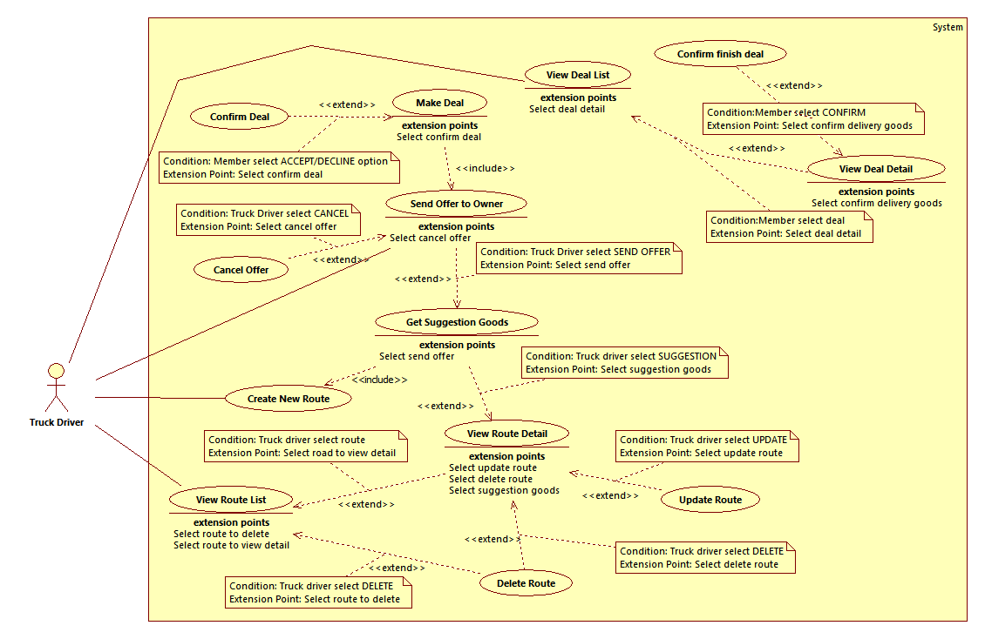

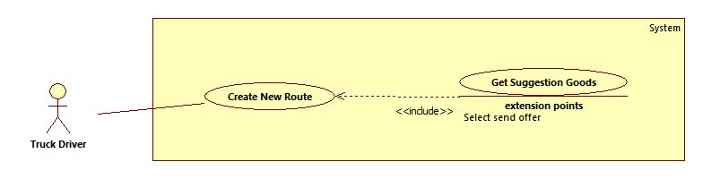

|  |  |  |  |
| --- | --- | --- | --- |
| **USE CASE – FTS001** | | | |
| **Use Case No.** | FTS001 | **Use Case Version** | 2.0 |
| **Use Case Name** | Create new route | | |
| **Author** | Nguyen Quang Thien | | |
| **Date** | 14/01/2015 | **Priority** | High |
| **Actor:**   * Truck Driver   **Summary:**   * Truck drivers post information about their route to the system.   **Goal:**   * Route information is added to the system.   **Triggers:**   * Truck driver touches “Tạo mới” button on action bar   **Preconditions:**   * User logs in as truck driver.   **Post Conditions:**   * **Success:**Information is added to the system. * **Fail:** No information is added. Error message is shown.   **Main Success Scenario:**   |  |  |  | | --- | --- | --- | | Step | Actor Action | System Respone | | 1 | Truck driver touches “Tạo mới” button on action bar. | Navigate to “Lộ trình mới” screen which contains:   * Địa điểm bắt đầu: textbox, min length: 1, max length: 100, required * Địa điểm đi qua 1: textbox, min length: 1, max length: 100, not required * Địa điểm đi qua 2: textbox, min length: 1, max length: 100, not required * Địa điểm kết thúc: textbox, min length: 1, max length: 100, required * Ngày bắt đầu: day picker, date range: current date – one month later, required * Giờ bắt đầu: time picker, time range: 6 hours from current time – 12 pm, required * Ngày kết thúc: day picker, date range: current date – one month later, required * Khối lượng có thể chở: textbox, min length: 1, max length: 5, min value: 1, max value: 20000, required * Hàng dễ vỡ: checkbox, not required * Hàng dễ cháy nổ: checkbox, not required * Hàng đông lạnh: checkbox, not required * Hàng thực phẩm: checkbox, not required * Tùy chỉnh lộ trình: link * Tạo: button | | 2 | Truck driver fills necessary information into the form. |  | | 3 | Truck driver touches “Tạo” button for the first time and 2 middle points are empty [Alternative 1, 2] | System suggests 2 middle points on the route and let truck driver chooses whether they want to add them to the route or not. Then system navigates truck driver to “Tùy chỉnh lộ trình” screen. |   **Alternative Scenario:**   |  |  |  | | --- | --- | --- | | Step | Actor Action | System Respone | | 1 | Truck driver touches “Tùy chỉnh lộ trình” link.  Truck driver modifies markers on the map and clicks “Cập nhật” button. | New route with markers is saved, “Lộ trình mới” screen is shown again. New route information are displayed on the textboxes. | | 2 | Truck driver touches “Tạo” button 2nd time | Route’s information is added to database, success message “Tạo mới thành công” is shown. System navigates driver to goods suggestion screen. [Exception 1, 2, 3 ,4 ,5 ,6 ,7 ,8 ,9, 10, 11, 12, 13] |   **Exceptions:**   |  |  |  | | --- | --- | --- | | No | Actor Action | System Response | | 1 | “Địa điểm bắt đầu” field is empty. | Error message “Điểm bắt đầu không được để trống.” is shown. | | 2 | “Địa điểm bắt đầu” field data length is longer than 100 characters. | Error message “Điểm bắt đầu chỉ dài tối đa 100 ký tự. Vui lòng nhập lại.” is shown. | | 3 | “Địa điểm đi qua 1” field data length is longer than 100 characters. | Error message “Điểm đi qua 1 chỉ dài tối đa 100 ký tự. Vui lòng nhập lại.” is shown. | | 4 | “Địa điểm đi qua 2” field data length is longer than 100 characters. | Error message “Điểm đi qua 2 chỉ dài tối đa 100 ký tự. Vui lòng nhập lại.” is shown. | | 5 | “Địa điểm kết thúc” field is empty. | Error message “Điểm kết thúc không được để trống.” is shown. | | 6 | “Địa điểm kết thúc” field data length is longer than 50 characters. | Error message “Điểm kết thúc chỉ dài tối đa 50 ký tự. Vui lòng nhập lại.” is shown. | | 7 | “Ngày kết thúc” field is empty. | Error message “Ngày kết thúc không được để trống.” is shown | | 8 | “Ngày kết thúc” field data is out of range. | Error message “Ngày kết thúc không phù hợp, vui lòng nhập lại.” is shown | | 9 | “Ngày kết thúc” field data is earlier than “Ngày bắt đầu” field data. | Error message “Ngày kết thúc không được sớm hơn ngày bắt đầu.” is shown | | 10 | “Khối lượng có thể chở” field is empty. | Error message “Khối lượng có thể chở không được để trống.” is shown. | | 11 | “Khối lượng có thể chở” field data is higher than 20000. | Error message “Khối lượng chở không vượt quá 20 tấn.” is shown. | | 12 | Driver app cannot connect to server | Error message “Không thể kết nối tới hệ thống.” is shown. | | 13 | Server error | Error message “Có lỗi xảy ra. Vui lòng thử lại.” is shown. |   **Relationships:** include “Get suggestion goods”  **Business Rules:**   * New route information is added to database with an active state. * Truck driver route can be modified by adding 2 more markers at most between starting and ending point of the map. * Truck driver can only add routes with starting date from current time to one month later. * If data is added successfully, system must notifies truck driver that new information is added. If data is failed to be added, system must also notifies truck driver about the error. | | | |

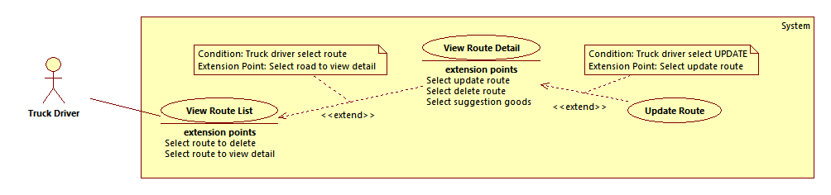

|  |  |  |  |
| --- | --- | --- | --- |
| **USE CASE – FTS002** | | | |
| **Use Case No.** | FTS002 | **Use Case Version** | 2.0 |
| **Use Case Name** | Update route | | |
| **Author** | Nguyen Quang Thien | | |
| **Date** | 14/01/2015 | **Priority** | High |
| **Actor:**   * Truck Driver   **Summary:**   * Truck drivers can update posted information about their route to the system.   **Goal:**   * Route information is updated to the system.   **Triggers:**   * Truck driver touches “Cập nhật” button in a route detail screen.   **Preconditions:**   * User logs in as truck driver.   **Post Conditions:**   * **Success:**New information is updated to the system. * **Fail:** No information is updated. Error message is shown.   **Main Success Scenario:**   |  |  |  | | --- | --- | --- | | Step | Actor Action | System Respone | | 1 | * Truck driver touches “Cập nhật” button in a route detail screen. | Navigate to “Cập nhật đường đi” screen which contains:   * Địa điểm bắt đầu: textbox, min length: 1, max length: 100, required * Địa điểm đi qua 1: textbox, min length: 1, max length: 100, not required * Địa điểm đi qua 2: textbox, min length: 1, max length: 100, not required * Địa điểm kết thúc: textbox, min length: 1, max length: 100, required * Ngày bắt đầu: day picker, date range: current date – one month later, required * Giờ bắt đầu: time picker, time range: 6 hours from current time – 12 pm, required * Ngày kết thúc: day picker, date range: current date – one month later, required * Khối lượng có thể chở: textbox, min length: 1, max length: 5, min value: 1, max value: 20000, required * Hàng dễ vỡ: checkbox, not required * Hàng dễ cháy nổ: checkbox, not required * Hàng đông lạnh: checkbox, not required * Hàng thực phẩm: checkbox, not required * Tùy chỉnh lộ trình: link * Lưu: button * Available data are loaded to the fields | | 2 | Truck driver updates necessary information into the form. [Alternative 1] |  | | 3 | Truck driver touches “Lưu” button | Route’s information is updated to database, success message “Cập nhật thành công” is shown. System navigates driver to good suggestion screen. [Exception 1, 2, 3 ,4 ,5 ,6 ,7 ,8 ,9, 10, 11, 12, 13, 14] |   **Alternative Scenario:**   |  |  |  | | --- | --- | --- | | Step | Actor Action | System Respone | | 1 | Truck driver touches “Tùy chỉnh lộ trình” link.  Truck driver modifies markers on the map and clicks “Cập nhật” button. | New route with markers is saved, “Lộ trình mới” page is shown again. New route information are displayed on the textboxes. |   **Exceptions:**   |  |  |  | | --- | --- | --- | | No | Actor Action | System Response | | 1 | “Địa điểm bắt đầu” field is empty. | Error message “Điểm bắt đầu không được để trống.” is shown. | | 2 | “Địa điểm bắt đầu” field data length is longer than 100 characters. | Error message “Điểm bắt đầu chỉ dài tối đa 100 ký tự. Vui lòng nhập lại.” is shown. | | 3 | “Địa điểm đi qua 1” field data length is longer than 100 characters. | Error message “Điểm đi qua 1 chỉ dài tối đa 100 ký tự. Vui lòng nhập lại.” is shown. | | 4 | “Địa điểm đi qua 2” field data length is longer than 100 characters. | Error message “Điểm đi qua 2 chỉ dài tối đa 100 ký tự. Vui lòng nhập lại.” is shown. | | 5 | “Địa điểm kết thúc” field is empty. | Error message “Điểm kết thúc không được để trống.” is shown. | | 6 | “Địa điểm kết thúc” field data length is longer than 50 characters. | Error message “Điểm kết thúc chỉ dài tối đa 50 ký tự. Vui lòng nhập lại.” is shown. | | 7 | “Ngày kết thúc” field is empty. | Error message “Ngày kết thúc không được để trống.” is shown | | 8 | “Ngày kết thúc” field data is out of range. | Error message “Ngày kết thúc không phù hợp, vui lòng nhập lại.” is shown | | 9 | “Ngày kết thúc” field data is earlier than “Ngày bắt đầu” field data. | Error message “Ngày kết thúc không được sớm hơn ngày bắt đầu.” is shown | | 10 | “Khối lượng có thể chở” field is empty. | Error message “Khối lượng có thể chở không được để trống.” is shown. | | 11 | “Khối lượng có thể chở” field data is higher than 20000. | Error message “Khối lượng chở không vượt quá 20 tấn.” is shown. | | 12 | Driver app cannot connect to server | Error message “Không thể kết nối tới hệ thống.” is shown. | | 13 | Server error | Error message “Có lỗi xảy ra. Vui lòng thử lại.” is shown. | | 14 | If there are related offers or orders with the route | Error message “Lộ trình đang có các đề nghị hoặc hóa đơn liên quan. Không thể cập nhật lộ trình này.” is shown. |   **Relationships:** extended by “View route detail”  **Business Rules:**   * Route information is updated to database with an active state. * Truck driver route can be modified by adding 2 more markers at max between starting and ending point of the map. * If there are available offers, truck driver cannot update the route information. To update route information, truck driver has to cancel and decline all the remaining offers. If there are available orders for the route, the route cannot be updated. * If data is updated successfully, system must notifies truck driver that new information is updated. If data is failed to be updated, system must also notifies truck driver about the error. | | | |

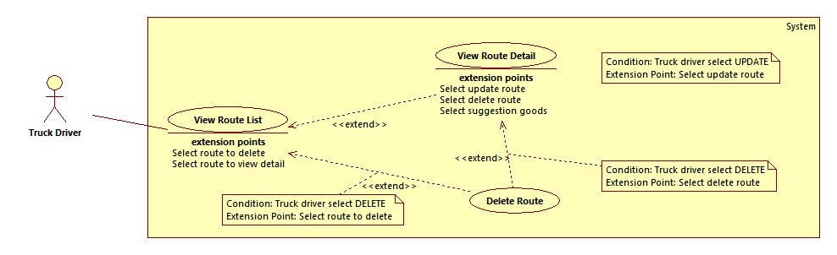

|  |  |  |  |
| --- | --- | --- | --- |
| **USE CASE – FTS003** | | | |
| **Use Case No.** | FTS003 | **Use Case Version** | 2.0 |
| **Use Case Name** | Delete Route | | |
| **Author** | Nguyen Quang Thien | | |
| **Date** | 14/01/2015 | **Priority** | High |
| **Actor:**   * Truck Driver   **Summary:**   * Truck drivers can delete posted information about their route to the system.   **Goal:**   * Route information is removed to the system.   **Triggers:**   * Truck driver touches “Hủy” button on “Thông tin lộ trình” screen.   **Preconditions:**   * User logs in as truck driver.   **Post Conditions:**   * **Success:** Current information is removed from the system. * **Fail:** No information is removed. Error message is shown.   **Main Success Scenario:**   |  |  |  | | --- | --- | --- | | Step | Actor Action | System Respone | | 1 | Truck driver touches “Hủy” button on “Thông tin lộ trình” screen. | Confirmation message “Bạn có muốn hủy lộ trình này không?” is shown. | | 2 | Truck driver touches “Có” button [Alternative 1] | Route’s information is removed from database, success message “Đã hủy lộ trình thành công” is shown. System navigates user to “Lộ trình” screen. [Exception 1, 2, 3] |   **Alternative Scenario:**   |  |  |  | | --- | --- | --- | | No | Actor Action | System Respone | | 1 | Truck driver touches “Không” button | No information is removed from the system, confirmation message is closed. |   **Exceptions:**   |  |  |  | | --- | --- | --- | | No | Actor Action | System Response | | 1 | If there are deals associated with current route | No information is removed from database. Error message “Đang có đề nghị hiện hành hoặc hóa đơn liên quan. Không thể xóa lộ trình.” is shown. | | 2 | Driver app cannot connect to server | Error message “Không thể kết nối tới hệ thống.” is shown. | | 3 | Server error | Error message “Có lỗi xảy ra. Vui lòng thử lại.” is shown. |   **Relationships:** extended by “View Route List”, extended by “View Route Detail”  **Business Rules:**   * Route information record remains in database but with an inactive state. * If there are available offers, truck driver cannot delete the route information. To delete route information, truck driver has to cancel and decline all the remaining offers. If there are available orders, the route cannot be deleted. * If data is deleted successfully, system must notifies truck driver that new information is deleted. If data is failed to be deleted, system must also notifies truck driver about the error. | | | |

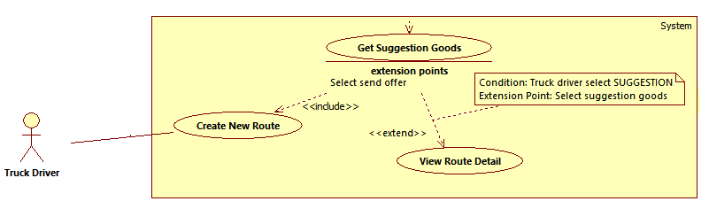

|  |  |  |  |
| --- | --- | --- | --- |
| **USE CASE – FTS003** | | | |
| **Use Case No.** | FTS003 | **Use Case Version** | 2.0 |
| **Use Case Name** | Get Suggestion Goods | | |
| **Author** | Nguyen Quang Thien | | |
| **Date** | 14/01/2015 | **Priority** | High |
| **Actor:**   * Truck Driver   **Summary:**   * Truck drivers views list of goods that match with a specific route.   **Goal:**   * List of goods is displayed correctly.   **Triggers:**   * Truck driver touches “Xem gợi ý” button on a Route Detail screen. * Truck driver touches “Tạo” button on “Lộ trình mới” screen   **Preconditions:**   * User logs in as truck driver.   **Post Conditions:**   * **Success:** Goods with appropriate conditions are displayed on screen. * **Fail:** No good is displayed. Error message is shown.   **Main Success Scenario:**   |  |  |  | | --- | --- | --- | | Step | Actor Action | System Respone | | 1 | Truck driver touches “Xem gợi ý” button on a Route Detail screen. [Alternative 1] | Goods with appropriate conditions are displayed on screen. [Exception 1,2] |   **Alternative Scenario:**   |  |  |  | | --- | --- | --- | | No | Actor Action | System Respone | | 1 | Truck driver touches “Tạo” button on “Lộ trình mới” screen. | New route is created in database. System navigates truck driver to “Gợi ý” screen where appropriate goods for the new route are displayed. [Exception 1,2] |   **Exceptions:**   |  |  |  | | --- | --- | --- | | No | Actor Action | System Response | | 1 | If there is no appropriate goods | Message “Không có hàng nào” is displayed on screen. | | 2 | Driver app cannot connect to server | Error message “Không thể kết nối tới hệ thống.” is shown. |   **Relationships:** extended by “View Route Detail”, included by “Create New Route”  **Business Rules:**   * The suggest list is displayed for each route. * Suggestion list is created based on route and goods’ info such as date, weight, categories …. * Matching is success if all these conditions are satisfied:   + Good’s deliver and receive place is in a 50-km area around truck driver’s route,  + Truck driver’s time interval and good owner’s time interval has an intersection,  + Good’s weight must be less than the weight the truck can load  + Good’s category is not in the category which truck doesn’t load   * One matching result acts as an offer from good owner to truck driver, which truck driver can accept immediately. | | | |

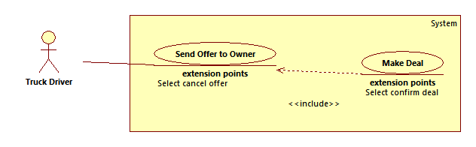

|  |  |  |  |
| --- | --- | --- | --- |
| **USE CASE – FTS004** | | | |
| **Use Case No.** | FTS004 | **Use Case Version** | 2.0 |
| **Use Case Name** | Send Offer To Owner | | |
| **Author** | Nguyen Quang Thien | | |
| **Date** | 14/01/2015 | **Priority** | High |
| **Actor:**   * Truck Driver   **Summary:**   * Truck driver sends new deal to goods owner   **Goal:**   * Deal is sent to goods owner, system notifies owner about the incoming deal   **Triggers:**   * Truck driver touches on a suggestion in suggestion list for a route.   **Preconditions:**   * User logs in as truck driver. * Truck driver must have at least 1 route information available * Goods must be available in database   **Post Conditions:**   * **Success:** Deal is sent to goods owner. Success message is shown. * **Fail:** Deal is not sent to goods owner. Error message is shown   **Main Success Scenario:**   |  |  |  | | --- | --- | --- | | Step | Actor Action | System Respone | | 1 | Truck driver touches on a suggestion in suggestion list for a route. | Redirect to “Gửi đề nghị” screen with owner’s listed items and 2 textboxes:   * Giá đề nghị (nghìn đồng): textbox, min length = 0, max length = 5, min value: 1, max value: 99.999, required * Ghi chú: textbox, min length = 0, max length = 50, not required * Gửi: button * Chấp nhận: button | | 2 | Truck driver fills in necessary information to the form. |  | | 3 | Truck driver touches “Gửi” button. | Offer is sent to the goods owner that truck driver wants to make a deal with. Success message “Gửi đề nghị thành công” is shown. System navigates driver to “Đề nghị gửi” screen [Exception 1, 2, 3, 4] |   **Alternative Scenario:** N/A  **Exceptions:**   |  |  |  | | --- | --- | --- | | No | Actor Action | System Response | | 1 | If there is an available offer between current good and route | Offer is not sent. Error message “Đang có một đề nghị hiện hành với cùng lộ trình và hàng hóa. Gửi đề nghị thất bại.” is shown. | | 2 | “Giá đề nghị (nghìn đồng)” field is empty | Error message “Giá đề nghị không được để trống.” is shown. | | 3 | Driver app cannot connect to server | Error message “Không thể kết nối tới hệ thống.” is shown. | | 4 | Server error | Error message “Có lỗi xảy ra. Vui lòng thử lại.” is shown. |   **Relationships:** included in “Make Deal”  **Business Rules:**   * System must check there is an available offer between current route and good. If there is, system will notifies user that the offer cannot be sent. * New offer is saved to database with pending state * If offer is sent successfully, system must notifies truck driver with success message and notifies goods owner that there’s a new offer. If offer is failed to be sent, system must also notifies truck driver about the error. | | | |

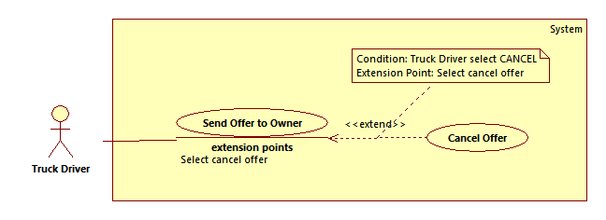

|  |  |  |  |
| --- | --- | --- | --- |
| **USE CASE – FTS005** | | | |
| **Use Case No.** | FTS005 | **Use Case Version** | 2.0 |
| **Use Case Name** | Cancel Offer | | |
| **Author** | Nguyen Quang Thien | | |
| **Date** | 14/01/2015 | **Priority** | High |
| **Actor:**   * Truck Driver   **Summary:**   * Truck driver cancel a sent offer to goods owner   **Goal:**   * Offer is cancelled. Success message is shown.   **Triggers:**   * Truck driver touches “Hủy” button in a sent offer detail page. * Truck driver choose “Hủy” option on a context menu for an offer on “Đề nghị nhận” page.   **Preconditions:**   * User logs in as truck driver. * Offer is created succesfully   **Post Conditions:**   * **Success:** Offer is cancelled. Success message is shown. * **Fail:** Offer is not cancelled. Error message is shown.   **Main Success Scenario:**   |  |  |  | | --- | --- | --- | | Step | Actor Action | System Respone | | 1 | Truck driver touches “Hủy” button in a sent offer detail page. [Alternative 1] | Confirmation message “Bạn có muốn hủy đề nghị này không?” is shown. | | 2 | Truck driver clicks “Có” button. [Alternative 2] | Offer is cancelled. Success message “Hủy đề nghị thành công.” is shown. [Exception 1, 2, 3] |   **Alternative Scenario:**   |  |  |  | | --- | --- | --- | | No | Actor Action | System Response | | 1 | Truck driver choose “Hủy” option on a context menu for an offer on “Đề nghị nhận” page. | Offer is cancelled. Success message “Hủy đề nghị thành công.” is shown. | | 2 | Truck driver clicks “Không” button. | “Chi tiết đề nghị” page is shown. |   **Exceptions:**   |  |  |  | | --- | --- | --- | | No | Actor Action | System Response | | 1 | Driver app cannot connect to server | Error message “Không thể kết nối tới hệ thống.” is shown. | | 2 | Server error | Error message “Có lỗi xảy ra. Vui lòng thử lại.” is shown. | | 3 | Offer is accepted/ declined before truck driver cancels it. | Error message “Đề nghị đã được chấp nhận/ từ chối. Không thể hủy đề nghị.” is shown. |   **Relationships:** Extended by “Send Offer to Owner”  **Business Rules:**   * Offer is marked with cancelled state in database. * If offer is accepted/ declined before truck driver cancels it, the offer state remains unchanged. * System must notifies truck drivers whether the offer is cancelled or not. * System must notifies good owner that the offer has been cancelled. | | | |

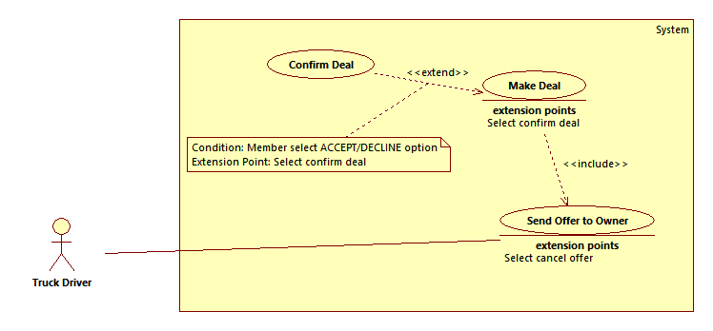

|  |  |  |  |
| --- | --- | --- | --- |
| **USE CASE – FTS006** | | | |
| **Use Case No.** | FTS006 | **Use Case Version** | 2.0 |
| **Use Case Name** | Confirm Deal | | |
| **Author** | Nguyen Quang Thien | | |
| **Date** | 14/01/2015 | **Priority** | High |
| **Actor:**   * Truck Driver   **Summary:**   * Truck driver accepts/ declines an offer from goods owner   **Goal:**   * Deal is accepted/ declined.   **Triggers:**   * Truck driver touches “Chấp nhận”/ “Từ chối” button on “Trả lời đề nghị” page * Truck driver chooses “Chấp nhận”/ “Từ chối” option on context menu of an offer on “Đề nghị nhận” page   **Preconditions:**   * User logs in as truck driver.   **Post Conditions:**   * **Success:** Offer is accepted/ declined, success message is shown * **Fail:** Offer is not accepted/ declined. Error message is shown   **Main Success Scenario:**   |  |  |  | | --- | --- | --- | | Step | Actor Action | System Respone | | 1 | Truck driver clicks “Chấp nhận” button on “Trả lời đề nghị” page [Alternative 1, 2, 3, 4] | Offer is accepted. Success message “Đề nghị đã được chấp nhận.” is shown. Displays order details with goods owner contact information. [Exception 1, 2, 3] |   **Alternative Scenario:**   |  |  |  | | --- | --- | --- | | Step | Actor Action | System Response | | 1 | Truck driver clicks “Từ chối” button on “Trả lời đề nghị” page | Offer is declined. Success message “Đề nghị đã được từ chối.” is shown. | | 2 | Truck driver clicks “Chấp nhận” button on “Gửi đề nghị” page. | Current offer’s price and good is accepted. Success message “Hàng hóa đã được chấp nhận” is shown. New deal and order is created. System navigates driver to the order’s detail of the accepted good. | | 3 | Truck driver chooses “Chấp nhận” option on context menu of an offer on “Đề nghị nhận” page | Offer is accepted. Success message “Đề nghị đã được chấp nhận.” is shown. Displays order details with goods owner contact information. | | 4 | Truck driver chooses “Từ chối” option on context menu of an offer on “Đề nghị nhận” page | Offer is declined. Success message “Đề nghị đã được từ chối.” is shown. |   **Exceptions:**   |  |  |  | | --- | --- | --- | | No | Actor Action | System Response | | 1 | Driver app cannot connect to server | Error message “Không thể kết nối tới hệ thống.” is shown. | | 2 | Server error | Error message “Có lỗi xảy ra. Vui lòng thử lại.” is shown. | | 3 | Offer is cancelled before truck driver accepts/ declines it. | Error message “Đề nghị đã bị hủy. Không thể chấp nhận/ từ chối đề nghị.” is shown. |   **Relationships:** extended by “Make Deal”  **Business Rules:**   * Offer is marked with accepted state in database * If the offer is cancelled before truck driver accepts/ declines it, the offer status remains unchanged. * System must notifies truck drivers whether the offer is accepted or not. * System must notifies good owner that the offer has been accepted. * After the offer is accepted, the good associated with the deal is marked with disabled state. Other offers with good’s weight heavier than the remaining weight that the truck can load are declined. | | | |

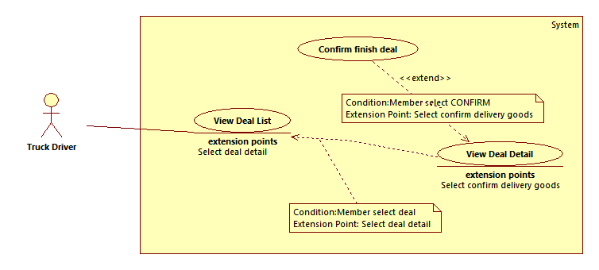

|  |  |  |  |
| --- | --- | --- | --- |
| **USE CASE – FTS008** | | | |
| **Use Case No.** | FTS008 | **Use Case Version** | 2.0 |
| **Use Case Name** | Confirm finish deal | | |
| **Author** | Nguyen Quang Thien | | |
| **Date** | 17/01/2015 | **Priority** | High |
| **Actor:**   * Truck Driver   **Summary:**   * Truck driver confirms delivery status of a deal   **Goal:**   * Delivery status is updated. Sending notification to goods owner.   **Triggers:**   * Truck driver touches “Đã giao hàng” button on “Chi tiết giao dịch” page   **Preconditions:**   * User logs in as truck driver.   **Post Conditions:**   * **Success:** Delivery status is updated. Sending notification to goods owner. * **Fail:** Delivery status is not updated. No notification is sent to goods owner. Error message is shown.   **Main Success Scenario:**   |  |  |  | | --- | --- | --- | | Step | Actor Action | System Respone | | 1 | Truck driver touches “Đã giao hàng” button on “Chi tiết giao dịch” page | Delivery status is updated. Update delivery status on screen. Notification is sent to goods owner. [Exception 1, 2] |   **Alternative Scenario:** N/A  **Exceptions:**   |  |  |  | | --- | --- | --- | | No | Actor Action | System Response | | 1 | Driver app cannot connect to server | Error message “Không thể kết nối tới hệ thống.” is shown. | | 2 | Server error | Error message “Có lỗi xảy ra. Vui lòng thử lại.” is shown. |   **Relationships:** extended by “View Deal Detail”  **Business Rules:**   * Truck driver account must be valid to confirm delivery status of a deal * The deal has to be accepted before truck driver can change its status * The deal is saved to database with completed status from truck driver, but it is not the final state of the deal. Delivery status is marked to completed when goods owner or staff confirm the status. * System must notifies truck drivers whether the offer is marked to be completed or not. | | | |





|  |  |  |  |
| --- | --- | --- | --- |
| **USE CASE – FTS001** | | | |
| **Use Case No.** | FTS001 | **Use Case Version** | 2.0 |
| **Use Case Name** | View Order List | | |
| **Author** | Nguyen Duy Khuong | | |
| **Date** | 02/01/2015 | **Priority** | Normal |
| **Actor:**   * Owner   **Summary:**   * Owner can view all their orders.   **Goal:**   * The purpose of this use case is to allowing owner to view all orders that they made.   **Triggers:**   * Owner wants to view Order List. * Owner clicks on “Hàng đang giao dich” tab at “Quản lý hàng” page.   **Preconditions:**   * User must be logged-in as Owner-role.   **Post Conditions:**   * **Success:**Owner can view list of order in screen or will see a message “No data available on table” if don’t have any order. * **Fail:** Owner is presented with an error message on screen.   **Main Success Scenario:**   |  |  |  | | --- | --- | --- | | Step | Actor Action | System Respone | | 1 | Select “Hàng đang giao dịch” tab at “Quản lý hàng” page. (with case owner have order)  [Alternative 1] | System loads screen.  +“Chọn hàng hoá”: [Type of goods: drop down list, raw source – GoodsCategory table].  +“Từ ngày”: [Pick up time: Datetime picker, default will select the date that prior to the current date 15days].  +“Đến ngày”:[ Delivery time:Datetime picker, default will select the current date].  + “Lọc”:[Filter:Button].  +Table includes:   * “STT”: [Ordinal numbers: int]. * “Loại hàng”:[Type of good: string] * “Thời gian giao hàng”: [Pick up time : string]. * “Thời gian nhận hàng”:[Delivery time : string] . * Last columns will have “Xem chi tiết” button view detail order.   [Exception 1, 2] |   **Alternative Scenario:**   |  |  |  | | --- | --- | --- | | Step | Actor Action | System Respone | | 1 | Select “Hàng đang giao dịch” tab at “Quản lý hàng” page. (with case owner dont have any order) | System loads screen.  +“Chọn hàng hoá”: [Type of goods: drop down list, raw source – GoodsCategory table].  +“Từ ngày”: [Pick up time: Datetime picker, default will select the date that before 15days the current date].  +“Đến ngày”:[ Delivery time:Datetime picker, default will select the current date].  + “Lọc”:[Filter: Button].  + Table show message box “No data available in table”.  [Exception 1, 2] |   **Exceptions:**   |  |  |  | | --- | --- | --- | | No | Actor Action | System Response | | 1 | Can’t load list deal with any error. | System shows message box “Không thể tải dữ liệu. Vui long thử lại sau” and will be sent error to the system. | | 2 | Owner doesn’t log in or over time session log in. | Show message box “Bạn phải đăng nhập để sử dụng tính năng này”. |   **Relationships:** N/A  **Business Rules:**   * All orders of owner will be taken form database. * Owner can view all their orders or view detail an order when clicks “Xem chi tiết” button at each order. * All orders will show on a table with function sort on each column. Paging of table will be not make users confuse. * With case successful. If owner have order, system will show all order on a table. If owner don’t have order, system will show message that no have data. * With case unsuccessful, system must also notifiesowner about the error. | | | |



|  |  |  |  |
| --- | --- | --- | --- |
| **USE CASE – FTS002** | | | |
| **Use Case No.** | FTS002 | **Use Case Version** | 2.0 |
| **Use Case Name** | View Order Detail | | |
| **Author** | Nguyen Duy Khuong | | |
| **Date** | 02/01/2015 | **Priority** | Normal |
| **Actor:**   * Owner   **Summary:**   * Owners can view order details.   **Goal:**   * The purpose of this use case is to allowing owner to view some information of order.   **Triggers:**   * Owner wants to view order details. * Owner clicks “Xem chi tiết” button in “Hàng đang giao dịch” tab at “Quản lý hàng” page.   **Preconditions:**   * User must be logged-in as Owner-role. * Owner must be choose anorder.   **Post Conditions:**   * **Success:**Owner can view all detail of order like “Thông tin hàng hoá”, “Thông tin bên giao nhận hàng”, “Trạng thái hàng”. * **Fail:** Owner is presented with an error message on screen.   **Main Success Scenario:**   |  |  |  | | --- | --- | --- | | Step | Actor Action | System Respone | | 1 | Owner clicks “Xem chi tiết” button in “Hàng đang giao dịch” tab at “Quản lý hàng” page. | System loads screen.  Form “Chi tiết hàng” includes:  1. At “Thông tin hàng hoá” will show all informationabout good:  + “Loại hàng”: [Type of good: drop down list, raw source – GoodsCategory table, disabled].  + “Khối lượng”: [Weight of good : text box, disabled].  + “Chi phí vận chuyển”: [Transportation cost : text box, disabled ].  + “Ghi chú”: [ Note about the good : textarea box, disabled].  2. At “Thông tin giao nhận hàng” will show all information about route:  + “Địa chỉ giao”:[ Location to pick up good: text box, disabled].  + “Thời gian giao”:[Pick uptime :Datetime picker, disabled].  + “Địa chỉ nhận”:[ Location to delivery  good:text box, disabled].  + “Thời gian nhận”:[ Delivery time :Datetime picker, disabled].  3.At “Trạng thái hàng” will show status about order  Table incudes:  + “Thời gian”: [Time of status: string].  + “Trạng thái”: [Status with 4 cases “Tạo hàng”, “Đã nhận hàng”, “Đã giao hàng”, “Hoàn thành”: string].  4. At the end of the form will show three buttons:  +“Xác nhận”:[Confirmorder: button].  +“Báo mất hàng”: [Reported lost good  : button].  +“Trở về”: [Back “Quản lý hàng” page: button].  [Exception 1, 2] |   **Alternative Scenario:**   |  |  |  | | --- | --- | --- | | Step | Actor Action | System Respone | |  | N/A | N/A |   **Exceptions:**   |  |  |  | | --- | --- | --- | | No | Actor Action | System Response | | 1 | Can’t load list detail order with any error. | System shows message box “Không thể tải được dữ liệu. Vui long thử lại sau” and will be sent error to the system. | | 2 | Owner doesn’t log in or over time session log in. | Show message box “Bạn phải đăng nhập để sử dụng tính năng này”. |   **Relationships:** N/A  **Business Rules:**   * All information of order will be taken form database. * Ownercan view all information about order and can confirm order or reported loss good. * If case successful, all data of order will be show to owner by system. * If case unsuccessful, system must also notifiesowner about the error. | | | |



|  |  |  |  |
| --- | --- | --- | --- |
| **USE CASE – FTS003** | | | |
| **Use Case No.** | FTS003 | **Use Case Version** | 2.0 |
| **Use Case Name** | Confirm Finish Order | | |
| **Author** | Nguyen Duy Khuong | | |
| **Date** | 02/01/2015 | **Priority** | High |
| **Actor:**   * Owner   **Summary:**   * Owners can confirm finish order.   **Goal:**   * The purpose of this use case is to allowing owner to confirm finish order.   **Triggers:**   * Owner wants to confirm finish order. * Owner clicks “Xác nhận” button at “Chi tiết hàng” page.   **Preconditions:**   * User must be logged-in as Owner-role. * Owner choose anorder wants to confirm finish.   **Post Conditions:**   * **Success:**Owner is presented with asuccess message on screen. * **Fail:** Owner is presented with an error message on screen.   **Main Success Scenario:**   |  |  |  | | --- | --- | --- | | Step | Actor Action | System Respone | | 1 | Owner clicks “Xác nhận” button at “Chi tiết hàng” page. | System show message box “Bạn có muốn xác nhận hoá đơn không?”.  + Đồng ý: [Accept: button].  + Không đồng ý: [Cancel: button].  [Alternative 1, 2]. |   **Alternative Scenario:**   |  |  |  | | --- | --- | --- | | Step | Actor Action | System Respone | | 1 | Owner clicks “Đồng ý” button. | System show message success “Vận chuyển hàng thành công. Cảm ơn bạn đã sử dụng dịch vụ của chúng tôi”. Status “Hoàn thành” and time confirm will be added at “Chi tiết hàng” page”.  [Exception 1, 2] | | 2 | Owner clicks “Không đồng ý” button. | Nothing to do and turn off message box. |   **Exceptions:**   |  |  |  | | --- | --- | --- | | No | Actor Action | System Response | | 1 | Can’t confirm with any error. | System show message “Đã xảy ra lỗi. Xin hãy thử lại” and will be sent error to the system. | | 2 | Owner doesn’t log in or over time session log in. | Show message “Bạn phải đăng nhập để sử dụng tính năng này”. |   **Relationships:** N/A  **Business Rules:**   * Owner account must be valid to confirm finish order**.** * The order will be added status “Hoàn thành” at “Chi tiết hàng ” page and will be saved to database. * After confirm successful, this order will be added to transaction history list at “Lịch sử giao dịch” page and deleted from order list at “Quản lý hàng” page. * When the status of order added “Hoàn thành”, money will be transfer to account of truck driver at bank. * If system have any error in confirm process, a notification will be sent toowner about the error and dropped confirm process. | | | |

## Software System Attribute

### Usability

#### Graphic User Interface

#### Usability

#### Installation

### Reliability

### Availability

### Security

### Maintainability

### Portability

### Performance

## Conceptual Diagram



### Data Dictionary

|  |  |
| --- | --- |
|  | |
|  |  |
|  |  |
|  |  |
|  |  |
|  |  |
|  |  |
|  |  |
|  |  |
|  |  |
|  |  |
|  |  |
|  |  |
|  |  |
|  |  |
|  |  |
|  |  |
|  |  |
|  |  |

# Software Design Description

## Design Overview

## System Architectural Design

### Web Application architecture description

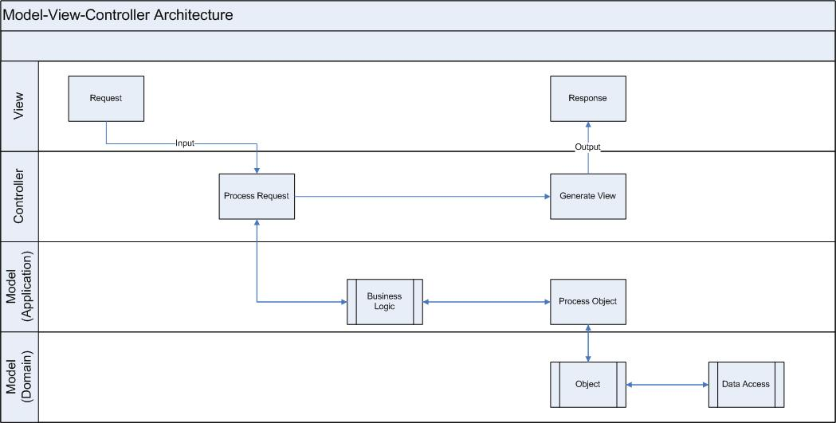

### Mobile Application architecture description

## Component Diagram

## Detailed Description

### Class Diagram



### Class Diagram Explanation

#### Role

|  |  |  |  |
| --- | --- | --- | --- |
|  |  |  |  |
|  |  |  |  |
|  |  |  |  |
|  |  |  |  |

### Interaction Diagram

#### <Truck driver> Create new route

**Summary:** This diagram shows how truck driver creates a new route

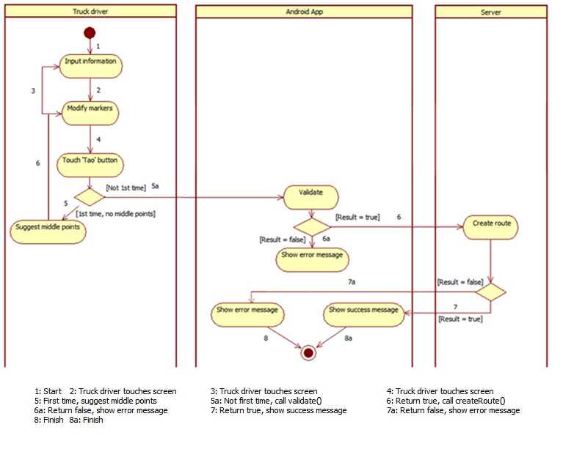

#### <Truck driver> Update route

**Summary:** This diagram shows how truck driver updates a current route

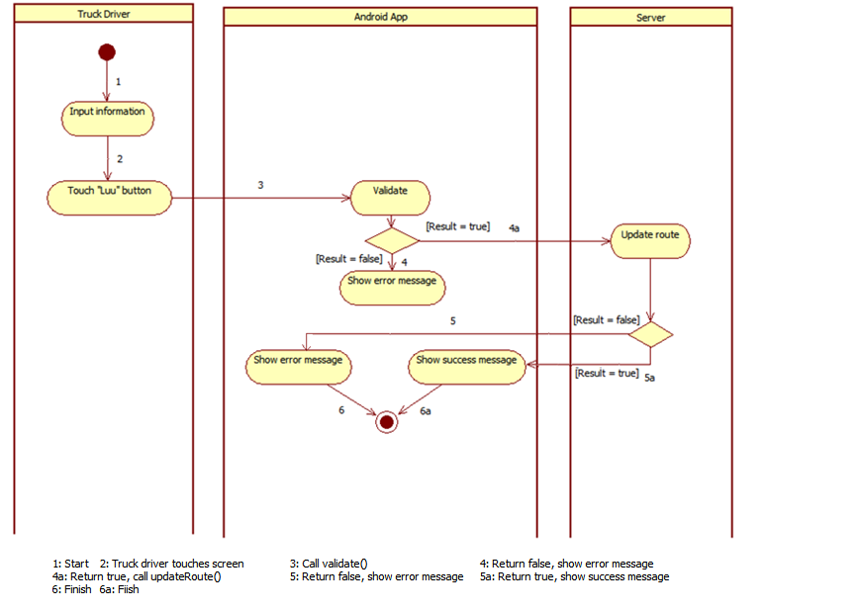

#### <Truck driver> Delete route

**Summary:** This diagram shows how truck driver delete a current route

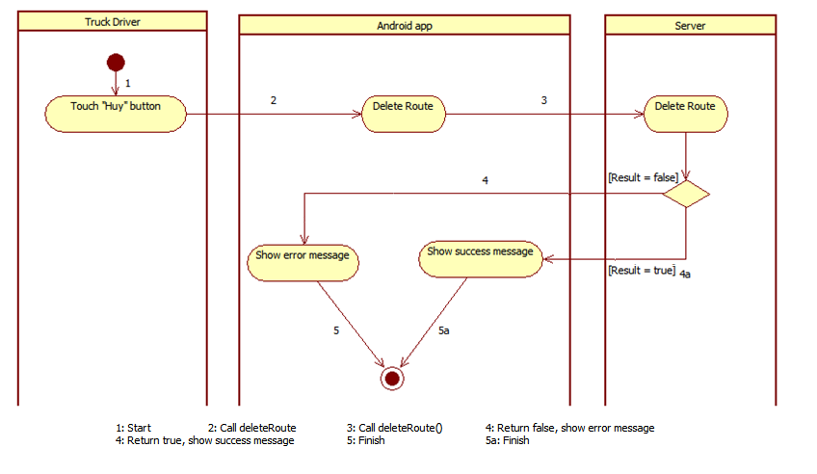

#### <Truck driver> Send offer to Owner

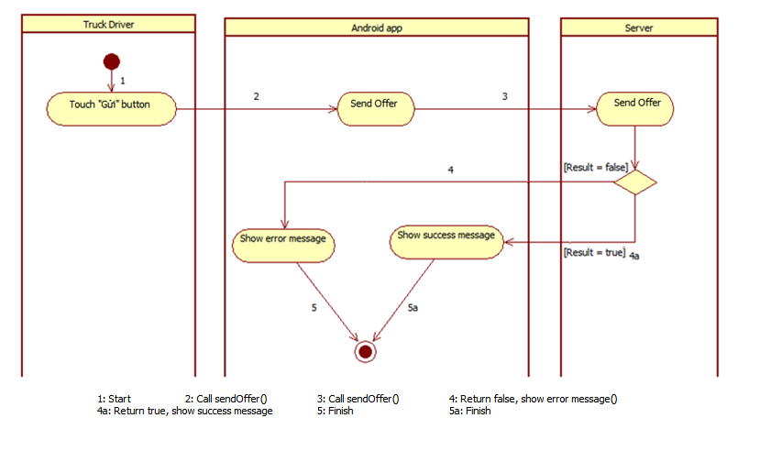**Summary:** This diagram shows how truck driver sends an offer to good owner

#### <Truck driver> Cancel offer

**Summary:** This diagram shows how truck driver cancels a sent offer

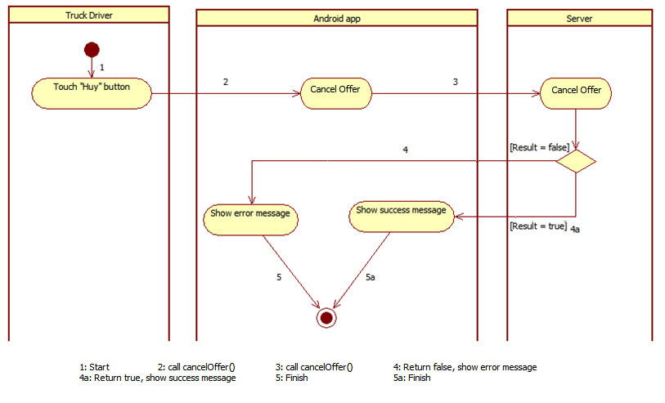

#### <Truck driver> Confirm deal

**Summary:** This diagram shows how truck driver accepts/ declines an offer from goods’ owner

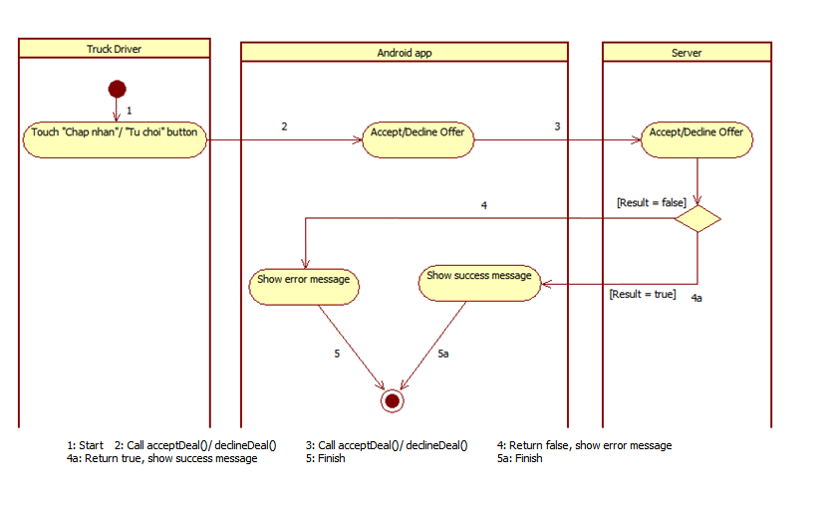

#### <Truck driver> Confirm finish deal

**Summary:** This diagram shows how truck driver confirms delivery status of the good

#### <Truck driver> Get Suggestion Goods

**Summary:** This diagram shows how truck driver confirms delivery status of the good

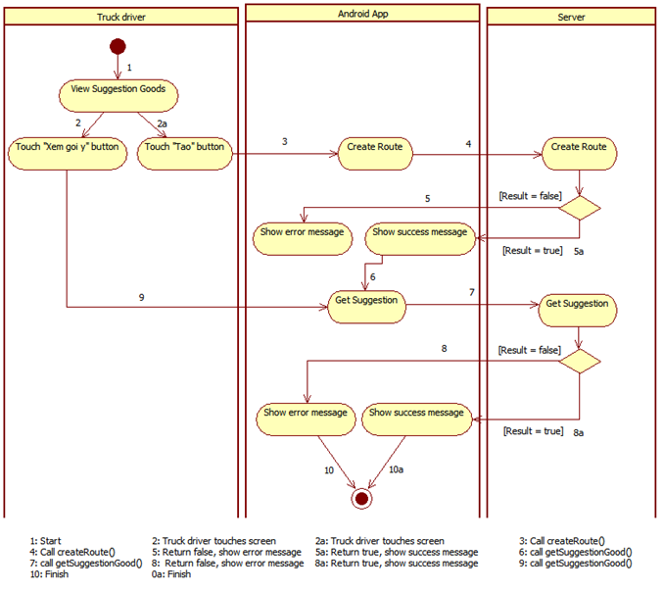

## User Interface Design

### Guest Interface Design

#### Login

Figure 12: Login

**Fields**

|  |  |  |  |  |  |  |  |
| --- | --- | --- | --- | --- | --- | --- | --- |
| **No** | **Field Name** | **Description** | **Read only** | **Mandatory** | **Control Type** | **Data Type** | **Length** |
|  |  |  |  |  |  |  |  |

**Buttons/ Hyperlinks**

|  |  |  |  |  |
| --- | --- | --- | --- | --- |
| **No** | **Function** | **Description** | **Validation** | **Outcome** |
|  |  |  |  |  |

## Database Design

### Logical Diagram

### Data Dictionary

## Algorithms

### Document Breakdown

#### Definition

#### Define Problem

#### Solution

#### Complexity

#### Flow Chart

### String Comparison

#### Define Problem

#### Requirement

#### Solution

#### Example

# System Implementation & Test

## Introduction

### Overview

### Test Approach

## Database Relationship Diagram

### Physical Diagram

### Data Dictionary

|  |  |
| --- | --- |
| **Entity Data dictionary: describe content of all entities** | |
| Entity Name | Description |
|  |  |
|  |  |
|  |  |
|  |  |
|  |  |
|  |  |
|  |  |
|  |  |
|  |  |
|  |  |
|  |  |
|  |  |
|  |  |
|  |  |
|  |  |
|  |  |
|  |  |
|  |  |

Table 14: Data Dictionary

|  |  |  |  |  |
| --- | --- | --- | --- | --- |
| **Entity name** | **Attributes** | **Description** | **Domain** | **Null** |
|  |  |  |  |  |
|  |  |  |  |
|  |  |  |  |
|  |  |  |  |
|  |  |  |  |

Table 15: Attribute Data Dictionary

## Performance Measures

### Clustering Performance

## Test Plan

### Features to be tested

### Features not to be tested

## System Testing Test Case

### Guest Test Case

#### Search Event

|  |  |  |  |  |  |  |  |
| --- | --- | --- | --- | --- | --- | --- | --- |
| **ID** | **Test Case Description** | **Test Case Procedure** | **Expected output** | **Inter-test Case Dependence** | **Result** | **Test Date** | **Note** |
|  |  |  |  |  |  |  |  |
|  |  |  |  |  |  |  |  |

# Software User’s Manual

## Installation Guide

### Setting up environment at server side

#### Hardware requirements

#### Software requirements

### Deployment at server side

#### Prepare deployment package

#### Configure Server before deploy

#### Deploy web application on server

### Setting up the environment at client side

#### Setting up for computer

## User Guide

# Appendix