Wine Quality Prediction Using Machine Learning
Đức-Phát BÙI¹
DH23TIN06, Nam Can Tho University
Abstract. Wine quality assessment is an important task in wine production and quality control. Traditional assessment relies substantially on sensory evaluation by human experts, while machine learning provides opportunities to analyze relationships between physicochemical properties and recorded quality scores. This paper presents an overview of machine learning approaches for wine quality prediction, focusing on dataset characteristics, classification algorithms, preprocessing techniques, and evaluation methods. The review considers Decision Tree, Random Forest, Support Vector Machine, and K-Nearest Neighbors as baseline classifiers, with XGBoost as a potential advanced method. It also examines feature selection, feature scaling, class imbalance, and the Synthetic Minority Over-sampling Technique (SMOTE). The UCI Wine Quality dataset is considered the primary data source because it contains physicochemical measurements for red and white Vinho Verde wines and has been widely used in previous research (Cortez et al., 2009). Existing studies indicate that model performance can vary according to target definition, data preprocessing, class-balancing strategy, and evaluation protocol. Therefore, accuracy alone may not provide sufficient evidence of model quality, particularly when some quality classes have substantially fewer observations than others. This paper proposes a structured experimental framework for comparing classification models under consistent conditions. The planned experiments examine model performance, the effects of feature scaling and SMOTE, feature selection, feature importance, and differences between red and white wine datasets. The framework provides a reproducible foundation for an undergraduate machine learning study and identifies opportunities for future work involving ensemble learning and explainable artificial intelligence.
Keywords: Wine Quality · Machine Learning · Classification · Feature Selection · SMOTE
1 Introduction
1.1 Research Background
Wine quality assessment is a complex task because wine characteristics are influenced by raw materials, fermentation conditions, chemical composition, storage, and sensory properties. Traditional quality assessment relies heavily on trained experts who evaluate sensory characteristics. Although expert evaluation remains important, it can be influenced by individual experience and assessment conditions. Physicochemical measurements therefore offer a complementary source of information for investigating wine quality through computational methods (Cortez et al., 2009).
Machine learning enables computational models to learn relationships between input features and known outcomes. In wine quality prediction, features such as alcohol, volatile acidity, residual sugar, chlorides, density, sulphates, and pH can be used to predict recorded quality scores. The UCI Wine Quality dataset is a commonly used benchmark for this task because it provides numerical physicochemical measurements and quality labels for red and white Vinho Verde wines (Cortez et al., 2009).
The topic also has a practical commercial context. Wine products differ in their production regions, grape varieties, alcohol concentrations, bottle sizes, brands, and prices. However, these market attributes should not be confused with the physicochemical variables in the UCI dataset. The latter supports model development using measured chemical properties rather than commercial product descriptions.
1.2 Research Objectives
The primary objective of this study is to establish a systematic framework for predicting wine quality using machine learning classification techniques. The study focuses on comparing classical classification algorithms and evaluating how preprocessing and data-balancing methods affect predictive performance.
The specific objectives are to compare Decision Tree, Random Forest, Support Vector Machine, and K-Nearest Neighbors; investigate the influence of feature scaling on algorithms sensitive to feature magnitudes; examine whether SMOTE improves performance on minority quality classes; and assess the contribution of feature selection to classification results.
A further objective is to identify important physicochemical features and investigate potential differences between red and white wine datasets. These objectives are intended to support a controlled and reproducible experiment rather than merely identify the model with the highest reported accuracy in unrelated studies.
1.3 Research Scope and Contributions
This paper focuses primarily on supervised classification using the UCI Wine Quality dataset. The four baseline models are Decision Tree (DT), Random Forest (RF), Support Vector Machine (SVM), and K-Nearest Neighbors (KNN). XGBoost may be included as an advanced comparison model if the implementation time and computational resources permit.
The proposed contribution is a consistent experimental design that compares algorithms under controlled preprocessing and evaluation conditions. The design also emphasizes the importance of class-sensitive metrics, particularly Macro-F1 and Balanced Accuracy, when the quality distribution is imbalanced.
The scope does not assume that a classification model replaces professional sensory evaluation. Instead, machine learning is considered a decision-support approach that estimates recorded quality categories from physicochemical measurements. The experimental conclusions will depend on the actual notebook results and will not be inferred from performance values reported in previous publications.
2 Related Work
2.1 Traditional Wine Quality Assessment
Wine quality assessment has traditionally involved sensory evaluation and expert judgment. However, physicochemical measurements provide additional information that can be analyzed statistically to investigate relationships between chemical composition and recorded quality scores.
Cortez et al. (2009) introduced a data-mining approach for wine quality assessment and made the associated dataset available for research. Their work established an important foundation for subsequent studies using machine learning to investigate wine quality from numerical measurements.
The resulting dataset has become useful for comparing classification and regression approaches. Nevertheless, its quality labels represent recorded sensory assessments rather than an objective chemical measurement of quality itself. A predictive model therefore estimates the relationship between chemical properties and those labels, not an absolute or universally accepted definition of wine quality.
2.2 Machine Learning for Wine Quality Prediction
Subsequent research has investigated different algorithms and feature sets for wine quality prediction. Gupta (2018) examined feature selection and machine learning techniques, highlighting the relevance of identifying informative physicochemical variables. Aich et al. (2018, 2019) investigated classification approaches using different feature sets for different types of wine.
Decision Tree is useful as an interpretable baseline because its predictions can be expressed through a sequence of feature-based decisions. Random Forest extends the tree-based approach by combining multiple decision trees, which can improve generalization and provide estimates of feature importance (Breiman, 2001).
SVM constructs decision boundaries in a feature space and can model nonlinear relationships through suitable kernels (Cortes & Vapnik, 1995). KNN classifies observations based on the labels of nearby training instances, making its performance dependent on the distance measure and feature scaling (Cover & Hart, 1967).
Research comparing these algorithms is valuable, but results must be interpreted in the context of each experiment. Differences in target grouping, train-test splits, preprocessing, class balancing, and hyperparameter tuning can make accuracy values from different papers incomparable.
2.3 Feature Selection and Class Imbalance
Feature selection is relevant because not all input variables necessarily contribute equally to predictive performance. Guyon and Elisseeff (2003) describe feature selection as an important component of machine learning that can reduce dimensionality and help identify informative variables.
Class imbalance presents another challenge. The UCI Wine Quality dataset contains many more observations in some quality categories than in others. A model that favors common categories may achieve reasonable overall accuracy while failing to identify less frequent classes.
SMOTE addresses this issue by generating synthetic examples for minority classes based on neighboring observations (Chawla et al., 2002). Sinaga et al. (2025) investigated a workflow combining SMOTE, feature selection, and parameter tuning for white wine quality classification. Their reported results demonstrate the potential influence of these components in their experimental setting; however, those results should not be assumed to transfer directly to every classification setup.
Recent studies have also explored ensemble learning and model interpretation. Jain et al. (2023) investigated machine-learning-based predictive modeling for wine quality, while Khan et al. (2026) examined feature engineering and SHAP-based interpretation. These directions suggest that model performance and the interpretability of predictions are both relevant to the development of wine quality prediction systems.
2.4 Research Gaps
The reviewed literature reveals several methodological issues that are relevant to a reproducible undergraduate study. First, different studies may formulate wine quality prediction as regression, multiclass classification, or binary classification. Consequently, a model evaluated on grouped quality labels cannot be directly compared with a model predicting the original numerical score.
Second, the effects of scaling, class balancing, and feature selection are not always isolated. When several techniques are applied simultaneously, it can be difficult to determine which component is responsible for a performance change. A controlled comparison should therefore evaluate individual components while keeping the remaining experimental conditions as consistent as possible.
Third, overall accuracy does not fully describe model behavior on an imbalanced dataset. Class-sensitive metrics and confusion matrices are necessary to understand which quality categories are predicted correctly and which are frequently confused.
Based on these issues, this study proposes a controlled comparison of DT, RF, SVM, and KNN, together with experiments on feature scaling, SMOTE, feature selection, feature importance, and red-versus-white wine performance. The objective is to produce transparent experimental evidence rather than claim a new algorithm.
3 Proposed Methodology
3.1 Research Framework
The proposed workflow consists of data acquisition, data inspection, preprocessing, model training, evaluation, and interpretation. The UCI Wine Quality dataset serves as the primary data source. After inspecting the target distribution and input variables, the data are divided into training and testing sets. The baseline classifiers are trained using the training data, and their predictions are evaluated on held-out data.
The workflow also includes controlled comparisons of selected preprocessing techniques. Feature scaling is examined for SVM and KNN, while SMOTE is evaluated as a strategy for addressing minority classes. Feature selection is investigated by comparing models trained with the original feature set against models trained with selected features.
To avoid information leakage, preprocessing operations that learn from data must be fitted using training data only. If cross-validation is used, operations such as scaling, feature selection, and SMOTE should be incorporated into the training pipeline so that information from validation folds does not influence model fitting.
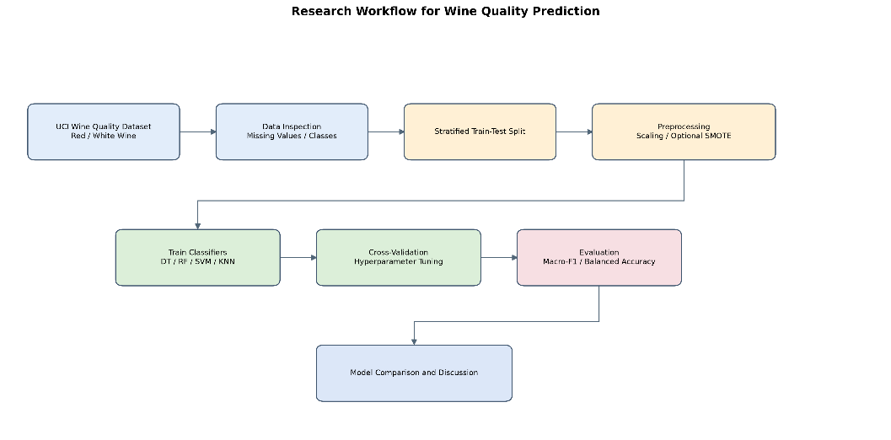
Fig. 1. Research Workflow for Wine Quality Prediction.

The system architecture illustrates the processing pipeline from physicochemical input features to predicted wine quality classes. The input data are preprocessed before being passed to the selected classifier. Model predictions are then evaluated using classification metrics and confusion matrices to support model comparison and interpretation.

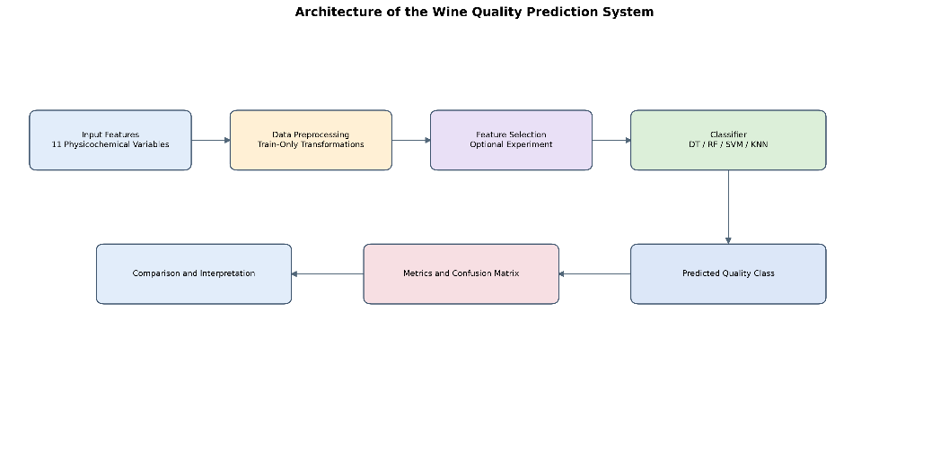
Fig. 2. Architecture of the Wine Quality Prediction System.
3.2 Dataset Description
The primary dataset is the Wine Quality dataset from the UCI Machine Learning Repository (Cortez et al., 2009). It contains two datasets relating to red and white Vinho Verde wines. The red wine dataset contains 1,599 observations, while the white wine dataset contains 4,898 observations, giving 6,497 observations if both datasets are combined.
Each observation contains 11 physicochemical input features: fixed acidity, volatile acidity, citric acid, residual sugar, chlorides, free sulfur dioxide, total sulfur dioxide, density, pH, sulphates, and alcohol. The target variable, quality, represents the recorded quality score.
The target can be modeled as a numerical value for regression or transformed into categories for classification. This study prioritizes classification, but the exact target formulation must be fixed before experiments are conducted. For example, a binary classification experiment could distinguish higher-quality wine from other wine, while multiclass classification could preserve several quality categories. Results from these formulations should not be compared as though they were the same task.
Table 1. Model performance comparison (to be completed after running the notebook)
Item | Description
Dataset source | UCI Machine Learning Repository, ID 186
Red wine observations | 1,599
White wine observations | 4,898
Combined observations | 6,497
Number of input features | 11
Target variable | quality
Input type | Physicochemical numerical measurements
Target use | Regression or classification
Important limitation | No brand, market price, or grape-variety fields

3.3 Data Preprocessing
The initial preprocessing stage examines data types, duplicate records, missing values, feature distributions, and target-class frequencies. Descriptive statistics and visualizations can be used to identify skewed features and potential relationships between physicochemical measurements and quality labels.
The train-test split should be performed before applying oversampling or any transformation that estimates parameters from the data. For classification, stratified splitting is appropriate because it attempts to preserve the class proportions in the training and testing sets.
StandardScaler can be applied to SVM and KNN because both methods may be sensitive to differences in feature magnitudes. Tree-based models such as DT and RF generally do not require feature standardization in the same way. The effect of scaling should therefore be evaluated as a model-specific preprocessing experiment.
SMOTE should only be applied to the training portion of the data. Applying it before the train-test split could allow synthetic observations derived from the full dataset to influence evaluation and lead to overly optimistic estimates. The test set should retain its original distribution so that evaluation reflects performance on unseen data.
3.4 Classification Algorithms
Four classical classifiers are proposed as baseline models.
Decision Tree. A Decision Tree learns decision rules by recursively splitting the feature space. Its structure can be inspected to understand the rules used for classification. However, a deep tree may overfit the training data, so parameters such as maximum depth and minimum samples per leaf may require tuning.
Random Forest. Random Forest combines predictions from multiple decision trees trained with randomized sampling and feature selection (Breiman, 2001). It is a suitable baseline because it can represent nonlinear relationships and interactions between physicochemical features. Feature importance can also provide an initial indication of variables associated with predictions.
Support Vector Machine. SVM seeks a decision boundary that separates classes and can use kernel functions to model nonlinear relationships (Cortes & Vapnik, 1995). Because SVM may be sensitive to feature scaling, standardized and non-standardized pipelines should be compared where appropriate.
K-Nearest Neighbors. KNN predicts the class of a new observation from nearby training observations (Cover & Hart, 1967). Its performance depends on the number of neighbors, distance measure, and feature scales. Scaling is therefore an important part of the KNN experiment.
XGBoost may be added as an advanced comparison because gradient-boosted trees have been widely applied to structured datasets (Chen & Guestrin, 2016). However, the four baseline algorithms should be implemented first to establish a clear and reproducible comparison.
3.5 Feature Selection and Class Balancing
Feature selection will be evaluated by comparing the original 11-feature baseline with a selected feature subset. A method such as ANOVA F-test can be used to rank or select features, provided that selection is fitted only on training data. The selected subset and selection parameters should be recorded to ensure reproducibility.
Class balancing will be investigated by comparing the baseline training procedure with a procedure using SMOTE. The same train-test split and model configuration should be retained where possible so that the comparison reflects the effect of oversampling rather than unrelated experimental changes.
The study should distinguish between the effect of an individual technique and the effect of a combined pipeline. For example, if scaling, SMOTE, feature selection, and hyperparameter tuning are introduced simultaneously, an improvement cannot automatically be attributed to any one of them. Separate experiments or ablation comparisons provide stronger evidence about the contribution of each component.
3.6 Evaluation Metrics
Accuracy measures the proportion of correctly classified observations. Although it is easy to interpret, it may hide poor performance on minority classes when the dataset is imbalanced (Sokolova & Lapalme, 2009).
Precision measures the proportion of predictions for a class that are correct, while Recall measures the proportion of actual instances of a class that are identified. F1 combines Precision and Recall. Macro-F1 calculates the F1 score for each class and averages them equally, making it useful when rare classes should receive comparable attention to common classes.
Balanced Accuracy provides a class-sensitive summary based on recall across classes. A confusion matrix shows how often each actual class is assigned to each predicted class, revealing which quality levels are commonly confused.
ROC-AUC may also be reported when suitable probability or decision scores are available. For imbalanced binary classification, Precision-Recall analysis may provide additional insight because it focuses on the trade-off between precision and recall (Fawcett, 2006; Saito & Rehmsmeier, 2015).
The main evaluation set should include Accuracy, Balanced Accuracy, Macro-Precision, Macro-Recall, Macro-F1, Weighted-F1, and a confusion matrix. Cross-validation can be used for model selection, while a held-out test set is reserved for final evaluation (Kohavi, 1995). The selected metrics and test protocol should be applied consistently across compared models.
4 Experiments
4.1 Experimental Environment
The experiments can be implemented in Python using Jupyter Notebook or Google Colab. Pandas and NumPy can be used for data handling, Matplotlib and Seaborn for visualization, and Scikit-learn for preprocessing, model training, and evaluation (Pedregosa et al., 2011). If SMOTE is included, the implementation can use the imbalanced-learn library.
The notebook should record the dataset version, selected target formulation, train-test split ratio, random seed, preprocessing steps, model parameters, and evaluation metrics. These details are necessary to support reproducibility and to explain differences between the present experiment and previous studies.
4.2 Experimental Design
The first experiment establishes baseline performance for DT, RF, SVM, and KNN using the same training and testing partitions. The target definition, input features, and evaluation metrics must remain consistent across the models.
The second experiment investigates feature scaling. SVM and KNN are evaluated with and without standardization, while other experimental conditions remain unchanged. The third experiment investigates SMOTE by comparing the original training distribution with an oversampled training set. The test set is not oversampled.
The fourth experiment examines feature selection by comparing a model trained on the complete input feature set with a model trained on the selected features. The fifth experiment analyzes feature importance and, if both datasets are evaluated separately, compares performance on red and white wine. A stratified cross-validation procedure can be used during model selection, followed by a single final evaluation on the held-out test set.
4.3 Model Performance Comparison
The results should be reported in a table such as the following after running the notebook.
Table 1. Model performance comparison (to be completed after running the notebook)
Model | Accuracy | Balanced Accuracy | Macro-Precision | Macro-Recall | Macro-F1
Decision Tree | To be measured | To be measured | To be measured | To be measured | To be measured
Random Forest | To be measured | To be measured | To be measured | To be measured | To be measured
SVM | To be measured | To be measured | To be measured | To be measured | To be measured
KNN | To be measured | To be measured | To be measured | To be measured | To be measured
XGBoost, if included | To be measured | To be measured | To be measured | To be measured | To be measured

The best model should not be selected based on Accuracy alone. Macro-F1 and Balanced Accuracy should also be considered because they reveal how well a model performs across less frequent quality classes. The confusion matrix should be examined to identify systematic misclassification between neighboring quality levels.
4.4 Impact of Feature Scaling and SMOTE
The feature-scaling experiment should report the difference in performance for SVM and KNN before and after standardization. Any observed change should be interpreted alongside the confusion matrix and class-level metrics. Standardization may affect distance-based and margin-based methods, but the magnitude and direction of its effect must be established empirically.
The SMOTE experiment should compare the baseline pipeline with the oversampling pipeline using the same held-out test set. An improvement in Macro-F1 or minority-class Recall may indicate that the classifier has become more effective at identifying less frequent classes. However, any such improvement should be weighed against possible changes in Precision and performance on common classes.
A separate feature-selection comparison should examine whether a reduced feature set maintains or improves predictive performance. If performance changes, the report should specify which features were selected and whether the selection process was fitted only on training data.
4.5 Feature Importance and Discussion
Feature importance can be investigated using the fitted Random Forest model or a suitable model-interpretation technique. The analysis should identify which physicochemical features contribute most strongly to predictions in the actual experiment. Feature importance should be interpreted cautiously because importance rankings may change with the model, target formulation, correlated inputs, and training data.
If red and white wines are evaluated separately, the discussion should compare their class distributions and model performance under clearly documented conditions. Differences may reflect dataset characteristics and class frequencies rather than an inherent superiority of a particular algorithm.
The final discussion should compare the observed results with previous studies while accounting for differences in preprocessing and experimental design. Published results, such as those reported by Sinaga et al. (2025), can provide context, but they should not be substituted for the results obtained from the present notebook.
5 Conclusion
This paper presents a structured approach to wine quality prediction using machine learning classification. The review identifies the UCI Wine Quality dataset as a suitable foundation for an undergraduate study and considers Decision Tree, Random Forest, Support Vector Machine, and K-Nearest Neighbors as baseline algorithms. It also highlights the relevance of feature scaling, class imbalance, feature selection, and evaluation metrics.
The proposed methodology emphasizes consistent experimental conditions and protection against data leakage. Accuracy should be complemented by Macro-F1, Balanced Accuracy, class-level metrics, and confusion matrices so that performance on minority quality classes is not overlooked. SMOTE and feature selection should be evaluated through controlled comparisons rather than introduced as a single combined procedure without further analysis.
The main contribution of the proposed work is a reproducible experimental framework for comparing classical classifiers and examining the influence of preprocessing choices. The actual conclusions regarding the best-performing model, the usefulness of SMOTE, and the most important physicochemical features must be drawn from the completed notebook experiments.
Future work may extend the baseline framework with XGBoost, explainable artificial intelligence methods such as SHAP, systematic hyperparameter optimization, and statistical comparisons across repeated validation runs. Additional data containing measurements from commercial wine products could also help investigate whether models developed on the UCI benchmark generalize to other wine populations.
References
1. Aich, S., Al-Absi, A.A., Hui, K.L., Lee, J.T., Sain, M.: A classification approach with different feature sets to predict the quality of different types of wine using machine learning techniques. In: International Conference on Advanced Communication Technology (2018). https://doi.org/10.23919/ICACT.2018.8323674
2. Aich, S., Al-Absi, A.A., Hui, K.L., Sain, M.: Prediction of quality for different type of wine based on different feature sets using supervised machine learning techniques. In: 21st International Conference on Advanced Communication Technology, pp. 1122–1127 (2019). https://doi.org/10.23919/ICACT.2019.8702017
3. Breiman, L.: Random forests. Mach. Learn. 45, 5–32 (2001). https://doi.org/10.1023/A:1010933404324
4. Chawla, N.V., Bowyer, K.W., Hall, L.O., Kegelmeyer, W.P.: SMOTE: Synthetic minority over-sampling technique. J. Artif. Intell. Res. 16, 321–357 (2002). https://doi.org/10.1613/jair.953
5. Chen, T., Guestrin, C.: XGBoost: A scalable tree boosting system. In: Proceedings of the 22nd ACM SIGKDD International Conference on Knowledge Discovery and Data Mining, pp. 785–794 (2016). https://doi.org/10.1145/2939672.2939785
6. Cortes, C., Vapnik, V.: Support-vector networks. Mach. Learn. 20, 273–297 (1995). https://doi.org/10.1007/BF00994018
7. Cortez, P., Teixeira, J., Cerdeira, A., Almeida, F., Matos, T., Reis, J.: Using data mining for wine quality assessment. Lect. Notes Comput. Sci. 5808, 66–79 (2009). https://doi.org/10.1007/978-3-642-04747-3_8
8. Cover, T.M., Hart, P.E.: Nearest neighbor pattern classification. IEEE Trans. Inf. Theory 13(1), 21–27 (1967). https://doi.org/10.1109/TIT.1967.1053964
9. Fawcett, T.: An introduction to ROC analysis. Pattern Recognit. Lett. 27(8), 861–874 (2006). https://doi.org/10.1016/j.patrec.2005.10.010
10. Gupta, Y.: Selection of important features and predicting wine quality using machine learning techniques. Procedia Comput. Sci. 125, 305–312 (2018). https://doi.org/10.1016/j.procs.2017.12.041
11. Guyon, I., Elisseeff, A.: An introduction to variable and feature selection. J. Mach. Learn. Res. 3, 1157–1182 (2003)
12. Jain, K., Kaushik, K., Gupta, S.K., Mahajan, S., Kadry, S.: Machine learning-based predictive modelling for the enhancement of wine quality. Sci. Rep. 13, 17042 (2023). https://doi.org/10.1038/s41598-023-44111-9
13. Khan, R., Goyal, A., Kanyal, H.S., Parashar, D., Sharma, S.K., Iqbal, M.: Improved machine learning framework with feature engineering and SHAP analysis for predicting wine quality. Discov. Appl. Sci. 8, 27 (2026). https://doi.org/10.1007/s42452-025-07999-8
14. Kohavi, R.: A study of cross-validation and bootstrap for accuracy estimation and model selection. In: Proceedings of the International Joint Conference on Artificial Intelligence, pp. 1137–1145 (1995)
15. Pedregosa, F., Varoquaux, G., Gramfort, A., et al.: Scikit-learn: Machine learning in Python. J. Mach. Learn. Res. 12, 2825–2830 (2011)
16. Saito, T., Rehmsmeier, M.: The precision-recall plot is more informative than the ROC plot when evaluating binary classifiers on imbalanced datasets. PLoS ONE 10(3), e0118432 (2015). https://doi.org/10.1371/journal.pone.0118432
17. Sinaga, T., Sirait, K.B., Pangaribuan, J.J., Barus, O.P., Romindo: Analisis kualitas wine menggunakan machine learning dengan pendekatan SMOTE dan seleksi fitur. INSOLOGI: Jurnal Sains dan Teknologi 4(3), 656–668 (2025). https://doi.org/10.55123/insologi.v4i3.5436
18. Sokolova, M., Lapalme, G.: A systematic analysis of performance measures for classification tasks. Inf. Process. Manag. 45(4), 427–437 (2009). https://doi.org/10.1016/j.ipm.2009.03.002

