ATI COURSE PROJECT 2026 · TRACK 2 · MIDTERM REPORT
ViGoEmotions: Fine-Grained Multi-Label Emotion Recognition for Vietnamese Social-Media Comments
Dataset analysis, fixed split, preprocessing, baseline models, evaluation, error analysis and the proposed Final research question
Team: [Team name] — [Member 1], [Member 2], [Member 3]
Date: [Submission date]
Code: executable notebooks and Python package in this submission (README.md); all tables and figures are regenerated by code.

Abstract
We study fine-grained multi-label emotion recognition on ViGoEmotions (EACL 2026), a corpus of 20,664 Vietnamese social-media comments annotated with 27 emotions plus neutral. We (i) analyse the label space, co-occurrence structure and informal-language phenomena; (ii) keep the official 80/10/10 split and audit its multi-label stratification; (iii) build a documented Vietnamese normalisation pipeline (Unicode NFC, VinAI tone normalisation, teencode and emoji handling, VnCoreNLP word segmentation); and (iv) benchmark the three required models — TF-IDF with One-vs-Rest Logistic Regression, a BiLSTM and PhoBERT with an independent sigmoid head trained with BCE — plus ViSoBERT, ViSoBERT-14GB and a probability-averaging ensemble, all evaluated with one shared module. At the default threshold τ = 0.5, PhoBERT reaches 0.629 Macro-F1 / 0.646 Micro-F1 on the held-out test set, above the best published baseline on the same split (ViSoBERT, 0.615). The ensemble reaches 0.643 / 0.664, and 0.653 / 0.669 with a single threshold fitted on validation. Label frequency correlates only weakly with per-label F1, PhoBERT's largest gains over the BiLSTM are on emoticon, long and teencode comments, and validation-optimal per-label thresholds range from 0.17 to 0.69 — motivating the Final research question on threshold calibration.

1. Introduction
A single social-media comment frequently expresses several emotions at once (for example sadness together with disappointment). The task is therefore multi-label: each of the 28 categories is an independent binary decision, and the model outputs one sigmoid probability per label instead of a softmax over mutually exclusive classes. Following the project brief, Macro-F1 and Micro-F1 are the headline metrics; exact-match subset accuracy is reported for completeness only.
Vietnamese social-media text adds difficulties absent from edited text: teencode and abbreviations (“ko”, “đc”, “vs”), elongated words, emoji and ASCII emoticons (“:))”, “=))”), missing diacritics and profanity. This Midterm establishes a clean, reproducible baseline study; the contributions are:
- a complete dataset analysis (inventory, frequency tiers, cardinality, co-occurrence/correlation, text length and an informal-language audit), computed from code;
- a fixed split with a quantitative stratification audit and frozen text-style subset definitions;
- a Vietnamese preprocessing pipeline that fixes a Unicode-normalisation bug in the official code and aligns tokenisation with each encoder's pre-training;
- the three required models plus stronger Vietnamese encoders and an ensemble, evaluated with all required metrics, parameter counts and wall-clock time;
- evidence-based answers to the five Midterm questions, an error analysis and the proposed Final research question.

2. Dataset and access protocol
ViGoEmotions (Hung et al., EACL 2026) contains 20,664 comments collected from Facebook (including the earlier UIT-VSMEC corpus), TikTok, YouTube, X, Reddit and Threads. The dataset is distributed as a gated Hugging Face dataset (uitnlp/vigoemotions) and in the authors' repository under a non-commercial research licence that forbids redistribution. Our submission therefore contains code, split identifiers, aggregate statistics, labels and predicted probabilities, but no raw comments; the manual error audit that needs text is written to a git-ignored private folder.
Table 1. Dataset summary (computed by `python -m vigo eda`).
Item | Value
total comments | 20,664
train comments | 16,531
val comments | 2,066
test comments | 2,067
labels (27 emotions + neutral) | 28
mean labels per comment |Y| | 1.909
label density | 0.0682
distinct label sets | 1,485
most frequent label (train) | amusement
rarest label (train) | relief
imbalance ratio max/min (train) | 4.52
median whitespace tokens (train) | 11

Table 2. Source platform inferred from the sample-id prefix.
Source | Train | Val | Test | Total | Share
Facebook (numeric id, incl. UIT-VSMEC) | 10,741 | 1,339 | 1,364 | 13,444 | 65.1%
TikTok | 3,609 | 463 | 436 | 4,508 | 21.8%
YouTube | 1,563 | 199 | 198 | 1,960 | 9.5%
X (Twitter) | 430 | 48 | 46 | 524 | 2.5%
Reddit | 140 | 13 | 14 | 167 | 0.8%
Threads | 48 | 4 | 9 | 61 | 0.3%

Table 3. Complete label inventory with positives per split and the frequency tier (training counts).
# | Label | Train | Val | Test | Train % | Tier
0 | amusement | 2,868 | 327 | 374 | 17.4% | head
1 | excitement | 824 | 91 | 98 | 5.0% | mid
2 | joy | 1,614 | 168 | 204 | 9.8% | head
3 | love | 1,175 | 148 | 143 | 7.1% | head
4 | desire | 762 | 102 | 80 | 4.6% | tail
5 | optimism | 1,046 | 122 | 142 | 6.3% | mid
6 | caring | 1,062 | 131 | 150 | 6.4% | head
7 | pride | 774 | 87 | 86 | 4.7% | mid
8 | admiration | 883 | 107 | 101 | 5.3% | mid
9 | gratitude | 765 | 96 | 108 | 4.6% | mid
10 | relief | 635 | 58 | 60 | 3.8% | tail
11 | approval | 917 | 119 | 115 | 5.5% | mid
12 | realization | 687 | 96 | 95 | 4.2% | tail
13 | surprise | 651 | 87 | 85 | 3.9% | tail
14 | curiosity | 840 | 112 | 100 | 5.1% | mid
15 | confusion | 676 | 89 | 84 | 4.1% | tail
16 | fear | 745 | 117 | 98 | 4.5% | tail
17 | nervousness | 728 | 109 | 96 | 4.4% | tail
18 | remorse | 707 | 96 | 87 | 4.3% | tail
19 | embarrassment | 885 | 137 | 107 | 5.3% | mid
20 | disappointment | 1,522 | 211 | 197 | 9.2% | head
21 | sadness | 2,785 | 354 | 345 | 16.9% | head
22 | grief | 747 | 97 | 86 | 4.5% | tail
23 | disgust | 1,206 | 164 | 141 | 7.3% | head
24 | anger | 1,589 | 185 | 189 | 9.6% | head
25 | annoyance | 2,662 | 331 | 343 | 16.1% | head
26 | disapproval | 969 | 123 | 112 | 5.9% | mid
27 | neutral | 821 | 94 | 116 | 5.0% | mid

3. Exploratory data analysis

3.1 Label frequency and head / mid / tail tiers
Positive counts range from 2,868 (amusement) to 635 (relief) in the training set, an imbalance ratio of only 4.5× — much milder than English GoEmotions. The tier rule was fixed before any evaluation: labels are ranked by training positive count and split at the tertiles, giving 9 head, 10 mid and 9 tail labels (Table 4). The same rule will be reused in the Final.
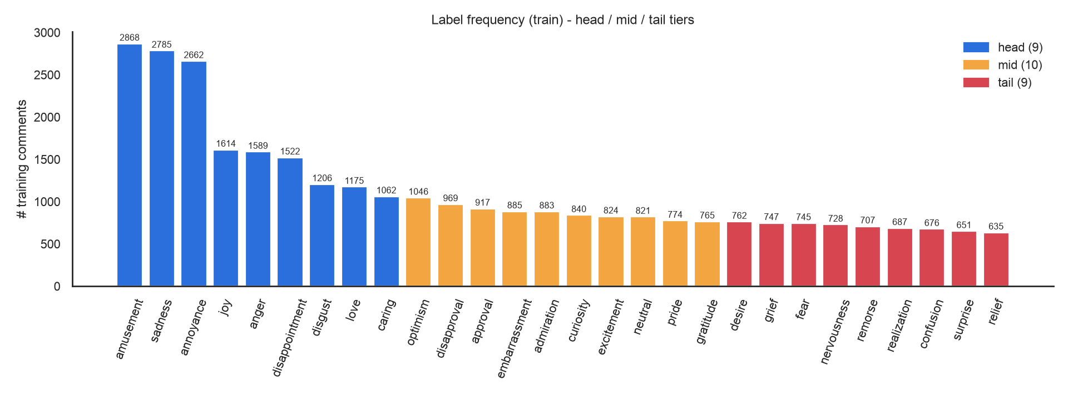
Figure 1. Training positives per label, coloured by tier.
Table 4. Frequency tiers (tertiles of training positive counts).
Tier | # labels | Min | Max | Labels
head | 9 | 1,062 | 2,868 | amusement, sadness, annoyance, joy, anger, disappointment, disgust, love, caring
mid | 10 | 765 | 1,046 | optimism, disapproval, approval, embarrassment, admiration, curiosity, excitement, neutral, pride, gratitude
tail | 9 | 635 | 762 | desire, grief, fear, nervousness, remorse, realization, confusion, surprise, relief

3.2 Label cardinality
Comments carry 1.91 labels on average (label density 0.068); 32.9% of training comments have exactly one label, 46.6% two, 17.6% three and 2.9% four or more. Only 3.5% are neutral-only, and 1,485 distinct label combinations occur. The distribution is almost identical across splits (Table 5), and |Y| is kept per sample for the cardinality-stratified analysis of the Final.
Table 5. Label cardinality per split (% of comments).
Split | n | Mean |Y| | |Y|=1 | |Y|=2 | |Y|=3 | |Y|=4 | |Y|=5 | Neutral only
train | 16,531 | 1.908 | 32.9% | 46.6% | 17.6% | 2.6% | 0.3% | 3.5%
val | 2,066 | 1.916 | 32.9% | 45.7% | 18.8% | 2.3% | 0.3% | 3.6%
test | 2,067 | 1.907 | 33.6% | 45.8% | 17.4% | 2.7% | 0.5% | 3.9%

3.3 Co-occurrence and pairwise correlation
All co-occurrence statistics are computed on training labels only, following the reproducibility rules. The strongest pairs form interpretable emotion families: a sadness family (sadness, grief, disappointment, embarrassment, remorse), an anxiety pair (fear–nervousness, the highest phi), a positive cluster (excitement, joy, love, optimism, caring, gratitude–relief) and a hostile cluster (anger, annoyance, disapproval, disgust). Grief almost always co-occurs with sadness (P(sadness | grief) = 0.83). Amusement is negatively correlated with sadness.
Table 6. Most frequent label pairs in the training set.
Label a | Label b | Count | P(b|a) | P(a|b) | phi
disappointment | sadness | 904 | 0.594 | 0.325 | 0.362
anger | annoyance | 699 | 0.440 | 0.263 | 0.247
sadness | grief | 620 | 0.223 | 0.830 | 0.384
amusement | joy | 568 | 0.198 | 0.352 | 0.155
annoyance | disapproval | 469 | 0.176 | 0.484 | 0.219
joy | love | 395 | 0.245 | 0.336 | 0.222
disgust | anger | 379 | 0.314 | 0.239 | 0.208
embarrassment | sadness | 366 | 0.414 | 0.131 | 0.156
excitement | joy | 359 | 0.436 | 0.222 | 0.261
disappointment | annoyance | 336 | 0.221 | 0.126 | 0.052
amusement | annoyance | 336 | 0.117 | 0.126 | -0.055
fear | nervousness | 322 | 0.432 | 0.442 | 0.411

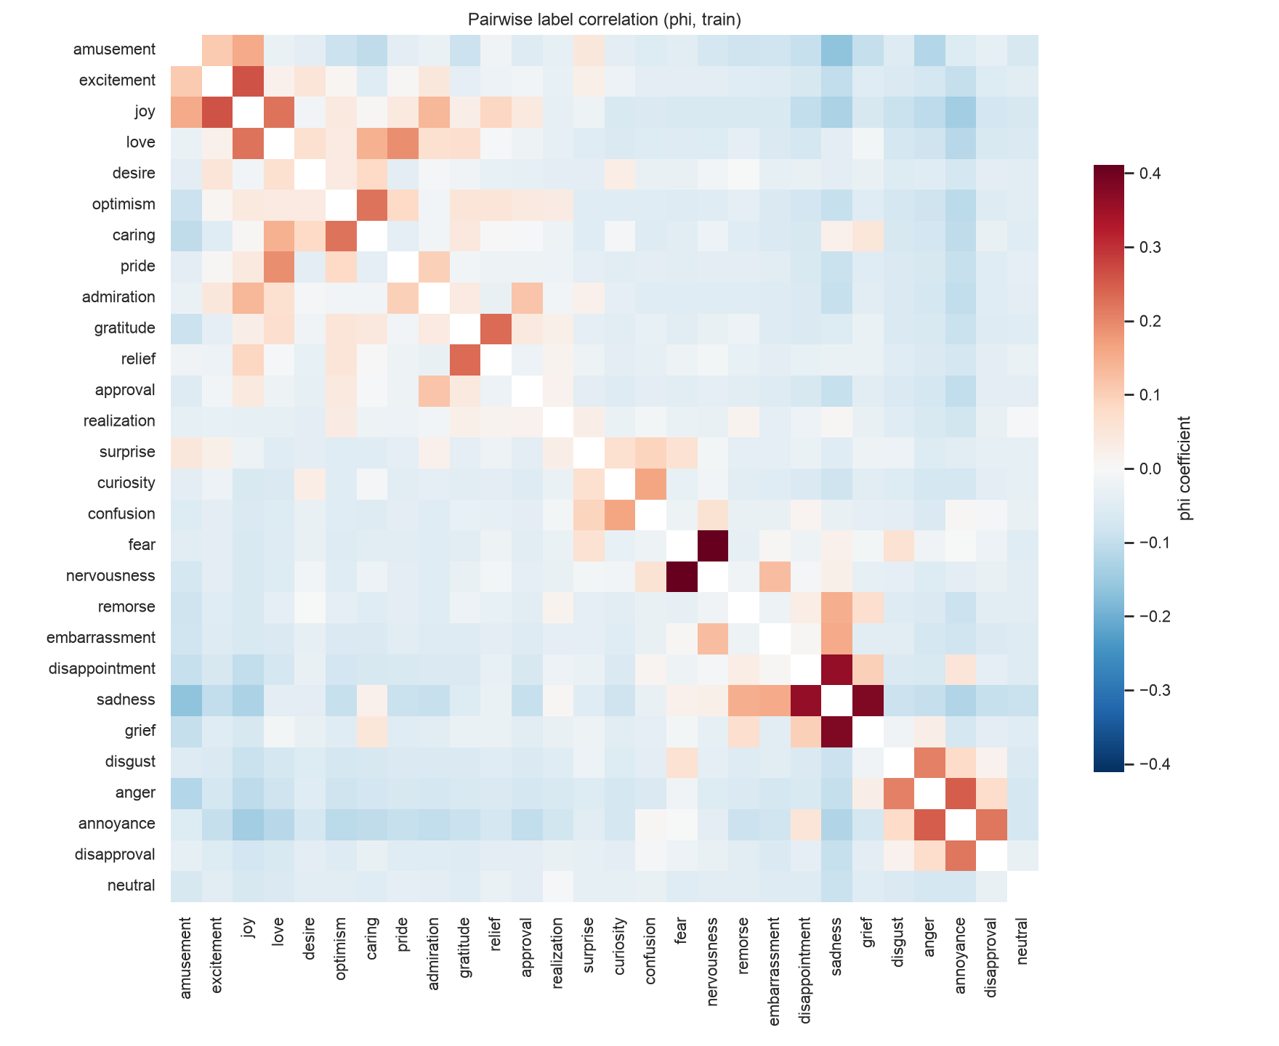
Figure 2. Pairwise phi correlation between labels (training set).

3.4 Text length
Comments are short: the median training comment has 11 whitespace tokens (47 characters), the 95th percentile 44 tokens and the 99th percentile 84 tokens. After PhoBERT tokenisation the 99th percentile is 85 sub-words, so max_len = 192 truncates only 0.01% of training comments; the BiLSTM uses 100 word tokens (above the 99th percentile of 78 segmented tokens).
Table 7. Comment length statistics.
Split | Unit | Min | P25 | Median | Mean | P90 | P95 | P99 | Max
train | tokens | 1 | 7 | 11 | 16 | 32 | 44 | 84 | 214
train | characters | 1 | 28 | 47 | 66.5 | 133 | 186 | 355 | 906
val | tokens | 1 | 7 | 12 | 16.1 | 32 | 44 | 88 | 143
val | characters | 1 | 27 | 47 | 66.5 | 130.5 | 187.8 | 363.4 | 641
test | tokens | 1 | 7 | 11 | 16.8 | 35 | 47 | 90.7 | 171
test | characters | 1 | 28 | 47 | 69.6 | 145 | 194 | 380 | 694

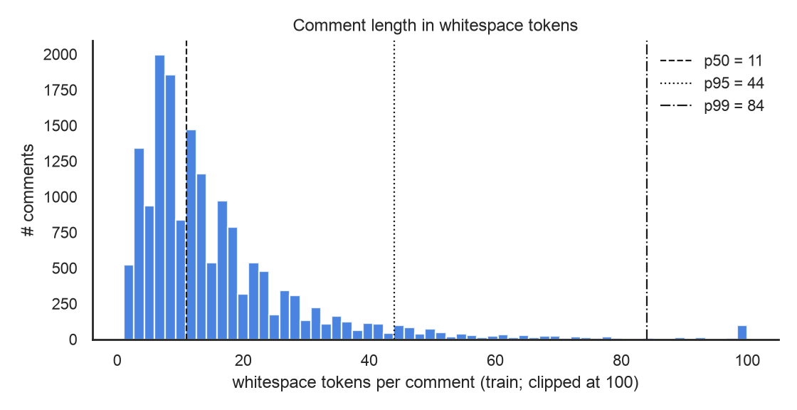
Figure 3. Distribution of whitespace tokens per training comment.

3.5 Informal Vietnamese: slang, teencode, emoji and non-standard syntax
Table 8 quantifies informal phenomena over all 20,664 comments (aggregates only). About a third of the comments contain at least one teencode or abbreviation token, a quarter contain emoji and one in nine contains an ASCII emoticon. Emoji are strongly tied to specific emotions: 48.8% of love comments and 44.4% of pride comments contain an emoji. These observations drive the preprocessing decisions: emoji are never deleted, teencode is expanded with a token-level dictionary, and elongations are squeezed.
Table 8. Informal-language audit (share of all comments).
Phenomenon | # comments | %
contains emoji | 5,153 | 24.9%
>= 2 emoji | 1,980 | 9.6%
ASCII emoticon (:)) =)) :v ^^) | 2,385 | 11.5%
teencode / abbreviation token (dictionary) | 6,559 | 31.7%
multi-char teencode token | 4,862 | 23.5%
elongated word (letter x3+, e.g. 'quáaaa') | 432 | 2.1%
repeated punctuation (!!, ??, ...) | 1,535 | 7.4%
laughter token (haha, hihi, kkk, =)) | 684 | 3.3%
@mention | 727 | 3.5%
URL | 0 | 0.0%
hashtag | 29 | 0.1%
ALL-CAPS word (>= 3 letters) | 291 | 1.4%
unaccented Vietnamese (>= 4 tokens, no diacritics) | 139 | 0.7%
anonymised person placeholder 'per' | 631 | 3.0%
<br> / line break | 614 | 3.0%
profanity / vulgar slang (dm, vl, vcl, đm, cc...) | 1,048 | 5.1%

Table 9. Most frequent teencode tokens and their normalisation.
Token | Normalised | Count
ko | không | 1,618
t | tao | 1,096
k | không | 965
e | em | 695
đc | được | 598
a | anh | 487
ng | người | 404
v | vậy | 299
r | rồi | 290
c | chị | 259
m | mày | 220
j | gì | 211

4. Train / validation / test protocol
We keep the official 80/10/10 split released with the dataset (16,531 / 2,066 / 2,067 comments) so that every number is directly comparable with the published baselines; the ids are stored in splits/official/. Because the brief asks for a stratified multi-label protocol, the "python -m vigo split" command audits this split against a random split and an iterative multi-label stratified split (Sechidis et al., 2011) generated with seed 42, using the label-distribution (LD) measure. The official split is only random-level stratified (mean LD 0.0035 vs 0.0044), whereas iterative stratification is about nine times better (0.0004); the rarest label (relief) has 58 validation positives. We retain the official split for comparability and store the iterative split in splits/iterative/ for a robustness check in the Final.
Table 10. Stratification audit of three 80/10/10 protocols (lower LD is better).
Protocol | Mean LD | Val LD | Test LD | Min val pos. | Min test pos.
official (released) | 0.00355 | 0.00573 | 0.00415 | 58 | 60
random (seed 42) | 0.00441 | 0.00469 | 0.00729 | 73 | 88
iterative stratified (seed 42) | 0.00041 | 0.00067 | 0.00055 | 75 | 76

Discipline: the training set fits models, vocabularies and co-occurrence statistics; the validation set is used for early stopping, hyper-parameter selection and threshold fitting; the test set is scored once per frozen model. The analysis script asserts that every model's test predictions are aligned with the same ordered test ids.

5. Preprocessing pipeline
The pipeline (src/vigo/data/preprocessing.py) is configurable per model and cached by a hash of the configuration and the code. Steps, in order:
- Unicode NFC and removal of emoji variation selectors and skin-tone modifiers. The official notebooks skip NFC; on decomposed (NFD) comments their regex teencode replacement corrupts words (e.g. “cảm” becomes “cảmày”). A unit test covers this case.
- Markup and identities: <br> and HTML entities are converted, @mentions become “@user”, URLs become “url”, hashtags lose “#”; text is lower-cased.
- Tone-mark placement with VinAI's old-to-new table (“hòa” → “hoà”, “thủy” → “thuỷ”), the convention of PhoBERT's pre-training data.
- Elongation: letters repeated three or more times are squeezed (“đẹppp” → “đẹp”, “quáaaa” → “quá”); “kkk” → “haha”; punctuation and emoticon runs are collapsed (“:)))))” → “:))”).
- Emoji: either kept as separate de-duplicated tokens, or translated into Vietnamese descriptions (😭 → “khóc lớn”) using the paper's dictionary, our additions and the Unicode CLDR Vietnamese names as a fallback.
- Teencode: token-level lookup in 441 official plus 62 added entries (“ko” → “không”, “đc” → “được”).
- Word segmentation (PhoBERT, BiLSTM, TF-IDF word n-grams) with VnCoreNLP RDRSegmenter, the segmenter used for PhoBERT's pre-training (the paper used pyvi); emoji and emoticon tokens bypass the segmenter.
Table 11. Model-specific preprocessing.
Model | Emoji | Segmentation | Tokeniser / vocabulary
TF-IDF + OvR LR | kept as tokens | VnCoreNLP | word 1–2-grams + char_wb 1–5-grams
BiLSTM | kept as tokens | VnCoreNLP | word vocabulary fitted on train (min_freq 2)
PhoBERT-base-v2 | → Vietnamese text | VnCoreNLP | PhoBERT BPE (64k)
ViSoBERT / ViSoBERT-14GB | kept (in vocabulary) | none (syllables) | SentencePiece (15k, includes emoji)

6. Models
M1 — TF-IDF + One-vs-Rest Logistic Regression. Word 1–2-grams on segmented text and character 1–5-grams (char_wb) with sublinear TF and min_df = 2 are concatenated (76,296 features). Each of the 28 labels has an L2-regularised logistic regression (liblinear). C ∈ {1, 2, 4, 8, 16} and class_weight ∈ {none, balanced} were selected on validation Macro-F1 at τ = 0.5 (selected: C = 4, class_weight = balanced).
M2 — BiLSTM. 300-d embeddings trained from scratch, spatial dropout 0.25, a 2-layer bidirectional LSTM with 256 units per direction, concatenated additive-attention and max pooling, dropout 0.3 and a linear layer with 28 sigmoid outputs. BCE loss, AdamW with a one-cycle schedule (max lr 2e-3), batch 64, up to 25 epochs with early stopping (patience 6) on validation Macro-F1; best epoch 15.
M3 — PhoBERT. vinai/phobert-base-v2 with the [CLS] representation, dropout 0.1 and a linear head with 28 independent sigmoids, trained with plain binary cross-entropy exactly as in the brief. AdamW, lr 3e-5 for the top layer with layer-wise decay 0.9 towards the embeddings, head lr 1e-3, weight decay 0.01, 10% linear warm-up then linear decay, batch 32, max_len 192, up to 10 epochs (patience 3); the head bias is initialised to the logit of each label's training prior, and batches are length-grouped with dynamic padding. Best epoch 9 by validation Macro-F1 at τ = 0.5.
Additional encoders. ViSoBERT (uitnlp/visobert), pre-trained on Vietnamese social-media text with emoji in its vocabulary, and ViSoBERT-14GB (5CD-AI/visobert-14gb-corpus), continued pre-training on 14 GB of Facebook comments, use the same recipe with raw emoji and no word segmentation (lr 4e-5 and 2e-5; the latter was lowered after the ViSoBERT validation curve over-fitted from epoch 4 — a validation-only decision). The ensemble averages the saved probabilities of PhoBERT, ViSoBERT and ViSoBERT-14GB with uniform weights; alternative compositions were compared on validation only (ensemble_composition_val.csv) and the planned three-transformer ensemble was kept because adding TF-IDF changed validation Macro-F1 by only about 0.002.

7. Evaluation protocol
One module (src/vigo/evaluation/metrics.py) scores every model on the same split and writes the same result format. Reported metrics: Macro-F1 and Micro-F1 over all 28 labels (headline, as in the paper), Macro-F1 over the 27 emotions only, weighted and sample-averaged F1, per-label precision/recall/F1/average precision, Hamming loss, label-ranking average precision (LRAP) and macro mean average precision (mAP) computed from continuous probabilities, subset accuracy (secondary), parameter count (all nn.Parameters; 28 × (features + 1) for the linear model) and wall-clock training time including per-epoch validation.
Decoding: the main tables use the fixed threshold τ = 0.5 for all labels. Probabilities are saved before binarisation, so two alternative strategies are fitted on validation only and then frozen: a global threshold τ* maximising validation Macro-F1, and per-label thresholds τ*_c maximising each label's validation F1 (grid 0.02–0.98, step 0.01).
Hardware and software: Apple M1 Pro, 32 GB, PyTorch 2.14.0 (MPS backend; the BiLSTM runs on CPU where it is faster), transformers 4.57.6, scikit-learn 1.9.1, Python 3.11.16. Seed 42 for Python, NumPy and PyTorch; exact checkpoint revisions are listed in hardware_and_versions.txt.

8. Results

8.1 Main results
Table 11 reports every required metric on the test set at τ = 0.5. PhoBERT improves over the BiLSTM by 0.117 Macro-F1 and over TF-IDF by 0.087. The TF-IDF model outperforms the BiLSTM: character n-grams are robust to teencode and spelling variation, while the BiLSTM learns its embeddings from only 16.5k comments. Among the additional encoders, ViSoBERT-14GB is the strongest (0.620); the three-transformer ensemble is the best system overall, with the lowest Hamming loss and the highest LRAP and mAP.
Table 12. Test results at τ = 0.5 (all required metrics). Hamming loss: lower is better.
Model | Macro-F1 | Micro-F1 | Macro-F1 (27 emo.) | Hamming | LRAP | mAP | Subset acc. | Params | Train time
TF-IDF + OvR LR | 0.542 | 0.558 | 0.554 | 0.0665 | 0.690 | 0.560 | 0.165 | 2.1M | 6 s
BiLSTM | 0.512 | 0.533 | 0.523 | 0.0581 | 0.668 | 0.539 | 0.209 | 5.2M | 21.6 min
PhoBERT-base-v2 | 0.629 | 0.646 | 0.637 | 0.0472 | 0.769 | 0.684 | 0.294 | 134.4M | 51.0 min
ViSoBERT | 0.613 | 0.632 | 0.622 | 0.0483 | 0.755 | 0.656 | 0.287 | 97.0M | 41.1 min
ViSoBERT-14GB | 0.620 | 0.642 | 0.628 | 0.0470 | 0.777 | 0.678 | 0.298 | 97.0M | 41.9 min
Ensemble (3) | 0.643 | 0.664 | 0.652 | 0.0429 | 0.793 | 0.710 | 0.321 | 328.4M | 134.0 min

Table 13. Validation results at τ = 0.5.
Model | Macro-F1 | Micro-F1 | Hamming | LRAP | mAP
TF-IDF + OvR LR | 0.531 | 0.550 | 0.0676 | 0.683 | 0.553
BiLSTM | 0.519 | 0.545 | 0.0572 | 0.668 | 0.533
PhoBERT-base-v2 | 0.632 | 0.644 | 0.0473 | 0.770 | 0.676
ViSoBERT | 0.609 | 0.623 | 0.0485 | 0.745 | 0.647
ViSoBERT-14GB | 0.617 | 0.633 | 0.0479 | 0.763 | 0.672
Ensemble (3) | 0.641 | 0.656 | 0.0433 | 0.786 | 0.711

8.2 Decoding strategies
Fitting thresholds on validation helps modestly on test: the ensemble improves from 0.643 to 0.653 Macro-F1 with a single global threshold (τ* = 0.32). Per-label thresholds always look best on validation but generalise worse than the global threshold for the ensemble, ViSoBERT and ViSoBERT-14GB — the validation-to-test gap of per-label tuning (last column) is consistently the largest. This is the central observation behind the proposed Final research question.
Table 14. Three decoding strategies; thresholds fitted on validation and frozen before test.
Model | Strategy | τ | Val Macro-F1 | Test Macro-F1 | Test Micro-F1 | Test Hamming | Gap (val − test)
TF-IDF + OvR LR | fixed | 0.50 | 0.531 | 0.542 | 0.558 | 0.0665 | -0.011
TF-IDF + OvR LR | global | 0.60 | 0.540 | 0.538 | 0.554 | 0.0596 | 0.002
TF-IDF + OvR LR | per-label | per-label | 0.555 | 0.539 | 0.546 | 0.0666 | 0.016
BiLSTM | fixed | 0.50 | 0.519 | 0.512 | 0.533 | 0.0581 | 0.007
BiLSTM | global | 0.31 | 0.524 | 0.524 | 0.541 | 0.0626 | 0.000
BiLSTM | per-label | per-label | 0.542 | 0.518 | 0.534 | 0.0628 | 0.024
PhoBERT-base-v2 | fixed | 0.50 | 0.632 | 0.629 | 0.646 | 0.0472 | 0.003
PhoBERT-base-v2 | global | 0.29 | 0.639 | 0.633 | 0.645 | 0.0535 | 0.006
PhoBERT-base-v2 | per-label | per-label | 0.655 | 0.634 | 0.647 | 0.0509 | 0.022
ViSoBERT | fixed | 0.50 | 0.609 | 0.613 | 0.632 | 0.0483 | -0.004
ViSoBERT | global | 0.27 | 0.617 | 0.616 | 0.633 | 0.0517 | 0.001
ViSoBERT | per-label | per-label | 0.634 | 0.613 | 0.625 | 0.0540 | 0.022
ViSoBERT-14GB | fixed | 0.50 | 0.617 | 0.620 | 0.642 | 0.0470 | -0.003
ViSoBERT-14GB | global | 0.38 | 0.623 | 0.625 | 0.645 | 0.0501 | -0.002
ViSoBERT-14GB | per-label | per-label | 0.644 | 0.623 | 0.642 | 0.0513 | 0.021
Ensemble (3) | fixed | 0.50 | 0.641 | 0.643 | 0.664 | 0.0429 | -0.002
Ensemble (3) | global | 0.32 | 0.655 | 0.653 | 0.669 | 0.0485 | 0.002
Ensemble (3) | per-label | per-label | 0.669 | 0.649 | 0.665 | 0.0477 | 0.021

8.3 Comparison with the published baselines
The authors report their test numbers at τ = 0.5 with a positive-weighted BCE loss on the same official split. Our PhoBERT alone (0.629) exceeds the paper's best model, ViSoBERT (0.615), and the paper's best PhoBERT configuration (0.593, emoji converted to text). Our ViSoBERT reproduces the published ViSoBERT result (0.613 vs 0.615). We list the differences in our recipe — NFC and tone normalisation, VnCoreNLP segmentation, extended emoji/teencode dictionaries, plain BCE with prior-initialised bias, layer-wise learning-rate decay at a lower learning rate — but we have not ablated them individually, so we make no claim about which factor is responsible.
Table 15. Test Macro-F1 / Micro-F1 compared with the published baselines (same split).
Model | Decoding | Macro-F1 | Micro-F1 | Source
PhoBERT-base-v2 (paper, emoji kept) | tau=0.5, pos_weight BCE | 0.563 | 0.574 | Hung et al. (EACL 2026) official notebooks
PhoBERT-base-v2 (paper, emoji->text) | tau=0.5, pos_weight BCE | 0.593 | 0.604 | Hung et al. (EACL 2026) official notebooks
CafeBERT (paper) | tau=0.5, pos_weight BCE | 0.612 | 0.625 | Hung et al. (EACL 2026) official notebooks
ViSoBERT (paper, best) | tau=0.5, pos_weight BCE | 0.615 | 0.635 | Hung et al. (EACL 2026) official notebooks
TF-IDF + OvR LR (ours) | tau=0.5 | 0.542 | 0.558 | this work
TF-IDF + OvR LR (ours) | per-label tau (val-tuned) | 0.539 | 0.546 | this work
BiLSTM (ours) | tau=0.5 | 0.512 | 0.533 | this work
BiLSTM (ours) | per-label tau (val-tuned) | 0.518 | 0.534 | this work
PhoBERT-base-v2 (ours) | tau=0.5 | 0.629 | 0.646 | this work
PhoBERT-base-v2 (ours) | per-label tau (val-tuned) | 0.634 | 0.647 | this work
ViSoBERT (ours) | tau=0.5 | 0.613 | 0.632 | this work
ViSoBERT (ours) | per-label tau (val-tuned) | 0.613 | 0.625 | this work
ViSoBERT-14GB (ours) | tau=0.5 | 0.620 | 0.642 | this work
ViSoBERT-14GB (ours) | per-label tau (val-tuned) | 0.623 | 0.642 | this work
Ensemble (3) (ours) | tau=0.5 | 0.643 | 0.664 | this work
Ensemble (3) (ours) | per-label tau (val-tuned) | 0.649 | 0.665 | this work

8.4 Per-label F1
Table 16. Test F1 per label at τ = 0.5 for all models (28 rows), with training frequency and tier.
Label | Train | Tier | TF-IDF | BiLSTM | PhoBERT | ViSoBERT | ViSo-14GB | Ensemble
amusement | 2,868 | head | 0.729 | 0.686 | 0.766 | 0.741 | 0.766 | 0.777
excitement | 824 | mid | 0.459 | 0.380 | 0.582 | 0.503 | 0.467 | 0.570
joy | 1,614 | head | 0.552 | 0.519 | 0.612 | 0.613 | 0.612 | 0.632
love | 1,175 | head | 0.665 | 0.674 | 0.721 | 0.748 | 0.732 | 0.764
desire | 762 | tail | 0.458 | 0.400 | 0.509 | 0.540 | 0.537 | 0.556
optimism | 1,046 | mid | 0.626 | 0.594 | 0.761 | 0.677 | 0.713 | 0.744
caring | 1,062 | head | 0.577 | 0.556 | 0.665 | 0.689 | 0.689 | 0.710
pride | 774 | mid | 0.682 | 0.649 | 0.719 | 0.705 | 0.724 | 0.729
admiration | 883 | mid | 0.498 | 0.443 | 0.640 | 0.607 | 0.640 | 0.656
gratitude | 765 | mid | 0.846 | 0.819 | 0.860 | 0.864 | 0.878 | 0.873
relief | 635 | tail | 0.442 | 0.504 | 0.607 | 0.574 | 0.588 | 0.632
approval | 917 | mid | 0.551 | 0.576 | 0.634 | 0.635 | 0.654 | 0.670
realization | 687 | tail | 0.377 | 0.244 | 0.442 | 0.452 | 0.450 | 0.494
surprise | 651 | tail | 0.464 | 0.394 | 0.579 | 0.560 | 0.568 | 0.579
curiosity | 840 | mid | 0.541 | 0.524 | 0.663 | 0.633 | 0.684 | 0.703
confusion | 676 | tail | 0.393 | 0.392 | 0.465 | 0.481 | 0.493 | 0.510
fear | 745 | tail | 0.683 | 0.632 | 0.704 | 0.700 | 0.655 | 0.719
nervousness | 728 | tail | 0.430 | 0.441 | 0.570 | 0.541 | 0.506 | 0.536
remorse | 707 | tail | 0.705 | 0.695 | 0.743 | 0.716 | 0.686 | 0.744
embarrassment | 885 | mid | 0.769 | 0.754 | 0.881 | 0.841 | 0.823 | 0.863
disappointment | 1,522 | head | 0.405 | 0.359 | 0.534 | 0.519 | 0.479 | 0.499
sadness | 2,785 | head | 0.675 | 0.636 | 0.732 | 0.719 | 0.750 | 0.760
grief | 747 | tail | 0.603 | 0.641 | 0.707 | 0.667 | 0.688 | 0.678
disgust | 1,206 | head | 0.438 | 0.427 | 0.500 | 0.481 | 0.494 | 0.502
anger | 1,589 | head | 0.554 | 0.532 | 0.620 | 0.613 | 0.656 | 0.657
annoyance | 2,662 | head | 0.513 | 0.465 | 0.617 | 0.630 | 0.616 | 0.647
disapproval | 969 | mid | 0.335 | 0.187 | 0.365 | 0.342 | 0.405 | 0.391
neutral | 821 | mid | 0.206 | 0.221 | 0.422 | 0.382 | 0.417 | 0.409

9. Midterm questions

Q1. Which emotion labels have the highest and lowest F1?
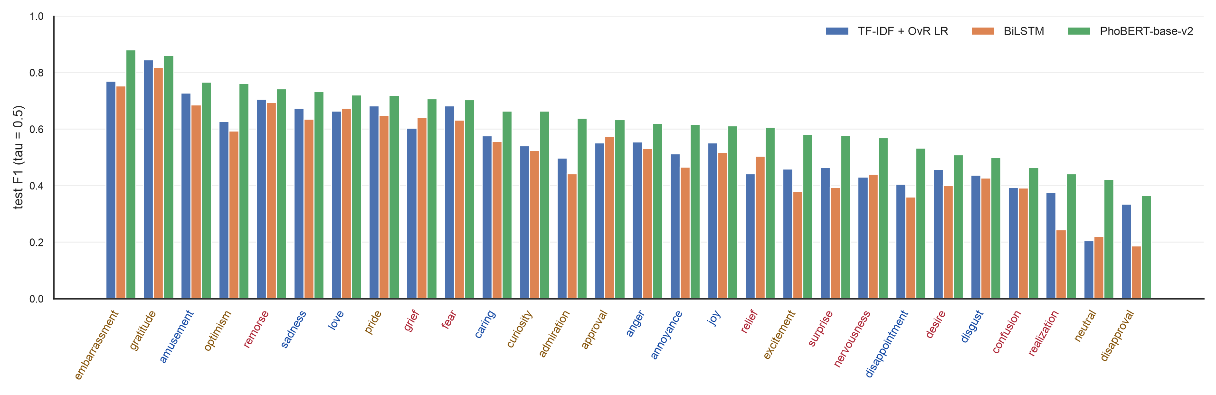
Figure 4. Test F1 per label for the three required models, sorted by PhoBERT (tick colour = tier: blue head, brown mid, red tail).
Answer. For PhoBERT the easiest labels are embarrassment (0.881), gratitude (0.860), amusement (0.766), optimism (0.761), remorse (0.743); the hardest are disapproval (0.365), neutral (0.422), realization (0.442), confusion (0.465), disgust (0.500). The ranking is consistent across the three models: gratitude and embarrassment are near the top for all of them, and disapproval, neutral and realization are at the bottom for all of them — the same weak labels reported in the original paper. The easy labels have explicit lexical markers (“cảm ơn”, “ngại quá”, laughter tokens); the hard ones are implicit and context-dependent (disapproval versus annoyance, a factual realization versus neutral). PhoBERT's largest gains over the baselines are on exactly these context-dependent labels (realization, neutral, disapproval, admiration).

Q2. How strongly does performance correlate with training label frequency?
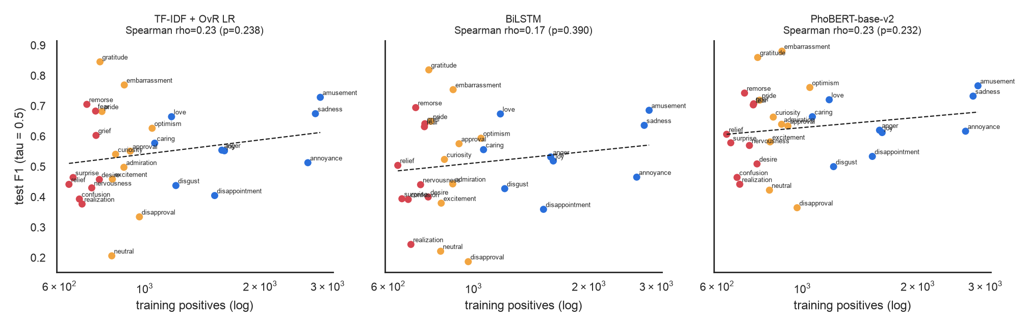
Figure 5. Per-label test F1 against training positives (log scale), with a log-linear fit.
Table 17. Correlation between training frequency and per-label test F1, and mean F1 per tier.
Model | Pearson r | p | Spearman ρ | p | Head F1 | Mid F1 | Tail F1
TF-IDF + OvR LR | 0.221 | 0.258 | 0.230 | 0.238 | 0.567 | 0.551 | 0.506
BiLSTM | 0.172 | 0.383 | 0.169 | 0.390 | 0.539 | 0.515 | 0.482
PhoBERT-base-v2 | 0.186 | 0.344 | 0.233 | 0.232 | 0.641 | 0.653 | 0.592

Answer. The correlation is positive but weak and not statistically significant for any model (Spearman ρ = 0.230, 0.169 and 0.233; all p > 0.2 over 28 labels). Tail labels are on average about five F1 points below head labels for PhoBERT (0.592 vs 0.641), but frequency explains little of the variation: disapproval (969 training positives) is the hardest label, the head label annoyance (2,662) scores only 0.617, while the tail labels remorse and grief exceed 0.70. With an imbalance ratio of only 4.5×, semantic ambiguity and overlap within emotion families matter more than rarity. These are correlations and do not establish causation.

Q3. Which emotion pairs co-occur most, and does the baseline preserve these dependencies?
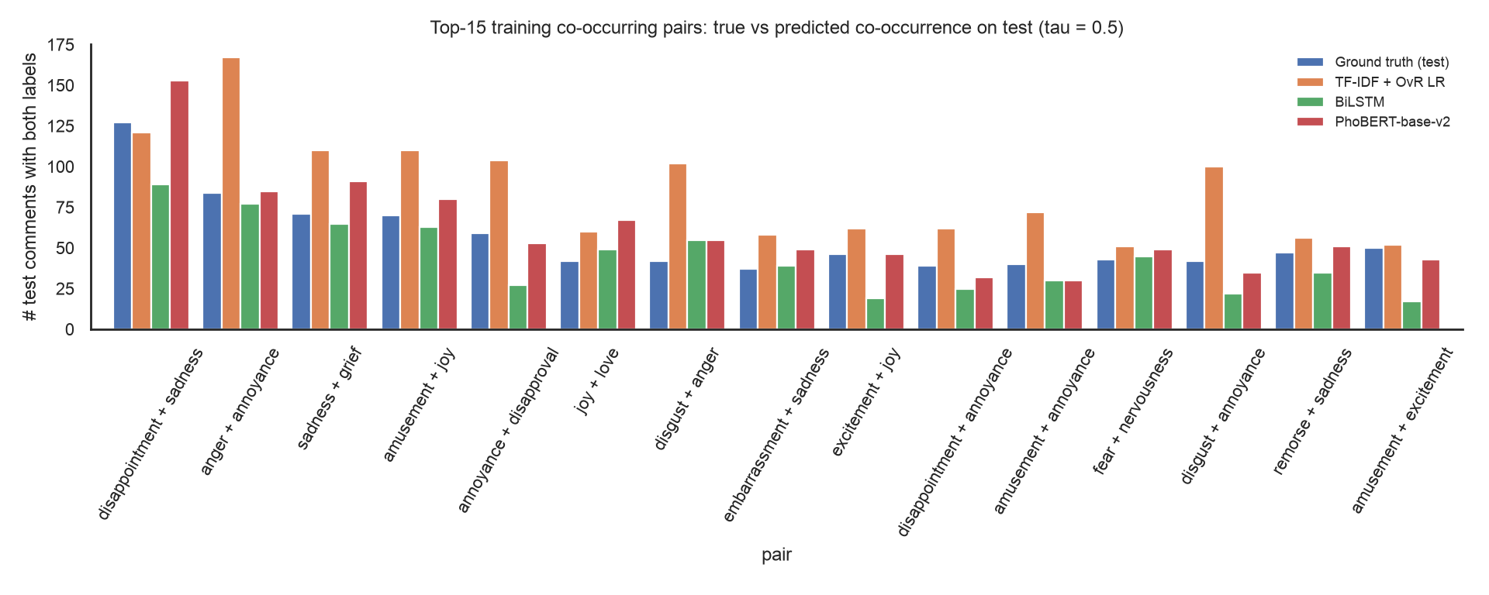
Figure 6. For the 15 most frequent training pairs: true co-occurrence on test versus predicted co-occurrence (τ = 0.5).
Table 18. Global dependency preservation on test (378 label pairs).
Model | r (pair counts) | r (phi) | ρ (phi) | True pairs | Pred. pairs | True |Y| | Pred. |Y|
TF-IDF + OvR LR | 0.921 | 0.918 | 0.844 | 2,466 | 4,698 | 1.907 | 2.304
BiLSTM | 0.940 | 0.931 | 0.887 | 2,466 | 1,658 | 1.907 | 1.577
PhoBERT-base-v2 | 0.972 | 0.962 | 0.915 | 2,466 | 2,314 | 1.907 | 1.826

Answer. The most frequent pairs are disappointment + sadness, anger + annoyance and sadness + grief (Table 6). All models are label-independent by construction, so dependencies can only be learned through the shared representation. PhoBERT preserves them best: the Pearson correlation between true and predicted pair counts over all 378 pairs is 0.972, and it predicts 1.826 labels per comment against 1.907 in the ground truth. TF-IDF with balanced class weights over-predicts (2.304 labels per comment, 4,698 predicted pairs versus 2,466 true ones), inflating hostile pairs such as disgust + anger (2.4×). The BiLSTM under-predicts (1.577 labels per comment) and loses pairs such as excitement + joy (0.41×). PhoBERT's remaining distortion is over-predicting joy + love (1.6×) and disappointment + sadness (1.2×).

Q4. On which text styles does PhoBERT most outperform the recurrent baseline?
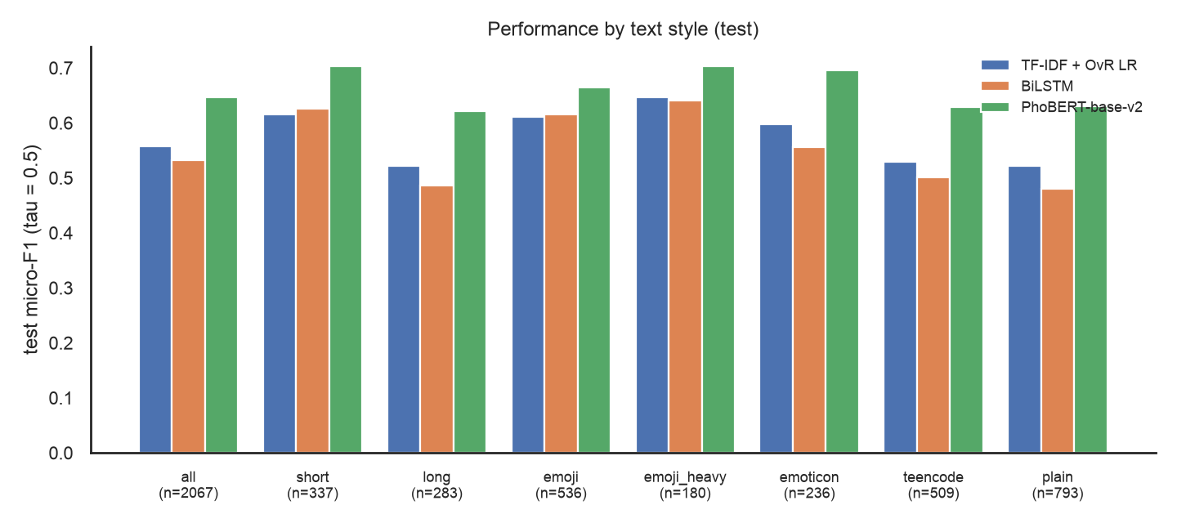
Figure 7. Test Micro-F1 by text-style subset (rules frozen in src/vigo/analysis/text_styles.py before evaluation).
Table 19. Macro-F1 by text style; Δ = PhoBERT − BiLSTM; 95% CI from a paired bootstrap (500 resamples) of the Micro-F1 difference.
Subset | Rule | n | TF-IDF | BiLSTM | PhoBERT | Δ Macro | Δ Micro 95% CI
all | all test comments | 2,067 | 0.542 | 0.512 | 0.629 | 0.117 | [+0.098, +0.128]
short | <= 5 whitespace tokens | 337 | 0.575 | 0.553 | 0.658 | 0.104 | [+0.042, +0.108]
long | >= 30 whitespace tokens | 283 | 0.473 | 0.414 | 0.577 | 0.163 | [+0.099, +0.172]
emoji | >= 1 emoji | 536 | 0.544 | 0.531 | 0.590 | 0.059 | [+0.019, +0.077]
emoji_heavy | >= 2 emoji characters | 180 | 0.557 | 0.531 | 0.619 | 0.088 | [+0.024, +0.105]
emoticon | >= 1 ASCII emoticon | 236 | 0.493 | 0.419 | 0.608 | 0.189 | [+0.099, +0.179]
teencode | >= 1 multi-character teencode-dictionary token | 509 | 0.501 | 0.468 | 0.596 | 0.128 | [+0.099, +0.155]
plain | not short, no emoji/emoticon/teencode | 793 | 0.526 | 0.486 | 0.628 | 0.142 | [+0.128, +0.174]

Answer. PhoBERT outperforms the BiLSTM on every subset, and every bootstrap interval excludes zero. The largest Macro-F1 gains are on comments with ASCII emoticons (+0.189), long comments (+0.163) and teencode comments (+0.128) — styles where the emotion must be inferred from context rather than a single cue. The smallest gains are on emoji comments (+0.059) and short comments (+0.104): an emoji is a strong lexical cue that the BiLSTM learns directly as a token, while PhoBERT only sees its Vietnamese description. This suggests complementing PhoBERT with an emoji-aware encoder (ViSoBERT), which the ensemble does.

Q5. How sensitive are the outputs to the default threshold of 0.5?
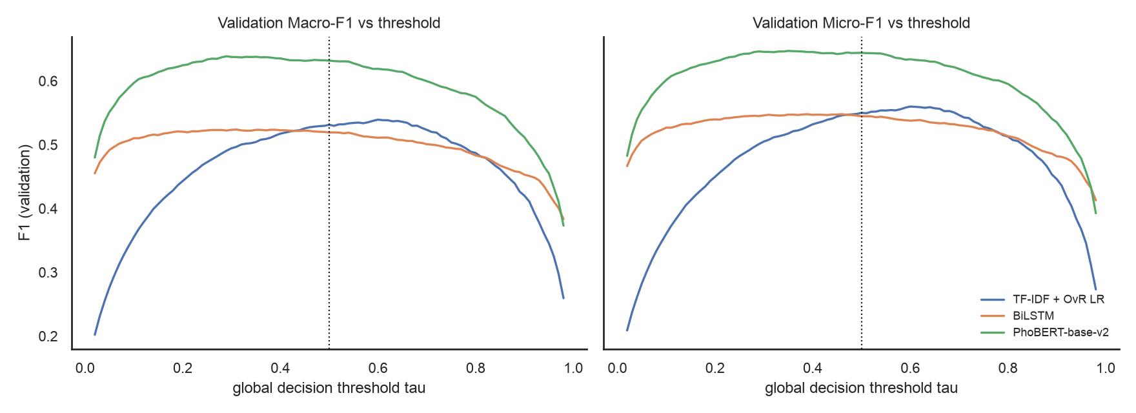
Figure 8. Validation Macro-F1 and Micro-F1 as a function of a global threshold.
Table 20. Validation Macro-F1 at several global thresholds.
Model | τ=0.3 | τ=0.4 | τ=0.5 | τ=0.6 | τ=0.7 | Best τ | F1 at best | Range in [0.3, 0.7]
TF-IDF + OvR LR | 0.495 | 0.517 | 0.531 | 0.540 | 0.523 | 0.6 | 0.540 | 0.045
BiLSTM | 0.523 | 0.523 | 0.519 | 0.511 | 0.501 | 0.31 | 0.524 | 0.023
PhoBERT-base-v2 | 0.638 | 0.635 | 0.632 | 0.619 | 0.600 | 0.29 | 0.639 | 0.038
ViSoBERT | 0.617 | 0.612 | 0.609 | 0.604 | 0.599 | 0.27 | 0.617 | 0.019
ViSoBERT-14GB | 0.621 | 0.623 | 0.617 | 0.606 | 0.585 | 0.38 | 0.623 | 0.038
Ensemble (3) | 0.654 | 0.652 | 0.641 | 0.622 | 0.586 | 0.32 | 0.655 | 0.069

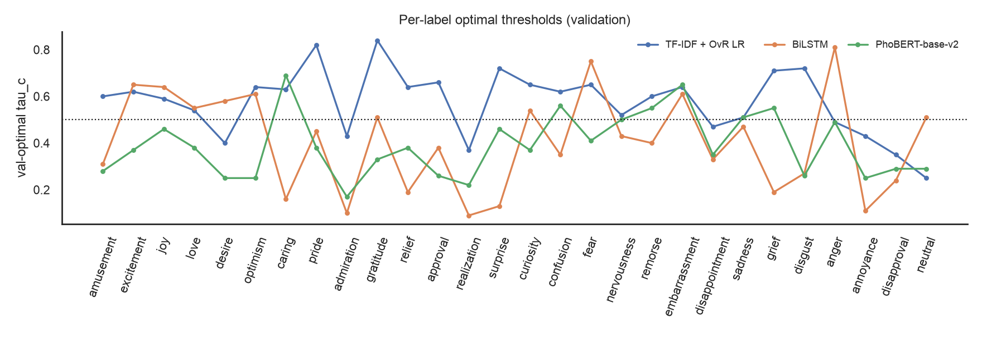
Figure 9. Validation-optimal threshold per label for the three required models.
Answer. On aggregate, 0.5 is close to optimal for PhoBERT: its validation Macro-F1 curve is flat between about 0.25 and 0.5 (best 0.639 at τ = 0.29 vs 0.632 at 0.5) and falls quickly above 0.6. The baselines behave differently: TF-IDF with balanced class weights prefers τ ≈ 0.6, the BiLSTM τ ≈ 0.31. Per label, however, the optimum varies widely — for PhoBERT from 0.17 (admiration) to 0.69 (caring), median 0.38 — so a single uniform threshold is not what individual labels prefer. Per-label tuning adds 0.023 Macro-F1 on validation but only 0.004 on test, a sign of threshold over-fitting on the small validation set.

10. Error analysis
We analyse PhoBERT on the test set at τ = 0.5 (error_by_label.csv, error_confusion_pairs.csv, error_by_bucket.csv). The code also extracts 97 cases for manual audit (25 false negatives, 25 false positives, 15 high-cardinality partial matches, and 8 each of short, emoji-heavy, teencode and emoticon comments); the public file lists ids, labels and probabilities only. Four recurring failure modes emerge:
- Confusion inside an emotion family. The most frequent pattern is a missed annoyance while sadness (24) or disappointment is predicted, followed by disgust ↔ annoyance ↔ anger. These pairs belong to the same families found in the correlation analysis (Section 3.3).
- Implicit, context-bound labels. Miss rates are highest for disapproval (68.8%), neutral (61.2%), realization (60.0%) and confusion (57.1%); realization is often predicted as neutral and neutral as annoyance.
- Pull towards about two labels. Single-label comments receive 0.760 spurious labels on average, while comments with four or more labels lose 1.894 labels; exact match falls from 40.9% (|Y| = 1) to 9.1% (|Y| ≥ 4).
- Long comments. Exact match is 19.8% on long comments versus 44.8% on short ones, with 0.887 vs 0.451 missed labels per comment.
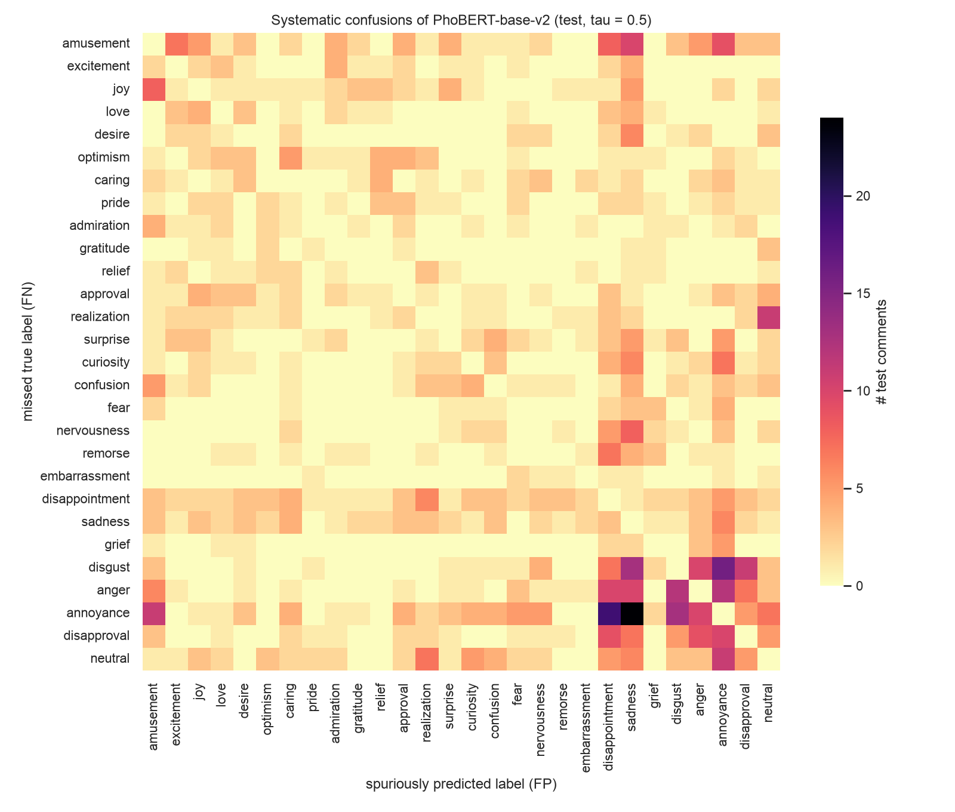
Figure 10. Missed true label (rows) versus spuriously predicted label (columns) in the same test comment, PhoBERT.
Table 21. Labels with the most false negatives (PhoBERT, test).
Label | Support | FN | FP | Miss rate | FP per 100
annoyance | 343 | 145 | 101 | 42.3% | 4.89
amusement | 374 | 105 | 59 | 28.1% | 2.85
disappointment | 197 | 90 | 97 | 45.7% | 4.69
joy | 204 | 80 | 77 | 39.2% | 3.73
anger | 189 | 78 | 58 | 41.3% | 2.81
disapproval | 112 | 77 | 45 | 68.8% | 2.18
disgust | 141 | 75 | 57 | 53.2% | 2.76
neutral | 116 | 71 | 52 | 61.2% | 2.52
sadness | 345 | 70 | 131 | 20.3% | 6.34
realization | 95 | 57 | 39 | 60.0% | 1.89

Table 22. Error profile by text style and by label cardinality (PhoBERT, test).
Bucket | n | Exact match | Samples-F1 | Micro-F1 | FN / comment | FP / comment
all | 2,067 | 0.294 | 0.628 | 0.646 | 0.701 | 0.620
style=short | 337 | 0.448 | 0.700 | 0.703 | 0.451 | 0.490
style=long | 283 | 0.198 | 0.600 | 0.622 | 0.887 | 0.767
style=emoji | 536 | 0.308 | 0.663 | 0.665 | 0.660 | 0.659
style=emoji_heavy | 180 | 0.333 | 0.702 | 0.704 | 0.611 | 0.622
style=emoticon | 236 | 0.305 | 0.674 | 0.696 | 0.669 | 0.521
style=teencode | 509 | 0.267 | 0.610 | 0.629 | 0.731 | 0.699
style=plain | 793 | 0.259 | 0.602 | 0.631 | 0.749 | 0.618
|Y|=1 | 695 | 0.409 | 0.592 | 0.570 | 0.299 | 0.760
|Y|=2 | 946 | 0.276 | 0.637 | 0.656 | 0.728 | 0.604
|Y|=3 | 360 | 0.156 | 0.668 | 0.689 | 1.186 | 0.450
|Y|>=4 | 66 | 0.091 | 0.645 | 0.673 | 1.894 | 0.318

Table 23. Example audited cases (public version: ids and labels only).
Type | Sample id | True labels | Predicted | Top probabilities
false negative | 3919 | confusion, fear | (none) | neutral(0.41), curiosity(0.27), confusion(0.13), sadness(0.09)
false negative | 15999 | amusement, optimism | (none) | admiration(0.36), annoyance(0.30), disgust(0.25), anger(0.22)
false negative | tik005017 | caring | anger, annoyance | anger(0.94), annoyance(0.69), disgust(0.15), disapproval(0.01)
false negative | 609 | amusement, relief | amusement | amusement(0.98), excitement(0.49), curiosity(0.35), joy(0.10)
false negative | 682 | amusement, neutral | disgust, anger | anger(0.76), disgust(0.62), annoyance(0.50), surprise(0.07)
false negative | 12013 | amusement | sadness | sadness(1.00), disappointment(0.40), caring(0.09), nervousness(0.02)
false negative | tik013247 | disappointment, sadness | realization | realization(0.78), remorse(0.49), confusion(0.44), sadness(0.10)
false negative | 20465 | approval | nervousness, disappointment, sadness, annoyance | disappointment(0.82), sadness(0.82), annoyance(0.71), nervousness(0.54)
false negative | 14149 | curiosity, neutral | approval | approval(0.78), caring(0.11), realization(0.09), gratitude(0.04)
false negative | 4766 | curiosity, disappointment, annoyance | curiosity | curiosity(0.61), amusement(0.36), excitement(0.25), desire(0.04)
false negative | tik012972 | remorse, sadness | sadness | sadness(1.00), love(0.33), disappointment(0.29), joy(0.16)
false negative | 4040 | surprise, disappointment, annoyance | disappointment, annoyance | disappointment(0.90), annoyance(0.69), disapproval(0.41), confusion(0.27)

Implications. The errors point to (i) dependency-aware decoding or modelling for emotion families, (ii) cardinality-aware or per-label decoding, which the threshold study of the Final investigates, and (iii) better handling of long, mixed comments, such as sentence-level aggregation.

11. Proposed Final research question
RQ1 (required): Is a single uniform decision threshold (τ = 0.5) optimal across all 27 emotion labels in the presence of class imbalance?
The Midterm already provides evidence. The per-label optima span 0.17–0.69. Lowering the global threshold raises PhoBERT's Micro-F1 on comments with |Y| ≥ 4 from 0.673 to 0.750 but lowers it on |Y| = 1 from 0.570 to 0.527. And the validation gain of per-label tuning shrinks on test. Planned controlled design:
- use the best Midterm network(s) with the backbone frozen; fit the fixed, global and per-label strategies on validation only and evaluate once on test;
- report Macro-F1, Micro-F1, per-label F1 and Hamming loss, broken down by head / mid / tail tier (rule of Section 3.1) and by |Y| = 1, 2, 3, ≥ 4;
- report the calibrated threshold profile τ*_c and the validation-to-test gap ΔF1 to quantify threshold over-fitting;
- robustness: three seeds with bootstrap confidence intervals, a per-label threshold shrunk towards the global one, and a check on the iterative-stratified split;
- optional extensions after RQ1: dependency-aware modelling (RQ2), imbalance-aware losses (RQ3) and noise robustness on teencode and unaccented text (RQ4).
Validation and test probabilities are already stored in the required schema (sample_id, true_label_vector, probability_vector, pred_fixed, pred_global, pred_per_label, label_cardinality) under results/predictions/.

12. Limitations
- All neural results come from a single seed (42); typical seed-to-seed variation for this task is around ±0.5 F1, so small differences (for example between ViSoBERT variants) are not conclusive.
- The recipe differences with the paper were not ablated individually; the gains over the published numbers are therefore not attributed to specific components.
- The official split is only random-level stratified, and the validation set holds as few as 58 positives for the rarest label, which limits threshold estimation.
- The ViSoBERT-14GB learning rate was set after inspecting the ViSoBERT validation curve (a validation-only decision, but still a form of adaptive tuning).
- Teencode dictionaries contain ambiguous entries (single letters such as “t”, “m”), and word segmentation makes errors on non-standard text; neither was evaluated intrinsically.
- CafeBERT and PhoBERT-large configurations are provided but were not run (they need a larger GPU); training times were measured on an Apple M1 Pro and are not comparable with GPU timings.

13. Reproducibility
All results in this report are regenerated from code with bash scripts/run_all.sh (or notebooks/00_colab_quickstart.ipynb on Google Colab), which calls the package command line (python -m vigo eda | split | train-tfidf | train-rnn | train-transformer | ensemble | analyze). The package is organised by responsibility: vigo.data (loading, split, preprocessing), vigo.models, vigo.training, vigo.evaluation, vigo.analysis and vigo.utils. Split ids (splits/), YAML configurations (configs/), saved probabilities (results/runs/, results/predictions/), environment records (hardware_and_versions.txt, results/runs/*/env.json) and unit tests (tests/) are included. Raw comments are not included, in line with the dataset licence.

References
- T. Q. Hung, P. T. Nam, S. T. Luu, K. V. Nguyen. ViGoEmotions: A Benchmark Dataset for Fine-grained Emotion Detection on Vietnamese Texts. EACL 2026, pp. 2805–2831. doi:10.18653/v1/2026.eacl-long.129. Code and dictionaries: github.com/ricardo-tran/ViGoEmotions.
- D. Q. Nguyen, A. T. Nguyen. PhoBERT: Pre-trained language models for Vietnamese. Findings of EMNLP 2020.
- Q.-N. Nguyen et al. ViSoBERT: A Pre-Trained Language Model for Vietnamese Social Media Text Processing. EMNLP 2023; 5CD-AI, visobert-14gb-corpus (Hugging Face).
- T. Vu, D. Q. Nguyen, D. Q. Nguyen, M. Dras, M. Johnson. VnCoreNLP: A Vietnamese Natural Language Processing Toolkit. NAACL 2018 (Demonstrations).
- VinAI Research. Vietnamese tone normalisation table (BARTpho repository); Unicode CLDR Vietnamese emoji annotations.
- D. Demszky et al. GoEmotions: A Dataset of Fine-Grained Emotions. ACL 2020.
- A. Graves, J. Schmidhuber. Framewise phoneme classification with bidirectional LSTM. Neural Networks, 2005.
- K. Sechidis, G. Tsoumakas, I. Vlahavas. On the stratification of multi-label data. ECML-PKDD 2011.
- I. Pillai, G. Fumera, F. Roli. Threshold optimisation for multi-label classifiers. Pattern Recognition 46(7), 2013.
- R. Alotaibi, P. Flach. Multi-label thresholding for cost-sensitive classification. Neurocomputing 436, 2021.
- C. Sun, X. Qiu, Y. Xu, X. Huang. How to Fine-Tune BERT for Text Classification? CCL 2019 (layer-wise learning-rate decay).

Appendix A. Midterm requirement checklist
Table 24. Brief requirements and the evidence produced by the code.
Requirement | Evidence (results/…)
Sample count and 27(+1)-label inventory | tables/dataset_summary.csv, label_inventory.csv
Label frequency, head / mid / tail | tables/label_frequency.csv, label_tiers.csv, figures/label_frequency.png
Label cardinality distribution | tables/cardinality_summary.csv, figures/cardinality_distribution.png
Co-occurrence and correlation matrix | tables/top_pairs.csv, correlation_matrix_train.csv, figures/cooccurrence.png, correlation.png
Text length (tokens and characters) | tables/text_length_stats.csv, figures/token_length.png, char_length.png
Informal Vietnamese review | tables/informal_text_audit.csv, teencode_top.csv, emoji_top.csv, emoji_rate_by_label.csv
Stratified multi-label split protocol | splits/official/*, tables/split_quality_audit.csv, split_label_coverage.csv
TF-IDF + OvR LR, BiLSTM, PhoBERT (sigmoid + BCE) | runs/tfidf_lr, runs/bilstm, runs/phobert (config, env, summary, probabilities)
Macro/Micro-F1, per-label F1, Hamming, LRAP/mAP, params, time | tables/main_results_test.csv, per_label_f1.csv
Q1–Q5 | tables/q1_*–q5_*, figures/q1_*–q5_*
Error analysis on edge cases | tables/error_*.csv, figures/error_confusion_pairs.png
Proposed Final research question | Section 11; predictions/ in the Final schema
Slides, notebooks, README | slides/, notebooks/, README.md

