|  |  |
| --- | --- |
|  | **MINISTRY OF EDUCATION AND TRAINING** |

**FPT UNIVERSITY**

|  |
| --- |
| Capstone Project Document |
| Designing a mobile robot navigation and  target tracking system   |  |  | | --- | --- | | **Group 2 – Embedded System** | | | **Group Members** | Bui Ha Duong Leader SE60772  Tran Vo Hoang Member SE60814  Truong Buu Hoang Duy Member SE60672  Duong Minh Tuan Member SE60642  Nguyen Huu Tai Member 60042 | | **Supervisor** | Tran Khanh Ninh | | **Ext Supervisor** | N/A | | **Capstone Project Code** | RNT | |

Ho Chi Minh City, 01/2014

# Introduction

## Scenario

Nowadays, the technology has the long steps if compared to the previous; it contributes to the development of science. From the initial idea is a mobile thing could help us in searching, detecting object(s) - the mobile robot navigation is a little part of the development contribution, and it could be used to search, find and relocate object in our environment. The one demand of science is to discovery, study new and strange place/ environments, there are many mobile robot used in this way like discovering harsh climate and dangerous place such as deep holes or in the deep of sea, new environment like Moon and Mars surfaces.

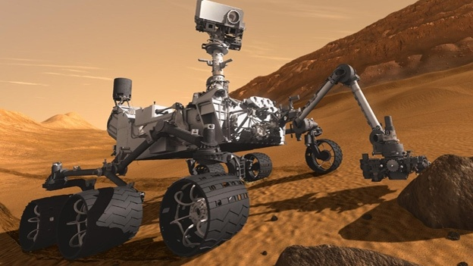

Figure A‑1 Curiosity Rover reaching Mars

The mobile robot has to work on the harsh climate and dangerous place where people cannot or hard to work: oxygen concentration is low or very low, radiation is unidentified, large temperature fluctuation, disaster like sandstorm, sleet etc., damaged by external impact by living creature, environment element. Following these reason and requirement, making a new kind of mobile robot with main missions are navigating, detecting and tracking object(s) is very important.

Besides that, this technology will have many benefits in the modern life. With algorithms for navigating, detecting, tracking object(s) and path planning, we can make new autonomous tools that help us to do things, works. For example: Google’s Self-Driving car, Robot Vacuum Cleaner…

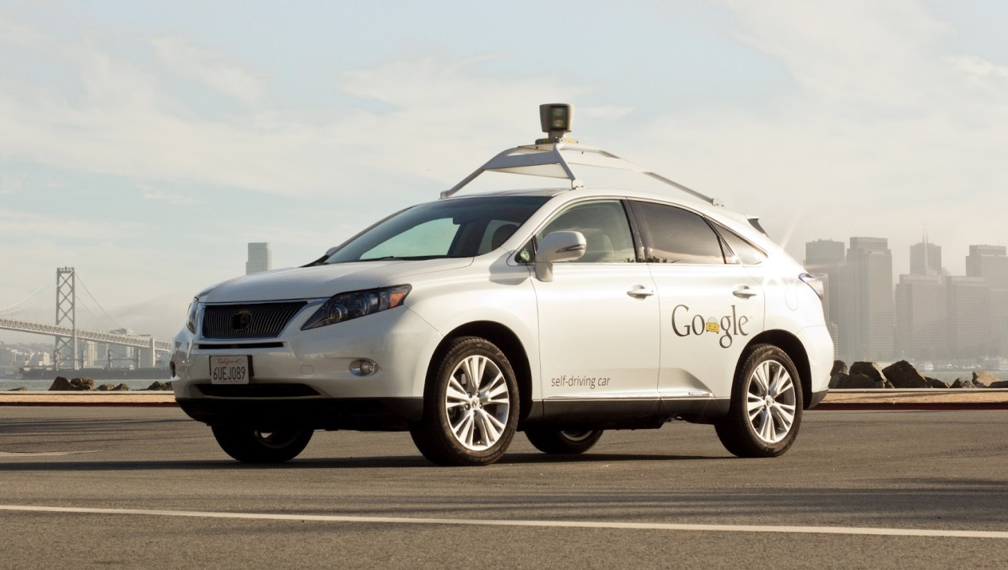

Figure A‑2 Google’s Self-Driving Car

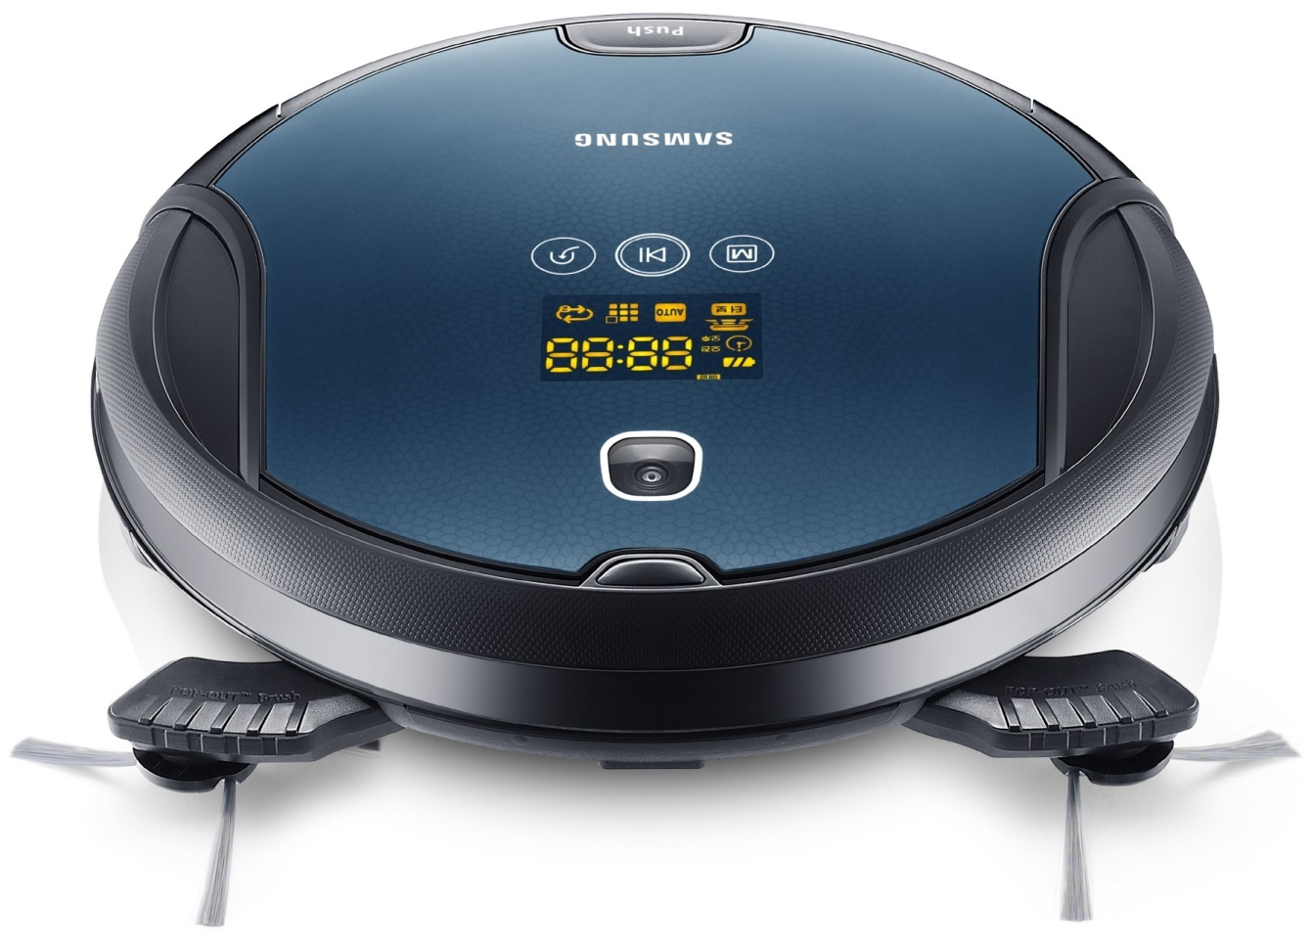

Figure A‑3 Robot Vacuum Cleaner

With the interest in science, our team had decided to develop a mobile robot can help us in navigating and detecting object(s) with hope to contribute in the development of science.

## Existing Project

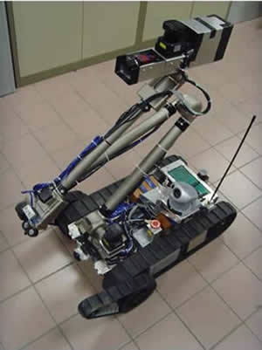

Figure A‑4 Robot X1 - National University of Singapore

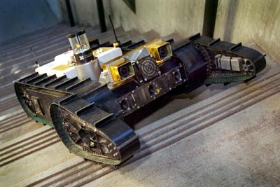

Figure A‑5 the autonomous Urbie is designed for various urban operations, including military reconnaissance and rescue operations.

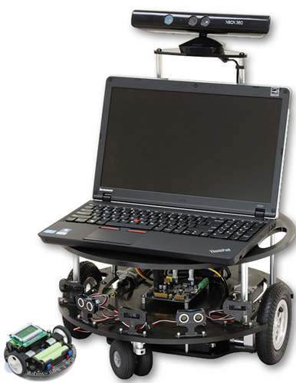

Figure A‑6 Autonomous Robot use Microsoft Kinect sensor

**Main features:**

* Autonomously navigation from unknown outdoor environment to indoor environment and navigation to a specified indoor location while avoiding obstacles;
* Searching, identifying and engaging all pre-specified targets in an uncertain indoor environment before it returns to the starting point;
* Negotiate a staircase before the entrance of the building;
* Identifying, locating and manipulating elevator buttons in order to autonomously operate the elevator.

## Proposed Solution and Approach

Our team proposed an autonomous mobile robot system has some advantages like:

* Low cost
* Light weight
* Low power consuming
* Vision based
* Two-wheeled robot platform
* Comparatively small in size
* Easy implementation
* Respond quickly with commands
* Efficient real-time solution for tracking object
* Can perform with a high degree of autonomy, which is particularly desirable in fields such as space exploration, cleaning floors…
* Gain information about the environment
* Work for an extended period with/without human intervention
* Move either all or part of itself throughout its operating environment with/without human assistance

So that, we have our approach:

* **Hardware**: Based on quality and cost, we mainly use products of Texas Instruments.
* **Firmware**: We use the TIVA™ C Series TM4C123G LaunchPad for the mobile robot’s brain.
* **Software**: We use C# .NET and EmguCV library for Graphical User Interface (GUI) and Image Processing.

## Project Overview

### Hardware Overview

### Firmware Overview

### Software Overview

## Scope of Project

The scope of this project is a prototype of an “Autonomous Mobile Robot”, includes hardware, firmware and software.

**Hardware – Mobile Robot:**

* Creating a Two-wheeled mobile robot
* Creating an Encoder system for mobile robot
* Creating a Driver circuit for dc servo motor
* Creating a Multi-sensor navigation system for the autonomous mobile robot

**Firmware:**

* Developing a motion control system for two-wheeled mobile robot
  + Go Ahead
  + Go Back
  + Turn Left
  + Turn Right
* Developing PID Algorithm for speed control
* Developing Communication between mobile robot and software
* Developing Communication between mobile robot and sensors

**Software:**

* Developing an integrated software environment for mobile robot navigation and path planning.
* Applying Computer Vision for tracking object(s)
* Applying Computer Vision for obstacles detection and avoidance.
* Applying Computer Vision for navigation and path planning.

## Team Introduction

|  |  |  |  |  |
| --- | --- | --- | --- | --- |
| **Roles and Responsibility** | | | | |
| **No** | **Full Name** | **Role** | **Position** | **Contact** |
| 1 | Trần Khánh Ninh | Project Owner | Instructor | NinhTK@fpt.edu.vn |
| 2 | Bùi Hà Dương | Project Manager/Developer | Team leader | DuongBHSE60772@fpt.edu.vn |
| 3 | Trần Võ Hoàng | Developer/Tester | Team member | HoangTVSE60814@fpt.edu.vn |
| 4 | Trương Bửu Hoàng Duy | Developer/Tester | Team member | DuyTBHSE60672@fpt.edu.vn |
| 5 | Dương Minh Tuấn | Developer/Tester | Team member | TuanDMSE60642@fpt.edu.vn |
| 6 | Nguyễn Hữu Tài | Developer/Tester | Team member | TaiNH60042@fpt.edu.vn |

Table A‑1 Team member and role in the project