1. Create a function that will receive an array of numbers as argument and will return a new array with distinct elements

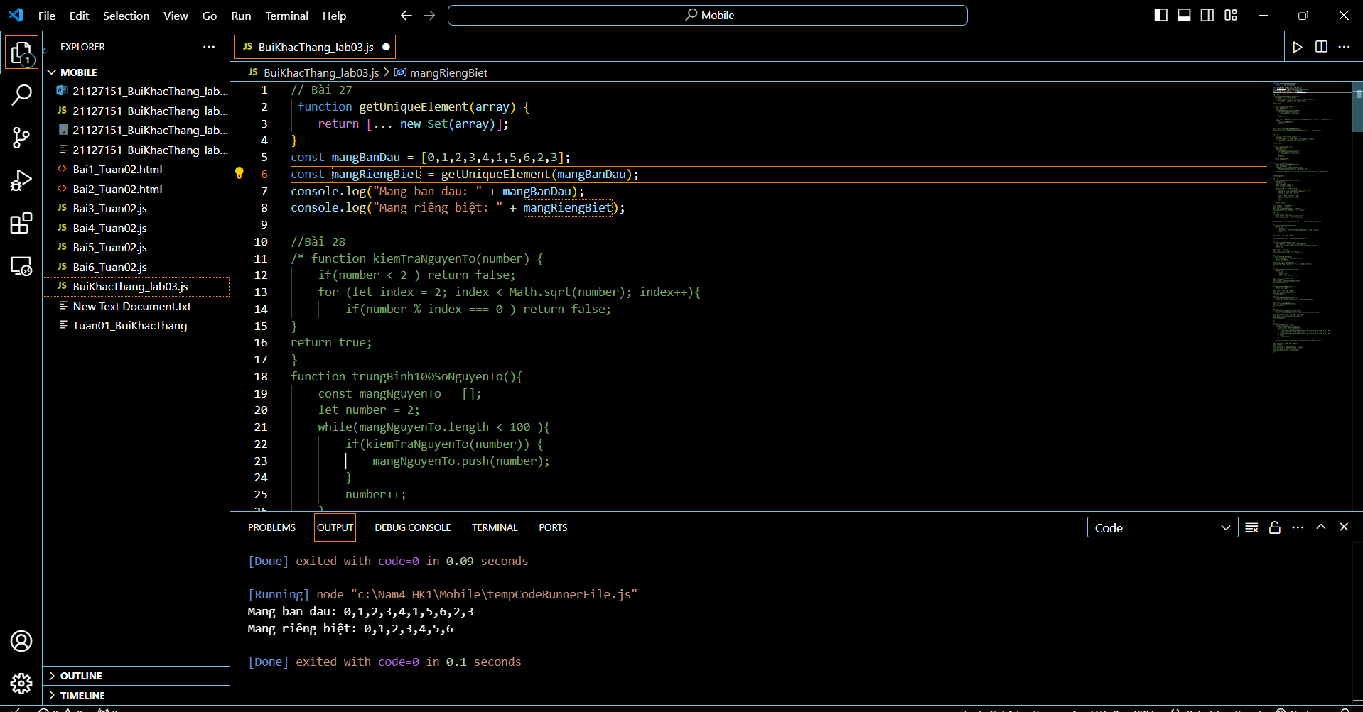

1. Calculate the sum of first 100 prime numbers and return them in an array

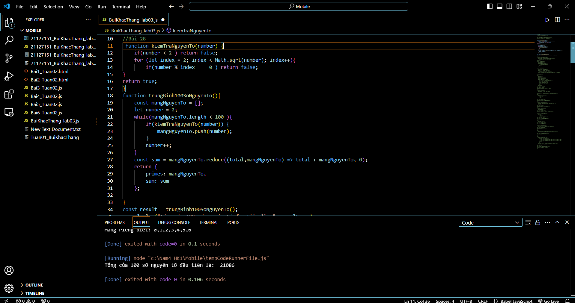

29. Print the distance between the first 100 prime numbers

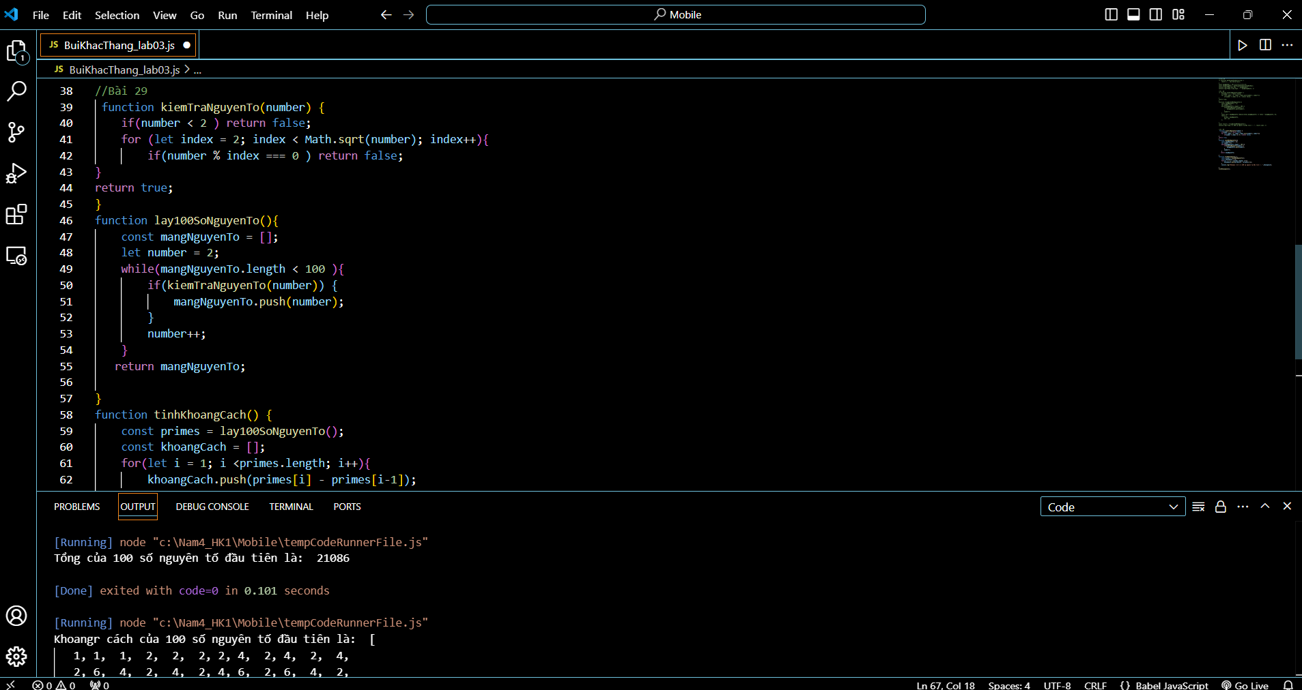

1. Create a function that will add two positive numbers of indefinite size. The numbers are received as strings and the result should be also provided as string.

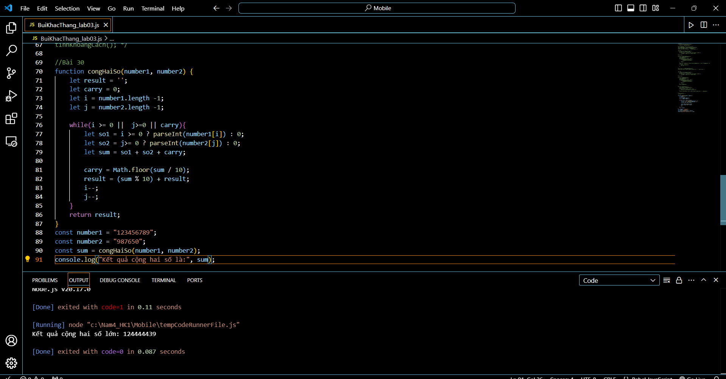

1. Create a function that will return the number of words in a text

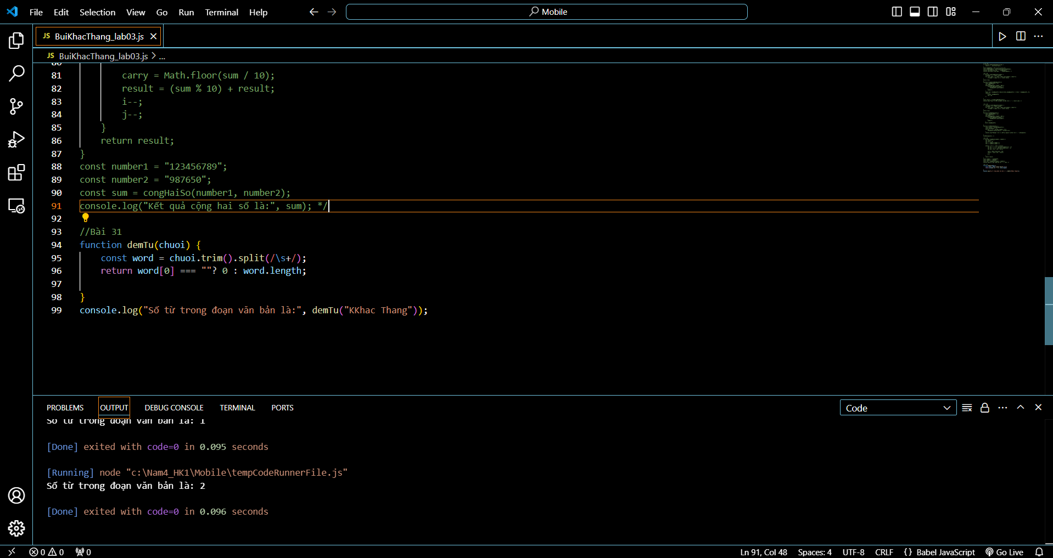

1. Create a function that will capitalize the first letter of each word in a text

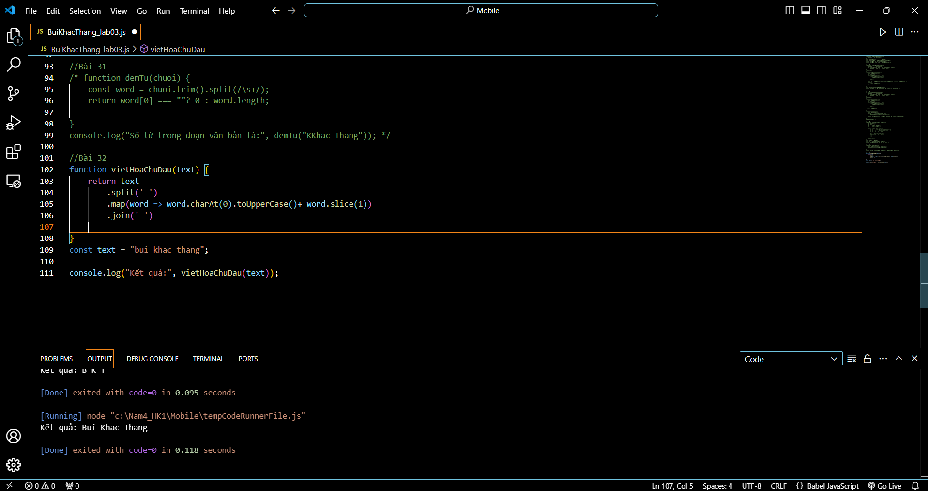

1. Calculate the sum of numbers received in a comma delimited string

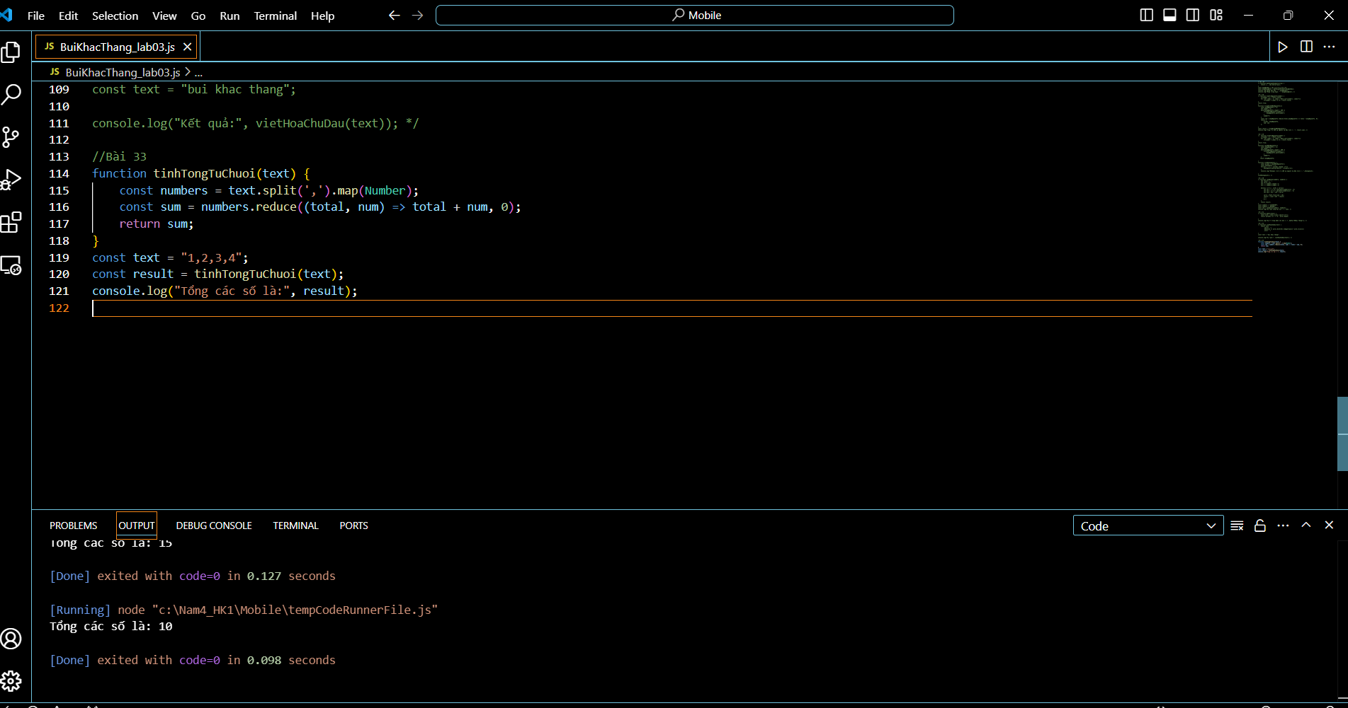

1. Create a function that returns an array with words inside a text.

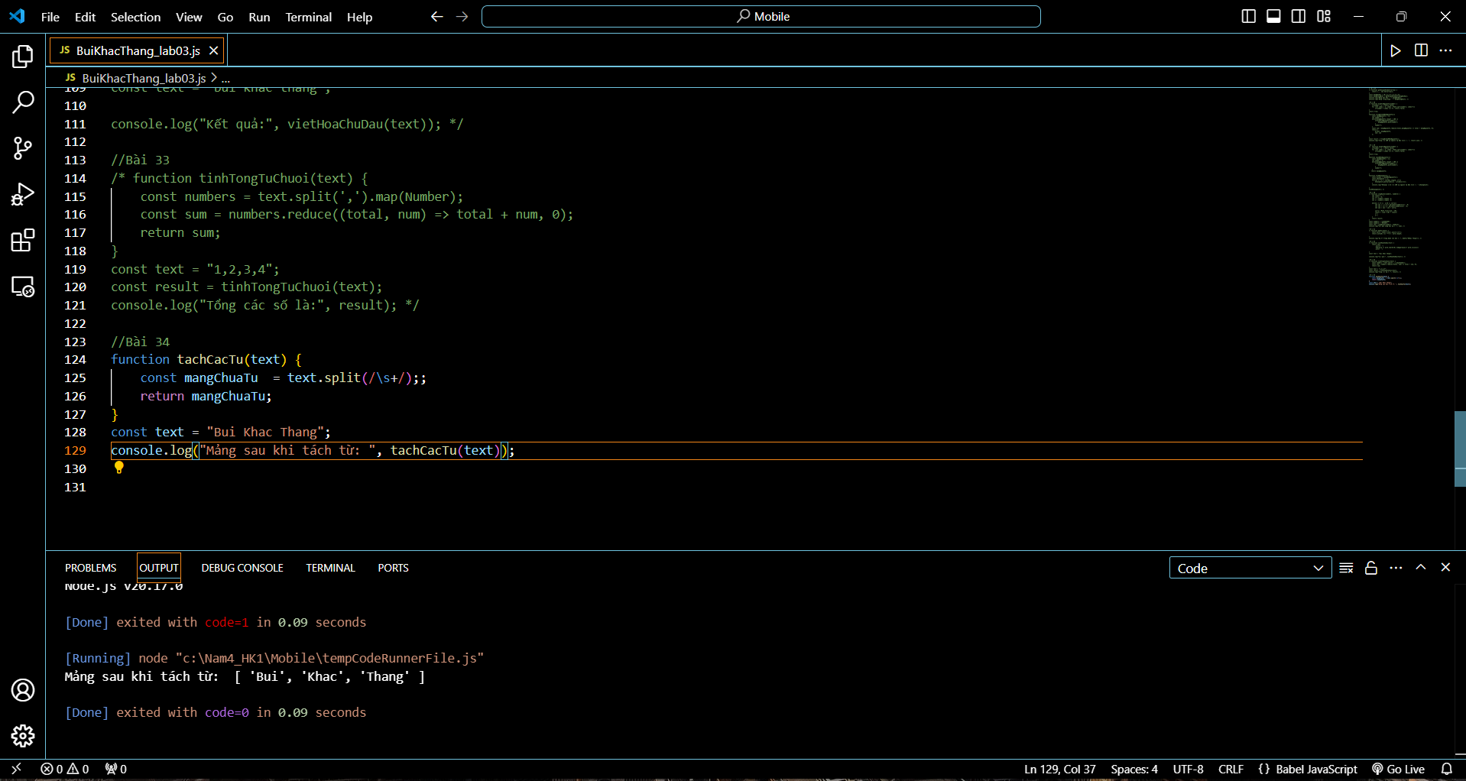

1. Create a function to convert a CSV text to a “bi-dimensional” array

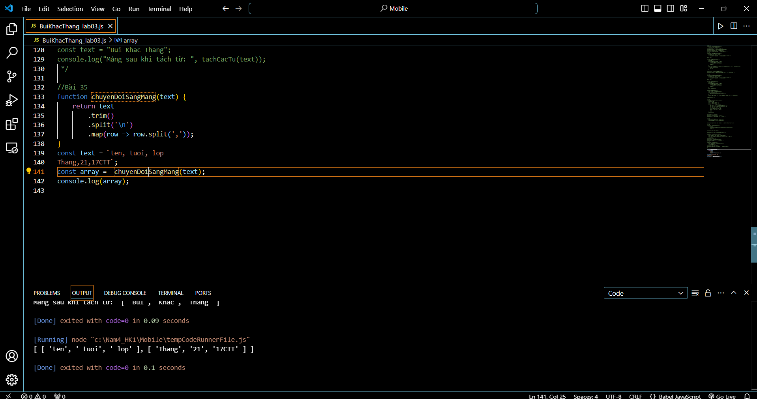

1. Create a function that converts a string to an array of characters

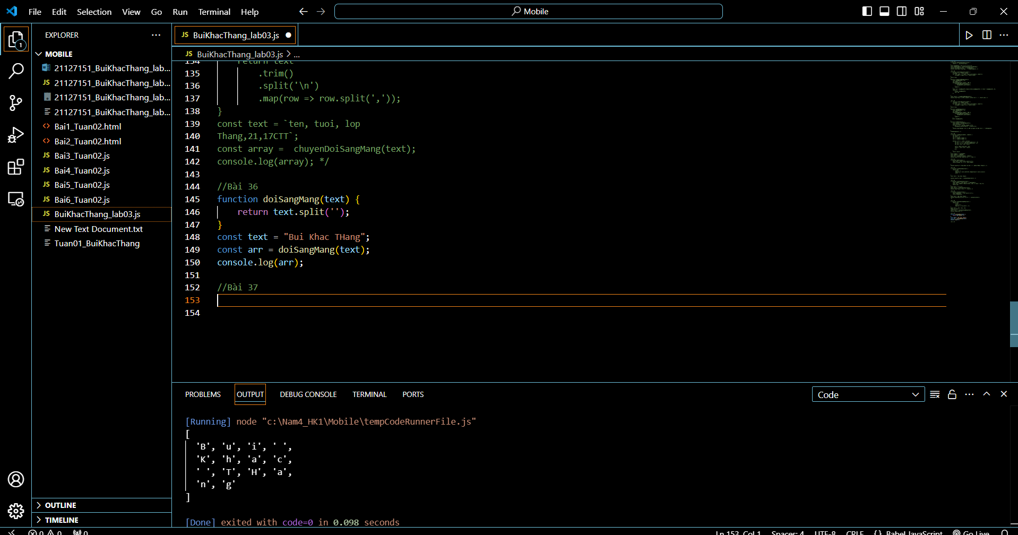

1. Create a function that will convert a string in an array containing the ASCII codes of each character

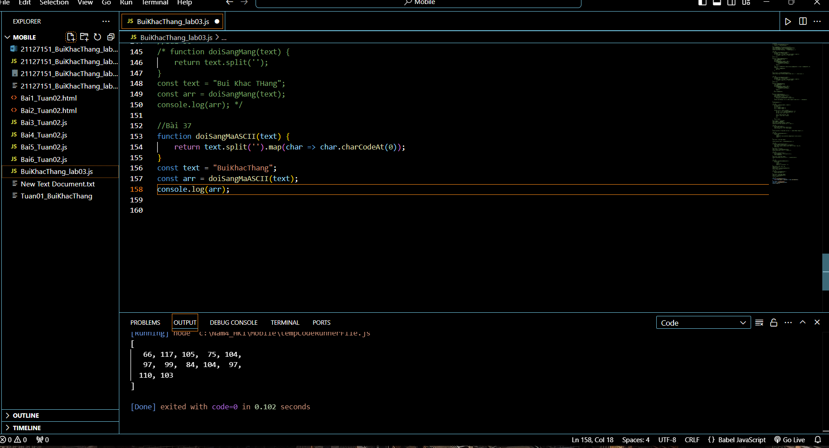

1. Create a function that will convert an array containing ASCII codes in a string

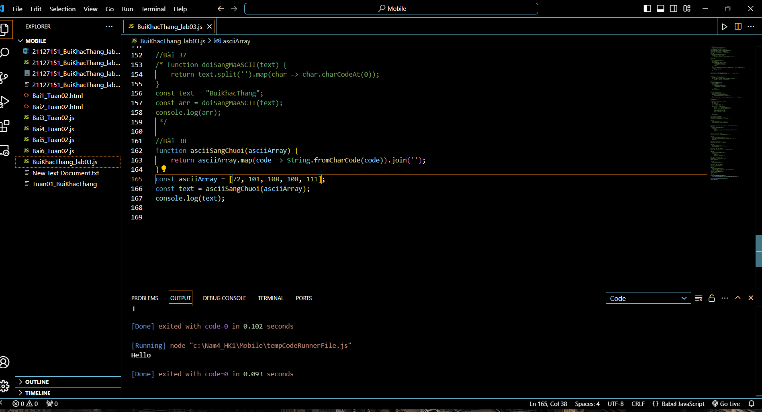

1. Implement the Caesar cypher

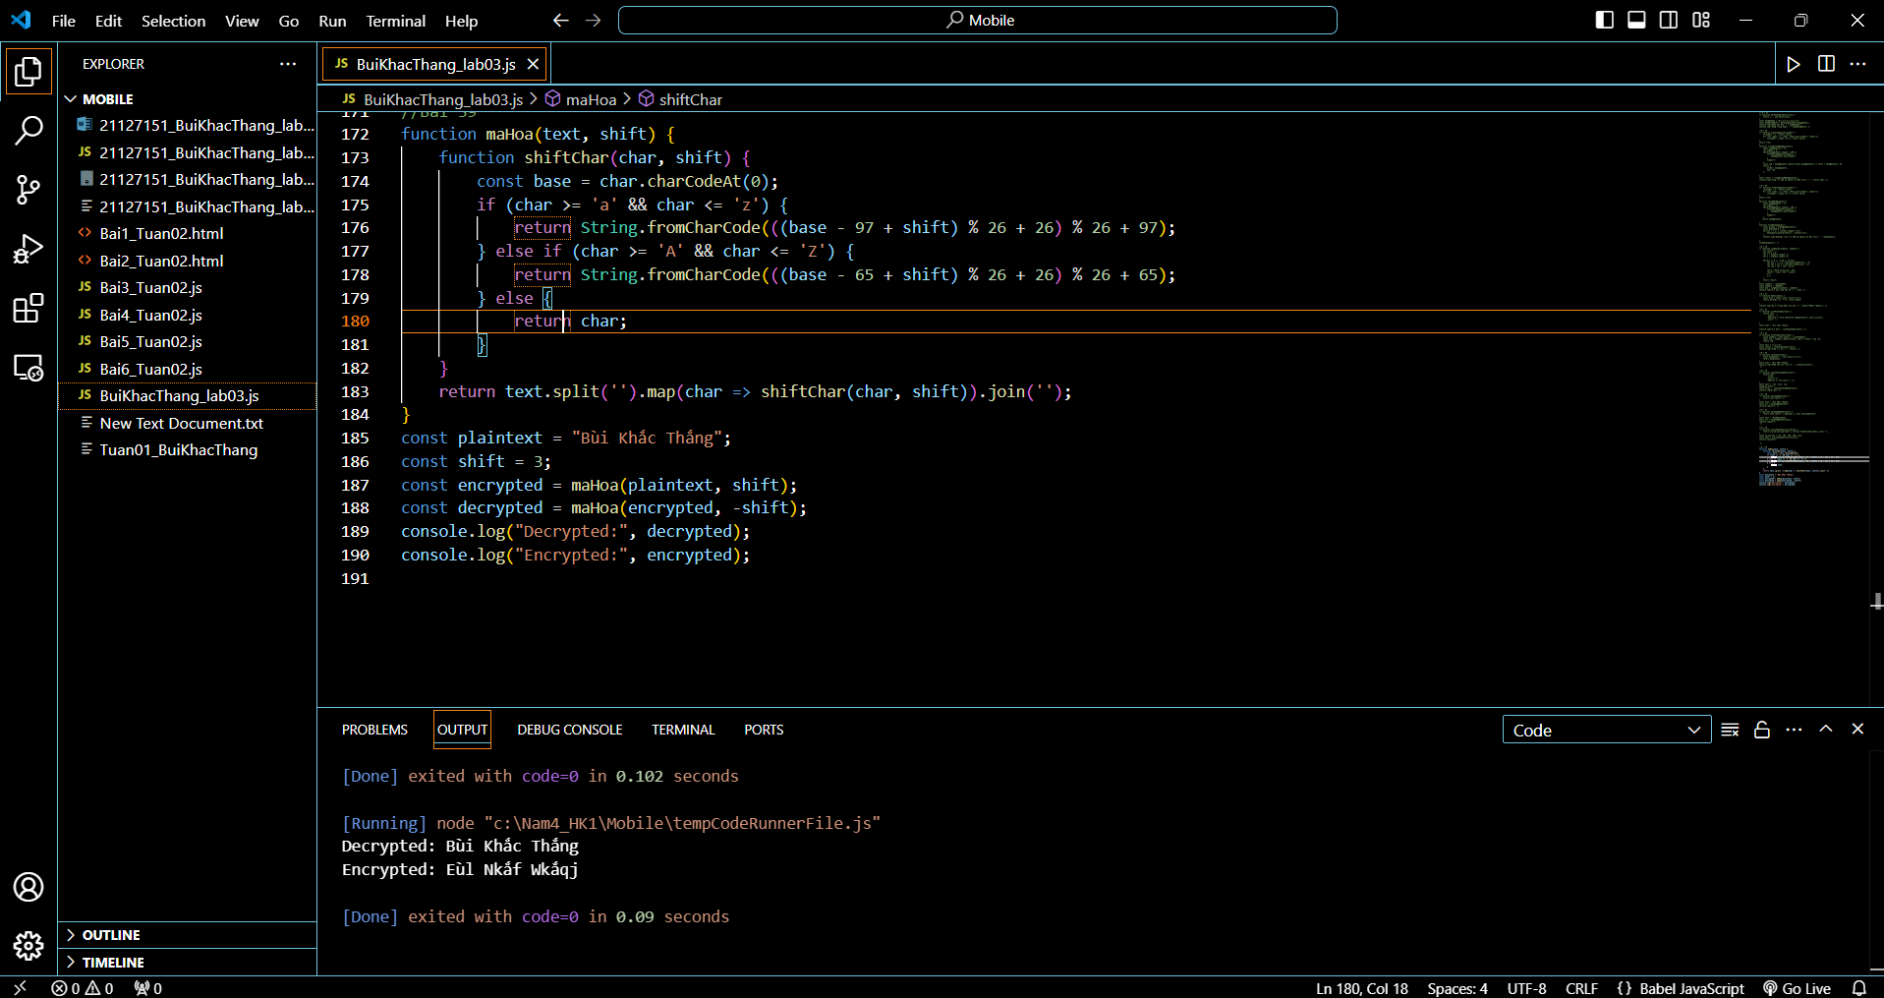

40. Implement the bubble sort algorithm for an array of numbers

41. Create a function to calculate the distance between two points defined by their x, y

coordinates

42. Create a function that will return a Boolean value indicating if two circles

defined by center coordinates and radius are intersecting

43. Create a function that will receive a bi-dimensional array as argument and a

number and will extract as a unidimensional array the column specified by the

number

44. Create a function that will convert a string containing a binary number into a

number

45. Create a function to calculate the sum of all the numbers in a jagged array

(contains numbers or other arrays of numbers on an unlimited number of

levels)

46. Find the maximum number in a jagged array of numbers or array of numbers

47. Deep copy a jagged array with numbers or other arrays in a new array

48. Create a function to return the longest word in a string

49. Shuffle an array of strings

50. Create a function that will receive n as argument and return an array of n

random numbers from 1 to n. The numbers should be unique inside the array.

51. Find the frequency of letters inside a string. Return the result as an array of

arrays. Each subarray has 2 elements: letter and number of occurrences.

52. Calculate Fibonacci(500) with high precision (all digits)

53. Calculate 70! with high precision (all digits)