Introduction to Software Engineering

Project Proposal & Plan

The student team is required to complete the Project Proposal & Plan documentation for the assigned course project, following the attached template.


Software Engineering Department
Faculty of Information and Technology
University of Science

Table of Contents
Objectives 1
1 Member Contribution Assessment 2
2 Vision 3
2.1 Preliminary Problem Statement 3
2.2 Product Position Statement 4
2.3 Stakeholders and Users 4
2.4 Scope and Key Features 5
3 Proposed Solution 7
3.1 Preliminary Architecture 7
3.2 Technology Stack 7
3.3 Hardware and Operating Environment 8
4 Project Plan 9
4.1 Process and Phase Gates 9
4.2 Work Breakdown Structure (WBS) 10
4.3 Estimation 10
4.4 Schedule 14
4.5 Roles and Responsibilities 14
4.6 Human Resources and Cost Estimate 15
5 Risk Management 16
6 Tools & Collaboration Setup 17
7 AI Usage Log 19

Project Proposal & Plan

Objectives
This document focus on the following topics:
- Completing the Project Proposal & Plan document with the following sections:
  - Vision
  - Proposed Solution
  - Project Plan
  - Risk Management
  - Tools & Collaboration Setup
- Including an AI usage log for this phase
- Understanding the Project Proposal & Plan document.

Member Contribution Assessment
[List every member. Contribution (%) must add up to 100%. Evidence: links to tasks on the board, commits or pull requests.]
ID | Name | Role(s) | Contribution (%) | Evidence
24127421 | Bùi Nguyễn Đăng Khoa | Team lead / Project manager; Business analyst (backup) | 25%
24127569 | Nguyễn Minh Trí | Business analyst; Tester (backup) | 25%
24127587 | Lý Sĩ Vĩ | Designer / Architect; Developer (backup) | 25%
23127074 | Vương Gia Khôi | Developer; Designer (backup) | 25%

Vision

Preliminary Problem Statement
People looking for a sports court need to find a facility that supports their sport, is in a suitable location, offers the amenities they need, and has an available time. At a multi-court facility, knowing that the facility has an open slot may not be enough: players may want to select a particular numbered court and see its availability before booking. They also need a clear indication that the selected court and time remain available while they complete the booking.
Facility owners and staff need to maintain information about facilities, individual courts, prices, operating hours, blocked periods, and bookings received through the application or entered by staff for offline bookings. If availability is not updated consistently, players may see outdated slots and operators may have difficulty coordinating requests for the same court and time.
In the booking flows the team reviewed on Datsan247, ALOBO, and Sportnet, the team did not observe a temporary “being booked” status that prevents another player from selecting the same court and time while a booking is being completed. This describes the user-facing flows tested and does not make a claim about competitors’ internal concurrency mechanisms. The system addresses this workflow with a court-specific booking process, a temporary hold on the selected time slot, and an availability check before confirmation.
The system is a responsive web application. A player can search and filter facilities by sport, location, and amenities; view a facility’s individually identified courts and available time slots; and select one court and slot. The system temporarily holds the selected slot for up to five minutes, checks availability again when the player confirms, and confirms the booking automatically if the slot is still available. If the player abandons the process or the hold expires, the slot becomes available again. An operator manages facility and court details, operating hours, prices, blocked times, and offline bookings entered into the shared schedule.
The system is a responsive browser-based application for current desktop and mobile browsers, backed by a cloud-hosted application and database. The project uses the course PA templates and is planned for a four-person student team within the course schedule. This proposal defines the project baseline and its initial scope.

Product Position Statement
Element | Content
For | People looking for sports courts and the operators responsible for managing those courts.
Who | Need to find a facility and a specific court and time that are available, while operators need to maintain a usable schedule for application bookings and offline bookings entered by staff.
The product | A responsive web application for sports-court discovery, court-specific booking, and schedule management.
That | Lets players view availability by individual court, temporarily hold a selected slot, and receive automatic confirmation if it remains available; operators manage the same schedule.
Unlike | Direct contact with facilities and existing online booking services, including Datsan247, ALOBO, and Sportnet. These products already provide overlapping facility discovery, court/time selection, booking, or operator-management functions.
Our product | Focuses on temporarily holding a selected court and time, checking availability again before confirmation, and providing operators with a shared schedule for application and offline bookings.

Stakeholders and Users
# | Stakeholder / user | Description | Main interests
1 | Course TA / project sponsor | Provides course guidance and reviews project deliverables; not a direct user of the application. | Feasible scope, clear project rationale, and complete course deliverables.
2 | Player | Searches for a suitable facility, checks a specific court and time, and makes or manages a booking. | Accurate availability, clear facility/court information, and a predictable booking result.
3 | Facility owner or operator | Maintains facility and court information, availability, blocked periods, and bookings received through or outside the application. | A current schedule, fewer conflicting booking attempts, and manageable booking records.

Scope and Key Features
The following MoSCoW priorities define the proposed release. Must-have features are planned for full implementation by PA5.
ID | Feature | Description | Priority (M/S/C/W)
F01 | Accounts and role access | Players access and manage their bookings; facility operators manage only the facilities assigned to them. | Must
F02 | Facility search and filters | Find facilities by sport and location, with filters for available amenities. | Must
F03 | Court details and availability | View facility information, individually identified courts, prices, and available time slots for a selected date. | Must
F04 | Booking and booking management | When a player selects a court and time, the system holds the slot for up to five minutes. On confirmation, it checks availability again and confirms automatically if the slot is still available; it releases an expired or abandoned hold. Players can view their booking status. | Must
F05 | Operator schedule management | Manage facility and court details, operating hours, prices, blocked periods, and offline bookings entered by the operator in the shared schedule. | Must

Out of scope:
- Online payment or deposits; native iOS/Android applications; public reviews and ratings; chat or social matching; tournament management; cross-facility no-show scoring or penalties; and integrations with external facility-management or payment systems.

Proposed Solution

Preliminary Architecture
The context diagram shows the two application roles and their interactions with the system. Booking results and status are displayed in the application.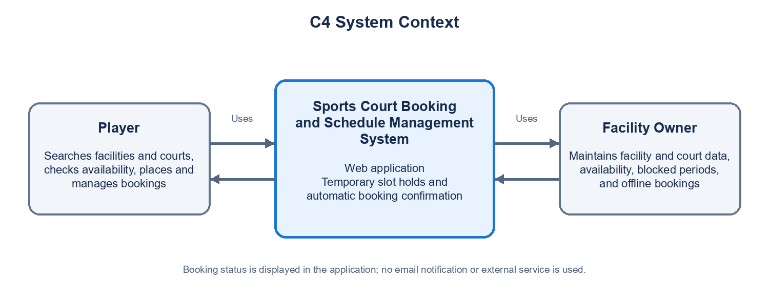

Technology Stack
Layer | Technology | Reason for choice
Front end | React | Supports a responsive browser interface and reusable components for player and operator views.
Back end | Node.js with Express | Provides API endpoints for facility search, booking, temporary slot holds, and schedule management.
Database | PostgreSQL | Stores related data such as users, facilities, courts, schedules, and bookings, and supports transactional booking operations.
Hosting / deployment | Cloud-hosted Linux environment | Makes the application available to the team for shared testing and course demonstration.
Testing & CI | Jest and GitHub Actions | Runs automated application tests and checks repository changes through continuous integration.

Hardware and Operating Environment
Players and facility owners access the responsive web application from laptops, tablets, and smartphones using current versions of Google Chrome or Apple Safari. The team develops and tests the application on its computers using Chrome and Safari browser environments, including desktop and mobile layouts. The application and PostgreSQL database run in a cloud-hosted Linux environment for shared testing and course demonstration. Booking confirmations and status are displayed in the application; the system does not send email notifications.

Project Plan

Process and Phase Gates
The project follows the course waterfall process. Each phase ends with a PA submission and review. The submitted deliverables form the baseline for the next phase; approved scope or design changes are recorded in the following PA.
PA | Phase | Due | Exit criteria (fill in)
PA1 | Initiation & planning | End of week 3 | Vision, scope, proposed solution, WBS, estimates, schedule, roles, cost estimate, risks, collaboration setup, contribution assessment, and AI usage log are reviewed and submitted.
PA2 | Requirements | End of week 5 | SRS, prioritized and measurable requirements, use cases, acceptance criteria, UI mockups, and requirement traceability are reviewed and baselined.
PA3 | Design | End of week 7 | Architecture, data model, interface flows, and architecture decisions are completed and reviewed against the PA2 baseline.
PA4 | Test planning | End of week 8 | Test strategy, test cases, requirement-to-test traceability, and test environment are prepared and reviewed.
PA5 | Implementation, testing & deployment | End of week 10 | The five Must-have functions are integrated; test results and defects are recorded; the application is deployed and ready for demonstration.
Final | Presentation & demo | Week 11 | The final presentation and working demonstration are completed against the approved project scope.

Work Breakdown Structure (WBS)
The WBS has three levels: level 1 is the project phase, level 2 is a deliverable group, and level 3 is an assignable work package. The table lists level-3 work packages. Each package has one accountable owner; effort is total person-hours across everyone contributing to that package.

Estimation
Estimation method: bottom-up planning judgment by work package. Estimates use the current five-function scope, a four-person team, 14 available project hours per member per week, the selected web technology stack, and beginner-level familiarity with AI assistance. Effort includes preparation, implementation or documentation, and the stated review/testing allowance. These are initial planning estimates, not measured historical data; the team records actual effort and reviews the remaining estimates at each phase gate. Effort is person-hours and is not calendar duration.
WBS ID | Work package | Owner | Effort (person-hours) | Method / assumptions
1.1.1 | Finalize problem statement, stakeholders, and five-function scope | Nguyễn Minh Trí | 6 | Draft and one team review.
1.1.2 | Complete context diagram, technology stack, and operating environment | Lý Sĩ Vĩ | 4 | One context diagram and one technology table.
1.2.1 | Prepare WBS, estimates, schedule, roles, cost, and risk plan | Bùi Nguyễn Đăng Khoa | 8 | Planning package for PA1.
1.2.2 | Set up repository, task board, and collaboration rules | Bùi Nguyễn Đăng Khoa | 4 | Initial project setup.
1.2.3 | Integrate, review, and submit PA1 | Bùi Nguyễn Đăng Khoa | 6 | One team review and document correction cycle.
2.1.1 | Confirm player/operator workflows and booking business rules | Nguyễn Minh Trí | 8 | Main flows, including temporary hold and confirmation.
2.1.2 | Write SRS and acceptance criteria | Nguyễn Minh Trí | 12 | Five core functions and basic quality requirements.
2.1.3 | Create use cases and requirement traceability | Nguyễn Minh Trí | 10 | Primary player and facility-owner flows.
2.2.1 | Create mockups for main screens | Lý Sĩ Vĩ | 10 | Responsive web views for both user roles.
2.2.2 | Review, revise, and baseline PA2 | Bùi Nguyễn Đăng Khoa | 6 | One formal team review.
2.3.1 | Build a small React–API–PostgreSQL feasibility slice | Vương Gia Khôi | 8 | Technical spike to validate the chosen stack; not a production feature.
3.1.1 | Create detailed C4 and deployment design | Lý Sĩ Vĩ | 8 | One web application, backend, and database.
3.1.2 | Design ERD/schema and booking-slot constraints | Lý Sĩ Vĩ | 10 | Focus on schedule and booking consistency.
3.1.3 | Record key architecture decisions | Lý Sĩ Vĩ | 6 | Decisions for stack, data, and booking workflow.
3.2.1 | Design screen flows and interface states | Lý Sĩ Vĩ | 8 | Based on PA2 requirements and mockups.
3.2.2 | Review traceability and baseline PA3 | Bùi Nguyễn Đăng Khoa | 4 | One design review.
4.1.1 | Define test strategy, environment, and entry/exit criteria | Nguyễn Minh Trí | 8 | Desktop/mobile web; Chrome and Safari.
4.1.2 | Design test cases for search, roles, availability, and booking | Nguyễn Minh Trí | 12 | Includes slot expiry and competing booking requests.
4.1.3 | Review test traceability and baseline PA4 | Nguyễn Minh Trí | 6 | Coverage of all five Must-have functions.
5.1.1 | Build application foundation, accounts, and role access | Vương Gia Khôi | 10 | Basic sign-in and two user roles.
5.1.2 | Implement facility search and filters | Vương Gia Khôi | 14 | Sport, location, and amenities.
5.1.3 | Implement court details and availability display | Vương Gia Khôi | 12 | Individual courts, prices, and time slots.
5.1.4 | Implement temporary hold, availability recheck, and booking status | Vương Gia Khôi | 20 | Hold expiry and competing requests.
5.1.5 | Implement operator schedule and offline booking entry | Vương Gia Khôi | 14 | Facility/court data, blocked time, shared schedule.
5.2.1 | Implement unit/API tests and basic CI | Vương Gia Khôi | 8 | Automated checks for core logic and repository changes.
5.2.2 | Run integration/system tests, record defects, and retest | Nguyễn Minh Trí | 10 | Execute PA4 cases and retest fixes.
5.2.3 | Deploy demo, prepare README and seed data, complete PA5 report | Bùi Nguyễn Đăng Khoa | 6 | One demo environment and test dataset.
6.1.1 | Prepare final presentation and demonstration flow | Bùi Nguyễn Đăng Khoa | 6 | Based on the deployed product.
6.1.2 | Rehearse and correct demonstration issues | Bùi Nguyễn Đăng Khoa | 4 | One full rehearsal.
7.1.1 | Hold weekly status meetings during W2–W10 | Bùi Nguyễn Đăng Khoa | 9 | Nine meetings; 15 minutes for four members per meeting.
7.1.2 | Prepare weekly status reports during W2–W10 | Bùi Nguyễn Đăng Khoa | 9 | Nine reports; about one person-hour per report.

Schedule
The schedule follows the course milestones. Weekly project capacity is 56 person-hours (four members × 14 hours). The Gantt chart shows phase windows and milestone dependencies.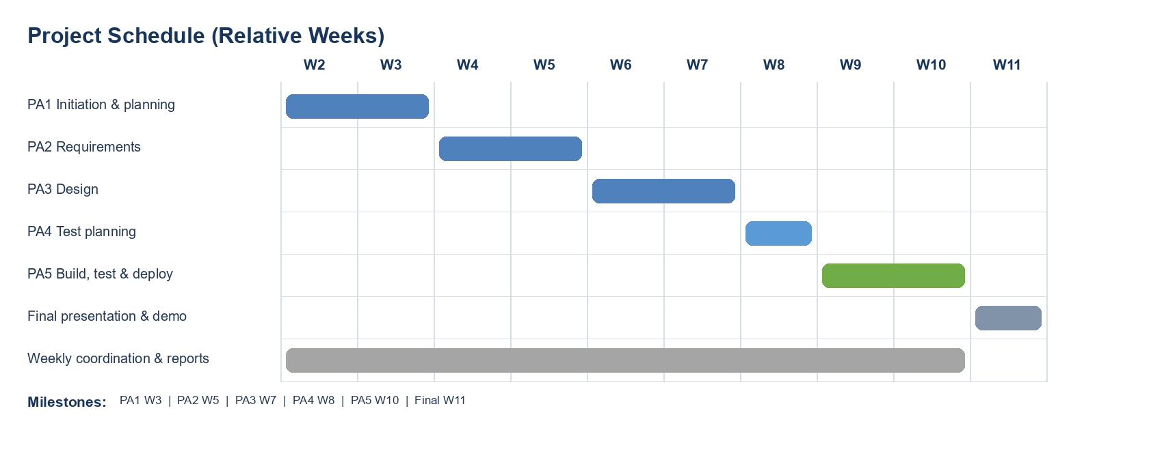
Dependencies and critical path: PA1 baseline → PA2 requirements → PA3 design → PA4 test plan → PA5 implementation, test, and deployment → Final presentation/demo. At the phase-gate level, this sequence follows the fixed course milestones; a delay to any gate affects the subsequent milestone. Weekly coordination and status reports run in parallel from W2 to W10.

Roles and Responsibilities
Role | Main | Backup | Responsibilities
Team lead / Project manager | Bùi Nguyễn Đăng Khoa | Lý Sĩ Vĩ | Plan and assign work, track progress, prepare weekly status reports, coordinate submissions, and serve as contact point.
Business analyst | Nguyễn Minh Trí | Bùi Nguyễn Đăng Khoa | Elicit and document requirements, organize reviews, and maintain requirement traceability.
Designer / Architect | Lý Sĩ Vĩ | Vương Gia Khôi | Prepare architecture, data and interface designs, diagrams, and design decisions.
Developers | Vương Gia Khôi | Lý Sĩ Vĩ | Implement features, write unit tests, review pull requests, and maintain CI.
Tester | Nguyễn Minh Trí | Bùi Nguyễn Đăng Khoa | Prepare test plan and cases, execute system tests, record defects, and prepare test report.

Human Resources and Cost Estimate
The project is planned for a four-member team, with an estimated availability of 14 hours per member per week (56 person-hours per week). The WBS estimates 266 person-hours for the full project. To meet the template’s cost-estimation requirement, the team applies an approximate junior-developer labor rate of VND 115,000 per person-hour, rounded from the ITviec 2025–2026 salary benchmark. The estimated labor value is approximately VND 30.6 million (266 person-hours × VND 115,000). Direct costs for software, hosting, and equipment are estimated at VND 0, assuming the team uses existing devices and eligible free tiers. This is a planning estimate of project resources, not a cash payment by the team. Source: ITviec Vietnam IT Salary & Recruitment Market Report 2025–2026, https://itviec.com/bao-cao/luong-it-va-thi-truong-tuyen-dung-it-vietnam.

Risk Management
Scores follow the course scale: Probability — Unlikely=10, Seldom=25, Occasional=50, Likely=75, Frequently=90; Loss — Negligible=10, Insignificant=25, Moderate=50, Serious=75, Catastrophic=90; RE = Probability × Loss.
ID | Risk | Type | Probability | Loss | RE | Mitigation / contingency | Owner
R1 | A key member is unavailable at a critical project time, delaying dependent work. | People | Occasional (50) | Serious (75) | 3,750 | Cross-train; keep shared notes and handoffs. | Bùi Nguyễn Đăng Khoa
R2 | Concurrent requests or expired holds cause incorrect slot availability. | Technology | Occasional (50) | Serious (75) | 3,750 | Validate booking logic early; test concurrency and hold expiry. | Vương Gia Khôi
R3 | Unclear booking or offline-booking rules cause rework. | Requirements | Occasional (50) | Serious (75) | 3,750 | Confirm workflows and acceptance criteria in PA2; track changes. | Nguyễn Minh Trí
R4 | Competing course commitments delay team coordination and dependent tasks. | Organizational | Occasional (50) | Moderate (50) | 2,500 | Hold weekly check-ins; keep owners, due dates, and backups current. | Bùi Nguyễn Đăng Khoa
R5 | Effort for learning, implementation, and testing is underestimated. | Estimation | Likely (75) | Serious (75) | 5,625 | Compare actual effort with WBS weekly; re-estimate at phase gates. | Bùi Nguyễn Đăng Khoa

Tools & Collaboration Setup
One of the main goals of the project is to practise teamwork for professional software development. The use of tools is monitored and graded (teamwork component). The team must use:
- Moodle – announcements and PA submissions.
- Communication – Slack, MS Teams or Discord: one channel per team; the TA is a member.
- Task board – GitHub Projects (recommended) or Jira: every WBS work package is a task with an owner and due date.
- Git repository – GitHub (recommended), GitLab or Bitbucket; the instructor and TA have access:
  - main branch is protected; changes are merged through pull requests with at least one review
  - README (description, setup), .gitignore; never commit secrets (.env, API keys, passwords)
  - commit messages follow the Conventional Commits style (feat:, fix:, docs:, test:, …)
- Weekly status meeting (15 minutes) and weekly status report (template provided), committed to /docs/management/weekly every week from week 2 to week 10. The weekly status report deadline is every Tuesday by 11:59 PM.
Repository structure:
Folder | Content
/src | Source code
/docs/management | Project plan; weekly status reports in /docs/management/weekly
/docs/requirements | Vision, SRS, use cases, mockups
/docs/design | Architecture (C4), ADRs, UML models, UI design
/docs/test | Test plan, test cases, test reports
/docs/ai-usage | AI usage logs
/pa/PA1 … /pa/PA5 | One sub-folder per PA submission (PDF + source files)

AI Usage Log
[Required in every PA (course GenAI policy). List each significant use of AI tools. Write “No AI tools were used” if none. Undisclosed AI use is treated as an academic integrity violation.]
# | Member | Tool | Task / purpose | How the output was verified and changed
1 | 23127074 – Vương Gia Khôi | ChatGPT | Reviewed the PA1 proposal and suggested improvements to scope, architecture, and risk management. | Compared with the PA1 template and course requirements; reviewed and revised the proposed scope, architecture, and risk management suggestions before keeping.
2 | 24127421 – Bùi Nguyễn Đăng Khoa | OpenAI Codex | Support drafting, reviewing, and editing PA1 sections for the sports-court booking project, including vision, proposed solution, project plan, risks, and collaboration setup. | Compared with the PA1 template, course slides, and project decisions shared by the team; reviewed and revised wording, scope, assumptions, and risk scores before keeping.
3 | 24127569 – Nguyễn Minh Trí | Google Gemini | Brainstormed project concepts, explored user pain points, and researched potential feature ideas for the sports-court booking platform. | Filtered the generated ideas, selected practical concepts that fit the course scope, and discarded overly complex suggestions to focus on real-world local needs.
4 | 24127587 – Lý Sĩ Vĩ | Claude (Anthropic) | Brainstormed possible project ideas and compared several options. Requested a sample project plan for a personal expense management app (overview, requirements, analysis, design, testing, report structure, and schedule) to understand PA plan contents. Asked about the project manager and designer roles and tools a designer needs (Figma). Summarized AI-log content for the report. | Used AI suggestions as references for structure and ideas, not copied directly. Compared them with the PA1 template, course slides, and team decisions on the sports-court booking project. Dropped content that did not fit and revised wording and scope before use.

