Introduction to Software Engineering

Software Requirements Specification

The student team is required to complete the Software Requirements Specification documentation for the assigned course project, following the attached template.


Software Engineering Department
Faculty of Information and Technology
University of Science

Table of Contents
Objectives 1
1 Member Contribution Assessment 2
2 Introduction 3
2.1 Purpose and Scope 3
2.2 Glossary 4
3 Problem Statement 6
4 Stakeholders 7
5 Requirements 8
5.1 Functional Requirements 8
5.2 Non-Functional Requirements 15
5.3 Domain Requirements and Business Rules 18
5.4 Acceptance Criteria 20
6 Use Case Model 27
6.1 Use Case Diagram 27
6.2 Actors 27
6.3 Use Case List 28
7 Use Case Specifications 29
7.1 Use Case UC-01 Register an account 29
7.2 Use Case UC-02 Sign in 31
7.3 Use Case UC-03 Search and filter facilities 32
7.4 Use Case UC-04 View facility details and court availability 33
7.5 Use Case UC-05 Select courts and proceed to a hold 34
7.6 Use Case UC-06 Confirm booking 36
7.7 Use Case UC-07 View bookings and notifications 38
7.8 Use Case UC-08 Cancel a booking 39
7.9 Use Case UC-09 Create and update a facility 41
7.10 Use Case UC-10 Update prices 42
7.11 Use Case UC-11 Mark time slots as unavailable 43
7.12 Use Case UC-12 Change operating hours or delete a court 44
7.13 Use Case UC-13 Enter an in-person booking 46
8 Prototype / Mockups 47
8.1 Screen illustrations 48
9 Requirements Traceability Matrix 58
10 Requirements Review 63
11 AI Usage Log 66

Software Requirements Specification

Objectives
This document focus on the following topics:
- Completing the Software Requirements Specification (SRS) document with the following sections:
  - Problem Statement
  - Stakeholders
  - Functional, non-functional and domain requirements
  - Use case model and use case specifications
  - Prototype / mockups
  - Traceability and requirements review
- Including an AI usage log for this phase
- Understanding the Software Requirements Specification (SRS) document.

Member Contribution Assessment
[List every member. Contribution (%) must add up to 100%. Evidence: links to tasks on the board, commits or pull requests.]
ID | Name | Role(s) | Contribution (%) | Evidence
23127074 | Vương Gia Khôi | Technical feasibility prototype; development | 0
24127421 | Bùi Nguyễn Đăng Khoa | Use cases and traceability; review coordination and document integration | 35 | PA2 requirements — PR #3
24127569 | Nguyễn Minh Trí | Requirements analysis and acceptance criteria | 35 | PA2 requirements — Trí’s branch
24127587 | Lý Sĩ Vĩ | Prototype and user interface design | 30 | UI design — PR #2

Introduction

Purpose and Scope
Purpose:
This Software Requirements Specification (SRS) defines what the T04 sports court booking web application must do. It develops the PA1 baseline (T04-PA1-ProjectProposal-Plan) into stakeholders, requirements, business rules and acceptance criteria. It provides input to PA2 use cases, interfaces and traceability, PA3 design, PA4 test planning and PA5 implementation.
Intended audience: the lecturer, teaching assistants and team members.
Product scope:
Five must-have features are in scope:
- F01 — Accounts and role access: players access and manage their own bookings; facility owners create and manage their own facilities. Delegating facility management to another account is not supported. Permission scope was clarified after PA1.
- F02 — Facility search and filters: search by sport and area/location, with filters for available amenities [Included in PA1].
- F03 — Court details and availability: view facility information, individually identified courts, prices and available time slots for a selected date [Included in PA1].
- F04 — Booking and booking management: temporarily hold selected slots for up to five minutes; recheck availability when the player confirms and automatically confirm if available; release holds after five minutes or abandonment; view booking status [Included in PA1].
- F05 — Operator schedule management: manage facility and court information, opening hours, prices and blocked periods, and enter in-person bookings into the shared schedule [Included in PA1].
Out of scope:
- Online payments or deposits [Included in PA1]. Payment method selection and payment status tracking are outside PA2 scope and will be discussed in a later phase.
- Native iOS/Android applications [Included in PA1].
- Public reviews and ratings [Included in PA1].
- Chat or social matching [Included in PA1].
- Tournament management [Included in PA1].
- Cross-facility no-show scoring or penalties [Included in PA1].
- Integration with external court management systems or payment gateways [Included in PA1].
- Notifications through email or external services; booking status is displayed only in the web application [Included in PA1].

Glossary

Term | Definition
Guest | A user who is not logged in. Guests may search, filter and view facilities and slot status, but must log in when selecting Proceed to booking.
Player | A logged-in user who searches facilities, selects slots, makes bookings, and views or cancels their own bookings. (PA1 §2.3)
Facility owner / operator | A user who creates and manages their own facilities; an owner may have multiple facilities. Delegating management to another account is not supported.
Facility / branch | A sports location with a sport, location, amenities and one or more courts. Each branch is a separate facility.
Court | An individually identified court within a facility. A booking covers one or more courts in the same facility.
Time slot | A 30-minute period on one court.
Booking | A booking belongs to one facility and includes one or more courts. Each court has consecutive slots; start times and slot counts may differ across courts. A booking cannot span multiple facilities.
Proceed to booking | The action taken by a logged-in user after selecting slots. The system validates the entire selection and creates a hold if valid. Selecting slots alone does not create a hold.
Temporary hold | Selected slots are reserved for up to five minutes after Proceed to booking; others cannot select those slots during the hold. (PA1 §2.1, F04)
Availability recheck | The system rechecks availability when the user confirms a booking during the hold. (PA1 F04)
Slot status | Available, held, booked or unavailable. The set of booking statuses remains open.
Blocked period | A period set by the owner during which a court is unavailable. It must be created at least 24 hours in advance. (PA1 F05)
In-person booking | A booking entered by the owner for their own facility using the same actions as a player, and recorded in the shared schedule. (PA1 F05)
Shared schedule | The single schedule containing app bookings, in-person bookings and blocked periods, ensuring consistent availability. (PA1 §2.1)
MoSCoW | Priority scale: Must, Should, Could, Won't.
SRS / PA | Software Requirements Specification / project assignment deliverables (PA1–PA5).

Problem Statement
Business context:
- Players need a facility supporting their sport, in a suitable location, with the required amenities and available times. At a facility with multiple courts, players can view each identified court's status and select one or more courts before booking.
- Facility owners / operators maintain facility and court information, prices, operating hours, blocked periods and bookings, including app bookings and in-person bookings they enter.
Current problems:
- For players:
- Availability is not updated consistently, so players may see slots that are no longer available.
- During booking, players need assurance that their selected courts and times remain available until completion.
- The team tried booking on Datsan247, ALOBO and Sportnet. In those trials, the team did not observe a temporary booking-in-progress status preventing others from selecting the same court and time during the booking process.
- For operators: inconsistent availability makes coordination difficult when multiple people request the same court and time.
Objectives:
- Players search and filter facilities by sport, location and amenities.
- Players view individually identified court availability and select one or more courts within one facility. Slots on each court must be consecutive; each slot lasts 30 minutes.
- Selected slots are held for up to five minutes. On confirmation, the system rechecks availability and automatically confirms if available. Expired or abandoned holds are released.
- Operators manage facility and court information, operating hours, prices, blocked periods and in-person bookings in one shared schedule.
Operating environment: a responsive web application for laptops, tablets and phones using current Google Chrome or Apple Safari versions. The application and PostgreSQL database run on cloud-hosted Linux for shared team testing and course demonstrations. Booking results and status appear in the application; no email is sent.
Design and implementation constraints:
- Technology: React frontend, Node.js with Express backend, PostgreSQL, Jest and GitHub Actions for testing and CI.
- Process and deadline: the course waterfall process. PA5 (implementation, testing and deployment) is due at the end of week 10, with all five Must features integrated.
- Resources: four members, approximately 14 hours per member per week.
- Scope: the out-of-scope items in section 2.1 also constrain the design.

Stakeholders

# | Stakeholder | Description | Interests/ concerns
1 | Course TA / project sponsor | Provides course guidance and evaluates project deliverables; not a direct application user. | Feasible scope, clear project rationale and complete deliverables.
2 | Player | Searches for suitable facilities, checks a specific court and time slot, and makes or manages bookings. | Accurate availability, clear facility and court information, and predictable booking outcomes.
3 | Facility owner or operator | Maintains facility and court information, availability, blocked periods and bookings received through or outside the application. | An up-to-date schedule, fewer conflicting booking requests and easy booking record management.

Requirements

Functional Requirements

ID | Requirement | Feature | Priority | Source
FR-01 | The system shall support player and facility owner account roles, with logged-in users accessing functions according to their roles. Guests may search, filter, view facilities and slot status, select slots, register and log in. When a guest selects Proceed to booking, login is required and no hold is created. After login, the user returns to the home page and must select again to book (FR-23, FR-24). | F01 | Must | PA1 §2.4 F01; WBS 5.1.1: account roles. Guest selection, registration, login and return to the home page were clarified after PA1.
FR-02 | The system shall allow logged-in players to access their own bookings. | F01 | Must | PA1 §2.4 F01  Included in PA1
FR-03 | The system shall allow each facility owner account to create and manage its own facilities. An owner may have multiple facilities, each branch is separate, and managing another owner's facilities or delegating management to another account is not supported. | F01 | Must | PA1 §2.4 F01 Included in PA1
FR-04 | The system shall allow guests and players to search facilities by sport and location without logging in. | F02 | Must | PA1 §2.4 F02 Included in PA1
FR-05 | The system shall allow guests and players to filter facilities by available amenities without logging in. | F02 | Must | PA1 §2.4 F02 Included in PA1
FR-06 | The system shall allow guests and players to view a facility and its individually identified courts. | F03 | Must | PA1 §2.4 F03 Included in PA1
FR-07 | The system shall display court prices. | F03 | Must | PA1 §2.4 F03  Included in PA1
FR-08 | The system shall display each court's 30-minute slots for the selected date, distinguishing available, held, booked and unavailable statuses. | F03 | Must | PA1 §2.4 F03 Included in PA1
FR-09 | The system shall allow users to select slots for one booking within one facility, including one or more courts with consecutive slots on each court. Start times and slot counts may differ across courts. A booking cannot span facilities. Selection alone does not create a hold. | F04 | Must | PA1 §2.1, §2.4 F04 (one court, one slot)  Added and clarified after PA1
FR-10 | When a logged-in user selects Proceed to booking and the entire selection is valid, the system shall hold all selected slots for up to five minutes and prevent others from selecting them during the hold. | F04 | Must | PA1 §2.1, §2.4 F04 Included in PA1
FR-11 | When the user confirms, the system shall verify that the hold is valid and belongs to that user, and recheck slot availability. If the hold has expired or is invalid, the system shall reject confirmation, notify the user and update availability. | F04 | Must | PA1 §2.4 F04 Included in PA1
FR-12 | If the slots remain valid at confirmation, the system shall automatically confirm the booking without owner approval. | F04 | Must | PA1 §2.4 F04  Included in PA1
FR-13 | At Proceed to booking, the system shall validate the entire selection. If any slot conflicts or is invalid, no slots shall be held; the system shall identify the problematic slot, clear all selections and update availability. If two requests compete for one slot, only one may acquire a hold. | F04 | Must | —
FR-14 | When an unconfirmed hold expires, the system shall reject confirmation immediately and complete release within five seconds. The booking screen shall show an expiry notification and temporarily disable confirmation during processing. After successful release, users may immediately return to slot selection. If processing fails, the system shall notify the user and prevent continuation as though release had succeeded. Cancellation, going back or changing selections shall submit a release request and update the shared schedule. | F04 | Must | PA1 §2.1, §2.4 F04 Included in PA1
FR-15 | The system shall display booking results and status in the application. | F04 | Must | PA1 §3.3  Included in PA1
FR-16 | The system shall allow players to view the status of their own bookings. | F04 | Must | PA1 §2.4 F04  Included in PA1
FR-17 | The system shall allow owners to create and manage their own facility and court information. | F05 | Must | PA1 §2.4 F05 Included in PA1
FR-18 | The system shall allow owners to manage operating hours; changes shall follow FR-29. | F05 | Must | PA1 §2.4 F05 Included in PA1
FR-19 | The system shall allow owners to manage prices. | F05 | Must | PA1 §2.4 F05  Included in PA1
FR-20 | The system shall allow owners to create blocked periods at least 24 hours in advance, following FR-29. | F05 | Must | PA1 §2.4 F05 Included in PA1
FR-21 | The system shall allow owners to enter in-person bookings for their own facilities using the player flow (select slots, acquire a hold and confirm), recording them in the shared schedule. In-person bookings are exempt from the advance booking limit in FR-27 and cannot override held or booked slots. | F05 | Must | PA1 §2.4 F05 Included in PA1
FR-22 | The system shall maintain one shared schedule for app bookings, in-person bookings and blocked periods. Displayed availability shall reflect this schedule. | F05 | Must | PA1 §2.1, §2.4 F05  Included in PA1
FR-23 | If a user is not logged in when selecting Proceed to booking, the system shall require login without creating a hold. After login, the user shall return to the home page and select again to book. | F01, F04 | Must | —
FR-24 | The system shall provide basic registration and login for guests, validate submitted information and report errors. After registration, the user shall return to the login page. | F01 | Must | —
FR-25 | Reloading the page during a hold shall preserve the remaining hold time rather than restart the five-minute period. | F04 | Must | —
FR-26 | On tab closure or disconnection, the system shall attempt early detection to release the hold. Otherwise, it shall follow the expiry handling in FR-14. Immediate detection is not guaranteed. | F04 | Must | —
FR-27 | Players may select Proceed to booking only at or before the cutoff of two 30-minute slots before the start time. In-person bookings by owners are exempt. Returning to selection shall apply the current time. | F04 | Must | —
FR-28 | The system shall allow players to cancel an entire booking at least three hours before its earliest start time; exactly three hours is permitted. Changes require cancellation and a new booking. Individual courts within a booking cannot be cancelled separately. | F04 | Must | —
FR-29 | When owners block slots, delete courts or change operating hours, the system shall require them to wait for affected holds to end or be confirmed, then retry with revalidation; display affected bookings and a warning; reject the entire change if any affected booking starts in less than 24 hours, measured from its earliest start (exactly 24 hours is allowed); and, upon owner confirmation, cancel affected bookings, update the schedule and notify users. | F05 | Must | —
FR-30 | For owner-cancelled bookings, the system shall provide an in-app notification identifying the reason, booking and affected courts/slots. No email or phone notification is sent; users must open the application to see it. | F05 | Must | PA1 §3.3: in-app status display. Cancellation notification content and affected court/time details were added by the team after PA1.
FR-31 | Before confirmation, the system shall display the facility, courts, selected times and remaining hold time. Holds shall not be automatically extended. | F04 | Must | —
FR-32 | At Proceed to booking, the system shall revalidate the entire selection against current availability, including other users' bookings or holds and owner blocking, court closure or operating hour changes. If any slot conflicts or is invalid, FR-13 applies: hold no slots, identify the problem, clear all selections and update availability for reselection. Automatic updates during selection are not required. | F04 | Must | —

Non-Functional Requirements

ID | Category | Requirement (measurable) | How it will be verified
NFR-01 | Compatibility | All Must functions shall display and work in current Google Chrome and Apple Safari versions in desktop and mobile layouts.  Included in PA1 (PA1 §2.1, §3.3) | Run AC-01 through AC-39 on both browsers and both layouts; all must pass.
NFR-02 | Booking consistency | No court and time slot may have more than one confirmed booking. When multiple requests compete for one slot, only one may acquire a hold.  Included in PA1 (PA1 §2.1, WBS 4.1.2, 5.1.4); | Automated concurrency test: submit simultaneous Proceed to booking requests for the same slot, repeated ten times. Each run must produce exactly one successful hold and zero duplicate bookings.
NFR-03 | Hold duration | A hold lasts up to five minutes without automatic extension. On expiry, confirmation is rejected immediately and an unconfirmed hold is released within five seconds; subsequent status reflects the shared schedule. Reloading preserves remaining hold time. Confirmed slots remain booked. Source: PA1 §2.4 F04; the five-second limit and details were clarified by the team after PA1. | Create an unconfirmed hold, reload and check remaining time. Measure expiry and release completion: reject confirmation on expiry and release within five seconds. Verify the notification, disabled confirmation during processing and immediate reselection after release. Verify failure notifications. Separately confirm before expiry and verify that slots remain booked.
NFR-04 | Security / authorization | The system shall reject all guest/player attempts to access owner management functions and owner attempts to manage another owner's facility. Public facility information remains accessible. Source: PA1 §2.4 F01. | Test facility management as a guest, player and different owner: reject all unauthorized access; separately verify that public information remains accessible.
NFR-05 | Security / credentials | Passwords shall not be stored as plain text.  Proposal confirmed by the team | Inspect the database: only password hashes are stored.
NFR-06 | Performance | With 50 concurrent users in the demo environment, facility searches and availability displays shall respond within two seconds at P95. The team confirmed the 50-user target. | Load-test 100 search and availability requests with 50 concurrent users; measure P95.
NFR-07 | Usability | First-time players, logged in before the test, shall complete searching, selecting slots, Proceed to booking and confirmation within three minutes without assistance. Registration and login time are excluded. | Observe at least three first-time users outside the team, already logged in. Measure from starting a search to successful confirmation; all must finish within three minutes without assistance.
NFR-08 | Data freshness | Owner schedule changes (in-person bookings, blocked periods, price or operating hour changes) shall appear on the next load or refresh of the relevant availability screen.  Confirmed by the team (derived from PA1 §2.1) | Perform each change as an owner, then reload availability as a player; the changes must appear.
NFR-09 | Constraint: notifications | Results, status and cancellation notifications shall appear only in the application. No email or phone notifications are sent; users must open the application to see them.  Included in PA1 (PA1 §3.3) | Inspect and demonstrate: no email or phone notification function; after owner cancellation, the player opens the application and sees the notification.

Domain Requirements and Business Rules

ID | Rule | Source (policy, law, standard)
BR-01 | A temporary hold lasts up to five minutes. | PA1 §2.4 F04. Included in PA1
BR-02 | While slots are held for one user, other users cannot select them. | PA1 §2.1. Included in PA1
BR-03 | A booking belongs to one facility and includes one or more courts. Each court has consecutive 30-minute slots; start times and slot counts may differ across courts. A booking cannot span facilities. | PA1 §2.1, §2.4 F03–F04 (one court, one slot). Added and clarified after PA1
BR-04 | Selecting slots does not create a hold. Only when a logged-in user selects Proceed to booking does the system validate the entire selection and hold it for up to five minutes. Booking confirmation is a later step. | —
BR-05 | If any slot conflicts or is invalid at Proceed to booking, no slots are held. Identify the problem, clear all selections and update availability. | —
BR-06 | Availability is rechecked on confirmation. Valid bookings are automatically confirmed without owner approval. | PA1 §2.4 F04. Included in PA1
BR-07 | Holds are not automatically extended. After five minutes, confirmation is rejected and unconfirmed holds are released within five seconds. Show expiry notification and disable confirmation during processing. Allow reselection immediately after release; notify users of processing failure. Cancellation, going back or changing selections requests release; reloading preserves remaining time. Attempt early detection of tab closure or disconnection; otherwise release on expiry. | PA1 §2.4 F04: expired or abandoned holds are released. Handling, notifications and the five-second limit were clarified by the team after PA1.
BR-08 | Players must select Proceed to booking at or before the cutoff of two 30-minute slots before the start time. In-person owner bookings are exempt. Reselection uses the current time. | —
BR-09 | Players may cancel an entire booking at least three hours before its earliest start; exactly three hours is allowed. Changes require cancellation and rebooking. Individual courts cannot be cancelled separately. | —
BR-10 | Each owner creates and manages their own facilities; an owner may have multiple facilities, each branch is separate, and management delegation to another account is not supported. | PA1 §2.4 F01; details. Included in PA1
BR-11 | Blocking slots, deleting courts and changing operating hours share these rules: wait for affected holds to end or be confirmed, then retry and revalidate; display affected bookings and a warning; reject the entire change if any affected booking's earliest start is less than 24 hours away; exactly 24 hours is allowed; upon confirmation, cancel affected bookings, update the schedule and notify users. | —
BR-12 | Blocked periods must be created at least 24 hours in advance. | —
BR-13 | App bookings, in-person bookings and blocked periods share one schedule determining availability. In-person bookings cannot override held or booked slots. | PA1 §2.1, §2.4 F05; details. Included in PA1
BR-14 | Guests may search, filter, and view details and status, but must log in at Proceed to booking. | —
BR-15 | The system does not process online payments or deposits. | PA1 §2.4 (out of scope). Included in PA1
BR-16 | Results, status and cancellation notifications appear only in the application, without email or phone notifications. Users must open the application to see them. | PA1 §3.3: in-app results and status. Cancellation notifications identifying the reason and affected courts and slots were added by the team after PA1.

Acceptance Criteria

ID | Related FR | Given | When | Then | Status
AC-01 | FR-04, FR-05, FR-06, FR-08 | A guest is not logged in. | The guest searches by sport and location, filters by amenities and opens facility details. | Results, courts, prices and each slot's status are visible without login. | —
AC-02 | FR-23 | A guest has selected some slots. | The guest selects Proceed to booking. | The system requires login and creates no hold. | —
AC-03 | FR-23, FR-24 | A guest has selected slots and is required to log in. | The guest logs in successfully. | The system returns to the home page with no hold; the user must select again to book. | —
AC-04 | FR-24 | A guest has no account. | The guest registers an account. | The system returns the user to the login page. | —
AC-05 | FR-01, FR-02 | Players P and Q both have bookings; P is logged in. | P opens their booking list. | Only P's bookings are listed. | Included in PA1
AC-06 | FR-01 | A player or guest. | The user attempts an owner function. | Access is denied and data remains unchanged. | Included in PA1
AC-07 | FR-03 | Owner O owns facility A; another owner owns facility B. | O attempts to manage or modify B. | The system denies management or modification; data remains unchanged. B's public information remains accessible. | Included in PA1
AC-08 | FR-03, FR-17 | Owner O has facilities A1 and A2. | O manages A1 and A2. | O can manage both as separate facilities. | —
AC-09 | FR-04 | Facilities exist for various sports and locations. | The user searches for sport S and location L. | All listed facilities support S and are in L; no matching facility is omitted. | Included in PA1
AC-10 | FR-05 | Search results are displayed. | The user selects an amenity filter. | Only facilities with that amenity remain. | Included in PA1
AC-11 | FR-06, FR-07, FR-08 | A facility has at least two courts. | The user opens the facility and selects date D. | Each court displays its identifier, price and 30-minute slots with available, held, booked or unavailable status. | Included in PA1
AC-12 | FR-09 | Slots are available. | The user selects slots without selecting Proceed to booking. | The slots are not held and remain selectable by others. | —
AC-13 | FR-09 | A facility has courts 1 and 2 with available slots. | The user selects two consecutive slots on court 1 (18:00–19:00) and three on court 2 (19:00–20:30). | The selection is valid; one booking includes both courts with different start times and slot counts. | —
AC-14 | FR-09 | The user has selected slots at facility A. | The user attempts to add facility B's slots to the same booking. | The system prevents bookings spanning multiple facilities. | —
AC-15 | FR-10 | The user is logged in with a valid selection. | The user selects Proceed to booking. | All selected slots are held for the user for up to five minutes. | Included in PA1
AC-16 | FR-08, FR-10 | User P holds slots. | Another user views and attempts to select them. | The slots appear held and cannot be selected by others. | Included in PA1
AC-17 | FR-13 | The user selected three slots; another user then held one before the user proceeded. | The user selects Proceed to booking. | No slots are held; the system identifies the problem, clears all selections and updates availability. | —
AC-18 | FR-13 | Two users select Proceed to booking for the same slot nearly simultaneously. | Both requests are processed. | Only one request acquires a hold. | —
AC-19 | FR-11, FR-12, FR-15 | The user's hold and slots remain valid. | The user confirms the booking. | Availability is rechecked, the booking is automatically confirmed and confirmed status appears in the application. | Included in PA1
AC-20 | FR-14 | The user has an unconfirmed hold and is on the booking screen. | Five minutes pass without confirmation. | On expiry, the system immediately rejects confirmation, shows an expiry notification and disables confirmation during release. Release completes within five seconds; reselection is available immediately afterwards. Processing failure is reported. Slot status reflects the shared schedule. | Release timing and notifications were clarified by the team after PA1.
AC-21 | FR-14 | The user has a hold. | The user cancels, goes back or changes selections. | The system receives the release request and the slots become available again. | —
AC-22 | FR-25 | The user has a hold with two minutes remaining. | The user reloads the page. | The hold continues with approximately two minutes remaining rather than restarting at five minutes. | —
AC-23 | FR-26 | The user has a hold. | The user closes the tab or disconnects. | The system attempts early detection and release; otherwise it releases on expiry. Immediate release is not guaranteed. | —
AC-24 | FR-27 | A slot starts at 18:00. | The player selects Proceed to booking at 17:00 (exactly two slots in advance) and at 17:01. | 17:00 is accepted; 17:01 is rejected. | —
AC-25 | FR-21, FR-27 | A slot starts in 30 minutes. | The owner enters an in-person booking for that slot at their own facility. | The in-person booking is accepted because it is exempt from the advance booking limit. | —
AC-26 | FR-28 | A booking's earliest start is 18:00. | The player cancels at 15:00 and at 15:01. | 15:00 (exactly three hours) is allowed; 15:01 is rejected. | —
AC-27 | FR-28 | A booking includes two courts. | The player wants to cancel only one court. | The system does not cancel individual courts; the player cancels the entire booking, or cancels and rebooks. | —
AC-28 | FR-29, FR-30 | A blocked period affects a booking whose earliest start is at least 24 hours away. | The owner blocks the period and confirms after the warning. | The system displays affected bookings and a warning, then cancels the bookings, updates the schedule and notifies users. | —
AC-29 | FR-29 | An affected booking's earliest start is less than 24 hours away. | The owner blocks slots, deletes a court or changes operating hours. | The system rejects the entire action and cancels no bookings. | —
AC-30 | FR-29 | An affected hold exists. | The owner attempts blocking, deletion or an operating hour change. | The owner waits for the hold to end or be confirmed, then retries; the system revalidates before processing. | —
AC-31 | FR-20 | A slot starts in less than 24 hours. | The owner attempts to create a blocked period for it. | The system rejects the request because blocking requires at least 24 hours of advance notice. | —
AC-32 | FR-30 | The player's booking was cancelled by the owner. | The player opens the application. | The player sees a notification identifying the reason, booking and affected courts/slots; no email or phone notification is sent. | Included in PA1
AC-33 | FR-21, FR-22 | The owner is logged in and slots are available. | The owner enters an in-person booking using the player flow. | The booking enters the shared schedule and slots become unavailable; held or booked slots are not overridden. | Included in PA1
AC-34 | FR-17, FR-18, FR-19 | The owner of facility A is logged in. | The owner creates or edits facility and court information, operating hours and prices. | Changes are saved and displayed to users; operating hour changes follow FR-29. | Included in PA1
AC-35 | FR-11, FR-14 | User P has an expired hold. | P selects Confirm booking. | The booking is not confirmed; the system notifies the user and updates availability. | Included in PA1
AC-36 | FR-11 | User P holds slots. | Another user attempts to confirm P's hold. | The system rejects confirmation because the hold does not belong to that user. | —
AC-37 | FR-13, FR-32 | The user selected three slots; another user then held one, or an owner schedule change made it invalid. | The user selects Proceed to booking. | The system validates the entire selection, holds no slots, identifies the problem, clears all selections and updates availability for reselection. | —
AC-38 | FR-31 | The user has a valid hold. | The confirmation screen is displayed. | The facility, courts, selected times and remaining hold time are displayed. | —
AC-39 | FR-31 | The user has a hold with one minute remaining. | The user remains on the confirmation screen. | The hold is not extended automatically. On five-minute expiry, confirmation is rejected immediately and the unconfirmed hold is released within five seconds as specified in FR-14. | —

Use Case Model

Use Case Diagram
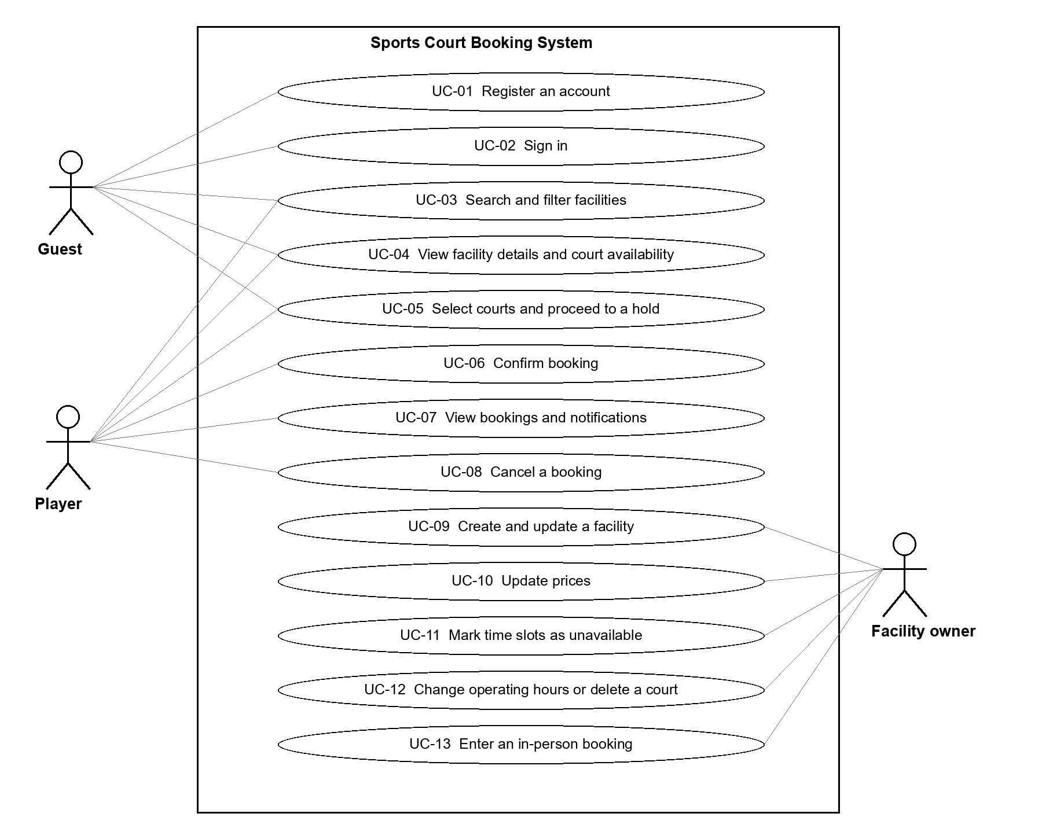
The diagram shows associations between actors and use cases. Logged-in users can also search and view courts; owners enter in-person bookings through UC-13.

Actors
Actor | Description
Guest | A user who is not logged in; may search, filter and view facilities, and register or sign in.
Player | A logged-in user who makes and manages their own bookings.
Facility owner | A user who creates and manages their own facilities and enters bookings for in-person customers.

Use Case List
ID | Use case | Primary actor | Priority | Related requirements
UC-01 | Register an account | Guest | Must | FR-01, FR-24
UC-02 | Sign in | Guest | Must | FR-01, FR-23, FR-24
UC-03 | Search and filter facilities | Guest or player | Must | FR-04, FR-05
UC-04 | View facility details and court availability | Guest or player | Must | FR-06, FR-07, FR-08
UC-05 | Select courts and proceed to a hold | Guest or player | Must | FR-01, FR-09, FR-10, FR-13, FR-23, FR-27, FR-32
UC-06 | Confirm booking | Player | Must | FR-11, FR-12, FR-14, FR-15, FR-25, FR-26, FR-31
UC-07 | View bookings and notifications | Player | Must | FR-02, FR-15, FR-16, FR-30
UC-08 | Cancel a booking | Player | Must | FR-02, FR-16, FR-28
UC-09 | Create and update a facility | Facility owner | Must | FR-03, FR-17
UC-10 | Update prices | Facility owner | Must | FR-03, FR-19
UC-11 | Mark time slots as unavailable | Facility owner | Must | FR-03, FR-20, FR-22, FR-29, FR-30
UC-12 | Change operating hours or delete a court | Facility owner | Must | FR-03, FR-17, FR-18, FR-22, FR-29, FR-30
UC-13 | Enter an in-person booking | Facility owner | Must | FR-03, FR-10, FR-11, FR-12, FR-21, FR-22, FR-27
Priority: Must for all use cases. Related requirement identifiers have been checked against Trí’s revised sections 2–5.

Use Case Specifications

Use Case UC-01 Register an account
Use case ID | UC-01
Use case name | Register an account
Brief description | Register an account in the sports court booking system.
Primary actor | Guest
Secondary actors | Not specified.
Priority | Must
Related requirements | FR-01, FR-24
Trigger | The guest selects registration.
Pre-conditions | Not logged in.
Post-conditions | An account is created and the user returns to the login page.
Main flow | 1. The guest selects registration. 2. The system displays the registration form. 3. The guest enters information and submits the registration. 4. The system validates the information, creates the account and returns the user to the login page.
Alternative flows | A1 at step 2: the guest returns to login; no account is created.
Exception flows | E1 at step 4: the information is invalid or the account cannot be created; the system notifies the guest so they can address the issue.
Business rules | Account registration is described at a basic level in PA2. Related rules: BR-14.
Non-functional constraints | NFR-01, NFR-05. See section 5.2 for the conditions and verification methods.

Use Case UC-02 Sign in
Use case ID | UC-02
Use case name | Sign in
Brief description | Sign in to the sports court booking system.
Primary actor | Guest
Secondary actors | Not specified.
Priority | Must
Related requirements | FR-01, FR-23, FR-24
Trigger | The guest selects login or proceeds to booking while not logged in.
Pre-conditions | An account exists.
Post-conditions | The user is authenticated and can access functions according to their role.
Main flow | 1. The guest opens the login page. 2. The guest enters and submits credentials. 3. The system checks the account. 4. The system authenticates the user, returns them to the home page and enables functions according to their role.
Alternative flows | A1 at step 1: a guest without an account selects registration (UC-01), then returns to login.
Exception flows | E1 at step 3: the credentials are invalid; the system displays an error and allows another attempt.
Business rules | After login, the user returns to the home page and must select again to book. Related rules: BR-14.
Non-functional constraints | NFR-01, NFR-04, NFR-05. See section 5.2 for the conditions and verification methods.

Use Case UC-03 Search and filter facilities
Use case ID | UC-03
Use case name | Search and filter facilities
Brief description | Search and filter facilities in the sports court booking system.
Primary actor | Guest or player
Secondary actors | Not specified.
Priority | Must
Related requirements | FR-04, FR-05
Trigger | The user opens facility search.
Pre-conditions | No login is required
Post-conditions | A list of results matching the search criteria is displayed.
Main flow | 1. The user enters the desired sport and location. 2. The user optionally selects amenity filters. 3. The system searches and displays matching facilities. 4. The user selects a facility to view its details (UC-04).
Alternative flows | A1 at step 2: no amenity filter is selected; the system uses the remaining criteria. A2 at step 4: the user changes the criteria and searches again.
Exception flows | E1 at step 3: no results are found; the system notifies the user and allows the criteria to be adjusted.
Business rules | Login is not required for searching. Related rules: BR-14.
Non-functional constraints | NFR-01, NFR-06, NFR-07. See section 5.2 for the conditions and verification methods.

Use Case UC-04 View facility details and court availability
Use case ID | UC-04
Use case name | View facility details and court availability
Brief description | View facility details and court availability in the sports court booking system.
Primary actor | Guest or player
Secondary actors | Not specified.
Priority | Must
Related requirements | FR-06, FR-07, FR-08
Trigger | The user selects a facility.
Pre-conditions | The facility has information available for display.
Post-conditions | The user views courts, prices and availability by date.
Main flow | 1. The system displays facility information, courts and prices. 2. The user selects a date. 3. The system displays each court’s 30-minute slots with available, held, booked or unavailable status. 4. The user may select another date or select available slots to begin booking (UC-05).
Alternative flows | A1 at step 4: the user only browses and then leaves the page.
Exception flows | E1 at step 3: no slots can be selected; the system displays the corresponding status.
Business rules | Each branch is a separate facility; a booking belongs to only one facility. Related rules: BR-03, BR-14.
Non-functional constraints | NFR-01, NFR-06, NFR-08. See section 5.2 for the conditions and verification methods.

Use Case UC-05 Select courts and proceed to a hold
Use case ID | UC-05
Use case name | Select courts and proceed to a hold
Brief description | Select courts and proceed to a temporary hold in the sports court booking system.
Primary actor | Guest or player
Secondary actors | Not specified.
Priority | Must
Related requirements | FR-01, FR-09, FR-10, FR-13, FR-23, FR-27, FR-32
Trigger | The user selects slots and selects Proceed to booking.
Pre-conditions | The user has viewed a facility’s schedule and must log in before a hold can be created.
Post-conditions | The entire selection is held for up to five minutes, or no slots are held.
Main flow | 1. The user selects one or more courts and available slots in the same facility. 2. The system displays the selections. 3. The user selects Proceed to booking. 4. If the user is logged in, the system continues validation. 5. The system rechecks the entire selection, access permissions, booking cutoff and conflicts. 6. If valid, the system holds the entire selection for up to five minutes and displays information for confirmation.
Alternative flows | A1 at step 4: if not logged in, the user is required to log in; a user without an account registers first. After login, the user returns to the home page and selects courts and times again; no hold has been created. A2 at step 1: start times and slot counts may differ across courts. A3: automatic availability updates during selection are not required; current availability is checked at Proceed to booking.
Exception flows | E1 at step 5: if a slot conflicts or is invalid because of another user’s hold or booking, or an owner’s schedule change, no slots are held. The system identifies the problem, clears all selections and updates availability for reselection. E2: if two requests compete for one slot, only one acquires a hold; the other follows E1. E3 at step 1: slots displayed as held, booked or unavailable cannot be selected; the system displays the corresponding status.
Business rules | Each slot lasts 30 minutes; slots on each court within a booking must be consecutive. Players must proceed at or before the cutoff of two slots before the start time; in-person owner bookings are exempt. Related rules: BR-02, BR-03, BR-04, BR-05, BR-08, BR-14.
Non-functional constraints | NFR-01, NFR-02, NFR-07. See section 5.2 for the conditions and verification methods.

Use Case UC-06 Confirm booking
Use case ID | UC-06
Use case name | Confirm booking
Brief description | Confirm a booking in the sports court booking system.
Primary actor | Player
Secondary actors | Not specified.
Priority | Must
Related requirements | FR-11, FR-12, FR-14, FR-15, FR-25, FR-26, FR-31
Trigger | The player confirms during an active hold.
Pre-conditions | A valid hold exists.
Post-conditions | The booking is confirmed; the shared schedule and booking status are updated.
Main flow | 1. The system displays the facility, courts, selected times and remaining hold time. 2. The player checks the details and selects Confirm booking. 3. The system verifies the hold’s validity and slot status, including that the hold belongs to the confirming user. 4. If valid, the system confirms the entire booking, updates the schedule and displays the result.
Alternative flows | A1 at step 2: the player cancels or goes back to change selections; the system releases the hold and returns to selection. A2: reloading the same page continues the hold with its remaining time, without resetting the timer.
Exception flows | E1: as soon as an unconfirmed hold reaches its five-minute expiry, the system rejects confirmation, displays an expiry notification and temporarily disables confirmation during release. Release completes within five seconds; the user may return to selection immediately afterwards. If processing fails, the system notifies the user and prevents continuation as though release had succeeded. E2: on tab closure or disconnection, the system attempts early detection and release; otherwise it follows E1 on expiry. E3: if the hold belongs to another user or is invalid, the system rejects confirmation and notifies the user.
Business rules | Holds last up to five minutes without automatic extension. On expiry, confirmation is rejected immediately and release completes within five seconds. There are no online payments. Related rules: BR-01, BR-06, BR-07, BR-15.
Non-functional constraints | NFR-01, NFR-02, NFR-03, NFR-07. See section 5.2 for the conditions and verification methods.

Use Case UC-07 View bookings and notifications
Use case ID | UC-07
Use case name | View bookings and notifications
Brief description | View bookings and notifications in the sports court booking system.
Primary actor | Player
Secondary actors | Not specified.
Priority | Must
Related requirements | FR-02, FR-15, FR-16, FR-30
Trigger | The player opens bookings or notifications.
Pre-conditions | Logged in
Post-conditions | The player views information and status for bookings belonging to their account.
Main flow | 1. The player opens their booking list. 2. The system displays booking statuses. 3. The player selects a booking. 4. The system displays its facility, courts and times. 5. The player views in-app notifications; if an owner’s action cancelled a booking, the notification identifies the reason and affected courts/times.
Alternative flows | A1 at step 3: the player selects cancellation according to UC-08.
Exception flows | E1: there are no bookings or notifications; the system displays an empty list.
Business rules | Notifications appear only in the application; users must open it to see them. Related rules: BR-16.
Non-functional constraints | NFR-01, NFR-09. See section 5.2 for the conditions and verification methods.

Use Case UC-08 Cancel a booking
Use case ID | UC-08
Use case name | Cancel a booking
Brief description | Cancel a booking in the sports court booking system.
Primary actor | Player
Secondary actors | Not specified.
Priority | Must
Related requirements | FR-02, FR-16, FR-28
Trigger | The player selects cancellation of a confirmed booking.
Pre-conditions | The player is logged in and owns the booking.
Post-conditions | The entire booking is cancelled and the schedule is updated if cancellation is permitted.
Main flow | 1. The player opens booking details. 2. The player selects cancellation. 3. The system checks the time until the booking’s earliest start. 4. If permitted, the system cancels the entire booking, updates the schedule and displays the result.
Alternative flows | A1: to change courts or times, the player cancels the booking and creates a new one.
Exception flows | E1 at step 3: less than three hours remain until the earliest start; the system rejects cancellation and notifies the player.
Business rules | Individual courts within a booking cannot be cancelled separately. Cancellation exactly three hours before the earliest start is allowed. Related rules: BR-09.
Non-functional constraints | NFR-01, NFR-04. See section 5.2 for the conditions and verification methods.

Use Case UC-09 Create and update a facility
Use case ID | UC-09
Use case name | Create and update a facility
Brief description | Create and update a facility in the sports court booking system.
Primary actor | Facility owner
Secondary actors | Not specified.
Priority | Must
Related requirements | FR-03, FR-17
Trigger | The owner creates or updates facility/court information.
Pre-conditions | The owner is logged in; updates require the owner to be the facility’s creator.
Post-conditions | Information is saved and displayed according to access permissions.
Main flow | 1. The owner opens facility management. 2. The owner chooses to create a facility or selects one they created to update. 3. The owner enters or edits facility and court information. 4. The system validates and saves valid information.
Alternative flows | A1: one owner may create and manage multiple facilities.
Exception flows | E1: information is invalid or outside the owner’s management permissions; the system rejects the action and notifies the owner.
Business rules | Only the creator manages a facility; delegating management to another account is not supported. Related rules: BR-10.
Non-functional constraints | NFR-01, NFR-04. See section 5.2 for the conditions and verification methods.

Use Case UC-10 Update prices
Use case ID | UC-10
Use case name | Update prices
Brief description | Update prices in the sports court booking system.
Primary actor | Facility owner
Secondary actors | Not specified.
Priority | Must
Related requirements | FR-03, FR-19
Trigger | The owner selects a price update.
Pre-conditions | The owner is logged in and is the facility’s creator.
Post-conditions | Prices are saved for display.
Main flow | 1. The owner opens pricing information for their facility. 2. The owner enters and submits changes. 3. The system validates and saves prices, which are displayed to viewers.
Alternative flows | A1: the owner cancels changes before submission.
Exception flows | E1: price data is invalid; the system notifies the owner and does not save it.
Business rules | Court prices are managed by the owner and displayed to viewers. Related rules: BR-10.
Non-functional constraints | NFR-01, NFR-04, NFR-08. See section 5.2 for the conditions and verification methods.

Use Case UC-11 Mark time slots as unavailable
Use case ID | UC-11
Use case name | Mark time slots as unavailable
Brief description | Mark time slots as unavailable in the sports court booking system.
Primary actor | Facility owner
Secondary actors | Not specified.
Priority | Must
Related requirements | FR-03, FR-20, FR-22, FR-29, FR-30
Trigger | The owner selects a period to block.
Pre-conditions | The owner is logged in and manages the relevant facility.
Post-conditions | The period becomes unavailable; affected bookings are cancelled in full and users are notified.
Main flow | 1. The owner selects a court and period to block. 2. The system checks the 24-hour limit, holds and affected bookings. 3. The system displays bookings that would be cancelled, affected portions and a warning. 4. The owner confirms. 5. The system rechecks the conditions; if valid, it cancels each affected booking in full, marks the period unavailable in the schedule and creates in-app notifications.
Alternative flows | A1 at step 4: the owner does not confirm; the schedule remains unchanged.
Exception flows | E1: an affected hold exists; the owner waits for it to expire or be confirmed, then retries and the system rechecks. E2: the blocked period starts in less than 24 hours, or any affected booking’s earliest start is less than 24 hours away; the entire action is rejected.
Business rules | Notifications identify the reason, booking and affected courts/times. Exactly 24 hours of advance notice is allowed. Related rules: BR-10, BR-11, BR-12, BR-13, BR-16.
Non-functional constraints | NFR-01, NFR-04, NFR-08, NFR-09. See section 5.2 for the conditions and verification methods.

Use Case UC-12 Change operating hours or delete a court
Use case ID | UC-12
Use case name | Change operating hours or delete a court
Brief description | Change operating hours or delete a court in the sports court booking system.
Primary actor | Facility owner
Secondary actors | Not specified.
Priority | Must
Related requirements | FR-03, FR-17, FR-18, FR-22, FR-29, FR-30
Trigger | The owner requests an operating hour change or court deletion.
Pre-conditions | The owner is logged in and manages the relevant facility.
Post-conditions | The change is applied; affected bookings are cancelled and users are notified.
Main flow | 1. The owner selects a court or operating schedule and enters changes. 2. The system identifies affected holds and bookings. 3. The system displays bookings that would be cancelled, affected portions and a warning. 4. The owner confirms the change. 5. The system rechecks; if valid, it applies the change, cancels each affected booking in full, updates the schedule and creates notifications.
Alternative flows | A1: the change affects no existing bookings; no bookings are cancelled. A2: the owner cancels the action before confirmation.
Exception flows | E1: an affected hold exists; wait for it to end and retry. E2: any affected booking’s earliest start is less than 24 hours away; the system rejects the entire change.
Business rules | Changes affecting bookings follow the same rules for waiting for holds, the 24-hour check, warnings and notifications. Exactly 24 hours is allowed. Related rules: BR-10, BR-11, BR-16.
Non-functional constraints | NFR-01, NFR-04, NFR-08, NFR-09. See section 5.2 for the conditions and verification methods.

Use Case UC-13 Enter an in-person booking
Use case ID | UC-13
Use case name | Enter an in-person booking
Brief description | Enter an in-person booking in the sports court booking system.
Primary actor | Facility owner
Secondary actors | Not specified.
Priority | Must
Related requirements | FR-03, FR-10, FR-11, FR-12, FR-21, FR-22, FR-27
Trigger | The owner makes a booking for an in-person customer.
Pre-conditions | Logged in as an owner; booking at a facility they manage.
Post-conditions | A valid booking is recorded in the shared schedule.
Main flow | 1. The owner selects courts and slots at their facility. 2. The owner acquires a hold and confirms according to UC-05 and UC-06. 3. The system records the booking in the shared schedule and displays the result.
Alternative flows | A1: select multiple courts, each with consecutive slots.
Exception flows | E1: a slot is held, booked or unavailable; no selection is held and the conflict is reported.
Business rules | Owners are exempt from the two-slot advance booking limit; all other rules apply as for players. Related rules: BR-03, BR-08, BR-10, BR-13.
Non-functional constraints | NFR-01, NFR-02, NFR-03, NFR-04, NFR-08. See section 5.2 for the conditions and verification methods.

Prototype / Mockups
Figma design: https://www.figma.com/design/8kKuNFJm1U89EHoOnszuV4/project?node-id=10-3&t=pb6DZzcpgMUNbjcS-1 (The interactive prototype has not been verified; check access permissions and the Present link before submission.)
The screens illustrate the main PA2 use cases. The Figma prototype also includes potential later-phase features, including payment-related screens, which are outside the current PA2 scope. The prototype uses example data and does not demonstrate production data processing or all exception flows.
Screen | Related use case(s) | Mockup / link
SC-01 Account registration | UC-01 | See the illustration below
SC-02 Sign in | UC-02 | See the Figma design link above
SC-03 Search for facilities | UC-03 | See the illustration below
SC-04 Facility details and pricing | UC-04 | See the illustration below
SC-05 Select courts and time slots | UC-05 | See the illustration below
SC-06 Temporary hold | UC-05, UC-06 | See the illustration below
SC-07 View bookings | UC-07 | See the illustration below
SC-08 Booking details and cancellation | UC-08 | See the SC-08 illustration below
SC-09 Manage facilities | UC-09 | See the Figma design link above
SC-10 Manage courts and prices | UC-09, UC-10 | See the illustration below
SC-11 Court schedule and unavailable slots | UC-11, UC-12 | See the illustration below
SC-12 Enter an in-person booking | UC-13 | See the illustration below
Prototype limitations: the booking flow may show inconsistent sample court times and totals between screens; its payment selection is a future-phase concept outside PA2. The owner direct-booking preview does not show all hold and confirmation steps, and the maintenance warning does not yet list affected bookings. These screens are illustrative and will be refined in later phases.

Screen illustrations
SC-01 Account registration — UC-01
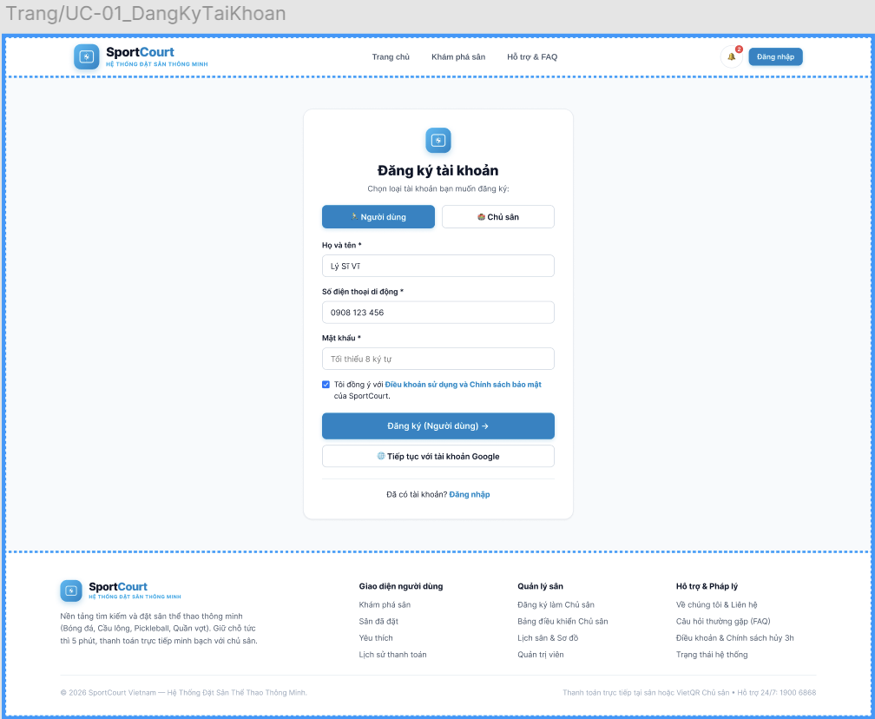
SC-03 Search for facilities — UC-03
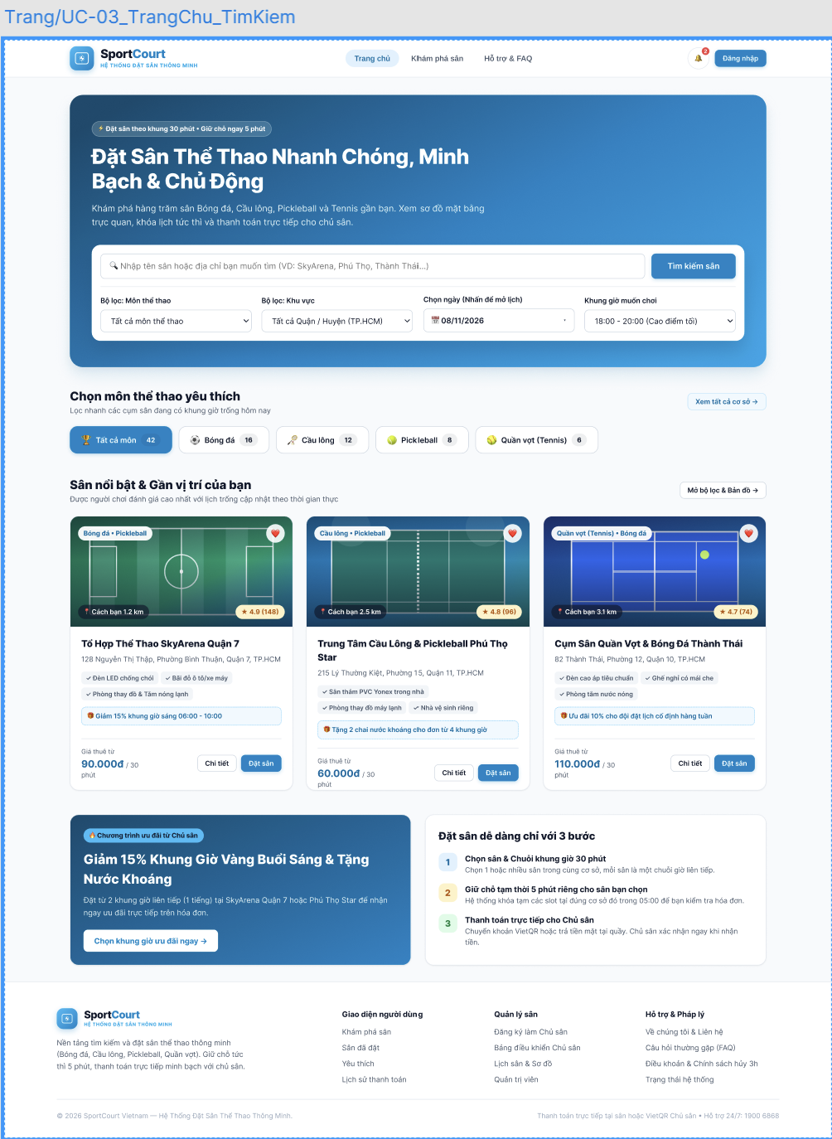
SC-04 Facility details and pricing — UC-04
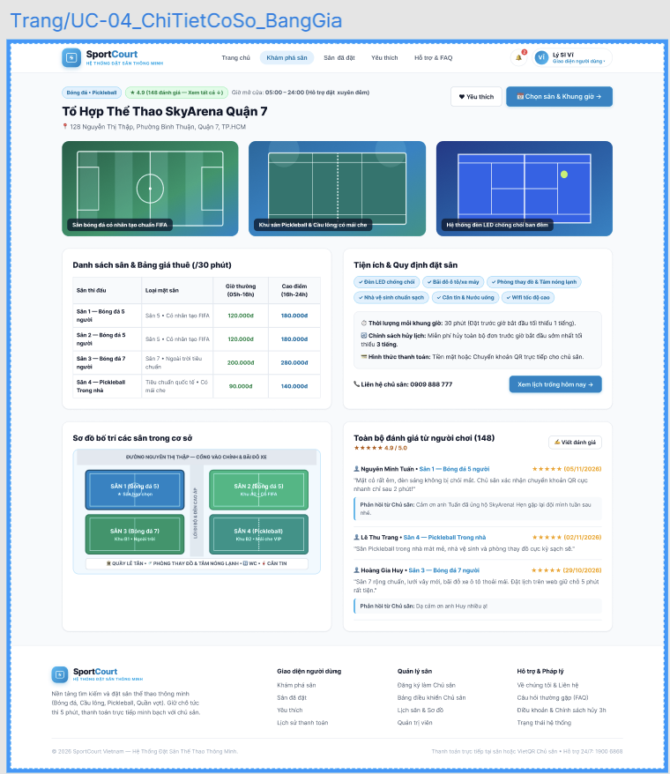
SC-05 Select courts and time slots — UC-05
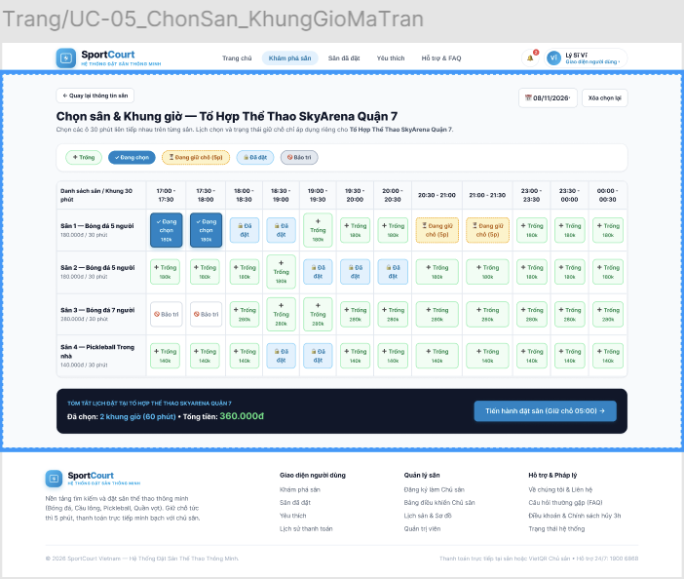
SC-06 Temporary hold — UC-05, UC-06
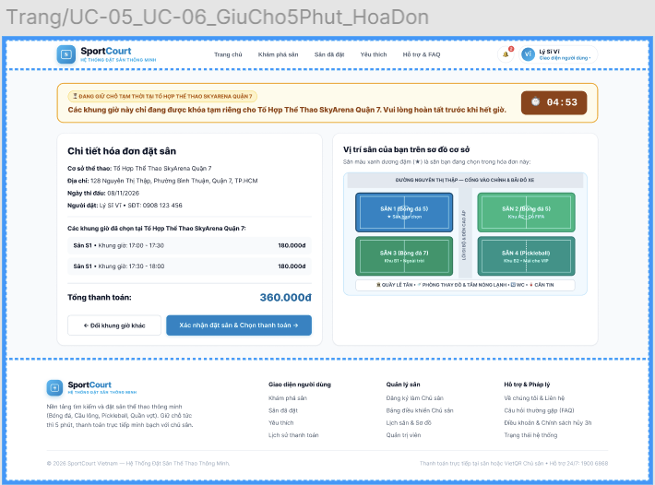
SC-07 View bookings — UC-07
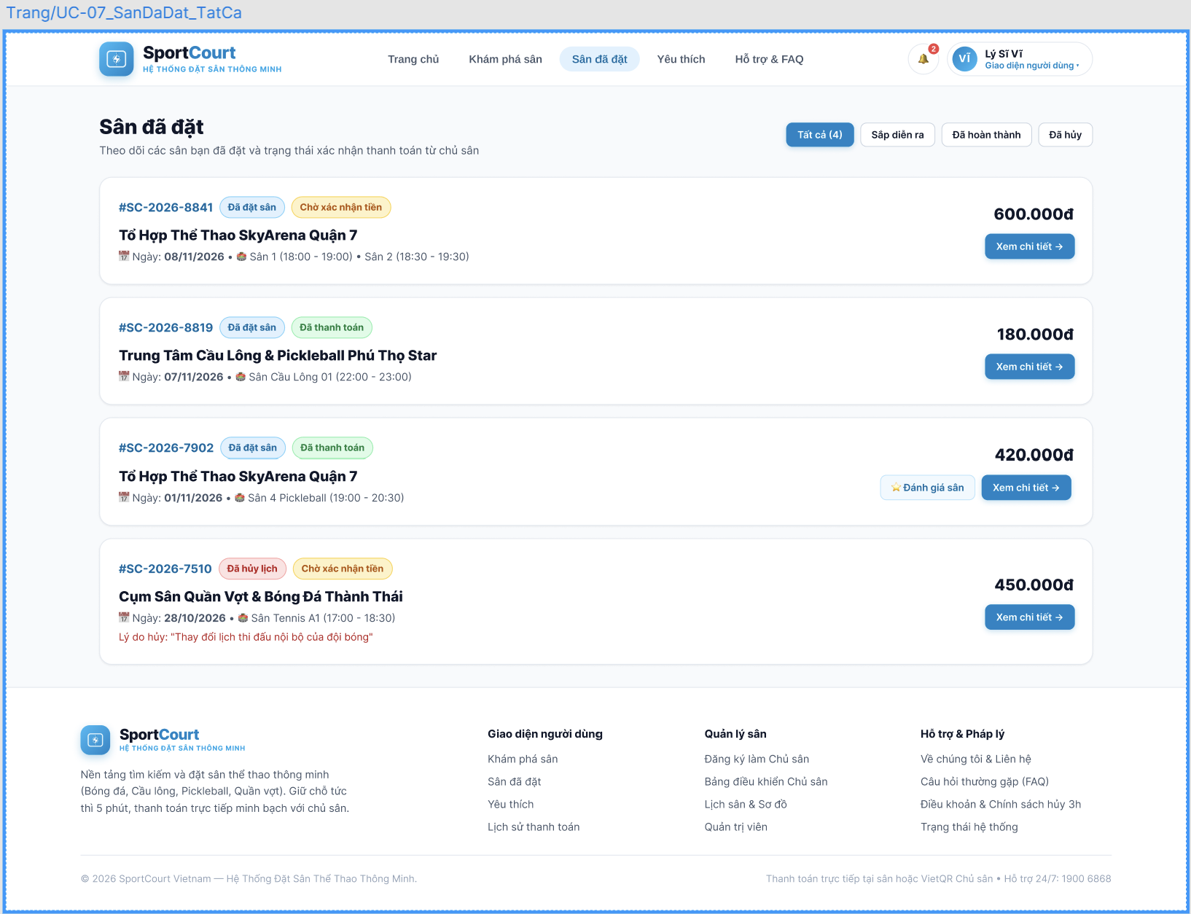
SC-10 Manage courts and prices — UC-09, UC-10
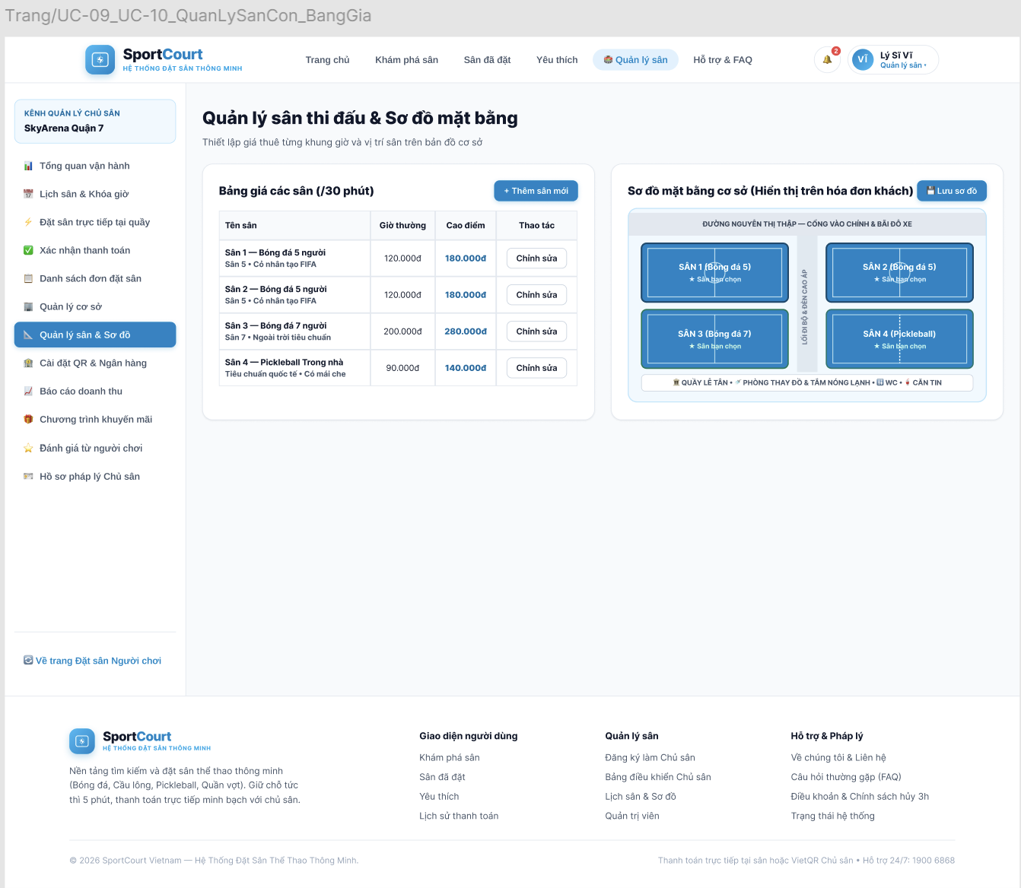
SC-11 Court schedule and unavailable slots — UC-11, UC-12
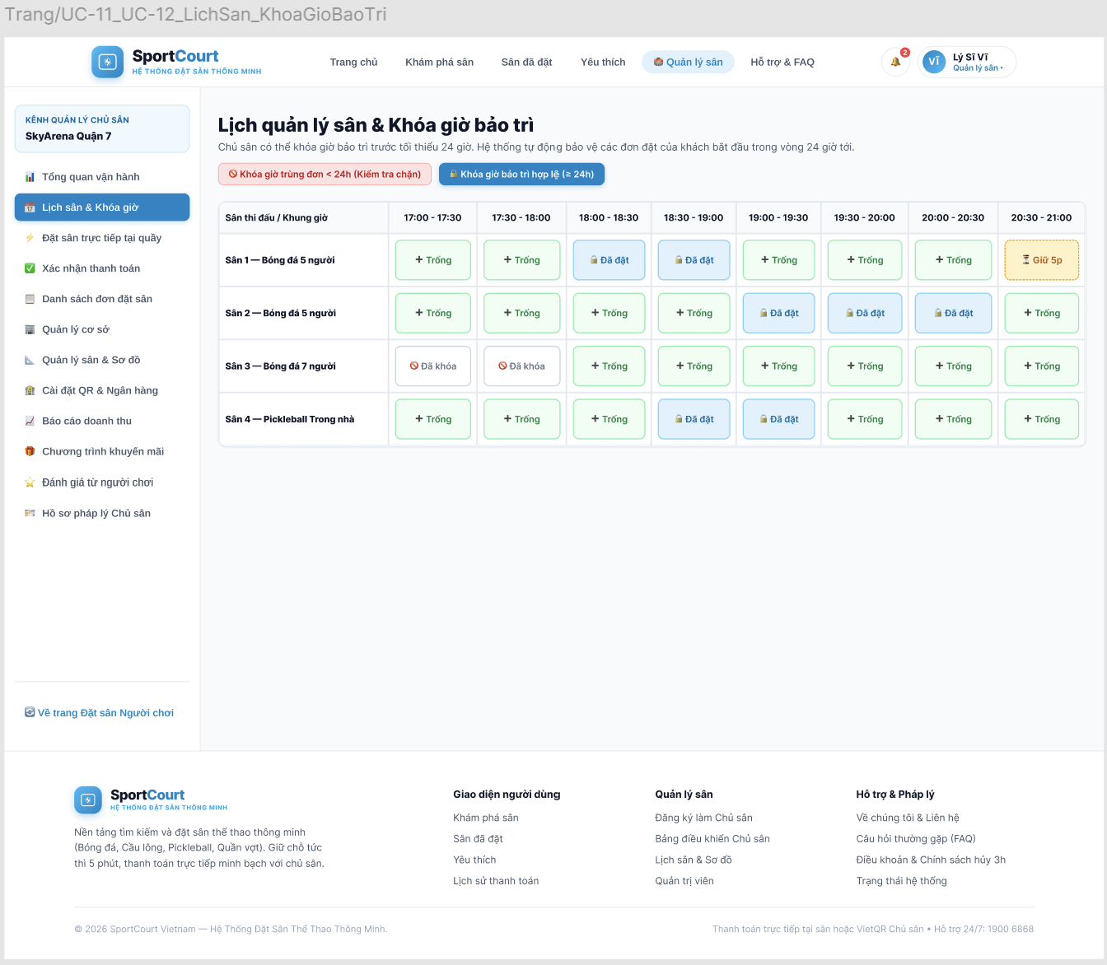
SC-12 Enter an in-person booking — UC-13
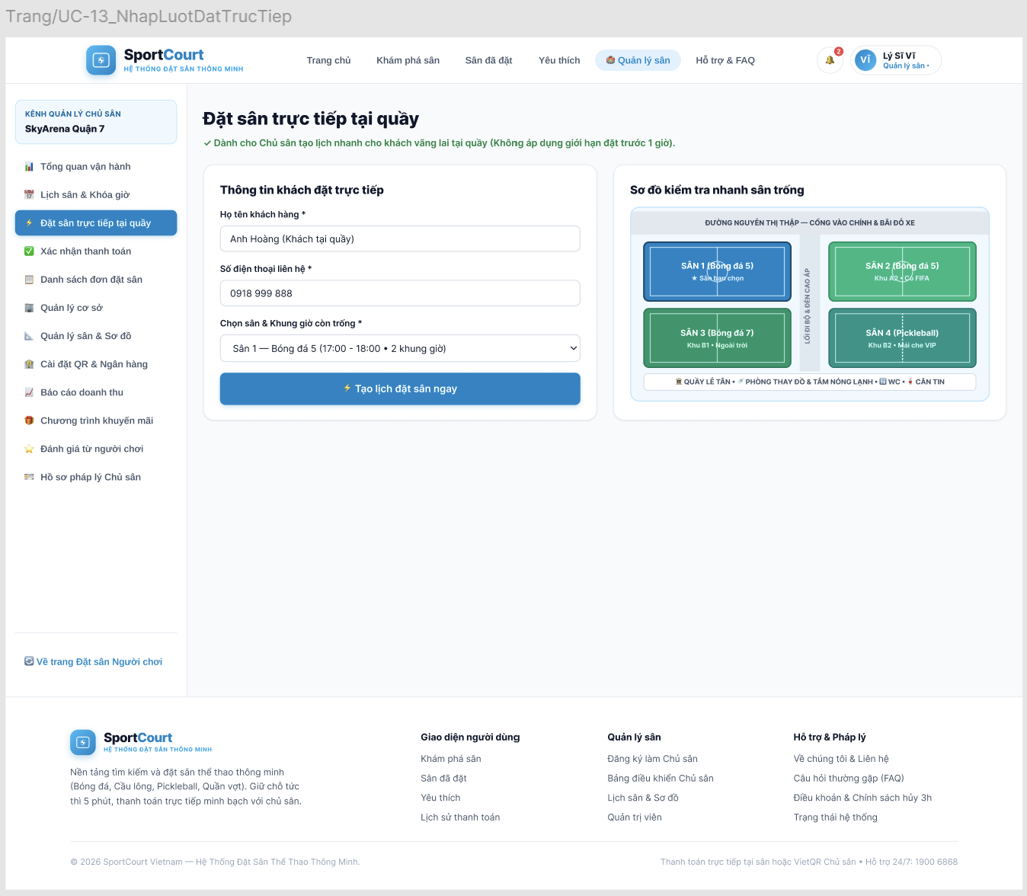
SC-08 Booking details and cancellation — UC-08
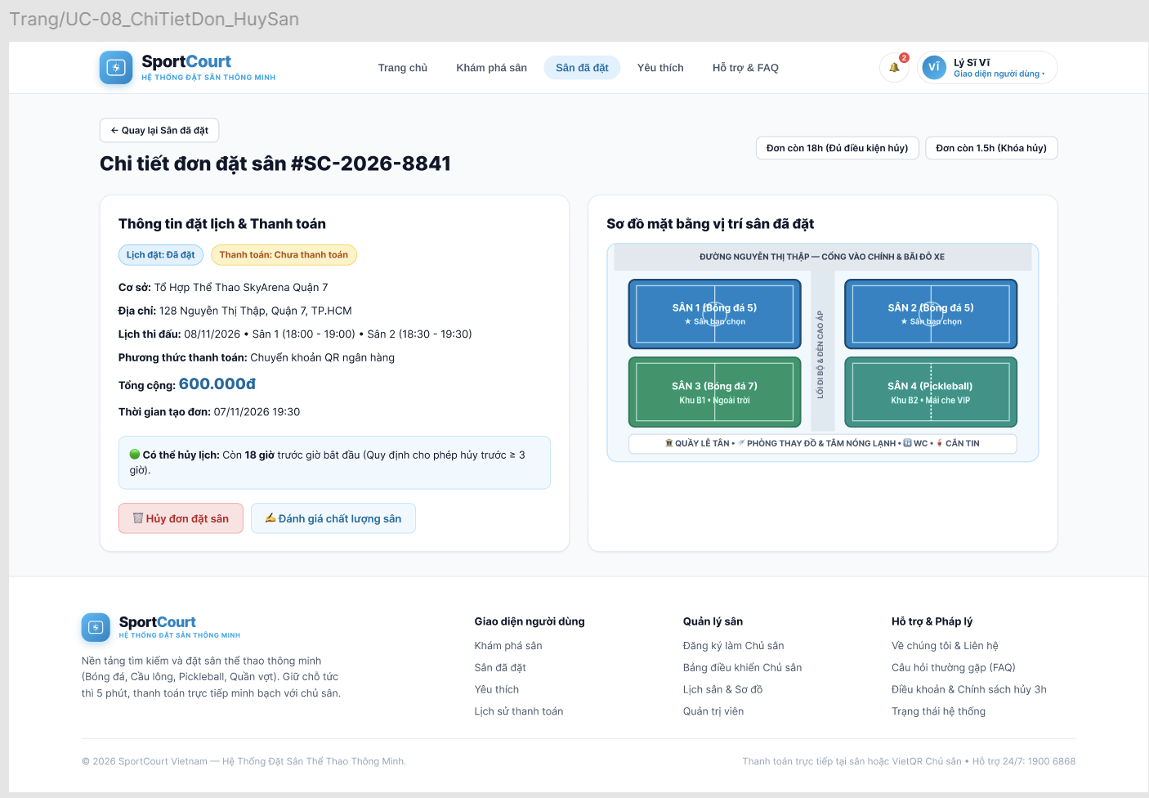
Accessibility review: Verify labels, contrast and keyboard use on the interactive prototype before final approval.

Requirements Traceability Matrix
The matrix links requirements to the use cases in Sections 6–7 and the screen list in Section 8. A screen associated with a use case does not prove that every step or exception is represented. PA3 design elements and PA4 test cases will be added in their respective phases.
Req. ID | Use case | Screen | Design element (PA3) | Test cases (PA4)
FR-01 | UC-01, UC-02, UC-05 | SC-01, SC-02, SC-05, SC-06 | — | —
FR-02 | UC-07, UC-08 | SC-07, SC-08 | — | —
FR-03 | UC-09, UC-10, UC-11, UC-12, UC-13 | SC-09, SC-10, SC-11, SC-12 | — | —
FR-04 | UC-03 | SC-03 | — | —
FR-05 | UC-03 | SC-03 | — | —
FR-06 | UC-04 | SC-04 | — | —
FR-07 | UC-04 | SC-04 | — | —
FR-08 | UC-04 | SC-04 | — | —
FR-09 | UC-05 | SC-05, SC-06 | — | —
FR-10 | UC-05, UC-13 | SC-05, SC-06, SC-12 | — | —
FR-11 | UC-06, UC-13 | SC-06, SC-12 | — | —
FR-12 | UC-06, UC-13 | SC-06, SC-12 | — | —
FR-13 | UC-05 | SC-05, SC-06 | — | —
FR-14 | UC-06 | SC-06 | — | —
FR-15 | UC-06, UC-07 | SC-06, SC-07 | — | —
FR-16 | UC-07, UC-08 | SC-07, SC-08 | — | —
FR-17 | UC-09, UC-12 | SC-09, SC-10, SC-11 | — | —
FR-18 | UC-12 | SC-11 | — | —
FR-19 | UC-10 | SC-10 | — | —
FR-20 | UC-11 | SC-11 | — | —
FR-21 | UC-13 | SC-12 | — | —
FR-22 | UC-11, UC-12, UC-13 | SC-11, SC-12 | — | —
FR-23 | UC-02, UC-05 | SC-02, SC-05, SC-06 | — | —
FR-24 | UC-01, UC-02 | SC-01, SC-02 | — | —
FR-25 | UC-06 | SC-06 | — | —
FR-26 | UC-06 | SC-06 | — | —
FR-27 | UC-05, UC-13 | SC-05, SC-06, SC-12 | — | —
FR-28 | UC-08 | SC-08 | — | —
FR-29 | UC-11, UC-12 | SC-11 | — | —
FR-30 | UC-07, UC-11, UC-12 | SC-07, SC-11 | — | —
FR-31 | UC-06 | SC-06 | — | —
FR-32 | UC-05 | SC-05, SC-06 | — | —
NFR-01 | UC-01, UC-02, UC-03, UC-04, UC-05, UC-06, UC-07, UC-08, UC-09, UC-10, UC-11, UC-12, UC-13 | SC-01, SC-02, SC-03, SC-04, SC-05, SC-06, SC-07, SC-08, SC-09, SC-10, SC-11, SC-12 | — | —
NFR-02 | UC-05, UC-06, UC-13 | SC-05, SC-06, SC-12 | — | —
NFR-03 | UC-06, UC-13 | SC-06, SC-12 | — | —
NFR-04 | UC-02, UC-08, UC-09, UC-10, UC-11, UC-12, UC-13 | SC-02, SC-08, SC-09, SC-10, SC-11, SC-12 | — | —
NFR-05 | UC-01, UC-02 | SC-01, SC-02 | — | —
NFR-06 | UC-03, UC-04 | SC-03, SC-04 | — | —
NFR-07 | UC-03, UC-05, UC-06 | SC-03, SC-05, SC-06 | — | —
NFR-08 | UC-04, UC-10, UC-11, UC-12, UC-13 | SC-04, SC-10, SC-11, SC-12 | — | —
NFR-09 | UC-07, UC-11, UC-12 | SC-07, SC-11 | — | —
BR-01 | UC-06 | SC-06 | — | —
BR-02 | UC-05 | SC-05, SC-06 | — | —
BR-03 | UC-04, UC-05, UC-13 | SC-04, SC-05, SC-06, SC-12 | — | —
BR-04 | UC-05 | SC-05, SC-06 | — | —
BR-05 | UC-05 | SC-05, SC-06 | — | —
BR-06 | UC-06 | SC-06 | — | —
BR-07 | UC-06 | SC-06 | — | —
BR-08 | UC-05, UC-13 | SC-05, SC-06, SC-12 | — | —
BR-09 | UC-08 | SC-08 | — | —
BR-10 | UC-09, UC-10, UC-11, UC-12, UC-13 | SC-09, SC-10, SC-11, SC-12 | — | —
BR-11 | UC-11, UC-12 | SC-11 | — | —
BR-12 | UC-11 | SC-11 | — | —
BR-13 | UC-11, UC-13 | SC-11, SC-12 | — | —
BR-14 | UC-01, UC-02, UC-03, UC-04, UC-05 | SC-01, SC-02, SC-03, SC-04, SC-05, SC-06 | — | —
BR-15 | UC-06 | SC-06 | — | —
BR-16 | UC-07, UC-11, UC-12 | SC-07, SC-11 | — | —

Requirements Review
Requirements review sessions: 1 and 8 November 2026. Participants in both sessions: Nguyễn Minh Trí, Lý Sĩ Vĩ and Bùi Nguyễn Đăng Khoa. The 8 November session reviewed Vĩ’s UI; Khoa is integrating PA2. Vĩ and Khôi had not reported further issues at the time of discussion.
# | Issue found | Requirement(s) | Resolution
1 | Login and hold timing was unclear | FR-01, FR-10, FR-23, FR-24 | 1 November: guests may browse and select slots; login is required when proceeding; a hold is created for a logged-in user only after validation.
2 | Conflicts and selection of multiple courts | FR-09, FR-13, FR-32 | 1 November: a booking belongs to one facility; each court has consecutive slots; if a conflict occurs, no slots are held, selections are cleared and availability is updated.
3 | Hold expiration, reload and disconnection | FR-14, FR-25, FR-26 | 1 November: holds last up to five minutes; reloading preserves the remaining time; upon expiry, confirmation is rejected immediately and the hold is released; the system attempts early detection of disconnection.
4 | Booking, cancellation and owner change limits | FR-27, FR-28, FR-29, FR-30 | 1 November: booking requires two slots of advance notice; the entire booking may be cancelled at least three hours before its earliest start; owner changes are subject to the 24-hour check, waiting for holds, warnings and notifications.
5 | Owner permissions and in-person bookings | FR-03, FR-21, FR-27 | 1 November: owners manage only the facilities they created; in-person bookings follow the booking flow and are exempt from the two-slot advance limit.
6 | Conditions for user count and time targets | NFR-06, NFR-07 | 1 November: the team confirmed the 50-user target; the three-minute target covers searching and booking, excluding registration and login. See section 5 for the relevant requirement identifiers.
7 | UI screens include expanded features and payment | FR-11, FR-12 | 8 November: retain expanded UI screens as reference for later phases. Payment method selection and payment status confirmation have not been sufficiently discussed and are excluded from PA2 requirements; booking confirmation follows the agreed booking rules.

AI Usage Log
[Required in every PA (course GenAI policy). List each significant use of AI tools. Write “No AI tools were used” if none. Undisclosed AI use is treated as an academic integrity violation.]
# | Member | Tool | Task / purpose | How the output was verified and changed
1 | 23127074 — Vương Gia Khôi | No AI tools were used
2 | 24127421 — Bùi Nguyễn Đăng Khoa | OpenAI Codex | Supported use case modelling and specifications, requirement traceability, review of the requirements and prototype, and integration of PA2 into the template. | Khoa checked drafts against PA1 and the PA2 template, reviewed scenarios and business rules with the team, supplied corrections, and revised the document and review findings.
3 | 24127569 — Nguyễn Minh Trí | Claude (Anthropic) | Drafted SRS sections 2–5 from PA1, identifying information from PA1, team decisions, proposals, and open questions. | Compared the draft against PA1 and the team leader’s version; brought proposals and open questions to the team, then revised the sections to reflect agreed decisions.
4 | 24127587 — Lý Sĩ Vĩ | Claude (Anthropic) | Summarised PA1 and PA2 requirements, brainstormed website pages and components, and drafted page specifications for the Section 8 Figma mockups. | Checked summaries and page lists against project documents and team decisions, corrected AI assumptions, removed an unapproved refund rule, added design ideas, and kept unresolved points for team discussion.

