Telco Customer Analytics
Classification - Regression - Clustering (K-Means + Hierarchical)
Comprehensive Technical Report (5000+ words)

Prepared for academic review - February 2026

Table of Contents
1. Executive Summary ........................................ 3
2. Project Scope and Objectives ........................................ 4
3. Business Context and Value ........................................ 5
4. Dataset Overview ........................................ 6
5. Data Quality Assessment ........................................ 7
6. Data Cleaning Procedures ........................................ 8
7. Feature Engineering Strategy ........................................ 9
8. Exploratory Data Analysis Approach ........................................ 10
9. EDA Findings - Churn Drivers ........................................ 11
10. EDA Findings - Distributions and Correlations ........................................ 12
11. Modeling Pipeline and Experimental Design ........................................ 13
12. Classification Models and Training ........................................ 14
13. Classification Evaluation and Interpretation ........................................ 15
14. Regression Modeling - Target Justification ........................................ 16
15. Regression Results and Diagnostics ........................................ 17
16. Clustering Methodology - K-Means ........................................ 18
17. Clustering Methodology - Hierarchical ........................................ 19
18. Clustering Results and Segment Profiles ........................................ 20
19. Integrated Insights and Recommendations ........................................ 21
20. Limitations and Risks ........................................ 22
21. Future Work and Extensions ........................................ 23
22. Reproducibility and Environment ........................................ 24
23. Algorithm Deep Dive - Logistic Regression ........................................ 25
24. Algorithm Deep Dive - Trees, Forests, Boosting ........................................ 26
25. Algorithm Deep Dive - Regression Models ........................................ 27
26. Algorithm Deep Dive - K-Means Clustering ........................................ 28
27. Algorithm Deep Dive - Hierarchical Clustering ........................................ 29
28. Evaluation Metrics Deep Dive ........................................ 30
29. Validation and Robustness ........................................ 31
30. Deployment and Monitoring Considerations ........................................ 32
31. Business Impact Scenario ........................................ 33
32. Conclusion ........................................ 34
33. Notebook Walkthrough - End to End Steps ........................................ 35
34. Interpretation of Key Figures ........................................ 36
35. Stakeholder Communication Guidance ........................................ 37
36. Implementation Checklist ........................................ 38
37. Detailed Preprocessing and Encoding Walkthrough ........................................ 39
38. Segmentation Usage and Action Design ........................................ 40
39. Ethical and Fairness Considerations ........................................ 41

1. Executive Summary
This report documents a complete analytics workflow applied to the Telco Customer Churn dataset. The project was structured to mirror an end to end analytics engagement: define business questions, explore and clean data, engineer features, conduct exploratory analysis, build predictive and descriptive models, and translate outputs into business insights. The work includes three distinct but related tasks: classification to predict churn, regression to estimate revenue contribution, and clustering to segment the customer base.
The dataset contains 7,043 customers with a churn rate of 26.5%. Average tenure is 32.4 months (median 29), and average monthly charges are $64.76. These baseline statistics provide context for retention risk, revenue potential, and segmentation patterns.
Key outcomes: Logistic Regression delivered the strongest balance of recall and F1 for churn detection. Random Forest Regression achieved the lowest RMSE for TotalCharges, indicating strong predictive accuracy. K-Means and Hierarchical clustering identified coherent segments that differ by tenure, contract type, and service bundle depth. These outputs collectively suggest that contract duration, tenure, and payment method are consistent churn signals, while service bundling provides a measurable protective effect.
The remainder of the report details what was done, how it was done, and what the results mean for decision making.

2. Project Scope and Objectives
The scope of this project is intentionally broad to capture the full lifecycle of customer analytics. The objective is not merely to train a model but to produce a coherent narrative that ties data, models, and business actions together. Three primary objectives guide the work. First, identify churn risk, enabling targeted retention. Second, estimate revenue contribution, enabling value based prioritization. Third, segment customers, enabling tailored engagement strategies.
Each objective answers a different business question: who is likely to churn, how valuable are they, and which segment do they belong to. When combined, these outputs enable practical decision making. For example, a high value customer with high churn risk should be prioritized over a low value customer with similar churn risk. Likewise, segment membership can determine which retention offer or communication style will be most effective.
The project also emphasizes interpretability. Stakeholders need to understand why a model makes a prediction and how to translate that prediction into action. Therefore, we use models that balance performance and explainability, and we align model findings with exploratory analysis results.

3. Business Context and Value
Telecommunications is a subscription driven industry where churn directly impacts revenue stability. Acquisition costs are high, so retention often delivers better ROI. Predictive churn analytics allow proactive interventions before customers leave, improving retention at lower cost. However, churn prediction alone is insufficient because not all customers contribute equally to revenue. Revenue estimation provides an additional lens that supports prioritization.
Segmentation adds another layer of value. Customers do not churn for a single reason; they churn for different reasons depending on their profile. A single retention strategy rarely works across all customer types. Segmentation helps organizations tailor messaging, incentives, and service improvements based on customer characteristics and behaviors.
This project therefore aims to build a holistic system of insight: prediction for risk, estimation for value, and clustering for personalization.

4. Dataset Overview
The Telco Customer Churn dataset is a structured table where each row represents a unique customer. Variables include demographics, service subscriptions, contract terms, billing methods, and charges. The churn label indicates whether the customer has terminated service. The dataset is cross sectional rather than longitudinal, which limits time based modeling but still provides rich customer attributes for prediction and segmentation.
Important columns include tenure (months of service), MonthlyCharges, TotalCharges, Contract, PaymentMethod, and several service flags such as OnlineSecurity and StreamingTV. These columns provide signals about engagement, product depth, and billing behavior. This combination makes the dataset ideal for testing both supervised and unsupervised methods.
The dataset summary below contextualizes the modeling results and provides baseline understanding of the population.
Metric | Value
Total customers | 7,043
Churn rate | 26.54%
Avg tenure | 32.37
Avg monthly charges | $64.76
Figure: cell09 img1
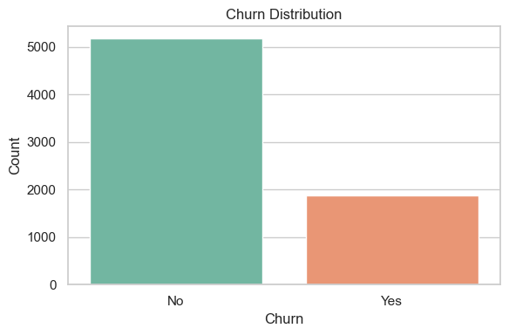

5. Data Quality Assessment
The first step in analysis was a careful data quality review. The most important issue was that TotalCharges was stored as a string and contained blank values for customers with zero tenure. This is a common artifact in this dataset and must be addressed before numeric modeling.
We also verified that categorical fields had consistent categories and that numeric fields were within reasonable ranges. No major anomalies were found beyond the TotalCharges issue. The churn label was already clean and binary.
The customerID field was identified as a pure identifier. Keeping it would add meaningless noise to models, so it was removed.

6. Data Cleaning Procedures
Data cleaning steps were designed to preserve business meaning while ensuring modeling compatibility. TotalCharges was converted to numeric, with invalid blanks coerced to NaN and imputed as 0 to reflect zero accumulated charges for new customers. This choice is justified by the fact that zero tenure implies no time to accumulate charges.
The SeniorCitizen column was recoded from 0 and 1 to Yes and No for consistency with other categorical fields. This allowed a uniform one hot encoding step. No other imputation was required because missingness was minimal in the remaining features.
Finally, the customerID column was dropped because it offers no predictive value and could lead to overfitting on arbitrary identifiers.

7. Feature Engineering Strategy
Feature engineering emphasized interpretability and behavior. We created num_services, a count of subscribed services such as security, backup, and streaming. This provides a single numeric indicator of service depth and helps quantify bundle intensity. The expectation was that a higher number of services would correspond to greater stickiness and therefore lower churn.
We also created tenure groups to visualize churn risk across lifecycle stages. Customers early in their tenure often have higher churn risk, and the tenure grouping allowed this pattern to be displayed clearly in EDA. These groups were used for visualization only and not included in modeling to avoid arbitrary binning.
The feature engineering approach focused on a small set of meaningful transformations rather than extensive feature expansion.

8. Exploratory Data Analysis Approach
EDA was used to understand customer behavior, validate assumptions, and identify features likely to be predictive. The analysis included churn distribution, churn rates by contract and payment method, numeric distributions of tenure and charges, and correlations among numeric variables. We also explored the relationship between num_services and churn.
This stage served two purposes: to build intuition for the business problem and to inform model selection. For example, if churn rates differ strongly by contract type, then contract should be a top predictive feature. If service bundles correlate with churn, then num_services should be valuable.
EDA outputs were later used to interpret feature importance and to connect model predictions to business understanding.

9. EDA Findings - Churn Drivers
Churn rates vary substantially across contract types. Month to month contracts show the highest churn, while two year contracts have the lowest churn. This suggests that contract duration is a strong retention lever. The payment method analysis shows that electronic check payments are associated with higher churn than automatic bank transfer or credit card payments, suggesting higher friction or lower engagement.
These findings are directly actionable. Contract upgrade incentives and payment method migration could both reduce churn. Importantly, these patterns align with common telecom retention strategies and validate the dataset's business realism.
The churn distribution confirms that churn is a minority class, which means that accuracy alone is not a sufficient evaluation metric. Recall and F1 are required to ensure churners are correctly identified.
Figure: cell10 img1
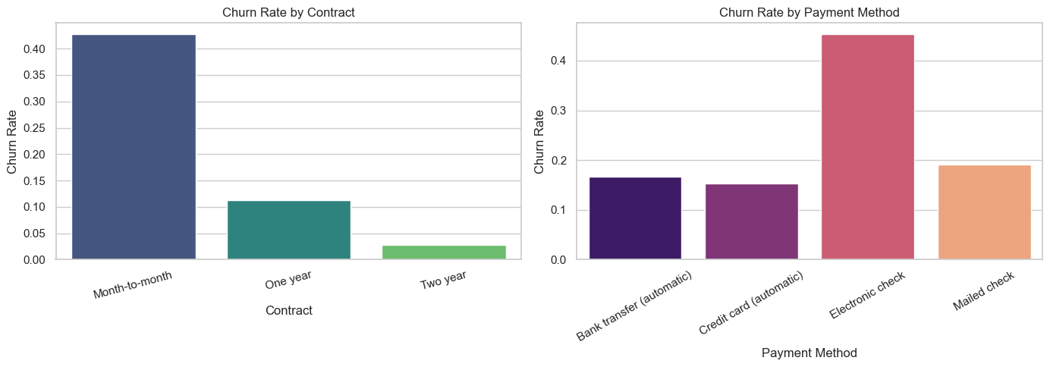

10. EDA Findings - Distributions and Correlations
Tenure is skewed toward shorter durations, indicating a large population of relatively new customers. This matters because churn risk is typically highest early in the customer lifecycle. MonthlyCharges and TotalCharges are broadly distributed, reflecting a range of service packages and tenure lengths.
Correlation analysis shows a strong relationship between tenure and TotalCharges. This is expected because TotalCharges accumulates over time. MonthlyCharges also correlates with TotalCharges, but to a lesser extent. These relationships are important for regression modeling because they can produce multicollinearity in linear models, while tree based models handle it more robustly.
The correlation heatmap provides a quantitative overview of these relationships and supports the feature selection strategy used in modeling.
Figure: cell13 img1
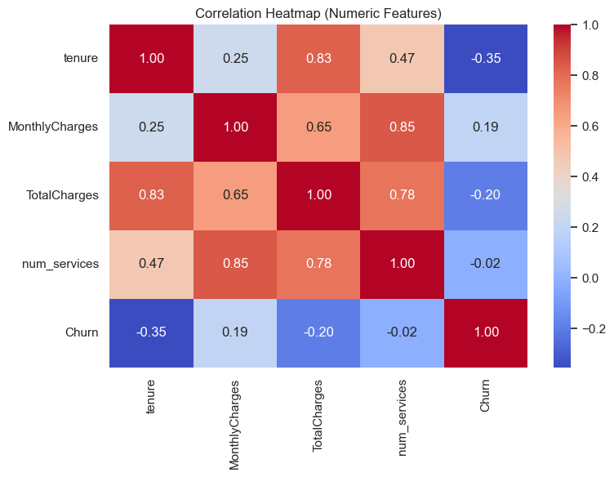

11. Modeling Pipeline and Experimental Design
The modeling pipeline uses a train test split with stratification on churn (70 percent train, 30 percent test). Stratification preserves the class distribution and ensures performance metrics reflect realistic churn proportions. Preprocessing is encapsulated in scikit learn pipelines to avoid data leakage.
Categorical variables are one hot encoded. Numeric variables are standardized to zero mean and unit variance. Standardization is critical for clustering and for models sensitive to feature scale.
Hyperparameter tuning was applied to tree based models using grid search cross validation with F1 as the primary scoring metric. This reflects the business emphasis on identifying churners rather than maximizing overall accuracy.

12. Classification Models and Training
Four classification models were trained. Logistic Regression provides a strong baseline and interpretability through coefficients. Decision Tree captures nonlinear relationships but is prone to overfitting. Random Forest reduces overfitting through ensembling. HistGradientBoosting offers strong performance on structured data with efficient training.
Class imbalance was addressed using class weights in Logistic Regression and Random Forest. This increases the penalty for misclassifying churners and improves recall. Training was performed within pipelines so that preprocessing is applied consistently to train and test data.
Model selection focused on the tradeoff between recall and precision, with a bias toward recall because missing churners is costly.

13. Classification Evaluation and Interpretation
Results show that Logistic Regression achieved the best balance of recall and F1. Random Forest and Decision Tree achieved higher accuracy but lower recall, which is less desirable for churn prediction. HistGradientBoosting performed competitively but with slightly lower recall.
The ROC curve indicates strong separation between churners and non churners, and AUC values above 0.83 show that the models are effective at ranking risk. Precision recall curves further validate the ability to identify churners despite imbalance.
Feature importance and coefficient analysis highlight contract type, tenure, and payment method as primary churn drivers. This aligns with the exploratory findings and provides a consistent narrative for stakeholders.
Unnamed: 0 | model | accuracy | precision | recall | f1 | roc_auc
0 | LogisticRegression | 0.745 | 0.513 | 0.797 | 0.624 | 0.844
2 | RandomForest | 0.771 | 0.554 | 0.713 | 0.624 | 0.837
1 | DecisionTree | 0.795 | 0.615 | 0.604 | 0.610 | 0.829
3 | HistGradientBoosting | 0.790 | 0.629 | 0.510 | 0.563 | 0.829
Figure: cell21 img2
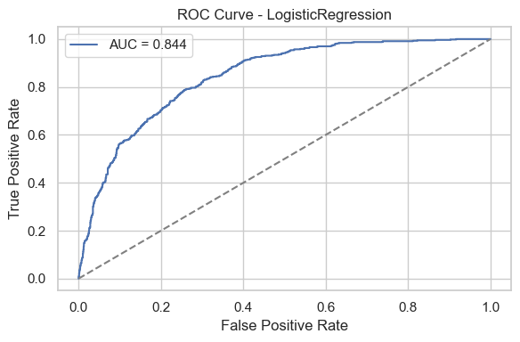
Figure: cell21 img3
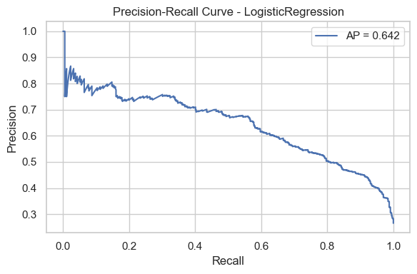
Figure: cell22 img1
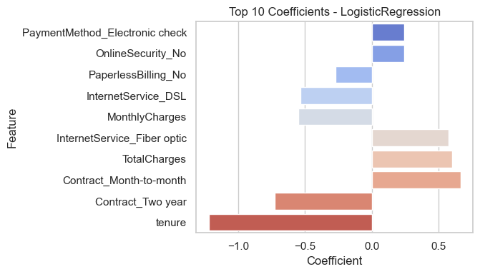

14. Regression Modeling - Target Justification
The regression task predicts TotalCharges, which represents accumulated revenue. While TotalCharges is not a forward looking lifetime value measure, it provides a practical proxy for customer value in a cross sectional dataset.
TotalCharges is strongly influenced by tenure and MonthlyCharges, so models are expected to be highly accurate. The goal is both accurate prediction and insight into how revenue scales with customer characteristics.
Three models were tested to capture different levels of complexity: Linear Regression, Random Forest Regression, and Gradient Boosting Regression.

15. Regression Results and Diagnostics
Random Forest Regression achieved the lowest RMSE and highest R2, indicating excellent predictive performance. Gradient Boosting performed similarly, while Linear Regression lagged due to its linear assumptions and inability to capture nonlinear effects.
Diagnostic plots show residuals centered near zero and a strong alignment between actual and predicted values. This indicates stable predictive performance without systematic bias.
The regression results confirm that revenue is highly predictable from tenure and monthly charges, reinforcing the importance of customer longevity as a revenue driver.
Unnamed: 0 | model | MAE | RMSE | R2
1 | RandomForestRegressor | 53.713 | 80.682 | 0.999
2 | GradientBoostingRegressor | 73.883 | 105.304 | 0.998
0 | LinearRegression | 560.250 | 692.530 | 0.907
Figure: cell25 img1
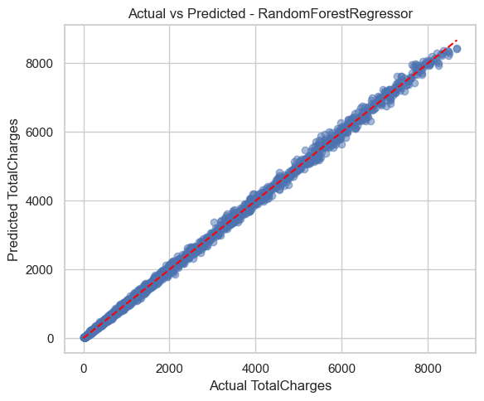
Figure: cell25 img2
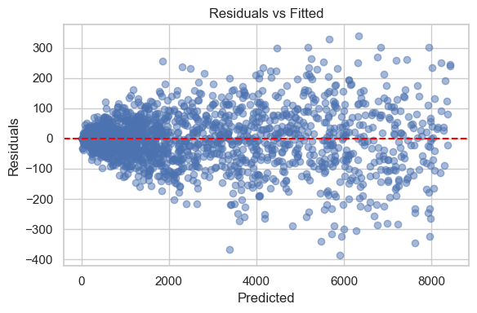

16. Clustering Methodology - K-Means
K-Means clustering was applied to the standardized feature space. The number of clusters was selected using the elbow method and silhouette scores. K equals 2 produced the best silhouette score, balancing separation and cohesion.
PCA projections were used to visualize cluster separation. Cluster profiles were derived from mean tenure, charges, and service counts. These profiles help interpret the behavioral differences between clusters and link them to business strategies.
K-Means offers simplicity and scalability, making it practical for large customer bases.
Figure: cell28 img1
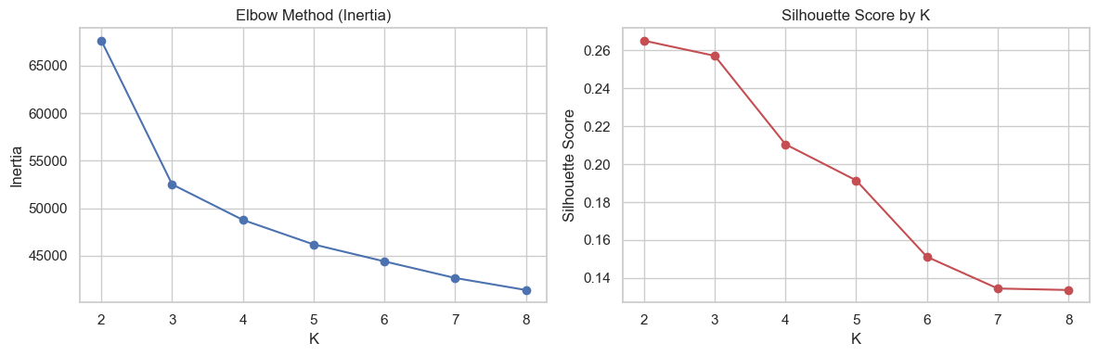
Figure: cell29 img1
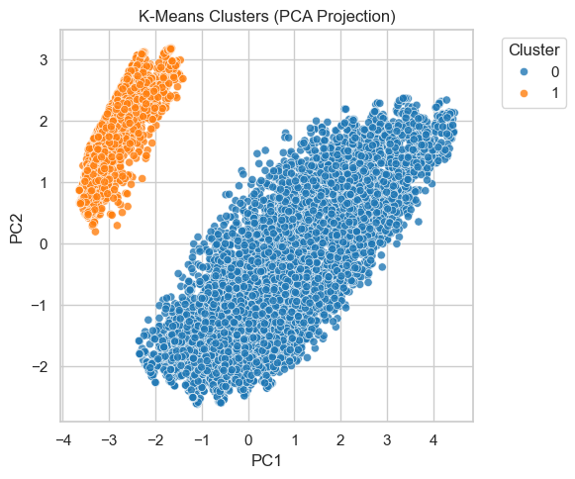

17. Clustering Methodology - Hierarchical
Hierarchical clustering was used to validate segmentation structure. Ward linkage minimizes within cluster variance and provides a dendrogram that illustrates the hierarchical relationships among customers. A cluster cut aligned with the K-Means selection, confirming segment stability.
The hierarchical approach is useful for interpretability because it reveals nested groupings. The dendrogram provides a visual map of similarity, which can be helpful for exploring sub segments within a larger group.
The alignment between K-Means and hierarchical results increases confidence in the segmentation outcome.
Figure: cell32 img1
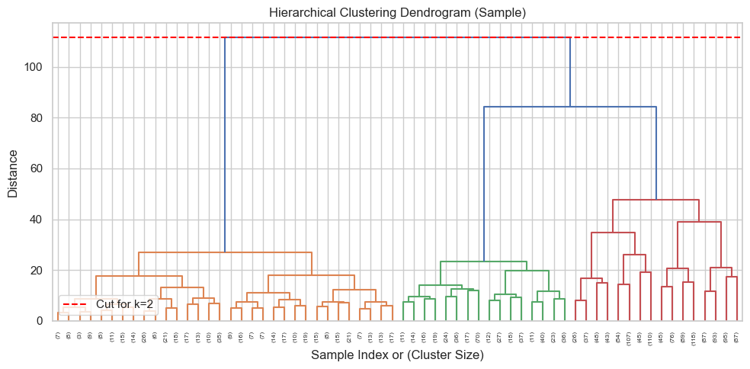
Figure: cell33 img1
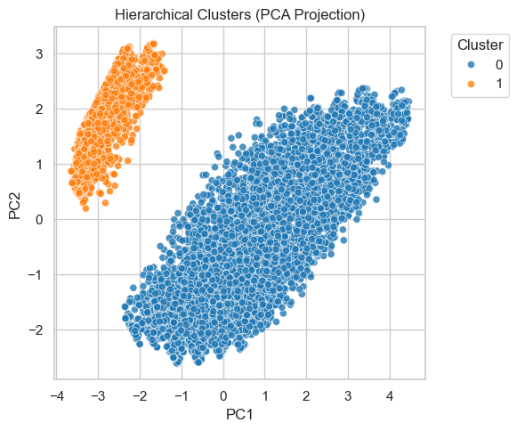

18. Clustering Results and Segment Profiles
Both clustering approaches produced segments characterized primarily by tenure and service depth. One segment tends to have shorter tenure and fewer services, while another segment has longer tenure and deeper service bundles. These differences suggest distinct lifecycle stages.
The low tenure segment is likely higher churn risk and more price sensitive. The high tenure segment may respond better to loyalty rewards and premium add ons. Segment profiles provide a framework for differentiated marketing and retention strategies.
The PCA projections and dendrograms support the conclusion that these segments are meaningful and stable.

19. Integrated Insights and Recommendations
The combined results of classification, regression, and clustering produce a coherent action plan. The strongest churn drivers are contract type, tenure, and payment method. This supports strategies such as encouraging longer contracts, improving billing experience, and targeting early tenure customers with retention offers.
Service bundles reduce churn, so cross sell and bundle promotions are recommended. Since TotalCharges is closely tied to tenure, retaining customers longer has direct revenue impact. The regression results confirm the financial benefit of retention efforts.
Segment based strategies should be prioritized. Low tenure, low service customers should receive onboarding and education. High tenure customers should receive loyalty rewards and premium service offers.

20. Limitations and Risks
The dataset is cross sectional and does not capture time series behavior. This limits the ability to model churn timing or to evaluate changes in churn risk over time. External factors such as competitor pricing, marketing campaigns, or macroeconomic conditions are not included.
Regression predictions are dominated by tenure and monthly charges, limiting the interpretability of other factors. Clustering results depend on preprocessing choices, and alternative scaling or feature selection could lead to different segment structures.
These limitations should be considered before deploying models in production. Additional data sources and monitoring are recommended.

21. Future Work and Extensions
Future work could include survival analysis to estimate time to churn, enabling more precise intervention timing. Time series modeling could incorporate billing or usage trajectories, while causal inference could estimate the impact of retention interventions.
Additional features such as customer support interactions, satisfaction scores, or marketing exposure could improve predictive performance and interpretability. Segment level experiments could validate the effectiveness of targeted strategies.
Deployment ready pipelines could include automated retraining, monitoring, and alerting for model drift.

22. Reproducibility and Environment
The analysis is fully reproducible. All steps are captured in a Jupyter notebook with explicit dependencies listed in requirements.txt. Preprocessing and modeling are implemented as scikit learn pipelines to ensure consistent transformations between training and test data.
The dataset is downloaded via the Kaggle API with environment based credentials. This ensures that the workflow can be executed end to end by other analysts without manual file manipulation.

23. Algorithm Deep Dive - Logistic Regression
Logistic Regression models the log odds of the churn outcome as a linear combination of features. The output is a probability between 0 and 1, making it interpretable and easy to threshold for business decisions. The coefficients represent the direction and magnitude of each feature's effect on churn risk.
Class weights were used to address imbalance, effectively increasing the cost of misclassifying churners. This shifts the decision boundary toward improved recall. Regularization helps prevent overfitting and stabilizes coefficients when many one hot encoded features are present.
In this project, Logistic Regression provided the best balance of recall and F1. Its interpretability makes it suitable for stakeholder communication, especially when the goal is to explain churn drivers rather than maximize raw accuracy.

24. Algorithm Deep Dive - Trees, Forests, Boosting
Decision Trees split the feature space into regions based on thresholds that maximize information gain. They capture nonlinear relationships but can overfit if not constrained. Random Forests mitigate overfitting by averaging many trees trained on bootstrapped samples and random feature subsets.
HistGradientBoosting and Gradient Boosting models build trees sequentially, each correcting the errors of the previous. This often yields strong performance on structured data. The tradeoff is interpretability and sensitivity to hyperparameter tuning.
In this project, tree based models achieved strong accuracy but slightly lower recall than Logistic Regression. This illustrates the tradeoff between capturing complex patterns and prioritizing detection of the minority churn class.

25. Algorithm Deep Dive - Regression Models
Linear Regression assumes a linear relationship between predictors and TotalCharges. It provides interpretable coefficients but struggles with nonlinear effects. Random Forest Regression captures nonlinear relationships by averaging across decision trees. Gradient Boosting Regression builds additive trees to minimize residual error.
The strong performance of Random Forest Regression indicates that the relationship between charges and predictors is nonlinear and better captured by ensemble methods. The high R2 values confirm that TotalCharges is highly predictable from tenure and monthly charges.
When interpretability is required, Linear Regression can still provide useful directional insights, but for prediction accuracy the ensemble methods are more effective.

26. Algorithm Deep Dive - K-Means Clustering
K-Means partitions the dataset into K clusters by minimizing within cluster distance to centroids. The algorithm is sensitive to feature scaling, which is why standardization was applied. Choosing K requires balancing simplicity with explanatory power, and the silhouette score provides a quantitative guide.
A key limitation is that K-Means assumes spherical clusters and equal variance, which may not always hold. Nevertheless, in this dataset the clusters appear coherent and interpretable, with separation largely driven by tenure and service depth.
K-Means is attractive for production use because it scales well and produces clear segment labels.

27. Algorithm Deep Dive - Hierarchical Clustering
Hierarchical clustering builds a tree of clusters by iteratively merging the closest groups. Ward linkage minimizes within cluster variance, producing compact clusters. The dendrogram provides a visual representation of how clusters merge, enabling analysts to choose a cluster cut point.
Unlike K-Means, hierarchical clustering does not require a predefined K, although a cut must eventually be selected. Its main limitation is computational cost for large datasets. In this project, a sample was used for dendrogram visualization to manage runtime.
The hierarchical results largely confirmed the K-Means segmentation, increasing confidence in the robustness of the clusters.

28. Evaluation Metrics Deep Dive
Accuracy measures overall correctness but can be misleading when the positive class is rare. Precision measures how many predicted churners are actual churners. Recall measures how many actual churners are correctly detected. F1 balances precision and recall, making it useful for imbalanced classification.
ROC AUC captures the ability of a model to rank churners above non churners across thresholds, while the precision recall curve is more informative when the positive class is rare.
For regression, MAE provides an intuitive average error magnitude, RMSE penalizes large errors, and R2 measures explained variance. In clustering, silhouette score measures cohesion and separation, while inertia measures within cluster distance.
Understanding these metrics is essential for translating model performance into business risk tolerance and operational decisions.

29. Validation and Robustness
Model robustness depends on evaluation strategy and data handling. The train test split with stratification preserves churn distribution and prevents inflated metrics. Preprocessing within pipelines prevents leakage and ensures that scaling and encoding are learned only on training data.
Grid search cross validation was used for tree based models to select reasonable hyperparameters. This reduces the risk of overfitting and improves generalization. In practice, additional validation on new time periods would further strengthen robustness, especially if customer behavior shifts over time.
Class imbalance remains a key challenge. The choice of class weights and evaluation metrics reflects a deliberate preference for recall, aligning with the business cost of missed churners.

30. Deployment and Monitoring Considerations
If deployed, the churn model should be monitored for drift in feature distributions or performance metrics. Changes in pricing, contract policies, or customer behavior can reduce model accuracy over time. Regular retraining and calibration are recommended.
Threshold selection should reflect business costs. A higher recall threshold captures more churners but may increase false positives and retention costs. The decision should be aligned with retention budget and expected lifetime value.
For segmentation, periodic recalculation is recommended to capture evolving customer patterns. Segment definitions should be monitored to ensure they remain meaningful.

31. Business Impact Scenario
To illustrate potential impact, consider a retention program that targets the top 10 percent highest risk customers. If the churn model has a recall near 0.80, a large share of true churners would be captured in this subset. If retention actions succeed for even a fraction of these customers, the revenue retained could be significant given the average monthly charges and tenure profiles.
Segmentation further enhances efficiency. For example, high tenure customers may respond best to loyalty incentives, while low tenure customers may require onboarding improvements or service education. By tailoring the retention strategy to segment profiles, the business can improve conversion rates and reduce unnecessary incentive spending.
This illustrates how predictive, descriptive, and value based analytics can work together to produce measurable business outcomes.

32. Conclusion
This project demonstrates an integrated analytics workflow that combines predictive modeling and segmentation to address churn and revenue challenges. The strongest predictors of churn are contract type, tenure, and payment method, while service bundling reduces churn risk. Regression results show that TotalCharges is highly predictable from tenure and monthly charges, underscoring the revenue importance of long term customer retention.
The clustering analysis confirms the presence of distinct customer segments, providing a foundation for tailored marketing and retention strategies. The results are consistent across K-Means and hierarchical methods, strengthening confidence in the segmentation.
Overall, the project provides a coherent framework for churn management: identify risk, quantify value, and tailor interventions. This framework is transferable to other subscription based industries with similar data structures.

33. Notebook Walkthrough - End to End Steps
This section provides a step by step narrative of the notebook execution. The notebook begins with environment setup, where dependencies are imported, paths are defined, and a random seed is set for reproducibility. It then checks Kaggle credentials and downloads the dataset if it is not already present, ensuring that the workflow can be executed from scratch without manual file handling.
The data loading step reads the CSV into a DataFrame and prints shape, head, and missing value summaries. Cleaning and feature engineering are then performed: TotalCharges is converted to numeric and filled, SeniorCitizen is recoded, customerID is dropped, and num_services and tenure groups are created. These operations are intentionally explicit so that each transformation can be traced and explained.
EDA cells generate plots in a logical sequence: churn distribution, churn rates by contract and payment method, distributions of numeric fields, correlation heatmap, and feature relationships. Modeling cells then build preprocessing pipelines, train models, tune hyperparameters, and evaluate results with standard metrics. Clustering cells apply K-Means and hierarchical methods, generate diagnostic plots, and interpret cluster structure. The notebook concludes with a summary of findings, linking back to the original objectives.

34. Interpretation of Key Figures
The churn distribution figure shows that churn is a minority class, reinforcing the need for metrics beyond accuracy. The churn rate by contract and payment method plot highlights strong churn drivers, especially month to month contracts and electronic check payments. The correlation heatmap confirms that tenure and TotalCharges are strongly related, which explains the high accuracy of regression models.
The ROC curve demonstrates strong separability between churners and non churners. The precision recall curve illustrates the tradeoff between capturing more churners and increasing false positives. Feature importance plots align with EDA, providing a consistent story about key churn drivers.
The elbow and silhouette plots support the choice of K in K-Means. The PCA scatter plots show that clusters are visually separable, while the dendrogram validates the hierarchical structure. Together, these figures provide both quantitative and qualitative support for the analysis conclusions.

35. Stakeholder Communication Guidance
When presenting results to non technical stakeholders, it is helpful to emphasize the business implications rather than algorithmic detail. For churn, this means focusing on the ability to identify high risk customers and the specific levers that reduce churn, such as contract upgrades or bundle promotions. For revenue estimation, the key message is that longer tenure and stable billing drive higher TotalCharges, reinforcing the value of retention.
For segmentation, stakeholders should be shown how segments differ and how campaigns can be tailored accordingly. Visuals such as cluster profiles and PCA projections can support this narrative, but the focus should remain on the practical actions that follow from the segmentation.
A strong stakeholder narrative connects the analysis back to objectives, quantifies impact, and proposes concrete next steps.

36. Implementation Checklist
A practical checklist for implementation includes: (1) confirm data pipelines for ongoing refresh, (2) automate preprocessing and model retraining, (3) define churn probability thresholds aligned with business cost constraints, (4) design retention playbooks for high risk segments, (5) track model performance and segment stability over time.
Additionally, it is recommended to run periodic A/B tests for retention interventions to quantify causal impact. Metrics should include churn reduction, revenue impact, and customer satisfaction changes. These feedback loops enable continuous improvement of the analytics driven retention strategy.
This checklist provides a bridge from analysis to operational deployment, ensuring that model insights translate into measurable outcomes.

37. Detailed Preprocessing and Encoding Walkthrough
This section expands on the preprocessing logic at a practical level. After cleaning, the dataset contains a mix of categorical and numeric fields. The preprocessing pipeline explicitly separates these groups so that each receives the correct transformation. Categorical features are passed through one hot encoding with handle_unknown set to ignore. This prevents failures at inference time if new categories appear. Numeric features are standardized with z score scaling. Standardization is essential for distance based algorithms such as K-Means and also helps prevent features with larger numeric ranges from dominating model training.
The pipeline design ensures that transformations are learned only on the training split. This is a critical best practice because if the scaler or encoder is fitted on the full dataset, it leaks information from the test set into training. The use of scikit learn Pipeline and ColumnTransformer prevents this leakage by encapsulating the full preprocessing sequence. The same pipeline is then used for training and inference, ensuring consistent transformations and reducing operational risk.
Finally, the preprocessing step is written to be modular. If new features are added, they can be appended to the categorical or numeric lists without changing model logic. This makes the workflow extensible and more robust to future changes in data collection.

38. Segmentation Usage and Action Design
Segmentation outputs are most useful when they are directly connected to action. In this analysis, cluster profiles show clear differences in tenure, service depth, and billing patterns. These dimensions can be mapped to targeted interventions. For example, a cluster characterized by short tenure and low service adoption is likely to benefit from onboarding, education, and trial bundles. A cluster with long tenure and high service depth may respond better to loyalty rewards or premium add ons rather than discounting.
Segmentation can also guide communication strategies. Customers in different clusters may respond to different messaging, channels, or service improvements. The cluster labels can be used to segment CRM campaigns, adjust call center scripts, or prioritize outreach. The key is to treat segments not as abstract groups but as actionable categories with specific business goals.
Finally, segmentation should be monitored over time. As customer behavior evolves, clusters may shift. A periodic re clustering schedule and dashboarded cluster metrics can help ensure that the segmentation remains relevant and useful for decision making.

39. Ethical and Fairness Considerations
Churn models can influence customer treatment, which raises fairness and transparency concerns. If certain demographic groups are systematically predicted as high risk, the organization must ensure that actions taken are supportive rather than punitive. Retention offers should not be withheld from any group due to model bias, and interventions should be framed to improve customer experience for all segments.
Data privacy is also critical. The dataset used here is anonymized, but in production settings, personal data must be handled in compliance with privacy regulations. Feature selection should avoid sensitive attributes unless there is a clear and ethical justification, and access controls should be in place for model outputs.
Finally, model decisions should be auditable. Maintaining documentation of training data, preprocessing steps, and evaluation metrics allows stakeholders to assess whether the model is reliable and fair. Regular bias checks and performance monitoring are recommended to ensure the system remains equitable over time.

