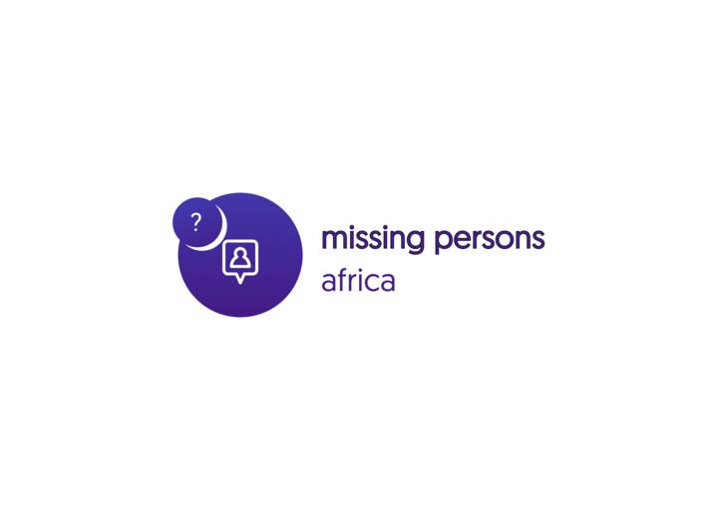
Questions to ask !

Questions about Scope

- What would you suggest the name of this project be ?
- Can our scope allow us build for multi-translation support ?
- Can our project scope allow for a Multiple country support (view_africa) ?
- What would be the high priority areas of focus during the development of this project?

Questions about Forms
- What Forms are meant to be filled by users (reporting, aiding, police)?
- What will be the form requirement for each form ?
- Brainstorm on values for each required form field ?
- what informations are required in the form validation process ?

Questions about Legal requirements content
- How can we have the executive and legislature actively involved in this?
- what information will be in our Content Disclaimer?

Our Law Enforcement Todo ?
- What valid contact information of law enforcement within any local Government should we have access to ?
- How can we make an initial data entry from existing police records in some areas ?
- How can we have a direct platform for law enforcement to upload details frequently ?

How do we Questions
- if ordinary users are allowed to supply information?
- How do we verify validity of submitted information ?
- If we allow users to signup for alerts via email, to help spread and notify other media/law/etc bodies about newly reported missing cases (see http://www.missingkids.org/amber)
- Who can signup for amber alerts ?

- How do we ensure adoption of the program ?

Communication & Awareness
- what will be the communication strategy
- how will resource information be curated
- homepage linking – blogs/resource page

Bugs and issue Tracking
How will ordinary users report bugs ?
How will more advanced users track bugs ?
What issues get a higher order of priority ?

Open Graph implementation
- Twitter rich cards
- Automated Tweets to a Twitter handle
- Automated Facebook posts to a page
- Automated Google+ posts
- og meta for sharing features
- Generate image and pdf function for posters

Building a successful Roadmap

In order to build a successful feature map, some of these questions will have to be answered and we would together as a team deliberate on them

questions ?
- where do users normally go to when they are looking for a loved one?
- who and which agency do they normally report to ?
- how is the information of a missing person usually shared?
- where should the users spend most of their time on the website ?
- who supplies information to the website ?
- what information should be collected in a report form
- what information should be submitted for identification

simple process statement

supplier: a user supplies information about a missing person, this may be but not limited to a law enforcement personnel or relative to the person been looked for.

Information: the information provided will be stated in the forms each supplier should fill, to either report a new case, or report a new sighting of any person, or query the database for cases that match any defined filter (un-resolved, resolved, recent etc).

Process: information from the form is collected and stored in our database, and a new event may or may not trigger for the supplier to take another action on the website. (events may include alerting associated users about the updated information, sending sms alerts to law enforcement phone numbers about a new report etc, asking the user the share the information they submitted on social media platforms).

Output: users can generate pdf or images from supplied information, share and save. Supplied information will appear will be updated in grids according to the tag they fall into, a unique url is generated for each main report about a missing person which can act as a reference, there is more to this output and we can all brainstorm on it as a team.

How the information is consumed: there is little to nothing we can control about how the information generated on our platform can be consumed, but we can create social incentives for every user that contributes to the platform in order to have as much as even a little confidence that what they did could make a change, help someone out, and also make them feel good for contributing at the same time.

Thanks so please review the questions and find out if there are any other questions which we arent asking.

- Name of missing person
- First Name

- Time and date
- What date did you see the missing person? (dd/mm/yyyy)(*)
- What time was it when you saw the missing person? (hh:mm)(*)

- Location
- Where did you see the missing person?
- Please be as specific as you can with geographical location.
- Where did you see the missing person?(*)

- Physical Appearance
- What did the missing person look like? Please fill in as much detail as you remember. For example, please include age, height, build, ethnic appearance, hair colour and style, eye colour, tattoos, piercings or any other distinctive feature they have.

What did the missing person look like?(*)

What were they wearing?
Please fill in as much detail as you remember. For example please include clothing, jewellery and any belongings that they had with them.
What were they wearing?

Circumstances
Please fill in as much detail as you remember. For example, what were they doing when you saw them? What made you notice them? Were they with anyone?
What were the circumstances?(*)

What Publicity did you see?
What Publicity did you see?(*)

When did you see it?

About you

All information we receive is passed to the police. Your identity will remain confidential to Missing People unless you indicate that it is ok for us to pass your details on to the police. The police often do want to speak to the person who saw the missing person to check details and help them find the person.
First Name

Surname

Email Address

Phone No.

Postcode

Address

May we give your name and contact details to the Police?

Missing people may have questions about the information you have provided.
May we contact you to ask such questions?

