Simon Says

If you ever marvelled at the electronic toys we had to play with during the 80s, you’ve probably already seen the “Simon Says” game. It was a big round disk, with four colours. It played a tune and flashed some lights and you had to replay the sequence by pressing large pie-slice shaped buttons.

It was like the Playstation 3 of it’s day.

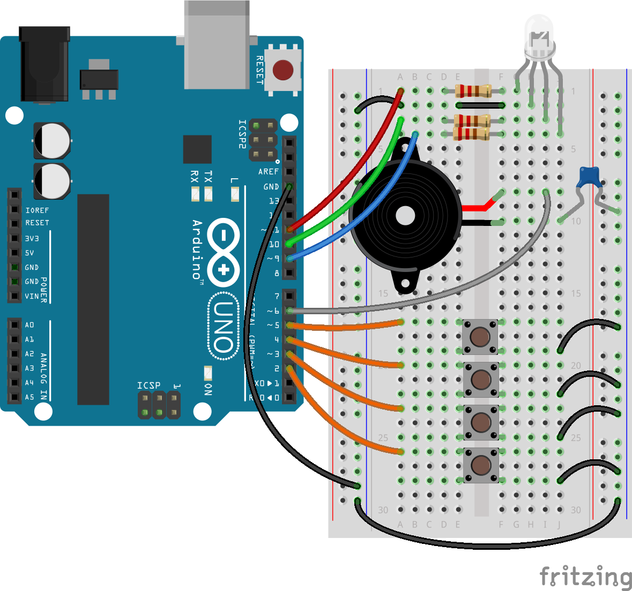

This project looks quite complex, but it’s actually using relatively simple components.
The trick with any big scary-looking project, is to break it down into little chunks.
We’ve already used buttons for inputs.
We’ve made rainbow colours with an RGB LED.
We already know how to create a variable voltage using the Arduino PWM pins, so the piezo buzzer in this project shouldn’t cause us any problems!
We’ve even looked at capacitors in the servo project.

For this project, it’s all about the code.

One component that may not be familiar is the capacitor between the piezo buzzer and the ground rail. In this case, we’re using the capacitor as a “blocking capacitor”.
When the buzzer pin sends a voltage, the capacitor charges up. When the pin goes low, the capacitor discharges.

In this way, we’re protecting the coil inside the piezo buzzer.
If there was a fault, and we left a voltage going into the buzzer, it could cause damage - the coil might get hot, and fail.

By using a blocking capacitor, a varying voltage is required to make the piezo actually make a sound (which is how sound waves work anyway).

