BUILDERKAKI

Build Your Website
A complete, plain-English guide — from where you are now to a live site online
This guide takes you from your current setup (Claude Code installed, sitting in your project folder) all the way to a working BuilderKaki website that anyone can visit. No coding knowledge assumed. Every command is written out exactly. The fixes for the Windows hiccups you already hit are included so you never get stuck on them again.
Work through it at your own pace. You can stop after any step and pick up later — nothing is lost.

The Big Picture
Before the detailed steps, here is the whole journey on one page. Six stages. You have already finished the first one. Keep this map in mind so you always know where you are and what comes next.

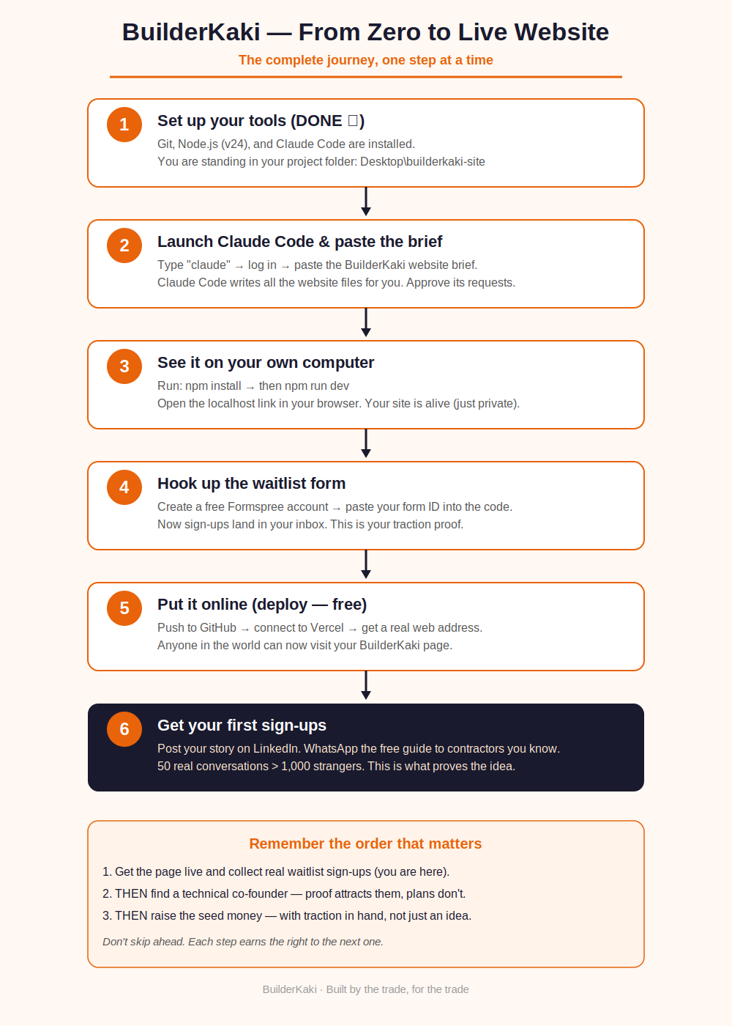

Stage 1 — Your Tools (Already Done)
You have already installed everything needed. For the record, here is what each piece does, in plain terms:
- Node.js — the engine that runs the website's building tools. You have v24, confirmed working.
- Git — keeps a history of your code and lets you push it online later.
- Claude Code — the AI that actually writes the website when you describe it.

You are currently inside your project folder. If you ever close PowerShell and need to get back to it, open PowerShell and type this one line:
cd $HOME\Desktop\builderkaki-site

REMEMBER: If a command is ever refused with a “running scripts is disabled” message, add .cmd to the command — for example npm.cmd instead of npm. That is the workaround that already worked for you.

Stage 2 — Launch Claude Code and Describe the Site
From inside your project folder, start Claude Code by typing:
claude
If that is refused, try claude.cmd instead.
The first time, it opens your web browser to log in. Sign in with your paid Claude account and approve access. It may ask you to pick a colour theme and to confirm you trust the files in this folder — say yes, it is your own empty folder.
Once you are in, the screen changes to Claude Code's own view. Now paste the brief below as your first message. This is the exact description of the BuilderKaki page — copy the whole thing:

PASTE THIS INTO CLAUDE CODE: (The full brief is on the next page so you can copy it cleanly.)

The website brief to paste
Build a validation landing page for BuilderKaki, an
education-first platform that teaches Singapore construction
subcontractors their contractual rights and helps them avoid
being taken advantage of on contracts.

Tech: React + Vite + Tailwind, mobile-first (users are on
phones), deployable to Vercel/Netlify with a README.
Brand: trustworthy and bold; orange #E8630A, dark navy
#1A1A2E, off-white #FFF8F3. "Kaki" is Singlish for "buddy."

Single page, these sections:
(1) Hero - headline "Don't let a contract sink your
business.", a subheadline about getting paid what you're
owed and spotting traps before signing, built by someone
with 14 years on site, plus an email waitlist signup.
(2) The problem - 3 cards: contracts written to trap you;
paid late or not at all; no one teaches you this.
(3) What you'll get - plain-English contract guides; a
community of experienced contractors; early access to tools
to track variations and claims.
(4) A repeated email call-to-action: "Join the waitlist -
get the free Contract Red Flags guide when we launch."
(5) A small footer link: "Are you an experienced contractor
or developer who wants to help build this? Get in touch."
(6) Footer with tagline "Built by the trade, for the trade."

Waitlist form: connect it to Formspree (leave a clear TODO
comment showing where I paste my Formspree form ID). Show a
"X contractors already signed up" counter I can update.
Build it, then give me the exact commands to run it locally
and to deploy.

Claude Code will think, then start creating files. It asks permission as it works — approve each request. It is working inside your empty folder, so there is nothing to break.

Stage 3 — See It On Your Own Computer
When Claude Code finishes, it will tell you to run two commands. Run them one at a time:
npm install
This downloads the building blocks. It takes a minute or two the first time and prints many lines — that is normal. (If refused, use npm.cmd install.)
npm run dev
This starts your website. It will show a local address such as http://localhost:5173. Hold Ctrl and click it, or copy it into your browser.
Your BuilderKaki page is now running on your own machine. It is private — only you can see it for now. To stop it, click back in PowerShell and press Ctrl + C.
TIP: Want changes? Just go back to Claude Code and describe them in plain words — “make the hero section darker”, “add a logo at the top”, “make the buttons bigger on mobile”. It edits the site for you while npm run dev keeps showing the live result.

Stage 4 — Make the Waitlist Actually Work
The signup form needs somewhere to send the emails. The easiest free option is Formspree. Here is the whole process:
- Go to formspree.io and create a free account.
- Create a new form. It gives you a form ID (a short code in a web address).
- Open your project in Claude Code and tell it: “Here is my Formspree form ID: [paste it]. Connect the waitlist form to it.”
- Test it: run npm run dev, submit your own email on the page, and check it arrives in Formspree.

That is it — every contractor who signs up now lands in your inbox. This list is the single most valuable thing you will build early on. It is the proof that turns “nice idea” into “people actually want this.”

Stage 5 — Put It Online (Free)
Right now the site only exists on your computer. To give it a real web address that anyone can visit, you “deploy” it. The free, beginner-friendly route is Vercel:
- Create a free account at github.com (this stores your code online).
- In Claude Code, ask: “Help me push this project to a new GitHub repository.” It will walk you through the exact commands.
- Create a free account at vercel.com and choose “Sign up with GitHub.”
- In Vercel, click “Add New Project”, pick your builderkaki-site repository, and click Deploy.
- After a minute, Vercel gives you a live web address. Your site is online.

ABOUT THE DOMAIN: Vercel gives you a free address ending in .vercel.app to start. When you are ready, buy builderkaki.sg from a registrar and connect it in Vercel's settings — but do an IPOS trademark check and an ACRA name check first, before you commit to the name in print.

Stage 6 — Get Your First Sign-Ups
A live site with no visitors proves nothing. Your first sign-ups come from two places, and neither costs money:

LinkedIn — your story is the hook
Post 2–3 times a week. You are the 14-year facade veteran building the thing you wish existed — that is a stronger hook than any advert. Each post shares one real lesson from your site experience and quietly points to the waitlist. Put the link in the first comment, not the post body.

Direct outreach — the fastest path
Message contractors you already know on WhatsApp. Send them the free “Contract Red Flags” guide, ask if it is useful, point them to the page. Fifty real conversations beat a thousand strangers, and each one is a warm sign-up.

The Order That Matters Most
It is tempting to chase a co-founder and investors now. Resist it. The sequence below is what gives you the best chance:
- Get the page live and collect real waitlist sign-ups. (You are here.)
- THEN find a technical co-founder — proof of demand attracts them; a plan alone does not.
- THEN raise the seed money — with traction in hand, not just an idea on paper.

Each step earns the right to the next one. Do them in order and you build on solid ground every time.

You've got everything you need.
Tools installed, brief ready, guide in hand. The next move is simple: launch Claude Code and paste the brief. One step at a time.

Disclaimer: This guide is general educational and technical information. Always do your own checks on business names, trademarks, domains and any legal matters before committing. BuilderKaki is not a law firm.

