
FULL-STACK WEBSITE, API AND MOBILE APPLICATION
Hariyo Mart Nepal
Technical Documentation and Implementation Guide
Fresh from Nepal’s farms to your home
DELIVERED SYSTEM
✓ Next.js responsive e-commerce website
✓ Express and MongoDB-ready API
✓ Expo React Native mobile application
✓ 84 seeded products and 172 documented routes
✓ Seven-province location-aware marketplace
✓ SEO, security, deployment and operations documentation
Version 1.0 | Prepared 2 August 2026

Document Control
Scope, status and intended use of the delivered repository.
Item | Details
Project | Hariyo Mart Nepal
Repository type | Monorepo: web, API, mobile and offline demo
Web technology | Next.js App Router, React and TypeScript
API technology | Node.js, Express, MongoDB/Mongoose-ready and Redis-ready
Mobile technology | Expo Router and React Native
Catalogue | 84 seeded products across Nepal’s seven provinces
Route inventory | 172 documented website routes
Status | Development-ready starter and working offline demonstration
Important note | Live payment credentials, OTP services, legal review and operational integrations are required before public launch.

Contents
1. Executive Summary | 11. Database Design
2. Delivered Package | 12. Authentication and Security
3. Brand and User Interface | 13. SEO and Content Strategy
4. System Architecture | 14. Setup and Local Execution
5. Website Application | 15. Deployment Architecture
6. Mobile Application | 16. Testing and Quality Assurance
7. Nepal Location-Based Marketplace | 17. Production Launch Requirements
8. Catalogue and Product Model | Appendix A. Repository Structure
9. Page and Route Architecture | Appendix B. API Endpoint Summary
10. Backend API | Appendix C. Seeded Product Catalogue

1. Executive Summary
Hariyo Mart Nepal is a premium, Nepal-focused farm-to-home commerce platform inspired by the organic, green and product-led visual language in the supplied reference images. The delivered package includes a modern website, an API service, a native mobile application starter, province-aware product data, role-based workspaces, SEO routes and an offline demonstration that opens without installing dependencies.
The website is data-driven rather than built as a collection of disconnected static files. Dynamic route templates generate product, category, province, article and dashboard pages from structured content. This approach produces more than 170 navigable routes while keeping the codebase maintainable. The catalogue contains 84 products distributed evenly across Nepal’s seven provinces.
Delivery status
The offline HTML demonstration is immediately viewable and includes responsive layout, a colour-theme switcher, province selector and functioning browser basket. The Next.js, API and Expo applications are supplied as source code and require dependency installation before local development or deployment.

Core business objectives
- Connect customers with traceable products from verified Nepalese farms and cooperatives.
- Support location-aware discovery and delivery across all seven provinces.
- Provide customer, farmer and administrator workspaces within one consistent design system.
- Create a scalable SEO structure for categories, products, provinces, farm stories and educational content.
- Prepare integrations for eSewa, Khalti, FonePay, cards and cash on delivery without embedding private credentials.

2. Delivered Package
Component | Location | What is included
Web application | apps/web | Next.js App Router pages, product catalogue, filters, basket, checkout UI, dashboards, metadata, sitemap, robots file and PWA manifest.
API service | apps/api | Express server, seed-mode catalogue, Mongoose models, authentication routes, order routes, province delivery quote and OpenAPI specification.
Mobile application | apps/mobile | Expo Router application with home, shop, province, basket, profile and product-detail screens.
Offline demonstration | demo/index.html | Dependency-free responsive website with theme switcher, location selector and working basket.
Brand assets | apps/web/public/brand | Original Hariyo Mart Nepal logo and application icon.
Content and SEO | apps/web/lib and docs | 84 product records, 16 categories, seven province records, 12 blog articles and route inventory.
Infrastructure | docker-compose.yml and .env.example | MongoDB, Redis and API container configuration with documented environment variables.
Documentation | docs and this DOCX | Architecture, database, deployment, API and complete route inventory resources.

Repository validation
The catalogue validation script confirms 84 unique products, 16 categories and seven provinces. The route inventory CSV contains 172 entries. JSON package files and the browser demonstration JavaScript were also syntax-checked during generation.

3. Brand and User Interface
The brand combines Himalayan geography, agricultural growth and a modern marketplace identity. The logo uses a mountain form and a leaf within a rounded forest-green icon. The typography is intentionally simple and high-contrast so the platform remains readable on low-cost mobile devices and in bright outdoor environments.
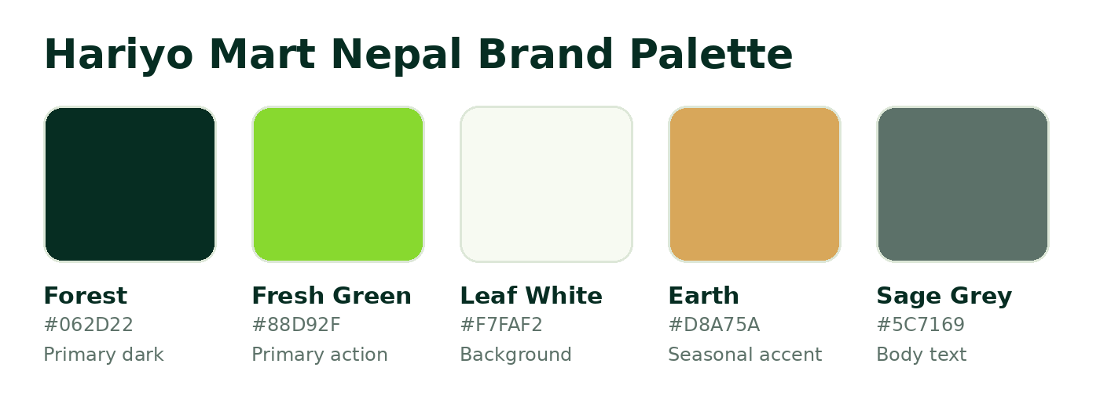
Figure 1. Hariyo Mart Nepal brand palette and usage hierarchy.

Theme switching
The web interface includes three visual themes: Forest, Lime and Earth. The selection is stored in the browser and applied through CSS variables. This permits seasonal campaigns, festival promotions or partner-specific visual variations without rebuilding components.

Desktop interface preview
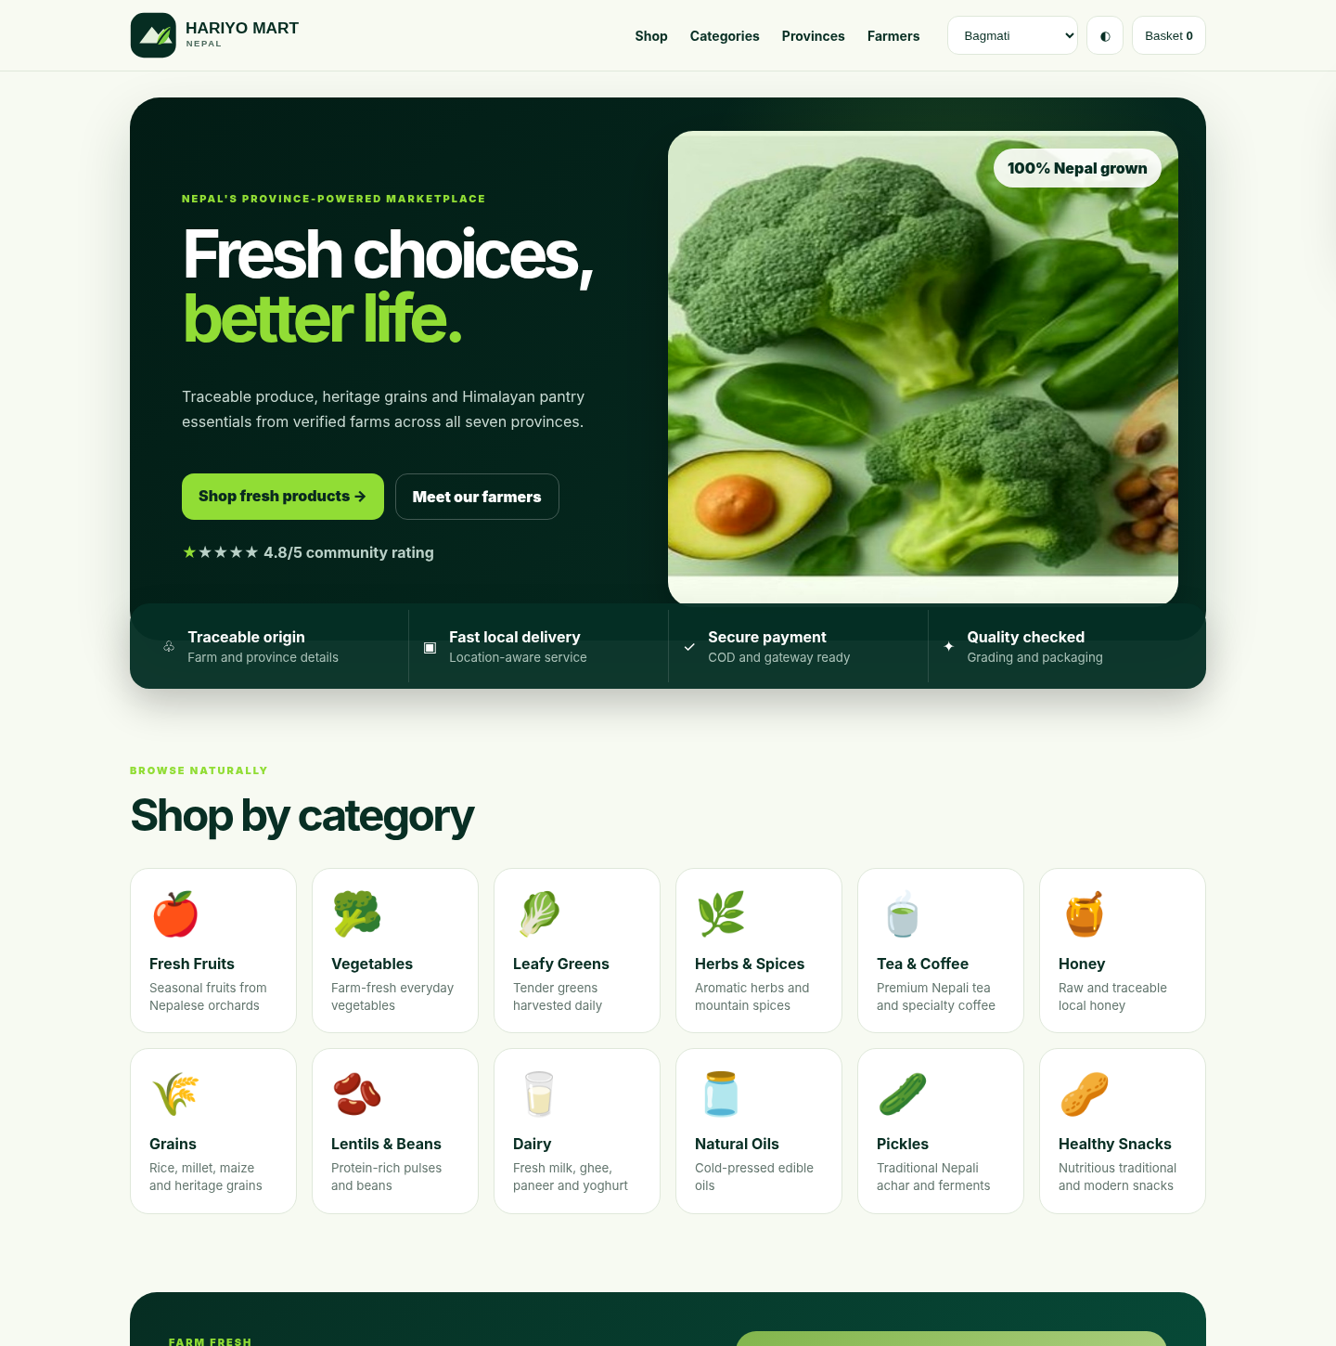
Figure 2. Desktop homepage hero, category discovery and trust features.

Catalogue and province preview
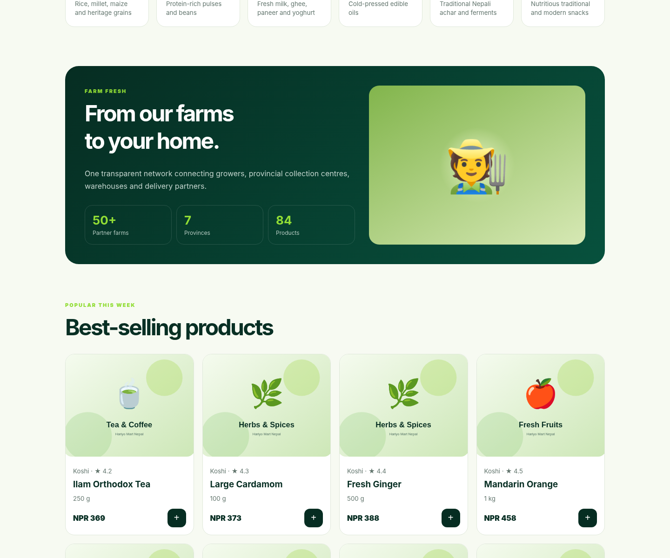
Figure 3. Product cards, farm narrative and province-focused discovery.

Mobile-responsive preview
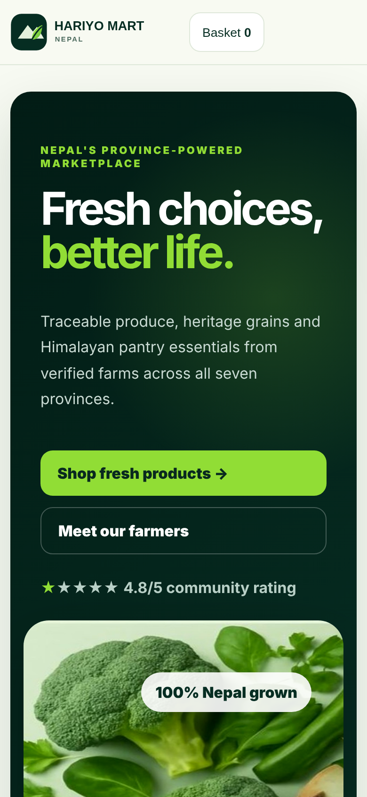 | Mobile-first behaviour  ✓ Navigation condenses to essential actions.  ✓ Hero content stacks before imagery.  ✓ Buttons expand to full width for touch accessibility.  ✓ Cards change from multi-column grids to a single-column reading flow.  ✓ The basket remains available from the header.

4. System Architecture
The system follows a service-oriented monorepo structure. The web and mobile clients share the same catalogue concepts but remain independently deployable. The API provides business operations, authentication, orders and province delivery logic. MongoDB stores operational records, while Redis is reserved for caching, sessions and short-lived data.
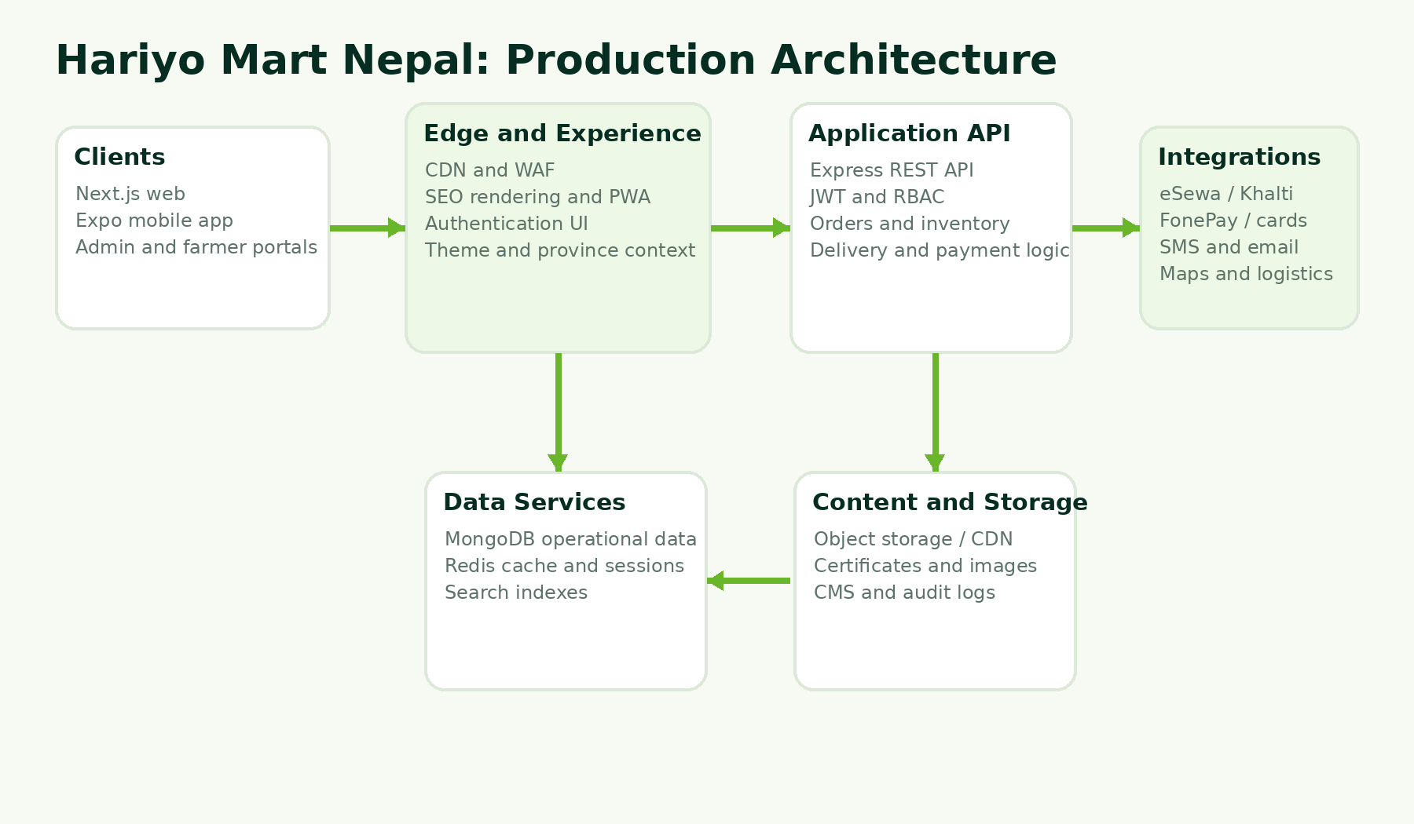
Figure 4. Recommended production architecture.

Architecture principles
- SEO pages are rendered by Next.js and can be statically generated from catalogue data.
- The API can run in seed mode when MongoDB is not configured, which simplifies demonstrations.
- Authentication and role checks remain within the API boundary.
- Images, certificates and media should be moved to object storage and served through a CDN.
- Payment gateway callbacks and notification jobs should be processed through secured server-side workflows.

5. Website Application

Public shopping experience
The website provides a hero-led homepage, category discovery, province landing pages, product detail pages, search and filtering, a persistent browser basket and checkout forms. Product cards display price, pack size, province, rating and availability context. Each product page contains product metadata, descriptive content, benefits, related products and JSON-LD structured data.

Customer account routes
Route | Purpose
/account/overview | Overview
/account/orders | Orders
/account/addresses | Addresses
/account/wishlist | Wishlist
/account/subscriptions | Subscriptions
/account/wallet | Wallet
/account/rewards | Rewards
/account/reviews | Reviews
/account/returns | Returns
/account/settings | Settings

Administration and farmer portals
Reusable dashboard components generate consistent workspaces for administrators and farmers. The supplied screens contain layout and metric placeholders that are ready to connect to protected API endpoints and live data.
Portal | Included sections
Administrator | Overview, users, products, categories, orders, inventory, warehouses, payments, delivery, coupons, content and analytics.
Farmer | Overview, products, harvest calendar, orders, inventory, payments, certifications and profile.

Progressive web application
The web app includes a manifest, application icon, start URL, theme colour and standalone display settings. Service-worker caching is intentionally not hard-coded because production caching must be aligned with inventory freshness, authentication and order security requirements.

6. Mobile Application
The native mobile starter is implemented with Expo Router and React Native. It uses a tab-based structure and shares the seeded catalogue model with the website. The mobile application is designed for Android and iOS and can be opened through Expo Go during development.
Screen | Main functions
Home | Brand hero, product discovery and direct navigation to shop.
Shop | Catalogue search and product cards.
Provinces | Seven-province discovery with regional specialties.
Product details | Image, origin, description, benefits and add-to-basket action.
Basket | Quantity summary, total and checkout continuation.
Profile | Orders, addresses, rewards, subscriptions, language and support entry points.

Mobile production extensions
- Replace localhost image paths with CDN URLs.
- Add secure token storage and refresh-token rotation.
- Integrate push notifications for order and delivery updates.
- Add GPS permission only when the user requests location-assisted delivery.
- Implement Nepali and English localization through translation files.
- Configure EAS Build, signing credentials and store metadata.

7. Nepal Location-Based Marketplace
Location is a primary business concept rather than a cosmetic filter. Each product record is linked to a province and district. The location API returns province records, province-specific products and a delivery quote containing serviceability, estimated days and delivery charge. In production, this model can be extended to Nepal’s districts, municipalities, wards, service zones, warehouses and delivery routes.
Province | Representative collection point | Seed specialties
Koshi Province | Ilam | Tea, cardamom, citrus
Madhesh Province | Dhanusha | Rice, mango, lentils
Bagmati Province | Kathmandu | Vegetables, dairy, mushrooms
Gandaki Province | Kaski | Apple, honey, coffee
Lumbini Province | Rupandehi | Grains, lentils, oils
Karnali Province | Jumla | Marshi rice, beans, walnuts
Sudurpashchim Province | Kailali | Millet, honey, citrus

Recommended delivery rule hierarchy
- Product-level restrictions, such as chilled, fragile or seasonal items.
- Warehouse and collection-centre availability.
- Province, district, municipality and ward service zones.
- Minimum order value, free-delivery threshold and delivery time window.
- Weather, road accessibility and temporary service suspensions.

8. Catalogue and Product Model
The repository includes 84 seeded products, with 12 products assigned to each province. The catalogue spans 16 categories, including fruits, vegetables, leafy greens, herbs and spices, tea and coffee, honey, grains, pulses, dairy, oils, pickles, snacks, baby food, sugar-free products, juices and dry fruits.
Product field | Purpose
slug | Stable SEO and API identifier.
name | Human-readable product title.
category | Filtering, navigation and related-product logic.
province and district | Origin and location-aware availability.
unit | Pack size or selling unit.
price and previous price | Current and promotional presentation.
rating and stock | Customer confidence and inventory status.
organic and featured | Badging and homepage merchandising.
short description | Search, cards and metadata.
long description | Product page content and storytelling.
benefits | Scannable trust and value statements.
image | Local asset path, replaceable by CDN media.

Catalogue governance
Production data should distinguish product master records from inventory batches. A product describes the commercial item, while a batch records farm, harvest date, quality grade, warehouse, expiry and quantity. This separation is necessary for traceability, recalls and accurate availability.

9. Page and Route Architecture
Route group | Count | Template
Product detail | 84 | /products/[slug]
Category landing | 16 | /categories/[slug]
Province marketplace | 7 | /provinces/[slug]
Information and policy | 18 | /info/[slug]
Blog article | 12 | /blog/[slug]
Customer account | 10 | /account/[section]
Administrator | 12 | /admin/[section]
Farmer | 8 | /farmer/[section]
Core pages | 5 | /, /shop, /cart, /checkout, /blog

Complete inventory
The complete list of 172 routes is included in docs/page-inventory.csv inside the downloadable project ZIP. Dynamic templates are used so content can grow without creating repetitive source files.

SEO route behaviour
- Products, categories, provinces and articles provide route-specific titles and descriptions.
- Product pages include canonical URLs, Open Graph data and Product structured data.
- The sitemap generates URLs from catalogue records.
- The robots file exposes the sitemap and permits public crawling.
- Metadata can be connected to a CMS without changing page templates.

10. Backend API
The Express API applies security headers, CORS, JSON body limits, request logging and rate limiting. Catalogue endpoints work with seeded JSON when MongoDB is absent. Authentication and order storage require MongoDB so the demonstration does not create misleading temporary accounts or orders.
Method | Endpoint | Function
GET | /health | Service and database status.
GET | /api/products | Product list with search, category, province, pagination and limit.
GET | /api/products/:slug | Single product by slug.
GET | /api/locations/provinces | Seven-province catalogue.
GET | /api/locations/provinces/:slug/products | Products from one province.
POST | /api/locations/delivery-quote | Serviceability, delivery fee and estimated days.
POST | /api/auth/register | Create an account when MongoDB is configured.
POST | /api/auth/login | Issue access and refresh tokens.
POST | /api/orders | Create authenticated order.
GET | /api/orders/mine | Current customer order history.

Example catalogue request
GET /api/products?province=karnali&category=grains&limit=12
Authorization: not required
Response: { "data": [...], "page": 1 }

API extension priorities
- Refresh-token rotation and token revocation.
- Farmer, inventory, warehouse and delivery CRUD endpoints.
- Payment initiation, signed callback validation and refunds.
- Media upload through signed object-storage URLs.
- Notification queue and background processing.
- Audit logging for sensitive administrative actions.

11. Database Design
Mongoose models are supplied for users, products and orders. The documentation recommends additional collections for farms, inventory batches, payments, deliveries, reviews, content and audit logs. The operational database is MongoDB, while Redis supports caching and transient data.
Collection | Key data and responsibility
users | Identity, role, phone, email, province, verification state and password hash.
farms | Ownership, location, verification, certifications, crops and farm story.
products | Commercial identity, category, origin, price, content, status and farmer relation.
inventory_batches | Lot number, farm, warehouse, harvest, grade, expiry and available quantity.
orders | Line snapshots, customer, totals, payment, address, status and timeline.
payments | Provider reference, status, settlement, refund and audit trail.
deliveries | Dispatch, driver, route, milestones, location events and proof of delivery.
reviews | Verified purchase, rating, moderation and farmer response.
content_entries | Pages, recipes, blogs, FAQs, language variants and publication state.
audit_logs | Actor, action, entity, before/after summary, IP and timestamp.

Indexing priorities
- Text index for product name, description and keywords.
- Compound product index on category, province, active status and stock.
- Order indexes on customer and created date, and on status and created date.
- Geospatial indexes for farms, warehouses and service zones.
- TTL indexes for OTP codes, password-reset tokens and temporary sessions.

12. Authentication and Security
The API includes JWT-based authentication middleware and role checks. Passwords are hashed with bcrypt. Security headers, CORS, request-size limits and rate limiting are enabled in the server entry point. These controls form a baseline and must be supplemented by production secrets, monitoring and security testing.
Control | Implementation or requirement
Passwords | bcrypt hashing; never store plaintext passwords.
Tokens | Short-lived access token and longer refresh token. Add rotation and revocation before launch.
RBAC | Customer, farmer, vendor, delivery, provincial administrator and administrator roles.
Input validation | Zod schemas for registration and order requests.
Transport | HTTPS required in all deployed environments.
Secrets | Environment variables and managed secret stores only.
Payments | Server-side signing, callback verification and reconciliation.
Abuse prevention | Rate limits, audit trails and suspicious activity monitoring.
Privacy | Consent, retention and deletion processes reviewed under applicable Nepalese law.
Administration | Multi-factor authentication recommended for privileged roles.

Security boundary
No private payment keys, SMS credentials or production secrets are included in the downloadable repository. This is intentional. Credentials must be created by the business and configured in deployment secrets.

13. SEO and Content Strategy
The website provides a scalable SEO foundation through route-specific metadata, semantic headings, canonical links, structured data, sitemap generation and robots configuration. The catalogue and content architecture support search intent based on product, category, province and educational topic.

Primary content clusters
Cluster | Examples
Transactional | Organic vegetables delivery Nepal, Ilam tea online, Mustang apple delivery, Marshi rice Nepal.
Location | Organic products in Bagmati, Karnali farm products, Koshi tea and spices.
Educational | How to store vegetables, Nepalese heritage grains, regional honey guide.
Trust and provenance | Farmer profiles, certifications, traceability, quality standards and sustainability.
Institutional | Restaurant supply, school food procurement, office subscriptions and bulk orders.

Editorial controls
- Use expert review for health, nutrition and farming claims.
- Maintain clear distinction between certified organic, naturally grown and general quality-checked products.
- Avoid duplicate descriptions across province and category pages.
- Translate meaningfully rather than using literal automated translation.
- Update seasonal availability, delivery coverage and prices from operational data.

14. Setup and Local Execution

Option A: immediate offline preview
1. Extract the ZIP archive.
2. Open the demo folder.
3. Open index.html in a modern browser.
This preview does not require Node.js, MongoDB or internet access. It demonstrates responsive design, theme switching, province selection and browser basket behaviour.

Option B: run the full development stack
cp .env.example .env
npm install
npm run dev:api
npm run dev:web

Open the website at http://localhost:3000 and the API at http://localhost:4000. Without MONGODB_URI, product endpoints use seed mode. Registration and order persistence remain disabled until MongoDB is connected.

Run the mobile application
npm run dev:mobile
# Open with Expo Go or an Android/iOS emulator

Docker services
docker compose up -d mongodb redis
# Then configure .env and start the API and web apps

Environment variables
Variable | Purpose
NEXT_PUBLIC_API_URL | Browser-visible API base URL.
NEXT_PUBLIC_SITE_URL | Canonical site URL used by metadata and sitemap.
MONGODB_URI | Operational database connection.
REDIS_URL | Cache and transient data service.
JWT_SECRET | Access-token signing secret.
JWT_REFRESH_SECRET | Refresh-token signing secret.
CORS_ORIGIN | Allowed web origin or origins.
ESEWA_MERCHANT_CODE | Merchant credential supplied by eSewa.
KHALTI_SECRET_KEY | Server credential supplied by Khalti.
FONEPAY_MERCHANT_CODE | Merchant credential supplied by FonePay.

15. Deployment Architecture
1. Deploy the Next.js application to Vercel or a Node-compatible hosting platform.
2. Deploy the API as a container behind HTTPS and a web application firewall.
3. Use managed MongoDB and Redis with backups, monitoring and network controls.
4. Serve media from object storage through a CDN.
5. Configure transactional email, SMS/OTP, payment gateways and map services.
6. Use separate development, staging and production environments.
7. Add background workers for notifications, payment reconciliation and search indexing.

Recommended release pipeline
Source control → automated tests → static analysis → build → staging deployment → acceptance testing → security review → production deployment → monitoring and rollback verification.

16. Testing and Quality Assurance
Test area | Minimum coverage
Unit tests | Pricing, totals, delivery rules, permissions and validation.
API integration | Authentication, catalogue filters, order creation and error responses.
End-to-end | Search, product page, basket, checkout, account and admin workflows.
Accessibility | Keyboard navigation, labels, colour contrast, focus states and screen-reader landmarks.
Responsive design | Small Android screens, tablets, laptops and wide desktop screens.
Security | Dependency scanning, authentication abuse, authorization bypass, injection and secret leakage.
Performance | Core Web Vitals, image optimization, API latency and database query plans.
Payments | Gateway sandbox certification, callback signatures, duplicate events and refunds.
Operations | Backups, restore testing, monitoring, alerts and incident procedures.

Completed checks
The delivered offline preview was rendered in desktop and mobile viewports and visually inspected. Catalogue uniqueness, package JSON parsing and demonstration JavaScript syntax were validated. Dependency installation and external gateway tests were not possible without network access and merchant credentials.

17. Production Launch Requirements
The repository is intentionally substantial but it is not a fully operated live marketplace. A public launch requires business decisions, credentials and operational data that cannot be safely invented. The following work must be completed by the project owner and implementation team.
Area | Required before launch
Business and legal | Company details, tax rules, invoices, terms, privacy notice, returns policy and legal review.
Farmer onboarding | Verification criteria, contracts, bank details, product standards and certificate review.
Live catalogue | Actual SKUs, prices, stock, images, batches, seasons and fulfilment constraints.
Payments | Merchant accounts, signed integrations, sandbox tests, callbacks, refunds and settlement reconciliation.
Delivery | Service zones, fees, warehouses, cold-chain rules, drivers, tracking and proof of delivery.
Identity | SMS/OTP provider, email domain, social login credentials and account recovery.
Content | Professional photography, reviewed product claims, Nepali translations and support information.
Infrastructure | Domains, HTTPS, backups, monitoring, logging, alerting and disaster recovery.
Mobile release | Store accounts, signing, privacy labels, screenshots, review compliance and support contact.

Honest completion statement
The ZIP provides a complete development foundation, working offline user-interface demonstration, structured content and implementation documentation. Live commercial operation still depends on genuine inventory, merchant credentials, legal approvals and logistics configuration.

Appendix A. Repository Structure
hariyo-mart-nepal/
├── apps/
│ ├── web/ Next.js website and SEO routes
│ ├── api/ Express API and Mongoose models
│ └── mobile/ Expo React Native application
├── demo/ Offline HTML/CSS/JavaScript preview
├── docs/ Architecture, API, database, previews and route inventory
├── scripts/ Catalogue validation
├── .env.example Environment variable template
├── docker-compose.yml
├── package.json Workspace scripts
└── README.md

Key web folders
Path | Responsibility
apps/web/app | Routes, layouts, metadata, sitemap, robots and API health route.
apps/web/components | Header, footer, product cards, basket, theme, shop and dashboards.
apps/web/lib | Catalogue, blog, information pages and dashboard route configuration.
apps/web/public | Logo, icon, hero image and category illustrations.

Appendix B. API Endpoint Summary
A machine-readable OpenAPI 3.1 specification is included at docs/openapi.yaml. It can be imported into Swagger UI, Postman or another API documentation tool.
Endpoint group | Current routes | Next production routes
Catalogue | List and detail products. | CRUD, variants, media, pricing, stock and search.
Locations | Provinces, province products and delivery quote. | Districts, municipalities, service zones, warehouses and routes.
Authentication | Register and login. | Refresh, logout, OTP, verification, recovery and social login.
Orders | Create order and current customer history. | Status changes, cancellation, returns, invoices and support.
Payments | Environment placeholders only. | Initiation, callbacks, settlement, refund and reconciliation.
Operations | Health route. | Metrics, jobs, alerts, audit export and administrative reports.

Appendix C. Seeded Product Catalogue

Koshi Province
Product | Category | Unit | Seed price
Ilam Orthodox Tea | Tea Coffee | 250 g | NPR 369
Large Cardamom | Herbs Spices | 100 g | NPR 373
Fresh Ginger | Herbs Spices | 500 g | NPR 388
Mandarin Orange | Fresh Fruits | 1 kg | NPR 458
Akabare Chilli | Herbs Spices | 200 g | NPR 484
Kiwi Fruit | Fresh Fruits | 1 kg | NPR 477
Bamboo Shoot Pickle | Pickles | 400 g | NPR 613
Green Tea | Tea Coffee | 100 g | NPR 540
Avocado | Fresh Fruits | 500 g | NPR 555
Buckwheat Flour | Grains | 1 kg | NPR 680
Lapsi Candy | Snacks | 250 g | NPR 673
Fresh Coriander | Leafy Greens | 100 g | NPR 754

Madhesh Province
Product | Category | Unit | Seed price
Basmati Rice | Grains | 5 kg | NPR 314
Malda Mango | Fresh Fruits | 1 kg | NPR 340
Red Lentils | Lentils Beans | 1 kg | NPR 377
Bottle Gourd | Vegetables | 1 pc | NPR 425
Cauliflower | Vegetables | 1 pc | NPR 451
Green Peas | Vegetables | 500 g | NPR 477
Sugarcane Jaggery | Sugar Free | 500 g | NPR 591
Makhana | Snacks | 200 g | NPR 518
Pigeon Pea | Lentils Beans | 1 kg | NPR 588
Mustard Greens | Leafy Greens | 250 g | NPR 669
Guava | Fresh Fruits | 1 kg | NPR 607
Amla Pickle | Pickles | 400 g | NPR 710

Bagmati Province
Product | Category | Unit | Seed price
Organic Broccoli | Vegetables | 500 g | NPR 358
Buffalo Ghee | Dairy | 500 ml | NPR 351
Oyster Mushroom | Vegetables | 250 g | NPR 421
Spinach Leaves | Leafy Greens | 250 g | NPR 447
Cherry Tomato | Vegetables | 500 g | NPR 473
Farm Yoghurt | Dairy | 500 ml | NPR 499
Fresh Paneer | Dairy | 500 g | NPR 536
Carrot | Vegetables | 1 kg | NPR 507
Cucumber | Vegetables | 1 kg | NPR 566
Microgreens | Leafy Greens | 100 g | NPR 636
Cold Brew Coffee | Tea Coffee | 250 ml | NPR 728
Baby Cereal Mix | Baby Food | 500 g | NPR 754

Gandaki Province
Product | Category | Unit | Seed price
Mustang Apple | Fresh Fruits | 1 kg | NPR 325
Wildflower Honey | Honey | 500 g | NPR 395
Himalayan Bean | Lentils Beans | 1 kg | NPR 410
Arabica Coffee | Tea Coffee | 250 g | NPR 447
Dried Apple | Dry Fruits | 250 g | NPR 451
Buckwheat Noodles | Snacks | 400 g | NPR 554
Fresh Trout Fillet | Snacks | 500 g | NPR 602
Mountain Thyme | Herbs Spices | 50 g | NPR 595
Pear | Fresh Fruits | 1 kg | NPR 522
Tangerine Marmalade | Sugar Free | 300 g | NPR 724
Pumpkin Seeds | Dry Fruits | 250 g | NPR 695
Organic Oats | Grains | 1 kg | NPR 721

Lumbini Province
Product | Category | Unit | Seed price
Mustard Oil | Oils | 1 L | NPR 303
Black Gram | Lentils Beans | 1 kg | NPR 329
Brown Rice | Grains | 2 kg | NPR 366
Turmeric Powder | Herbs Spices | 200 g | NPR 458
Chickpeas | Lentils Beans | 1 kg | NPR 429
Flattened Rice | Grains | 1 kg | NPR 521
Sesame Oil | Oils | 500 ml | NPR 514
Tomato Pickle | Pickles | 400 g | NPR 584
Papaya | Fresh Fruits | 1 kg | NPR 544
Maize Flour | Grains | 1 kg | NPR 636
Peanut Butter | Snacks | 350 g | NPR 695
Herbal Infusion | Tea Coffee | 100 g | NPR 754

Karnali Province
Product | Category | Unit | Seed price
Marshi Rice | Grains | 2 kg | NPR 303
Jumla Walnut | Dry Fruits | 500 g | NPR 351
Black Bean | Lentils Beans | 1 kg | NPR 366
Sea Buckthorn Juice | Juices | 750 ml | NPR 502
Red Rice | Grains | 2 kg | NPR 418
Dried Apricot | Dry Fruits | 250 g | NPR 510
Nettle Powder | Herbs Spices | 100 g | NPR 547
Foxtail Millet | Grains | 1 kg | NPR 595
Mountain Garlic | Herbs Spices | 250 g | NPR 643
Chino Rice | Grains | 1 kg | NPR 625
Hemp Seed | Dry Fruits | 250 g | NPR 651
Herbal Salt | Herbs Spices | 200 g | NPR 710

Sudurpashchim Province
Product | Category | Unit | Seed price
Finger Millet Flour | Grains | 1 kg | NPR 391
Chiuri Honey | Honey | 500 g | NPR 351
Lemon Pickle | Pickles | 400 g | NPR 388
Roasted Soybean | Snacks | 300 g | NPR 458
Kodo Cookies | Snacks | 250 g | NPR 462
Citrus Squash | Juices | 750 ml | NPR 510
Horse Gram | Lentils Beans | 1 kg | NPR 514
Cold-Pressed Sesame Oil | Oils | 500 ml | NPR 694
Local Banana | Fresh Fruits | 1 dozen | NPR 610
Radish Pickle | Pickles | 400 g | NPR 658
Amaranth Flour | Grains | 1 kg | NPR 706
Forest Herb Tea | Tea Coffee | 100 g | NPR 754

