Research 1: Machine Learning approach for water portability prediction: addressing class imbalance with SMOTE (Russia)

* Random Forest Classifier was used for this Research
* Accuracy: 69.36% and ROC-AUC: 0.63
* Accuracy: 67.07% and ROC-AUC: 0.64, after applying SMOTE

Research 2: Optimizing Machine Learning for water safety: A comparative analysis with dimensionality reduction and classifier performance in portability prediction

* SVM: 69% accuracy
* XGBoost, KNN, Gaussian Naïve Biays and RF: 62- 68% Accuracy
* After applying Principal Component Analysis (PCA) –
* Nearly 100% Accuracy

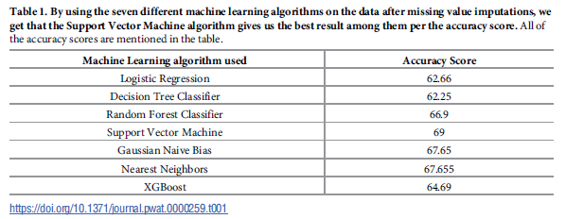

Research 3: Drinking water potability prediction using Machine Learning approaches: a case study of Indian Rivers

* XGBoost: 98.93% accuracy

Research 4: Predicting the Water Potability Index Using ML (Bulgaria)

* DT: 88% (Modified)
* SVC: 83% (Modified)
* RF: 81% (Modified)
* Compared Patel’s Research

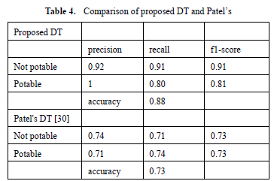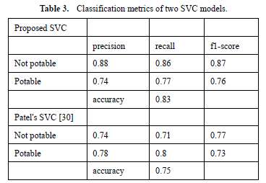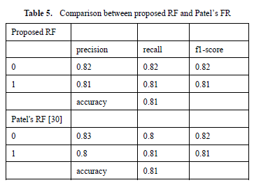

Research 5: Water potability prediction using ML

* RF: 74%

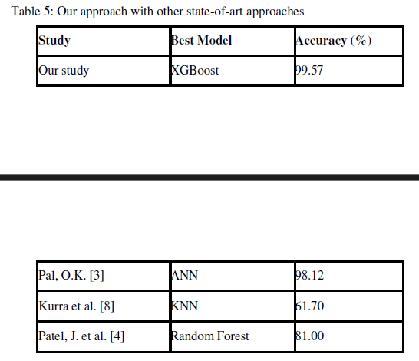

Research 6: Understanding the concept of water potability

* RF: 70%

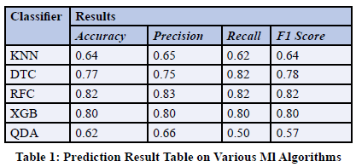

Research 7: A Machine Learning based water portability prediction Model by using SMOTE (Patel’s research)

* RF, XGBoost: 81% accuracy

