Git Basics – Study Notes and Assignments
These notes provide a beginner-friendly introduction to Git, version control systems, and why developers use Git in real-world software development.

Original Notes Reference
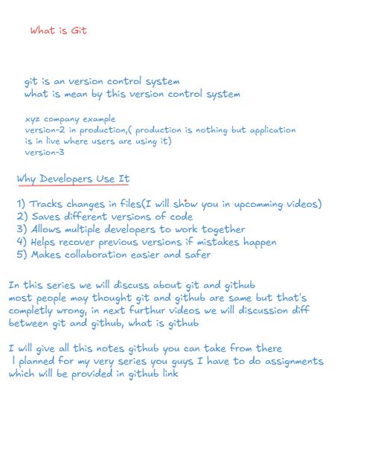

What is Git?
Git is a distributed version control system used by developers to track changes in source code. It helps developers manage different versions of a project and collaborate efficiently.

What is a Version Control System?
A Version Control System (VCS) is a tool that records changes made to files over time. It allows developers to return to previous versions whenever needed.
Example:
- Version 1: Initial application
- Version 2: Application deployed to production and used by users
- Version 3: Added new features and bug fixes

Why Developers Use Git
- Tracks changes in files and source code.
- Saves different versions of the code.
- Allows multiple developers to work together.
- Helps recover previous versions if mistakes happen.
- Makes collaboration easier and safer.

Important Note
In this series, we will discuss both Git and GitHub. Many beginners think Git and GitHub are the same, but they are different technologies. Upcoming videos will explain the differences between Git and GitHub in detail.

Assignment Questions
1. What is Git? Explain in your own words.
2. What is a Version Control System?
3. Why is version control important in software development?
4. List five advantages of using Git.
5. Explain how Git helps developers work together.
6. What happens if a developer makes a mistake in code? How does Git help?
7. Write a real-world example showing different software versions.
8. Research and write about the history of Git.

