LECTURE NOTES ON

CIRCUIT THEORY I (ELE 712)

DEPARTMENT OF ELECTRICAL AND ELECTRONIC ENGINEERING

NIGERIAN DEFENCE ACADEMY(NDA)



ELEMENTARY SIGNALS
In this chapter, the knowledge of basic elementary signal, its representation and analysis will be discussed.
The subtopics are
A. REPRESENTATION OF DISCRETE TIME SIGNALS
- Graphical representation
- Functional representation
- Tabular representation
- Sequence representation
B. BASIC ELEMENTARY SIGNALS (STANDARD SIGNALS) TYPES
- Unit step function.
- Unit ramp function.
- Unit impulse function
- Sinusoidal function
- Unit parabolic function
- Real exponential function
- Complex exponential function
- Rectangular pulse function
- Signum function
- Sinc function
C. BASIC OPERATIONS ON SIGNALS
- Time shifting
- Time reversal
- Time scaling
- Amplitude scaling
- Signal addition
- Signal multiplication
D. CLASSIFICATION OF SIGNALS
- Continuous time and discrete time signals
- Deterministic and random signals
- Periodic and non periodic signals
- Energy and power signals
- Even and odd signals

INTRODUCTION
Signal constitute an important part of our daily life. Anything that carries information can be called a signal. A signal is defined as a single-valued function of one or more independent variable which contains some information. A signal can also be defined as a time varying physical phenomenon which is intended to convey information. A signal can be a function of time, temperature, pressure, distance etc. if a signal depends on only one independent variable it is called one dimensional signal and if it depends on two independent variables, it is called a two-dimensional signal.
REPRESENTATION OF DISCRETE TIME SIGNAL.
A signal is said to be discrete when it is defined at only discrete instant of time. There are four ways of representing the discrete time signals.
Note: - For discrete time signals, the independent variable is time ‘’n” and it is represented by x(n)
- GRAPHICAL REPRESENTATION.
Considering a signal x(n) with values
X (-2) = -3, x (-1) = 2, x (0) = 0, x (1) = 3, x (2) = 1 and x (3) = 2
The graphical representation of these discrete time signals is as shown figure 1
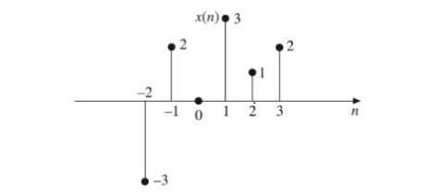
Figure 1 Graphical representation of signals
- TABULAR REPRESENTATION.
In this type of signal representation, the sampling instant “n” and the signal magnitude are represented in a tabular form.
Using the signal values given in the graphical representation, the tabular representation of the values is shown in table 1
Table 1 Tabular representation of signals
n | -2 | -1 | 0 | 1 | 2 | 3
x(n) | -3 | 2 | 0 | 3 | 1 | 2

- FUNCTIONAL REPRESENTATION
In this signal representation, the amplitude of the signal is written against the values of n.
Considering a signal x(n) with values
x(-2) = -3, x(-1) = 2 x(0) = 0, x(1) = 3, x(2) = 1 and x(3) = 2. The functional representation is given as
$$x\left(n\right)=\left\{\begin{aligned}-3 for n= -2 \\ 2 for n=-1 \\ 0 for n=0\end{aligned}\right.$$
$$x\left(n\right)=\left\{\begin{aligned}3 for n=1 \\ 1 for n=2 \\ 2 f or n=3\end{aligned}\right.$$
Another example of functional representation is
$$x\left(n\right)=\left\{\begin{aligned}3^{n} for n≥0 \\ 0 for n<0\end{aligned}\right.$$
- SEQUENCE REPRESENTATION.
Given a finite duration signals used in the functional representation. The sequence representation is
X(n) = (-3,2,0,3,1,2)
The arrow mark denotes the n = 0 term. In the case whereby there was no arrow indicated, then the first term corresponds to n = 0

BASIC ELEMENTARY SIGNAL TYPES
Elementary signals play vital role in the study of signals and systems. They serve as basic building block for the construction of more complex signals. The elementary signals are also called standard signals.
- UNIT STEP FUNCTION.
The step function is the type of elementary function which exist only for positive time and is zero (0) for negative time
The unit step function is a step function that has unity magnitude. The usefulness of the unit step function lies in the fact that if we want a signal to have a value of zero for t<0 and the signal to start at t=0, we only need to multiply the signal with unit step function u(t)
The continuous time unit step function u(t) is defined as
$$u\left(t\right)=\left\{\begin{aligned}1 for ≥0 \\ 0 for t<0\end{aligned}\right.$$
The shifted unit step function u (t – a) is defined as
$$u\left(t-a\right)=\left\{\begin{aligned}1 for t≥a \\ 0 for t<a\end{aligned}\right.$$
That is, it is zero if (t – a) < 0 and equal to 1 if the argument (t – a)$≥0$.
The unit step function is graphically represented in figure 2 (a) and (b).
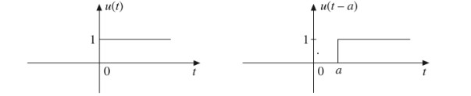
Figure 2 (a) Unit step function (b) Delayed unit step function
The discrete time unit step sequence u(n)
$$u\left(n\right)=\left\{\begin{aligned}1 for n≥0 \\ 0 for n<0\end{aligned}\right.$$
For the shifted version of the discrete unit step sequence
$$u\left(n-k\right)=\left\{\begin{aligned}1 for n ≥k \\ 0 for t<0\end{aligned}\right.$$
The graphical representation is shown in figure 3(a) and (b)
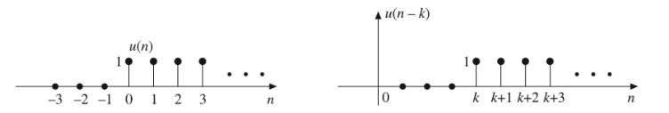
Figure 3 Discrete (a) Unit step function (b) Delayed unit step function
- UNIT RAMP FUNCTION.
The continuous unit ramp function r(t) is defined as
$$r\left(t\right)=\left\{\begin{aligned} t for t≥0 \\ 0 for t<0\end{aligned}\right.$$
Therefore r(t) = t u(t).
It is a signal whose amplitude varies linearly and can be obtained by integrating the unit step function.
$$r\left(t\right)=\int{u\left(t\right)dt=\int{dt}=t for t≥0}$$
$$u\left(t\right)=\frac{d}{dt}r(t)$$
The shifted version of the unit ramp signal is given by
$$r\left(t-a\right)=\left\{\begin{aligned}t-a for t≥a \\ 0 for t<a\end{aligned}\right.$$
$$r\left(t-a\right)=\left(t-a\right)u(t-a)$$
The graphical representation of r(t) and r (t – a) is shown in Figure 4
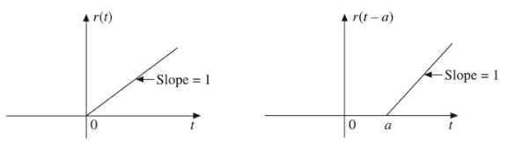
Figure 4 (a) Unit Ramp function (b) Delayed Unit Ramp function
The discrete time unit ramp r(n) is defined as
$$r\left(n\right)=\left\{\begin{aligned}n for n≥0 \\ 0 for t<0\end{aligned}\right.$$
$$r\left(n\right)=nu(n)$$
The shifted version of discrete time ramp $r\left(n-k\right)$
$$r\left(n-k\right)=\left\{\begin{aligned}n-k for n≥k \\ 0 for n<k\end{aligned}\right.$$
$$r\left(n-k\right)=(n-k)u(n-k)$$

Graphical representation of r(n) and r (n – 2) is shown in figure 5
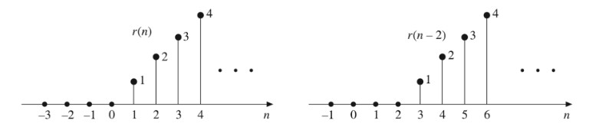
Figure 5 Discrete (a) Unit Ramp function (b) Delayed Unit Ramp function
- UNIT IMPULSE FUNCTION
The continuous time unit impulse function(t) “Dirac” plays an important role in signal analysis. It is defined as
$$∂(t)=\left\{\begin{aligned}1 for t=0 \\ 0 for t≠0\end{aligned}\right.$$
That is $\int_{-∞}^{∞}{∂\left(t\right)dt=1}$
A delayed version of unit impulse function $∂\left(t-a\right)$
$$∂(t-a)=\left\{\begin{aligned}1 for t=a \\ 0 for t≠a\end{aligned}\right.$$
The graphical representation of $∂\left(t\right) and ∂\left(t-a\right)$are shown in figure 6
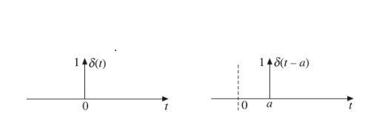
Figure 6 (a) Unit Impulse function (b) Delayed Unit Impulse function
The unit step function is the integral of unit impulse function.
$$u\left(t\right)=\int_{-∞}^{∞}{∂\left(t\right)dt}$$
$$∂\left(t\right)=d/{dt}u(t)$$
The discrete time unit impulse function d(n) is defined as
$$∂(n)=\left\{\begin{aligned}1 for n=0 \\ 0 for n≠0\end{aligned}\right.$$
The shifted version of the unit impulse function $∂(n-k)$ is defined as
$$∂(n-k)=\left\{\begin{aligned}1 for n=k \\ 0 for n≠k\end{aligned}\right.$$
The graphical representation of unit impulse function (discrete) is shown in figure 7
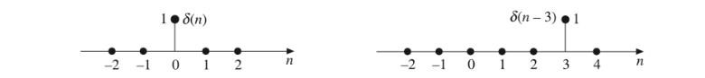
Figure 7 Discrete (a) Unit Impulse function (b) Delayed Unit Impulse function
- UNIT PARABOLIC FUNCTION.
The continuous time unit parabolic function p(t) is defined as
$$p\left(t\right)=\left\{\begin{aligned}\frac{t^{2}}{2} for t≥0 \\ 0 for t<0\end{aligned}\right.$$
or $p\left(t\right)=\frac{t^{2}}{2}u(t)$
The shifted version of the unit parabolic function $p(t-a)$ is defined as
$$p\left(t-a\right)=\left\{\begin{aligned}\frac{{(t-a)}^{2}}{2} for t≥a \\ 0 for t<a\end{aligned}\right.$$
or $p\left(t-a\right)=\frac{{(t-a)}^{2}}{2}u(t-a)$

The graphical representation for p (t) and p (t – a) is illustrated in figure 8(a) and the delayed version in (b)
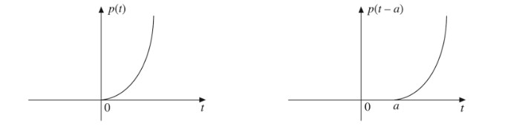
Figure 8 (a) Unit Parabolic function (b) Delayed Unit Parabolic function

The unit parabolic function can be obtained by integrating the unit ramp function or the double integral of the unit step function.
$$p\left(t\right)=\iint{u\left(t\right)dt=\int{r\left(t\right)dt=\int{tdt}=\frac{t^{2}}{2}for t≥0}}$$
The relationship between the parabolic ramp and unit step function is
$$r\left(t\right)=\frac{d}{dt}p\left(t\right) u\left(t\right)=\frac{d^{2}}{{dt}^{2}}p(t)$$
The discrete time unit parabolic sequence p(n) is defined as
$$p\left(n\right)=\left\{\begin{aligned}\frac{n^{2}}{2} for n≥0 \\ 0 for n<0\end{aligned}\right.$$
or $p\left(n\right)=\frac{n^{2}}{2}u(n)$
the shifted version of the discrete time unit parabolic sequence p (n – k) is defined as
$$p\left(n-k\right)=\left\{\begin{aligned}\frac{({n-k)}^{2}}{2} for n≥k \\ 0 for n<k\end{aligned}\right.$$
or $p\left(n-k\right)=\frac{({n-k)}^{2}}{2}u(n-k)$
The graphical representation of unit parabolic p(n) and p (n – 3) is shown in figure 9
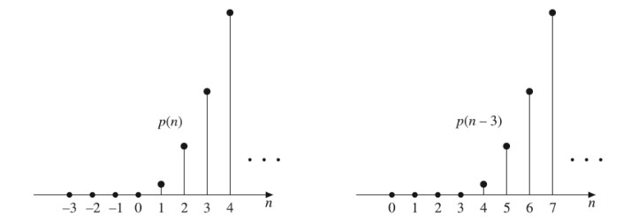
Figure 9 (a) Unit Parabolic function (b) Delayed Unit Parabolic function

- SINUSOIDAL SIGNAL
A continuous time sinusoidal signal is given
$$x\left(t\right)=Asin(ωt+∅)$$
Where
A = Amplitude
$ω$ = angular frequency
$∅$ = phase angle in radians
f = frequency
The time period of a continuous time sinusoidal signal is given by
T = $\frac{1}{f}=\frac{2π}{ω}$

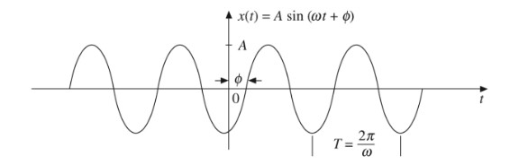
Figure 10 Sinusoidal Waveform
The discrete time sinusoidal sequence is given by
$x\left(n\right)=Asin(φn+∅)$ where n = integer.
the period of discrete time sinusoidal sequence is
N = $\frac{2π}{ω}m$
where N and m are integer
Note for a discrete time signal to be periodic the angular frequency $ω$ must be a rational multiple of $2π$
The graphical representation of sinusoidal signal (discrete) shown in figure 11
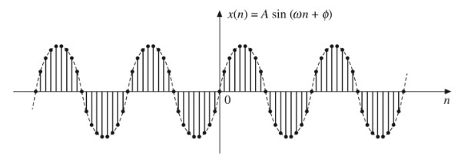
Figure 11 Discrete time sinusoidal waveform
- REAL EXPONENTIAL SIGNAL
A continuous time real exponential signal is defined as
$x\left(t\right)=Ae^{αt}$where A and α are real
Where A =Amplitude
The exponential gotten depends on the values of a and it has these three conditions
- if $α$ =0 x(t) is constant for all time
- if α is positive i.e. α $>$0 the signal grows exponentially
- if α is negative i.e. α $<$0 the signal decays exponentially
The waveform of the three conditions is represented in figure 12 (a), (b), and (c).

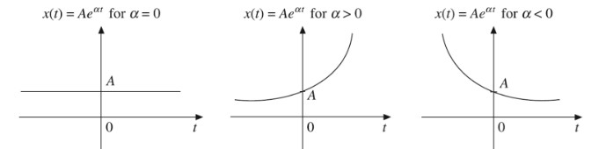
- (b) (c)
Figure 12 Continous time real exponential signal at (a) $α$ =0, (b) α $>$0 and (c) α $<$0
The discrete time real exponential sequence is defined as
$$x\left(n\right)=α^{n} for all n$$
graphical representation of discrete time real exponential sequence
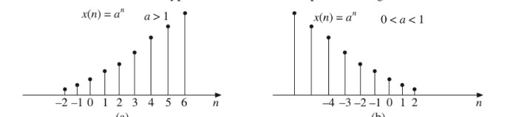
Figure 13 Discrete time real exponential signal at (a) $α$ =0, (b) α $>$0 and (c) α $<$0
- COMPLEX EXPONENTIAL SIGNAL
The complex exponential signal is defined as
$x\left(t\right)={Ae}^{st }$ s= Complex variable, A= Amplitude
$$s = σ+jω$$
$$x\left(t\right) =A^{ }e^{(σ+jω)t }$$
=${Ae}^{σt }e^{jωt }$
= ${Ae}^{σt }(\cos{ωt}+j\sin{ωt)}$
The different waveform for the values of $σ and ω$ are shown in figure 14
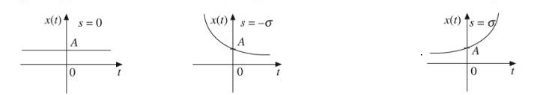
- (b) (c)
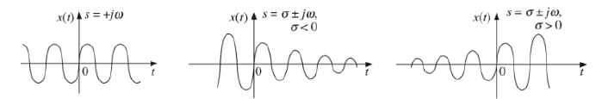
(d) (e) (f)
Figure 14 Complex exponential signals
The discrete time complex exponential sequence is defined as
$$x\left(t\right)=a^{n }e^{j(ω_{o}nt+ø)}$$
= $a^{n }\cos\left(ω_{o}n+ø\right)+ja^{n}\sin\left(ω_{o}n+∅\right)$
For $α=1$the real and imaginary part are sinusoidal
$α >1$ the amplitude of the sinusoidal grows exponentially
$α<$ 1 the amplitude of the sinusoidal decays exponentially
These statements are represented graphically in figure 15
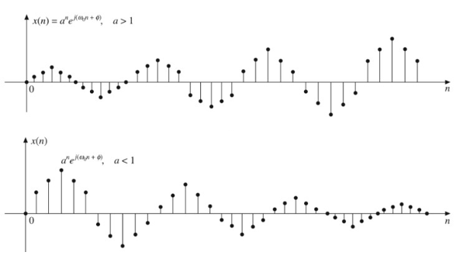
Figure 15 Discrete complex exponential sequence
- RECTANGULAR PULSE SIGNAL
A rectangular pulse signal is a basic function with a constant amplitude over a specific time duration and zero value elsewhere. The unit rectangular pulse signal is defined as
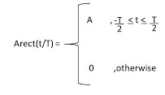
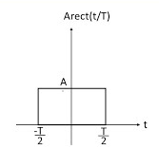
Figure 16 Graphical representation of the rectangular pulse function
It is widely used as a foundational building block in digital communications, radar systems, and signal processing analysis.
ix SIGNUM FUNCTION
A signum signal (or signum function, denoted as sgn(t)) is a math function that extracts the sign of a real number, giving an output of +1 for positive values, -1 for negative values, and 0 when the input is zero. The Signum function sgn (t) defined as
$$sgn(t)\left\{\begin{aligned}1 for t>0 \\ -1 for t<0\end{aligned}\right.$$
Graphical representation of unit signum function is shown figure 17
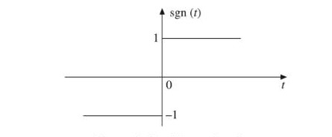
Figure 17 Signum function
Signal Processing: Used to find whether a signal is positive or negative.

Control Systems: Helps systems react differently to positive and negative errors.

- SINC FUNCTION
The sine function Sinc(t) is defined as
Sinc(t) =$\frac{sint}{t} for-∞<t<∞$
The sinc function oscillates with period 2$π$ and decays with increasing t. it is an even function of t
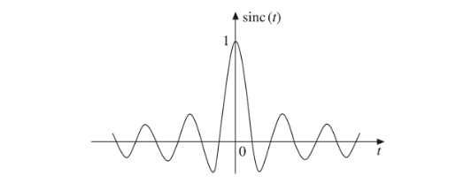
Figure 18 Graphical representation of Sinc function

BASIC OPERATIONS ON SIGNALS
The basic operations on signals are as follows
- TIME SHIFTING
The time shifting of a continuous time signal is mathematically represented by
$$y\left(t\right)=x(t- to)$$
Time shifting may result in time advance or time delay. If T is positive, the shift is to the right delaying the signal. If T is negative, the shift is to the left causing signal advance.
Example: let x(t) be signal shown in figure 19 at x(t) = 1 at -2 to 2 but 0 otherwise, find x (t – 2)
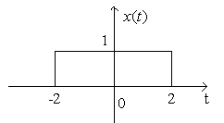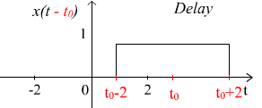
Figure 19 (a) Signal (b) Delayed version
For discrete time signal, time shifting is denoted as
Y_{(n)} = x (n – N) where N is an integer value
- TIME REVERSAL
The time reversal of a signal is the folding of a signal about the vertical axis or at the line t = 0. It is simply taking a mirror image of the signal about the x axis.
Note: time reversal only affects odd signals. It does not affect even signals.
Example: x (t) be a signal shown in figure 20(a), find x(-t)
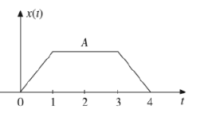
Figure 20 (a)
Graphically we can find x (-t) by taking mirror image of x(t) about vertical axis shown in figure 20(b).
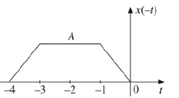
(b)
- TIME SCALING
Time scaling is the compression or expansion of signal on its time axis. It increases or decreases the duration of the existence of a signal it is mathematically expressed as
Y (t) = x(at)
If $α$ $>1$ it results in compression by a factor of $α$
If $α$ $<1 it results in expansion by a factor a$
Time scaling is illustrated in figure 21 (a), (b), and (c). (a) is the original signa, (b) is the signal compression and (c) is the signal expansion.
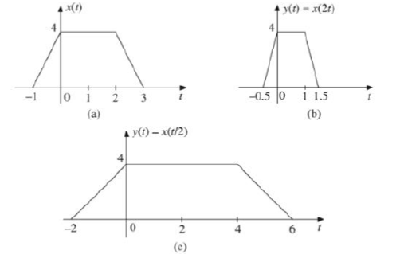
Figure 21 Time Scaling
- AMPLITUDE SCALING
Amplitude Scaling is the amplificatory attenuation of a signal. By using amplitude scaling, we can increase or decrease the strength or gain of the signal which depends on the scaling factor. It is mathematically represented by
y(t) = Ax(t) where A = scaling factor
the amplitude of y(t) at any instant is equal to A times the amplitude of x(t) at that instant. If A $>1$it is AMPLIFICATION and if A $<$ 1 it is ATTENUATION. Figure 22 shows the (a) original signal and (b) Amplification
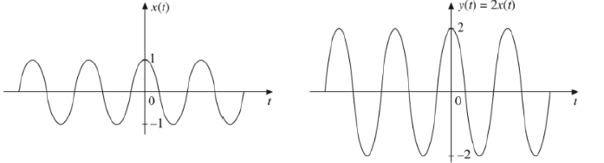
Figure 22 (a) (b)

- SIGNAL ADDITION
The sum of two continuous time signals x₁(t) and x₂(t) can be obtained by adding their values at every instant of time. Similarly, the subtraction of one continuous time signal x₂(t) from another signal x₁(t) can be obtained by subtracting the values of x₂(t) from x₁(t) at every instant of time.
To be able to illustrate this, let us graphically in figure 23 show the addition of signal x₁(t) with signal x₂(t) as well as the subtraction of x₁(t) from x₂(t).
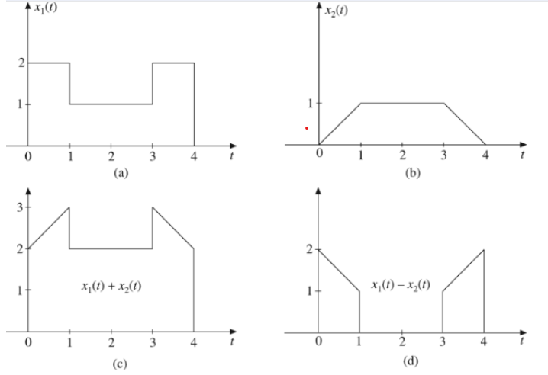
Figure 23 Signal Addition and Signal Subtraction
- SIGNAL MULTIPLICATION
Signal multiplication is also a basic signal operation. The multiplication of two continuous time signal can be performed by multiplying their values at every instant of time.
Let x₁(t) and x₂(t) are two signals which are multiplied to create a new signal y(t)
Y(t) = x₁(t) * x₂(t)
Signal multiplication is graphically represented in Figure 24
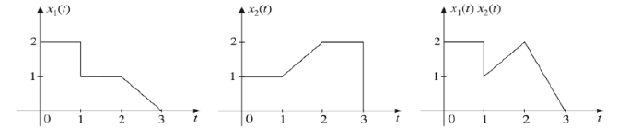
Figure 24 Signal Multiplication
CLASSIFICATION OF SIGNALS
Signals that are defined at every instant of time is known as a continuous time signals and are denoted by x(t) while signal that are defined only at discrete instant of time are known as discrete time signals. They are denoted by x(n) where n is an integer.
Both continuous time and discrete time signals may further be classified as
- DETERMINISTIC AND RANDOM SIGNALS
A signal is said to be deterministic if it exhibits no uncertainty of its magnitude and phase at any given instant of time. It has a regular pattern and can be completely represented by mathematical equation of any time.
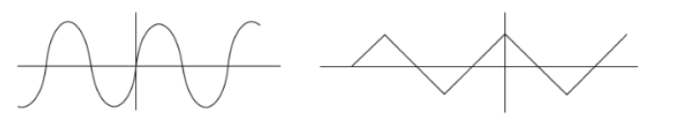
Figure 25 Deterministic signal
A signal is said to be random if it is characterized by uncertainty about its occurrence. The pattern of such signal is irregular. Random signal cannot be represented by a mathematical equation.
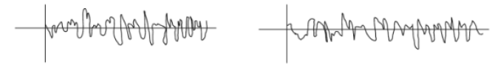
Figure 26 Random Signal
- PERIODIC AND APERIODIC SIGNAL
A signal which repeats itself after a fixed time period is called a periodic signal.it is mathematically represented by
x(t) = x (t + T)
for a discrete signal the mathematical representation is given as
x(m) = (n + N) where N = period
Aperiodic or non-periodic signal does not satisfy the condition
x(t) = x (x + T)
therefore, mathematically a non-periodic signal is represented as
x$≠x (t+T)$
for discrete non periodic signal is represented by
x(m) $≠$ x (n + N) where n is an integer.
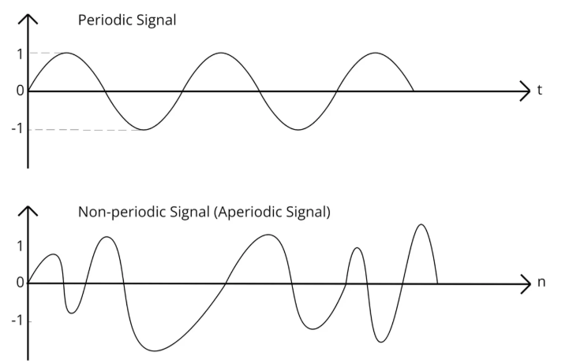
Figure 27 Periodic and Aperiodic signal
- ENERGY AND POWER SIGNAL
ENERGY SIGNAL
A signal is said to be an energy signal if and only if its total energy E is finite (i.e. 0$<E<∞)$
for energy signal average power = 0
A signal is said to be a power signal if its average power p is finite (i.e. 0$<P<∞)$and total energy E = $∞$
Energy Signal
For Continuous Time Signal (CT)
E = $\lim_{T→∞}{\int_{t=-T}^{T}{{\left|x(t)\right|}^{2}}}$
Discrete Time Signal (DT)
E = $\lim_{N→∞}{\sum_{n=-N}^{N}{{ \left|x(n)\right|}^{2}}}$
POWER SIGNAL
Continuous Time Signal (CT)
P = $\lim_{T→∞}{\frac{1}{2T}}$ $\int_{t=-T}^{T}{\left|x(t)\right|.^{2}dt}$
Discrete Time Signal (DT)
P =$\lim_{N→∞}{\frac{1}{2N+1}\sum_{n=-N}^{N}{\left|x(n)\right|.^{2}}}$
- EVEN AND ODD SIGNAL
Even (Symmetric) signal
A continuous time signal x(t) is said to be even signal if it satisfies the condition.
x(t) = x(-t) for all t
A discrete time signal x(n) is said to be an even (symmetric) signal if it satisfies the condition
x(n) = x(-n) for all n
even signals are symmetrical about the vertical axis or time origin. Cosine wave is an example of an even signal. Some even signals are shown in figure28
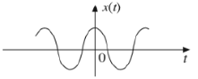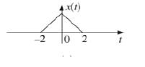
Figure 28 Even Signal
Odd (antisymmetric signal)
A continuous time signal x(t) is said to be an odd (anti symmetric) signal if it satisfies the condition.
x(-t) = -x(t) for all t
a discrete time signal x(n) is said to be an odd signal if it satisfies the condition.
x(-n) = -x(n) for all n
odd signals are antisymmetric about the vertical axis. Sine wave is an example of an odd signal for an odd signal x(t) = 0. Some odd signals are shown in figure 29
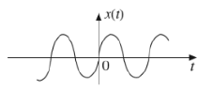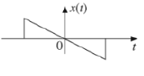
Figure 29 Odd Signals
Therefore, any signal x(t) can be expressed as the sum of even and odd components
x(t) = x_{e} (t) + x_{o}(t)
where x_{e} (t) = even components
x_{o}(t) = odd components
DERIVATION OF EVEN AND ODD PARTS OF A SIGNAL
even signal x(t) = x(-t)
odd signal x(-t) = -x(t)
$$x\left(t\right)=x_{e}\left(t\right)+x_{o}(t)$$
$$x\left(-t\right)=x_{e}\left(-t\right)+x_{o}(-t)$$
$$x_{e}\left(t\right)-x_{o}(t)$$
For the even part
$$x\left(t\right)+x\left(-t\right)=x_{e}\left(t\right)+x_{o}\left(t\right)+x_{e}\left(t\right)-x_{o}\left(t\right)$$
$$={2x}_{e}\left(t\right)$$
$$\frac{x\left(t\right)+x(-t)}{2}=\frac{2x_{e}(t)}{2}$$
$$x_{e}\left(t\right)=\frac{1}{2}\left(x\left(t\right)+x\left(-t\right)\right)$$
For the odd part
$$x\left(t\right)-x\left(-t\right)=\left[x_{e}\left(t\right)+x_{o}\left(t\right)\right]-[x_{e}\left(t\right)-x_{0}\left(t\right)]$$
$$=\left[x_{e}\left(t\right)+x_{o}\left(t\right)\right]-[x_{e}\left(t\right)-x_{0}\left(t\right)]$$
$$2x_{o}(t)$$
$$\frac{x\left(t\right)-x(-t)}{2}= \frac{2x_{o}(t)}{2}$$
$$x_{o}\left(t\right)=\frac{1}{2}\left(x\left(t\right)+x\left(-t\right)\right)$$
For the discrete time signal
$$x_{e}\left(n\right)=\frac{1}{2}\left(x\left(n\right)+x\left(-n\right)\right)$$
$$x_{o}\left(n\right)=\frac{1}{2}\left(x\left(n\right)+x\left(-n\right)\right)$$
Product of even and odd signal
- The product of two even signals is an even signal.
$$x_{1}\left(-t\right)=x_{1}\left(t\right)$$
$$x_{2}\left(-t\right)=x_{2}(t)$$
$$then x\left(-t\right)=x_{1}\left(-t\right)x_{2}(t)$$
$$= x_{1}\left(t\right)x_{2}\left(t\right)=x\left(t\right)$$
Therefore x(t) is an even signal.
- The product of two odd signals is an even signal.
$$x_{1}\left(-t\right)=x_{1}\left(t\right)$$
$$x_{2}\left(-t\right)={-x}_{2}(t)$$
$$then x\left(-t\right)=x_{1}\left(-t\right)x_{2}(-t)$$
$$= {[-x}_{1}\left(t\right)][-x_{2}\left(t\right)]$$

$$=x_{1}\left(t\right)x_{2}\left(t\right)=x(t)$$
Therefore x(t) is an even signal.
- The product of an even signal and an odd signal equals an odd signal.
If x₁(t) is even and x₂(t) is odd.
$$x_{1}\left(-t\right)=x_{1}\left(t\right)$$
$$x_{2}\left(-t\right)={-x}_{2}(t)$$
$$then x\left(-t\right)=x_{1}\left(-t\right)x_{2}(-t)$$
$$= {[-x}_{1}\left(t\right)][-x_{2}\left(t\right)]$$
$$-x\left(t\right)$$
Therefore x(t) is an odd signal.

WORKED EXAMPLES
- Sketch each of the signals
- $x\left[n\right]=∂\left[n\right]+∂[n-3]$
EXPLANATION
For a unit impulse function, it is guided by the condition
$$∂\left(n\right)=\left\{\begin{aligned}1 for n=0 \\ 0 for n≠0\end{aligned}\right.$$
And for the shifted version
$$∂\left(n-k\right)=\left\{\begin{aligned}1 for n=k \\ 0 for n≠k\end{aligned}\right.$$
Which means that
The x(n) can only be 1 at n = 0 and n =3 else the value will be 0.
- x(n) = u[n] – [n – 5]

- x(t) =$∂\left(t+2\right)$
- x(t) = $e^{-t}u(t)$
- Express the following as sum of weighted displayed impulses
$$x\left[n\right]=\sum_{k_{2}-∞}^{∞}{a_{k}∂[n-k]}$$

$$at n=1 x\left[n\right]=∂\left[n-1\right]$$
$$at n=2 x\left[n\right]=-2∂[n-2]$$
$$at n=3 x\left[n\right]=3∂[n-3]$$
$$at n=4 x\left[n\right]=-2∂[n-4]$$
$$at n=5 x\left[n\right]=∂[n-5]$$
Therefore $x\left[n\right]=∂\left[n-1\right]-2∂\left[n-2\right]+3∂\left[n-3\right]-2∂n-4]+∂[n-5]$

- Express the following sequence as a sum of step functions, i.e., in the form
$$s\left[n\right]=\sum_{k_{2}-∞}^{∞}{a_{k}u[n-k]}$$
NOW DO THIS!!!
- Give the discrete signal $x\left[n\right]$ in (a), sketch the signal $x\left[n-1\right]$ and $x\left[n+1\right]$
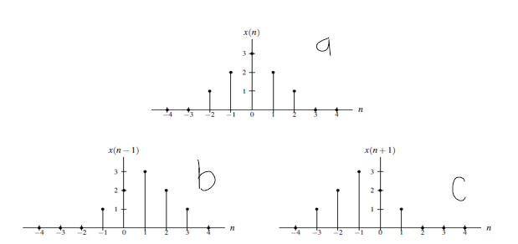

- Consider a signal $x\left[n\right]$, plot $x\left[n-3\right]$and $x\left[n+2\right]$
Signal advance
y(n) = x(n+2)
Signal delay
y(n) = x(n-3)
29

- Consider the signal $x(t)$, plot $x(2t)$ and $x(t/2)$
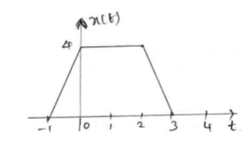
(i) x(2t)
t= -0.5, x(2x-0.5) = x (-1) = 0
t=0, x(2x0) = x (0) = 4
t=0.5, x (2x0.5) = x (1) = 4
t=1, x(2x1) = x (2) = 4
t=1.5, x (2x1.5) = x (3) = 0
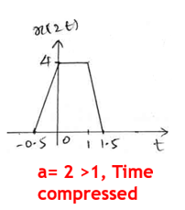
(i) x(t/2)
t=-2, x (-2/2) = x (-1) = 0
t=-1, x (-1/2) = x (-0.5) = 3
t=0, x (0/2) = x (0) = 4
t= 1, x (1/2) = x (0.5) = 4
t=3, x (3/2) = x (1.5) = 4
t=4, x (4/2) = x (2) = 4
t=6, x (6/2) = x (3) = 0
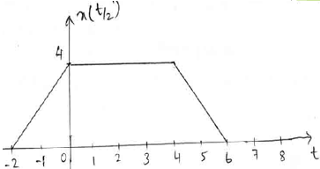

- Consider a signal$x$[n] = {0,4,3,2,1,2,3,4,0}, Plot y(n)= $x$ (2n) and $x$ (n/2)
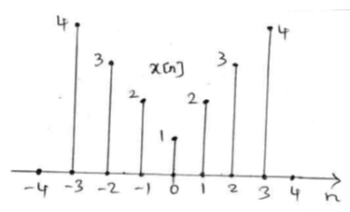
(i) y(n) = x(2n);
y (0) = x(2x0) = x (0) = 1
y (1) = x(2x1) = x (2) = 3
y (2) = x(2x2) = x (4) = 0
y (-1) = x(2x-1) = x (-2) = 3
y (-2) = x(2x-2) = x (-4) = 0
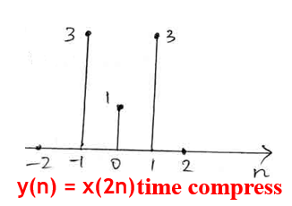
(ii) y(n) = x(n/2);
y (-2) = x (-2/2) = x (-1) = 2
y (-4) = x (-4/2) = x (-2) = 3
y (-6) = x (-6/2) = x (-3) = 4
y (0) = x (0/2) = x (0) = 1
y (2) = x (2/2) = x (1) = 2
y (4) = x (4/2) = x (2) = 3
y (6) = x (6/2) = x (3) = 4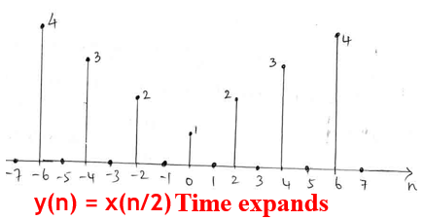

- Consider the signal $x(t)$, plot (a) $x(2t+2),$ and (b) $x(t/2-2)$
To solve this question, we need to follow the precedence rule, that is if Time shifting and Time scaling, time reversal and amplitude scaling occurs in same signal.
Rule:
(a)
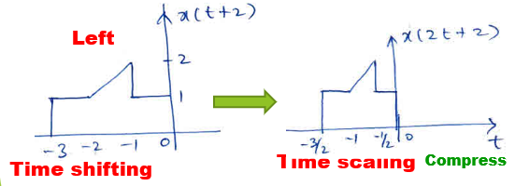
(b)
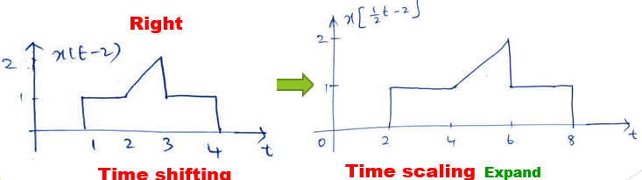
- Sketch the even and odd part of the signal
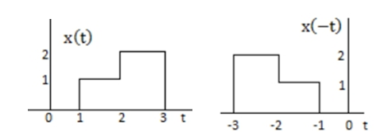
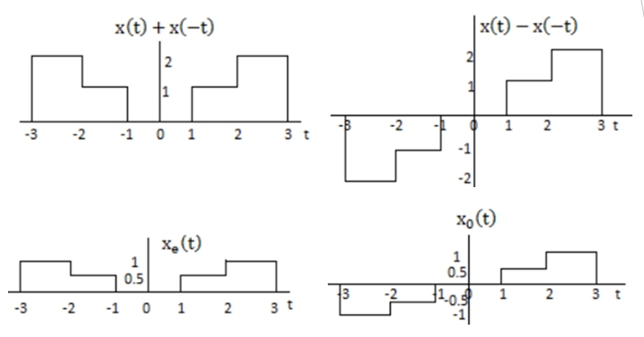
- Determine even and odd part of the signal x$\left(n\right)=\cos{2n}+\sin{4n}$
Even Part: $x_{e}\left(n\right)=\frac{1}{2}\left[x\left(n\right)+x\left(-n\right)\right]$
$x\left(n\right)=\cos{2n}+\sin{4n}$
$x\left(-n\right)=\cos\left(-2n\right)+\sin\left(-4n\right)=\cos{2n}-\sin{4n}$
$x\left(n\right)+x\left(-n\right)=\cos{2n}+\sin{4n}+\cos{2n}-\sin{4n}= 2\cos{2n}$
${∴x}_{e}\left(n\right)=\cos{2n}$
Odd Part: ${ x}_{o}\left(n\right)=\frac{1}{2}[x\left(n\right)-x\left(-n\right)]$
$x\left(n\right)=\cos{2n}+\sin{4n}$
$x\left(-n\right)=\cos\left(-2n\right)+\sin\left(-4n\right)=\cos{2n}-\sin{4n}$
$x\left(n\right)-x\left(-n\right)=\cos{2n}+\sin{4n}-\left(\cos{2n}-\sin{4n}\right)= 2\sin{4n}$
${∴x}_{o}\left(n\right)=\sin{4n}$
- Check whether the following are periodic or not. If periodic, determine fundamental time period.
(i) $x\left(t\right)=sin20πt$
Solution:
$Ω=20π$ Fundamental time period $T=\frac{2π}{Ω}=\frac{2π}{20π}=\frac{1}{10}s$
Hence x(t) is periodic with period
$$(ii) x\left(t\right)=2\cos\left(2t+5\right)+4sin\left(4t+6\right)$$
$$Ω_{1}=2$$
Fundamental time period $T_{1}=\frac{2π}{Ω_{1}}=\frac{2π}{2}=π$ $\frac{T_{1}}{T_{2}}=\frac{2}{1}$
$$T=1T_{1}=2T_{2}=π$$
$$Ω_{2}=4$$
Fundamental time period $T_{2}=\frac{2π}{Ω_{2}}=\frac{2π}{4}=\frac{π}{2}$
$$\frac{T_{1}}{T_{2}}=\frac{π}{\frac{π}{2}}=2(It is rational number)$$
Hence x(t) is periodic with period T=$π$s
$$(iii) x\left(t\right)=2\cos\left(3t+1\right)-4sin⁡(4πt)$$
Solution:
$$Ω_{1}=3$$
Fundamental time period $T_{1}=\frac{2π}{Ω_{1}}=\frac{2π}{3}$
$$Ω_{2}=4π$$
Fundamental time period $T_{2}=\frac{2π}{Ω_{2}}=\frac{2π}{4π}=\frac{1}{2}$
$$\frac{T_{1}}{T_{2}}=\frac{\frac{2π}{3}}{\frac{1}{2}}=\frac{4π}{3}\left(It is irrational number\right)$$
Hence x(t) is Aperiodic
$$(iv) x\left(n\right)=sin20πn$$
Solution:
$$ω=20π$$
Fundamental time period $N=\frac{2πm}{ω}=\frac{2πm}{20π}=\frac{1}{10}m$
$$N=1(taking m=10)$$
Hence x(n) is periodic with period $N=1$

$$(v) x\left(n\right)=cos20n$$
Solution:
$$ω=20$$
Fundamental time period $N=\frac{2πm}{ω}=\frac{2πm}{20}=\frac{πm}{10}$
N could not be an integer for any value of m.
Hence x(n) is aperiodic
(vi) $x\left(n\right)=2\cos\left(5πn+5\right)+4sin⁡(6πn+6)$
Solution:
$$ω_{1}=5π$$
Fundamental time period $N_{1}=\frac{2πm}{ω_{1}}=\frac{2πm}{5π}=\frac{2m}{5}$
$$N_{1}=2(taking m=5)$$
$$ω_{2}=6π$$
Fundamental time period $N_{2}=\frac{2πm}{ω_{2}}=\frac{2πm}{6π}=\frac{m}{3}$
$N_{2}=1(taking m=3)$
N=LCM ($N_{1},N_{2})$=LCM (2,1) =2
x(n) is Periodic with period N=2s
- Check if it is a power or energy signal
i. $x\left(t\right)=e^{-3t}u(t)$
$$Energy E_{∞}=\lim_{T→∞}{\int_{-T}^{T}{{|x\left(t\right)|}^{2}dt=}}\lim_{T→∞}{\int_{0}^{T}{{|e^{-3t}|}^{2}dt= \lim_{T→∞}\int_{0}^{T}{e^{-6t}}}dt=\lim_{T→∞}}{\left[\frac{e^{-6t}}{-6}\right]}_{0}^{T}$$
$$=\lim_{T→∞}\left[\frac{e^{-6T}}{-6}-\left[\frac{e^{-0}}{-6}\right]\right]=\frac{1}{6}<∞ ∵e^{-∞}=0, e^{-0}=1$$
$Power P_{∞}=\underset{T→∞}{\lim{ }}{\frac{1}{2T}\int_{-T}^{T}{{\left|x\left(t\right)\right|}^{2}dt=}}\lim_{T→∞}{\frac{1}{2T}\int_{0}^{T}{{\left|e^{-3t}\right|}^{2}dt= }}\lim_{T→∞}\frac{1}{2T}\int_{0}^{T}{e^{-6t}}dt$
$${\underset{ T→∞}{= lim}\frac{1}{2T}\left[\frac{e^{-6t}}{-6}\right]}_{0}^{T}=\lim_{T→∞}{\frac{1}{2T}\left[\frac{e^{-6T}}{-6}-\frac{e^{-0}}{-6}\right]}=\lim_{T→∞}{\frac{1}{2T}\left[\frac{1}{6}\right]}=0 ∵e^{-∞}=0, e^{-0}$$
∵$\frac{1}{∞}=0$
Since energy value is finite and average power is zero, the given signal is an energy signal.
$$ii.x\left(t\right)=4\cos{3Ω_{o}t}$$
$$Energy E_{∞}=\lim_{T→∞}{\int_{-T}^{T}{{|x\left(t\right)|}^{2}dt=}}\lim_{T→∞}{\int_{-T}^{T}{{|4\cos{3Ω_{o}t}|}^{2}dt=}}\lim_{T→∞}{\int_{-T}^{T}{16\cos^{2}3Ω_{o}tdt}}$$
$$=\lim_{T→∞}\int_{-T}^{T}{16\left[\frac{1+\cos{6Ω_{o}t}}{2}\right]}dt=\lim_{T→∞}\int_{-T}^{T}{8}dt ∵\int_{-T}^{T}{8}\cos{6Ω_{o}t}dt=0$$
$$=\lim_{T→∞}8{\left[t\right]}_{-T}^{T}=\lim_{T→∞}16T=∞$$
$Power P_{∞}=\underset{T→∞}{\lim{ }}{\frac{1}{2T}\int_{-T}^{T}{{\left|x\left(t\right)\right|}^{2}dt=}}\lim_{T→∞}{\frac{1}{2T}\int_{-T}^{T}{{\left|4\cos{3Ω_{o}t}\right|}^{2}dt= }}\lim_{T→∞}\frac{1}{2T}\int_{-T}^{T}{16\cos^{2}3Ω_{o}t}dt$
$$=\lim_{T→∞}\frac{1}{2T}\int_{-T}^{T}{16\left[\frac{1+\cos{6Ω_{o}t}}{2}\right]}dt=\lim_{T→∞}\frac{1}{2T}\int_{-T}^{T}{8}dt ∵\int_{-T}^{T}{8}\cos{6Ω_{o}t}dt=0$$
$$=\lim_{T→∞}\frac{1}{2T}8{\left[t\right]}_{-T}^{T}=\lim_{T→∞}\frac{1}{2T}16T=8 W$$
Since energy value is infinite and average power is finite, the given signal is power signal.
(iii)$x\left(n\right)=e^{j\left(\frac{πn}{4}+\frac{π}{2}\right)}$
$$Energy E_{∞}=\lim_{N→∞}\sum_{n=-N}^{N}{{\left|x(n)\right|}^{2}}=\lim_{N→∞}\sum_{n=-N}^{N}{{\left|e^{j(\frac{πn}{4}+\frac{π}{2})}\right|}^{2}=}\lim_{N→∞}\sum_{n=-N}^{N}{1^{2}=\lim_{N→∞}2N+1=∞}$$
$$∵\left|e^{j(ωn+θ)}\right|=1 and \sum_{n=-N}^{N}{1=2N+1}$$
$$Average power P_{∞}=\lim_{N→∞}\frac{1}{2N+1}\sum_{n=-N}^{N}{{\left|x(n)\right|}^{2}}=\lim_{N→∞}\frac{1}{2N+1}\sum_{n=-N}^{N}{{\left|e^{j(\frac{πn}{4}+\frac{π}{2})}\right|}^{2}}$$
$$\lim_{=N→∞}\frac{1}{2N+1}\sum_{n=-N}^{N}{1^{2}=\lim_{N→∞}\frac{1}{2N+1}}\left(2N+1\right)=1$$
Since energy value is infinite and average power is finite, the given signal is power signal

