Metal–Semiconductor Interfaces
ELE 717 Solid State Electronics · Week 11 · Group presentation notes
Subtopics: (1) Schottky barrier diode physics versus ohmic contact mechanisms; (2) energy band diagrams under equilibrium and applied bias.
Learning objectives. After this topic you should be able to:
- Define work function, electron affinity and Fermi level, and relate them for a doped semiconductor.
- Draw the energy band diagram of a metal and an n-type semiconductor before and after contact.
- Explain how a Schottky barrier forms, and calculate the barrier height, built-in potential and depletion width.
- Draw and explain the band diagrams under forward and reverse bias, and use the thermionic-emission equation.
- Explain the three ways of making an ohmic contact, and why heavy doping works.
- Compare Schottky and ohmic contacts, and answer examination question 49.
Units. All quantities are in SI units. Energies are quoted in electron-volts (eV), which SI accepts for use alongside its units ($1 eV=1.6×{10}^{−19} J$). A work function $Φ$ is a potential in volts; $qΦ$ is the corresponding energy, and its value in eV equals the value of $Φ$ in volts.

1. Introduction
Every semiconductor device has to be connected to the outside world with metal. Where a metal touches a semiconductor, a metal–semiconductor interface (or contact) is formed. When the two materials touch, electrons move from one to the other until a single Fermi level runs through both. This charge transfer can leave an energy barrier at the interface, and that barrier decides how current flows. There are two kinds of contact:
- A Schottky contact has a barrier to majority carriers, so it is rectifying: current flows easily in one direction (forward bias) and very little in the other (reverse bias). A diode made this way is a Schottky barrier diode (SBD). The rectifying metal–semiconductor contact was explained by Walter Schottky and Nevill Mott in 1938–39.
- An ohmic contact has no barrier that limits the current, so it conducts equally in both directions with a linear current–voltage (I–V) graph. Every transistor terminal, solar-cell finger and integrated-circuit connection needs one.
A practical Schottky diode contains both: a rectifying contact on top and an ohmic contact underneath (Figure 1).
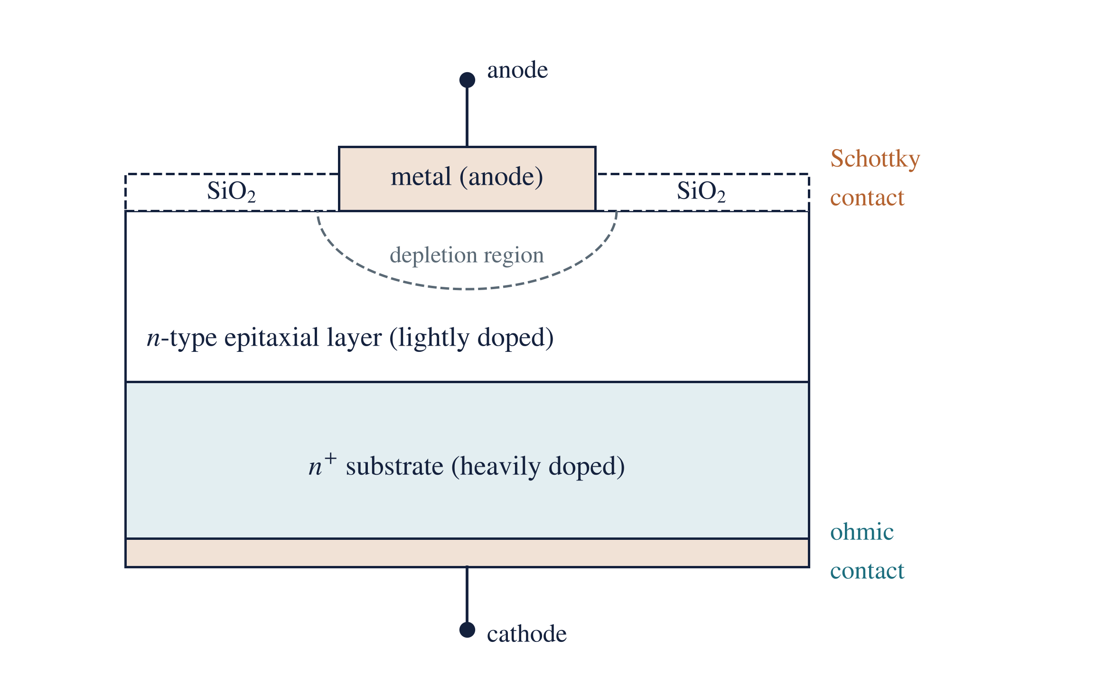
Figure 1. A Schottky barrier diode in cross-section. The metal anode on a lightly doped n-type epitaxial layer forms the rectifying Schottky contact, with a depletion region beneath it. The heavily doped $n^{+}$ substrate and the metal underneath form the ohmic cathode contact. The oxide ring insulates the edges of the metal.

2. Key terms and definitions
Metal. A material with a very large density of free electrons (about ${10}^{28} m^{−3}$), so it conducts very well. Its electron states are filled up to the Fermi level, with empty states immediately above. Examples: aluminium, gold, platinum, titanium, tungsten.
Semiconductor. A material whose conductivity lies between that of a metal and an insulator and can be controlled by doping, temperature, light and electric field. Examples: silicon (Si), germanium (Ge), gallium arsenide (GaAs).
Doping; n-type and p-type. Adding a small, controlled amount of impurity. Donor atoms (concentration $N_{D}$, e.g. phosphorus in Si) give free electrons and make the material n-type; acceptor atoms (concentration $N_{A}$, e.g. boron) create holes and make it p-type. The carrier in the majority (electrons in n-type, holes in p-type) is the majority carrier.
Band edges and band gap. $E_{c}$ is the bottom of the conduction band (the lowest energy of a free electron); $E_{v}$ is the top of the valence band. No electron states exist between them. The band gap is
$$E_{g}=E_{c}−E_{v}$$
where $E_{g}$ is the band-gap energy (1.12 eV for Si at 300 K), $E_{c}$ the conduction-band edge and $E_{v}$ the valence-band edge.
Fermi level ($E_{F}$). The energy at which a state has a 50 % probability of being occupied by an electron. In n-type material it lies close to $E_{c}$, in p-type close to $E_{v}$. At thermal equilibrium the Fermi level is flat: it has the same value everywhere in materials that are in contact. For n-type silicon,
$$E_{c}−E_{F}=kTln\left(\frac{N_{c}}{N_{D}}\right)$$
where $kT=0.0259 eV$ at 300 K, $N_{c}=2.8×{10}^{25} m^{−3}$ is the effective density of states in the conduction band of Si, and $N_{D}$ is the donor concentration in $m^{−3}$.
Vacuum level ($E_{vac}$). The energy of an electron at rest just outside the material. It is the common reference from which the other energies below are measured.
Work function ($Φ$). The minimum energy needed to take an electron from the Fermi level to the vacuum level:
$$qΦ_{m}=E_{vac}−E_{F,m}, qΦ_{s}=E_{vac}−E_{F,s}$$
where $Φ_{m}$ and $Φ_{s}$ are the work functions of the metal and of the semiconductor, $E_{F,m}$ and $E_{F,s}$ their Fermi levels, and $q=1.6×{10}^{−19} C$ the electronic charge. A metal with a large work function holds its electrons tightly.
Electron affinity ($χ$). The energy from the bottom of the conduction band to the vacuum level:
$$qχ=E_{vac}−E_{c}$$
Unlike $Φ_{s}$, the electron affinity does not depend on doping; it is a fixed property of the material (Si 4.05 eV, GaAs 4.07 eV, Ge 4.0 eV). The two are related by
$$qΦ_{s}=qχ+\left(E_{c}−E_{F}\right)$$
so the semiconductor work function does change with doping, because doping moves $E_{F}$.
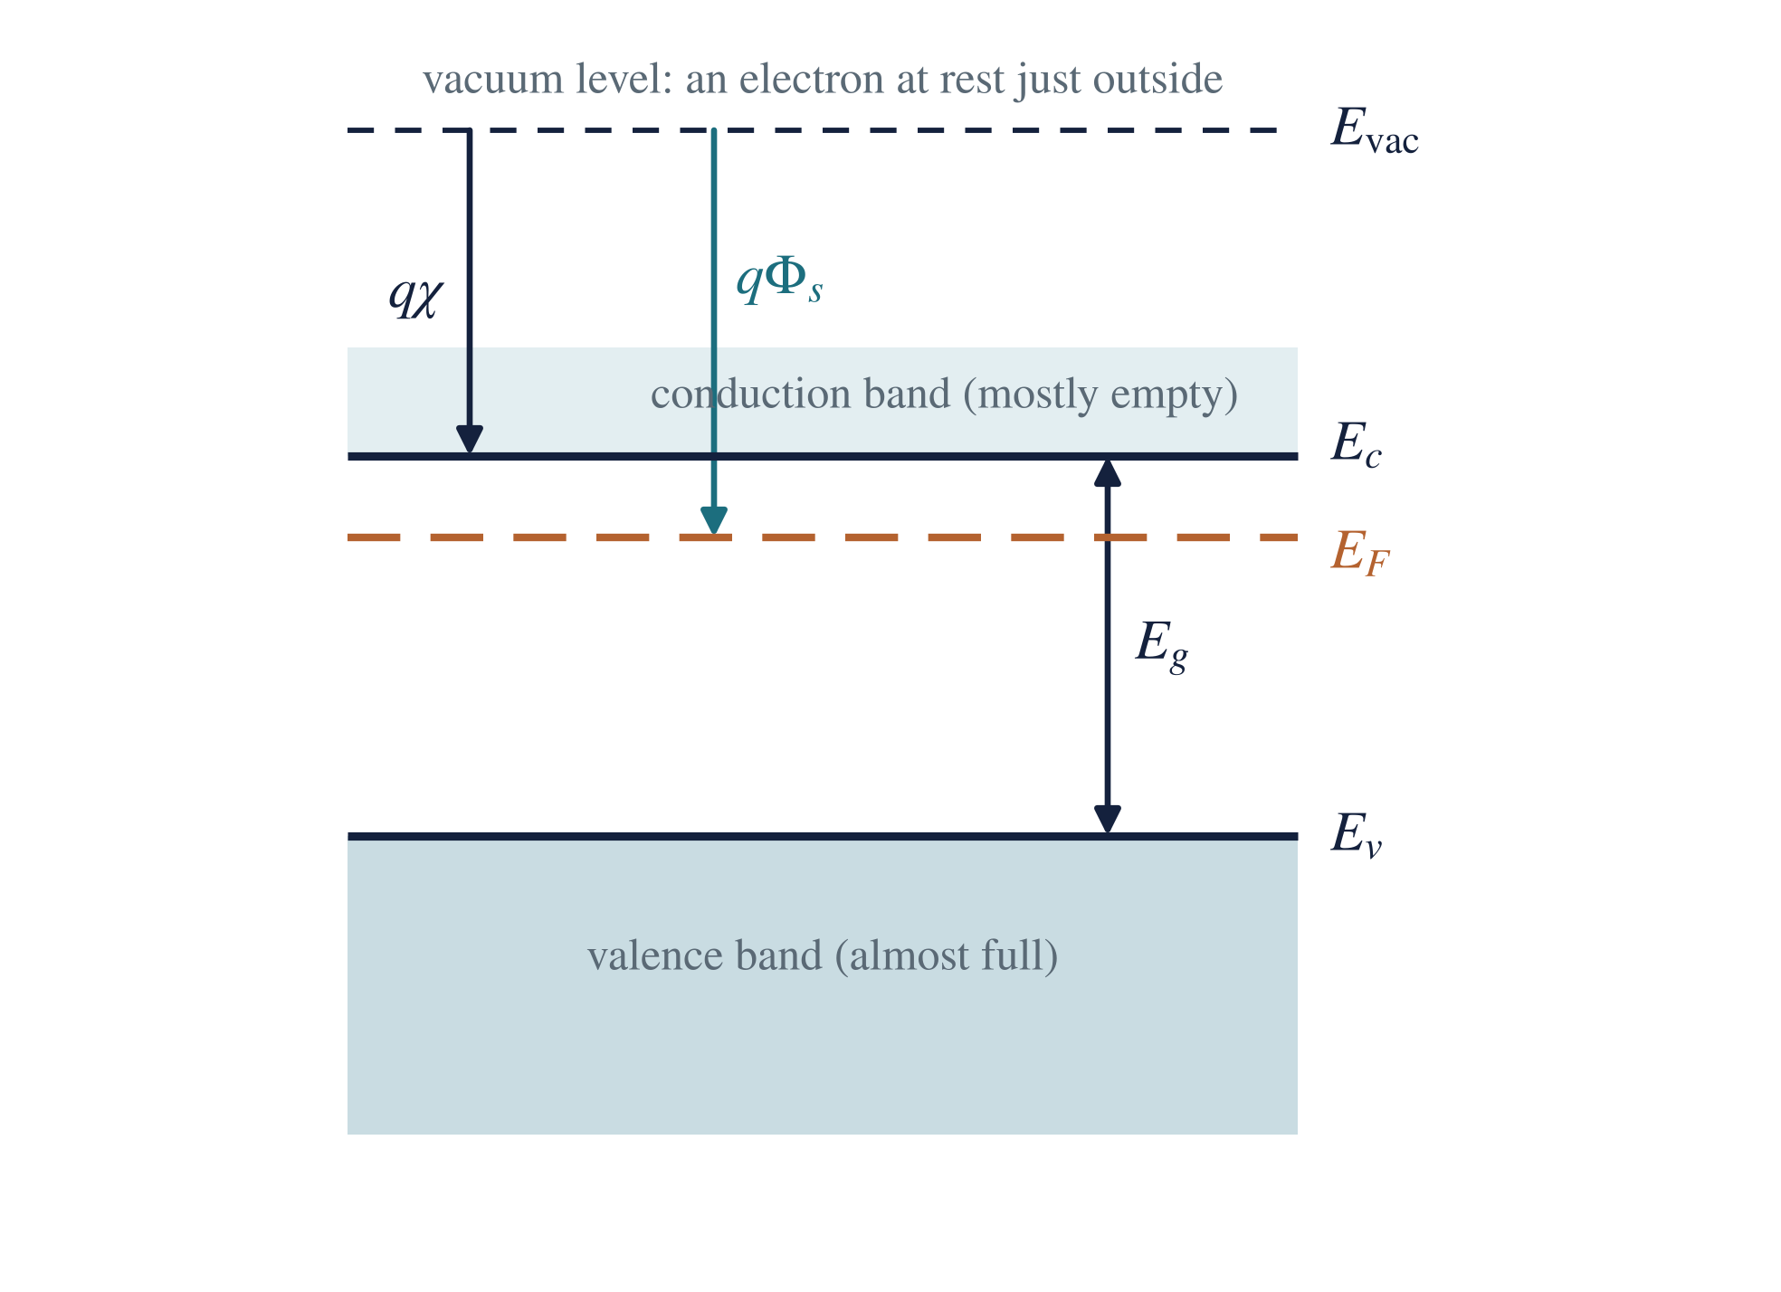
Figure 2. Energy levels of an isolated n-type semiconductor. The conduction band starts at $E_{c}$ and is mostly empty; the valence band below $E_{v}$ is almost full. The electron affinity $qχ$ is measured from $E_{c}$ to the vacuum level, the work function $qΦ_{s}$ from $E_{F}$.
Table 1. Work functions of common contact metals and electron affinities of semiconductors.
Metal | Al | Ti | Cr | W | Au | Ni | Pt
$Φ_{m}$ (eV) | 4.28 | 4.33 | 4.5 | 4.55 | 5.10 | 5.15 | 5.65

Semiconductor | Si | Ge | GaAs
$χ$ (eV) | 4.05 | 4.0 | 4.07
$E_{g}$ (eV) | 1.12 | 0.66 | 1.42
Depletion region. A layer next to the interface emptied of free carriers, leaving only the fixed, charged dopant ions (positive donor ions in n-type). Accumulation layer: the opposite, a thin layer with extra majority carriers.
Built-in potential ($V_{bi}$). The voltage across the depletion region at equilibrium.
Thermionic emission. Carriers crossing over a barrier using their thermal energy. Tunnelling (field emission): carriers passing through a barrier thin enough (a few nanometres), a quantum-mechanical effect.

3. Energy band diagram before contact
Before the materials touch, each has its own Fermi level. Lining them up against the common vacuum level (Figure 3) shows which way electrons will move on contact. For a metal on n-type silicon with $Φ_{m}>Φ_{s}$, the semiconductor’s Fermi level lies higher than the metal’s by $q\left(Φ_{m}−Φ_{s}\right)$. Electrons always move from the higher Fermi level to the lower one, so on contact they will flow from the semiconductor into the metal.
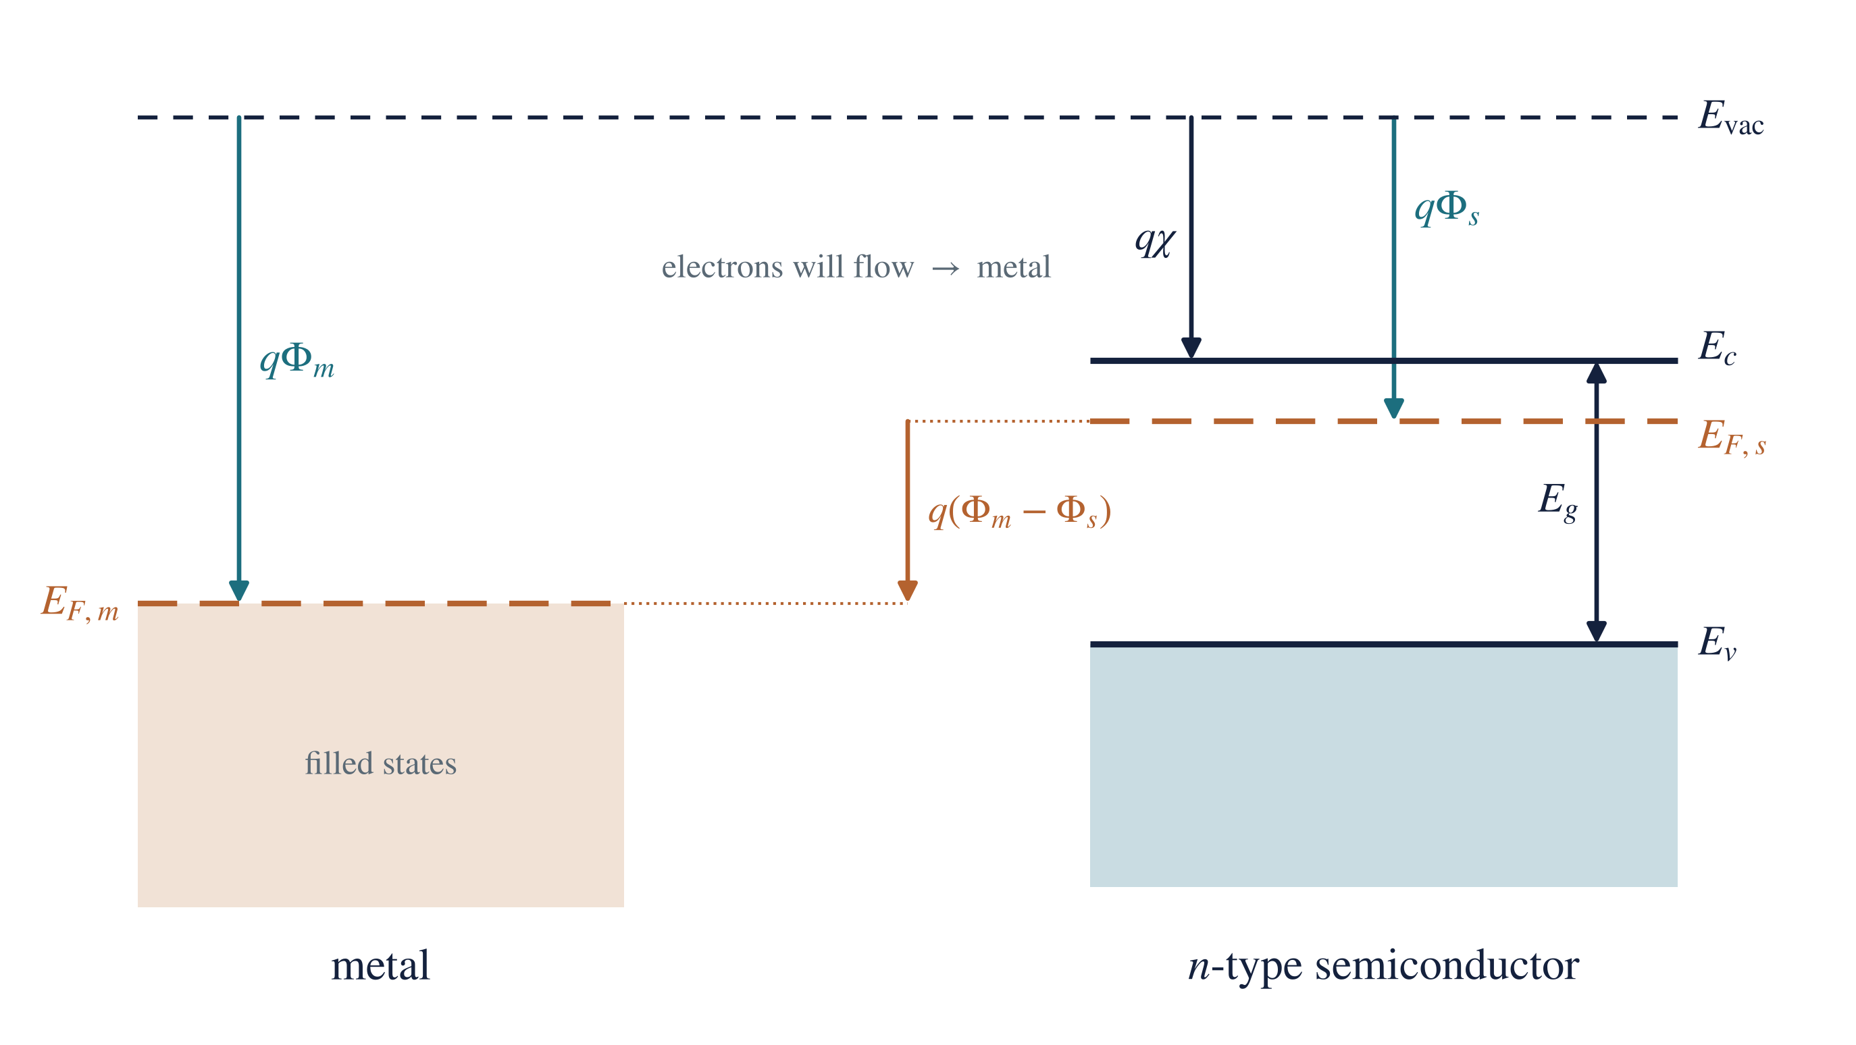
Figure 3. A metal and an n-type semiconductor before contact, measured from the common vacuum level. With $Φ_{m}>Φ_{s}$, the semiconductor’s Fermi level lies higher by $q\left(Φ_{m}−Φ_{s}\right)$.
Which contact forms depends on the two work functions (ideal case):
Semiconductor | $Φ_{m}>Φ_{s}$ | $Φ_{m}<Φ_{s}$
n-type | Schottky (rectifying): depletion, bands bend up | Ohmic: accumulation, bands bend down
p-type | Ohmic: hole accumulation | Schottky (rectifying): bands bend down, barrier to holes

4. How a Schottky barrier forms
Consider an ideal metal on n-type silicon with $Φ_{m}>Φ_{s}$, and no interface states (the Schottky–Mott model). When contact is made:
- Electrons flow from the semiconductor into the metal, because the semiconductor’s Fermi level is higher.
- Positive donor ions are left behind. Near the interface the semiconductor loses its free electrons, uncovering the fixed ionised donors $N_{D}^{+}$.
- A depletion region of width $W$ forms, holding positive charge; an equal negative charge sits as a thin sheet of extra electrons on the metal surface.
- An electric field appears between the positive ions and the negative sheet, pointing from the semiconductor towards the metal.
- The bands bend upward towards the interface, because the field raises the electron energy near the metal.
- The flow stops when the Fermi levels line up. At equilibrium there is a single, flat Fermi level: $E_{F,m}=E_{F,s}$. Electrons still cross in both directions, but the two flows are equal, so the net current is zero.
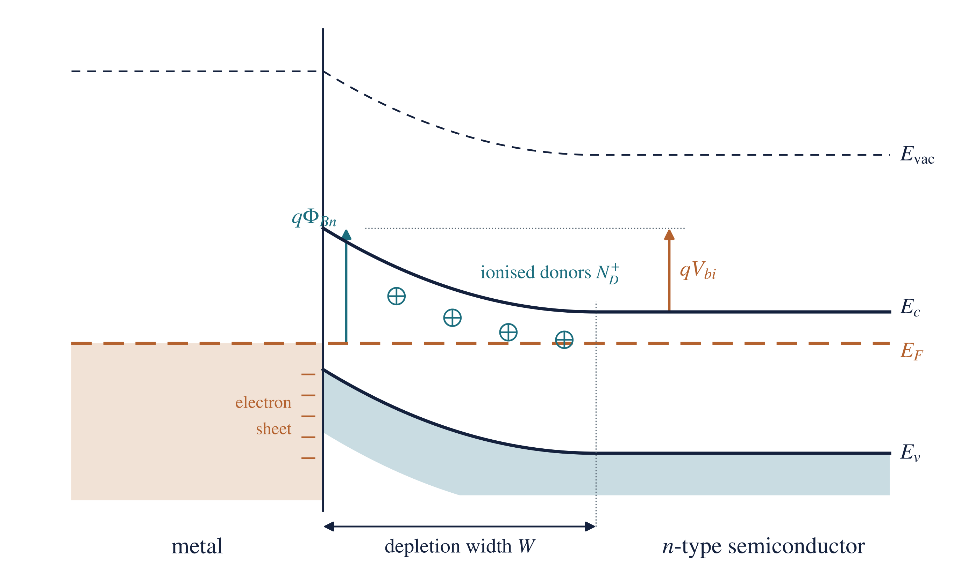
Figure 4. A Schottky contact at equilibrium. The Fermi level is flat; the semiconductor bands bend upward over the depletion width $W$. An electron in the metal faces the barrier $qΦ_{Bn}$; an electron in the semiconductor faces the smaller built-in barrier $qV_{bi}$. Ionised donors fill the depletion region and a sheet of electrons sits on the metal surface.

4.1 Barrier height and built-in potential
There are now two barriers, depending on which side the electron starts from (Figure 4).
Barrier height (seen from the metal). Because the vacuum level is continuous at the interface, the conduction-band edge at the interface sits at $qχ$ below the vacuum level, while the metal Fermi level sits at $qΦ_{m}$ below it:
$$qΦ_{Bn}=q\left(Φ_{m}−χ\right)$$
where $Φ_{Bn}$ is the Schottky barrier height for electrons (n-type), $Φ_{m}$ the metal work function and $χ$ the electron affinity. This is the Schottky–Mott rule. The barrier height is set by the interface and does not change with applied bias.
Built-in potential (seen from the semiconductor). The total band bending equals the original difference in Fermi levels:
$$qV_{bi}=q\left(Φ_{m}−Φ_{s}\right)=qΦ_{Bn}−\left(E_{c}−E_{F}\right)$$
p-type semiconductor. A rectifying contact needs $Φ_{m}<Φ_{s}$, and the barrier is for holes:
$$qΦ_{Bp}=E_{g}−q\left(Φ_{m}−χ\right)$$
so that, for the same metal, $qΦ_{Bn}+qΦ_{Bp}=E_{g}$.

4.2 The depletion region
With the depletion approximation (no free carriers inside $0<x<W$, uniform doping), the charge density is $ρ=qN_{D}$ in the depletion region. Integrating Poisson’s equation once gives a field that is largest at the interface and falls linearly to zero at $x=W$; integrating again gives the parabolic band bending (Figure 5). The results are
$$W=\sqrt{\frac{2ε_{s}\left(V_{bi}−V\right)}{qN_{D}}}, E_{max}=\frac{qN_{D}W}{ε_{s}}$$
where $W$ is the depletion width (m), $ε_{s}=11.7ε_{0}=1.04×{10}^{−10} F m^{−1}$ the permittivity of silicon, $V$ the applied voltage (positive for forward bias), $N_{D}$ the donor concentration ($m^{−3}$) and $E_{max}$ the peak electric field at the interface ($V m^{−1}$). The depletion region acts like a parallel-plate capacitor of capacitance per unit area $C=ε_{s}/W$, which is the basis of C–V measurement (Week 12).
Two consequences matter later: $W∝{\left(V_{bi}−V\right)}^{1/2}$, so reverse bias widens the region; and $W∝1/\sqrt{N_{D}}$, so heavy doping makes it very thin.
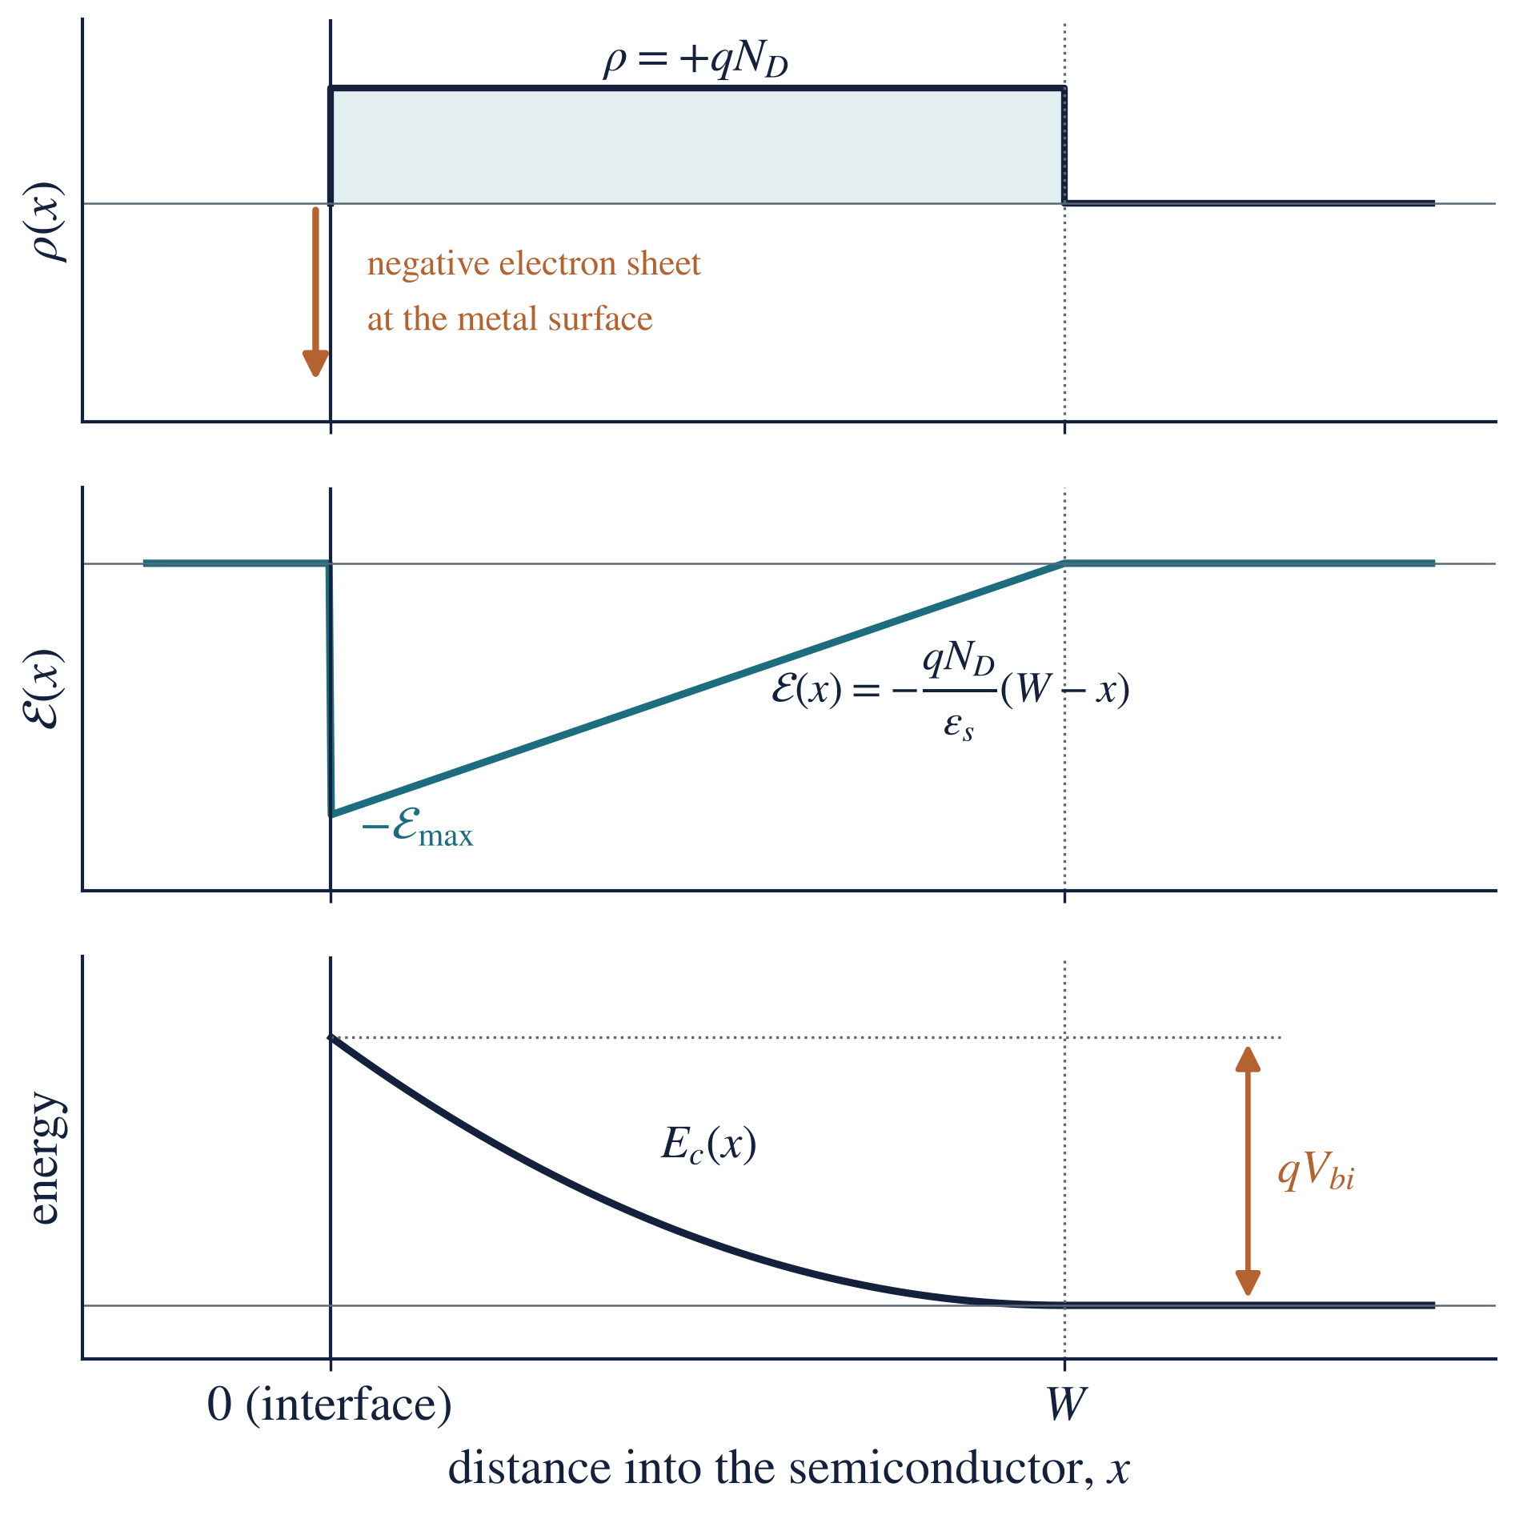
Figure 5. The depletion region of a Schottky contact: charge density (positive donors, with the balancing electron sheet in the metal), electric field (largest at the interface) and conduction-band edge (bent up by $qV_{bi}$).

4.3 Real interfaces: Fermi-level pinning and image-force lowering
Fermi-level pinning. Measured barrier heights depend much less on the metal than the Schottky–Mott rule predicts (Figure 6). The reason is interface states: dangling bonds and defects at the surface create electron states in the band gap. They hold, or “pin”, the Fermi level near a fixed energy at the surface, whatever metal is used. On n-Si most barriers lie between 0.5 and 0.9 eV; on n-GaAs almost every metal gives about 0.8 eV. In calculations, use a measured barrier height when one is given.
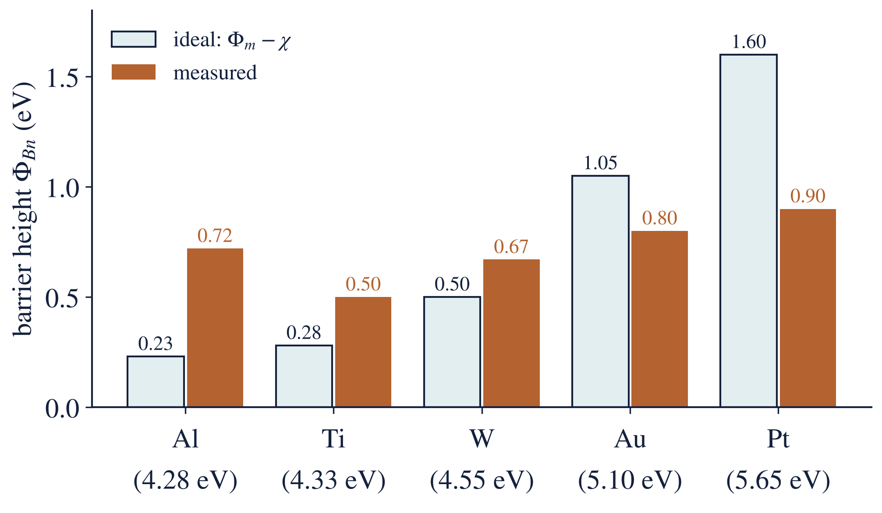
Figure 6. Ideal ($Φ_{m}−χ$) and typical measured barrier heights for metals on n-type silicon. The measured values vary much less than the ideal ones: the Fermi level is pinned by interface states. Measured values are typical literature values (Sze and Ng).
Image-force lowering. An electron near the metal is attracted by the positive “image” charge it induces in the metal. This rounds off the top of the barrier and lowers it slightly by
$$ΔΦ=\sqrt{\frac{q E_{max}}{4πε_{s}}}$$
For the gold contact of Example 2 below ($E_{max}=5.1×{10}^{6} V m^{−1}$), $ΔΦ≈0.025 V$: small, but it grows with reverse bias and is one reason the reverse current of a Schottky diode does not fully saturate.

5. Energy band diagrams under applied bias
When a voltage is applied, the two sides are no longer in equilibrium, so there is no single flat Fermi level: the semiconductor’s Fermi level moves by $qV$ relative to the metal’s. The key rule: the barrier seen from the metal, $qΦ_{Bn}$, stays fixed; the applied voltage appears across the depletion region and changes only the barrier seen from the semiconductor (Figure 7).
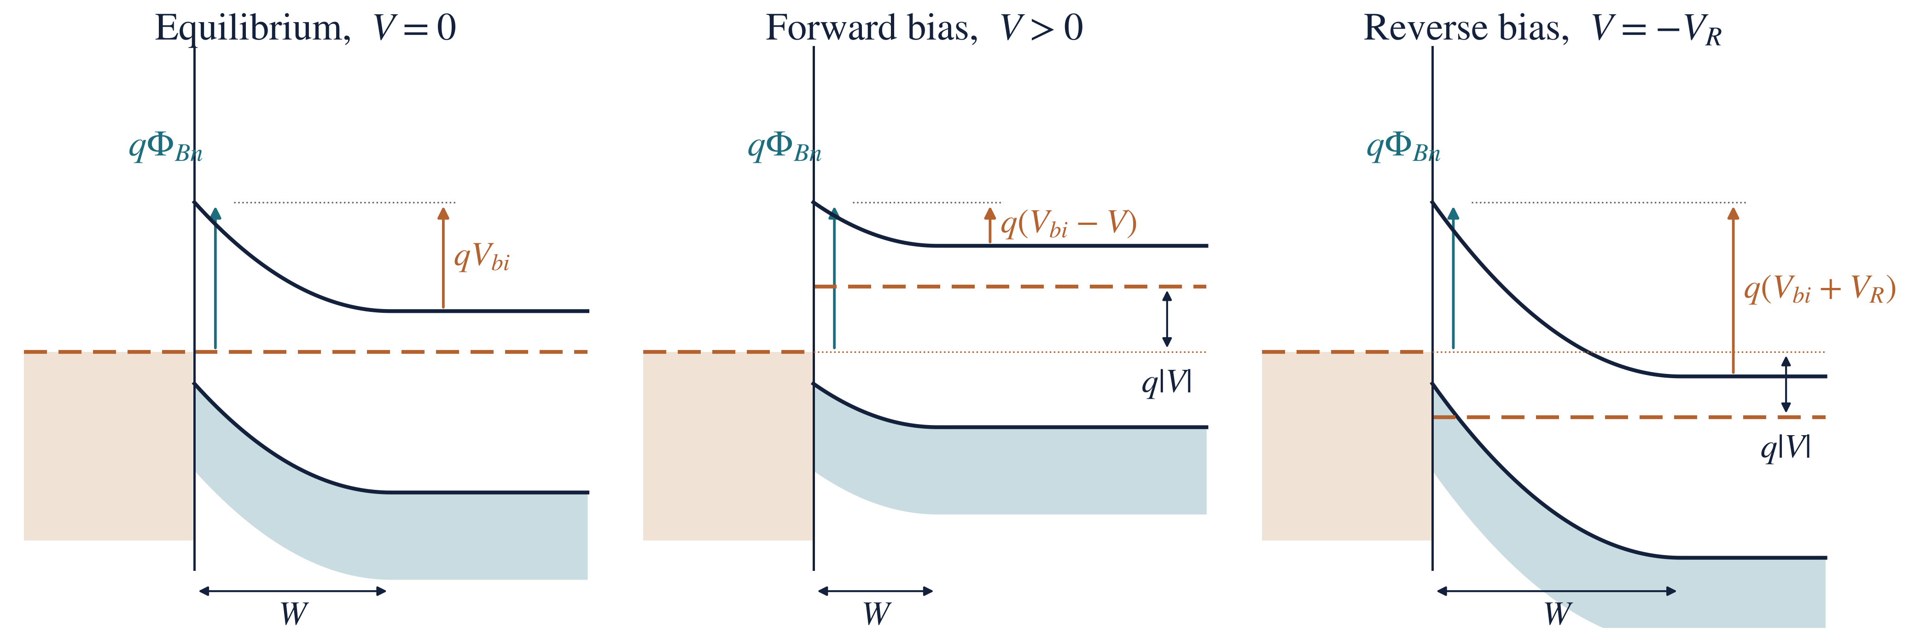
Figure 7. The Schottky contact at equilibrium, under forward bias and under reverse bias. The barrier from the metal, $qΦ_{Bn}$, does not change. Forward bias lowers the semiconductor-side barrier to $q\left(V_{bi}−V\right)$ and narrows W; reverse bias raises it to $q\left(V_{bi}+V_{R}\right)$ and widens $W$.
 | Equilibrium, $V=0$ | Forward bias, $V>0$ (metal positive) | Reverse bias, $V=−V_{R}$ (metal negative)
Fermi levels | one flat $E_{F}$ | semiconductor $E_{F}$ raised by $qV$ | semiconductor $E_{F}$ lowered by $qV_{R}$
Band bending | $qV_{bi}$ | $q\left(V_{bi}−V\right)$, smaller | $q\left(V_{bi}+V_{R}\right)$, larger
Depletion width | $W_{0}$ | narrower | wider
Electrons semiconductor → metal | balance the reverse flow | increase by $exp\left(qV/kT\right)$ | almost stopped
Electrons metal → semiconductor | small, over $qΦ_{Bn}$ | unchanged | unchanged: this is the saturation current
Net current | zero | large, rises exponentially | small, about $−I_{s}$
At large reverse voltage the field becomes strong enough for breakdown. Schottky diodes break down at lower voltages than comparable p–n diodes.

6. Current transport: thermionic emission
In a Schottky diode the current is carried by majority carriers (electrons in n-type) crossing over the barrier. Only electrons with enough thermal energy get over, so the current depends exponentially on the barrier height and on temperature:
$$J=J_{s}\left[exp\left(\frac{qV}{ηkT}\right)−1\right], J_{s}=A^{**} T^{2}exp\left(−\frac{qΦ_{Bn}}{kT}\right)$$
where
- $J$ is the current density ($A m^{−2}$); the current is $I=JA$ for a contact of area $A$, so $I=I_{s}\left[exp\left(qV/ηkT\right)−1\right]$ with $I_{s}=J_{s}A$;
- $J_{s}$ is the saturation current density ($A m^{−2}$);
- $V$ is the applied voltage, positive for forward bias (V);
- $η$ is the ideality factor: 1 for ideal thermionic emission, 1.0–1.1 for a good diode (some books write it as $n$);
- $k=1.381×{10}^{−23} J K^{−1}$ is the Boltzmann constant ($kT/q=0.0259 V$ at 300 K) and $T$ the absolute temperature (K);
- $A^{**}$ is the effective Richardson constant, about $1.1×{10}^{6} A m^{−2} K^{−2}$ for n-type Si.
The I–V curve has the same shape as a p–n diode’s, but $J_{s}$ is typically ${10}^{3}$–${10}^{8}$ times larger, so the Schottky diode turns on at a lower voltage (about 0.2–0.4 V on Si, against 0.6–0.7 V) and has a larger reverse leakage current (Figure 8). Other transport routes add to thermionic emission in real diodes: tunnelling through the top of the barrier at heavy doping (thermionic-field emission), recombination in the depletion region, and the voltage drop across the series resistance.
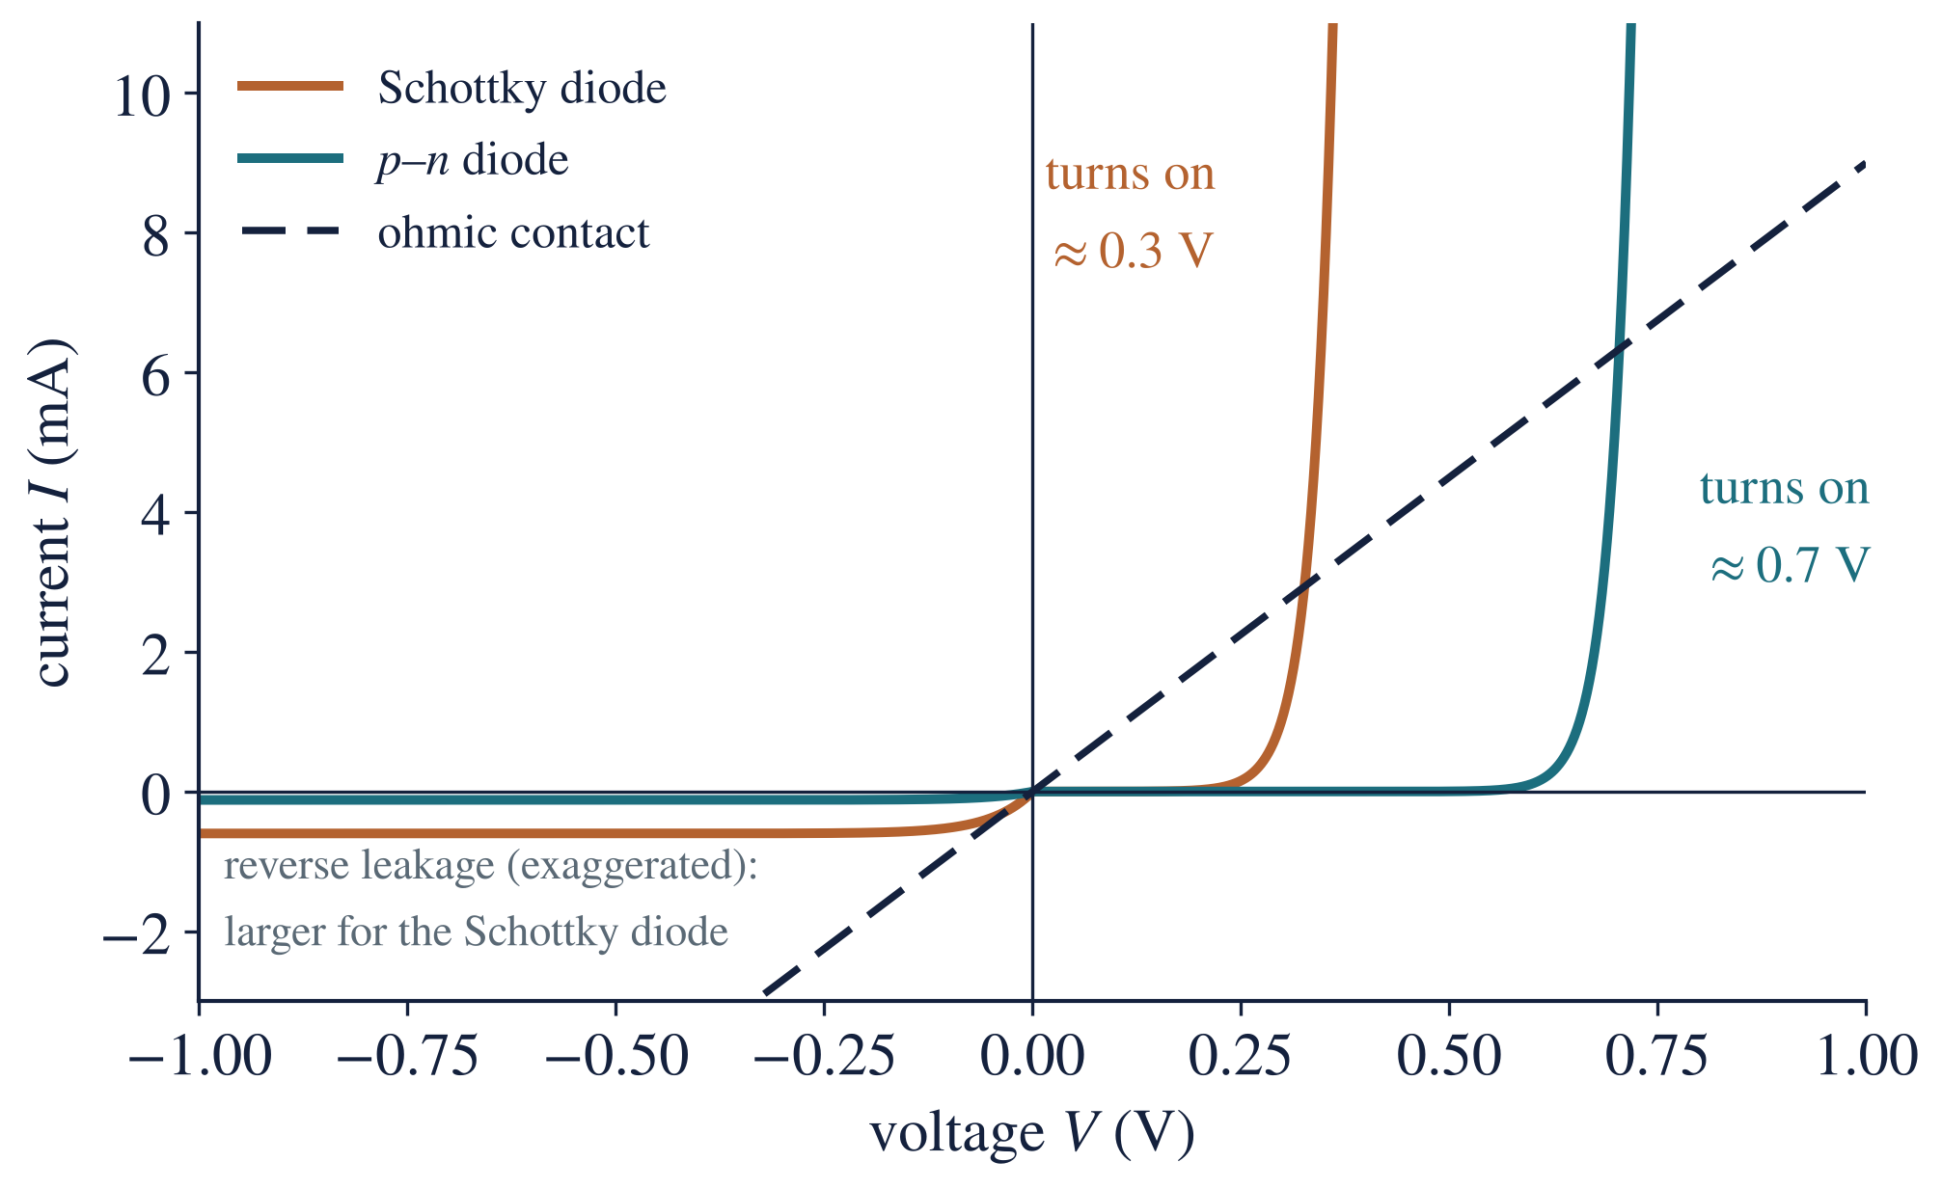
Figure 8. Current–voltage curves of a Schottky diode, a silicon p–n diode and an ohmic contact. The Schottky diode turns on at a lower voltage but leaks more in reverse (reverse currents exaggerated for visibility).

6.1 Schottky diode versus p–n diode
 | Schottky diode | p–n junction diode
Current carried by | majority carriers only | minority carriers injected and diffusing
Transport mechanism | thermionic emission over the barrier | diffusion
Stored minority charge | practically none | yes, $Q≈Iτ$
Switching speed | very fast, no reverse-recovery delay | slower (recovery time about $τ$)
Turn-on voltage (Si) | 0.2–0.4 V | 0.6–0.7 V
Reverse leakage | higher | lower
Breakdown voltage | lower | higher
Applications of Schottky contacts: fast, low-loss rectifiers in switching power supplies; RF and microwave detectors and mixers; clamping diodes that stop transistors saturating (Schottky TTL); gates of MESFETs and HEMTs; photodetectors and some solar-cell structures.

7. Ohmic contacts
An ohmic contact lets current flow equally easily in both directions, with a linear I–V characteristic and a resistance negligible compared with the device:
$$V=IR_{c}, R_{c}=\frac{ρ_{c}}{A}$$
where $V$ is the voltage across the contact (V), $I$ the current (A), $R_{c}$ the contact resistance (Ω), $A$ the contact area ($m^{2}$), and $ρ_{c}$ the specific contact resistance ($Ω m^{2}$), which allows contacts of different sizes to be compared. Good contacts reach $ρ_{c}≈{10}^{−10}$–${10}^{−12} Ω m^{2}$.
An ohmic contact is not necessarily a contact with no barrier. It may have a barrier that is so low, or so thin, that it does not restrict the current. There are three ways to make one (Figure 9).
Method 1: a low work-function metal (accumulation). For n-type, choose $Φ_{m}<Φ_{s}$ (for p-type, $Φ_{m}>Φ_{s}$). On contact, electrons flow from the metal into the semiconductor and pile up in an accumulation layer; the bands bend downward and there is no barrier to electrons in either direction. In practice, Fermi-level pinning makes suitable metals rare for Si and GaAs, so this method alone is unreliable.
Method 2: heavy doping, so that electrons tunnel (the practical method). Dope the semiconductor very heavily just under the contact ($n^{+}$ or $p^{+}$, above about ${10}^{25} m^{−3}$). The barrier height does not change, but since
$$W∝\frac{1}{\sqrt{N_{D}}}$$
the barrier becomes only a few nanometres thick. Electrons then tunnel straight through it in both directions (field emission). The specific contact resistance falls steeply, roughly exponentially, as the doping rises.
Method 3: contact engineering. Clean the surface (remove the native oxide), deposit the metal and anneal it so that it reacts with the semiconductor to form a stable compound with a low barrier: a silicide ($TiSi_{2}$, $CoSi_{2}$, NiSi) on silicon, or an alloyed Au–Ge–Ni contact on n-GaAs. This is combined with Method 2 in practice.
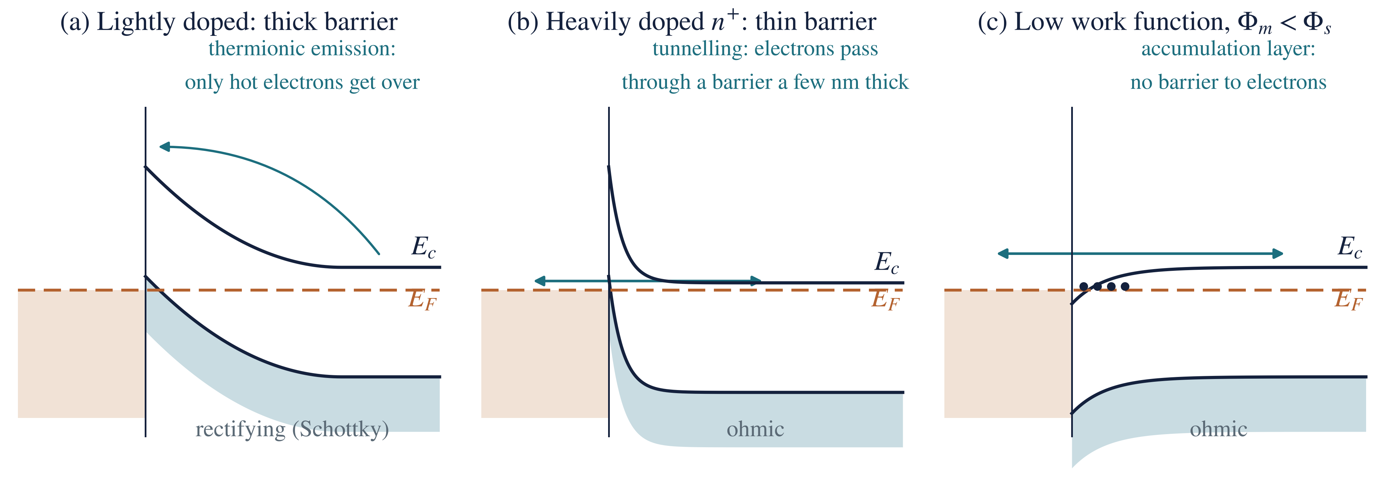
Figure 9. (a) A lightly doped contact has a thick barrier that electrons can only cross by thermionic emission: rectifying. (b) A heavily doped $n^{+}$ contact has a barrier so thin that electrons tunnel through it: ohmic. (c) A low work-function metal ($Φ_{m}<Φ_{s}$) gives downward bending and an accumulation layer with no barrier: ohmic.
 | Thermionic emission | Tunnelling (field emission)
How the electron crosses | over the top of the barrier | through the barrier
Needs | enough thermal energy | a thin barrier (a few nm)
Doping under the contact | light to moderate ($≤{10}^{23} m^{−3}$) | heavy ($≥{10}^{25} m^{−3}$)
Temperature dependence | strong, $∝T^{2}exp\left(−qΦ_{Bn}/kT\right)$ | weak
Gives | Schottky (rectifying) contact | ohmic contact
Applications of ohmic contacts: source, drain and gate connections of MOSFETs; emitter, base and collector contacts of BJTs; front and back contacts of solar cells (a poor contact adds series resistance and lowers the fill factor and output power); contacts to LEDs and lasers; every connection in an integrated circuit and every test structure.
Stability of contacts. Contacts must survive hot processing and years of use. Problems include aluminium “spiking” into shallow junctions (prevented with 1 % Si in the Al or a TiN barrier), electromigration of the metal at high current density, and reactions or native oxide at the interface that change $Φ_{Bn}$ and $ρ_{c}$.

8. Schottky contact versus ohmic contact
Feature | Schottky contact | Ohmic contact
Electrical behaviour | rectifying | non-rectifying
I–V curve | exponential, asymmetric | straight line through the origin
Work-function condition (n-type) | $Φ_{m}>Φ_{s}$ | $Φ_{m}<Φ_{s}$, or any metal on $n^{+}$
Doping under the contact | moderate (${10}^{21}$–${10}^{23} m^{−3}$) | heavy ($>{10}^{25} m^{−3}$)
Band bending (n-type) | upward: depletion layer | downward (accumulation) or a very thin barrier
Barrier to majority carriers | yes: $qΦ_{Bn}$ and $qV_{bi}$ | none, or thin enough to tunnel through
Transport | thermionic emission | free flow or tunnelling
Resistance | depends on bias and polarity | small and constant
Advantages | fast switching; low forward voltage | low resistance; efficient current collection
Limitations | higher leakage; lower breakdown voltage | needs heavy doping and careful processing
Used for | rectifiers, detectors, clamps, MESFET gates | connecting every device to the circuit

9. Worked examples
All examples are for silicon at 300 K: $χ=4.05 eV$, $E_{g}=1.12 eV$, $kT=0.02585 eV$, $N_{c}=2.8×{10}^{25} m^{−3}$, $ε_{s}=1.04×{10}^{−10} F m^{−1}$, $q=1.6×{10}^{−19} C$.

Example 1: work function of doped silicon
Question. Find the work function of n-type silicon with $N_{D}=1×{10}^{22} m^{−3}$.
Given: $N_{D}=1×{10}^{22} m^{−3}$, $N_{c}=2.8×{10}^{25} m^{−3}$, $χ=4.05 eV$. Find: $Φ_{s}$.
Formula: $E_{c}−E_{F}=kTln\left(N_{c}/N_{D}\right)$, then $qΦ_{s}=qχ+\left(E_{c}−E_{F}\right)$.
Solution.
$$E_{c}−E_{F}=\left(0.02585\right)ln\left(\frac{2.8×{10}^{25}}{1×{10}^{22}}\right)=\left(0.02585\right)\left(7.94\right)=0.205 eV$$
$$Φ_{s}=4.05+0.205=4.26 eV$$
Answer: $Φ_{s}=4.26 eV$. What this means: any metal with $Φ_{m}>4.26 eV$ (gold, nickel, platinum) tends to form a Schottky barrier on this silicon.

Example 2: an ideal gold contact
Question. Gold ($Φ_{m}=5.10 eV$) is deposited on the silicon of Example 1. Using the Schottky–Mott model, find the barrier height, built-in potential, depletion width and peak field at zero bias.
Given: $Φ_{m}=5.10 eV$, $χ=4.05 eV$, $Φ_{s}=4.26 eV$, $N_{D}=1×{10}^{22} m^{−3}$, $V=0$. Find: $Φ_{Bn}$, $V_{bi}$, $W$, $E_{max}$.
Formulas: $qΦ_{Bn}=q\left(Φ_{m}−χ\right)$; $qV_{bi}=q\left(Φ_{m}−Φ_{s}\right)$; $W=\sqrt{2ε_{s}V_{bi}/qN_{D}}$; $E_{max}=qN_{D}W/ε_{s}$.
Solution.
$$Φ_{Bn}=5.10−4.05=1.05 eV, V_{bi}=5.10−4.26=0.84 V$$
$$W=\sqrt{\frac{2 \left(1.04×{10}^{−10}\right) \left(0.84\right)}{\left(1.6×{10}^{−19}\right) \left(1×{10}^{22}\right)}}=3.3×{10}^{−7} m$$
$$E_{max}=\frac{\left(1.6×{10}^{−19}\right)\left(1×{10}^{22}\right)\left(3.3×{10}^{−7}\right)}{1.04×{10}^{−10}}=5.1×{10}^{6} V m^{−1}$$
Answer: $Φ_{Bn}=1.05 eV$, $V_{bi}=0.84 V$, $W=3.3×{10}^{−7} m$ (0.33 μm), $E_{max}=5.1×{10}^{6} V m^{−1}$. What this means: the barrier is 0.33 μm thick, far too thick to tunnel through, so the contact rectifies. In practice Fermi-level pinning gives a measured $Φ_{Bn}≈0.80 eV$ for gold on n-Si.

Example 3: barrier height from the work function
Question. A metal with $Φ_{m}=4.70 eV$ contacts n-type silicon. Find the ideal barrier height.
Formula: $qΦ_{Bn}=q\left(Φ_{m}−χ\right)$. Solution: $Φ_{Bn}=4.70−4.05=0.65 eV$.
Answer: $Φ_{Bn}=0.65 eV$. What this means: an electron in the metal needs at least 0.65 eV, about 25 times $kT$, to enter the semiconductor; only a tiny fraction have it, which is why the reverse current is small.

Example 4: forward current of a Schottky diode
Question. An ideal Schottky diode ($η=1$) has a saturation current of 2 μA. Find the current at a forward voltage of 0.20 V at 300 K.
Given: $I_{s}=2×{10}^{−6} A$, $V=0.20 V$, $kT/q=0.02585 V$. Find: $I$.
Formula: $I=I_{s}\left[exp\left(qV/ηkT\right)−1\right]$.
Solution. The exponent is $qV/kT=0.20/0.02585=7.737$, so $exp\left(7.737\right)=2291$:
$$I=\left(2×{10}^{−6}\right)\left[exp\left(\frac{0.20}{0.02585}\right)−1\right]=\left(2×{10}^{−6}\right)\left(2290\right)=4.58×{10}^{−3} A$$
Answer: $I=4.58 mA$. What this means: only 0.2 V raises the current more than two-thousand-fold above $I_{s}$; every further 0.1 V multiplies it by $exp\left(0.1/0.02585\right)≈48$.

Example 5: why heavy doping gives an ohmic contact
Question. The voltage across the depletion region under a contact on n-Si is 0.60 V. Find $W$ for $N_{D}=1×{10}^{22}$ and $1×{10}^{25} m^{−3}$.
Formula: $W=\sqrt{2ε_{s}\left(V_{bi}−V\right)/qN_{D}}$.
Solution.
$$W=\sqrt{\frac{2 \left(1.04×{10}^{−10}\right) \left(0.60\right)}{\left(1.6×{10}^{−19}\right) \left(1×{10}^{22}\right)}}=2.79×{10}^{−7} m \left(279 nm\right)$$
$$W=\sqrt{\frac{2 \left(1.04×{10}^{−10}\right) \left(0.60\right)}{\left(1.6×{10}^{−19}\right) \left(1×{10}^{25}\right)}}=8.8×{10}^{−9} m \left(8.8 nm\right)$$
Answer: 279 nm at ${10}^{22} m^{−3}$ and 8.8 nm at ${10}^{25} m^{−3}$ (a thousand times the doping, $\sqrt{1000}=31.6$ times thinner). What this means: electrons cannot tunnel through 279 nm, so the lightly doped contact rectifies; a barrier under about 10 nm thick passes a large tunnelling current, so the heavily doped contact is ohmic, even though the barrier height is unchanged.

Example 6: a contact on p-type silicon
Question. Aluminium ($Φ_{m}=4.28 eV$) is deposited on p-type silicon. Find the ideal barrier height for holes.
Formula: $qΦ_{Bp}=E_{g}−q\left(Φ_{m}−χ\right)$. Solution: $Φ_{Bp}=1.12−\left(4.28−4.05\right)=0.89 eV$.
Answer: $Φ_{Bp}=0.89 eV$: Al on p-Si is ideally a Schottky contact, while Al on n-Si ($Φ_{Bn}=0.23 eV$, ideally) would be nearly ohmic. What this means: the same metal can be rectifying on one type of silicon and ohmic on the other.

10. Examination question solved
Question 49. Differentiate between a Schottky barrier diode and an ohmic contact. Explain their energy-band characteristics.
What the examiner wants: the definition of each; band diagrams before contact, at equilibrium and under bias for the Schottky diode; the barrier formulas; the two practical ways of making an ohmic contact; the I–V behaviour; and a comparison table.
Model answer.
Both are metal–semiconductor contacts. A Schottky barrier diode is a contact with a significant barrier to majority carriers, so it rectifies. An ohmic contact has no barrier that limits the current, so it conducts equally in both directions with a linear I–V characteristic, $V=IR_{c}$. Both are explained with band diagrams using one rule: at equilibrium the Fermi level is flat. The cases below are for a metal on n-type silicon.
(a) Before contact. Energies are measured from the common vacuum level. The semiconductor work function depends on doping, $qΦ_{s}=qχ+\left(E_{c}−E_{F}\right)$. If $Φ_{m}>Φ_{s}$, the semiconductor’s Fermi level is higher, and electrons will flow into the metal on contact (Figure 3).
(b) Schottky barrier ($Φ_{m}>Φ_{s}$, moderate doping). On contact, electrons flow from the semiconductor into the metal, leaving ionised donors behind. A depletion region of width $W$ forms, the field bends the bands upward towards the interface, and the flow stops when the Fermi levels align (Figure 4). Two barriers result:
$$qΦ_{Bn}=q\left(Φ_{m}−χ\right), qV_{bi}=q\left(Φ_{m}−Φ_{s}\right), W=\sqrt{\frac{2ε_{s}\left(V_{bi}−V\right)}{qN_{D}}}$$
Under forward bias (metal positive) the semiconductor Fermi level rises by $qV$, the band bending falls to $q\left(V_{bi}−V\right)$, $W$ narrows, and electrons flow over the barrier into the metal: the current rises exponentially. Under reverse bias the bending rises to $q\left(V_{bi}+V_{R}\right)$, $W$ widens, and only the small flow over the fixed barrier $qΦ_{Bn}$ remains: the saturation current (Figure 7). Current is by thermionic emission of majority carriers:
$$J=A^{**} T^{2}exp\left(−\frac{qΦ_{Bn}}{kT}\right)\left[exp\left(\frac{qV}{ηkT}\right)−1\right]$$
There is no stored minority charge, so the diode switches very fast and turns on at a low voltage (0.2–0.4 V on Si), but it leaks more in reverse than a p–n diode. For gold on n-Si with $N_{D}={10}^{22} m^{−3}$: $Φ_{Bn}=1.05 eV$ ideally (about 0.8 eV measured, because of Fermi-level pinning), $V_{bi}=0.84 V$ and $W=0.33 μm$.
(c) Ohmic contact. There are two band-diagram routes (Figure 9):
- Accumulation ($Φ_{m}<Φ_{s}$ on n-type). Electrons flow from the metal into the semiconductor and accumulate at the surface; the bands bend downward, and there is no barrier to electrons in either direction.
- Heavy doping ($N_{D}>{10}^{25} m^{−3}$, the practical method). The barrier height is unchanged, but since $W∝1/\sqrt{N_{D}}$ the barrier becomes only a few nanometres thick (8.8 nm at ${10}^{25} m^{−3}$ for 0.6 V, against 279 nm at ${10}^{22} m^{−3}$), and electrons tunnel through it in both directions.
A good ohmic contact has a specific contact resistance $ρ_{c}≈{10}^{−10}$–${10}^{−12} Ω m^{2}$; silicides on heavily doped silicon are standard.
(d) Comparison. The table in Section 8 summarises the differences: a Schottky contact has upward band bending, a fixed barrier $qΦ_{Bn}$, thermionic emission and a rectifying exponential I–V curve; an ohmic contact has downward bending or a tunnel-thin barrier, free flow or tunnelling, and a linear, symmetric I–V curve.
Marking checklist: definitions of each; $qΦ_{s}=qχ+\left(E_{c}−E_{F}\right)$ and the work-function condition; the formation steps (electron flow, depletion, upward bending, Fermi levels align); $qΦ_{Bn}=q\left(Φ_{m}−χ\right)$ and $qV_{bi}=q\left(Φ_{m}−Φ_{s}\right)$; band diagrams before contact, at equilibrium, forward and reverse bias with $qΦ_{Bn}$ fixed; the thermionic-emission equation; the two ohmic routes (accumulation; heavy doping and tunnelling); a comparison table.
Common mistakes: saying an ohmic contact “has no barrier” (the practical $n^{+}$ contact has one, just a very thin one); drawing $Φ_{Bn}$ changing with bias (only the semiconductor-side barrier changes); reversing the conditions for p-type; confusing $Φ_{Bn}$ (from the metal Fermi level) with $V_{bi}$ (from the semiconductor conduction band); writing the band gap as $E_{v}−E_{c}$ (it is $E_{c}−E_{v}$).

11. Summary
- At equilibrium the Fermi level is flat; electrons flow from the higher Fermi level to the lower one when two materials touch.
- $qΦ_{s}=qχ+\left(E_{c}−E_{F}\right)$. A metal on n-type with $Φ_{m}>Φ_{s}$ forms a Schottky barrier; $Φ_{m}<Φ_{s}$, or heavy doping, gives an ohmic contact.
- Schottky barrier: depletion region, upward band bending, $qΦ_{Bn}=q\left(Φ_{m}−χ\right)$, $qV_{bi}=q\left(Φ_{m}−Φ_{s}\right)$, $W=\sqrt{2ε_{s}\left(V_{bi}−V\right)/qN_{D}}$. In real contacts the barrier is set largely by Fermi-level pinning.
- Under bias $qΦ_{Bn}$ stays fixed; only the semiconductor-side barrier changes, to $q\left(V_{bi}−V\right)$ or $q\left(V_{bi}+V_{R}\right)$.
- Current is thermionic emission of majority carriers: $J=A^{**}T^{2}exp\left(−qΦ_{Bn}/kT\right)\left[exp\left(qV/ηkT\right)−1\right]$. Schottky diodes are fast, turn on at a low voltage and leak more than p–n diodes.
- Ohmic contacts: accumulation (low barrier), tunnelling through a thin barrier made by heavy doping ($W∝1/\sqrt{N_{D}}$), and silicide contact engineering. An ohmic contact may still have a barrier; what matters is that it does not limit the current.

Symbols used
Symbol | Meaning | SI unit
$q$ | electronic charge, $1.6×{10}^{−19}$ | C
$k$ | Boltzmann constant, $1.381×{10}^{−23}$ | $J K^{−1}$
$T$ | absolute temperature | K
$E_{vac},E_{c},E_{v},E_{F}$ | vacuum level, conduction-band edge, valence-band edge, Fermi level | eV (J)
$E_{g}$ | band gap, $E_{c}−E_{v}$ | eV
$Φ_{m},Φ_{s}$ | work function of the metal, of the semiconductor | V ($qΦ$ in eV)
$χ$ | electron affinity | V ($qχ$ in eV)
$Φ_{Bn},Φ_{Bp}$ | Schottky barrier height for electrons, for holes | V ($qΦ_{B}$ in eV)
$V_{bi}$ | built-in potential | V
$V,V_{R}$ | applied voltage (positive forward); reverse voltage | V
$N_{D},N_{A}$ | donor, acceptor concentration | $m^{−3}$
$N_{c}$ | effective density of states in the conduction band | $m^{−3}$
$W$ | depletion width | m
$ε_{0},ε_{s}$ | permittivity of free space ($8.854×{10}^{−12}$), of the semiconductor | $F m^{−1}$
$E,E_{max}$ | electric field, its peak value | $V m^{−1}$
$ρ$ | charge density | $C m^{−3}$
$J,J_{s}$ | current density, saturation current density | $A m^{−2}$
$I,I_{s}$ | current, saturation current | A
$A^{**}$ | effective Richardson constant | $A m^{−2} K^{−2}$
$η$ | ideality factor | —
$A$ | contact area | $m^{2}$
$R_{c},ρ_{c}$ | contact resistance; specific contact resistance | Ω; $Ω m^{2}$
$ΔΦ$ | image-force barrier lowering | V

References
- S. M. Sze and K. K. Ng, Physics of Semiconductor Devices, 3rd edition, Wiley, 2007, chapter 3.
- B. G. Streetman and S. K. Banerjee, Solid State Electronic Devices, 7th edition, Pearson, 2015, section 5.7.
- D. A. Neamen, Semiconductor Physics and Devices: Basic Principles, 4th edition, McGraw-Hill, 2012, chapter 9.
- E. H. Rhoderick and R. H. Williams, Metal–Semiconductor Contacts, 2nd edition, Oxford University Press, 1988.

