NIGERIAN DEFENCE ACADEMY
DEPARTMENT OF ELECTRICAL/ELECTRONICS ENGINEERING
ELE 712 TUTORIAL QUESTIONS
1 (a) Write short notes on any three (3) elementary signals
(b) State using necessary equations the relationship between unit step, unit ramp and unit parabolic functions
2. (a) For the signal shown in fig 1 find $x(2t+3)$
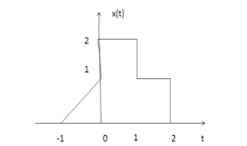
Fig 1
(b) Given that the even signal x(n) = x(-n) and the odd signal x(-n) = - x(n), derive the expression for even and odd parts of a signal, hence find the odd and even parts of the signal. $x\left(n\right)=\left(2, 2, 3,6,5\right)$
3 Express the following sequence as a sum of step functions, i.e., in the form
$$s\left[n\right]=\sum_{k_{2}-∞}^{∞}{a_{k}u[n-k]}$$
Fig 2
4 Determine whether the following signals are periodic or non periodic
(a) $sin\frac{2π}{3}t$ (b) $e^{jwt}$
5 In an LC circuit, the maximum current is 2A. if L = 1mH and C = 10 $μF$. What is the maximum charge on the capacitor during oscillation.
6 Find i(t) in fig 3 for t > 0 assuming the switch has been closed for a long time.
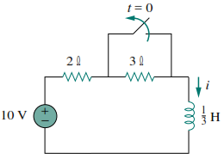
Fig 3
7 Find Vc, Vx and I₀ for $≥0$ in fig 4, given Vc (0) = 20v
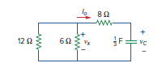
Fig 4
8 Give the general expression for Laplace transform and Fourier transform
9 Mention three (3) properties of Laplace and Fourier transform
10 Find the Laplace transform of, (a) f(t) = $\cos{2t}$ + $e^{2t}t≥0$
11 Show that the Laplace transforms of $\cos{wt }$u(t) = $\frac{s}{s^{2}+w^{2}}$
12 Obtain the Fourier transform of $\frac{10jw+4}{jw^{2}+6jw+8}$

