Virtualization and File Management in Windows
MATHEEN R. TABID
December 19, 2025

QUIMSON, KYLE F.
BANCAIRIN, AL-JHAY

By:

In Partial Fulfillment of the
Requirements for the Degree of
BACHELOR OF SCIENCE IN COMPUTER SCIENCE
Introduction

Background of the Study
Windows has become the main everyday operating system for many types of users, including students, office workers, gamers, and people learning cybersecurity. On the same Windows computer, it is common to store personal documents, school files, work requirements, game installs, mods, and downloads from many websites. This setup creates a real problem: safe and unsafe activities often happen in the same place. When users run unknown installers, open suspicious attachments, or test powerful tools directly on the main system, the risk is no longer only about the program itself. The risk becomes about what that program can reach, such as saved passwords, private files, and important folders. Because of this, modern Windows use needs a practical way to separate risky tasks from personal and valuable data.
Virtualization answers that need by allowing Windows to run another operating system inside an isolated environment. Hyper-V is Microsoft’s platform that provides a foundation for running virtual machines, which means users can create a separate system for testing, learning, and controlled experiments without replacing their main Windows installation (Microsoft). Windows also provides Windows Sandbox, which is a lightweight isolated desktop designed for safely running applications, testing, and exploring unknown files, while keeping what happens inside the sandbox isolated from the host through hypervisor-based virtualization (Microsoft). In addition, many users choose third-party virtualization tools like Oracle VM VirtualBox, which is described as a cross-platform virtualization application that lets a computer run multiple operating systems inside multiple virtual machines at the same time (Oracle, n.d.). These tools make it realistic for learners and security-focused users to run specialized systems such as Kali Linux, and Kali’s own documentation explains that using Kali inside VirtualBox keeps it separate from the host, supports network interaction for labs, and allows users to revert to snapshots when mistakes happen (Kali Linux Documentation, n.d.). In real life, this matters because users do not learn, test, and explore safely by being perfect. They learn safely by having a controlled environment that can be reset.
Virtualization is strongly connected to Windows file management because a virtual machine is not only an “environment,” it is also a collection of files stored on the Windows drive. For example, virtual hard disks such as VHD or VHDX are disk image files designed primarily for Hyper-V virtual machines, and they behave like real disks when attached in Windows (Microsoft). This means the security of virtualization depends on how well Windows protects and organizes those VM files. If VM folders are placed in messy locations, shared without thinking, or stored in areas where other accounts can access them, then the VM’s isolation becomes weaker in practice. Windows file management also controls access through permissions. Windows access control is the process of authorizing users and groups to access objects on a computer, and an access control list (ACL) is a structured list that defines which users or groups are allowed or denied specific access rights to an object like a file or folder (Microsoft).This directly affects virtualization workflows because users often move files between the host and the VM, such as tools, installers, lab data, and reports. If users handle file transfers carelessly, they can bring risky files from the VM into the host or expose personal host folders to untrusted programs running inside the VM. Therefore, studying Windows virtualization together with Windows file management is important because safe use is not only about running another operating system. It is also about controlling how files are stored, who can access them, and how data moves between isolated spaces and the main Windows system.
Purpose of the Research
This study aims to explain how virtualization on Windows helps people run and test another operating system safely, such as Kali Linux, without risking their main Windows files. It also aims to show that virtualization is closely tied to Windows file management because virtual machines are stored as files on the Windows drive, and Windows controls who can access those files using permissions (Microsoft, 2023). This matters for cybersecurity learners, gamers, and normal users because virtualization can reduce damage from unsafe downloads, while good file management helps protect documents, game saves, and VM files from being accidentally changed, copied, or exposed (NIST, 2011).
Scope and Delimitations
This study focuses on Windows 10 and Windows 11 computers and how users use virtualization to run other systems like Kali Linux using Hyper-V, Windows Sandbox, and Oracle VM or Virtual Box. It also focuses on how virtualization connects to Windows file management, because a virtual machine is stored as Windows files such as VHD or VHDX, and these files must be organized and protected like any other important data. The study also covers basic Windows permissions through access control lists, since permissions help control who can open, copy, or change VM files and important folders.
This study is limited to desktop or laptop use for learning, safe testing, and daily file handling, and it does not cover cloud virtualization, large server setups, or advanced enterprise-only features. It also does not teach illegal hacking, and Kali Linux is only discussed for legal practice, labs, and defensive learning.

Research Questions:
- What is virtualization, and what is a virtual machine in Windows use?
- How do Hyper-V, Virtual Box, and VMware help users run another operating system on Windows?
- Why do many users run Kali Linux in a virtual machine instead of installing it directly?
- How does virtualization help reduce risk when testing unknown files or tools compared to using the main Windows system?
- How are virtual machines stored as files in Windows, and why does storage location matter?
- How do Windows file permissions help protect VM files and important personal folders from unwanted access?
- How can file sharing between the host and the virtual machine improve work, and how can it create risks?
- What simple file management habits help users keep VM files, downloads, and personal files organized and safer?

Review Related Literature
Early research explains why virtualization can work in a stable and predictable way. According to Popek and Goldberg (1974), a virtual machine is an efficient and isolated duplicate of the real machine, and a virtual machine monitor should provide efficiency, resource control, and equivalence. They also explain a key requirement for virtualization to be possible: the machine must be able to safely trap and control sensitive actions so the monitor can keep control and protect resources. This classic idea is important because it shows that “isolation” is not magic. It is a design goal that depends on rules, control, and correct handling of privileged actions.
Modern guidance builds on these ideas but focuses more on real-world use and real-world risks. Scarfone, Souppaya, and Hoffman (2011) explain that full virtualization is widely used for server and desktop work because it supports efficiency, testing, and recovery. However, they also warn that virtualization adds extra layers, and those layers can increase the security workload. They further explain that features that make it easy to share information between systems can become an attack path if they are not controlled carefully, and dynamic virtual environments can make security boundaries harder to maintain. This creates a clear contrast: virtualization supports isolation, but careless sharing and weak control can weaken that same isolation.
Windows provides built-in options that make virtualization practical for everyday users. According to Microsoft (2025), Hyper-V is built into Windows and Windows Server and can create and run virtual machines with strong workload isolation, supporting Windows and Linux guest systems. Microsoft (2025) also explains that Windows Sandbox is a lightweight, isolated desktop used for testing apps and exploring unknown files, and it stays isolated from the host using hypervisor-based virtualization. For Linux workflows, Microsoft (2025) explains that WSL 2 uses virtualization to run a real Linux kernel inside a lightweight utility virtual machine, allowing Linux tools while still working alongside Windows. These tools show that Windows supports different levels of “virtual environments,” from full virtual machines to lightweight isolation.
Third-party virtualization tools are also widely used on Windows because they support multi-OS work and flexible lab setups. According to Oracle (2023), VirtualBox is a cross-platform virtualization application that can run multiple operating systems inside multiple virtual machines at the same time. For ethical hacking and cybersecurity training, Kali Linux documentation explains that running Kali inside VirtualBox keeps it separate from the host, supports working with other machines in a lab, and allows snapshots so users can revert after mistakes. This is especially useful for students and beginners who need a safe space to practice tools without damaging their main system.
At the same time, security-focused sources show that some convenience features should be limited when security matters. For example, Broadcom’s VMware vSphere security guidance notes that in high-security environments, host–guest file transfer functions like HGFS can be disabled to reduce the risk that attackers use shared-folder style features to move files through the guest OS. This supports the argument made by NIST: file sharing is useful, but it can also create a direct path between systems if not controlled.

Relevant concepts or theories
A key concept in the literature is isolation. Virtualization creates separation between the host system (Windows) and the guest system (the VM). This is the core reason virtualization is used for testing and security labs.
Another concept is security boundaries. NIST explains that virtual environments add layers and moving parts, so boundaries must be planned and protected across the hypervisor, host OS, guest OS, applications, and storage.
A third concept is host–guest data movement, especially file sharing. NIST notes that some hosted virtualization designs include tools that support sharing files with the host OS, which can be useful but also risky if not controlled.
Industry security guidance for VMware also points out that in high-security settings, host–guest file sharing functions may be disabled to reduce risk of file transfer abuse.
Even general best-practice summaries warn that shared folders expose host files to programs inside the VM, which can increase risk if the VM is untrusted.
A final concept that connects directly to this study is Windows file management and access control. VM storage is still storage on Windows. Microsoft explains that VHD and VHDX are disk image file formats designed primarily for Hyper-V virtual machines.
This means the VM’s “disk” is actually a file that can be copied, moved, deleted, or attacked if it is not protected. On top of that, Windows controls file access using security rules. Microsoft explains that an access control list (ACL) is a list of entries that define what access is allowed or denied for users and groups, and Windows checks these rules when something tries to access a file or folder. Microsoft also notes that NTFS supports security descriptors and other features that improve security and data management, which matters for protecting both personal folders and VM storage folders.
Overall, the related literature agrees that virtualization is valuable because it provides a separate space for testing, learning, and running other operating systems. According to Microsoft (2025), Windows Sandbox is designed for safely running apps and exploring unknown files in an isolated desktop. Microsoft (2025) explains that Hyper-V supports running Windows and Linux virtual machines with strong isolation. Oracle explains that VirtualBox enables running multiple operating systems inside multiple VMs, and Kali Linux documentation supports using Kali in a VM with snapshots for easy recovery during lab testing.
However, there is still a gap in simple, user-focused research that clearly connects virtualization safety to everyday Windows file management habits. Many sources explain features and benefits, but they do not clearly translate them into simple workflows for students, gamers, and beginners who regularly move files between Windows and a VM. At the same time, NIST warns that convenience features like sharing information between systems can become attack paths, and that added layers can make security boundaries harder to maintain. In security-focused settings, guidance even recommends disabling some host–guest file transfer functions to reduce risk.

Because of this gap, the present study can focus on how Windows file management choices affect virtualization safety in practice, especially how VM storage files (VHD/VHDX), folder organization, NTFS protections, and ACL permissions influence whether a VM stays “separate” or becomes an easy bridge into the host system.

Methodology
Research Design
This study uses a descriptive cross-sectional survey. It describes what respondents know and do about virtualization and Windows file handling. The survey is answered only once by each respondent, so the data shows a “snapshot” of their current awareness and habits.
Respondents and Sampling
The respondents are 10 to 20 college students who use Windows. They may use Windows for school work, gaming, downloading files, or basic computer tasks. Respondents are chosen through convenience sampling, which means the survey is given to students who are easy to reach and willing to answer.
Research Instrument
The study uses a survey questionnaire with short and clear items. It has four parts:
- Profile (year level, Windows version, device type, main use)
- Virtualization awareness and usage (Hyper-V, VirtualBox, VMware, Windows Sandbox, WSL 2)
- Kali Linux experience (if they used it in a VM and why)
- Windows file management habits (VM storage location, permissions, file sharing, folder organization)
Some questions use a 5-point Likert scale (Strongly Agree to Strongly Disagree) to measure opinions about safety and file sharing risk.

Data Collection Procedure
The researcher will personally ask the questions using a printed questionnaire. Respondents will answer the survey in one sitting. The researcher will collect all responses within the same time period to keep the study cross-sectional.
Data Analysis
Responses will be summarized using frequency and percentage (example: how many used Virtual Box, how many store VM files on C: drive). Likert-scale items will be summarized using counts and simple averages to show the common opinion of the group.

Ethical Considerations
Participation is voluntary. Respondents are informed that the study is for academic purposes only. Names are not required. Results are reported only in group form.
Results and Findings
This section presents the survey results from 10 to 20 Windows-using college students about virtualization and Windows file management. The findings are organized according to the eight research questions and are reported using frequency and percentage (and simple Likert response counts where applicable). The goal of this section is to show what the data says in a clear and direct way, using tables where needed, while deeper explanation and meaning will be discussed in the next section.

A. Respondents and Profiles
Dataset: n = 15 respondents
- Windows 11: 9 (60%)
- Windows 10: 6 (40%)
- Laptop users: 12 (80%)
- Desktop users: 3 (20%)
- Main use: School 6 (40%), Gaming 4 (26.7%), Both 5 (33.3%)
Finding: Most respondents used Windows 11 and most used laptops, which suggests virtualization and file habits are mostly based on typical student laptop use.

B. Findings per Research Question

Q1. What is virtualization, and what is a virtual machine in Windows use?
(n = 15):
- Aware of “virtualization”: 10 (40%)
- Aware of “virtual machine (VM)”: 11 (60%)
Finding: Most respondents had heard of virtualization and virtual machines, but a noticeable minority were not familiar, showing that awareness is not universal.
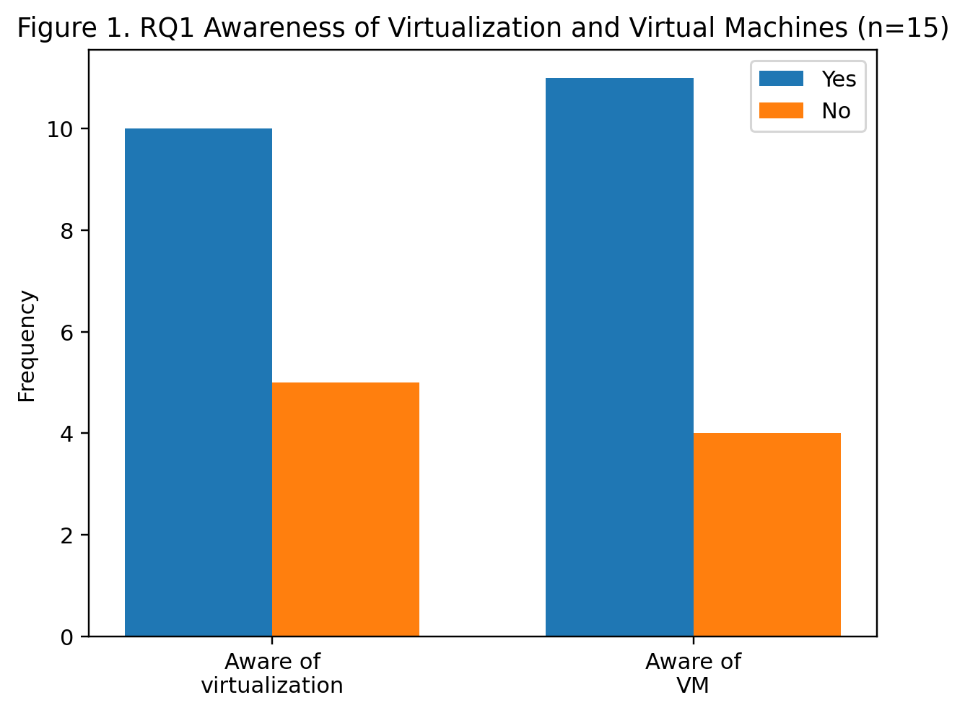
Figure 1. Windows Version shows that most respondents use Windows 11 (60%), while 40% use Windows 10. This suggests the group mostly uses a newer Windows version, so their virtualization and file-handling habits likely reflect newer Windows setups.

Q2. How do Hyper-V, VirtualBox, and VMware help users run another OS on Windows?
- VirtualBox: 8 (53.3%)
- VMware: 3 (20.0%)
- Hyper-V: 2 (13.3%)
- Windows Sandbox: 5 (33.3%)
- WSL 2: 4 (26.7%)
- None: 4 (26.7%)
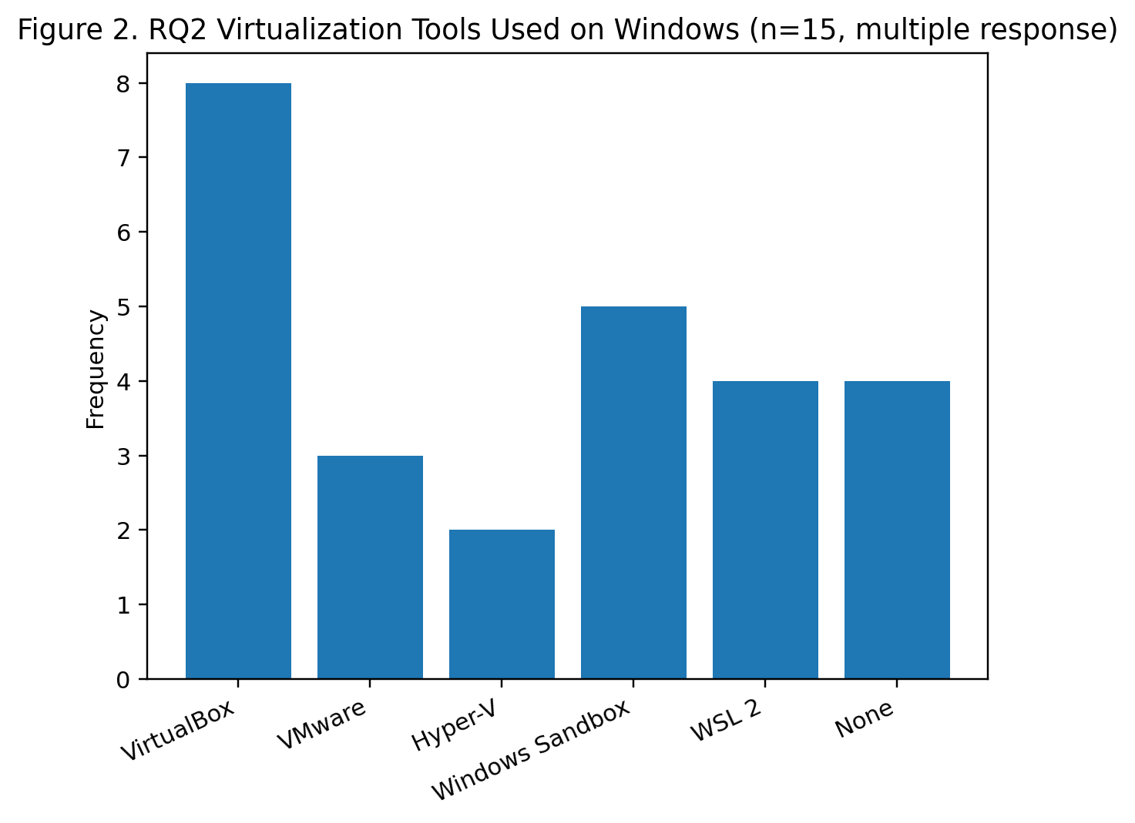Finding: VirtualBox was the most used tool. This suggests that most respondents who try virtualization prefer tools that are common in school labs and beginner-friendly.

Figure 2 shows that VirtualBox is the most used tool (8, 53.3%), followed by Windows Sandbox (5, 33.3%) and WSL 2 (4, 26.7%). Fewer respondents used VMware (3, 20.0%) and Hyper-V (2, 13.3%), while 4 respondents (26.7%) reported using none. This suggests VirtualBox is the most common choice among students.

Q3. Why do many users run Kali Linux in a VM instead of installing it directly?
- Used Kali Linux before: 6 (40.0%)
- Ran Kali inside a VM: 5 (33.3%)
If ran Kali in VM (n = 5), main reason:
- Safer because it is separated from Windows: 2 (40%)
- School requirement: 2 (40%)
- Easier to reset: 1 (20%)
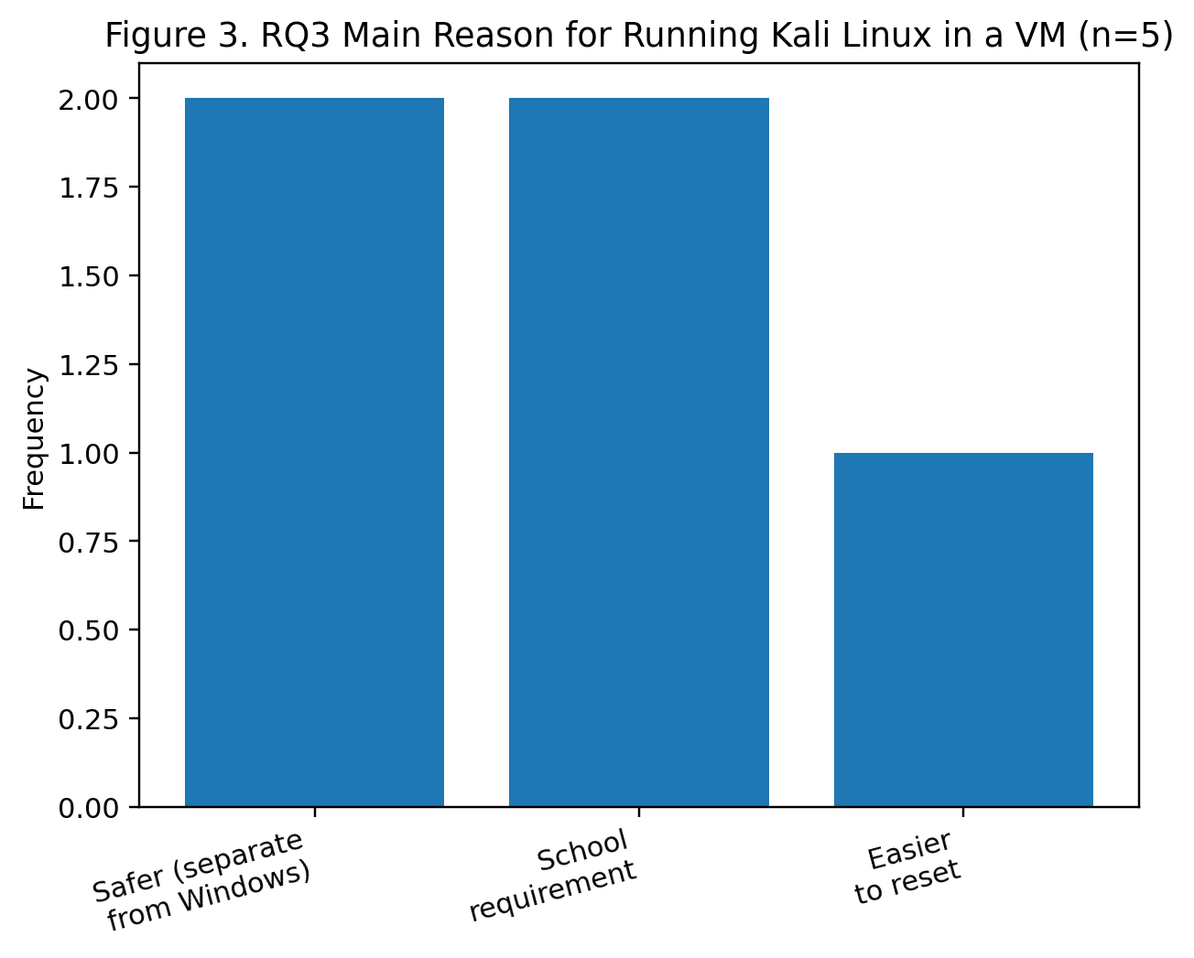Finding: Students mostly use Kali in a VM for safety and school activities, showing that virtualization is linked to controlled learning and reduced risk.

Figure 3 shows that among those who ran Kali in a VM (n = 5), the main reasons were safety (2, 40%) and school requirement (2, 40%), while 1 (20%) chose it because it is easier to reset. This shows students use Kali in a VM mainly for safe practice and academic tasks.

RQ4. How does virtualization reduce risk when testing unknown files or tools?
- Strongly Agree: 6 (40.0%)
- Agree: 7 (46.7%)
- Neutral: 2 (13.3%)
- Disagree: 0
- Strongly Disagree: 0
Finding: Almost all respondents agreed that virtualization is safer than testing directly on the main system, which supports virtualization as a risk-reduction practice.
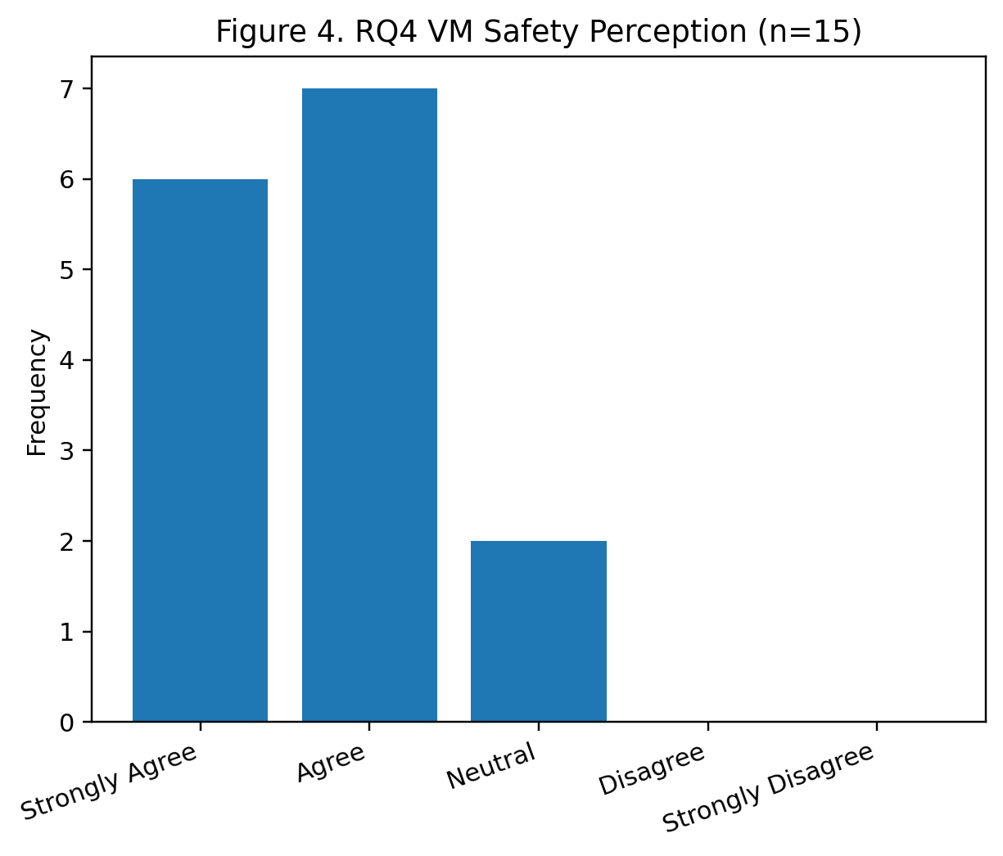

Figure 4 shows strong agreement that a VM is safer than testing directly on the main system: Strongly Agree = 6 (40.0%), Agree = 7 (46.7%), Neutral = 2 (13.3%), and no Disagree/Strongly Disagree responses. This supports the idea that respondents view virtualization as a risk-reduction method.

Q5. How are virtual machines stored as files in Windows, and why does storage location matter?
- Store VM files on C: drive: 6 (40.0%)
- Store VM files on another internal drive (D: or similar): 4 (26.7%)
- Store on external drive: 2 (13.3%)
- Store in cloud-synced folder: 1 (6.7%)
- Not sure: 2 (13.3%)
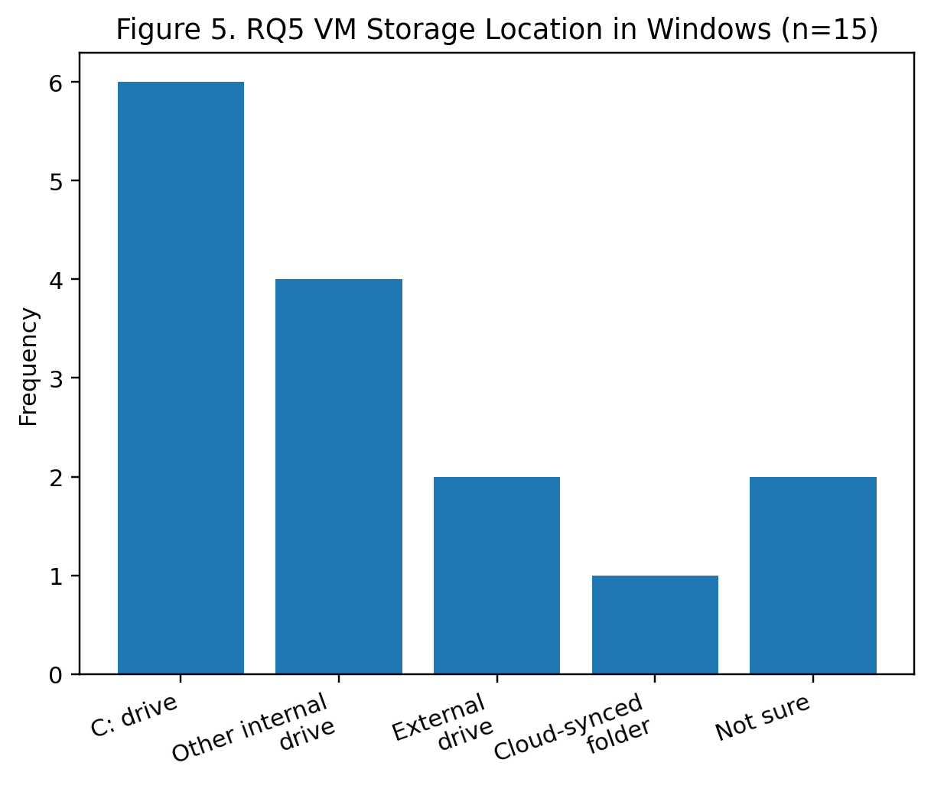Finding: Many respondents stored VM files on the C: drive. This can be risky because the system drive can fill up faster and VM files are large, so poor location choices may affect performance and organization.

Figure 5 shows that VM files are most commonly stored on the C: drive (6, 40.0%), followed by another internal drive (4, 26.7%), external drive (2, 13.3%), and cloud-synced folder (1, 6.7%), while 2 (13.3%) were not sure. This suggests many respondents use the default/system drive, which can affect organization and available space.

RQ6. How do Windows file permissions help protect VM files and personal folders?
- Have changed folder permissions before: 4 (26.7%)
- Set permissions on VM folders: 2 (13.3%)
Finding: Most respondents did not use folder permissions, showing a gap between having virtualization tools and applying file protection practices.

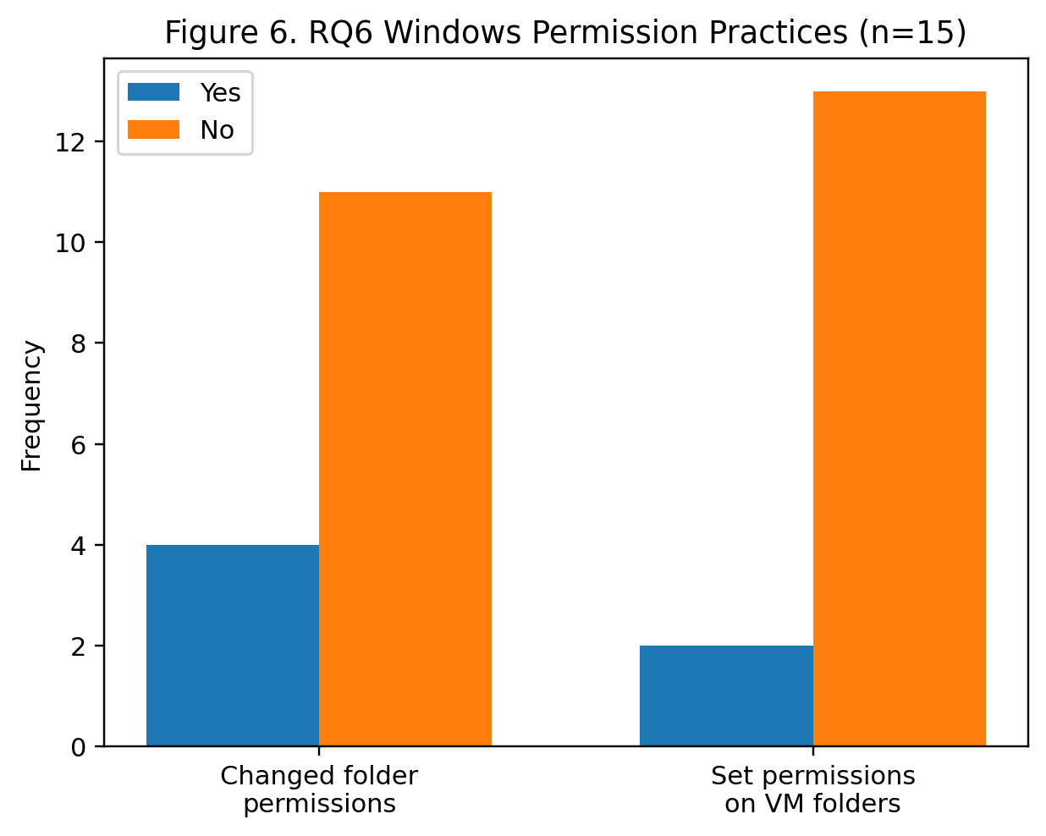

Figure 6 shows that only 4 respondents (26.7%) have changed folder permissions before, and only 2 respondents (13.3%) set permissions on VM folders. This highlights a gap between using virtualization and applying file protection practices.

Q7. How can file sharing between host and VM help and create risks?
- Shares folders between host and VM: 7 (46.7%)
- Does not share folders: 8 (53.3%)
Likert item: “Sharing folders between host and VM can increase risk if the VM is not trusted.”
- Strongly Agree: 5 (33.3%)
- Agree: 6 (40.0%)
- Neutral: 4 (26.7%)
- Disagree: 0
- Strongly Disagree: 0
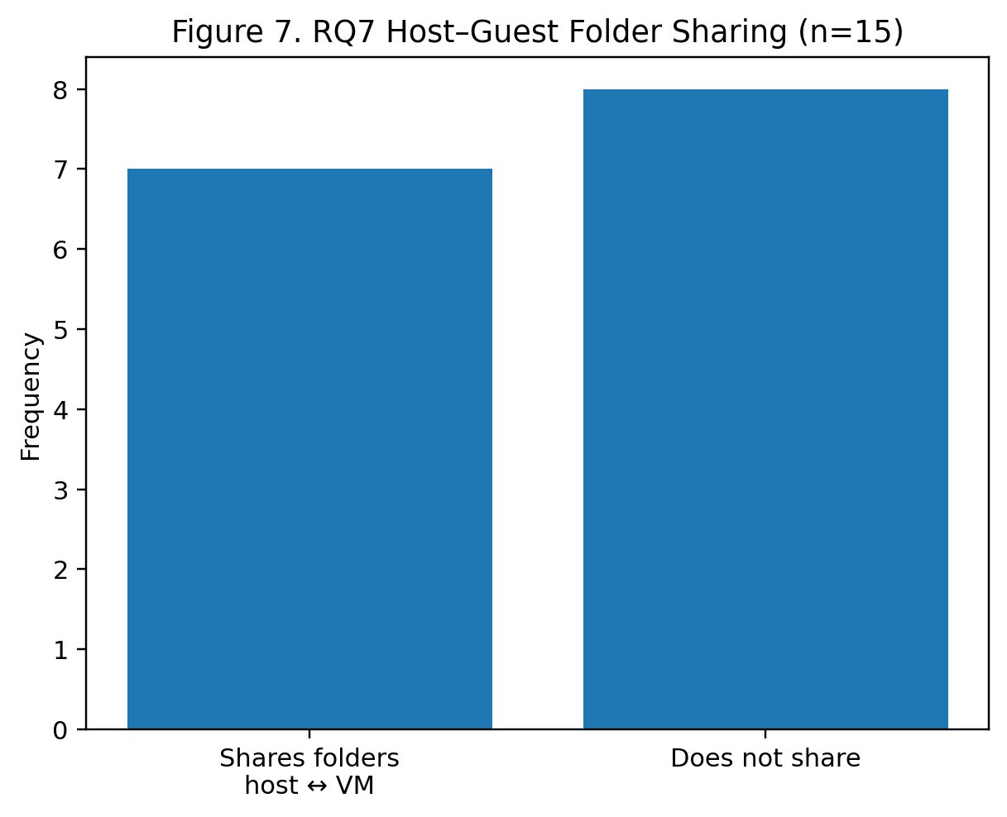Finding: Many respondents use sharing because it is convenient, but most also agree it can increase risk. This shows a trade-off between speed and safety.

Figure 7 shows that 7 respondents (46.7%) share folders between the host and VM, while 8 (53.3%) do not. This suggests many students use sharing for convenience, but slightly more avoid it, which can help keep isolation stronger.

Q8. What file management habits keep VM files and personal files safer?
- Keeps VM files in one dedicated folder: 8 (53.3%)
- Separates downloads from school/work folders: 9 (60.0%)
- Deletes unknown installers after testing: 6 (40.0%)
- Regularly backs up important files: 5 (33.3%)
Finding: Organization habits were more common than security habits like backups. This suggests students are more likely to manage clutter than plan recovery.
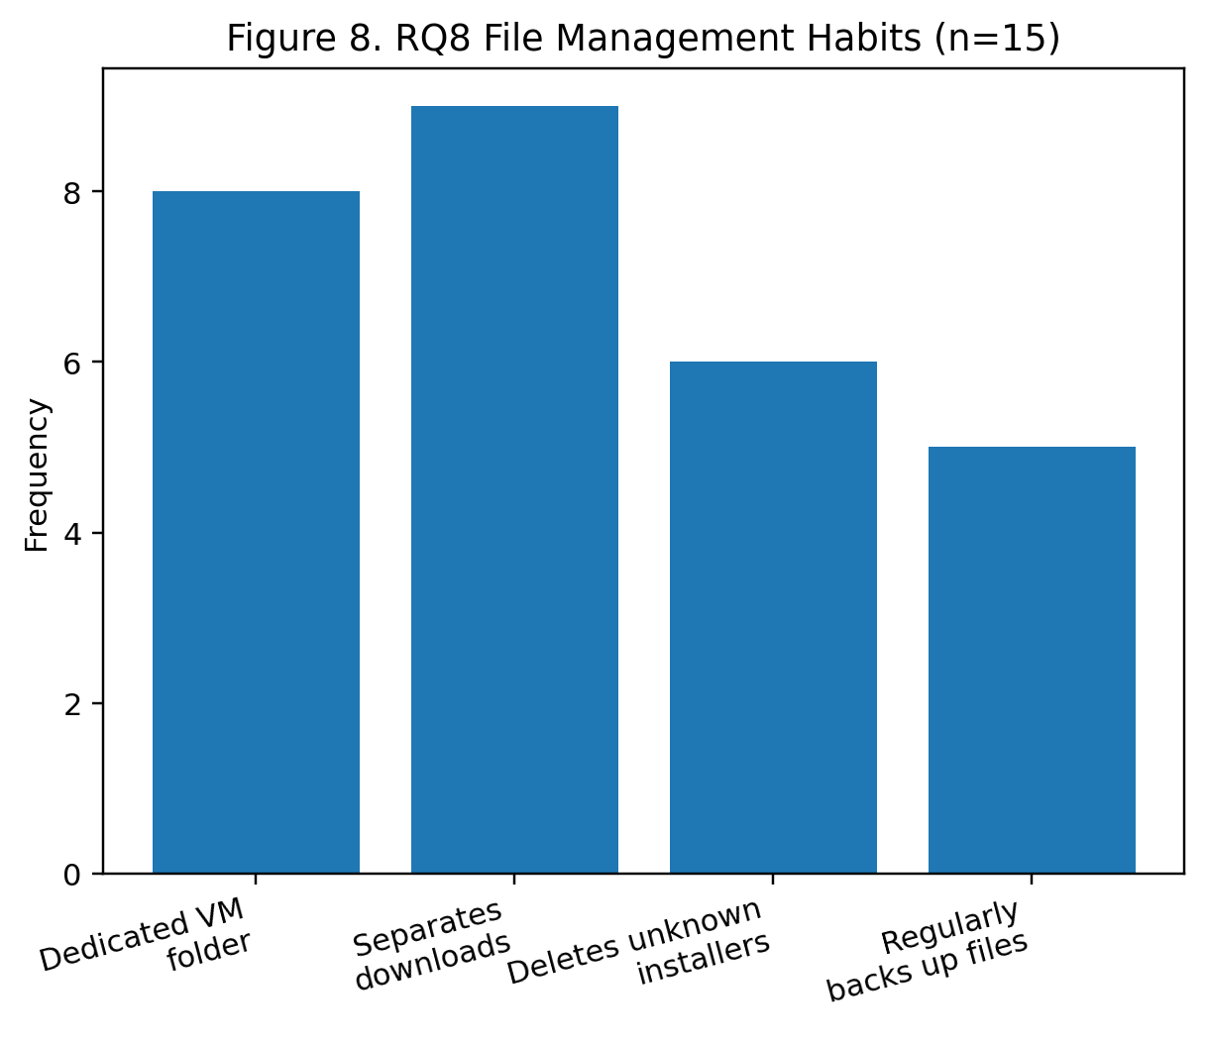
Figure 8 shows that 9 respondents (60.0%) separate downloads from school/work folders and 8 (53.3%) keep VM files in a dedicated folder. Fewer respondents delete unknown installers after testing (6, 40.0%) and regularly back up files (5, 33.3%). This suggests organization habits are more common than recovery habits like backups.
Discussion
This section explains what the survey results mean and why they matter. A discussion section should interpret findings, connect them to related literature, and explain practical meaning, instead of repeating the results discussion below follows the eight research questions using the survey data (n = 15).

Q1. Awareness of virtualization and virtual machines
Most respondents were aware of virtualization (66.7%) and virtual machines (73.3%), which shows that these concepts are already familiar to many students. However, the remaining group who were not aware is still important because virtualization is often used for safe testing and controlled learning. When users do not understand what a VM is, they may treat it like a normal app and ignore basic safety steps like storing VM files properly or limiting file sharing. This supports the idea from classic virtualization theory that the goal of virtualization is controlled and reliable separation, not just running another OS for fun (Popek & Goldberg, 1974).

Q2. Tools used to run another operating system on Windows
Virtual Box was the most used tool (53.3%), while Hyper-V and VMware were less used. This suggests that students prefer tools that feel simpler to install and use for school labs. At the same time, Windows includes built-in virtualization options like Hyper-V and Windows Sandbox that support isolated environments for testing and development. This means many users may be missing built-in options that could help them test files faster and safer without building a full VM every time.

Q3. Why users run Kali Linux in a VM instead of installing directly
Among the respondents who ran Kali in a VM (n = 5), the main reasons were safety and school requirement (both 40%). This matches the idea that Kali is best used in a controlled lab setup. Kali documentation directly supports running Kali in Virtual Box because it is separate from the host and supports snapshots for recovery. This is important for cybersecurity learners because one mistake in tools, settings, or downloads should not damage the main Windows system.

Q4. Virtualization as risk reduction for unknown files or tools
Almost all respondents agreed that a VM is safer than testing on the main Windows system (86.7% Agree or Strongly Agree). This aligns with Microsoft’s description of Windows Sandbox as an isolated desktop for safely running applications and exploring unknown files using hypervisor-based virtualization. It also aligns with NIST guidance that virtualization can isolate systems, but security depends on how well all parts are protected. In simple terms, students understand the safety value of isolation, but isolation is only strong when users avoid risky shortcuts.

Q5. VM storage as Windows files and why location matters
Many respondents stored VM files on the C: drive (40%). This matters because VM files are large and can consume storage quickly, which can lead to slow performance, low disk space, and messy file organization. When VM files are stored carelessly, users may delete the wrong files or lose important VM data. NIST also reminds that storage is part of virtualization security, meaning the VM is only as safe as the way its files are stored and protected.

Q6. Windows file permissions as protection
Only 26.7% had changed folder permissions before, and only 13.3% set permissions on VM folders. This is a key weak point because permissions are one of the simplest protections Windows offers. If VM folders are open to anyone who uses the computer, VM disk files and shared folders can be copied, modified, or deleted. This result supports the security warning from NIST that virtualization security depends on every component, including storage and access control.

Q7. Host–guest file sharing as convenience and risk
Almost half of respondents share folders between host and VM (46.7%). This shows that convenience is a strong reason for users to connect the VM and the host. But the same connection can weaken isolation because files can move easily between systems. NIST notes that virtual machines may have access to shared resources such as files on the host OS, which means shared access can become a path for problems to spread if the VM is not trusted. This explains why users should treat shared folders carefully, especially when testing unknown tools.

Q8. File management habits for safer and more organized use
The most common habits were separating downloads (60%) and keeping VM files in a dedicated folder (53.3%). These are good habits because they reduce confusion and make it easier to locate VM files and lab files. However, only 33.3% regularly back up important files, which is a weakness. In real use, one corrupted VM, accidental deletion, or a bad download can cause data loss. This means students are better at organization than recovery planning, and recovery planning is important for both normal users and security learners.

Conclusion and Recommendation
Based on the survey results (n = 15), most respondents are already aware of virtualization and virtual machines, but awareness is still not universal. Many respondents also believe that using a VM is safer than testing directly on the main Windows system, which supports the idea that isolation is a practical safety advantage. This matches how Windows Sandbox is described as an isolated desktop for safely running applications and exploring unknown files. However, the results also show gaps in real practice. Many respondents store VM files on the C: drive, few apply Windows folder permissions to protect VM folders, and almost half use host–guest folder sharing, which can weaken isolation if the VM is not trusted. These concerns align with NIST guidance that virtualized environments add layers and security boundaries that must be managed, including how host resources and shared access are handled. Overall, the findings show that students understand the value of virtualization, but many still need simple habits that connect virtualization to Windows file management and safer workflows.

Recommendations
- Use the right isolation tool for the task. For quick testing of unknown apps or files, use Windows Sandbox because it is designed for lightweight isolation and safe testing. For longer lab work (like Kali Linux), use a full VM in Virtual Box, Hyper-V, or VMware.
- Use snapshots before risky changes in a VM. Before installing new tools, drivers, or unknown files inside a VM, create a snapshot so you can revert quickly if something breaks or becomes unsafe. Virtual Box snapshots are designed to save a VM state and return to it later.
- Store VM files in a dedicated folder, not mixed with downloads. Keep VM files in one clear location (example: a “VMs” folder) to avoid accidental deletion and confusion. If possible, store large VM files on a separate internal drive with enough space, instead of filling the C: drive.
- Protect VM folders using Windows permissions. Apply basic permissions to VM folders so not everyone on the computer can open, copy, or delete VM disk files. Windows uses access control lists (ACLs) to allow or deny access rights to users and groups, so permissions are a simple way to protect VM storage.
- Limit host–guest sharing when doing risky testing. Shared folders and easy file transfer are convenient, but they can create a direct path between the VM and the host. NIST warns that virtualization security depends on controlling boundaries and shared access, so sharing should be minimized when the VM is used for unknown tools or suspicious files.
- Separate “lab files” from personal files. For cybersecurity learners and ethical hackers using Kali Linux, keep lab tools, captured files, and testing outputs inside the VM or in a controlled lab folder, not in personal document folders. This reduces the chance of mixing risky files with important data.
- Add simple recovery habits. Because only a smaller group reported regular backups, students should adopt a basic backup routine for important files (school files, projects, game saves). This supports safer recovery if a mistake or malware causes loss, even outside virtualization.
These recommendations are meant to help students, gamers, and cybersecurity learners use virtualization in a safer and more organized way by combining isolation with strong Windows file management practices, especially storage location, permissions, and controlled file sharing.

References

Boone, H. N., Jr., & Boone, D. A. (2012). Analyzing Likert data. Journal of Extension, 50(2).
Communications of the ACM, 17(7), 412–421. https://doi.org/10.1145/361011.361073
https://doi.org/10.1111/j.1365-2929.2004.02012.x
https://eric.ed.gov/?id=EJ1042448
https://learn.microsoft.com/en-us/windows/security/application-security/application-isolation/windows-sandbox/windows-sandbox-overview
https://learn.microsoft.com/en-us/windows/security/identity-protection/access-control/access-control
https://learn.microsoft.com/en-us/windows/wsl/about
https://learn.microsoft.com/en-us/windows-server/storage/disk-management/manage-virtual-hard-disks
https://learn.microsoft.com/en-us/windows-server/storage/file-server/ntfs-overview
https://learn.microsoft.com/en-us/windows-server/virtualization/hyper-v/hyper-v-on-windows-server
https://search.gesis.org/publication/zis-Likert1932A
https://www.virtualbox.org/manual/
Jamieson, S. (2004). Likert scales: How to (ab)use them. Medical Education, 38(12), 1217–1218.
Kali Linux Documentation. (n.d.). Kali inside VirtualBox (Guest VM).
Likert, R. (1932). A technique for the measurement of attitudes. Archives of Psychology, 140, 1–55.
Microsoft. (2025). Hyper-V overview.
Microsoft. (2025). What is the Windows Subsystem for Linux (WSL)?
Microsoft. (2025). Windows Sandbox.
Microsoft. (2025, April 7). Access control overview.
Microsoft. (2025, June 18). NTFS overview.
Microsoft. (2025, June 25). Manage Virtual Hard Disks (VHD).
National Institute of Standards and Technology. https://doi.org/10.6028/NIST.SP.800-125
Oracle. (2023). Oracle VM VirtualBox user manual: Snapshots.
Popek, G. J., & Goldberg, R. P. (1974). Formal requirements for virtualizable third generation architectures.
Retrieved December 19, 2025, from https://core.vmware.com/security-configuration
Retrieved December 19, 2025, from https://www.kali.org/docs/virtualization/install-virtualbox-guest-vm/
Scarfone, K., Souppaya, M., & Hoffman, P. (2011). Guide to security for full virtualization technologies (SP 800-125).
VMware (Broadcom). (n.d.). vSphere security configuration guidance (shared folder / host-guest transfer controls).

